Descendants of Angus MacDonell (1740-?)
Compiled by Allan Robertson
36 Forster Ave.
Thorold, ON
L2V4J5
forsteralal@cogeco.ca
2021-07-20

Contents
Introduction 5
Family of the Starting Person 7
Angus MacDonell 7
Families of his Descendants 9
1st Generation 9
Alexander MacDonell 9
2nd Generation 11
Alexander MacDonell and ? Morrison 11
Angus MacDonell and ? Morrison 11
Annie MacDonell and Alexander MacNeil 12
3rd Generation 13
Flora MacDonell and Angus MacDonell 13
Allan MacDonell and Kate MacDonald 14
Annie MacDonell and Angus Campbell 14
Alexander MacDonell 15
Annie MacNeil and James MacMillan 15
4th Generation 17
Allan MacDonell and Mary MacDonald 17
Alexander MacDonell and Vina MacGinnis 18
5th Generation 19
Flora MacDonell and John MacLean 19
Charlotte MacDonell and James Robertson 20
Angus MacDonell and Dawn Matchette 27
Allan MacDonell and Margaret MacDonald 28
6th Generation 29
Elizabeth MacLean and Franco Fortunato 29
Helen MacLean and George Colter 29
Allan Robertson and Virginia Worobel 31
Lois Robertson 40
Lois Robertson and Joseph Dalton 42
Lois Robertson and Harold Little 43
Lois Robertson and ? Cyr 44
Vivian Robertson 44
Vivian Robertson and Roy Gray 45
Vivian Robertson and ? ? 46
Allan MacDonell and Kathy Barden 47
7th Generation 51
Jenny Robertson and Steve Taylor 51
Adele Robertson 56
Adele Robertson and Jeffery Craige 59
Adele Robertson and Geard Seward 60
Lara Robertson and Jeremy Bowen 61
Michelle Dusette and Brian Procter 64
Lisa Robertson and John Brown 66
Index of Places 69
Index of Individuals 71

Introduction
The following pages list data for all known family members as of <2021-07-20>.
Each immediate family is presented in their own section that contains a graphical family tree as well as a description with information about each referenced person and their children. The child section provides information about the children of the preceding couple. When a child has offspring of their own this is presented in a separate family section for that child. In this case a '+' is used to denote that an individual will appear later in the book as a parent with his/her own children and there is a link to the appropriate family reference number. For children with partners but no offspring the partner data is given with the reference family. Roman numerals, followed by a period, are used to indicate the birth order.
In the chapter titled "Family of the Starting Person" the ancestors of Angus MacDonell are presented in a kind of enhanced Pedigree Chart which displays the graphic representation of their direct-line ancestors and the children of the couple. This chapter contains information about the couple whose offspring are listed in the later chapters.
The chapter titled "Families of his Descendants" provides details (as known as of the publication date) for the offspring of Angus MacDonell. There is a chapter for each generation. Relatives are listed in the order of the nearness of their relationship.
Sources for the information provided are given in the footnotes.
This document reports the details of 92 individuals, of whom 50 are male and 38 are female. The sex of 4 individuals is unknown. Of the 9 individuals with recorded birth and death dates, the average lifespan was 64.7 years. Of these, 4 males averaged 64.8 years, and 5 females averaged 64.6 years. The longest living male was Angus Hugh MacDonell (1831–1917), who died aged 86. The longest living female was Mary Christina MacDonald (1895–1978), who died aged 83.

Family of the Starting Person

Angus MacDonell
?
MacDonell
1710–
Angus
MacDonell
1740–
Alexander
MacDonell
1790–

1. Angus MacDonell was born in 1740 in Scotland. He was the son of ? MacDonell.
Son of Angus MacDonell:
+ 2 m I. Alexander MacDonell was born in 1790.

Families of his Descendants

1st Generation

Alexander MacDonell
?
MacDonell
1710–
 | Angus
 | MacDonell
 | 1740–
 |  |  |  |  | Alexander
 |  |  |  |  | MacDonell
 |  |  |  |  | 1790–
 |  |  |  |  |  |  |  | Alexander |  |  |  | Allan |  |  |  | Angus |  |  |  | Annie
 |  |  |  |  |  |  |  | MacDonell |  |  |  | MacDonell |  |  |  | MacDonell |  |  |  | MacDonell
 |  |  |  |  |  |  |  | ca.1823–

2. Alexander MacDonell was born in 1790. He was the son of Angus MacDonell (1).
Alexander was from Murlegan, Scotland. He was a Captain in the British army and later settled on the west side of Mabou Harbour,N.S. about 1823.
Children of Alexander MacDonell:
+ 3 m I. Alexander MacDonell was born in Scotland about 1823.
m II. Allan MacDonell.
+ 4 m III. Angus MacDonell.
+ 5 f IV. Annie MacDonell.

2nd Generation

Family of Alexander MacDonell and ? Morrison
Angus
MacDonell
1740–
 | Alexander |  |  |  |  |  |  |  |  |  |  |  |  |  |  |  | Roderick
 | MacDonell |  |  |  |  |  |  |  |  |  |  |  |  |  |  |  | Morrison
 | 1790–
 |  |  |  |  | Alexander |  |  |  |  |  |  |  |  |  |  |  |  |  |  |  | ?
 |  |  |  |  | MacDonell |  |  |  |  |  |  |  |  |  |  |  |  |  |  |  | Morrison
 |  |  |  |  | ca.1823–
 |  |  |  |  |  |  |  |  | Married
Flora |  |  |  | Allan |  |  |  | Alexander |  |  |  | Angus |  |  |  | Roderick |  |  |  | John |  |  |  | James |  |  |  | Annie
MacDonell |  |  |  | MacDonell |  |  |  | MacDonell |  |  |  | MacDonell |  |  |  | MacDonell |  |  |  | MacDonell |  |  |  | MacDonell |  |  |  | MacDonell
1841–1919

3. Alexander MacDonell was born about 1823 in Scotland. He was the son of Alexander MacDonell (2).
He married ? Morrison. They had eight children. She was the daughter of Roderick Morrison.
Children of Alexander MacDonell and ? Morrison:
+ 6 f I. Flora MacDonell was born in 1841. She died on July 30, 1919, at the age of 78.
+ 7 m II. Allan MacDonell.
m III. Alexander MacDonell.
m IV. Angus MacDonell.
m V. Roderick MacDonell.
m VI. John MacDonell.
m VII. James MacDonell.
+ 8 f VIII. Annie MacDonell.

Family of Angus MacDonell and ? Morrison
Angus
MacDonell
1740–
 |  | Alexander
 |  | MacDonell
 |  | 1790–
 |  |  |  |  |  |  |  | Angus |  |  |  |  |  |  |  |  |  |  |  |  |  |  |  |  |  |  |  |  |  |  |  | ?
 |  |  |  |  |  |  |  | MacDonell |  |  |  |  |  |  |  |  |  |  |  |  |  |  |  |  |  |  |  |  |  |  |  | Morrison
 |  |  |  |  |  |  |  |  |  |  |  |  |  | Married
 |  |  |  |  |  |  |  |  |  |  |  |  |  |  | Alexander |  |  |  |  |  | Mary |  |  |  |  |  | Katie
 |  |  |  |  |  |  |  |  |  |  |  |  |  |  | MacDonell |  |  |  |  |  | MacDonell |  |  |  |  |  | MacDonell

4. Angus MacDonell. He was the son of Alexander MacDonell (2).
He married ? Morrison. They had three children.
Children of Angus MacDonell and ? Morrison:
+ 9 m I. Alexander MacDonell.
f II. Mary MacDonell.
f III. Katie MacDonell.

Family of Annie MacDonell and Alexander MacNeil
 |  |  |  |  |  |  |  |  |  |  |  |  |  |  |  | Angus
 |  |  |  |  |  |  |  |  |  |  |  |  |  |  |  | MacDonell
 |  |  |  |  |  |  |  |  |  |  |  |  |  |  |  | 1740–
 |  |  |  |  |  |  |  |  |  |  |  |  |  |  |  |  | Alexander
 |  |  |  |  |  |  |  |  |  |  |  |  |  |  |  |  | MacDonell
 |  |  |  |  |  |  |  |  |  |  |  |  |  |  |  |  | 1790–
 |  |  |  |  | Alexander |  |  |  |  |  |  |  |  |  |  |  |  |  |  |  | Annie
 |  |  |  |  | MacNeil |  |  |  |  |  |  |  |  |  |  |  |  |  |  |  | MacDonell
 |  |  |  |  |  |  |  |  | Married
 |  |  |  |  |  |  |  | Annie |  |  |  | Neil |  |  |  | Alexander |  |  |  | Daniel
 |  |  |  |  |  |  |  | MacNeil |  |  |  | MacNeil |  |  |  | MacNeil |  |  |  | MacNeil

5. Annie MacDonell. She was the daughter of Alexander MacDonell (2).
She married Alexander MacNeil. They had four children.
Children of Annie MacDonell and Alexander MacNeil:
+ 10 f I. Annie MacNeil.
m II. Neil MacNeil.
m III. Alexander MacNeil.
m IV. Daniel MacNeil.

3rd Generation

Family of Flora MacDonell and Angus MacDonell
 |  |  |  |  |  |  |  |  |  |  |  |  |  |  |  | Alexander |  |  |  |  |  |  |  | Roderick
 |  |  |  |  |  |  |  |  |  |  |  |  |  |  |  | MacDonell |  |  |  |  |  |  |  | Morrison
 |  |  |  |  |  |  |  |  |  |  |  |  |  |  |  | 1790–
 | Allan Ban |  |  |  |  |  |  |  | ? |  |  |  |  |  |  |  | Alexander |  |  |  |  |  |  |  | ?
 | MacDonell |  |  |  |  |  |  |  | MacEachern |  |  |  |  |  |  |  | MacDonell |  |  |  |  |  |  |  | Morrison
 |  |  |  |  |  |  |  |  |  |  |  |  |  |  |  |  | ca.1823–
 |  |  |  |  | Angus Hugh |  |  |  |  |  |  |  |  |  |  |  |  |  |  |  | Flora
 |  |  |  |  | MacDonell |  |  |  |  |  |  |  |  |  |  |  |  |  |  |  | MacDonell
 |  |  |  |  | 1831–1917 |  |  |  |  |  |  |  |  |  |  |  |  |  |  |  | 1841–1919
 |  |  |  |  |  |  |  |  | Married
Mary C |  |  |  | Hugh |  |  |  | Maggie A |  |  |  | Julia |  |  |  | Catherine A |  |  |  | Alexander |  |  |  | Allan |  |  |  | Archibald
MacDonell |  |  |  | MacDonell |  |  |  | MacDonell |  |  |  | MacDonell |  |  |  | MacDonell |  |  |  | MacDonell |  |  |  | MacDonell |  |  |  | MacDonell
1868– |  |  |  | 1870– |  |  |  | 1873– |  |  |  | 1874– |  |  |  | 1876– |  |  |  | 1878– |  |  |  | 1880–1926 |  |  |  | 1883–
 |  |  |  |  |  |  |  |  |  |  |  |  |  |  |  |  |  |  |  |  |  |  |  | 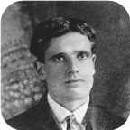

6. Flora MacDonell was born in 1841. She was the daughter of Alexander MacDonell (3) and ? Morrison.
Flora died on July 30, 1919, at the age of 78. She was buried in Judique,N.S.
She married Angus Hugh MacDonell. They had eight children.
Angus Hugh was born in 1831. He was the son of Allan Ban MacDonell and ? MacEachern.
Angus Hugh reached 86 years of age and died on February 15, 1917. He was buried in Judique.
Angus Hugh MacDonell lived in Judique, Cape Breton, N.S.
Children of Flora MacDonell and Angus Hugh MacDonell:
f I. Mary C MacDonell was born in 1868.
m II. Hugh MacDonell was born in 1870.
f III. Maggie A MacDonell was born in 1873.
f IV. Julia MacDonell was born in 1874.
f V. Catherine A MacDonell was born in 1876.
m VI. Alexander MacDonell was born in 1878.
+ 11 m VII. Allan MacDonell was born in 1880. He died in March 1926 at the age of 46.
  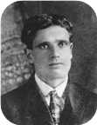
  Allan
m VIII. Archibald MacDonell was born in 1883.

Family of Allan MacDonell and Kate MacDonald
Alexander |  |  |  |  |  |  |  |  |  |  |  | Roderick
MacDonell |  |  |  |  |  |  |  |  |  |  |  | Morrison
1790–
 |  | Alexander |  |  |  |  |  |  |  |  |  |  |  | ? |  |  |  |  |  |  |  |  |  |  |  | Alasdair
 |  | MacDonell |  |  |  |  |  |  |  |  |  |  |  | Morrison |  |  |  |  |  |  |  |  |  |  |  | MacDonald
 |  | ca.1823–
 |  |  |  |  |  |  |  | Allan |  |  |  |  |  |  |  |  |  |  |  |  |  |  |  |  |  |  |  |  |  |  |  | Kate
 |  |  |  |  |  |  |  | MacDonell |  |  |  |  |  |  |  |  |  |  |  |  |  |  |  |  |  |  |  |  |  |  |  | MacDonald
 |  |  |  |  |  |  |  |  |  |  |  |  |  | Married
 |  |  |  |  |  |  |  |  |  |  |  |  |  |  |  |  |  |  |  |  | Alexander Ackie
 |  |  |  |  |  |  |  |  |  |  |  |  |  |  |  |  |  |  |  |  | MacDonell

7. 369 Allan MacDonell. He was the son of Alexander MacDonell (3) and ? Morrison.
He married Kate MacDonald. They had one son. She was the daughter of Alasdair MacDonald.
Son of Allan MacDonell and Kate MacDonald:
+ 12 m I. Alexander Ackie MacDonell was born in Port Hood, N.S. He died in Port Hood.

Family of Annie MacDonell and Angus Campbell
 |  |  |  |  |  |  |  |  |  |  |  |  |  |  |  | Alexander |  |  |  |  |  |  |  | Roderick
 |  |  |  |  |  |  |  |  |  |  |  |  |  |  |  | MacDonell |  |  |  |  |  |  |  | Morrison
 |  |  |  |  |  |  |  |  |  |  |  |  |  |  |  | 1790–
 |  |  |  |  |  |  |  |  |  |  |  |  |  |  |  |  | Alexander |  |  |  |  |  |  |  | ?
 |  |  |  |  |  |  |  |  |  |  |  |  |  |  |  |  | MacDonell |  |  |  |  |  |  |  | Morrison
 |  |  |  |  |  |  |  |  |  |  |  |  |  |  |  |  | ca.1823–
 |  |  |  |  | Angus |  |  |  |  |  |  |  |  |  |  |  |  |  |  |  | Annie
 |  |  |  |  | Campbell |  |  |  |  |  |  |  |  |  |  |  |  |  |  |  | MacDonell
 |  |  |  |  |  |  |  |  | Married

8. Annie MacDonell. She was the daughter of Alexander MacDonell (3) and ? Morrison.
She married Angus Campbell.

Alexander MacDonell
Alexander
MacDonell
1790–
 |  | Angus |  |  |  |  |  |  |  |  |  |  |  | ?
 |  | MacDonell |  |  |  |  |  |  |  |  |  |  |  | Morrison
 |  |  |  |  |  |  |  | Alexander
 |  |  |  |  |  |  |  | MacDonell
 |  |  |  |  |  |  |  |  |  |  |  |  |  |  |  |  |  |  |  |  | William
 |  |  |  |  |  |  |  |  |  |  |  |  |  |  |  |  |  |  |  |  | MacDonell

9. Alexander MacDonell. He was the son of Angus MacDonell (4) and ? Morrison.
Daughter of Alexander MacDonell:
f I. William MacDonell.

Family of Annie MacNeil and James MacMillan
 |  |  |  |  |  |  |  |  |  |  |  |  |  |  |  |  |  |  |  |  |  |  |  | Alexander
 |  |  |  |  |  |  |  |  |  |  |  |  |  |  |  |  |  |  |  |  |  |  |  | MacDonell
 |  |  |  |  |  |  |  |  |  |  |  |  |  |  |  |  |  |  |  |  |  |  |  | 1790–
 |  |  |  |  |  |  |  |  |  |  |  |  |  |  |  |  | Alexander |  |  |  |  |  |  |  | Annie
 |  |  |  |  |  |  |  |  |  |  |  |  |  |  |  |  | MacNeil |  |  |  |  |  |  |  | MacDonell
 |  |  |  |  | James Duncan |  |  |  |  |  |  |  |  |  |  |  |  |  |  |  | Annie
 |  |  |  |  | MacMillan |  |  |  |  |  |  |  |  |  |  |  |  |  |  |  | MacNeil
 |  |  |  |  |  |  |  |  | Married

10. Annie MacNeil. She was the daughter of Alexander MacNeil and Annie MacDonell (5).
She married James Duncan MacMillan.

4th Generation

Family of Allan MacDonell and Mary MacDonald
Allan Ban |  |  |  | ? |  |  |  | Alexander |  |  |  | ? |  |  |  | William |  |  |  | Catherine
MacDonell |  |  |  | MacEachern |  |  |  | MacDonell |  |  |  | Morrison |  |  |  | MacDonald |  |  |  | MacMaster
 |  |  |  |  |  |  |  | ca.1823– |  |  |  |  |  |  |  | 1799– |  |  |  | 1810–
 | Angus Hugh |  |  |  |  |  |  |  | Flora |  |  |  |  |  |  |  | William Little |  |  |  |  |  |  |  | Charlotte
 | MacDonell |  |  |  |  |  |  |  | MacDonell |  |  |  |  |  |  |  | MacDonald |  |  |  |  |  |  |  | MacDougall
 | 1831–1917 |  |  |  |  |  |  |  | 1841–1919 |  |  |  |  |  |  |  | 1844–1917 |  |  |  |  |  |  |  | 1849–1934
 |  |  |  |  |  |  |  |  |  |  |  |  |  |  |  |  |  |  |  |  |  |  |  |  | 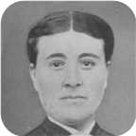
 |  |  |  |  | Allan |  |  |  |  |  |  |  |  |  |  |  |  |  |  |  | Mary Christina
 |  |  |  |  | MacDonell |  |  |  |  |  |  |  |  |  |  |  |  |  |  |  | MacDonald
 |  |  |  |  | 1880–1926 |  |  |  |  |  |  |  |  |  |  |  |  |  |  |  | 1895–1978
 |  |  |  |  |  |  |  |  |  |  |  |  |  |  |  |  |  |  |  |  | 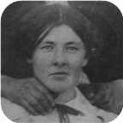
 |  |  |  |  |  |  |  |  | Married
 |  |  |  |  |  |  |  | Flora Isabel |  |  |  | Charlotte Helen |  |  |  | Angus John |  |  |  | Allan Joseph
 |  |  |  |  |  |  |  | MacDonell |  |  |  | MacDonell |  |  |  | MacDonell |  |  |  | MacDonell
 |  |  |  |  |  |  |  | 1920– |  |  |  | 1922–2005 |  |  |  | 1924– |  |  |  | 1926–1980
 |  |  |  |  |  |  |  | 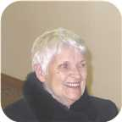 |  |  |  | 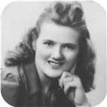

11. Allan MacDonell was born in 1880. He was the son of Angus Hugh MacDonell and Flora MacDonell (6).  Allan died in March 1926 at the age of 46.
  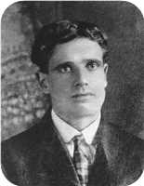
  Allan MacDonell
Allan MacDonell lived in Judique, Cape Breton, N.S.
He married Mary Christina MacDonald. They had four children.  Mary Christina was born in Judique,N.S., on Thursday, January 31, 1895. She was the daughter of William Little MacDonald and Charlotte MacDougall.
  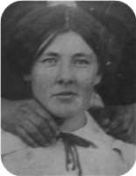
  Mary Christina MacDonald
She was employed in Homemaker. Mary Christina reached 83 years of age and died in Mulgrave,N.S., on February 20, 1978. She was buried in Port Hood, N.S.
Children of Allan MacDonell and Mary Christina MacDonald:
+ 13 f I. Flora Isabel MacDonell was born on March 19, 1920.
  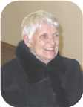
  Flora
+ 14 f II. Charlotte Helen MacDonell was born in Judique, Nova Scotia, on December 25, 1922. She died on April 29, 2005, at the age of 82.
  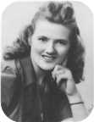
  Charlotte
+ 15 m III. Angus John MacDonell was born on December 17, 1924.
+ 16 m IV. Allan Joseph MacDonell was born in 1926. He died in 1980 at the age of 54.

Family of Alexander MacDonell and Vina MacGinnis
Alexander |  |  |  |  |  | ? |  |  |  |  |  | Alasdair
MacDonell |  |  |  |  |  | Morrison |  |  |  |  |  | MacDonald
ca.1823–
 |  | Allan |  |  |  |  |  |  |  |  |  |  |  | Kate |  |  |  |  |  |  |  |  |  |  |  | William |  |  |  |  |  |  |  |  |  |  |  | Annie
 |  | MacDonell |  |  |  |  |  |  |  |  |  |  |  | MacDonald |  |  |  |  |  |  |  |  |  |  |  | MacInnis |  |  |  |  |  |  |  |  |  |  |  | MacLean
 |  |  |  |  |  |  |  |  |  |  |  |  |  |  |  |  |  |  |  |  |  |  |  |  |  | 1872–1942
 |  |  |  |  |  |  |  | Alexander Ackie |  |  |  |  |  |  |  |  |  |  |  |  |  |  |  |  |  |  |  |  |  |  |  | Vina
 |  |  |  |  |  |  |  | MacDonell |  |  |  |  |  |  |  |  |  |  |  |  |  |  |  |  |  |  |  |  |  |  |  | MacGinnis
 |  |  |  |  |  |  |  |  |  |  |  |  |  |  |  |  |  |  |  |  |  |  |  |  |  |  |  |  |  |  |  | 1912–1960
 |  |  |  |  |  |  |  |  |  |  |  |  |  | Married
 |  |  |  |  |  |  |  |  |  |  |  |  |  |  |  |  |  |  |  |  | Francine
 |  |  |  |  |  |  |  |  |  |  |  |  |  |  |  |  |  |  |  |  | MacDonell

12. Alexander Ackie MacDonell was born in Port Hood, N.S. He was the son of Allan MacDonell (7) and Kate MacDonald.
Alexander Ackie died in Port Hood. He was buried in Port Hood.
He married Vina MacGinnis. They had one daughter.
Vina was born in 1912. She was the daughter of William MacInnis and Annie MacLean.
Vina reached 48 years of age and died in 1960.
Daughter of Alexander Ackie MacDonell and Vina MacGinnis:
f I. Francine MacDonell.

5th Generation

Family of Flora MacDonell and John MacLean
 |  |  |  |  |  |  |  |  |  |  |  |  |  |  |  |  |  |  |  |  |  |  |  | Angus Hugh |  |  |  |  |  | Flora |  |  |  |  |  | William Little |  |  |  |  |  | Charlotte
 |  |  |  |  |  |  |  |  |  |  |  |  |  |  |  |  |  |  |  |  |  |  |  | MacDonell |  |  |  |  |  | MacDonell |  |  |  |  |  | MacDonald |  |  |  |  |  | MacDougall
 |  |  |  |  |  |  |  |  |  |  |  |  |  |  |  |  |  |  |  |  |  |  |  | 1831–1917 |  |  |  |  |  | 1841–1919 |  |  |  |  |  | 1844–1917 |  |  |  |  |  | 1849–1934
 |  |  |  |  |  |  |  |  |  |  |  |  |  |  |  |  |  |  |  |  |  |  |  |  |  | Allan |  |  |  |  |  |  |  |  |  |  |  | Mary Christina
 |  |  |  |  |  |  |  |  |  |  |  |  |  |  |  |  |  |  |  |  |  |  |  |  |  | MacDonell |  |  |  |  |  |  |  |  |  |  |  | MacDonald
 |  |  |  |  |  |  |  |  |  |  |  |  |  |  |  |  |  |  |  |  |  |  |  |  |  | 1880–1926 |  |  |  |  |  |  |  |  |  |  |  | 1895–1978
 |  |  |  |  |  |  |  | John |  |  |  |  |  |  |  |  |  |  |  |  |  |  |  |  |  |  |  |  |  |  |  | Flora Isabel
 |  |  |  |  |  |  |  | MacLean |  |  |  |  |  |  |  |  |  |  |  |  |  |  |  |  |  |  |  |  |  |  |  | MacDonell
 |  |  |  |  |  |  |  |  |  |  |  |  |  |  |  |  |  |  |  |  |  |  |  |  |  |  |  |  |  |  |  | 1920–
 |  |  |  |  |  |  |  |  |  |  |  |  |  | Married
 |  |  |  |  |  |  |  |  | Elizabeth |  |  |  |  |  | Victoria |  |  |  |  |  | Helen |  |  |  |  |  | Cathy |  |  |  |  |  | David William
 |  |  |  |  |  |  |  |  | MacLean |  |  |  |  |  | MacLean |  |  |  |  |  | MacLean |  |  |  |  |  | MacLean |  |  |  |  |  | MacLean
 |  |  |  |  |  |  |  |  | 1942–
 |  |  |  |  |  |  |  |  |  |  |  |  |  |  |  |  |  |  |  |  |  |  |  |  |  |  |  |  |  |  |  |  | 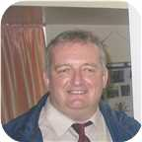

13. Flora Isabel MacDonell was born on Friday, March 19, 1920. She is the daughter of Allan MacDonell (11) and Mary Christina MacDonald.
  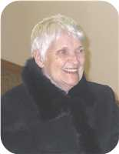
  Flora Isabel MacDonell
She married John MacLean. They have five children.
John is employed in Fron Churchview,N.S.
Children of Flora Isabel MacDonell and John MacLean:
+ 17 f I. Elizabeth MacLean was born in 1942.
f II. Victoria MacLean.
+ 18 f III. Helen MacLean.
  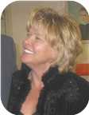
  Helen
f IV. Cathy MacLean.
m V. David William MacLean.
  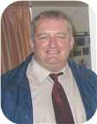
  David

Family of Charlotte MacDonell and James Robertson
James Alexander |  |  |  | Annie Fraser |  |  |  | Arthur |  |  |  | Ocenia |  |  |  | Angus Hugh |  |  |  | Flora |  |  |  | William Little |  |  |  | Charlotte
Robertson |  |  |  | Campbell |  |  |  | Ives |  |  |  | Fraser |  |  |  | MacDonell |  |  |  | MacDonell |  |  |  | MacDonald |  |  |  | MacDougall
1859–1947 |  |  |  | 1867–1960 |  |  |  | 1854–1913 |  |  |  | 1853–1935 |  |  |  | 1831–1917 |  |  |  | 1841–1919 |  |  |  | 1844–1917 |  |  |  | 1849–1934
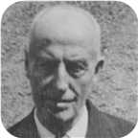 |  |  |  | 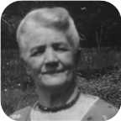 |  |  |  | 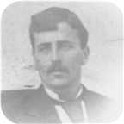 |  |  |  | 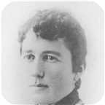
 | Leonard Bowman |  |  |  |  |  |  |  | Louisa Reid |  |  |  |  |  |  |  | Allan |  |  |  |  |  |  |  | Mary Christina
 | Robertson |  |  |  |  |  |  |  | Ives |  |  |  |  |  |  |  | MacDonell |  |  |  |  |  |  |  | MacDonald
 | 1890–1972 |  |  |  |  |  |  |  | 1889–1982 |  |  |  |  |  |  |  | 1880–1926 |  |  |  |  |  |  |  | 1895–1978
 | 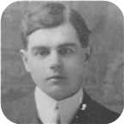 |  |  |  |  |  |  |  | 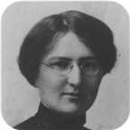
 |  |  |  |  | James Ives |  |  |  |  |  |  |  |  |  |  |  |  |  |  |  | Charlotte Helen
 |  |  |  |  | Robertson |  |  |  |  |  |  |  |  |  |  |  |  |  |  |  | MacDonell
 |  |  |  |  | 1917–1989 |  |  |  |  |  |  |  |  |  |  |  |  |  |  |  | 1922–2005
 |  |  |  |  | 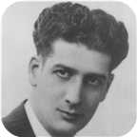
 |  |  |  |  |  |  |  |  | Marriage: 1942
 |  |  |  |  |  |  |  | Allan James |  |  |  | Lois Christina |  |  |  | Lewis William |  |  |  | Vivian Louise
 |  |  |  |  |  |  |  | Robertson |  |  |  | Robertson |  |  |  | Robertson |  |  |  | Robertson
 |  |  |  |  |  |  |  | 1943– |  |  |  | 1948–1979 |  |  |  | 1951– |  |  |  | 1957–
 |  |  |  |  |  |  |  |  |  |  |  | 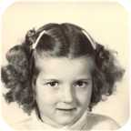 |  |  |  | 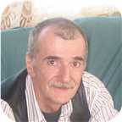 |  |  |  | 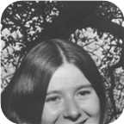

14. Charlotte Helen MacDonell was born on Monday, December 25, 1922, in Judique, Nova Scotia. She was the daughter of Allan MacDonell (11) and Mary Christina MacDonald.  Charlotte Helen died on April 29, 2005, at the age of 82.
  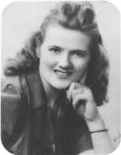
  Charlotte Helen MacDonell
At the age of 19, Charlotte Helen married James Ives Robertson on Wednesday, April 29, 1942, in Cadillac,Quebec, when he was 25 years old. They had four children.  James Ives was born in Stellarton, Nova Scotia, on Sunday, January 28, 1917.
  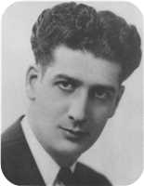
  James Ives Robertson
He was the son of Leonard Bowman Robertson and Louisa Reid Ives. He was educated in Cumunity College.
James Ives was employed in Sheet Metal worker. James Ives reached 72 years of age and died in Pictou, Nova Scotia, Canada, on October 14, 1989.
James was a sheet metal worker by trade. Most of his working career was spent at the Pictou shipyard (Ferguson Industries Ltd.).
Children of Charlotte Helen MacDonell and James Ives Robertson:
+ 19 m I. Allan James Robertson was born in Pictou, Nova Scotia, Canada, on August 26, 1943.
  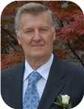
  Allan
+ 20 f II. Lois Christina Robertson was born in St Catharines, Ontario, on April 30, 1948. She died in Pictou, Nova Scotia, Canada, on January 23, 1979, at the age of 30.
  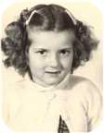
  Lois
m III. Lewis William Robertson was born on December 25, 1951. He is employed in Factory Worker.
  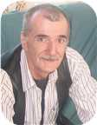
  Lewis
+ 21 f IV. Vivian Louise Robertson was born in Pictou, Nova Scotia, Canada, on January 30, 1957.
  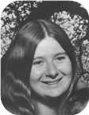
  Vivian

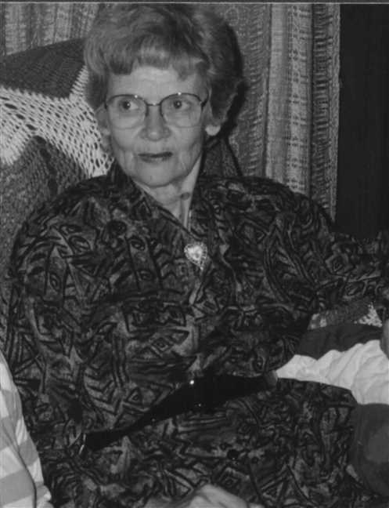  Figure 1: Charlotte H MacDonell |  | 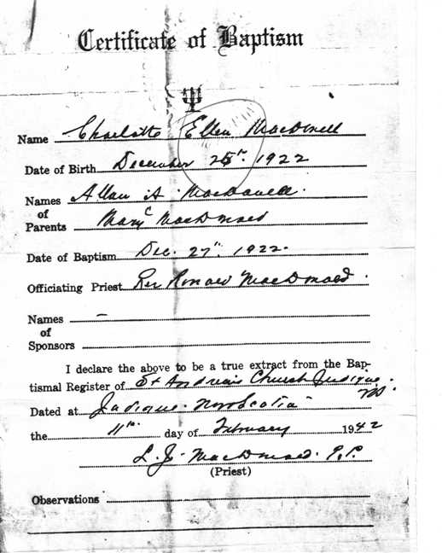  Figure 2: Charlotte Helen McDonell's Baptism Certificate

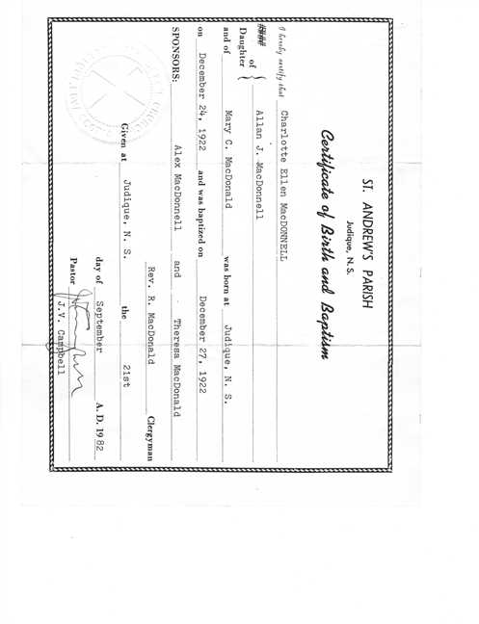  Figure 3: Charlotte Helen's Baptism 2 |  | 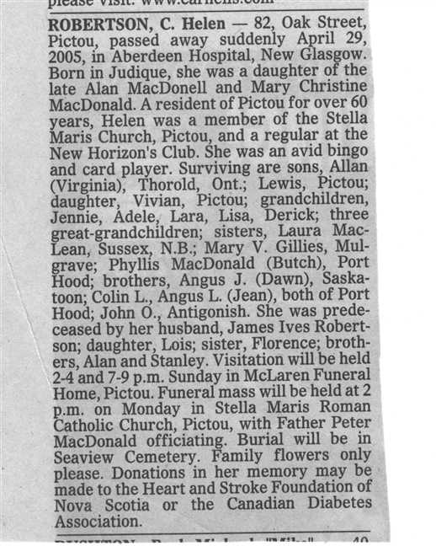  Figure 4: Charlotte Helen's Obit

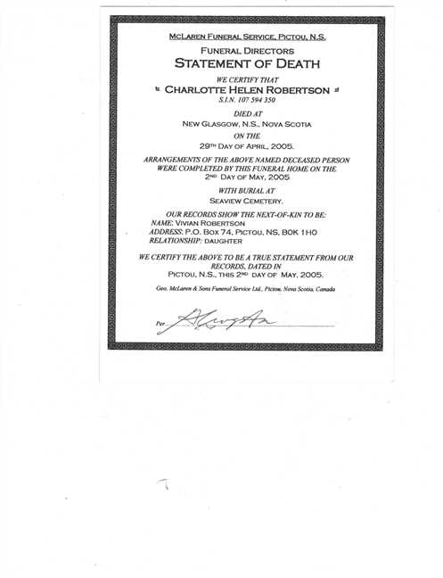  Figure 5: Statement of Death |  | 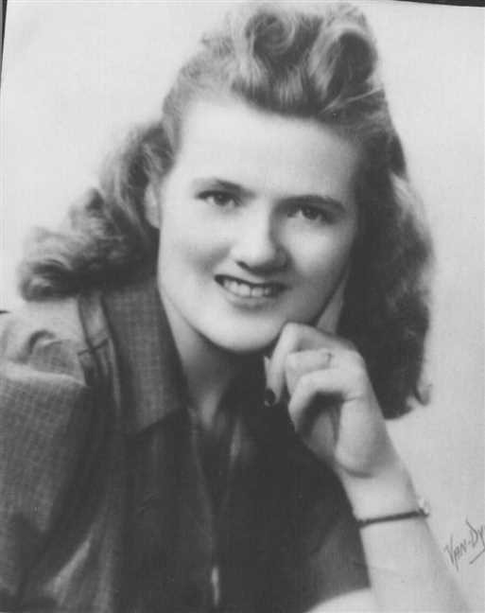  Figure 6: Charlotte H MacDonell

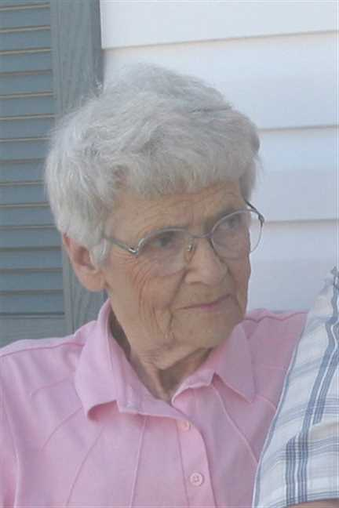  Figure 7: Charlotte H MacDonell |  | 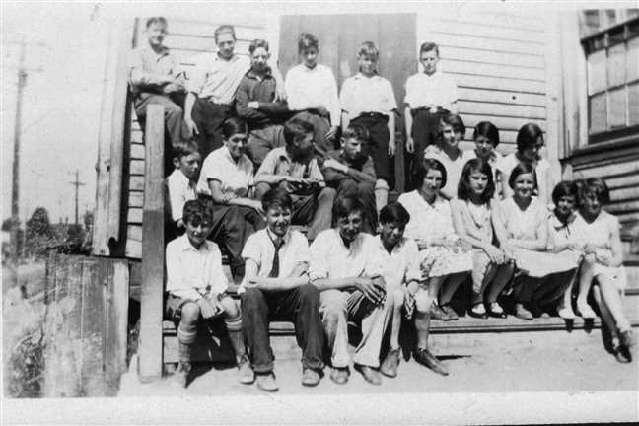  Figure 8: Dad's Grade 8 Class June 1930

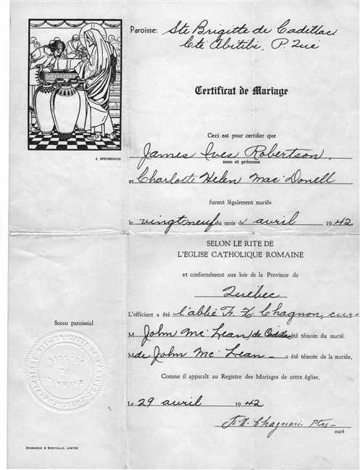  Figure 9: Helen and James Robertson Marrige |  | 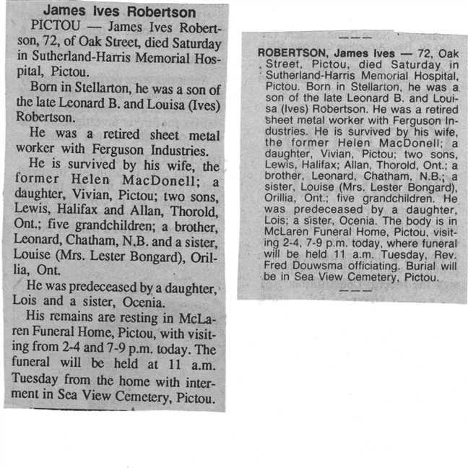  Figure 10: James Robertson's Obits

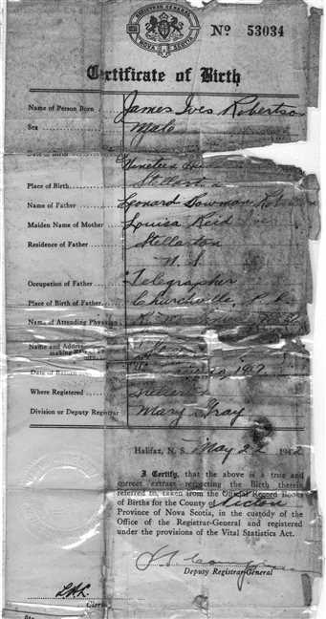  Figure 11: James Robertson' Baptism |  | 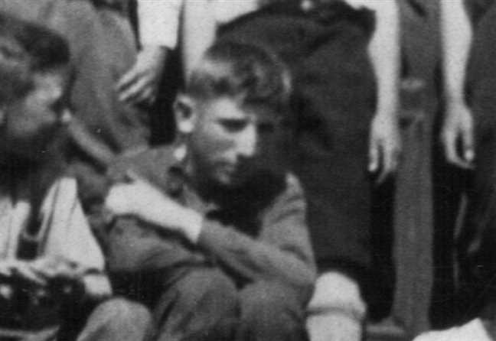  Figure 12: James Robertson's Grade 8 class photo HD croped

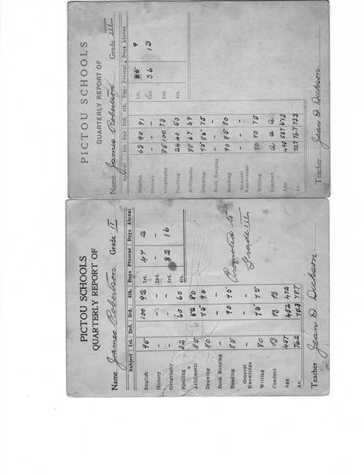  Figure 13: Dad's Grade 2 and 3 Report Cards |  | 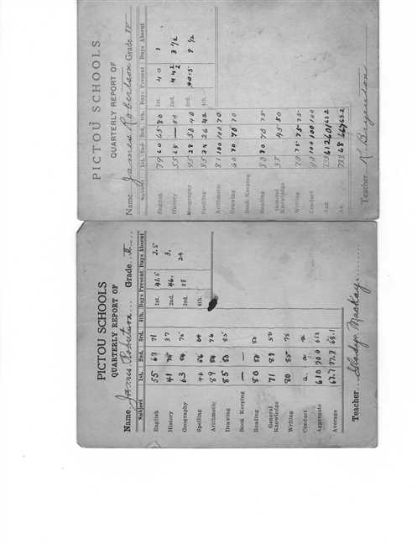  Figure 14: Dad's Grade 4 and 5 Report Cards

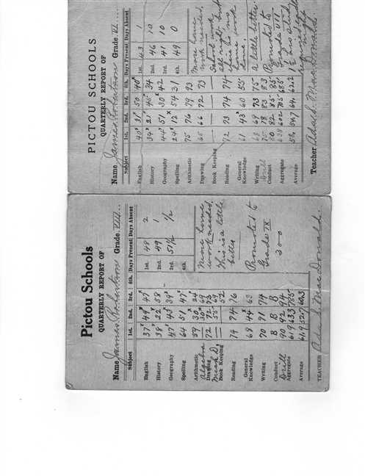  Figure 15: Dad's Grade 6 and 8 Report Cards |  | 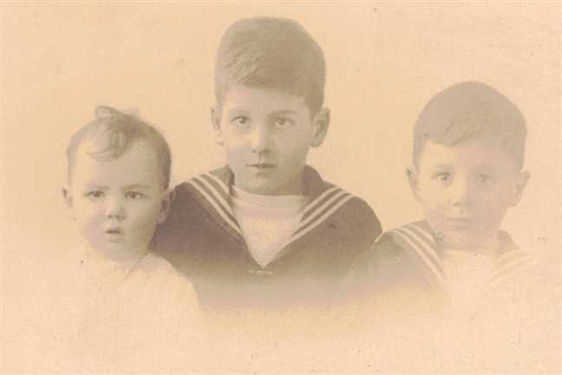  Figure 16: Nora James Leonard Robertson

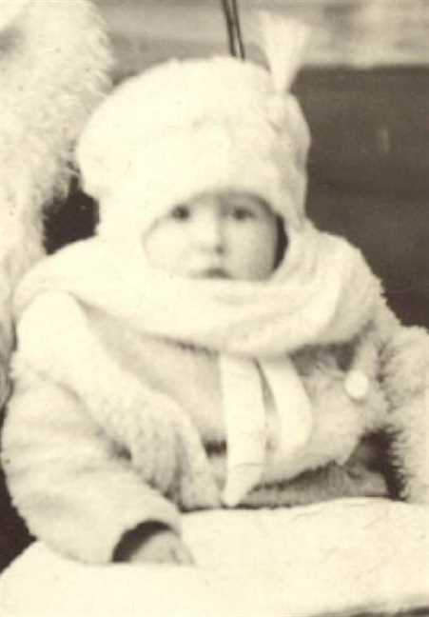  Figure 17: James Ives Robertson |  | 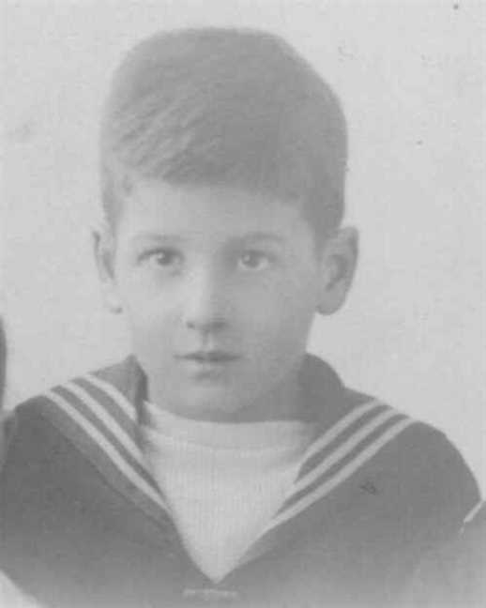  Figure 18: James I Robertson

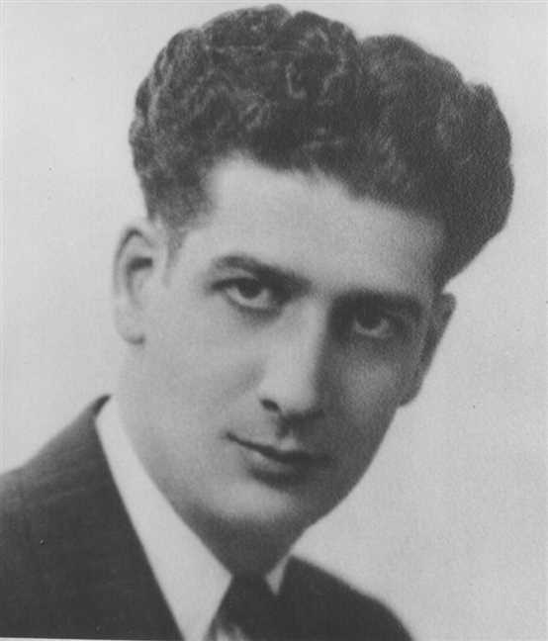
Figure 19: James Ives Robertson

Family of Angus MacDonell and Dawn Matchette
Angus Hugh |  |  |  |  |  | Flora |  |  |  |  |  | William Little |  |  |  |  |  | Charlotte
MacDonell |  |  |  |  |  | MacDonell |  |  |  |  |  | MacDonald |  |  |  |  |  | MacDougall
1831–1917 |  |  |  |  |  | 1841–1919 |  |  |  |  |  | 1844–1917 |  |  |  |  |  | 1849–1934
 |  | Allan |  |  |  |  |  |  |  |  |  |  |  | Mary Christina
 |  | MacDonell |  |  |  |  |  |  |  |  |  |  |  | MacDonald
 |  | 1880–1926 |  |  |  |  |  |  |  |  |  |  |  | 1895–1978
 |  |  |  |  |  |  |  | Angus John |  |  |  |  |  |  |  |  |  |  |  |  |  |  |  |  |  |  |  |  |  |  |  | Dawn
 |  |  |  |  |  |  |  | MacDonell |  |  |  |  |  |  |  |  |  |  |  |  |  |  |  |  |  |  |  |  |  |  |  | Matchette
 |  |  |  |  |  |  |  | 1924–
 |  |  |  |  |  |  |  |  |  |  |  |  |  | Married
 |  |  |  |  |  |  |  |  |  |  |  |  |  |  |  |  |  |  |  |  | Allan Angus
 |  |  |  |  |  |  |  |  |  |  |  |  |  |  |  |  |  |  |  |  | MacDonell
 |  |  |  |  |  |  |  |  |  |  |  |  |  |  |  |  |  |  |  |  | 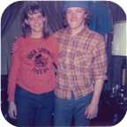

15. Angus John MacDonell was born on Wednesday, December 17, 1924. He is the son of Allan MacDonell (11) and Mary Christina MacDonald.
He married Dawn Matchette. They have one son.
Son of Angus John MacDonell and Dawn Matchette:
+ 22 m I. Allan Angus MacDonell.
  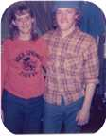
  Allan

Family of Allan MacDonell and Margaret MacDonald
Angus Hugh |  |  |  | Flora |  |  |  | William Little |  |  |  | Charlotte
MacDonell |  |  |  | MacDonell |  |  |  | MacDonald |  |  |  | MacDougall
1831–1917 |  |  |  | 1841–1919 |  |  |  | 1844–1917 |  |  |  | 1849–1934
 | Allan |  |  |  |  |  |  |  | Mary Christina
 | MacDonell |  |  |  |  |  |  |  | MacDonald
 | 1880–1926 |  |  |  |  |  |  |  | 1895–1978
 |  |  |  |  | Allan Joseph |  |  |  |  |  |  |  |  |  |  |  |  |  |  |  | Margaret
 |  |  |  |  | MacDonell |  |  |  |  |  |  |  |  |  |  |  |  |  |  |  | MacDonald
 |  |  |  |  | 1926–1980
 |  |  |  |  |  |  |  |  | Married
 |  |  |  |  |  |  |  |  |  |  |  | Debbie |  |  |  | Lois
 |  |  |  |  |  |  |  |  |  |  |  | MacDonell |  |  |  | MacDonell

16. Allan Joseph MacDonell was born in 1926. He was the son of Allan MacDonell (11) and Mary Christina MacDonald.
Allan Joseph was employed in Operated heating business in Toledo OH. He died in 1980 at the age of 54.
He married Margaret MacDonald. They had two daughters.
Daughters of Allan Joseph MacDonell and Margaret MacDonald:
f I. Debbie MacDonell.
f II. Lois MacDonell.

6th Generation

Family of Elizabeth MacLean and Franco Fortunato
 |  |  |  |  |  |  |  |  |  |  |  |  |  |  |  |  |  |  |  |  |  |  |  | Allan |  |  |  | Mary Christina
 |  |  |  |  |  |  |  |  |  |  |  |  |  |  |  |  |  |  |  |  |  |  |  | MacDonell |  |  |  | MacDonald
 |  |  |  |  |  |  |  |  |  |  |  |  |  |  |  |  |  |  |  |  |  |  |  | 1880–1926 |  |  |  | 1895–1978
 |  |  |  |  |  |  |  |  |  |  |  |  |  |  |  |  | John |  |  |  |  |  |  |  | Flora Isabel
 |  |  |  |  |  |  |  |  |  |  |  |  |  |  |  |  | MacLean |  |  |  |  |  |  |  | MacDonell
 |  |  |  |  |  |  |  |  |  |  |  |  |  |  |  |  |  |  |  |  |  |  |  |  | 1920–
 |  |  |  |  | Franco |  |  |  |  |  |  |  |  |  |  |  |  |  |  |  | Elizabeth
 |  |  |  |  | Fortunato |  |  |  |  |  |  |  |  |  |  |  |  |  |  |  | MacLean
 |  |  |  |  |  |  |  |  |  |  |  |  |  |  |  |  |  |  |  |  | 1942–
 |  |  |  |  |  |  |  |  | Married

17. Elizabeth MacLean was born in 1942. She is the daughter of John MacLean and Flora Isabel MacDonell (13).
She married Franco Fortunato.

Family of Helen MacLean and George Colter
 |  |  |  |  |  |  |  |  |  |  |  |  |  |  |  |  |  |  |  |  |  |  |  | Allan |  |  |  | Mary Christina
 |  |  |  |  |  |  |  |  |  |  |  |  |  |  |  |  |  |  |  |  |  |  |  | MacDonell |  |  |  | MacDonald
 |  |  |  |  |  |  |  |  |  |  |  |  |  |  |  |  |  |  |  |  |  |  |  | 1880–1926 |  |  |  | 1895–1978
 |  |  |  |  |  |  |  |  |  |  |  |  |  |  |  |  | John |  |  |  |  |  |  |  | Flora Isabel
 |  |  |  |  |  |  |  |  |  |  |  |  |  |  |  |  | MacLean |  |  |  |  |  |  |  | MacDonell
 |  |  |  |  |  |  |  |  |  |  |  |  |  |  |  |  |  |  |  |  |  |  |  |  | 1920–
 |  |  |  |  | George |  |  |  |  |  |  |  |  |  |  |  |  |  |  |  | Helen
 |  |  |  |  | Colter |  |  |  |  |  |  |  |  |  |  |  |  |  |  |  | MacLean
 |  |  |  |  |  |  |  |  | Married

18. Helen MacLean. She is the daughter of John MacLean and Flora Isabel MacDonell (13).
  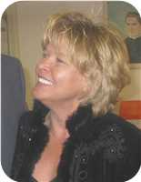
  Helen MacLean
She married George Colter.

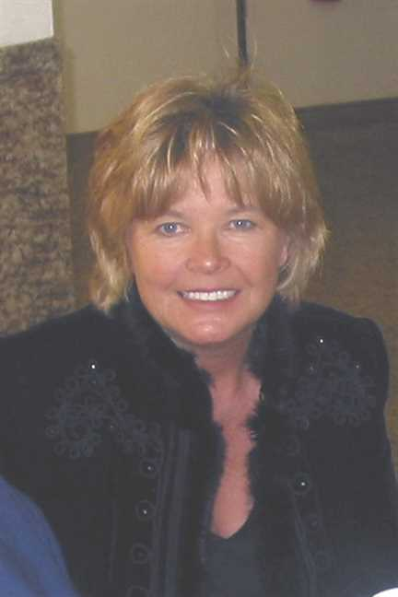
Figure 20: Helen MacLean

Family of Allan Robertson and Virginia Worobel
Leonard Bowman |  |  |  |  |  | Louisa Reid |  |  |  |  |  | Allan |  |  |  |  |  | Mary Christina |  |  |  |  |  | Stephen |  |  |  |  |  | Catherine |  |  |  |  |  | Demetro |  |  |  |  |  | Dora
Robertson |  |  |  |  |  | Ives |  |  |  |  |  | MacDonell |  |  |  |  |  | MacDonald |  |  |  |  |  | Worobel |  |  |  |  |  | Kohut |  |  |  |  |  | Kolynchuk |  |  |  |  |  | Kwasnica
1890–1972 |  |  |  |  |  | 1889–1982 |  |  |  |  |  | 1880–1926 |  |  |  |  |  | 1895–1978 |  |  |  |  |  |  |  |  |  |  |  |  |  |  |  |  |  | 1897–1945 |  |  |  |  |  | 1899–1972
 |  |  |  |  |  |  |  |  |  |  |  |  |  |  |  |  |  |  |  |  |  |  |  | 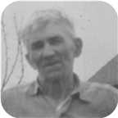 |  |  |  |  |  |  |  |  |  |  |  | 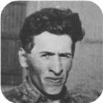 |  |  |  |  |  | 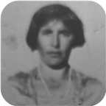
 |  | James Ives |  |  |  |  |  |  |  |  |  |  |  | Charlotte Helen |  |  |  |  |  |  |  |  |  |  |  | John |  |  |  |  |  |  |  |  |  |  |  | Jean
 |  | Robertson |  |  |  |  |  |  |  |  |  |  |  | MacDonell |  |  |  |  |  |  |  |  |  |  |  | Worobel |  |  |  |  |  |  |  |  |  |  |  | Kolynchuk
 |  | 1917–1989 |  |  |  |  |  |  |  |  |  |  |  | 1922–2005 |  |  |  |  |  |  |  |  |  |  |  | 1922–1979 |  |  |  |  |  |  |  |  |  |  |  | 1925–2012
 |  |  |  |  |  |  |  |  |  |  |  |  |  |  |  |  |  |  |  |  |  |  |  |  |  | 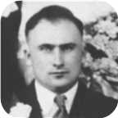 |  |  |  |  |  |  |  |  |  |  |  | 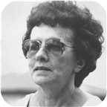
 |  |  |  |  |  |  |  | Allan James |  |  |  |  |  |  |  |  |  |  |  |  |  |  |  |  |  |  |  |  |  |  |  | Virginia
 |  |  |  |  |  |  |  | Robertson |  |  |  |  |  |  |  |  |  |  |  |  |  |  |  |  |  |  |  |  |  |  |  | Worobel
 |  |  |  |  |  |  |  | 1943– |  |  |  |  |  |  |  |  |  |  |  |  |  |  |  |  |  |  |  |  |  |  |  | 1945–
 |  |  |  |  |  |  |  |  |  |  |  |  |  |  |  |  |  |  |  |  |  |  |  |  |  |  |  |  |  |  |  | 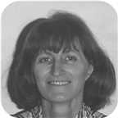
 |  |  |  |  |  |  |  |  |  |  |  |  |  | Marriage: 1969
 |  |  |  |  |  |  |  |  |  |  |  |  |  |  | Jenny Lind |  |  |  |  |  | Adele Marie |  |  |  |  |  | Lara Lynn
 |  |  |  |  |  |  |  |  |  |  |  |  |  |  | Robertson |  |  |  |  |  | Robertson |  |  |  |  |  | Robertson
 |  |  |  |  |  |  |  |  |  |  |  |  |  |  | 1970– |  |  |  |  |  | 1971– |  |  |  |  |  | 1973–
 |  |  |  |  |  |  |  |  |  |  |  |  |  |  | 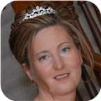 |  |  |  |  |  | 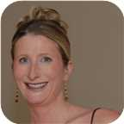 |  |  |  |  |  | 

19. Allan James Robertson was born on Thursday, August 26, 1943, in Pictou, Nova Scotia, Canada. He is the son of James Ives Robertson and Charlotte Helen MacDonell (14).  Allan James was educated in BSc,MSc St Francis Xavier Univ. 1965,1967. He is employed in Chemist.
  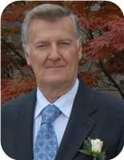
  Allan James Robertson
Allan James Robertson was born on Thursday, August 26, 1943, in Pictou, Nova Scotia, Canada. He is the son of James Ives Robertson and Charlotte Helen MacDonell. Allan's Father was born in Stellerton, NS but lived mainly in Pictou, NS. Allan's Mother was born in Judique on Cape Breton Island, NS She mainly grew up there but also later on lived in nearby Port Hood, NS. His paternal ancestors originated from a Scottish immigrant (John Robertson) who received a substantial land grant in the Churchville area of Pictou county, NS. Allan's maternal grandmother out lived three husbands (Allan MacDonell was the second and Father to Allan's Mother) The third husband was James MacDonald and he was the sheriff of Richmond county- Port Hood is the county seat. James's brother Angus L MacDonald was the premier of NS at one time. He has the Halifax harbour bridge named after him.
Allan's parents met in a place called Catalac, Quebec. They moved to Pictou, NS and then moved briefly to St, Catharines, ON where Allan's sister Lois was born in 1948. They lived in an apartment on Church St near Geneva St. Later that year, the family moved back to Pictou and lived for a brief period in a rented home on Beaches Road - near Laudon’s Beach. They then moved to Elm St in Pictou, NS. Later, they moved to 21 Chestnut St - Allan is most familiar with this address as he lived there from grade school until grade 10. Then his parents "swapped" homes with his paternal grand parents who lived 95 Faulkland St - SE corned of Faulkland and Patterson St. The house is still there but the number has changed due a change in the house numbering system. Bea's (nick name for his paternal grandmother) cousin - Margaret Harris (nee Fraser) lived in a home on Patterson St - across from Bea’s home. (SW corner of Faulkland and Patterson streets)
The home was actually jointly owned by Bea and her older (unmarried) sister Annie Ives. When Annie died, she willed her half to Allan's Father, When Bea died, Allan's Father got the home but his brother Len and sister Louise received all the fine antique furniture. Allan still has in his possession two mantle decorations that belonged to Bea's Mother - Ocenia Fraser. These pieces may even predate her as there is no record as to where they came from.
Allan's Father worked in the ship yard as a sheet metal worker. He later started his own business from some funding from his brother Len. However it was not entirely successful. They eventually sold the house and moved to a trailer home at 7 Oak St. Allan’s Father died in 1989.
Allan's kindergarten year was at the former Patterson school on Wellsford St near Poplar St. Grades 1 and 2 were at Stella Maris Convent. Allan remembers one of his class mates (his last name was Bell) drown after falling of the wharf. The whole class went to the funeral after visiting the remains in the family home. (Grades 3-6 were at the former Dawson school (now gone). Grades 7 and 8 were back at the Patterson school and finally grades 9 to 12 were at Pictou Academy. Allan's grades were "average" up until Grade 11 then in Grade 12, he and one of his friends (Wayne Madore) decided that they would be first in their class. Wayne did graduate 1st but Allan was 2nd. They edged out a girl (Maureen Mullins) who had continually placed first in her class through out her Junior and Senior high school years.
His closest friends while growing up were Wayne Madore and Melton Scanlan - they married two sisters and became teachers. They lived in Green Hill - near Pictou. John Murray who attended Dalhousie University and became a medical doctor. He practised in Sussex NB. Larry McCormack who also addended St Francis University and became a geologist.
In his younger years, Allan was very close to his paternal grandmother (Louisa "Bea" Robertson - nee Ives). He spent a lot of time with her and had a lot of fun playing cards with her. He was her "favourite grand child" - perhaps because he was the first. His grandmother also lived in St Catharines with him and his parents. Allan would often walk (mostly run) with her to Montebello Park and also visit with a family friends (Browns?) who lived at 56 lake St.
Bea willed him an old family photo album that belonged to her grandfather - William Ives. That photo album along with a booklet on the history of the Robertson family which was updated by his uncle Len Robertson, got Allan very much interested in the family genealogy. The result is this family tree of over 27,000 related persons.
Because of the influence of his high school science teacher (Mr. Peter Whyte), he decided to be a chemist. Mr. Whyte allowed Allan and his friend Wayne to stay after school and "experiment" in the lab - unsupervised!!. In hind sight, not a wise thing to do - but they survived with "all of their fingers" still attached.
Both Allan and Wayne enter the bachelors program at St Francis Xavier University in 1961 and took up chemistry as their major. Allan graduated from St Francis Xavier University (BS Hon. in 1965 and received his MSc 1967). Unfortunately, his friend Wayne got hooked on golf in his third year and then dropped out of university. He later took up teaching and did very well.
Allan lived on campus for his under graduate years and then boarded off campus while working on his master’s degree. Part of that time he lived with the Ray MacDonald family - Ray was a news announcer at the local radio station (CJFX). The MacDonald’s had five children - 4 boys named Mathew, Mark, Luke and John and one daughter - Mary.
His closest friends while at university were Tony McPhee-from Sydney, NS and one of the brightest students who was also a chemistry major. Tony taught Allan how to play chess. Out of hundreds of games, Allan only won once. Bruce Barron - a "pre-med". student from Portland, ME, Marry Osiany - she came from Hungary with her family in 1956 after the Hungarian uprising. Gary McQuade - also his roommate in his junior year. Gary was from Ottawa and was one of the star hockey players with St FX.
During his Freshman year, one of his chemistry lab instructors was a graduate student named "Bud Gallivan" - a nephew to "Danny Gallivan" who was a famous hockey announcer for the Montreal Canadians. Bud went on to Notre Dame University where he obtained his PhD. He then went to work for American Cyanamid at the corporate research lab in Stamford, CT. Bud rose through the ranks and eventually became VP of the division in which Allan worked. Allan’s boss at that time was a direct report to Bud and on his boss' passing, Allan reported to Bud for a brief period. Unfortunately, later in the same year, Bud died from a sudden heart attack. It was shortly after that that Allan was transferred from research to marketing. This was a traumatic change for a month or so, but then he thoroughly enjoyed the new position.
While at university, during the summer holidays, Allan worked as a lab technician for the then Cyanamid of Canada in Niagara Falls, ON. He worked at the "Welland Plant". For the first 4 summers, Allan resided with his Aunt and Uncle (Louise and Les Bongard). Louise is Allan's Father's younger sister. He hung out with his cousin Robert (Robbie). In later years, Robbie mover to Lunenburg, NS with his second wife.
He bought his first car in the summer of 1965 - a 1956 Ford Fairlane - for $160. Later, he drove it to Nova Scotia that fall and during the following spring, he sold it for $200 to a local in the Antigonish area.
During the summer of 1965, he resided at 138 Page St. in Catharines, ON. This is when he met his future wife - Virginia Worobel- who lived next door at 136 Page St. Virginia was in a nursing program at St. Joseph’s in Toronto. They "dated" - mostly by mail for about 2 years.
After Allan got his MSc degree in January of 1967, he moved back to 138 Page St. and got a permanent job with Cyanamid. Virginia finished her nursing program in 1968.
For the better part of a year during 1968 and Allan was transferred to Cyanamid’s Bound Brook NJ site. He boarded at a private home in Summerset, NJ for about 6 months (Mrs. Tureck’s home). While there he met a couple of friends who also worked for Cyanamid - Paul Gastrock and George Menghi. Both cane to Allan and Virginia’s wedding on April 19 of 1969.
After about 6 months, Allan rented an apartment in Raritan, NJ, During this year, he would commute to St Catharines every other weekend.
Then in December of 1968 he moved back to 136 Page St - just in time for a 3 -4 month labour strike at Cyanamid. During that period he was part of the management team that ran the Welland Plant as well as a limestone quarry in Beechville, ON. While at Beechville, he had a half hour training course on how to drive one of those huge trucks used to haul crude limestone from the quarry to the crusher. After 3 weeks of that he was reassigned to the Welland Plant as an operator in the production area - he much preferred this job.
The strike finally ended about a week prior to the wedding on April 19, 1969.. The wedding took place at the St Catharines cathedral with the reception at the Ukrainian Black Sea hall. It was a typical Ukrainian style wedding with approximately 150 guests. Allan's parents as well as his younger siblings, and aunts and uncles from Chatham, New Brunswick and Montreal attended. Virginia also had several relatives from Saskatoon and Winnipeg and Fort Frances, ON also attended.
Virginia's sister and brother-in-law were maid of honour and best man Allan's cousin Robert Bongard and Allan’s sister Lois as well as Virginia's cousin and a best friend - Ann Cotnam were also in the wedding party.
After the reception, they stayed over night at Prudholms hotel in Vineland before heading off to Jamaica for a week long honeymoon. They landed in Montego Bay and rented a car. They stayed there for two nights ant then toured the Island. Finally flew home from Kingston.
Virginia and Allan lived with her Mom at 136 Page St for about a year - during which Jenny was born on Jan 30, 1970. During the summer of the following year, they moved into a newly built home at 80 Meredith Dr. in St Catharines. Virginia's Mom moved with them. On July 6 of 1971 Adele was born and on August 11 of 1973 Lara was born.
The house on Meredith D.r was starting to get a bit crowded. They then bought their current home at 36 Forster Ave in Thorold for the amazing low price of $64,000 which likely would sell got $400,000 today (2018)
Allan spent his working career as a research chemist with Cyanamid of Canada Inc. - which later became Cytec Canada Inc. 1995 Since his retirement in 2013, Cytec was bought by Belgian company called Solvay. For about 40 years, he worked in the lab and then for the last 11 years, he took on a marketing role. Over his career, he obtained 12 patents and either authored or co-authored about 50 scientific papers. He also received a Circle of Excellence Award from the company for scientific achievement. As part of the award, there was a weekend all expenses paid visit to NYC - including a Broadway play and gala dinner with the other award winners and company executives. Stayed at a fancy hotel on Park avenue.
The job - especially in the later years, involved a considerable amount of travel - either to scientific conferences or visiting customers - almost all were outside of Canada - mainly in the US, Europe, South Africa and Australia. At several of the conferences, - those related to phosphorus chemistry- he presented talks. They took place is such places as Duke University in Durahm,SC, Tallin, Estonia, Saltzberg, Austria, Jeruslahem, San Francisco and Sundhi, Japan .On some occasions such as the conferences, Virginia came along.
In December of 1995, Cyanamid became Cytec. Allan eventually retired in April of 2013 after 51 years of serving with Cyanamid/Cytec. This was the second longest service term within the company. The company put on a great retirement party with about 70 employees attending. The guests also included the company CEO and well as the corporate HR VP.
At the age of 25, Allan James married Virginia Worobel on Saturday, April 19, 1969, in St Catharines, Niagara, Ontario, Canada, when she was 23 years old. They have three daughters.  Virginia was born in St Catharines, Ontario, on Monday, October 15, 1945.
  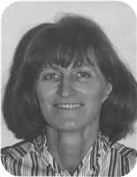
  Virginia Worobel
She is the daughter of John Worobel and Jean Kolynchuk.
Virginia received her RN degree from St Josephs (Toronto) in 1968. She worked for a time at Hotel Dieu (St Catharines) and later at The St Catharines General.
Daughters of Allan James Robertson and Virginia Worobel:
+ 23 f I. Jenny Lind Robertson was born in St. Catharines, Ontario, on January 30, 1970.
  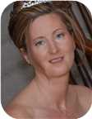
  Jenny
+ 24 f II. Adele Marie Robertson was born in St. Catharines on July 06, 1971.
  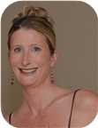
  Adele
+ 25 f III. Lara Lynn Robertson was born in St. Catharines on August 11, 1973.
  
  Lara

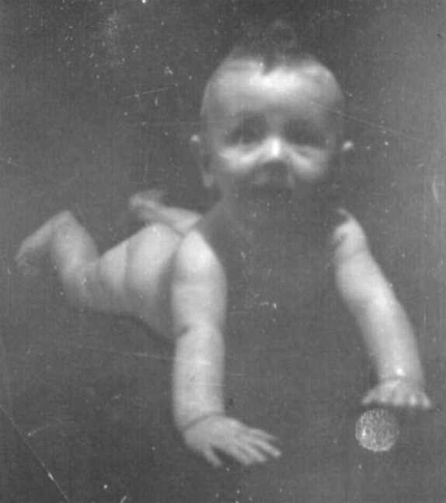  Figure 21: Allan James Robertson |  | 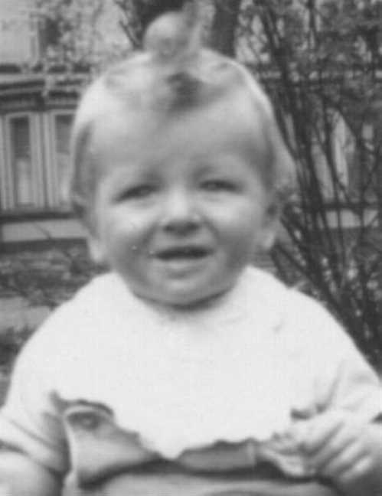  Figure 22: Allan James Robertson

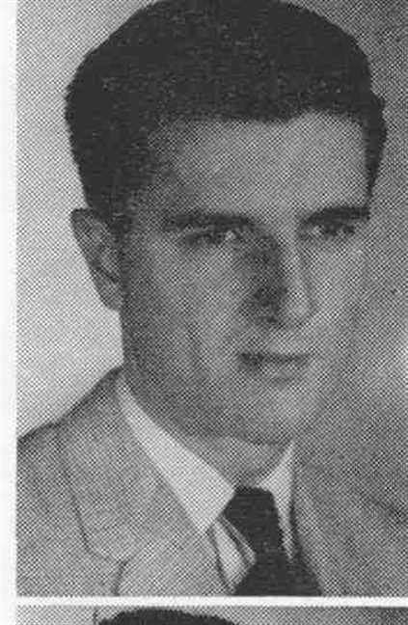  Figure 23: Allan James Robertson |  | 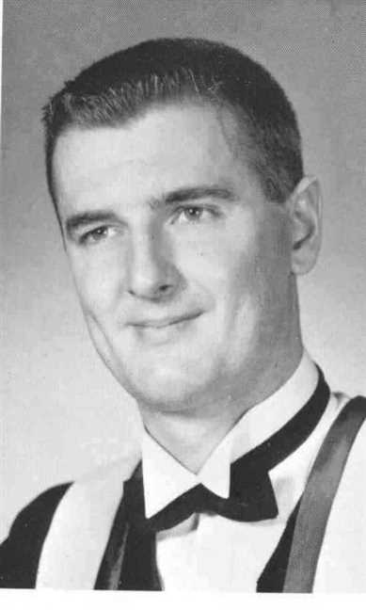  Figure 24: Allan James Robertson

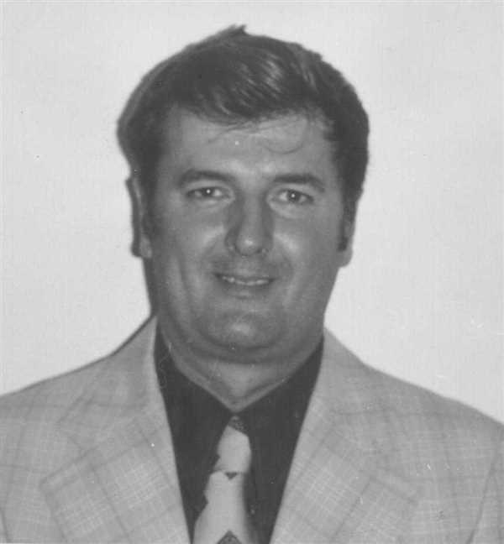  Figure 25: Allan James Robertson |  | 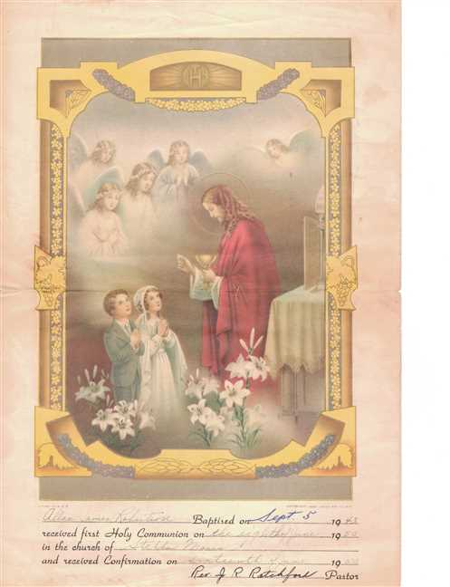  Figure 26: Allan Robertson's Baptism

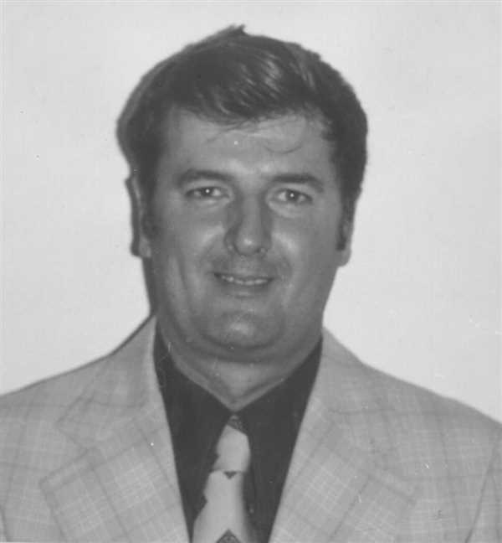  Figure 27: Allan James Robertson |  | 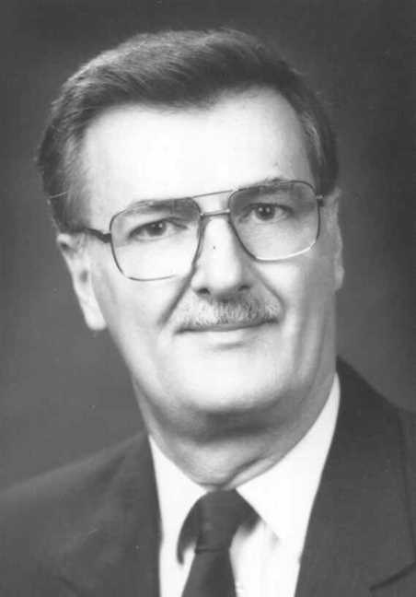  Figure 28: Allan James Robertson

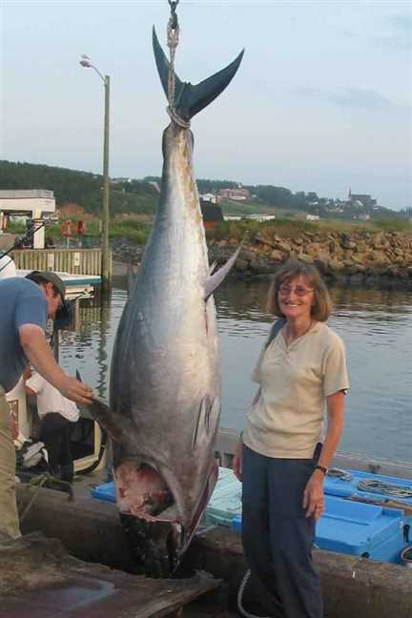  Figure 29: Vige and tuna |  | 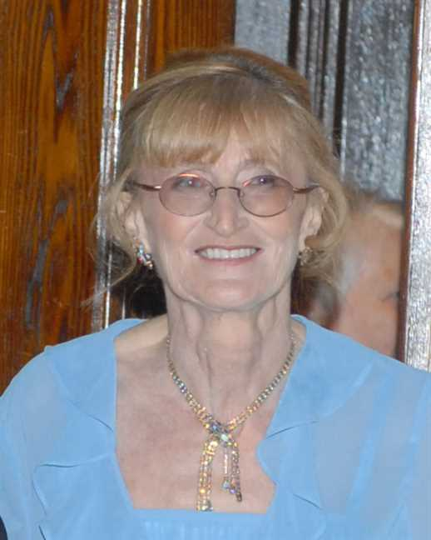  Figure 30: Virginia

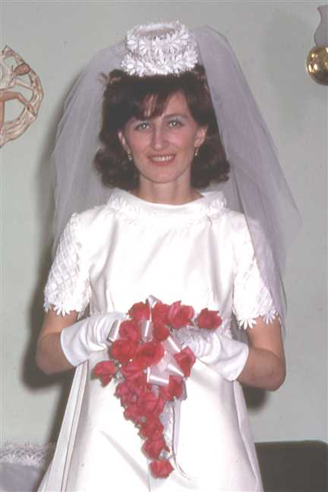  Figure 31: 196903-04Vige2b |  | 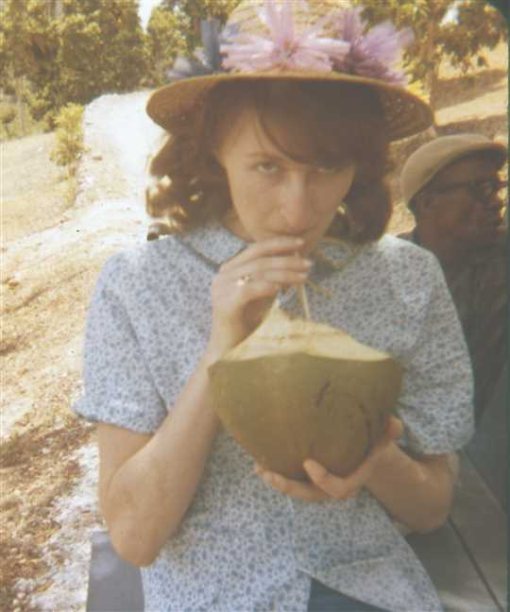  Figure 32: 196963-04YVige5

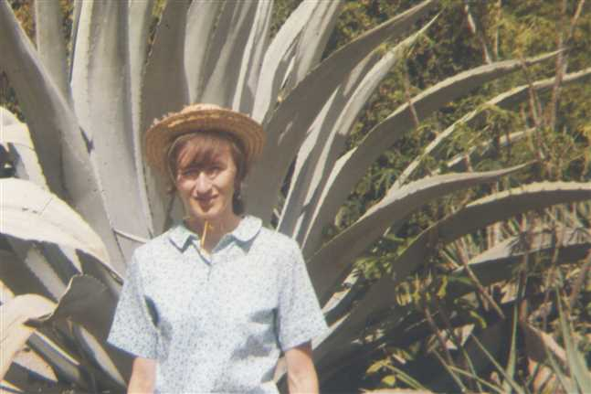  Figure 33: 196967-04YVige9 |  | 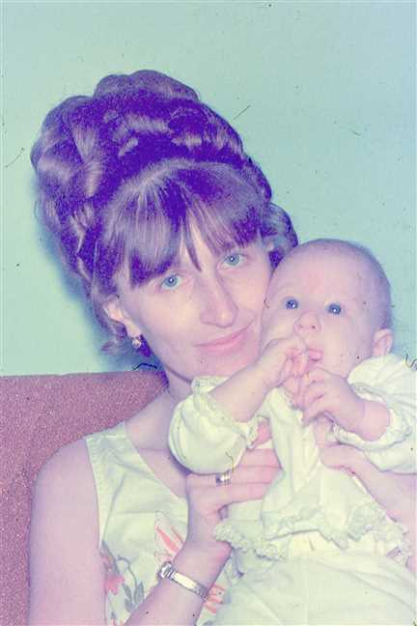  Figure 34: 197046-05Vige

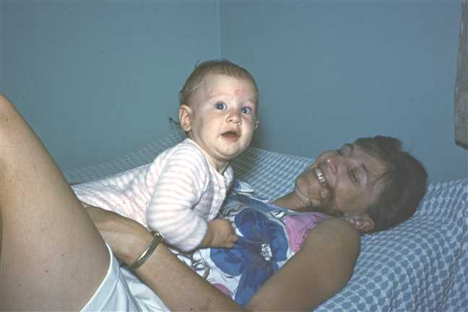  Figure 35: 197092-07VigeJenny2 |  | 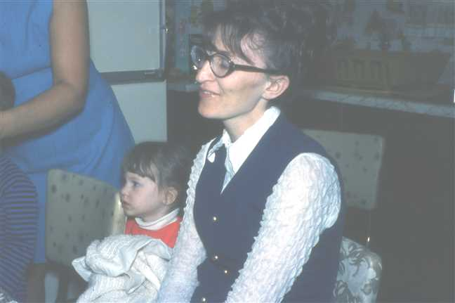  Figure 36: 1972-05JennyVige

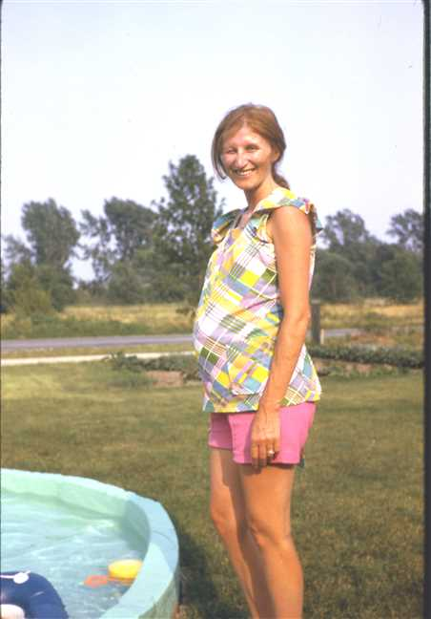  Figure 37: 1973-07Virginia |  | 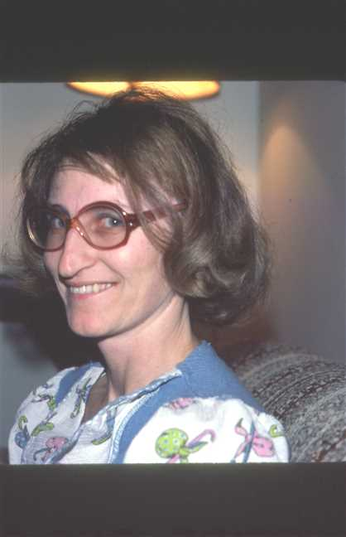  Figure 38: 1978-01Vige

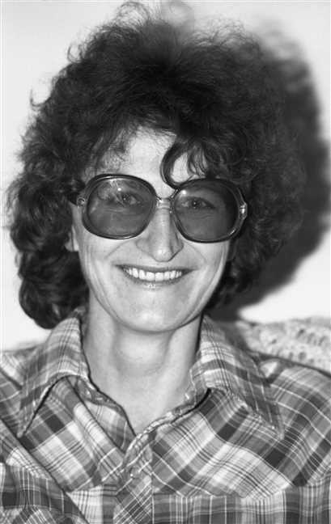  Figure 39: img001676 |  | 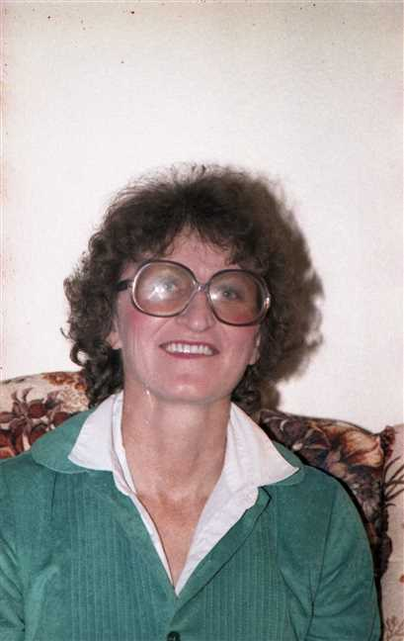  Figure 40: img001267

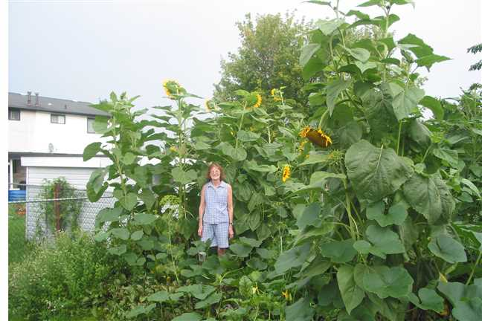
Figure 41: Garden1

Lois Robertson
20. Lois Christina Robertson was born on Friday, April 30, 1948, in St Catharines, Ontario. She was the daughter of James Ives Robertson and Charlotte Helen MacDonell (14).  Lois Christina was educated in High School. She was employed in Secretary.
  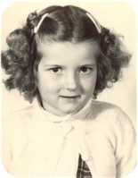
  Lois Christina Robertson
Lois Christina died in Pictou, Nova Scotia, Canada, on January 23, 1979, at the age of 30. Her cause of death was Complications from diabeties.
Lois was a diabetic from a very young age. (About 2 yr.) She had two children - one child from her first husband. The first was born in Montreal (about 1963) and the second born in St Catharines,Ont. (Nov. 3/1969) The first child was still-born. The second child was adopted at birth by a Dusette family in St Catharines, ON. She was named Michelle and later married Brian Procter.
She was married and divorced twice and was a friend of ? Cyr ( Pictou N.S.) who is the father of Michelle.
Lois died young due to diabetes complications.
Marriages with Joseph Dalton, Harold Little (Page 43) and ? Cyr (Page 44) are known.

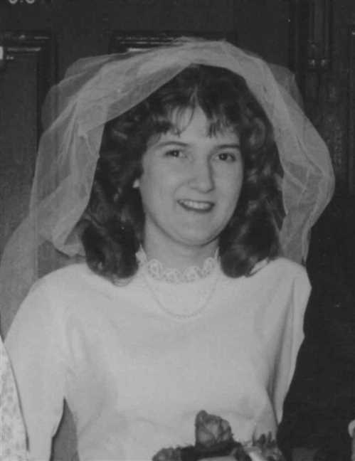  Figure 42: Lois Christina Robertson |  | 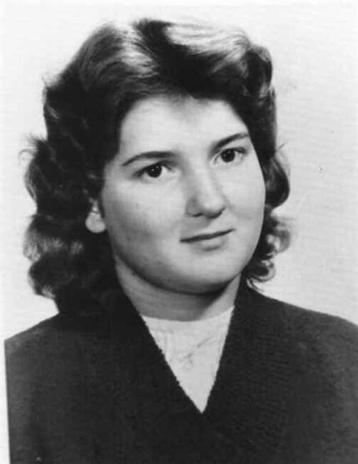  Figure 43: Lois Christina Robertson

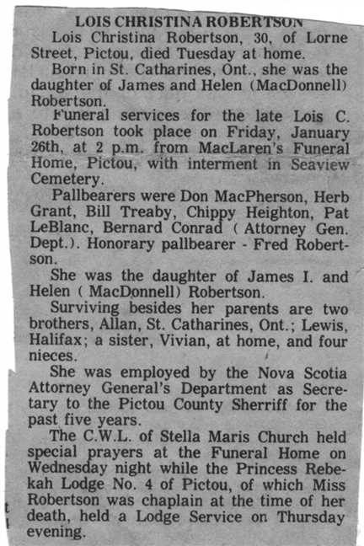
Figure 44: Lois Robertson Obit

Family of Lois Robertson and Joseph Dalton
 |  |  |  |  |  |  |  |  |  |  |  |  |  |  |  | Leonard Bowman |  |  |  | Louisa Reid |  |  |  | Allan |  |  |  | Mary Christina
 |  |  |  |  |  |  |  |  |  |  |  |  |  |  |  | Robertson |  |  |  | Ives |  |  |  | MacDonell |  |  |  | MacDonald
 |  |  |  |  |  |  |  |  |  |  |  |  |  |  |  | 1890–1972 |  |  |  | 1889–1982 |  |  |  | 1880–1926 |  |  |  | 1895–1978
 |  |  |  |  |  |  |  |  |  |  |  |  |  |  |  |  | James Ives |  |  |  |  |  |  |  | Charlotte Helen
 |  |  |  |  |  |  |  |  |  |  |  |  |  |  |  |  | Robertson |  |  |  |  |  |  |  | MacDonell
 |  |  |  |  |  |  |  |  |  |  |  |  |  |  |  |  | 1917–1989 |  |  |  |  |  |  |  | 1922–2005
 |  |  |  |  | Joseph |  |  |  |  |  |  |  |  |  |  |  |  |  |  |  | Lois Christina
 |  |  |  |  | Dalton |  |  |  |  |  |  |  |  |  |  |  |  |  |  |  | Robertson
 |  |  |  |  |  |  |  |  |  |  |  |  |  |  |  |  |  |  |  |  | 1948–1979
 |  |  |  |  |  |  |  |  | Divorce: 1963

Here are the details about Lois Christina Robertson's first marriage, with Joseph Dalton. You can read more about Lois Christina on page 40.
Lois Christina Robertson married Joseph Dalton. They were divorced in 1963.

Family of Lois Robertson and Harold Little
 |  |  |  |  |  |  |  |  |  |  |  |  |  |  |  | Leonard Bowman |  |  |  | Louisa Reid |  |  |  | Allan |  |  |  | Mary Christina
 |  |  |  |  |  |  |  |  |  |  |  |  |  |  |  | Robertson |  |  |  | Ives |  |  |  | MacDonell |  |  |  | MacDonald
 |  |  |  |  |  |  |  |  |  |  |  |  |  |  |  | 1890–1972 |  |  |  | 1889–1982 |  |  |  | 1880–1926 |  |  |  | 1895–1978
 |  |  |  |  |  |  |  |  |  |  |  |  |  |  |  |  | James Ives |  |  |  |  |  |  |  | Charlotte Helen
 |  |  |  |  |  |  |  |  |  |  |  |  |  |  |  |  | Robertson |  |  |  |  |  |  |  | MacDonell
 |  |  |  |  |  |  |  |  |  |  |  |  |  |  |  |  | 1917–1989 |  |  |  |  |  |  |  | 1922–2005
 |  |  |  |  | Harold |  |  |  |  |  |  |  |  |  |  |  |  |  |  |  | Lois Christina
 |  |  |  |  | Little |  |  |  |  |  |  |  |  |  |  |  |  |  |  |  | Robertson
 |  |  |  |  |  |  |  |  |  |  |  |  |  |  |  |  |  |  |  |  | 1948–1979
 |  |  |  |  |  |  |  |  | Divorce: 1977

Here are the details about Lois Christina Robertson's second marriage, with Harold Little. You can read more about Lois Christina on page 40.
Lois Christina Robertson married Harold Little. They were divorced in 1977.

Family of Lois Robertson and ? Cyr
 |  |  |  |  |  |  |  |  |  |  |  |  |  |  |  |  |  |  |  |  |  |  |  | Leonard Bowman |  |  |  |  |  | Louisa Reid |  |  |  |  |  | Allan |  |  |  |  |  | Mary Christina
 |  |  |  |  |  |  |  |  |  |  |  |  |  |  |  |  |  |  |  |  |  |  |  | Robertson |  |  |  |  |  | Ives |  |  |  |  |  | MacDonell |  |  |  |  |  | MacDonald
 |  |  |  |  |  |  |  |  |  |  |  |  |  |  |  |  |  |  |  |  |  |  |  | 1890–1972 |  |  |  |  |  | 1889–1982 |  |  |  |  |  | 1880–1926 |  |  |  |  |  | 1895–1978
 |  |  |  |  |  |  |  |  |  |  |  |  |  |  |  |  |  |  |  |  |  |  |  |  |  | James Ives |  |  |  |  |  |  |  |  |  |  |  | Charlotte Helen
 |  |  |  |  |  |  |  |  |  |  |  |  |  |  |  |  |  |  |  |  |  |  |  |  |  | Robertson |  |  |  |  |  |  |  |  |  |  |  | MacDonell
 |  |  |  |  |  |  |  |  |  |  |  |  |  |  |  |  |  |  |  |  |  |  |  |  |  | 1917–1989 |  |  |  |  |  |  |  |  |  |  |  | 1922–2005
 |  |  |  |  |  |  |  | ? |  |  |  |  |  |  |  |  |  |  |  |  |  |  |  |  |  |  |  |  |  |  |  | Lois Christina
 |  |  |  |  |  |  |  | Cyr |  |  |  |  |  |  |  |  |  |  |  |  |  |  |  |  |  |  |  |  |  |  |  | Robertson
 |  |  |  |  |  |  |  |  |  |  |  |  |  |  |  |  |  |  |  |  |  |  |  |  |  |  |  |  |  |  |  | 1948–1979
 |  |  |  |  |  |  |  |  |  |  |  |  |  | Married
 |  |  |  |  |  |  |  |  |  |  |  |  |  |  |  |  |  |  |  |  | Michelle
 |  |  |  |  |  |  |  |  |  |  |  |  |  |  |  |  |  |  |  |  | Dusette
 |  |  |  |  |  |  |  |  |  |  |  |  |  |  |  |  |  |  |  |  | 1969–

Here are the details about Lois Christina Robertson's third marriage, with ? Cyr. You can read more about Lois Christina on page 40.
Lois Christina Robertson married ? Cyr. They had one child.
Child of Lois Christina Robertson and ? Cyr:
+ 26 I. Michelle Dusette was born in St Catharines, Ontario, Canada, on November 03, 1969.

Vivian Robertson
21. Vivian Louise Robertson was born on Wednesday, January 30, 1957, in Pictou, Nova Scotia, Canada. She is the daughter of James Ives Robertson and Charlotte Helen MacDonell (14).
  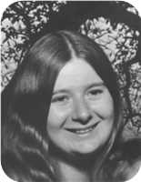
  Vivian Louise Robertson
Marriages with Roy Edward Gray and ? ? (Page 46) are known.

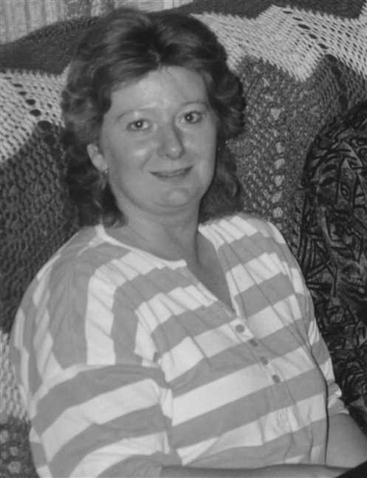
Figure 45: Vivian Robertson

Vivian Robertson and Roy Gray
 |  |  |  |  |  |  |  |  |  |  |  |  |  |  |  |  |  |  |  |  |  |  |  | Leonard Bowman |  |  |  |  |  | Louisa Reid |  |  |  |  |  | Allan |  |  |  |  |  | Mary Christina
 |  |  |  |  |  |  |  |  |  |  |  |  |  |  |  |  |  |  |  |  |  |  |  | Robertson |  |  |  |  |  | Ives |  |  |  |  |  | MacDonell |  |  |  |  |  | MacDonald
 |  |  |  |  |  |  |  |  |  |  |  |  |  |  |  |  |  |  |  |  |  |  |  | 1890–1972 |  |  |  |  |  | 1889–1982 |  |  |  |  |  | 1880–1926 |  |  |  |  |  | 1895–1978
 |  | Frederick Elmer Dicki |  |  |  |  |  |  |  |  |  |  |  | Jessie Winifred |  |  |  |  |  |  |  |  |  |  |  | James Ives |  |  |  |  |  |  |  |  |  |  |  | Charlotte Helen
 |  | Gray |  |  |  |  |  |  |  |  |  |  |  | Davis |  |  |  |  |  |  |  |  |  |  |  | Robertson |  |  |  |  |  |  |  |  |  |  |  | MacDonell
 |  |  |  |  |  |  |  |  |  |  |  |  |  | 1919– |  |  |  |  |  |  |  |  |  |  |  | 1917–1989 |  |  |  |  |  |  |  |  |  |  |  | 1922–2005
 |  |  |  |  |  |  |  | Roy Edward |  |  |  |  |  |  |  |  |  |  |  |  |  |  |  |  |  |  |  |  |  |  |  | Vivian Louise
 |  |  |  |  |  |  |  | Gray |  |  |  |  |  |  |  |  |  |  |  |  |  |  |  |  |  |  |  |  |  |  |  | Robertson
 |  |  |  |  |  |  |  | 1951– |  |  |  |  |  |  |  |  |  |  |  |  |  |  |  |  |  |  |  |  |  |  |  | 1957–
 |  |  |  |  |  |  |  |  |  |  |  |  |  | Partner
 |  |  |  |  |  |  |  |  |  |  |  |  |  |  |  |  |  |  |  |  | Lisa
 |  |  |  |  |  |  |  |  |  |  |  |  |  |  |  |  |  |  |  |  | Robertson
 |  |  |  |  |  |  |  |  |  |  |  |  |  |  |  |  |  |  |  |  | 1974–
 |  |  |  |  |  |  |  |  |  |  |  |  |  |  |  |  |  |  |  |  | 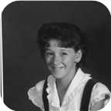

Here are the details about Vivian Louise Robertson's first relationship, with Roy Edward Gray. You can read more about Vivian Louise on page 44.
Vivian Louise Robertson is partnered with Roy Edward Gray. They have one daughter.
Roy Edward was born in Pictou, N.S., on Thursday, August 09, 1951. He is the son of Frederick Elmer Dicki Gray and Jessie Winifred Davis.
Daughter of Vivian Louise Robertson and Roy Edward Gray:
+ 27 f I. Lisa Robertson was born in Pictou, Nova Scotia, Canada, on August 08, 1974.
  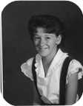
  Lisa

Family of Vivian Robertson and ? ?
 |  |  |  |  |  |  |  |  |  |  |  |  |  |  |  |  |  |  |  |  |  |  |  | Leonard Bowman |  |  |  |  |  | Louisa Reid |  |  |  |  |  | Allan |  |  |  |  |  | Mary Christina
 |  |  |  |  |  |  |  |  |  |  |  |  |  |  |  |  |  |  |  |  |  |  |  | Robertson |  |  |  |  |  | Ives |  |  |  |  |  | MacDonell |  |  |  |  |  | MacDonald
 |  |  |  |  |  |  |  |  |  |  |  |  |  |  |  |  |  |  |  |  |  |  |  | 1890–1972 |  |  |  |  |  | 1889–1982 |  |  |  |  |  | 1880–1926 |  |  |  |  |  | 1895–1978
 |  |  |  |  |  |  |  |  |  |  |  |  |  |  |  |  |  |  |  |  |  |  |  |  |  | James Ives |  |  |  |  |  |  |  |  |  |  |  | Charlotte Helen
 |  |  |  |  |  |  |  |  |  |  |  |  |  |  |  |  |  |  |  |  |  |  |  |  |  | Robertson |  |  |  |  |  |  |  |  |  |  |  | MacDonell
 |  |  |  |  |  |  |  |  |  |  |  |  |  |  |  |  |  |  |  |  |  |  |  |  |  | 1917–1989 |  |  |  |  |  |  |  |  |  |  |  | 1922–2005
 |  |  |  |  |  |  |  | ? |  |  |  |  |  |  |  |  |  |  |  |  |  |  |  |  |  |  |  |  |  |  |  | Vivian Louise
 |  |  |  |  |  |  |  | ? |  |  |  |  |  |  |  |  |  |  |  |  |  |  |  |  |  |  |  |  |  |  |  | Robertson
 |  |  |  |  |  |  |  |  |  |  |  |  |  |  |  |  |  |  |  |  |  |  |  |  |  |  |  |  |  |  |  | 1957–
 |  |  |  |  |  |  |  |  |  |  |  |  |  | Married
 |  |  |  |  |  |  |  |  |  |  |  |  |  |  |  |  |  |  |  |  | Derek
 |  |  |  |  |  |  |  |  |  |  |  |  |  |  |  |  |  |  |  |  | Robertson
 |  |  |  |  |  |  |  |  |  |  |  |  |  |  |  |  |  |  |  |  | 1990–

Here are the details about Vivian Louise Robertson's first marriage, with ? ?. You can read more about Vivian Louise on page 44.
Vivian Louise Robertson married ? ?. They have one son.
Son of Vivian Louise Robertson and ? ?:
m I. Derek Robertson was born in Pictou,NS, in August 1990.

Allan MacDonell and Kathy Barden
Allan |  |  |  |  |  | Mary Christina
MacDonell |  |  |  |  |  | MacDonald
1880–1926 |  |  |  |  |  | 1895–1978
 |  | Angus John |  |  |  |  |  |  |  |  |  |  |  | Dawn
 |  | MacDonell |  |  |  |  |  |  |  |  |  |  |  | Matchette
 |  | 1924–
 |  |  |  |  |  |  |  | Allan Angus |  |  |  |  |  |  |  |  |  |  |  |  |  |  |  |  |  |  |  |  |  |  |  | Kathy
 |  |  |  |  |  |  |  | MacDonell |  |  |  |  |  |  |  |  |  |  |  |  |  |  |  |  |  |  |  |  |  |  |  | Barden
 |  |  |  |  |  |  |  |  |  |  |  |  |  |  |  |  |  |  |  |  |  |  |  |  |  |  |  |  |  |  |  | –2000
 |  |  |  |  |  |  |  |  |  |  |  |  |  | Partner
 |  |  |  |  |  |  |  |  |  |  |  |  |  |  |  |  |  |  |  |  | Alysha
 |  |  |  |  |  |  |  |  |  |  |  |  |  |  |  |  |  |  |  |  | Reinard
 |  |  |  |  |  |  |  |  |  |  |  |  |  |  |  |  |  |  |  |  | 1976–
 |  |  |  |  |  |  |  |  |  |  |  |  |  |  |  |  |  |  |  |  | 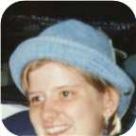

22. Allan Angus MacDonell. He is the son of Angus John MacDonell (15) and Dawn Matchette.  Allan Angus is employed in RCMP officer.
  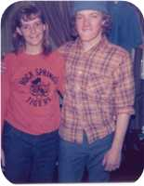
  Allan Angus MacDonell
Kathy Bardon and Allan Angus MacDonell were girlfriend and boyfriend when their parents lived in Rollingrock, Wyoming. They had a child together - Alysha (b. 1976). They were never married and Allan and his parents moved from Wyoming before Alysha was born. Kathy later married a Reinard and had two more children - Jeanette and Patrick. Alysha took the surname - Reinard and was adopted by her step-Father. Kathy died of brest cancer in 2000. Alysha got her PhD in space physics from the Univ. of Michigan. She married.
Alysha later made contact with Allan Robertson through the internet while searching for family ancestors - see the communications in the notes for Alysha. After her Mother died in 2000, she began to look for her real Father.
Allan Angus later married and is a detective with the RCMP near Edmunton,Alta.
He was partnered with Kathy Barden. They had one daughter.  Kathy died in 2000.
  Kathy Barden
Kathy Bardon and Allan Angus MacDonell were girlfriend and boyfriend when their parents lived in Rollingrock, Wyoming. They had a child together - Alysha (b. 1976). They were never married and Allan and his parents moved from Wyoming before Alysha was born. Kathy later married a Reinard and had two more children - Jeanette and Patrick. Alysha took the surname - Reinard and was adopted by her step-Father. Kathy died of brest cancer in 2000. Alysha got her PhD in space physics from the Univ. of Michigan. She married.
Alysha later made contact with Allan Robertson through the internet while searching for family ancestors - see the communications in the notes for Alysha. After her Mother died in 2000, she began to look for her real Father.
Allan Angus later married and is a detective with the RCMP near Edmunton,Alta.
Daughter of Allan Angus MacDonell and Kathy Barden:
f I. Alysha Reinard was born in 1976.
  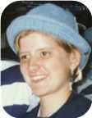
  Alysha

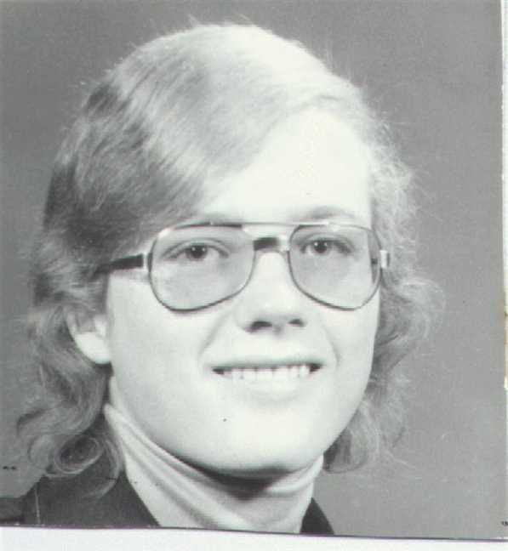  Figure 46: allanhighschool |  | 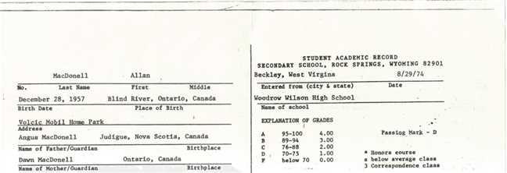  Figure 47: allanhighschoolrecords

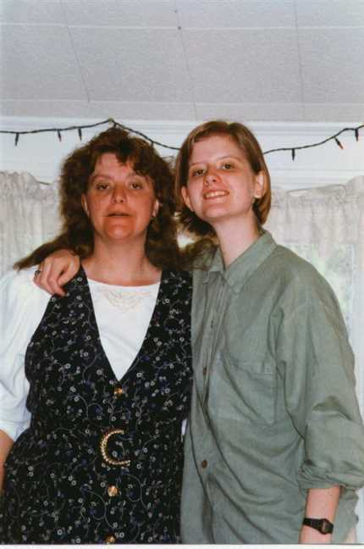
Figure 48: anmompatsgraduation

7th Generation

Family of Jenny Robertson and Steve Taylor
Willam J |  |  |  | Hazel |  |  |  |  |  |  |  |  |  |  |  | James Ives |  |  |  | Charlotte Helen |  |  |  | John |  |  |  | Jean
Taylor |  |  |  | MaBee |  |  |  |  |  |  |  |  |  |  |  | Robertson |  |  |  | MacDonell |  |  |  | Worobel |  |  |  | Kolynchuk
1921–2012 |  |  |  |  |  |  |  |  |  |  |  |  |  |  |  | 1917–1989 |  |  |  | 1922–2005 |  |  |  | 1922–1979 |  |  |  | 1925–2012
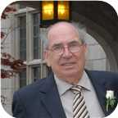
 | William George |  |  |  |  |  |  |  | Betty Ann |  |  |  |  |  |  |  | Allan James |  |  |  |  |  |  |  | Virginia
 | Taylor |  |  |  |  |  |  |  | ? |  |  |  |  |  |  |  | Robertson |  |  |  |  |  |  |  | Worobel
 | –2007 |  |  |  |  |  |  |  |  |  |  |  |  |  |  |  | 1943– |  |  |  |  |  |  |  | 1945–
 |  |  |  |  |  |  |  |  | 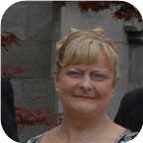
 |  |  |  |  | Steve |  |  |  |  |  |  |  |  |  |  |  |  |  |  |  | Jenny Lind
 |  |  |  |  | Taylor |  |  |  |  |  |  |  |  |  |  |  |  |  |  |  | Robertson
 |  |  |  |  |  |  |  |  |  |  |  |  |  |  |  |  |  |  |  |  | 1970–
 |  |  |  |  | 
 |  |  |  |  |  |  |  |  | Divorce: 2017
 |  |  |  |  |  |  |  |  |  |  |  | Peyton Jackson |  |  |  | James Elliott
 |  |  |  |  |  |  |  |  |  |  |  | Taylor |  |  |  | Taylor
 |  |  |  |  |  |  |  |  |  |  |  | 2009– |  |  |  | 2011–
 |  |  |  |  |  |  |  |  |  |  |  | 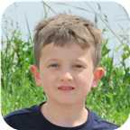 |  |  |  | 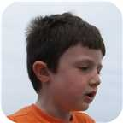

23. Jenny Lind Robertson was born on Friday, January 30, 1970, in St. Catharines, Ontario. She is the daughter of Allan James Robertson (19) and Virginia Worobel.
  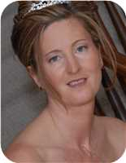
  Jenny Lind Robertson
She married Steve Taylor. They were separated in Welland, Ontario, Canada, in 2017. They have two sons. He is the son of William George Taylor and Betty Ann ?.
  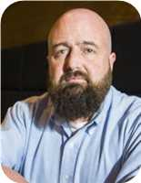
  Steve Taylor
Sons of Jenny Lind Robertson and Steve Taylor:
m I. Peyton Jackson Taylor was born in St Catharines on May 21, 2009.
  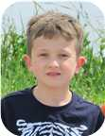
  Peyton
m II. James Elliott Taylor was born in St Catharines on March 16, 2011.
  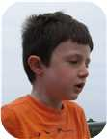
  James

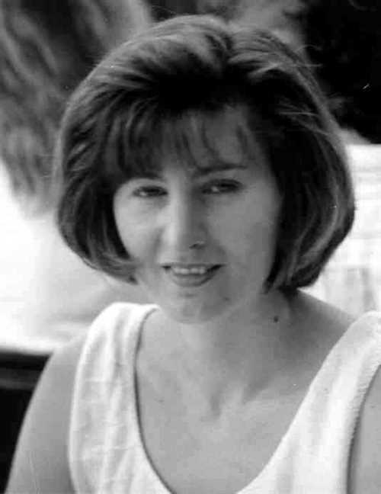  Figure 49: Jenny Lind Robertson |  | 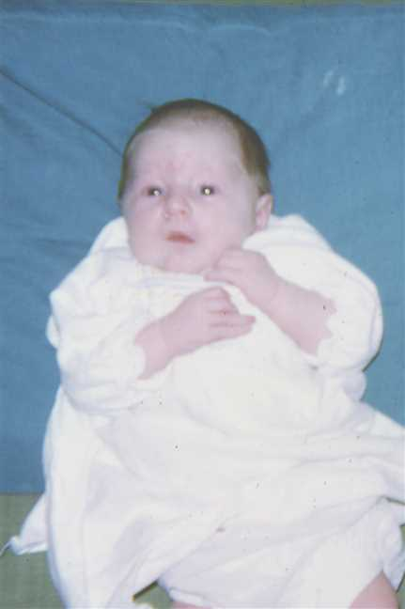  Figure 50: 197008-02Jenny5

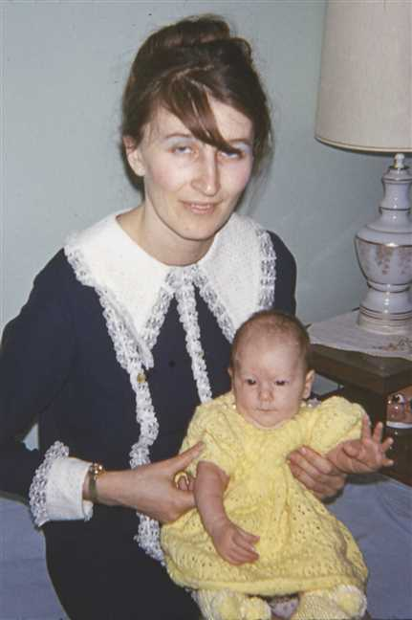  Figure 51: 197031-03VigeJenny |  | 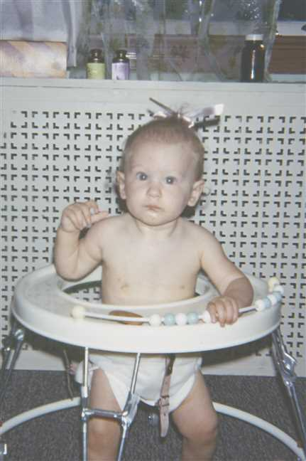  Figure 52: 197097-08Jenny2

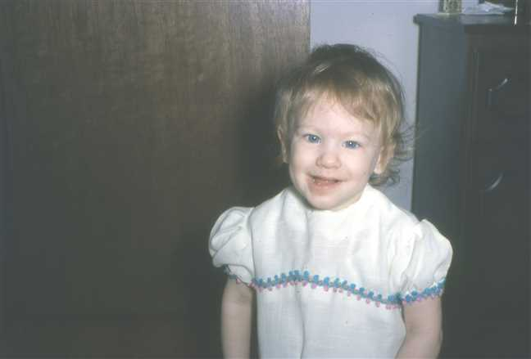  Figure 53: 1971-04Jenny |  | 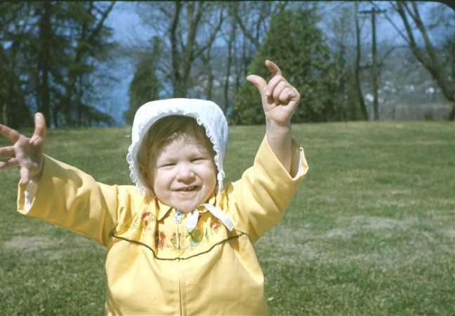  Figure 54: 1971-05Jenny6

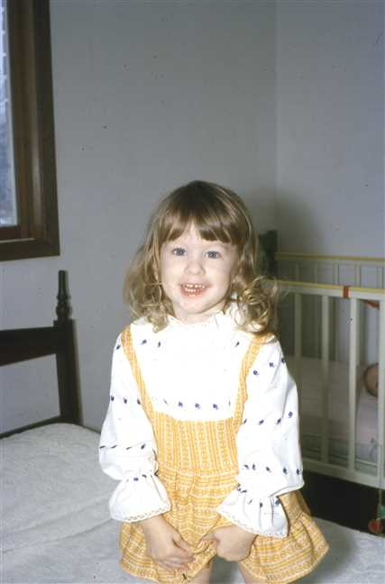  Figure 55: 1972-02Jenny |  | 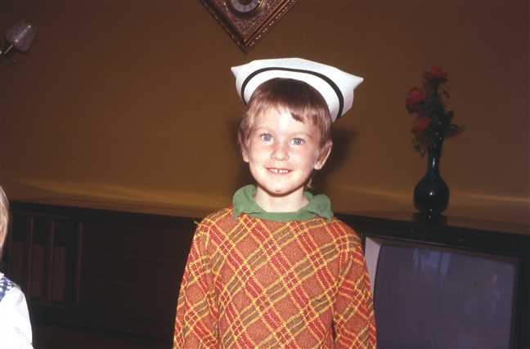  Figure 56: 1973-10JenyNurseHat

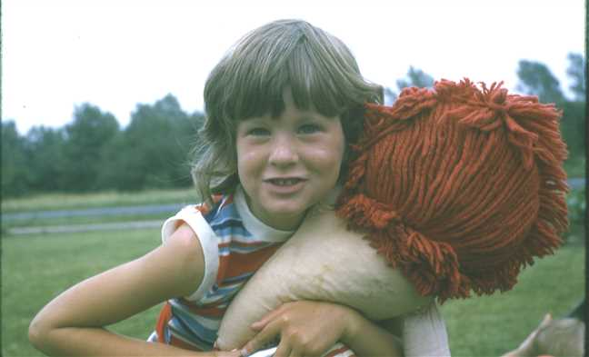  Figure 57: 1974-07Jenny3 |  | 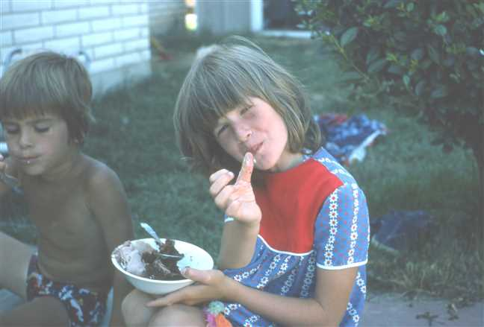  Figure 58: 1975-07Adele'sBirthday8

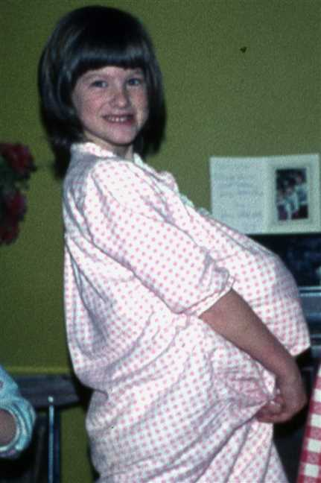  Figure 59: 1976-Jenny |  | 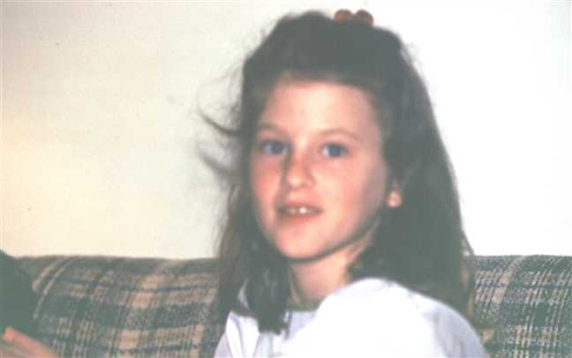  Figure 60: 1978-03Jenny

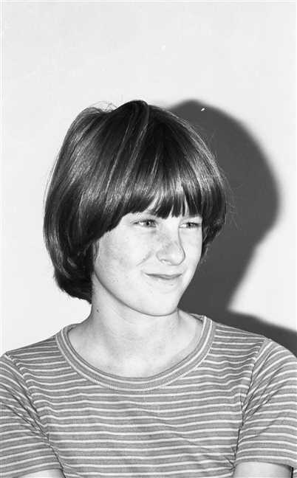  Figure 61: img001380 |  | 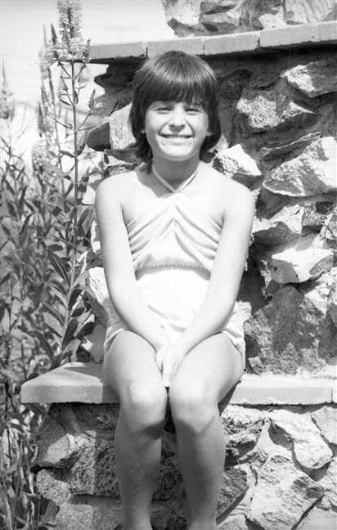  Figure 62: img001660

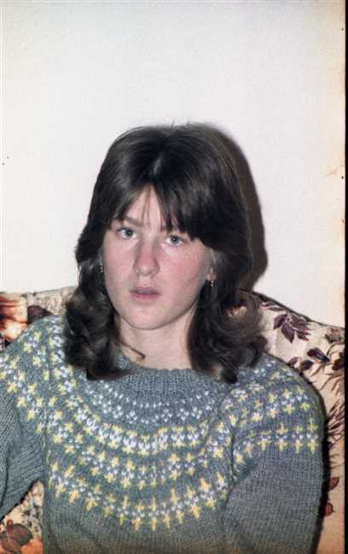  Figure 63: img001281 |  | 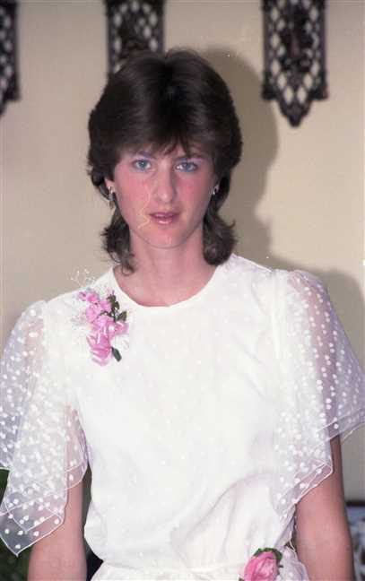  Figure 64: img001215

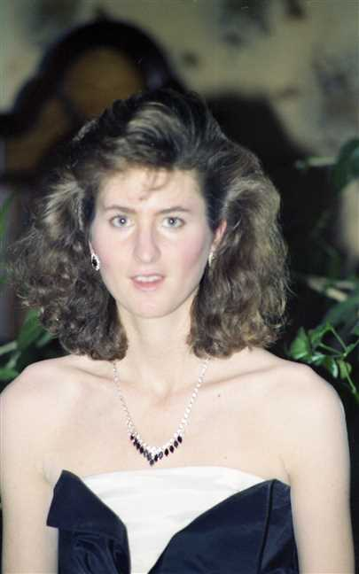  Figure 65: img001115 |  | 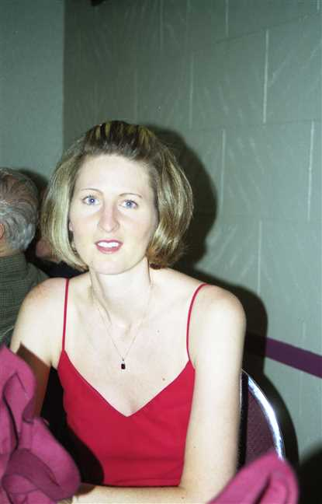  Figure 66: img001167

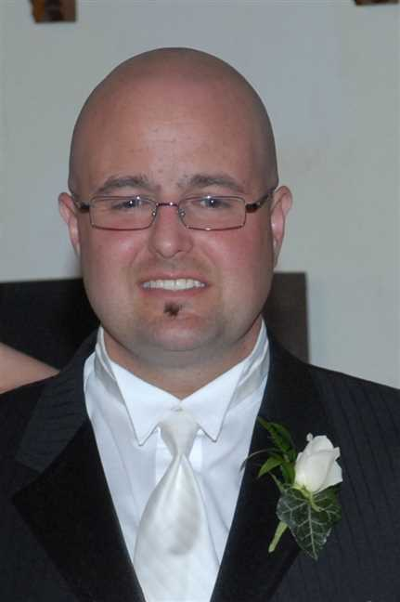
Figure 67: Steve

Adele Robertson
24. Adele Marie Robertson was born on Tuesday, July 06, 1971, in St. Catharines, Ontario. She is the daughter of Allan James Robertson (19) and Virginia Worobel.
  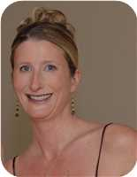
  Adele Marie Robertson
Adele never married either Jeff Graige or Geard Seward.
Marriages with Jeffery Craige and Geard Seward (Page 60) are known.

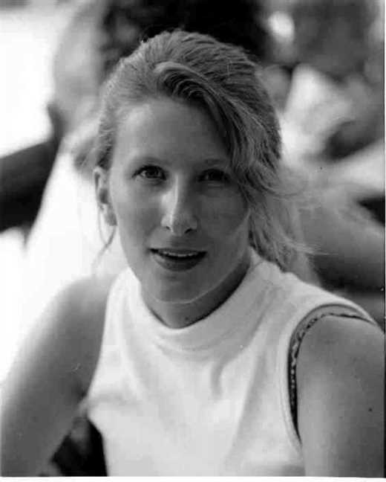  Figure 68: Adele Marie Robertson |  | 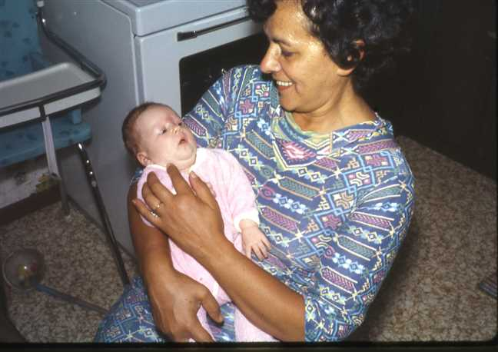  Figure 69: 1971-07AdeleBaba

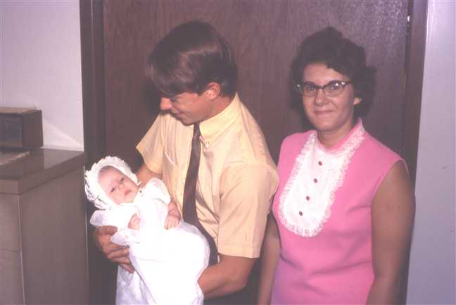  Figure 70: 1971-08AdeleAnnieDavid |  | 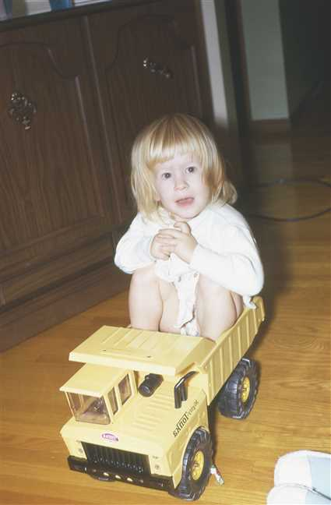  Figure 71: 1972-12Adele2

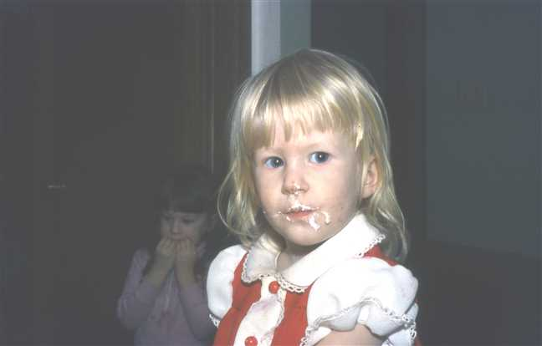  Figure 72: 1973-01Adele7 |  | 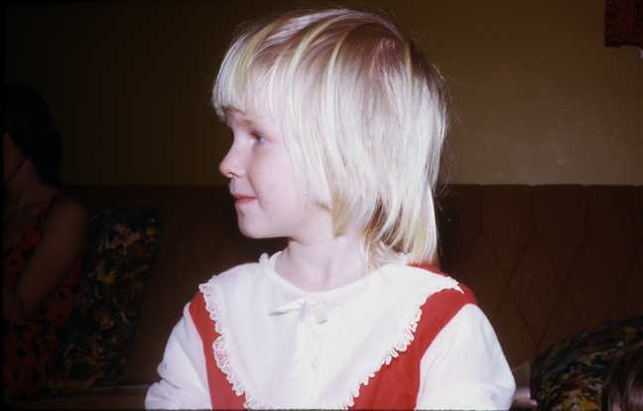  Figure 73: 1974-02Adele3

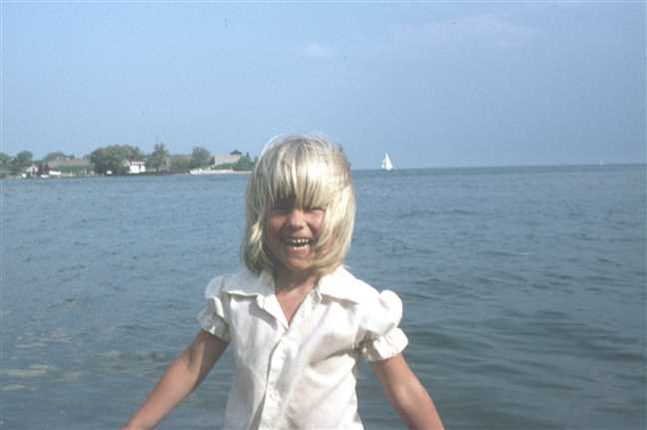  Figure 74: 1975-07Adele2 |  | 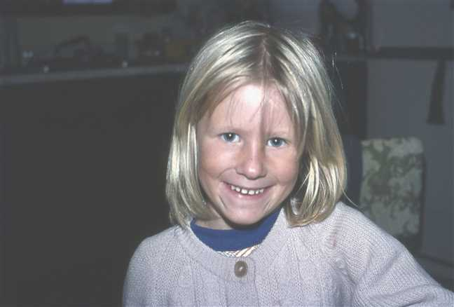  Figure 75: 1976-08Adele

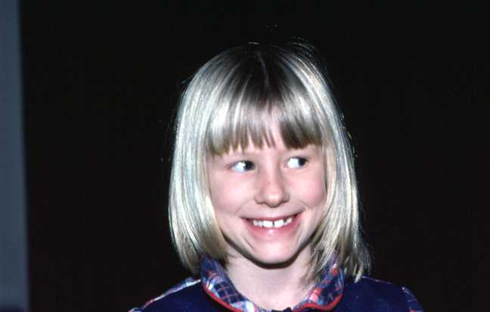  Figure 76: 1978-01Adele |  | 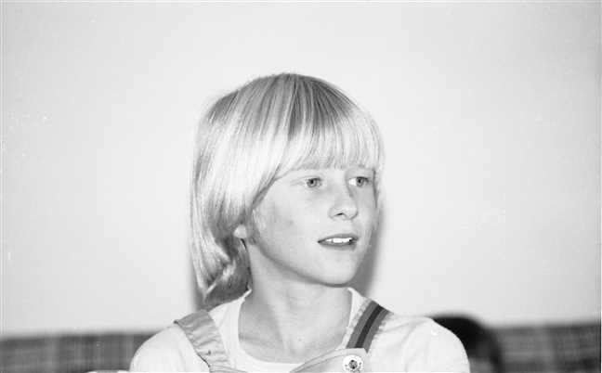  Figure 77: img001365

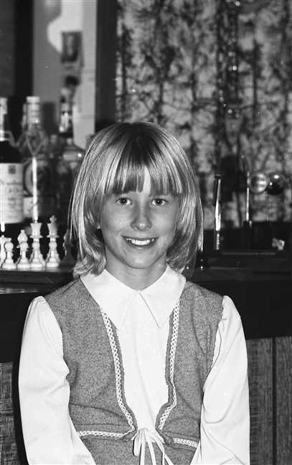  Figure 78: img001488 |  | 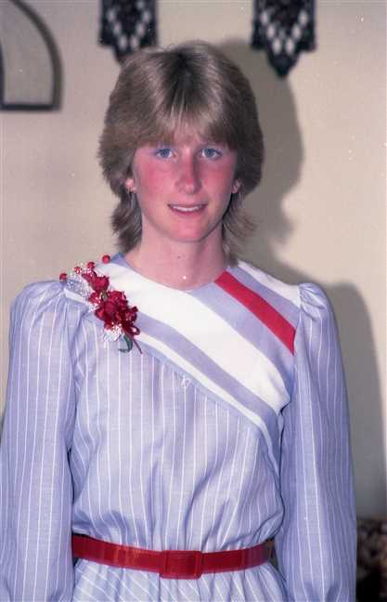  Figure 79: img001214

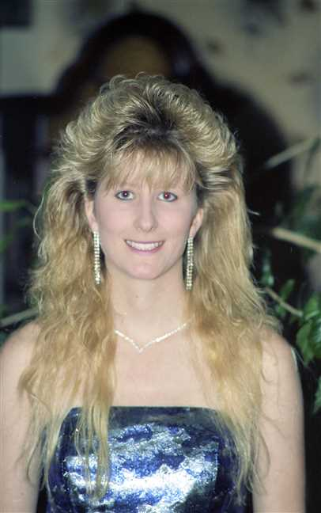
Figure 80: img001114

Family of Adele Robertson and Jeffery Craige
 |  |  |  |  |  |  |  |  |  |  |  |  |  |  |  |  |  |  |  |  |  |  |  | James Ives |  |  |  |  |  | Charlotte Helen |  |  |  |  |  | John |  |  |  |  |  | Jean
 |  |  |  |  |  |  |  |  |  |  |  |  |  |  |  |  |  |  |  |  |  |  |  | Robertson |  |  |  |  |  | MacDonell |  |  |  |  |  | Worobel |  |  |  |  |  | Kolynchuk
 |  |  |  |  |  |  |  |  |  |  |  |  |  |  |  |  |  |  |  |  |  |  |  | 1917–1989 |  |  |  |  |  | 1922–2005 |  |  |  |  |  | 1922–1979 |  |  |  |  |  | 1925–2012
 |  | ? |  |  |  |  |  |  |  |  |  |  |  | Jean |  |  |  |  |  |  |  |  |  |  |  | Allan James |  |  |  |  |  |  |  |  |  |  |  | Virginia
 |  | Craige |  |  |  |  |  |  |  |  |  |  |  | ? |  |  |  |  |  |  |  |  |  |  |  | Robertson |  |  |  |  |  |  |  |  |  |  |  | Worobel
 |  |  |  |  |  |  |  |  |  |  |  |  |  |  |  |  |  |  |  |  |  |  |  |  |  | 1943– |  |  |  |  |  |  |  |  |  |  |  | 1945–
 |  |  |  |  |  |  |  | Jeffery |  |  |  |  |  |  |  |  |  |  |  |  |  |  |  |  |  |  |  |  |  |  |  | Adele Marie
 |  |  |  |  |  |  |  | Craige |  |  |  |  |  |  |  |  |  |  |  |  |  |  |  |  |  |  |  |  |  |  |  | Robertson
 |  |  |  |  |  |  |  |  |  |  |  |  |  |  |  |  |  |  |  |  |  |  |  |  |  |  |  |  |  |  |  | 1971–
 |  |  |  |  |  |  |  |  |  |  |  |  |  | Married
 |  |  |  |  |  |  |  |  |  |  |  |  |  |  |  |  |  |  |  |  | Jude Allan
 |  |  |  |  |  |  |  |  |  |  |  |  |  |  |  |  |  |  |  |  | Robertson
 |  |  |  |  |  |  |  |  |  |  |  |  |  |  |  |  |  |  |  |  | 2004–
 |  |  |  |  |  |  |  |  |  |  |  |  |  |  |  |  |  |  |  |  | 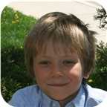

Here are the details about Adele Marie Robertson's first marriage, with Jeffery Craige. You can read more about Adele Marie on page 56.
Adele Marie Robertson married Jeffery Craige. They have one son. He is the son of ? Craige and Jean ?.
Jeff was adopted by Jean Craige and her first husband. Jeff's real parents are unknown but his biological Father is believed to be Austrian and his biological Mother is believed tobe Jamacian. Jeff has another older son - Kyle by another but unknown woman. He also has two more daughters by two other but unknown women.
Son of Adele Marie Robertson and Jeffery Craige:
m I. Jude Allan Robertson was born in St. Catharines, ON, on November 10, 2004.
  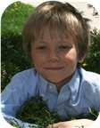
  Jude

Family of Adele Robertson and Geard Seward
 |  |  |  |  |  |  |  |  |  |  |  |  |  |  |  |  |  |  |  |  |  |  |  | James Ives |  |  |  |  |  | Charlotte Helen |  |  |  |  |  | John |  |  |  |  |  | Jean
 |  |  |  |  |  |  |  |  |  |  |  |  |  |  |  |  |  |  |  |  |  |  |  | Robertson |  |  |  |  |  | MacDonell |  |  |  |  |  | Worobel |  |  |  |  |  | Kolynchuk
 |  |  |  |  |  |  |  |  |  |  |  |  |  |  |  |  |  |  |  |  |  |  |  | 1917–1989 |  |  |  |  |  | 1922–2005 |  |  |  |  |  | 1922–1979 |  |  |  |  |  | 1925–2012
 |  | ? |  |  |  |  |  |  |  |  |  |  |  | Lynda |  |  |  |  |  |  |  |  |  |  |  | Allan James |  |  |  |  |  |  |  |  |  |  |  | Virginia
 |  | Seward |  |  |  |  |  |  |  |  |  |  |  | ? |  |  |  |  |  |  |  |  |  |  |  | Robertson |  |  |  |  |  |  |  |  |  |  |  | Worobel
 |  |  |  |  |  |  |  |  |  |  |  |  |  |  |  |  |  |  |  |  |  |  |  |  |  | 1943– |  |  |  |  |  |  |  |  |  |  |  | 1945–
 |  |  |  |  |  |  |  | Geard |  |  |  |  |  |  |  |  |  |  |  |  |  |  |  |  |  |  |  |  |  |  |  | Adele Marie
 |  |  |  |  |  |  |  | Seward |  |  |  |  |  |  |  |  |  |  |  |  |  |  |  |  |  |  |  |  |  |  |  | Robertson
 |  |  |  |  |  |  |  |  |  |  |  |  |  |  |  |  |  |  |  |  |  |  |  |  |  |  |  |  |  |  |  | 1971–
 |  |  |  |  |  |  |  |  |  |  |  |  |  | Married
 |  |  |  |  |  |  |  |  |  |  |  |  |  |  |  |  |  |  |  |  | Genevieve Alice
 |  |  |  |  |  |  |  |  |  |  |  |  |  |  |  |  |  |  |  |  | Seward
 |  |  |  |  |  |  |  |  |  |  |  |  |  |  |  |  |  |  |  |  | 2014–

Here are the details about Adele Marie Robertson's second marriage, with Geard Seward. You can read more about Adele Marie on page 56.
Adele Marie Robertson married Geard Seward. They have one daughter. He is the son of ? Seward and Lynda ?.
Daughter of Adele Marie Robertson and Geard Seward:
f I. Genevieve Alice Seward was born in St Catharines, Ontario, Canada, on May 19, 2014.

Family of Lara Robertson and Jeremy Bowen
Wilfred Fletcher |  |  |  |  |  | Helen |  |  |  |  |  | Pedro |  |  |  |  |  | Carmen |  |  |  |  |  | James Ives |  |  |  |  |  | Charlotte Helen |  |  |  |  |  | John |  |  |  |  |  | Jean
Bowen |  |  |  |  |  | Brodeur |  |  |  |  |  | Traverso |  |  |  |  |  | Soler |  |  |  |  |  | Robertson |  |  |  |  |  | MacDonell |  |  |  |  |  | Worobel |  |  |  |  |  | Kolynchuk
1927–2018 |  |  |  |  |  |  |  |  |  |  |  | 1927–2019 |  |  |  |  |  | –1991 |  |  |  |  |  | 1917–1989 |  |  |  |  |  | 1922–2005 |  |  |  |  |  | 1922–1979 |  |  |  |  |  | 1925–2012
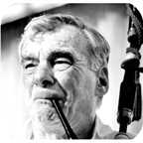 |  |  |  |  |  |  |  |  |  |  |  | 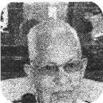
 |  | Ronald |  |  |  |  |  |  |  |  |  |  |  | Miriam |  |  |  |  |  |  |  |  |  |  |  | Allan James |  |  |  |  |  |  |  |  |  |  |  | Virginia
 |  | Bowen |  |  |  |  |  |  |  |  |  |  |  | Traverso |  |  |  |  |  |  |  |  |  |  |  | Robertson |  |  |  |  |  |  |  |  |  |  |  | Worobel
 |  |  |  |  |  |  |  |  |  |  |  |  |  |  |  |  |  |  |  |  |  |  |  |  |  | 1943– |  |  |  |  |  |  |  |  |  |  |  | 1945–
 |  |  |  |  |  |  |  |  |  |  |  |  |  | 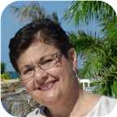
 |  |  |  |  |  |  |  | Jeremy |  |  |  |  |  |  |  |  |  |  |  |  |  |  |  |  |  |  |  |  |  |  |  | Lara Lynn
 |  |  |  |  |  |  |  | Bowen |  |  |  |  |  |  |  |  |  |  |  |  |  |  |  |  |  |  |  |  |  |  |  | Robertson
 |  |  |  |  |  |  |  | 1975– |  |  |  |  |  |  |  |  |  |  |  |  |  |  |  |  |  |  |  |  |  |  |  | 1973–
 |  |  |  |  |  |  |  | 
 |  |  |  |  |  |  |  |  |  |  |  |  |  | Married
 |  |  |  |  |  |  |  |  |  |  |  |  |  |  |  |  |  |  |  |  | Avalyn
 |  |  |  |  |  |  |  |  |  |  |  |  |  |  |  |  |  |  |  |  | Bowen
 |  |  |  |  |  |  |  |  |  |  |  |  |  |  |  |  |  |  |  |  | 2012–
 |  |  |  |  |  |  |  |  |  |  |  |  |  |  |  |  |  |  |  |  | 

25. Lara Lynn Robertson was born on Saturday, August 11, 1973, in St. Catharines, Ontario. She is the daughter of Allan James Robertson (19) and Virginia Worobel.
  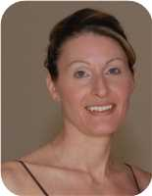
  Lara Lynn Robertson
She married Jeremy Bowen. They have one daughter.  Jeremy was born on Friday, December 26, 1975. He is the son of Ronald Bowen and Miriam Traverso.
  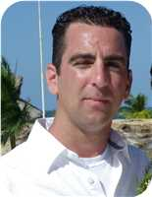
  Jeremy Bowen
Daughter of Lara Lynn Robertson and Jeremy Bowen:
I. Avalyn Bowen was born in St Catharines, Ontario, Canada, on October 11, 2012.
  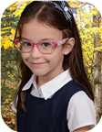
  Avalyn

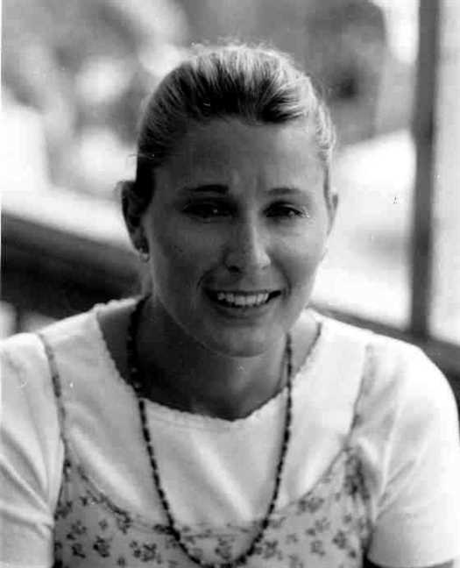  Figure 81: Lara Lynn Robertson |  | Figure 82: 1973-07Virginia(1)

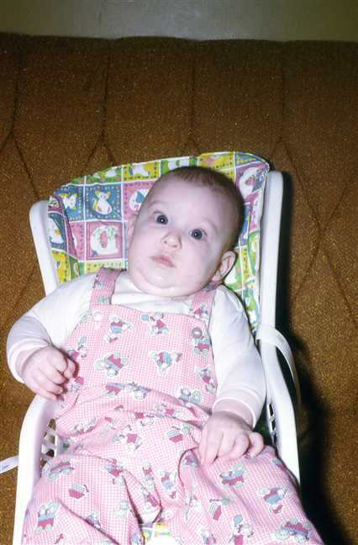  Figure 83: 1974-01Lara2 |  | 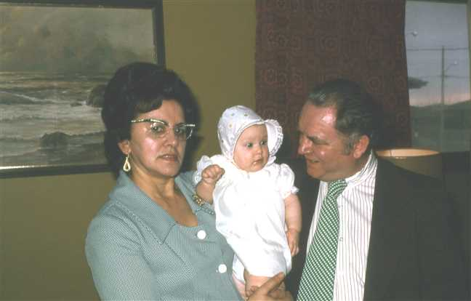  Figure 84: 1974-03BabaLaraWally

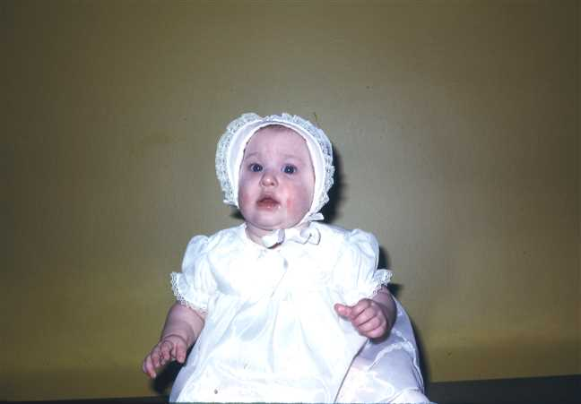  Figure 85: 1974-03Lara |  | 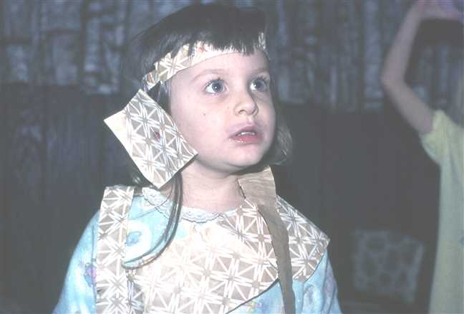  Figure 86: 1976-11Lara

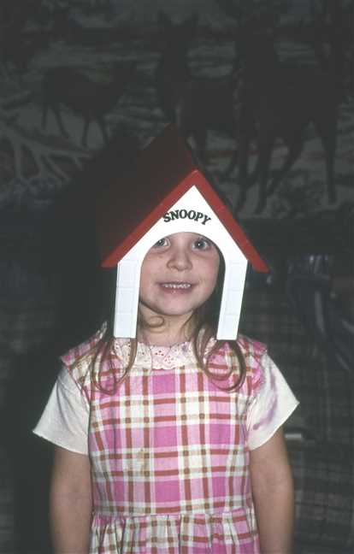  Figure 87: 1977-01Lara3 |  | 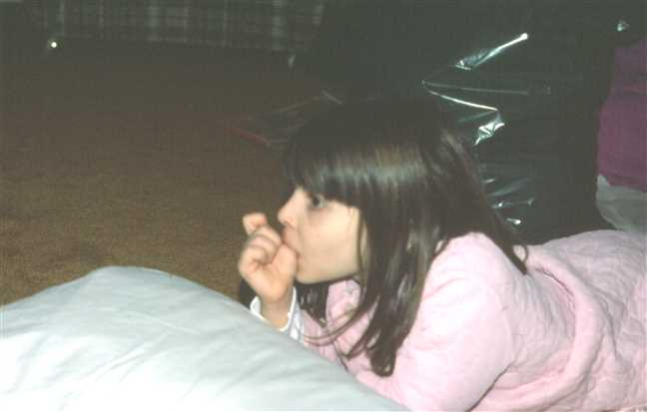  Figure 88: 1978-01Lara4

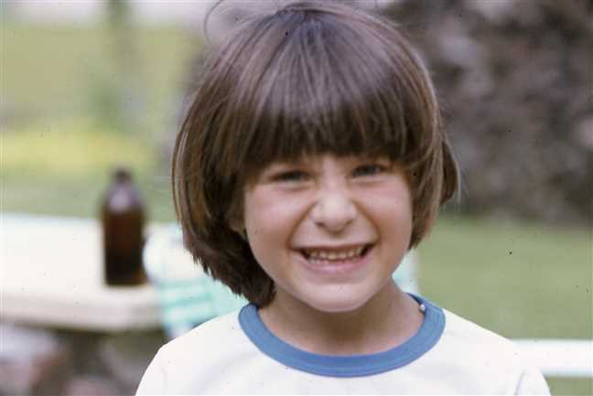  Figure 89: 1978-06Lara2 |  | 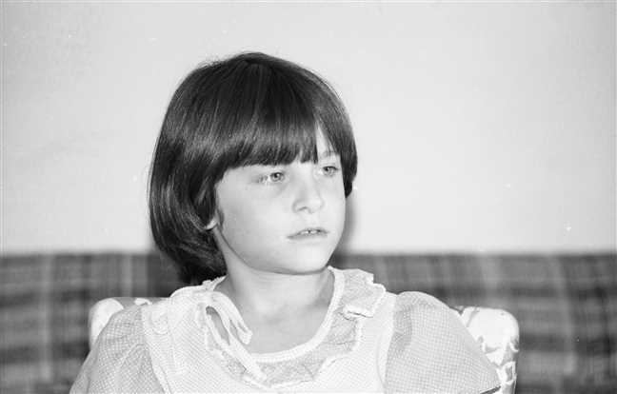  Figure 90: img001426

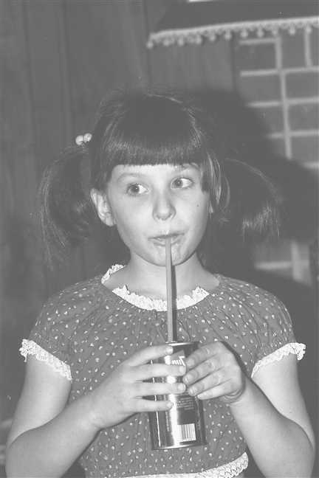  Figure 91: 1981-01 Lara |  | 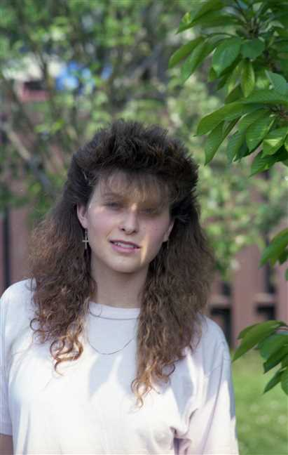  Figure 92: img001040

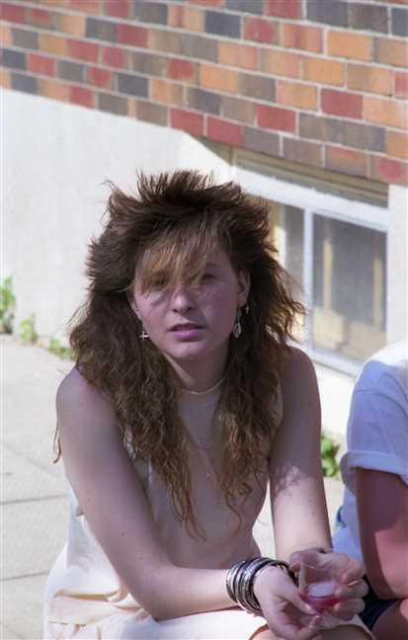
Figure 93: img001056

Family of Michelle Dusette and Brian Procter
 |  |  |  |  |  |  |  | James Ives |  |  |  | Charlotte Helen
 |  |  |  |  |  |  |  | Robertson |  |  |  | MacDonell
 |  |  |  |  |  |  |  | 1917–1989 |  |  |  | 1922–2005
 | ? |  |  |  |  |  |  |  | Lois Christina
 | Cyr |  |  |  |  |  |  |  | Robertson
 |  |  |  |  |  |  |  |  | 1948–1979
 |  |  |  |  | Michelle |  |  |  |  |  |  |  |  |  |  |  |  |  |  |  | Brian
 |  |  |  |  | Dusette |  |  |  |  |  |  |  |  |  |  |  |  |  |  |  | Procter
 |  |  |  |  | 1969–
 |  |  |  |  |  |  |  |  | Marriage: 1995
 |  |  |  |  |  |  |  |  |  |  |  | Jessica |  |  |  | Rebecca
 |  |  |  |  |  |  |  |  |  |  |  | Procter |  |  |  | Procter
 |  |  |  |  |  |  |  |  |  |  |  | 1997– |  |  |  | 2001–

26. Michelle Dusette was born on Monday, November 03, 1969, in St Catharines, Ontario, Canada. He or she is a child of ? Cyr and Lois Christina Robertson (20).
Michelle married Brian Procter in 1995. They have two children.
Children of Michelle Dusette and Brian Procter:
I. Jessica Procter was born in St Catharines on January 16, 1997.
II. Rebecca Procter was born in St Catharines on April 03, 2001.

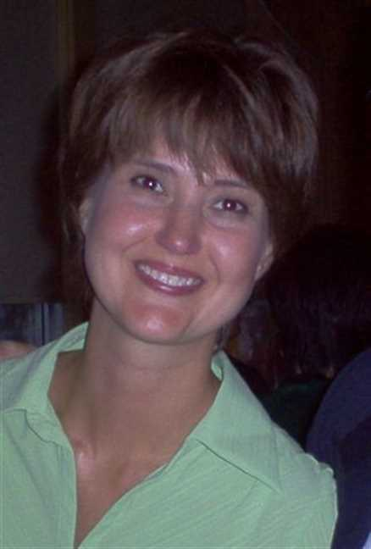  Figure 94: michelle pic |  | 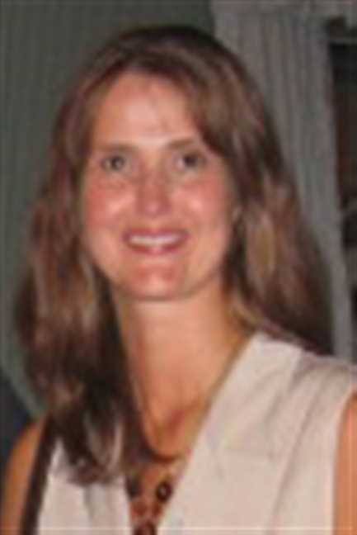  Figure 95: Michelle2

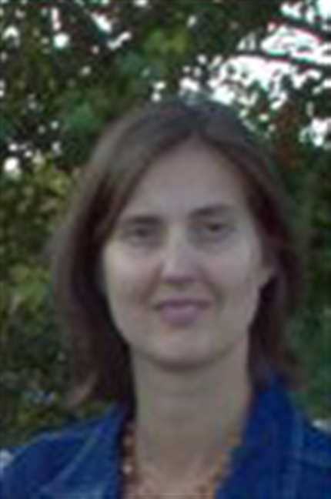  Figure 96: Michelle3 |  | 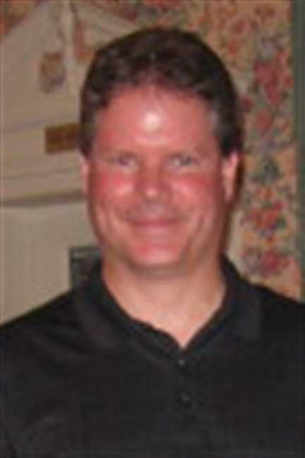  Figure 97: Brian

Lisa Robertson and John Brown
 |  |  |  |  |  |  |  | Kipling |  |  |  | Mary Ellen |  |  |  | Frederick Elmer Dicki |  |  |  | Jessie Winifred |  |  |  | James Ives |  |  |  | Charlotte Helen
 |  |  |  |  |  |  |  | MacKenzie |  |  |  | Foley |  |  |  | Gray |  |  |  | Davis |  |  |  | Robertson |  |  |  | MacDonell
 |  |  |  |  |  |  |  | ca.1910–1968 |  |  |  | –1987 |  |  |  |  |  |  |  | 1919– |  |  |  | 1917–1989 |  |  |  | 1922–2005
 | Joseph Owen |  |  |  |  |  |  |  | Catherine Alexandra |  |  |  |  |  |  |  | Roy Edward |  |  |  |  |  |  |  | Vivian Louise
 | Brown |  |  |  |  |  |  |  | MacKenzie |  |  |  |  |  |  |  | Gray |  |  |  |  |  |  |  | Robertson
 | 1932– |  |  |  |  |  |  |  | 1935–1992 |  |  |  |  |  |  |  | 1951– |  |  |  |  |  |  |  | 1957–
 |  |  |  |  | John Christopher |  |  |  |  |  |  |  |  |  |  |  |  |  |  |  | Lisa
 |  |  |  |  | Brown |  |  |  |  |  |  |  |  |  |  |  |  |  |  |  | Robertson
 |  |  |  |  | 1971– |  |  |  |  |  |  |  |  |  |  |  |  |  |  |  | 1974–
 |  |  |  |  |  |  |  |  | Partner
 |  |  |  |  |  |  |  |  |  |  |  | William Blair Robertson |  |  |  | Devon Alexander
 |  |  |  |  |  |  |  |  |  |  |  | Brown |  |  |  | Brown
 |  |  |  |  |  |  |  |  |  |  |  | 1996– |  |  |  | 2003–
 |  |  |  |  |  |  |  |  |  |  |  | 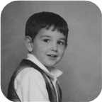

27. Lisa Robertson was born on Thursday, August 08, 1974, in Pictou, Nova Scotia, Canada. She is the daughter of Roy Edward Gray and Vivian Louise Robertson (21).
  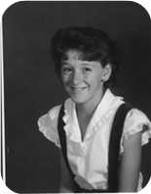
  Lisa Robertson
She is partnered with John Christopher Brown. They have two sons.
John Christopher was born in Pictou, N.S., on Saturday, March 13, 1971. He is the son of Joseph Owen Brown and Catherine Alexandra MacKenzie.
Sons of Lisa Robertson and John Christopher Brown:
m I. William Blair Robertson Brown was born in New Glasgow, Nova Scotia, on January 12, 1996.
  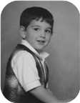
  William
m II. Devon Alexander Brown was born in Saskatoon, Sask., on March 28, 2003.

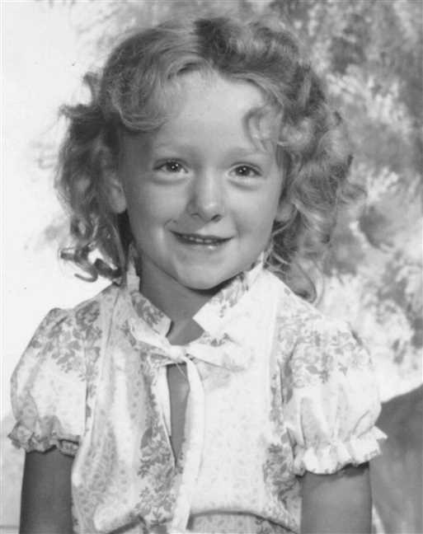  Figure 98: Lisa Robertson |  | 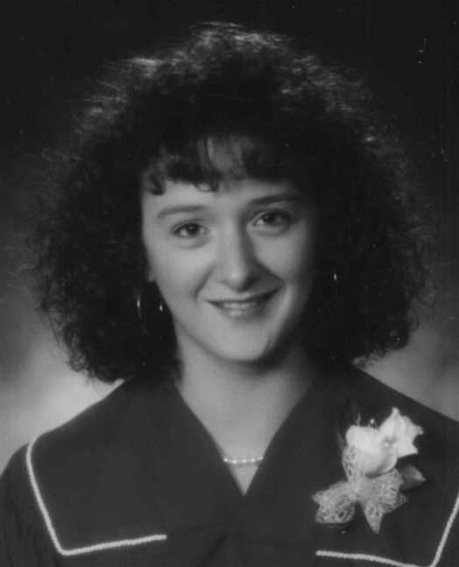  Figure 99: Lisa Robertson

Index of Places

BSc, MSc St Francis Xavier Univ. 1965, 1967
Robertson, Allan James (1943–) 31
Cadillac, Quebec
MacDonell, Charlotte Helen (1922–2005) 21
Robertson, James Ives (1917–1989) 21
Chemist
Robertson, Allan James (1943–) 31
Cumunity College
Robertson, James Ives (1917–1989) 21
Factory Worker
Robertson, Lewis William (1951–) 21
Fron Churchview, N.S.
MacLean, John 19
High School
Robertson, Lois Christina (1948–1979) 40
Homemaker
MacDonald, Mary Christina (1895–1978) 17
Judique, N.S.
MacDonald, Mary Christina (1895–1978) 17
MacDonell, Angus Hugh (1831–1917) 13
MacDonell, Flora (1841–1919) 13
Judique, Nova Scotia
MacDonell, Charlotte Helen (1922–2005) 18, 20
Mulgrave, N.S.
MacDonald, Mary Christina (1895–1978) 17
New Glasgow, Nova Scotia
Brown, William Blair Robertson (1996–) 66
Operated heating business in Toledo OH
MacDonell, Allan Joseph (1926–1980) 28
Pictou, N.S.
Brown, John Christopher (1971–) 66
Gray, Roy Edward (1951–) 46
Pictou, Nova Scotia, Canada
(45.6782° N, 62.7071° W)
Robertson, Allan James (1943–) 21, 31
Robertson, James Ives (1917–1989) 21
Robertson, Lisa (1974–) 46, 66
Robertson, Lois Christina (1948–1979) 21, 40
Robertson, Vivian Louise (1957–) 21, 44
Pictou, NS
Robertson, Derek (1990–) 46
Port Hood, N.S.
MacDonald, Mary Christina (1895–1978) 17
MacDonell, Alexander Ackie 14, 18
RCMP officer
MacDonell, Allan Angus 47
Saskatoon, Sask.
Brown, Devon Alexander (2003–) 66
Scotland
MacDonell, Alexander (ca.1823–) 9, 11
MacDonell, Angus (1740–) 7
Secretary
Robertson, Lois Christina (1948–1979) 40
Sheet Metal worker
Robertson, James Ives (1917–1989) 21
St Catharines, Niagara, Ontario, Canada
(43.1592° N, 79.2465° W)
Robertson, Allan James (1943–) 35
Worobel, Virginia (1945–) 35
St Catharines, Ontario
Robertson, Lois Christina (1948–1979) 21, 40
Worobel, Virginia (1945–) 35
St Catharines, Ontario, Canada
(43.1667° N, 79.2334° W)
Bowen, Avalyn (2012–) 61
Dusette, Michelle (1969–) 44, 64
Procter, Jessica (1997–) 64
Procter, Rebecca (2001–) 65
Seward, Genevieve Alice (2014–) 60
Taylor, James Elliott (2011–) 52
Taylor, Peyton Jackson (2009–) 52
St. Catharines, ON
Robertson, Jude Allan (2004–) 59
St. Catharines, Ontario
Robertson, Adele Marie (1971–) 36, 56
Robertson, Jenny Lind (1970–) 35, 51
Robertson, Lara Lynn (1973–) 36, 61
Stellarton, Nova Scotia
Robertson, James Ives (1917–1989) 21
Welland, Ontario, Canada
(42.9935° N, 79.2393° W)
Robertson, Jenny Lind (1970–) 51
Taylor, Steve 51

Index of Individuals

?
? 46
Betty Ann 51
Jean 59
Lynda 60
Barden
Kathy (–2000) 47, 48
Bowen
Avalyn (2012–) 61
Jeremy (1975–) 61
Ronald 61
Wilfred Fletcher (1927–2018) 61
Brodeur
Helen 61
Brown
Devon Alexander (2003–) 66
John Christopher (1971–) 66
Joseph Owen (1932–) 66
William Blair Robertson (1996–) 66
Campbell
Angus 14
Annie Fraser (1867–1960) 20
Colter
George 29, 30
Craige
? 59
Jeffery 59
Cyr
? 44, 64
Dalton
Joseph 42
Davis
Jessie Winifred (1919–) 45, 46, 66
Dusette
Michelle (1969–) 44, 64
Foley
Mary Ellen (–1987) 66
Fortunato
Franco 29
Fraser
Ocenia (1853–1935) 20
Gray
Frederick Elmer Dicki 45, 46, 66
Roy Edward (1951–) 45, 46, 66
Ives
Arthur (1854–1913) 20
Louisa Reid (1889–1982) 20, 21, 31, 42, 43, 44, 45, 46
Kohut
Catherine 31
Kolynchuk
Demetro (1897–1945) 31
Jean (1925–2012) 31, 35, 51, 59, 60, 61
Kwasnica
Dora (1899–1972) 31
Little
Harold 43
MaBee
Hazel 51
MacDonald
Alasdair 14, 18
Kate 14, 18
Margaret 28
Mary Christina (1895–1978) 17, 19, 20, 27, 28, 29, 31, 42, 43, 44, 45, 46, 47
William (1799–) 17
William Little (1844–1917) 17, 19, 20, 27, 28
MacDonell
? (1710–) 7, 9
Alexander 11, 12, 15
Alexander (1790–) 7, 9, 11, 12, 13, 14, 15
Alexander (1878–) 13
Alexander (ca.1823–) 9, 11, 13, 14, 17, 18
Alexander Ackie 14, 18
Allan 9, 11, 14, 18
Allan (1880–1926) 13, 17, 19, 20, 27, 28, 29, 31, 42, 43, 44, 45, 46, 47
Allan Angus 27, 47
Allan Ban 13, 17
Allan Joseph (1926–1980) 17, 18, 28
Angus 9, 11, 15
Angus (1740–) 7, 9, 11, 12
Angus Hugh (1831–1917) 13, 17, 19, 20, 27, 28
Angus John (1924–) 17, 18, 27, 47
Annie 9, 11, 12, 14, 15
Archibald (1883–) 13
Catherine A (1876–) 13
Charlotte Helen (1922–2005) 17, 18, 20, 31, 40, 42, 43, 44, 45, 46, 51, 59, 60, 61, 64, 66
Debbie 28
Flora (1841–1919) 11, 13, 17, 19, 20, 27, 28
Flora Isabel (1920–) 17, 19, 29, 30
Francine 18
Hugh (1870–) 13
James 11
John 11
Julia (1874–) 13
Katie 11, 12
Lois 28
Maggie A (1873–) 13
Mary 11, 12
Mary C (1868–) 13
Roderick 11
William 15
MacDougall
Charlotte (1849–1934) 17, 19, 20, 27, 28
MacEachern
? 13, 17
MacGinnis
Vina (1912–1960) 18
MacInnis
William (1872–1942) 18
MacKenzie
Catherine Alexandra (1935–1992) 66
Kipling (ca.1910–1968) 66
MacLean
Annie 18
Cathy 19, 20
David William 19, 20
Elizabeth (1942–) 19, 29
Helen 19, 29, 30
John 19, 29, 30
Victoria 19
MacMaster
Catherine (1810–) 17
MacMillan
James Duncan 15
MacNeil
Alexander 12, 15
Annie 12, 15
Daniel 12
Neil 12
Matchette
Dawn 27, 47
Morrison
? 11, 12, 13, 14, 15, 17, 18
Roderick 11, 13, 14
Procter
Brian 64
Jessica (1997–) 64
Rebecca (2001–) 64, 65
Reinard
Alysha (1976–) 47, 48
Robertson
Adele Marie (1971–) 31, 36, 56, 59, 60
Allan James (1943–) 20, 21, 31, 51, 56, 59, 60, 61
Derek (1990–) 46
James Alexander (1859–1947) 20
James Ives (1917–1989) 20, 21, 31, 40, 42, 43, 44, 45, 46, 51, 59, 60, 61, 64, 66
Jenny Lind (1970–) 31, 35, 51
Jude Allan (2004–) 59
Lara Lynn (1973–) 31, 36, 61
Leonard Bowman (1890–1972) 20, 21, 31, 42, 43, 44, 45, 46
Lewis William (1951–) 20, 21
Lisa (1974–) 45, 46, 66
Lois Christina (1948–1979) 20, 21, 40, 42, 43, 44, 64
Vivian Louise (1957–) 20, 21, 44, 45, 46, 66
Seward
? 60
Geard 60
Genevieve Alice (2014–) 60
Soler
Carmen (–1991) 61
Taylor
James Elliott (2011–) 51, 52
Peyton Jackson (2009–) 51, 52
Steve 51
Willam J (1921–2012) 51
William George (–2007) 51
Traverso
Miriam 61
Pedro (1927–2019) 61
Worobel
John (1922–1979) 31, 35, 51, 59, 60, 61
Stephen 31
Virginia (1945–) 31, 35, 51, 56, 59, 60, 61

