Descendants of Charles Fraser (1748-1811)
Compiled by Allan Robertson
36 Forster Ave.
Thorold, ON
L2V4J5
forsteralal@cogeco.ca
2021-07-20

Contents
Introduction 7
Families of the Starting Person 9
Charles Fraser 9
Charles Fraser and Ann? 9
Charles Fraser and Ann ? 10
Families of the Descendants 11
1st Generation 11
Catharine Fraser 11
Catharine Fraser and George Ives 11
Catharine Fraser and William Symptom 11
Jane Fraser and James Fraser 11
Christina Fraser and James McDougall 11
Grace Fraser and William McDougall 12
Mary Fraser and John Mackay 12
2nd Generation 13
Anna Ives and Matthew Patterson 13
Jane Ives and Archibald Fraser 14
John Ives and Sarah Ives 16
William Ives and Christiana Fraser 17
John Fraser and Annie Robertson 26
? Fraser 29
William Fraser and Jessie Matheson 29
3rd Generation 31
Georgina Fraser and Joseph Graham 31
James Ives and Fanny Ives 32
Robert Ives and Grace McLeod 33
George Ives and Amelia McLeod 34
Charles Ives 36
Charles Ives and Anna McPhail 37
Charles Ives and Margaret Copeland 38
Emma Ives and Simpson Harris 39
Arthur Ives and Ocenia Fraser 43
Ocenia Fraser and Arthur Ives 45
James Fraser and M Russel 46
Anna Fraser and George Kernaghan 47
Jessie Fraser and Charles Rood 48
Alice Fraser and Alvin Daniels 55
4th Generation 57
Sarah Ives and Henry Kitchin 57
Henry Ives and Isabel Troop 58
Edith Ives and Edward MacDonald 58
Alexander Ives and Jessie Ross 59
Frederick Ives and ? ? 60
William Ives and Virginia Moore 61
Christina Ives and James Bethume 62
Daniel Harris and Jean Gesner 63
Margaret Harris and William Fraser 64
Christina Harris and Harry McKiel 65
Louisa Ives and Leonard Robertson 66
Daniel Ives and Laura Manship 70
Lewis Ives and Jenny Eastwood 72
John Ives and Jessie MacMillan 74
Mary Rood and Henry Gray 75
5th Generation 77
Charles Ives 77
Charles Ives and Eleanor Colburg 78
Charles Ives and Maisie 78
William Ives and Winnifred Murray 79
Virginia Ives and ? Mills 79
James Robertson and Charlotte MacDonell 80
Leonard Robertson and Edna Bell 86
Norah Robertson and Lester Bongard 89
Russel Ives and Beryl Walker 91
Frances Ives and William MacCaullum 92
Hilda Ives and George Wright 92
James Ives and Gladys Gaston 93
David Ives and Florence Smith 95
Norah Ives and Clwyd Ramscar 96
Charles Gray and Catherine Clark 98
Harry Gray and Dorothy Phillips 99
John Gray 99
John Gray and Clare Dennison 100
John Gray and Dorothy Hartling 101
6th Generation 103
Allan Robertson and Virginia Worobel 103
Lois Robertson 112
Lois Robertson and Joseph Dalton 114
Lois Robertson and Harold Little 115
Lois Robertson and ? Cyr 116
Vivian Robertson 116
Vivian Robertson and Roy Gray 117
Vivian Robertson and ? ? 118
Leonard Robertson and Laysha Lenyk 119
Janet Robertson and John Champion 120
Robert Bongard 121
Robert Bongard and Catherine Brooks 121
Robert Bongard and Yvone ? 122
John Bongard and ? ? 122
Norah Bongard and Jerrery Biggs 123
John Ives and Iris ? 124
Marjory Ives and Arleigh Cornelius 124
John Ives and Tammy ? 125
Sarah Ives and ? Fraser 125
Pearl Ives and William MacMillan 126
John Ramscar and Anne MacKenzie 126
Jessie Ramscar and John Allan 127
? Gray and David Chappell 128
Allan Gray and Donna Hunter 128
Robert Gray and Penny MacIntyre 129
Norma Gray and Mark Dewolfe 130
Leslie Gray and Brice Murphy 131
Eleanor Gray and Phillip Goodman 131
7th Generation 133
Jenny Robertson and Steve Taylor 133
Adele Robertson 138
Adele Robertson and Jeffery Craige 141
Adele Robertson and Geard Seward 142
Lara Robertson and Jeremy Bowen 143
Michelle Dusette and Brian Procter 146
Lisa Robertson and John Brown 148
Index of Places 151
Index of Individuals 157

Introduction
The following pages list data for all known family members as of <2021-07-20>.
Each immediate family is presented in their own section that contains a graphical family tree as well as a description with information about each referenced person and their children. The child section provides information about the children of the preceding couple. When a child has offspring of their own this is presented in a separate family section for that child. In this case a '+' is used to denote that an individual will appear later in the book as a parent with his/her own children and there is a link to the appropriate family reference number. For children with partners but no offspring the partner data is given with the reference family. Roman numerals, followed by a period, are used to indicate the birth order.
In the chapter titled "Families of the Starting Person" the ancestors of Charles Fraser are presented in a kind of enhanced Pedigree Chart which displays the graphic representation of their direct-line ancestors and the children of the couple. This chapter contains information about the couple whose offspring are listed in the later chapters.
The chapter titled "Families of the Descendants" provides details (as known as of the publication date) for the offspring of Charles Fraser. There is a chapter for each generation. Relatives are listed in the order of the nearness of their relationship.
Sources for the information provided are given in the footnotes.
This document reports the details of 253 individuals, of whom 137 are male and 112 are female. The sex of 4 individuals is unknown. Of the 85 individuals with recorded birth and death dates, the average lifespan was 56.1 years. Of these, 53 males averaged 51.9 years, and 32 females averaged 63.2 years. The longest living male was William J Fraser (1816–1914), who died aged 98. The longest living female was 3rd greatgranmother Jane Fraser (1779–1879), who died aged 100.

Families of the Starting Person

Charles Fraser
1. Charles Fraser was born in 1748. He died in 1811 at the age of 63. Charles was buried in Lauel Hill Cemetery, Pictou, NS.
Charles was a Hector passenger
Marriages with (unknown given name) Ann? and Ann ? (Page 10) are known.

Family of Charles Fraser and Ann?
 |  |  |  |  |  |  |  | Charles |  |  |  |  |  |  |  |  |  |  |  |  |  |  |  |  |  |  |  |  |  |  |  | (unknown given name)
 |  |  |  |  |  |  |  | Fraser |  |  |  |  |  |  |  |  |  |  |  |  |  |  |  |  |  |  |  |  |  |  |  | Ann?
 |  |  |  |  |  |  |  | 1748–1811
 |  |  |  |  |  |  |  |  |  |  |  |  |  | Married
 |  |  |  |  |  |  |  |  |  |  |  | Catharine |  |  |  |  |  | Donald |  |  |  |  |  | Donald |  |  |  |  |  | Grace
 |  |  |  |  |  |  |  |  |  |  |  | Fraser |  |  |  |  |  | Fraser |  |  |  |  |  | Fraser |  |  |  |  |  | Fraser
 |  |  |  |  |  |  |  |  |  |  |  | 1778–1865 |  |  |  |  |  | 1780–1851 |  |  |  |  |  | 1789–
 |  |  |  |  |  |  |  |  |  |  |  | 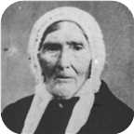
 |  |  |  |  |  |  |  |  | Nancy |  |  |  |  |  | Jane |  |  |  |  |  | John |  |  |  |  |  | Christina |  |  |  |  |  | Mary
 |  |  |  |  |  |  |  |  | Fraser |  |  |  |  |  | Fraser |  |  |  |  |  | Fraser |  |  |  |  |  | Fraser |  |  |  |  |  | Fraser
 |  |  |  |  |  |  |  |  | 1776–1854 |  |  |  |  |  | 1779–1879 |  |  |  |  |  | 1787– |  |  |  |  |  | 1790–1832

Here are the details about Charles Fraser's first marriage, with (unknown given name) Ann?. You can read more about Charles on page 9.
Charles Fraser married (unknown given name) Ann?. They had nine children.
Children of Charles Fraser and (unknown given name) Ann?:
f I. Nancy Fraser was born in 1776. She died in 1854 at the age of 78.
+ 2 f II. Catharine Fraser was born in 1778. She died in 1865 at the age of 87.
  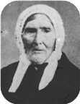
  Catharine
+ 3 f III. Jane Fraser was born in West River,Pictou Co.,Nova Scotia, in 1779. She died in West River on November 13, 1879, at the age of 100.
m IV. Donald Fraser was born in 1780. He died in 1851 at the age of 71.
m V. John Fraser was born in 1787.
m VI. Donald Fraser was born in 1789.
+ 4 f VII. Christina Fraser was born in 1790. She died in 1832 at the age of 42.
+ 5 f VIII. Grace Fraser.
+ 6 f IX. Mary Fraser.

Family of Charles Fraser and Ann ?
 |  |  |  |  | Charles |  |  |  |  |  |  |  |  |  |  |  |  |  |  |  | Ann
 |  |  |  |  | Fraser |  |  |  |  |  |  |  |  |  |  |  |  |  |  |  | ?
 |  |  |  |  | 1748–1811
 |  |  |  |  |  |  |  |  | Married
 |  |  |  |  |  |  |  |  |  |  |  | Catharine |  |  |  | Jane
 |  |  |  |  |  |  |  |  |  |  |  | Fraser |  |  |  | Fraser
 |  |  |  |  |  |  |  |  |  |  |  | 1778–1865 |  |  |  | 1779–1879

Here are the details about Charles Fraser's second marriage, with Ann ?. You can read more about Charles on page 9.
Charles Fraser married Ann ?. They had two daughters.
Daughters of Charles Fraser and Ann ?:
+ 2 f I. Catharine Fraser was born in 1778. She died in 1865 at the age of 87.
  Catharine
+ 3 f II. Jane Fraser was born in West River in 1779. She died in West River on November 13, 1879, at the age of 100.

Families of the Descendants

1st Generation

Catharine Fraser
2. Catharine Fraser was born in 1778. She was the daughter of Charles Fraser (1) and (unknown given name) Ann?.  Catharine died in 1865 at the age of 87. She was buried in Greenwood Cemetery, Pictou Landing,N.S.
  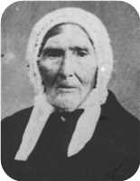
  Catharine Fraser
Marriages with George Ives and William Symptom (Page 11) are known.

Family of Catharine Fraser and George Ives
Here are the details about Catharine Fraser's first marriage, with George Ives. You can read more about Catharine on page 11.
Catharine Fraser married George Ives on Monday, October 26, 1795. They had eight children.  George was born about 1770. George reached 92 years of age and died on April 16, 1862.
  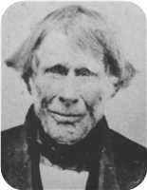
  George Ives

Family of Catharine Fraser and William Symptom
Here are the details about Catharine Fraser's second marriage, with William Symptom. You can read more about Catharine on page 11.
Catharine Fraser married William Symptom.

Family of Jane Fraser and James Fraser
3. 3rd greatgranmother Jane Fraser was born in 1779 in West River,Pictou Co.,Nova Scotia. She was the daughter of Charles Fraser (1) and Ann ?.
Jane died in West River on November 13, 1879, at the age of 100. She was buried in Durham Cemetery, N.S.
Jane married James Fraser on Monday, December 22, 1800. They had five children.
James was born in 1777. James reached 76 years of age and died in West River, Nova Scotia, on September 08, 1853.

Family of Christina Fraser and James McDougall
 |  |  |  |  |  |  |  |  |  |  |  |  |  |  |  |  | Charles |  |  |  |  |  |  |  | (unknown given name)
 |  |  |  |  |  |  |  |  |  |  |  |  |  |  |  |  | Fraser |  |  |  |  |  |  |  | Ann?
 |  |  |  |  |  |  |  |  |  |  |  |  |  |  |  |  | 1748–1811
 |  |  |  |  | James |  |  |  |  |  |  |  |  |  |  |  |  |  |  |  | Christina
 |  |  |  |  | McDougall |  |  |  |  |  |  |  |  |  |  |  |  |  |  |  | Fraser
 |  |  |  |  |  |  |  |  |  |  |  |  |  |  |  |  |  |  |  |  | 1790–1832
 |  |  |  |  |  |  |  |  | Married

4. Christina Fraser was born in 1790. She was the daughter of Charles Fraser (1) and (unknown given name) Ann?.
Christina died in 1832 at the age of 42.
She married James McDougall.

Family of Grace Fraser and William McDougall
 |  |  |  |  |  |  |  |  |  |  |  |  |  |  |  |  | Charles |  |  |  |  |  |  |  | (unknown given name)
 |  |  |  |  |  |  |  |  |  |  |  |  |  |  |  |  | Fraser |  |  |  |  |  |  |  | Ann?
 |  |  |  |  |  |  |  |  |  |  |  |  |  |  |  |  | 1748–1811
 |  |  |  |  | William |  |  |  |  |  |  |  |  |  |  |  |  |  |  |  | Grace
 |  |  |  |  | McDougall |  |  |  |  |  |  |  |  |  |  |  |  |  |  |  | Fraser
 |  |  |  |  | –1845
 |  |  |  |  |  |  |  |  | Married

5. Grace Fraser. She was the daughter of Charles Fraser (1) and (unknown given name) Ann?.
She married William McDougall. William died in 1845.

Family of Mary Fraser and John Mackay
 |  |  |  |  |  |  |  |  |  |  |  |  |  |  |  |  | Charles |  |  |  |  |  |  |  | (unknown given name)
 |  |  |  |  |  |  |  |  |  |  |  |  |  |  |  |  | Fraser |  |  |  |  |  |  |  | Ann?
 |  |  |  |  |  |  |  |  |  |  |  |  |  |  |  |  | 1748–1811
 |  |  |  |  | John |  |  |  |  |  |  |  |  |  |  |  |  |  |  |  | Mary
 |  |  |  |  | Mackay |  |  |  |  |  |  |  |  |  |  |  |  |  |  |  | Fraser
 |  |  |  |  |  |  |  |  | Married

6. Mary Fraser. She was the daughter of Charles Fraser (1) and (unknown given name) Ann?.
She married John Mackay.

2nd Generation

Family of Anna Ives and Matthew Patterson
John |  |  |  | Margaret |  |  |  | Matthew |  |  |  |  |  |  |  | John |  |  |  | ? |  |  |  | Charles |  |  |  | (unknown given name)
Patterson |  |  |  | Snodgrass |  |  |  | Harris |  |  |  |  |  |  |  | Ives |  |  |  | ? |  |  |  | Fraser |  |  |  | Ann?
1708– |  |  |  | 1710– |  |  |  | 1735–1829 |  |  |  |  |  |  |  | ca.1740–ca.1782 |  |  |  |  |  |  |  | 1748–1811
 | John |  |  |  |  |  |  |  | Ann |  |  |  |  |  |  |  | George |  |  |  |  |  |  |  | Catharine
 | Patterson |  |  |  |  |  |  |  | Harris |  |  |  |  |  |  |  | Ives |  |  |  |  |  |  |  | Fraser
 | 1748–1808 |  |  |  |  |  |  |  | ca.1766–1823 |  |  |  |  |  |  |  | ca.1770–1862 |  |  |  |  |  |  |  | 1778–1865
 |  |  |  |  |  |  |  |  |  |  |  |  |  |  |  |  | 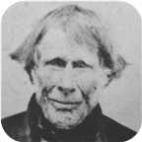
 |  |  |  |  | Matthew |  |  |  |  |  |  |  |  |  |  |  |  |  |  |  | Anna
 |  |  |  |  | Patterson |  |  |  |  |  |  |  |  |  |  |  |  |  |  |  | Ives
 |  |  |  |  | 1785–1858 |  |  |  |  |  |  |  |  |  |  |  |  |  |  |  | 1800–1878
 |  |  |  |  |  |  |  |  |  |  |  |  |  |  |  |  |  |  |  |  | 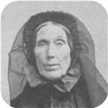
 |  |  |  |  |  |  |  |  | Marriage: 1843

7. Anna Ives was born on Thursday, December 11, 1800. She was the daughter of George Ives and Catharine Fraser (2).  Anna died on August 18, 1878, at the age of 77. She was buried in Laurel Hill Cemetery, Pictou, N.S.
  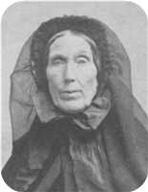
  Anna Ives
Anna married Matthew Patterson on Saturday, April 22, 1843. Matthew was born in 1785. He was the son of John Patterson and Ann Harris.
Matthew reached 73 years of age and died in Pictou, Nova Scotia, Canada, on April 13, 1858.

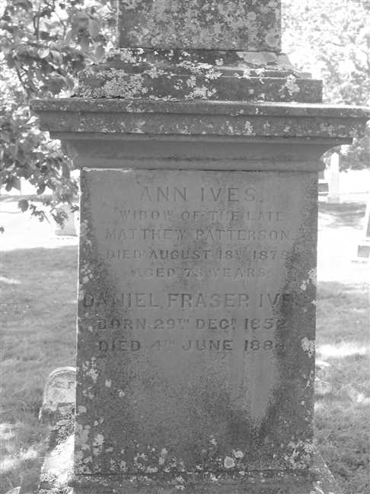  Figure 1: Grave Stone |  | 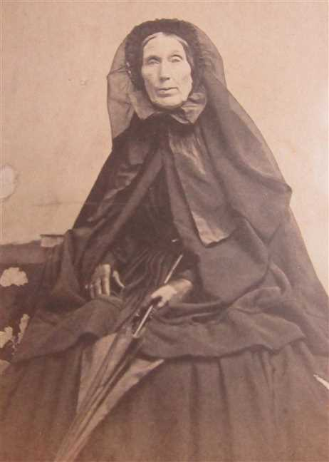  Figure 2: Ann Ives

Family of Jane Ives and Archibald Fraser
 |  |  |  |  |  |  |  |  |  |  |  |  |  |  |  | John |  |  |  | ? |  |  |  | Charles |  |  |  | (unknown given name)
 |  |  |  |  |  |  |  |  |  |  |  |  |  |  |  | Ives |  |  |  | ? |  |  |  | Fraser |  |  |  | Ann?
 |  |  |  |  |  |  |  |  |  |  |  |  |  |  |  | ca.1740–ca.1782 |  |  |  |  |  |  |  | 1748–1811
 |  |  |  |  |  |  |  |  |  |  |  |  |  |  |  |  | George |  |  |  |  |  |  |  | Catharine
 |  |  |  |  |  |  |  |  |  |  |  |  |  |  |  |  | Ives |  |  |  |  |  |  |  | Fraser
 |  |  |  |  |  |  |  |  |  |  |  |  |  |  |  |  | ca.1770–1862 |  |  |  |  |  |  |  | 1778–1865
 |  |  |  |  | Archibald |  |  |  |  |  |  |  |  |  |  |  |  |  |  |  | Jane
 |  |  |  |  | Fraser |  |  |  |  |  |  |  |  |  |  |  |  |  |  |  | Ives
 |  |  |  |  | 1801–1892 |  |  |  |  |  |  |  |  |  |  |  |  |  |  |  | 1806–1856
 |  |  |  |  |  |  |  |  | Marriage: 1833
 |  |  |  |  |  |  |  |  |  |  |  | Georgina |  |  |  | James Turner
 |  |  |  |  |  |  |  |  |  |  |  | Fraser |  |  |  | Fraser
 |  |  |  |  |  |  |  |  |  |  |  | 1839–1933 |  |  |  | 1842–
 |  |  |  |  |  |  |  |  |  |  |  | 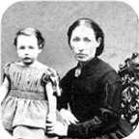

8. Jane Ives was born on Tuesday, January 07, 1806. She was the daughter of George Ives and Catharine Fraser (2).
Jane died on May 24, 1856, at the age of 50. She was buried in Greenwood Cemetery, Pictou Landing , NS.
It is not absolutely certain that this Jane Ives is a daughter of George Ives. However, she would be about the correct age and George inherited his Father's property at Fisher's Grant. This wedding was recorded in the Colonial Patriot - Tues. Aug. 13,1833. The paster was Rev. Lewis.
Jane Ives is listed as a student in the 1822-3 school year in the Fisher's Grant School taught be Hugh Dunbar (b.1792). William and Isabella Ives are also listed as students. Hugh Dunbar was later a minister in Sumerside P.E.I.
Jane married Archibald Fraser on Tuesday, August 06, 1833. They had two children.
Archibald was born in 1801. He reached 91 years of age and died in 1892.
Archibald Fraser was from the West River.
Children of Jane Ives and Archibald Fraser:
+ 14 f I. Georgina Fraser was born in Fisher's Grant, N.S., on June 18, 1839. She died in 1933 at the age of 93.
  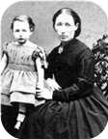
  Georgina
m II. James Turner Fraser was born on December 04, 1842.

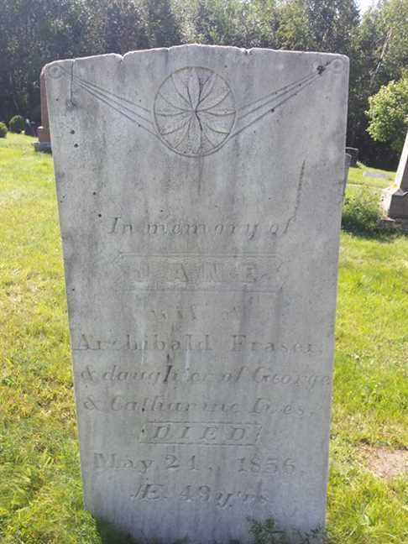
Figure 3: Jane Ives

Family of John Ives and Sarah Ives
John |  |  |  | ? |  |  |  | Charles |  |  |  | (unknown given name)
Ives |  |  |  | ? |  |  |  | Fraser |  |  |  | Ann?
ca.1740–ca.1782 |  |  |  |  |  |  |  | 1748–1811
 | George |  |  |  |  |  |  |  | Catharine
 | Ives |  |  |  |  |  |  |  | Fraser
 | ca.1770–1862 |  |  |  |  |  |  |  | 1778–1865
 |  |  |  |  | John Turner |  |  |  |  |  |  |  |  |  |  |  |  |  |  |  | Sarah Frances
 |  |  |  |  | Ives |  |  |  |  |  |  |  |  |  |  |  |  |  |  |  | Ives
 |  |  |  |  | 1804–1876
 |  |  |  |  | 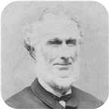
 |  |  |  |  |  |  |  |  | Marriage: 1840
 |  |  |  |  |  |  |  |  |  |  |  | James |  |  |  | Robert
 |  |  |  |  |  |  |  |  |  |  |  | Ives |  |  |  | Ives
 |  |  |  |  |  |  |  |  |  |  |  | ca.1824–1873 |  |  |  | 1842–
 |  |  |  |  |  |  |  |  |  |  |  | 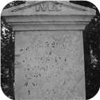

9. John Turner Ives was born in July 1804. He was the son of George Ives and Catharine Fraser (2).  John Turner was employed in Merchant. He died in Pictou,N.S., on April 04, 1876, at the age of 71. John Turner was buried in Haliburton Cemetery, Pictou.
  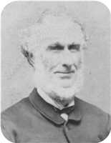
  John Turner Ives
MACDONALD, ALEXANDER C. (1849 - 1929)
BORN: Scotch Hill, Pictou County 27 January 1849
Commenced working as a Clerk with John T. Ives (General Merchants). After Ive’s death, he continued the business with Henry G. Ives, as John T. Ives & Company. Later he obtained, with his partner and F. D. Corbett of Halifax (firm of Corbett & Richardson, Commission Merchants), a controlling interest in the Logan Tannery Co., Lyons Brook, serving successfully as Manager, until the Tannery was destroyed by fire in 1911. Of late years, he spent much of his time in Florida.
Served on Town Council as was Mayor from 1901 - 1905 inclusive.
Married to Laura M. Farquarson - Died March 28/31.
Member of First Presbyterian Church.
Eastern Chronicle Apr.6,1876
April 4: Died - John T. Ives, Merchant & Shipbuilder, Pictou, age 72.
John Turner married Sarah Frances Ives on Thursday, February 13, 1840. They had two sons.
Sons of John Turner Ives and Sarah Frances Ives:
+ 15 m I. James Ives was born in Brule Point, Colchester Co.,N.S, about 1824. He died on January 12, 1873, at the age of 49.
  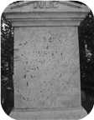
  James
+ 16 m II. Robert Ives was born in Brule Point, Colchester Co. NS, in 1842.

Family of William Ives and Christiana Fraser
John |  |  |  |  |  | ? |  |  |  |  |  | Charles |  |  |  |  |  | (unknown given name) |  |  |  |  |  |  |  |  |  |  |  |  |  |  |  |  |  | Roderick |  |  |  |  |  | Christiana
Ives |  |  |  |  |  | ? |  |  |  |  |  | Fraser |  |  |  |  |  | Ann? |  |  |  |  |  |  |  |  |  |  |  |  |  |  |  |  |  | MacKay |  |  |  |  |  | Grant
ca.1740–ca.1782 |  |  |  |  |  |  |  |  |  |  |  | 1748–1811 |  |  |  |  |  |  |  |  |  |  |  |  |  |  |  |  |  |  |  |  |  |  |  | 1746–1829 |  |  |  |  |  | 1752–1818
 |  | George |  |  |  |  |  |  |  |  |  |  |  | Catharine |  |  |  |  |  |  |  |  |  |  |  | Daniel |  |  |  |  |  |  |  |  |  |  |  | Catherine
 |  | Ives |  |  |  |  |  |  |  |  |  |  |  | Fraser |  |  |  |  |  |  |  |  |  |  |  | Fraser |  |  |  |  |  |  |  |  |  |  |  | MacKay
 |  | ca.1770–1862 |  |  |  |  |  |  |  |  |  |  |  | 1778–1865 |  |  |  |  |  |  |  |  |  |  |  | 1769–1850 |  |  |  |  |  |  |  |  |  |  |  | 1775–1864
 |  |  |  |  |  |  |  | William |  |  |  |  |  |  |  |  |  |  |  |  |  |  |  |  |  |  |  |  |  |  |  | Christiana Ann
 |  |  |  |  |  |  |  | Ives |  |  |  |  |  |  |  |  |  |  |  |  |  |  |  |  |  |  |  |  |  |  |  | Fraser
 |  |  |  |  |  |  |  | 1808–1880 |  |  |  |  |  |  |  |  |  |  |  |  |  |  |  |  |  |  |  |  |  |  |  | 1813–1900
 |  |  |  |  |  |  |  | 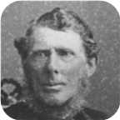 |  |  |  |  |  |  |  |  |  |  |  |  |  |  |  |  |  |  |  |  |  |  |  | 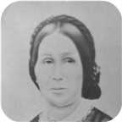
 |  |  |  |  |  |  |  |  |  |  |  |  |  | Marriage: 1840
 |  |  |  |  |  | George Daniel |  |  |  |  |  | Catherine Fraser |  |  |  |  |  | William Howard |  |  |  |  |  | Emma |  |  |  |  |  | Daniel Fraser
 |  |  |  |  |  | Ives |  |  |  |  |  | Ives |  |  |  |  |  | Ives |  |  |  |  |  | Ives |  |  |  |  |  | Ives
 |  |  |  |  |  | 1840– |  |  |  |  |  | 1843–1847 |  |  |  |  |  | 1846–1848 |  |  |  |  |  | 1850–1933 |  |  |  |  |  | 1852–1884
 |  |  |  |  |  | 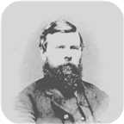 |  |  |  |  |  | 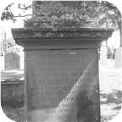 |  |  |  |  |  | 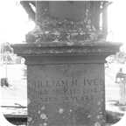 |  |  |  |  |  | 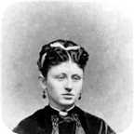
 |  |  |  |  |  |  |  |  | Charles William |  |  |  |  |  | John Robert |  |  |  |  |  | William |  |  |  |  |  | Infant Daughter |  |  |  |  |  | Arthur
 |  |  |  |  |  |  |  |  | Ives |  |  |  |  |  | Ives |  |  |  |  |  | Ives |  |  |  |  |  | Ives |  |  |  |  |  | Ives
 |  |  |  |  |  |  |  |  | 1841–1921 |  |  |  |  |  | 1845–1845 |  |  |  |  |  | ca.1849– |  |  |  |  |  | 1851–1851 |  |  |  |  |  | 1854–1913
 |  |  |  |  |  |  |  |  | 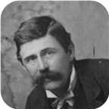 |  |  |  |  |  |  |  |  |  |  |  |  |  |  |  |  |  |  |  |  |  |  |  | 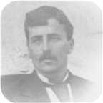

10. William Ives was born on Wednesday, April 27, 1808. He was the son of George Ives and Catharine Fraser (2).  William died on July 13, 1880, at the age of 72. He was buried in Laurel Hill Cemetery, Pictou, N.S.
  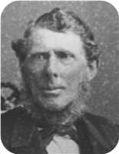
  William Ives
William Ives was a merchant in Pictou. He was the original owner of a photograph album which contained many of the old "Ives", "Fraser", "Rood", "Copeland" and "Robertson" photos contained in this Family Tree data base. It was passed to his granddaughter Louisa Reid Ives and finally to her grandson Allan James Robertson. A family bible owned by William is now at the McCulloch Center in Pictou, NS
William is listed as a 58 year old merchant in the 1871 Pictou County census.
The folowing is a record of a sale of land by William Ives to the British Government to be used as an Indian reservation. The property is located across the harbour from Pictou town.
Transcript of Treaty IT-282/IA-142, (1874)
Source of transcripts for the SchoolNet site:
Indian Treaties and Surrenders: From 1680 to 1890 Vol. I-II. (Ottawa: Brown Chamberlin [Queen's Printer], 1891)
No. 142.
This INDENTURE made this seventh day of December, in the year of Our
Lord one thousand eight hundred and seventy-four, between William Ives,
of the town and County of Pictou, in the Province of Nova Scotia merchant,
and Christianna Ives, his wife, of the one part, and Her Majesty Queen
Victoria, represented herein by the Minister of the Interior of the
Dominion of Canada, of the other part.
WHEREAS, Her said majesty Queen Victoria, represented as aforesaid,
has agreed with the said William Ives to purchase the lot of land
hereinafter described for the use and benefit of the Micmac Indians in the
County of Pictou aforesaid, for the price or sum hereinafter mentioned.
NOW THEREFORE, this Indenture witnesseth that the said William Ives
and Christianna Ives his wife, in consideration of the sum of one thousand
one hundred and fifty-seven dollars of lawful money of Canada to the said
William Ives, in hand well and truly paid by Her said Majesty, represented
herein as aforesaid, at or before the ensealing and delivery of these
presents, the receipt whereof is hereby acknowledged, have and each of
them hath granted, bargained, sold, aliened, enfeoffed, released, remised,
conveyed and confirmed, and by these presents do and each of them doth
grant, biargain, sell, alien, enfeoff, release, remise, convey and confirm
unto Her Majesty Queen Victoria, represented as aforesaid, Her heirs and
successors.
All that certain lot and piece of land situate, lying and being at Fisher's
Grant, in the said County of Pictou, and described as follows, that is to
say :-
Beginning on the north shore of Boat Harbour, at the south-east corner
of lands owned by James G. Sproull, and running thence north thirty-seven
degrees forty-five minutes west by the magnet of June, 1873, along the
east line of said Sproull's land seventy-four chains, thence north fifty-
two degrees fifteen minutes east by the magnet aforesaid, along the south
line of lands owned by the said William Ives, eleven chains and thirty-five
links to the west line of Edwin Sproull's land, thence south thirty-
seven degrees and forty-five minutes east by the magnet aforesaid, along
the last mentioned line and west line of lands owned by James G. Sproull
aforesaid and William Powell the elder sixty-one chains and eighty-five
links to the waters of Boat Harbour aforesaid, thence south-
eastwardly,southwardly and westwardly, and by the various courses of
the shore of said Boat Harbour to the place of beginning, containing
eighty-nine acres, more or less.
Together with all and singular the houses, outhouses, barns, buildings,
ways, waters, watercourses, easements, privileges and appurtenances to
the same, belonging or in any wise appertaining, and the reversion and
reversions, remainder and remainders, rents, issues and profits thereof,
and also all the estate, right, title, interest, claim, property and demand,
both at law and in equity of them, the said William Ives and Christianna
Ives, his wife, of, in, to or out of the same or any part thereof to have and
to hold the said land and premises with the appurtenances and every part
thereof unto Her said Majesty Queen Victoria, represented as aforesaid,
Her heirs and successor, to Her and their sole use, benefit, and behoof
forever.
And the said William Ives doth hereby for himself, his heirs, executors
and administrators, grant, covenant, promise, and agree to and with Her
said Majesty Queen Victoria, represented as aforesaid, Her heirs and
successors, in manner following, that is to say :
That it shall and maybe lawful for Her said Majesty, represented as
aforesaid, Her heirs and successors, from time to time and at all times
hereafter, peaceably and quietly to enter into the said land and premises,
and to have, hold, occupy, posses and enjoy the same without the lawful
let; suit, hindrance, eviction, denial or disturbance of, from or by the said
William Ives or Christianiia Ives, his wife, or any person or persons
whomsoever lawfully claiming or to claim the same.
And also, that the said William Ives and Christianna Ives, his wife, or
one of them, have a good, sure, perfect and indefeasible estate of
inheritance in fee simple in the said land and premises, and have good
right, full power and lawful authority to sell and convey the same in
manner and form as they are hereby sold and conveyed or mentioned, or
intended so to be.
And lastly, that the said William Ives and his heirs, the said land and
premises, and every part thereof, unto Her said Majesty Queen Victoria,
represented as aforesaid, Her heirs and successors, against the lawful
claims of all persons whomsoever, shall and will by these presents
warrant and forever defend :
IN WITNESS WHEREOF, the parties to these presents have hereto their
hands and seals set and affixed on the day and year first above written.
Signed, sealed and delivered
in presence of WILLIAM IVES. [L.S.]
DANIEL F. IVES, CHRISTIANNA IVES [L.S.]
G.H. ELLIOT.
PROVINCE OF NOVA SCOTIA,
HALIFAX, S.S.
Be it remembered that on this seventh day of December, one thousand
eight hundred and seventy-four, before me the subscriber personally
came and appeared Christianna Ives, wife of William Ives, mentioned in
the foregoing Indenture, who having been by me examined separate and
apart from her said husband, did declare and acknowledge that she
executed the said Indenture as and for her act and deed without fear,
threat or compulsion, of, from or by her said husband, and for a full
release of all her claims to the land therein described.
G. H. ELLIOT,
Barrister and Notary Public.
Recorded 3rd March, l875.
Lib. S. Folio. 217.
R. W. SCOTT,
Secretary of State and Registrar General of Canada.
--------------------------------------------------------------------------------
--------------------------------------------------------------------------------
William Ives is listed as a student in the 1822-3 school year in the Fisher's Grant School taught be Hugh Dunbar (b.1792). Hugh Dunbar was later a minister in Sumerside P.E.I.
At the age of 31, William married Christiana Ann Fraser on Thursday, February 13, 1840, when she was 26 years old. They had ten children.  Christiana Ann was born on Monday, April 12, 1813. She was the daughter of Daniel Fraser and Catherine MacKay.
  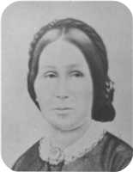
  Christiana Ann Fraser
Christiana Ann reached 86 years of age and died on March 19, 1900. She was buried in Laurel Hill Cemetery.
Description Will of Christiana Ives of Pictou, NS
(Handwritten)
Will of Christiana Ives, deceased
Certified Copy for Reg of Deeds
I Christiana Ives of Pictou in the County of Pictou Widow of William Ives late of Pictou aforesaid Merchant deceased do hereby make publish and declare this to be my last will and testament hereby revoking all wills at by me any time heretofore made.
I appoint my son George D Ives and Frederick W Fraser Druggist of said Pictou to be the executors and trustees of this my Will
I give devise and bequeath to Maggie Ives wife of my son Charles W Ives the bill of Sale or chattel Mortgage filed in the Registry of Deeds for Pictou County on or about the 16th day of February AD 1884 and made by the said Charles W Ives as Grantor to me as grantee, the money due me thereon, the household furniture and other property therein described or conveyed and I also give to said Maggie Ives all other my household furniture now in her possession or that of her late husband Charles W Ives
I also give devise and bequeath to said Maggie Ives all my case of Silver ware (except the tea Service herein after mentioned) now in her possession
I give and bequeath to my daughter Emma Harris my writing desk and Silver tea Service
I give and bcqueath to Ocenia Ives wife of my son Arthur Ives all my household furniture now in the farm house on the south side of the West River Road wherein they reside
I give and bequeath to Christiana daughter of the said Arthur my share in the Merchant's Bank Halifax Capital Stock now held by me
I give devise and bequeath all my real and personal estate not hereinbefore of unto my said executors and trustees in trust that they may my said executors and trustees shall see call in and convert into money the same or such part thereof as shall not consist of money and shall with and out of the previous produced by such sale calling in and Conversion and with and out of my ready money pay my funeral and Testamentary expenses and
debts and shall stand possessed of the residue or remainder upon the trusts following viz to pay the following legacies
I To pay my son William H Ives the Sum of one thousand five hundred dollars
2 To pay my son George D Ives the Sum of Six hundred dollars
3 To pay my Grandson Fred Ives son of George D Ives the sum of one hundred dollars
4 To pay Willie and Christiana Ives the children of my son Charles W Ives the Sum of fifty dollars each
5 To pay to Daniel Fraser, Lewis and Louisa children of my son Arthur Ives the Sum of fifty dollars each
6 To pay to Daniel F Harris and Christiana Harris children of my daughter Emma Harris the Sum of fifty dollars each
If any residue and monies be their remaining I will and direct that they shall be equally divided between the respective wives of my son George D Charles W and Arthur Ives and my daughter Emma Harris to each an equal share
It is also my will and hereby expressly declare and direct that the foregoing devises and bequests are respectively intended to be and shall be construed to be in full satisfaction and discharge of any debts or debt which at the time of my death may be owing by me to such respective deviser or legatees or the husband or wife of such respective deviser or legatee whether such legacy or devise shall be less or more in value or amount than the debts owning or claimed
I do will and direct that should any of the legatees under this my will or the husband or wife of such legatees after my death commence any legal proceedings against my executors or estate for the recovery of any alleged just debtedness that hereupon all legacies and bequests hereinbefore made to such legatee or the husband or wife of the person commencing such proceedings shall lapse determine and become forfeit null and void
In Witness Whereof I have hereunto set my hand to this my will the tenth day of July
Signed Christiana Ives L.S.
Signed by the within named Christiana Ives as her last Will and Testament in the presence of us who in her presence and in the presence of each other have hereunto subscribed our names as witnesses.
Signed Bessie A Ross
Signed Jno W Ross
County of Pictou S.S.
In the Court of Probate of Wills
I John D. McLeod Registrar of said Court do hereby certify that the foregoing paper writing is a correct copy of the last Will and Testament of Christiana Ives late of West River Road in the County of Pictou Widow deceased which said will was duly admitted to Probate in said Court at Pictou on the llth day of June 1900.
Given under my hand at Pictou aforesaid this 10th.day of June 1900.
John D. MacLeod Registrar
Stamp
PROVINCE OF NOVA SCOTIA, REGISTRAR OF DEEDS
Office, County of Pictou, AUG 14 1900 I certify that the within instrument was duly registered at 11 AM of the above day in Book 3, page 255 - 257 on the certificate of John D. MacLeod Reg
John Yorstor. Registrar
Children of William Ives and Christiana Ann Fraser:
+ 17 m I. George Daniel Ives was born on November 11, 1840.
  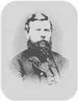
  George
+ 18 m II. Charles William Ives was born on February 09, 1841. He died in 1921 at the age of 79.
  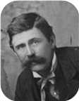
  Charles
f III. Catherine Fraser Ives was born on August 01, 1843. She died on April 08, 1847, at the age of 3. Catherine Fraser was buried in Laurel Hill Cemetery.
  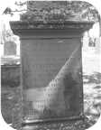
  Catherine
m IV. John Robert Ives was born on February 24, 1845. He died on December 12, 1845. John Robert was buried in Laurel Hill Cemetery.
m V. William Howard Ives was born on November 01, 1846. He died on January 22, 1848, at the age of 1. William Howard was buried in Laurel Hill Cemetery.
  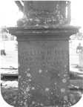
  William
m VI. William Ives was born about 1849.
+ 19 f VII. Emma Ives was born on April 09, 1850. She died on July 26, 1933, at the age of 83.
  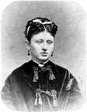
  Emma
f VIII. Infant Daughter Ives was born on August 08, 1851. She died on August 18, 1851. Infant Daughter was buried in Laurel Hill Cemetery.
m IX. Daniel Fraser Ives was born on December 29, 1852. He died on June 04, 1884, at the age of 31. Daniel Fraser was buried in Laurel Hill Cemetery.
+ 20 m X. Arthur Ives was born on March 03, 1854. He died on June 30, 1913, at the age of 59.
  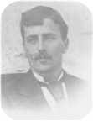
  Arthur

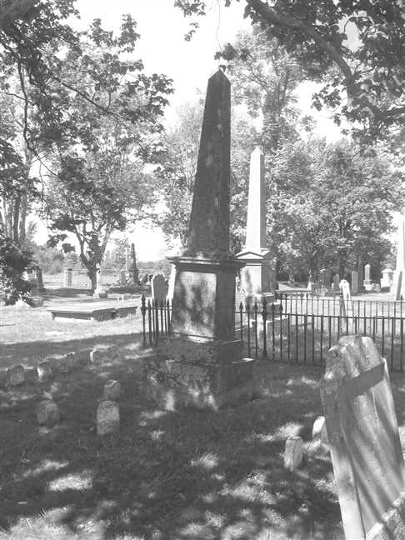  Figure 4: Grave Stone |  | 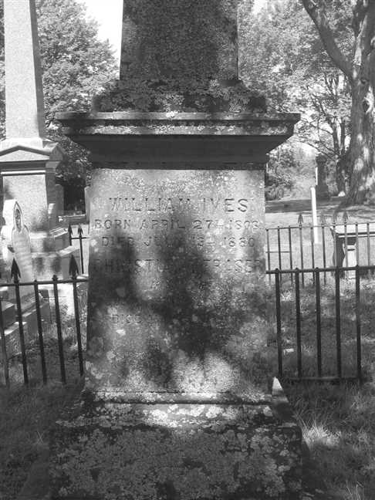  Figure 5: Grave Stone

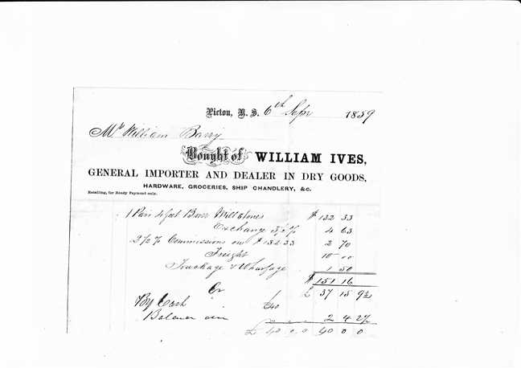  Figure 6: William Ives.Invoice.1859.Russel Maclean.Apr.2019 |  | 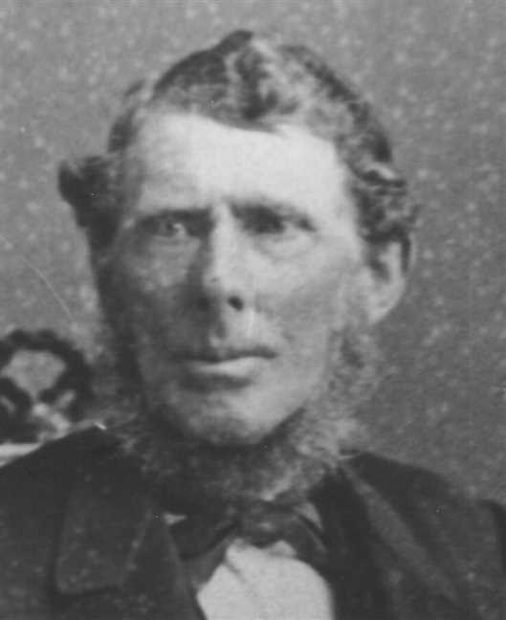  Figure 7: William Ives

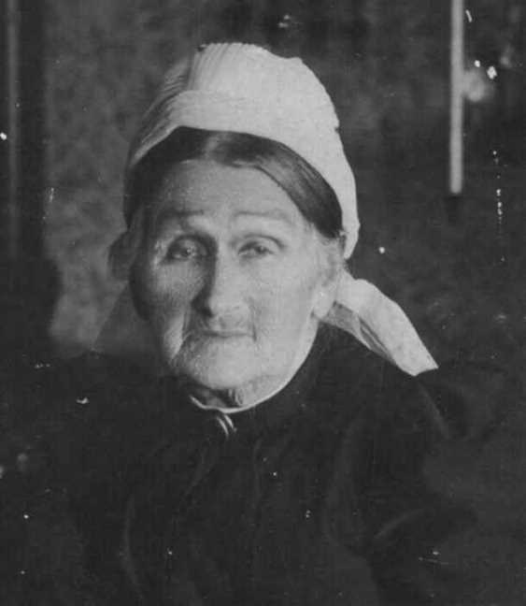
Figure 8: Christina Ann Fraser

Family of John Fraser and Annie Robertson
Hugh |  |  |  |  |  | Magdalen |  |  |  |  |  | Charles |  |  |  |  |  | Ann |  |  |  |  |  | John |  |  |  |  |  | Margaret |  |  |  |  |  | Colin |  |  |  |  |  | Isabella
Fraser |  |  |  |  |  | MacKenzie |  |  |  |  |  | Fraser |  |  |  |  |  | ? |  |  |  |  |  | Robertson |  |  |  |  |  | MacKay |  |  |  |  |  | Mackenzie |  |  |  |  |  | MacKenzie
1744–1803 |  |  |  |  |  | 1749–1826 |  |  |  |  |  | 1748–1811 |  |  |  |  |  |  |  |  |  |  |  | ca.1729–1818 |  |  |  |  |  | ca.1732–1825 |  |  |  |  |  | 1721–1825
 |  |  |  |  |  |  |  |  |  |  |  |  |  |  |  |  |  |  |  |  |  |  |  | 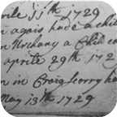 |  |  |  |  |  | 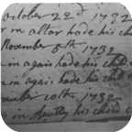
 |  | James |  |  |  |  |  |  |  |  |  |  |  | Jane |  |  |  |  |  |  |  |  |  |  |  | William |  |  |  |  |  |  |  |  |  |  |  | Christina
 |  | Fraser |  |  |  |  |  |  |  |  |  |  |  | Fraser |  |  |  |  |  |  |  |  |  |  |  | Robertson |  |  |  |  |  |  |  |  |  |  |  | MacKenzie
 |  | 1777–1853 |  |  |  |  |  |  |  |  |  |  |  | 1779–1879 |  |  |  |  |  |  |  |  |  |  |  | 1769–1848 |  |  |  |  |  |  |  |  |  |  |  | 1780–1832
 |  |  |  |  |  |  |  |  |  |  |  |  |  |  |  |  |  |  |  |  |  |  |  |  |  | 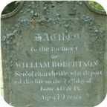 |  |  |  |  |  |  |  |  |  |  |  | 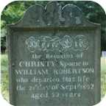
 |  |  |  |  |  |  |  | John |  |  |  |  |  |  |  |  |  |  |  |  |  |  |  |  |  |  |  |  |  |  |  | Annie
 |  |  |  |  |  |  |  | Fraser |  |  |  |  |  |  |  |  |  |  |  |  |  |  |  |  |  |  |  |  |  |  |  | Robertson
 |  |  |  |  |  |  |  | 1808–1894 |  |  |  |  |  |  |  |  |  |  |  |  |  |  |  |  |  |  |  |  |  |  |  | 1818–1909
 |  |  |  |  |  |  |  | 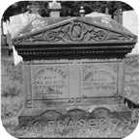 |  |  |  |  |  |  |  |  |  |  |  |  |  |  |  |  |  |  |  |  |  |  |  | 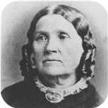
 |  |  |  |  |  |  |  |  |  |  |  |  |  | Marriage: 1846
 |  |  | Ocenia |  |  |  |  |  | James William |  |  |  |  |  | Mary Jane |  |  |  |  |  | Anna |  |  |  |  |  | Jessie |  |  |  |  |  | Alice |  |  |  |  |  | John T Ives
 |  |  | Fraser |  |  |  |  |  | Fraser |  |  |  |  |  | Fraser |  |  |  |  |  | Fraser |  |  |  |  |  | Fraser |  |  |  |  |  | Fraser |  |  |  |  |  | Fraser
 |  |  | 1853–1935 |  |  |  |  |  | 1848–1882 |  |  |  |  |  | 1850–1940 |  |  |  |  |  | ca.1852– |  |  |  |  |  | 1855–1947 |  |  |  |  |  | ca.1857– |  |  |  |  |  | 1861–1863
 |  |  | 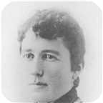 |  |  |  |  |  | 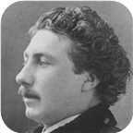 |  |  |  |  |  | 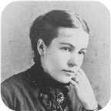 |  |  |  |  |  | 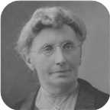 |  |  |  |  |  | 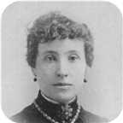 |  |  |  |  |  | 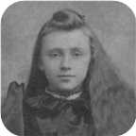 |  |  |  |  |  | 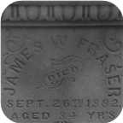

11. John Fraser was born in 1808 in West River,Pictou Co.,Nova Scotia. He was the son of James Fraser and Jane Fraser (3).  John died in New Glasgow on February 13, 1894, at the age of 86. He was buried in Durham Cemetery, N.S.
  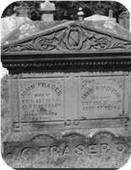
  John Fraser
John Fraser - spouse of Annie Robertson - was at one time the operator of "The Twelve Mile House" along the West River. The inn - a stage coach stop bteween Truro and Pictou - was originally built in 1838. In 1860, the future King Edward V - then Prince of Wales - stopped there on his way from Truro to Pictou. The old inn has long since been torn down but the front door was salvaged by Clifford Rose from the then owner - Arthur MacLeod of Saltsprings. It was placed in the Pioneer Museum of Pictou County at Green Hill Look-off.
At the age of 38, John married Annie Robertson on Thursday, February 05, 1846, in New Glasgow, Nova Scotia (home of Alex. Fraser), when she was 27 years old. They had seven children.  Annie was born on Friday, July 10, 1818. She was the daughter of William Robertson and Christina MacKenzie.
  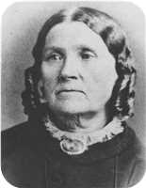
  Annie Robertson
Annie reached 91 years of age and died in New Glasgow,Nova Scotia, on December 17, 1909. She was buried in Durham Cemetery, N.S.
John Fraser - spouse of Annie Robertson - was at one time the operator of "The Twelve Mile House" along the West River. The inn - a stage coach stop bteween Truro and Pictou - was originally built in 1838. In 1860, the future King Edward V - then Prince of Wales - stopped there on his way from Truro to Pictou. The old inn has long since been torn down but the front door was salvaged by Clifford Rose from the then owner - Arthur MacLeod of Saltsprings. It was placed in the Pioneer Museum of Pictou County at Green Hill Look-off.
Children of John Fraser and Annie Robertson:
+ 21 f I. Ocenia Fraser was born in 1853. She died on March 19, 1935, at the age of 82.
  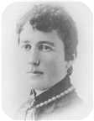
  Ocenia
+ 22 m II. James William Fraser was born in 1848. He died on September 26, 1882, at the age of 34.
  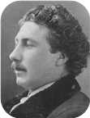
  James
f III. Mary Jane Fraser was born on August 18, 1850. She died in Durham, Nova Scotia, on April 19, 1940, at the age of 89.
  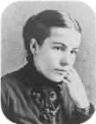
  Mary
+ 23 f IV. Anna Fraser was born about 1852.
  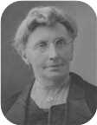
  Anna
+ 24 f V. Jessie Fraser was born in Twelve Mile House,West River,Pictou Co.,N.S., on December 30, 1855.
  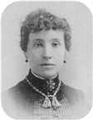
  Jessie
She died in New Glasgow,Nova Scotia, on November 23, 1947, at the age of 91.
+ 25 f VI. Alice Fraser was born about 1857.
  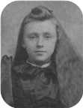
  Alice
m VII. John T Ives Fraser was born in September 1861. He died on February 03, 1863, at the age of 1.
  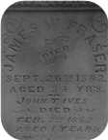
  John

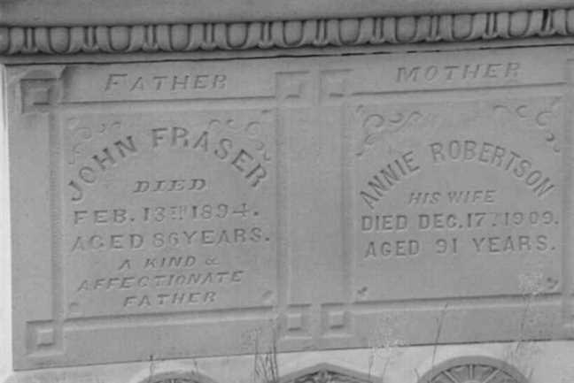  Figure 9: John Fraser Grave Marker |  | Figure 10: Annie Robertson Grave Marker

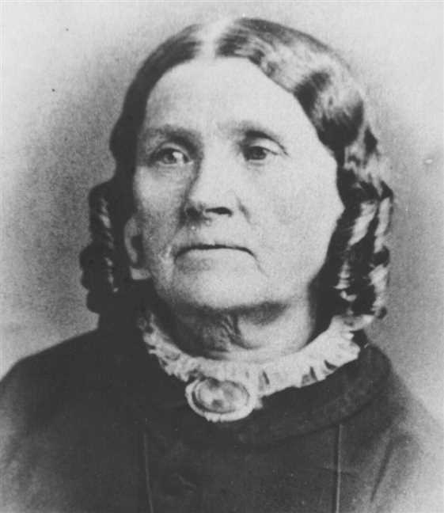
Figure 11: Annie Robertson

? Fraser
Hugh |  |  |  |  |  | Magdalen |  |  |  |  |  | Charles |  |  |  |  |  | Ann
Fraser |  |  |  |  |  | MacKenzie |  |  |  |  |  | Fraser |  |  |  |  |  | ?
1744–1803 |  |  |  |  |  | 1749–1826 |  |  |  |  |  | 1748–1811
 |  | James |  |  |  |  |  |  |  |  |  |  |  | Jane
 |  | Fraser |  |  |  |  |  |  |  |  |  |  |  | Fraser
 |  | 1777–1853 |  |  |  |  |  |  |  |  |  |  |  | 1779–1879
 |  |  |  |  |  |  |  | ?
 |  |  |  |  |  |  |  | Fraser
 |  |  |  |  |  |  |  |  |  |  |  |  |  |  |  |  |  |  |  |  | John J
 |  |  |  |  |  |  |  |  |  |  |  |  |  |  |  |  |  |  |  |  | Fraser
 |  |  |  |  |  |  |  |  |  |  |  |  |  |  |  |  |  |  |  |  | 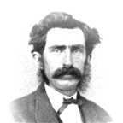

12. ? Fraser. He was the son of James Fraser and Jane Fraser (3).
Son of ? Fraser:
m I. John J Fraser.
  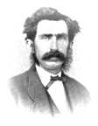
  John

Family of William Fraser and Jessie Matheson
Hugh |  |  |  | Magdalen |  |  |  | Charles |  |  |  | Ann
Fraser |  |  |  | MacKenzie |  |  |  | Fraser |  |  |  | ?
1744–1803 |  |  |  | 1749–1826 |  |  |  | 1748–1811
 | James |  |  |  |  |  |  |  | Jane |  |  |  |  |  |  |  | William
 | Fraser |  |  |  |  |  |  |  | Fraser |  |  |  |  |  |  |  | Matheson
 | 1777–1853 |  |  |  |  |  |  |  | 1779–1879
 |  |  |  |  | William J |  |  |  |  |  |  |  |  |  |  |  |  |  |  |  | Jessie
 |  |  |  |  | Fraser |  |  |  |  |  |  |  |  |  |  |  |  |  |  |  | Matheson
 |  |  |  |  | 1816–1914 |  |  |  |  |  |  |  |  |  |  |  |  |  |  |  | –1902
 |  |  |  |  |  |  |  |  | Married

13. William J Fraser was born in 1816. He was the son of James Fraser and Jane Fraser (3).
William J died in 1914 at the age of 98.
He married Jessie Matheson. She was the daughter of William Matheson.
Jessie died in October 1902.

3rd Generation

Family of Georgina Fraser and Joseph Graham
Thomas |  |  |  | Elizabeth |  |  |  |  |  |  |  |  |  |  |  |  |  |  |  |  |  |  |  | George |  |  |  | Catharine
Graham |  |  |  | Grant |  |  |  |  |  |  |  |  |  |  |  |  |  |  |  |  |  |  |  | Ives |  |  |  | Fraser
1776–1839 |  |  |  | 1771– |  |  |  |  |  |  |  |  |  |  |  |  |  |  |  |  |  |  |  | ca.1770–1862 |  |  |  | 1778–1865
 | Thomas |  |  |  |  |  |  |  | Mary |  |  |  |  |  |  |  | Archibald |  |  |  |  |  |  |  | Jane
 | Graham |  |  |  |  |  |  |  | McLellan |  |  |  |  |  |  |  | Fraser |  |  |  |  |  |  |  | Ives
 | 1807–1864 |  |  |  |  |  |  |  | 1807–1892 |  |  |  |  |  |  |  | 1801–1892 |  |  |  |  |  |  |  | 1806–1856
 |  |  |  |  | Joseph Cunard |  |  |  |  |  |  |  |  |  |  |  |  |  |  |  | Georgina
 |  |  |  |  | Graham |  |  |  |  |  |  |  |  |  |  |  |  |  |  |  | Fraser
 |  |  |  |  | 1836–1917 |  |  |  |  |  |  |  |  |  |  |  |  |  |  |  | 1839–1933
 |  |  |  |  | 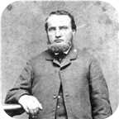
 |  |  |  |  |  |  |  |  | Married
 |  |  |  |  |  |  |  |  |  |  |  | John T |  |  |  | Charles Archibald
 |  |  |  |  |  |  |  |  |  |  |  | Graham |  |  |  | Graham
 |  |  |  |  |  |  |  |  |  |  |  | 1866–1867 |  |  |  | 1863–1882

14. Georgina Fraser was born on Tuesday, June 18, 1839, in Fisher's Grant, N.S. She was the daughter of Archibald Fraser and Jane Ives (8).  Georgina died in 1933 at the age of 93.
  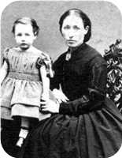
  Georgina Fraser
She married Capt. Joseph Cunard Graham. They had two sons.  Joseph Cunard was born in New Glasgow,N.S., in 1836. He was the son of Thomas Graham and Mary McLellan.  Joseph Cunard reached 81 years of age and died in New Glasgow in 1917.
  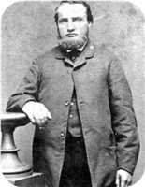
  Joseph Cunard Graham
Capt. Joe Graham had his masters ticket and skippered his first ship across the Pacific Ocean before he was twenty-one. In later life, he built or shared in the building of the sailing ships "Tana", "Cabot", "Lochael" and the "Minnie Gordon".
Sons of Georgina Fraser and Joseph Cunard Graham:
m I. John T Graham was born in 1866. He died on September 12, 1867, at the age of 1.
m II. Charles Archibald Graham was born in 1863. He died in Pugwash on November 11, 1882, at the age of 19.
  Charles

Family of James Ives and Fanny Ives
George |  |  |  | Catharine
Ives |  |  |  | Fraser
ca.1770–1862 |  |  |  | 1778–1865
 | John Turner |  |  |  |  |  |  |  | Sarah Frances |  |  |  |  |  |  |  | James
 | Ives |  |  |  |  |  |  |  | Ives |  |  |  |  |  |  |  | Ives
 | 1804–1876 |  |  |  |  |  |  |  |  |  |  |  |  |  |  |  | ca.1790–
 |  |  |  |  | James |  |  |  |  |  |  |  |  |  |  |  |  |  |  |  | Fanny Black
 |  |  |  |  | Ives |  |  |  |  |  |  |  |  |  |  |  |  |  |  |  | Ives
 |  |  |  |  | ca.1824–1873 |  |  |  |  |  |  |  |  |  |  |  |  |  |  |  | 1828–1874
 |  |  |  |  |  |  |  |  | Marriage: 1853
John Clift |  |  |  | William |  |  |  | Sarah Frances |  |  |  | Lewis N |  |  |  | Henry G |  |  |  | Welsford B |  |  |  | Alfred J |  |  |  | Edith Lillian
Ives |  |  |  | Ives |  |  |  | Ives |  |  |  | Ives |  |  |  | Ives |  |  |  | Ives |  |  |  | Ives |  |  |  | Ives
ca.1853–1858 |  |  |  | ca.1855–1857 |  |  |  | 1856– |  |  |  | ca.1858–1895 |  |  |  | 1858– |  |  |  | ca.1861–1929 |  |  |  | 1862–1883 |  |  |  | 1867–
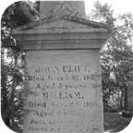 |  |  |  |  |  |  |  |  |  |  |  | 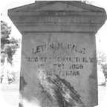 |  |  |  |  |  |  |  |  |  |  |  | 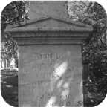

15. James Ives was born about 1824 in Brule Point, Colchester Co.,N.S. He was the son of John Turner Ives (9) and Sarah Frances Ives.  James died on January 12, 1873, at the age of 49. He was buried in Haliburton Cemetery, Pictou,N.S.
  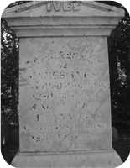
  James Ives
James married Fanny Black Ives in 1853. They had eight children.
Fanny Black was born in Halifax,NS, in 1828. She was the daughter of James Ives.
Fanny Black reached 46 years of age and died on September 05, 1874. She was buried in Haliburton Cemetery, Pictou,N.S.
Children of James Ives and Fanny Black Ives:
m I. John Clift Ives was born about 1853. He died on March 31, 1858, at the age of 5. John Clift was buried in Haliburton Cemetery.
  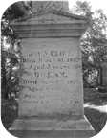
  John
m II. William Ives was born about 1855. He died on September 26, 1857, at the age of 2. William was buried in Haliburton Cemetery.
+ 26 f III. Sarah Frances Ives was born on January 13, 1856.
m IV. Lewis N Ives was born about 1858. He died in Brooklyn,NY, on September 14, 1895, at the age of 37. Lewis N was buried in Haliburton Cemetery, Pictou,N.S.
  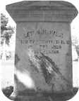
  Lewis
+ 27 m V. Henry G Ives was born in 1858.
m VI. Welsford B Ives was born about 1861. He died on March 06, 1929, at the age of 68. Welsford B was buried in Haliburton Cemetery.
m VII. Alfred J Ives was born in 1862. He died in Amherst,N.S, on July 02, 1883, at the age of 21. Alfred J was buried in Haliburton Cemetery, Pictou,N.S.
  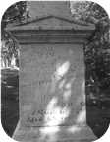
  Alfred
+ 28 f VIII. Edith Lillian Ives was born in 1867.

Family of Robert Ives and Grace McLeod
George |  |  |  | Catharine
Ives |  |  |  | Fraser
ca.1770–1862 |  |  |  | 1778–1865
 | John Turner |  |  |  |  |  |  |  | Sarah Frances
 | Ives |  |  |  |  |  |  |  | Ives
 | 1804–1876
 |  |  |  |  | Robert |  |  |  |  |  |  |  |  |  |  |  |  |  |  |  | Grace
 |  |  |  |  | Ives |  |  |  |  |  |  |  |  |  |  |  |  |  |  |  | McLeod
 |  |  |  |  | 1842– |  |  |  |  |  |  |  |  |  |  |  |  |  |  |  | 1858–
 |  |  |  |  |  |  |  |  | Married
 |  |  |  |  |  |  |  |  |  |  |  | Alexander William |  |  |  | James
 |  |  |  |  |  |  |  |  |  |  |  | Ives |  |  |  | Ives
 |  |  |  |  |  |  |  |  |  |  |  | 1879– |  |  |  | 1881–

16. Robert Ives was born in 1842 in Brule Point, Colchester Co. NS. He was the son of John Turner Ives (9) and Sarah Frances Ives.
He married Grace McLeod. They had two sons.
Grace was born in 1858.
Sons of Robert Ives and Grace McLeod:
+ 29 m I. Alexander William Ives was born in 1879.
m II. James Ives was born in 1881.

Family of George Ives and Amelia McLeod
George |  |  |  |  |  | Catharine |  |  |  |  |  | Daniel |  |  |  |  |  | Catherine
Ives |  |  |  |  |  | Fraser |  |  |  |  |  | Fraser |  |  |  |  |  | MacKay
ca.1770–1862 |  |  |  |  |  | 1778–1865 |  |  |  |  |  | 1769–1850 |  |  |  |  |  | 1775–1864
 |  | William |  |  |  |  |  |  |  |  |  |  |  | Christiana Ann |  |  |  |  |  |  |  |  |  |  |  | James
 |  | Ives |  |  |  |  |  |  |  |  |  |  |  | Fraser |  |  |  |  |  |  |  |  |  |  |  | McLeod
 |  | 1808–1880 |  |  |  |  |  |  |  |  |  |  |  | 1813–1900
 |  |  |  |  |  |  |  | George Daniel |  |  |  |  |  |  |  |  |  |  |  |  |  |  |  |  |  |  |  |  |  |  |  | Amelia
 |  |  |  |  |  |  |  | Ives |  |  |  |  |  |  |  |  |  |  |  |  |  |  |  |  |  |  |  |  |  |  |  | McLeod
 |  |  |  |  |  |  |  | 1840–
 |  |  |  |  |  |  |  |  |  |  |  |  |  |  |  |  |  |  |  |  |  |  |  |  |  |  |  |  |  |  |  | 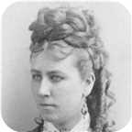
 |  |  |  |  |  |  |  |  |  |  |  |  |  | Married
 |  |  |  |  |  |  |  |  |  |  |  |  |  |  | Frederick George |  |  |  |  |  | William |  |  |  |  |  | Jane Oxley
 |  |  |  |  |  |  |  |  |  |  |  |  |  |  | Ives |  |  |  |  |  | Ives |  |  |  |  |  | Ives
 |  |  |  |  |  |  |  |  |  |  |  |  |  |  | ca.1876–1915 |  |  |  |  |  | 1874–1875 |  |  |  |  |  | 1875–1875
 |  |  |  |  |  |  |  |  |  |  |  |  |  |  | 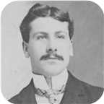

17. George Daniel Ives was born on Wednesday, November 11, 1840. He was the son of William Ives (10) and Christiana Ann Fraser.
  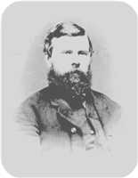
  George Daniel Ives
George Ives is listed as a 30 year old merchant in the 1871 Pictou County census.
He married Amelia McLeod. They had three children. She was the daughter of James McLeod.
  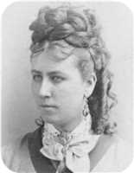
  Amelia McLeod
Children of George Daniel Ives and Amelia McLeod:
+ 30 m I. Frederick George Ives was born about 1876. He died on February 27, 1915, at the age of 39.
  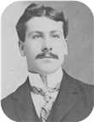
  Frederick
m II. William Ives was born in February 1874. He died on October 09, 1875, at the age of 1.
f III. Jane Oxley Ives was born on April 02, 1875. She died on September 25, 1875.

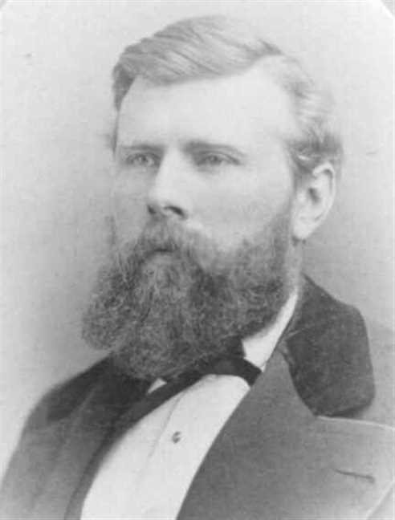  Figure 12: George Daniel Ives |  | 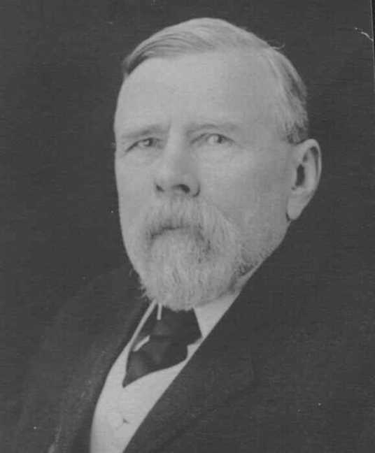  Figure 13: George Daniel Ives

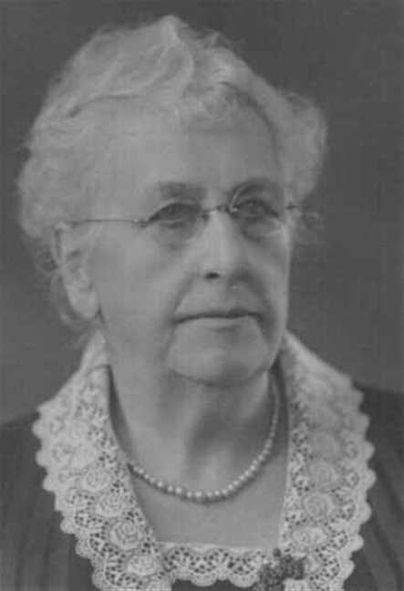
Figure 14: Amelia McLeod

Charles Ives
18. Charles William Ives was born on Tuesday, February 09, 1841. He was the son of William Ives (10) and Christiana Ann Fraser.  Charles William died in 1921 at the age of 79. He was buried in Haliburton, Pictou,N.S.
  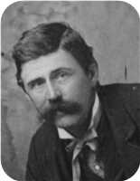
  Charles William Ives
Charles Ives is listed as a 29 year old merchant in the 1871 Pictou County census.
Eastern Chronicle June 14,1877
June 7: Married - Charles Ives, Esq., to Maggie, youngest daughter
of R. S. Copeland, Esq., M.P.P., of Merigomish, at the residence of the
bride's brother, by Rev. H. McDonald Scott, B.D.
Marriages with Anna McPhail and Margaret Maggie Copeland (Page 38) are known.

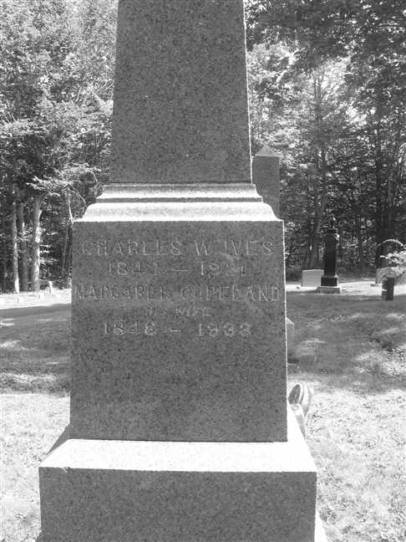
Figure 15: Grave Stone

Family of Charles Ives and Anna McPhail
George |  |  |  | Catharine |  |  |  | Daniel |  |  |  | Catherine
Ives |  |  |  | Fraser |  |  |  | Fraser |  |  |  | MacKay
ca.1770–1862 |  |  |  | 1778–1865 |  |  |  | 1769–1850 |  |  |  | 1775–1864
 | William |  |  |  |  |  |  |  | Christiana Ann |  |  |  |  |  |  |  | Alexander
 | Ives |  |  |  |  |  |  |  | Fraser |  |  |  |  |  |  |  | McPhail
 | 1808–1880 |  |  |  |  |  |  |  | 1813–1900
 |  |  |  |  | Charles William |  |  |  |  |  |  |  |  |  |  |  |  |  |  |  | Anna
 |  |  |  |  | Ives |  |  |  |  |  |  |  |  |  |  |  |  |  |  |  | McPhail
 |  |  |  |  | 1841–1921 |  |  |  |  |  |  |  |  |  |  |  |  |  |  |  | 1844–1872
 |  |  |  |  |  |  |  |  | Marriage: 1872

Here are the details about Charles William Ives first marriage, with Anna McPhail. You can read more about Charles William on page 36.
Charles William Ives married Anna McPhail on Wednesday, January 17, 1872, in Pictou,N.S. by Rev. William C Brown. Anna was born in 1844. She was the daughter of Alexander McPhail.
Anna reached 28 years of age and died in Pictou,N.S., in 1872.
Anna was with child when she slipped and fell. She lost the baby and later died herself.
January 17: Married - Charles W. Ives, to Anna Gibb, daughter of Alex
McPhail, Esq., at Pictou by Rev. William C. Brown

Family of Charles Ives and Margaret Copeland
George |  |  |  |  |  | Catharine |  |  |  |  |  | Daniel |  |  |  |  |  | Catherine |  |  |  |  |  | Samuel |  |  |  |  |  | Catharine
Ives |  |  |  |  |  | Fraser |  |  |  |  |  | Fraser |  |  |  |  |  | MacKay |  |  |  |  |  | Copeland |  |  |  |  |  | O'Brian
ca.1770–1862 |  |  |  |  |  | 1778–1865 |  |  |  |  |  | 1769–1850 |  |  |  |  |  | 1775–1864 |  |  |  |  |  | –ca.1807
 |  | William |  |  |  |  |  |  |  |  |  |  |  | Christiana Ann |  |  |  |  |  |  |  |  |  |  |  | Robert S |  |  |  |  |  |  |  |  |  |  |  | Janet
 |  | Ives |  |  |  |  |  |  |  |  |  |  |  | Fraser |  |  |  |  |  |  |  |  |  |  |  | Copeland |  |  |  |  |  |  |  |  |  |  |  | Smith
 |  | 1808–1880 |  |  |  |  |  |  |  |  |  |  |  | 1813–1900 |  |  |  |  |  |  |  |  |  |  |  | 1800–1885 |  |  |  |  |  |  |  |  |  |  |  | 1805–1874
 |  |  |  |  |  |  |  | Charles William |  |  |  |  |  |  |  |  |  |  |  |  |  |  |  |  |  |  |  |  |  |  |  | Margaret Maggie
 |  |  |  |  |  |  |  | Ives |  |  |  |  |  |  |  |  |  |  |  |  |  |  |  |  |  |  |  |  |  |  |  | Copeland
 |  |  |  |  |  |  |  | 1841–1921 |  |  |  |  |  |  |  |  |  |  |  |  |  |  |  |  |  |  |  |  |  |  |  | 1848–1933
 |  |  |  |  |  |  |  |  |  |  |  |  |  |  |  |  |  |  |  |  |  |  |  |  |  |  |  |  |  |  |  | 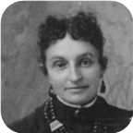
 |  |  |  |  |  |  |  |  |  |  |  |  |  | Marriage: 1877
 |  |  |  |  |  |  |  |  | Robert Copeland |  |  |  |  |  | William Alexander |  |  |  |  |  | Jannet |  |  |  |  |  | Charles Copeland |  |  |  |  |  | Christina Nan
 |  |  |  |  |  |  |  |  | Ives |  |  |  |  |  | Ives |  |  |  |  |  | Ives |  |  |  |  |  | Ives |  |  |  |  |  | Ives
 |  |  |  |  |  |  |  |  | 1878–1883 |  |  |  |  |  | 1880– |  |  |  |  |  | 1882–1882 |  |  |  |  |  | 1883–1888 |  |  |  |  |  | 1884–
 |  |  |  |  |  |  |  |  | 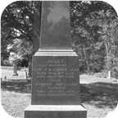 |  |  |  |  |  |  |  |  |  |  |  |  |  |  |  |  |  | 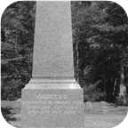

Here are the details about Charles William Ives second marriage, with Margaret Maggie Copeland. You can read more about Charles William on page 36.
Charles William Ives married Margaret Maggie Copeland on Thursday, June 07, 1877, in Merigomish,N.S. - Smith Copeland's home. They had five children.  Margaret Maggie was born in 1848. She was the daughter of Robert S Copeland and Janet Smith.  Margaret Maggie reached 85 years of age and died in 1933. She was buried in Haliburton, Pictou,N.S.
  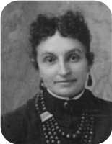
  Margaret Maggie Copeland
Eastern Chronicle June 14,1877
June 7: Married - Charles Ives, Esq., to Maggie, youngest daughter
of R. S. Copeland, Esq., M.P.P., of Merigomish, at the residence of the
bride's father, by Rev. H. McDonald Scott, B.D.
Children of Charles William Ives and Margaret Maggie Copeland:
m I. Robert Copeland Ives was born on July 09, 1878. He died on March 21, 1883, at the age of 4. Robert Copeland was buried in Haliburton Cemetery, Pictou,N.S.
  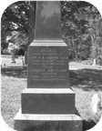
  Robert
+ 31 m II. William Alexander Ives was born on December 25, 1880.
f III. Jannet Ives was born on January 15, 1882. She died on July 18, 1882. Jannet was buried in Haliburton Cemetery, Pictou,N.S.
m IV. Charles Copeland Ives was born on January 26, 1883. He died on May 20, 1888, at the age of 5. Charles Copeland was buried in Haliburton Cemetery, Pictou,N.S.
  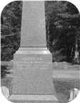
  Charles
+ 32 f V. Christina Nan Ives was born on September 08, 1884.

Family of Emma Ives and Simpson Harris
John W |  |  |  |  |  |  |  |  |  |  |  |  |  |  |  |  |  |  |  |  |  |  |  | George |  |  |  |  |  | Catharine |  |  |  |  |  | Daniel |  |  |  |  |  | Catherine
Harris |  |  |  |  |  |  |  |  |  |  |  |  |  |  |  |  |  |  |  |  |  |  |  | Ives |  |  |  |  |  | Fraser |  |  |  |  |  | Fraser |  |  |  |  |  | MacKay
 |  |  |  |  |  |  |  |  |  |  |  |  |  |  |  |  |  |  |  |  |  |  |  | ca.1770–1862 |  |  |  |  |  | 1778–1865 |  |  |  |  |  | 1769–1850 |  |  |  |  |  | 1775–1864
 |  | William H |  |  |  |  |  |  |  |  |  |  |  | Anne |  |  |  |  |  |  |  |  |  |  |  | William |  |  |  |  |  |  |  |  |  |  |  | Christiana Ann
 |  | Harris |  |  |  |  |  |  |  |  |  |  |  | Arnseon |  |  |  |  |  |  |  |  |  |  |  | Ives |  |  |  |  |  |  |  |  |  |  |  | Fraser
 |  | 1805–1883 |  |  |  |  |  |  |  |  |  |  |  | 1815–1889 |  |  |  |  |  |  |  |  |  |  |  | 1808–1880 |  |  |  |  |  |  |  |  |  |  |  | 1813–1900
 |  | 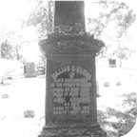
 |  |  |  |  |  |  |  | Simpson J |  |  |  |  |  |  |  |  |  |  |  |  |  |  |  |  |  |  |  |  |  |  |  | Emma
 |  |  |  |  |  |  |  | Harris |  |  |  |  |  |  |  |  |  |  |  |  |  |  |  |  |  |  |  |  |  |  |  | Ives
 |  |  |  |  |  |  |  | 1852–1934 |  |  |  |  |  |  |  |  |  |  |  |  |  |  |  |  |  |  |  |  |  |  |  | 1850–1933
 |  |  |  |  |  |  |  |  |  |  |  |  |  | Married
 |  |  | William Henry |  |  |  |  |  | Joseph Ives |  |  |  |  |  | George Stewart |  |  |  |  |  | Daniel Fraser |  |  |  |  |  | Margaret McLeod |  |  |  |  |  | Christina Ives |  |  |  |  |  | Mary Glennie
 |  |  | Harris |  |  |  |  |  | Harris |  |  |  |  |  | Harris |  |  |  |  |  | Harris |  |  |  |  |  | Harris |  |  |  |  |  | Harris |  |  |  |  |  | Harris
 |  |  | 1882–1965 |  |  |  |  |  | 1883–1902 |  |  |  |  |  | 1885–1968 |  |  |  |  |  | 1887–1970 |  |  |  |  |  | 1888– |  |  |  |  |  | 1890– |  |  |  |  |  | 1891–1891
 |  |  | 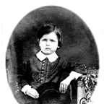 |  |  |  |  |  | 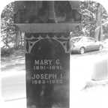 |  |  |  |  |  |  |  |  |  |  |  | 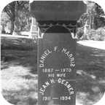 |  |  |  |  |  |  |  |  |  |  |  | 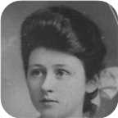

19. Emma Ives was born on Tuesday, April 09, 1850. She was the daughter of William Ives (10) and Christiana Ann Fraser.  Emma died on July 26, 1933, at the age of 83. She was buried in Haliburton, Pictou,N.S.
  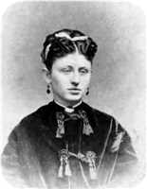
  Emma Ives
She married Simpson J Harris. They had seven children.
Simpson J was born in 1852. He was the son of William H Harris and Anne Arnseon.
He was employed in Sheriff. Simpson J reached 82 years of age and died in 1934. He was buried in Haliburton, Pictou,N.S.
Simpson was the Sheriff of Pictou - last in the line of six Sheriff Harrises covering 140-150 years and four generations.
Notes from Debra Arnison-Sutton
J. Sim Harris was the attorney for many legal documents for Joseph Simpson ARNISON of Pictou, Nova Scotia (from archives of Dalhousie University, Halifax, NS; copies held by Debra Arnison Sutton) 1860s, 1870s
------
High Sheriff of Pictou, NS, 1894-ish
Pictou town website has a historical photo of his house
Genealogical history of the Duncan-Stuart family in America; Stuart, Joseph A; Caxton Press, 1894; http://www.heritagequestonline.com/prod/genealogy/ (subscription site I was able to access briefly on a trial basis)
online images of book pages 94-95
Page 94:
"We have alread mentioned the children of Dr. HARRIS, and will now speak more especially of the son John W. and his descendants, many of whom are residents of the United States.
In 1811 John Washington HARRIS succeeded his cousin Thomas HARRIS, sr., as Deputy Sheriff [of Pictou], which office he held some years, then was made High Sheriff and continued in office till 1857. At that time his eyesight had become so impaired, presumably from exposure to winter snow and dazzling sunlight, that he resigned in favor of his son William H. [HARRIS], who had been his Deputy. William held the office till his death in 1883, at which time his son George S. [HARRIS] was formally appointed High Sheriff. As his father's deputy he had discharged the active duties of the office, his father's failing eyesight making it impossible for him to them. --- George S. HARRIS was Sheriff but a short time, for in 1885 he, too, passed away, and his only brother, J. Sim HARRIS, was appointed to succeed him. A Pictou paper published some years since said "The Shrievalty in this County has become hereditary and fixed in the family of HARRIS, and the appointment of any other than one of that name would be passing strange." The present incumbent is the fifth in office, and fifth of that name to occupy an office which has existed in that county one-hundred-and-two years.--- since the year 1791."
Children of Emma Ives and Simpson J Harris:
m I. William Henry Harris was born on March 07, 1882. He died on December 02, 1965, at the age of 83. William Henry was buried in Haliburton.
  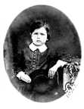
  William
m II. Joseph Ives Harris was born on May 13, 1883. He died in September 1902 at the age of 19. Joseph Ives was buried in Haliburton.
  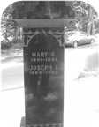
  Joseph
m III. George Stewart Harris was born on June 30, 1885. He died on March 21, 1968, at the age of 82.
+ 33 m IV. Daniel Fraser Harris was born on May 21, 1887. He died on April 24, 1970, at the age of 82.
  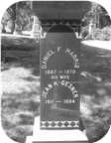
  Daniel
+ 34 f V. Margaret McLeod Harris was born on May 03, 1888.
+ 35 f VI. Christina Ives Harris was born on September 27, 1890.
  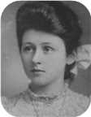
  Christina
f VII. Mary Glennie Harris was born on April 04, 1891. She died on July 10, 1891. Mary Glennie was buried in Haliburton.

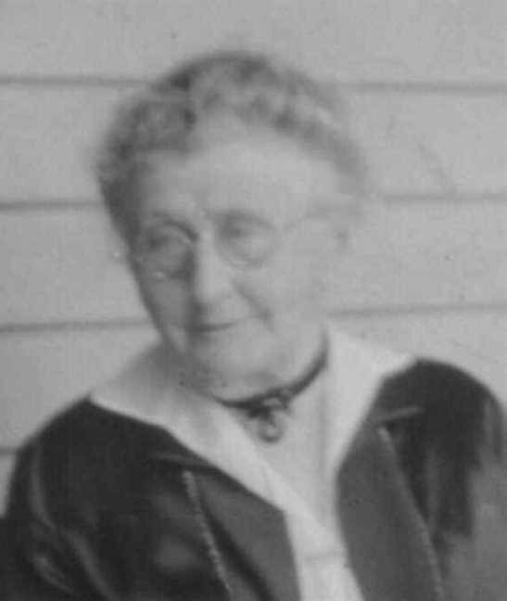  Figure 16: Emma Ives |  | 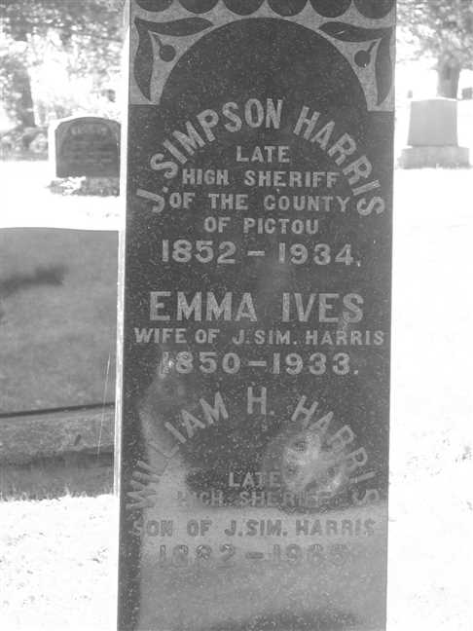  Figure 17: Grave Stone

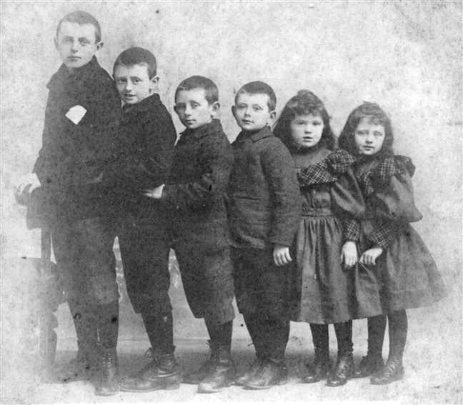
Figure 18: Harris children

Family of Arthur Ives and Ocenia Fraser
George |  |  |  |  |  | Catharine |  |  |  |  |  | Daniel |  |  |  |  |  | Catherine |  |  |  |  |  | James |  |  |  |  |  | Jane |  |  |  |  |  | William |  |  |  |  |  | Christina
Ives |  |  |  |  |  | Fraser |  |  |  |  |  | Fraser |  |  |  |  |  | MacKay |  |  |  |  |  | Fraser |  |  |  |  |  | Fraser |  |  |  |  |  | Robertson |  |  |  |  |  | MacKenzie
ca.1770–1862 |  |  |  |  |  | 1778–1865 |  |  |  |  |  | 1769–1850 |  |  |  |  |  | 1775–1864 |  |  |  |  |  | 1777–1853 |  |  |  |  |  | 1779–1879 |  |  |  |  |  | 1769–1848 |  |  |  |  |  | 1780–1832
 |  | William |  |  |  |  |  |  |  |  |  |  |  | Christiana Ann |  |  |  |  |  |  |  |  |  |  |  | John |  |  |  |  |  |  |  |  |  |  |  | Annie
 |  | Ives |  |  |  |  |  |  |  |  |  |  |  | Fraser |  |  |  |  |  |  |  |  |  |  |  | Fraser |  |  |  |  |  |  |  |  |  |  |  | Robertson
 |  | 1808–1880 |  |  |  |  |  |  |  |  |  |  |  | 1813–1900 |  |  |  |  |  |  |  |  |  |  |  | 1808–1894 |  |  |  |  |  |  |  |  |  |  |  | 1818–1909
 |  |  |  |  |  |  |  | Arthur |  |  |  |  |  |  |  |  |  |  |  |  |  |  |  |  |  |  |  |  |  |  |  | Ocenia
 |  |  |  |  |  |  |  | Ives |  |  |  |  |  |  |  |  |  |  |  |  |  |  |  |  |  |  |  |  |  |  |  | Fraser
 |  |  |  |  |  |  |  | 1854–1913 |  |  |  |  |  |  |  |  |  |  |  |  |  |  |  |  |  |  |  |  |  |  |  | 1853–1935
 |  |  |  |  |  |  |  |  |  |  |  |  |  | Marriage: 1876
 |  |  |  |  |  |  |  |  | Louisa Reid |  |  |  |  |  | Annie |  |  |  |  |  | Daniel Fraser |  |  |  |  |  | Lewis Zindord |  |  |  |  |  | John Fraser
 |  |  |  |  |  |  |  |  | Ives |  |  |  |  |  | Ives |  |  |  |  |  | Ives |  |  |  |  |  | Ives |  |  |  |  |  | Ives
 |  |  |  |  |  |  |  |  | 1889–1982 |  |  |  |  |  | 1880–1956 |  |  |  |  |  | 1887–1964 |  |  |  |  |  | 1888–1941 |  |  |  |  |  | 1895–1970
 |  |  |  |  |  |  |  |  | 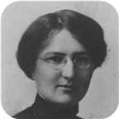 |  |  |  |  |  | 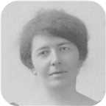 |  |  |  |  |  | 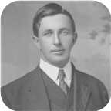 |  |  |  |  |  | 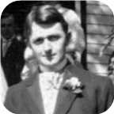 |  |  |  |  |  | 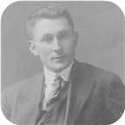

20. Arthur Ives was born on Friday, March 03, 1854. He was the son of William Ives (10) and Christiana Ann Fraser.  Arthur died on June 30, 1913, at the age of 59. He was buried in Haliburton Cemetery, Pictou,N.S.
  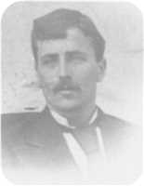
  Arthur Ives
Arthur Ives is listed as a 17 year old store clerk in the 1871 Pictou County census.
Eastern Chronicle July 6,1876
July 3: Married - Arthur Ives, merchant, Pictou, to Ocenia, daughter
of John Fraser, 12 Mile House, at the residence of the bride's father,
by Rev. G. Roddick.
Arthur married Ocenia Fraser on Monday, July 03, 1876, in 12 Mile House, Pictou Co., N.S. They had five children.  Ocenia was born in 1853. Ocenia reached 82 years of age and died on March 19, 1935.
  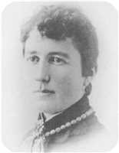
  Ocenia Fraser
This family is duplicated because of common ancestors. See person reference number 21 on page 45.
Children of Arthur Ives and Ocenia Fraser:
+ 36 f I. Louisa Reid Ives was born on September 23, 1889. She died in Pictou, Nova Scotia, Canada, on March 09, 1982, at the age of 92.
  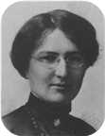
  Louisa
f II. Annie Ives was born on January 27, 1880. She died in New Glasgow,N.S., on November 09, 1956, at the age of 76.
  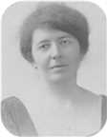
  Annie
+ 37 m III. Daniel Fraser Ives was born on February 07, 1887. He died on March 13, 1964, at the age of 77.
  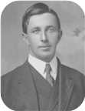
  Daniel
+ 38 m IV. Lewis Zindord Ives was born on July 02, 1888. He died on December 15, 1941, at the age of 53.
  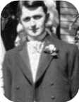
  Lewis
+ 39 m V. John Fraser Ives was born in Pictou,Nova Scotia, on October 12, 1895. He died in Plymouth Park, Nova Scotia, on July 25, 1970, at the age of 74.
  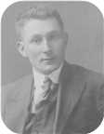
  John

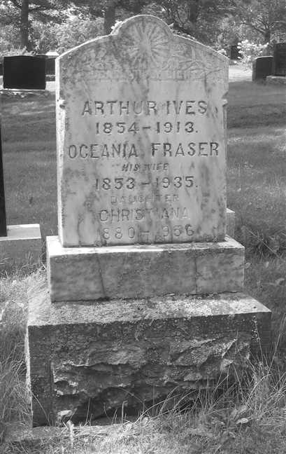  Figure 19: Grave Stone |  | 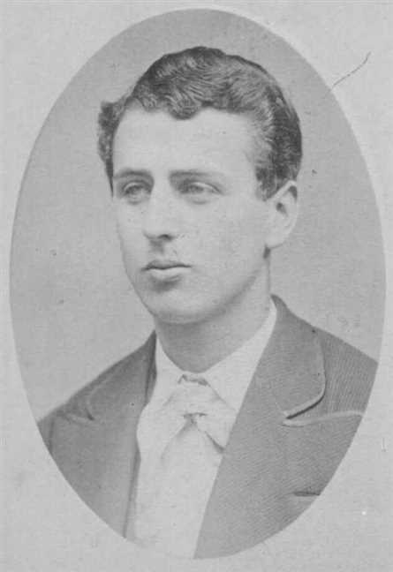  Figure 20: Arthur Ives

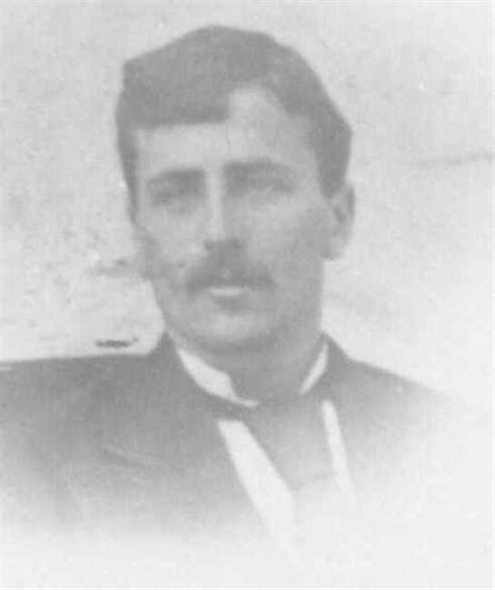  Figure 21: Arthur Ives |  | 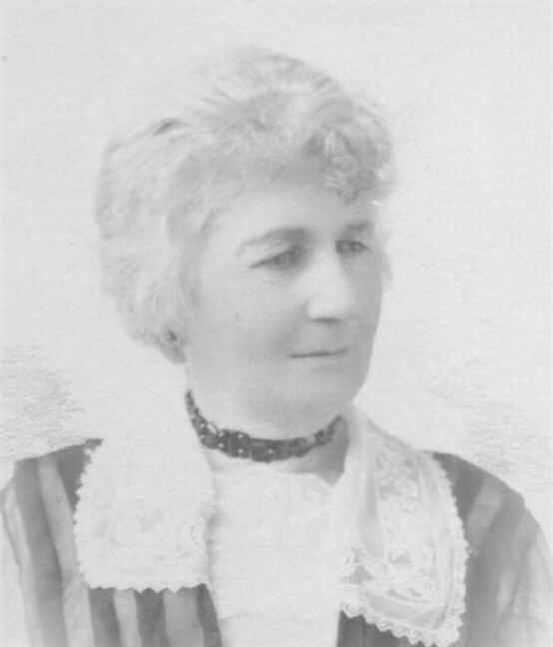  Figure 22: Oceniae Fraser

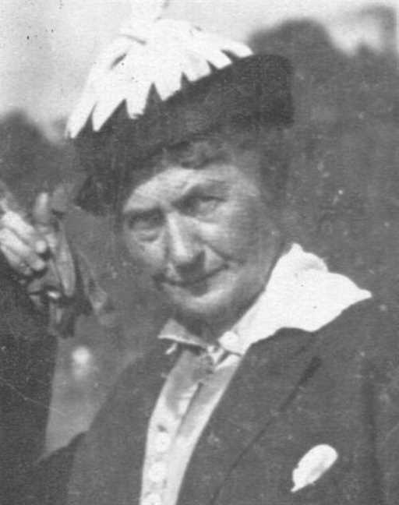  Figure 23: Oceniae Fraser |  | 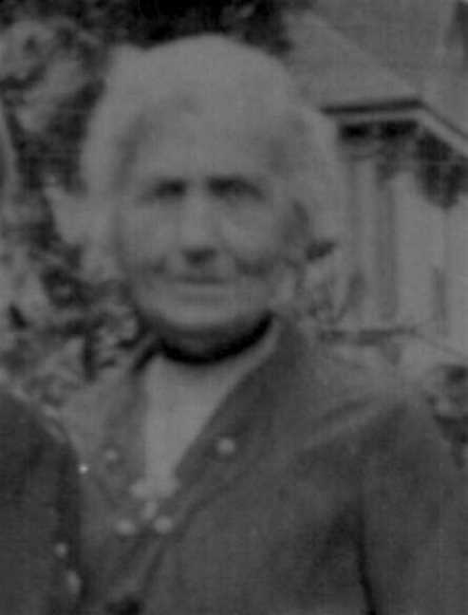  Figure 24: Oceniae Fraser

Family of Ocenia Fraser and Arthur Ives
21. Ocenia Fraser was born in 1853. She was the daughter of John Fraser (11) and Annie Robertson.  Ocenia died on March 19, 1935, at the age of 82. She was buried in Haliburton Cemetery, Pictou,N.S.
  Ocenia Fraser
Eastern Chronicle July 6,1876
July 3: Married - Arthur Ives, merchant, Pictou, to Ocenia, daughter
of John Fraser, 12 Mile House, at the residence of the bride's father,
by Rev. G. Roddick.
At the age of 23, Ocenia married Arthur Ives on Monday, July 03, 1876, in 12 Mile House, Pictou Co., N.S., when he was 22 years old. They had five children.  Arthur was born on Friday, March 03, 1854. Arthur reached 59 years of age and died on June 30, 1913.
  Arthur Ives
This family is duplicated because of common ancestors. For further details see person reference number 20 on page 43.

Family of James Fraser and M Russel
James |  |  |  |  |  | Jane |  |  |  |  |  | William |  |  |  |  |  | Christina
Fraser |  |  |  |  |  | Fraser |  |  |  |  |  | Robertson |  |  |  |  |  | MacKenzie
1777–1853 |  |  |  |  |  | 1779–1879 |  |  |  |  |  | 1769–1848 |  |  |  |  |  | 1780–1832
 |  | John |  |  |  |  |  |  |  |  |  |  |  | Annie
 |  | Fraser |  |  |  |  |  |  |  |  |  |  |  | Robertson
 |  | 1808–1894 |  |  |  |  |  |  |  |  |  |  |  | 1818–1909
 |  |  |  |  |  |  |  | James William |  |  |  |  |  |  |  |  |  |  |  |  |  |  |  |  |  |  |  |  |  |  |  | M
 |  |  |  |  |  |  |  | Fraser |  |  |  |  |  |  |  |  |  |  |  |  |  |  |  |  |  |  |  |  |  |  |  | Russel
 |  |  |  |  |  |  |  | 1848–1882
 |  |  |  |  |  |  |  |  |  |  |  |  |  | Married
 |  |  |  |  |  |  |  |  |  |  |  |  |  |  |  |  |  |  |  |  | William Russel
 |  |  |  |  |  |  |  |  |  |  |  |  |  |  |  |  |  |  |  |  | Fraser

22. James William Fraser was born in 1848. He was the son of John Fraser (11) and Annie Robertson.  James William died on September 26, 1882, at the age of 34. He was buried in Durham Cemetery.
  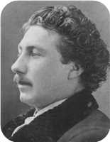
  James William Fraser
He married M Russel. They had one son.
Son of James William Fraser and M Russel:
m I. William Russel Fraser.

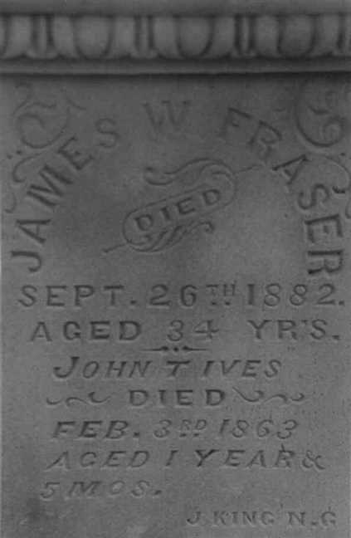
Figure 25: Jas.Wm.Fraser Grave Marker

Family of Anna Fraser and George Kernaghan
 |  |  |  |  |  |  |  |  |  |  |  |  |  |  |  | James |  |  |  | Jane |  |  |  | William |  |  |  | Christina
 |  |  |  |  |  |  |  |  |  |  |  |  |  |  |  | Fraser |  |  |  | Fraser |  |  |  | Robertson |  |  |  | MacKenzie
 |  |  |  |  |  |  |  |  |  |  |  |  |  |  |  | 1777–1853 |  |  |  | 1779–1879 |  |  |  | 1769–1848 |  |  |  | 1780–1832
 |  |  |  |  |  |  |  |  |  |  |  |  |  |  |  |  | John |  |  |  |  |  |  |  | Annie
 |  |  |  |  |  |  |  |  |  |  |  |  |  |  |  |  | Fraser |  |  |  |  |  |  |  | Robertson
 |  |  |  |  |  |  |  |  |  |  |  |  |  |  |  |  | 1808–1894 |  |  |  |  |  |  |  | 1818–1909
 |  |  |  |  | George |  |  |  |  |  |  |  |  |  |  |  |  |  |  |  | Anna
 |  |  |  |  | Kernaghan |  |  |  |  |  |  |  |  |  |  |  |  |  |  |  | Fraser
 |  |  |  |  |  |  |  |  |  |  |  |  |  |  |  |  |  |  |  |  | ca.1852–
 |  |  |  |  |  |  |  |  | Married

23. Anna Fraser was born about 1852. She was the daughter of John Fraser (11) and Annie Robertson.
  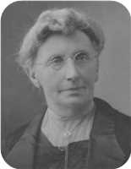
  Anna Fraser
She married George Kernaghan.

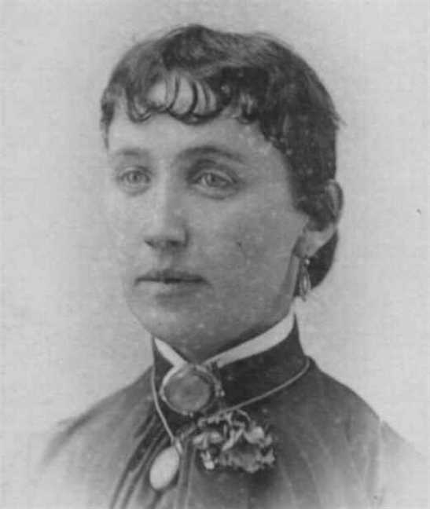
Figure 26: Anna Fraser

Family of Jessie Fraser and Charles Rood
 |  |  |  | Hannah |  |  |  | Jerimiah |  |  |  | Catherine |  |  |  | James |  |  |  | Jane |  |  |  | William |  |  |  | Christina
 |  |  |  | Trail |  |  |  | Carroll |  |  |  | Keene |  |  |  | Fraser |  |  |  | Fraser |  |  |  | Robertson |  |  |  | MacKenzie
 |  |  |  |  |  |  |  |  |  |  |  |  |  |  |  | 1777–1853 |  |  |  | 1779–1879 |  |  |  | 1769–1848 |  |  |  | 1780–1832
 | Stephen Bamford |  |  |  |  |  |  |  | Mary Anne |  |  |  |  |  |  |  | John |  |  |  |  |  |  |  | Annie
 | Rood |  |  |  |  |  |  |  | Carroll |  |  |  |  |  |  |  | Fraser |  |  |  |  |  |  |  | Robertson
 | 1813–1890 |  |  |  |  |  |  |  | 1818–1877 |  |  |  |  |  |  |  | 1808–1894 |  |  |  |  |  |  |  | 1818–1909
 |  |  |  |  | Charles Lever |  |  |  |  |  |  |  |  |  |  |  |  |  |  |  | Jessie
 |  |  |  |  | Rood |  |  |  |  |  |  |  |  |  |  |  |  |  |  |  | Fraser
 |  |  |  |  | 1850–1922 |  |  |  |  |  |  |  |  |  |  |  |  |  |  |  | 1855–1947
 |  |  |  |  | 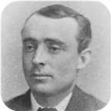
 |  |  |  |  |  |  |  |  | Marriage: 1878
 |  |  |  |  |  |  |  |  |  |  |  | Harry Morrison |  |  |  | Mary Alice
 |  |  |  |  |  |  |  |  |  |  |  | Rood |  |  |  | Rood
 |  |  |  |  |  |  |  |  |  |  |  | 1878–1880 |  |  |  | 1880–1973
 |  |  |  |  |  |  |  |  |  |  |  |  |  |  |  | 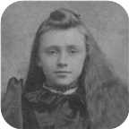

24. Jessie Fraser was born on Sunday, December 30, 1855, in Twelve Mile House,West River,Pictou Co.,N.S. She was the daughter of John Fraser (11) and Annie Robertson.  Jessie died in New Glasgow,Nova Scotia, on November 23, 1947, at the age of 91. She was buried in Haliburton, Pictou,N.S.
  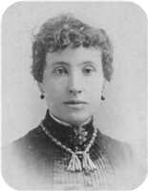
  Jessie Fraser
Jessie Fraser passed away at 2 pm on Sunday, Nov. 23,1947. The funeral service was held at the home of her daughter and Son-in-law -Mrs and Mr. Henry Gray (Washing and Forbes Sts.)
FUNERAL OF CHARLES ROOD
(New Glasgow News, Monday)
This morning at 9:30 many hundreds of the chief citizens of New Glasgow and many in the humbler ranks of life, assembled at the late residence of the late Charles L. Rood on Temperance Street, to pay their last tribute of regard and affection for a man who was held in the highest esteem by all who new him, and this extended over a long life time.
Rev. Robert Farquhar, St. Andrew's, of whose church the deceased had been a member for many years, conducted the services, assisted by Rev. Robert Johnston. The choir of the church had previously assembled and opened with a beautiful rendering of "0 God Our help in ages past" in which the mourners joined. Then followed "Asleep In Jesus". Rev. Mr. Farquhar then paid an eloquent tribute to the many high qualities and generous characteristics of the deceased gentleman. During the service the bells of St. Andrew's tolled a solemn dirge.
On the completion of the service, the coffin was removed to the waiting hearse, the pall bearers being Hector Sutherland, B. DeVeber, John Church and Angus Grant. A procession was then formed of those in the house, and the hundreds of mourners who has assembled outside, being unable to obtain entrance to the building, and slowly winded its way to the station.
The chief mourners were Alexander MacGregor, ex-M.P., the deceased's business partner, Henry Gray, son-in-law, Lewis and Daniel Ives, nephews.
A large and representative number of New Glasgow citizens accompanied the body by train to be present at the burial.
The services in Pictou were conducted in St. Andrew's Church after which the remains were taken to Haliburton Cemetery for interment, the funeral cortege being a large one.
The Evening News had the following notice of Mr. Rood's death:-
Mr. Charles L. Rood, one of New Glasgow's leading citizens, passed to the life beyond at 10:40 o'clock last night. He had been in good health until some ten days ago when he contracted pneumonia. His condition soon became critical, the best medical skill was secured but the end came as stated.
Deceased was 71 years of age. He was born at River John and removed to Pictou with his mother when a boy of fifteen. His mother started a hotel in a small way and in the course of a short time the business passed into her son's hands. He developed it and in due time the Revere Hotel became one of the leading hostelries of eastern Nova Scotia.
Subsequently, he sold the hotel and then moved to Elmsdale where for a couple of years he was engaged in gold mining with the late Evan Thompson and others.
He then moved to New Glasgow and formed a partnership with Alex. McGregor, ex M.P. As Rood & McGregor they conducted an extensive lumber business for the past twenty five years. During that period they conducted the largest lumbering operations in Eastern Nova Scotia.
Deceased was a man of few words but his word was as good as his bond. In business circles he was held in the highest regard. He was always a strong Conservative and his death comes as a distinct loss to the party of his choice.
He was always ready to assist those in need of help whom he deemed deserving and his good deeds were done so that his right hand was not aware what was done by his left. Mr. Rood shunned publicity and his acts of charity were hid as if it were under a bushel.
He will be missed in St. Andrew's Church at which he was a regular attendant and to which he always contributed freely.
He is survived by his widow and one daughter, Mrs. Henry Gray, New Glasgow. He is also survived by three sisters, Mrs. Malcolm Morrison, Vancouver, Mrs. D.W. Kitchin, Weston, Mass. and Mrs. George Fiske also of Weston. Two brothers and two sisters predeceased him.
Pictou Advocate, 17 March 1922 p.3.
Mrs. Charles L. Rood
New Glasgow- Mrs. Charles L. Rood passed away at 2 p.m. Sunday, November 23rd. The funeral service was held at home of her son-in-law and daughter, Mr. and Mrs. Henry Gray, corner of Washington and Forbes Streets, at 2 o'clock Tuesday. Burial was in Haliburton Cemetery, Pictou.
Mrs. Rood was, previous to her marriage, Jessie Fraser, daughter of John Fraser , West River and Annie Robertson of Churchvllle. She was born in the Twelve Mile House, West River in 1855, and would have been 92 years of age on December 30th.
Her nearest remaining relatives are: her daughter: Alla (Mrs. Gray) three grandsons, Charles L. Gray, New Glasgow, Harry A. Gray, Brockville, Ont. and Alan J. Vancouver and two great grandchildren; also one sister, Mrs. Alice Daniels, Rowley, Mass. Her husband passed away in 1922.
Mrs. Rood will long be remembered with kindly thoughts by many persons for her unfailing kindness and charity, never having refused anyone in trouble and giving generously, quietly, without publicity of any kind.
Pictou Advocate, 27 November 1947, p.10.
Other vitals:
Deaths
Rood, Capt. James H., Halifax, Pictou Advocate 23 August 1901 p.1.
Rood, John, formerly of Pictou, Pictou Advocate 18 March, 1898 p.6.
News
Stephen Rood of River John, Tavern Keeper charged of selling liquor to minors: if convicted, license
could be revoked. Eastern Chronicle, February 7, 1856 p.3.
At River John on the 10th June the bark owned by Mr. James Kitchin called "Handy" 444 tons. Mr. Rood, builder.
Rood, Mr. and Mrs. Charles, new house constructed on Temperance Street, New Glasgow. Pictou Advocate 21 May 1910 p.7.
Rood, Charles L., New Glasgow, estate valued at $340,000. Pictou Advocate 31 March 1922 p.1.
At the age of 22, Jessie married Charles Lever Rood on Thursday, May 02, 1878, when he was 27 years old. They had two children.  Charles Lever was born in River John, Nova Scotia, on Friday, December 20, 1850. He was the son of Stephen Bamford Rood and Mary Anne Carroll.
  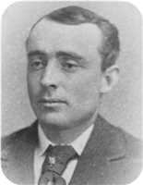
  Charles Lever Rood
Charles Lever reached 71 years of age and died in New Glasgow,Nova Scotia, on March 09, 1922. He was buried in Haliburton, Pictou,N.S.
Charles, when he was 15, moved to Pictou with his Mother. His father (Stephen Bamford Rood) appearently deserted the family and went out west. She operated an inn there called the Revere. The business later passed to Charles and he developed into one of the finest hotels in the area. He subsequently sold the hotel and went into partnership with Evan Thompson. They worked together in the gold mining business near Elmsdale, N.S. He then moved to New Glasgow where he went into partnership with Alexander McGregor and operated a successful lumber business.
Charles and Jessie married in West River. The minister was Rev. George Roddick. The wittnesses were Arthur Ives and Peter MacKenzie. The wedding was announced in the Presbyterian Witness - May 11,1878 : " Married on Mat 2, by Rev George Roddick - Charles L. Rood, of Pictou and Jessie,d/o John Fraser, Twelve Mile House, West River."
In 1881, the Rood family had a man servent -James Phillips (born in Barbados). Penny Lane (b. July 1878) was a servent living with the Rood family in 1901. ( 1901 census )
His political leanings were conservative. In he later years, he lived at 95 Temperance St., New Glasgow,N.S. The house was constructed in 1910 ( Pictou Advocate - May 12,1910). The builder was an architect by the name of D. Henderson.
He had been in generally good health but contacted pneumonia after a dental appointment and ten days later, died at 10:40 pm
Rev. Robert Farquar conducted the funeral service at St . Andrews Church. The pall bearers were Hector Sutherland, B. DeVeber, John Church and Angus Grant. He was burried in Haliburton Cemetery, Pictou, N.S.
Charles and his wife Jessie are burried in the Rood Family plot along with his mother Mary Carroll, son Harry Morrison Rood and sister Hannah Jane Rood.
FUNERAL OF CHARLES ROOD
(New Glasgow News, Monday)
This morning at 9:30 many hundreds of the chief citizens of New Glasgow and many in the humbler ranks of life, assembled at the late residence of the late Charles L. Rood on Temperance Street, to pay their last tribute of regard and affection for a man who was held in the highest esteem by all who new him, and this extended over a long life time.
Rev. Robert Farquhar, St. Andrew's, of whose church the deceased had been a member for many years, conducted the services, assisted by Rev. Robert Johnston. The choir of the church had previously assembled and opened with a beautiful rendering of "0 God Our help in ages past" in which the mourners joined. Then followed "Asleep In Jesus". Rev. Mr. Farquhar then paid an eloquent tribute to the many high qualities and generous characteristics of the deceased gentleman. During the service the bells of St. Andrew's tolled a solemn dirge.
On the completion of the service, the coffin was removed to the waiting hearse, the pall bearers being Hector Sutherland, B. DeVeber, John Church and Angus Grant. A procession was then formed of those in the house, and the hundreds of mourners who has assembled outside, being unable to obtain entrance to the building, and slowly winded its way to the station.
The chief mourners were Alexander MacGregor, ex-M.P., the deceased's business partner, Henry Gray, son-in-law, Lewis and Daniel Ives, nephews.
A large and representative number of New Glasgow citizens accompanied the body by train to be present at the burial.
The services in Pictou were conducted in St. Andrew's Church after which the remains were taken to Haliburton Cemetery for interment, the funeral cortege being a large one.
The Evening News had the following notice of Mr. Rood's death:-
Mr. Charles L. Rood, one of New Glasgow's leading citizens, passed to the life beyond at 10:40 o'clock last night. He had been in good health until some ten days ago when he contracted pneumonia. His condition soon became critical, the best medical skill was secured but the end came as stated.
Deceased was 71 years of age. He was born at River John and removed to Pictou with his mother when a boy of fifteen. His mother started a hotel in a small way and in the course of a short time the business passed into her son's hands. He developed it and in due time the Revere Hotel became one of the leading hostelries of eastern Nova Scotia.
Subsequently, he sold the hotel and then moved to Elmsdale where for a couple of years he was engaged in gold mining with the late Evan Thompson and others.
He then moved to New Glasgow and formed a partnership with Alex. McGregor, ex M.P. As Rood & McGregor they conducted an extensive lumber business for the past twenty five years. During that period they conducted the largest lumbering operations in Eastern Nova Scotia.
Deceased was a man of few words but his word was as good as his bond. In business circles he was held in the highest regard. He was always a strong Conservative and his death comes as a distinct loss to the party of his choice.
He was always ready to assist those in need of help whom he deemed deserving and his good deeds were done so that his right hand was not aware what was done by his left. Mr. Rood shunned publicity and his acts of charity were hid as if it were under a bushel.
He will be missed in St. Andrew's Church at which he was a regular attendant and to which he always contributed freely.
He is survived by his widow and one daughter, Mrs. Henry Gray, New Glasgow. He is also survived by three sisters, Mrs. Malcolm Morrison, Vancouver, Mrs. D.W. Kitchin, Weston, Mass. and Mrs. George Fiske also of Weston. Two brothers and two sisters predeceased him.
Pictou Advocate, 17 March 1922 p.3.
Mrs. Charles L. Rood
New Glasgow- Mrs. Charles L. Rood passed away at 2 p.m. Sunday, November 23rd. The funeral service was held at home of her son-in-law and daughter, Mr. and Mrs. Henry Gray, corner of Washington and Forbes Streets, at 2 o'clock Tuesday. Burial was in Haliburton Cemetery, Pictou.
Mrs. Rood was, previous to her marriage, Jessie Fraser, daughter of John Fraser , West River and Annie Robertson of Churchvllle. She was born in the Twelve Mile House, West River in 1855, and would have been 92 years of age on December 30th.
Her nearest remaining relatives are: her daughter: Alla (Mrs. Gray) three grandsons, Charles L. Gray, New Glasgow, Harry A. Gray, Brockville, Ont. and Alan J. Vancouver and two great grandchildren; also one sister, Mrs. Alice Daniels, Rowley, Mass. Her husband passed away in 1922.
Mrs. Rood will long be remembered with kindly thoughts by many persons for her unfailing kindness and charity, never having refused anyone in trouble and giving generously, quietly, without publicity of any kind.
Pictou Advocate, 27 November 1947, p.10.
Other vitals:
Deaths
Rood, Capt. James H., Halifax, Pictou Advocate 23 August 1901 p.1.
Rood, John, formerly of Pictou, Pictou Advocate 18 March, 1898 p.6.
News
Stephen Rood of River John, Tavern Keeper charged of selling liquor to minors: if convicted, license
could be revoked. Eastern Chronicle, February 7, 1856 p.3.
At River John on the 10th June the bark owned by Mr. James Kitchin called "Handy" 444 tons. Mr. Rood, builder.
Rood, Mr. and Mrs. Charles, new house constructed on Temperance Street, New Glasgow. Pictou Advocate 21 May 1910 p.7.
Rood, Charles L., New Glasgow, estate valued at $340,000. Pictou Advocate 31 March 1922 p.1.
Children of Jessie Fraser and Charles Lever Rood:
m I. Harry Morrison Rood was born on October 05, 1878. He died in Haliburton Cemetry ,Pictou N.S., on July 24, 1880, at the age of 1.
+ 40 f II. Mary Alice Rood was born in Pictou on April 11, 1880. She was also known as Alla.  Mary Alice died in New Glasgow, N.S., on August 21, 1973, at the age of 93.
  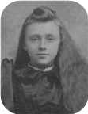
  Mary

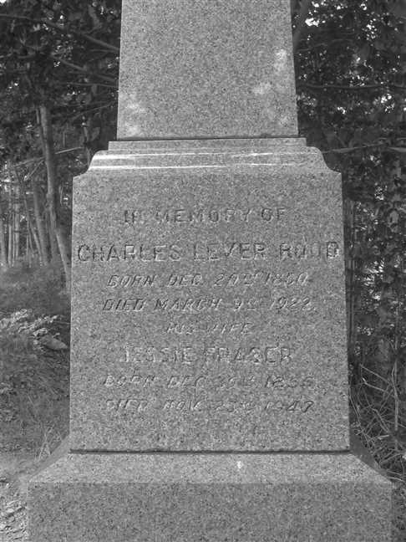  Figure 27: Grave Stone |  | 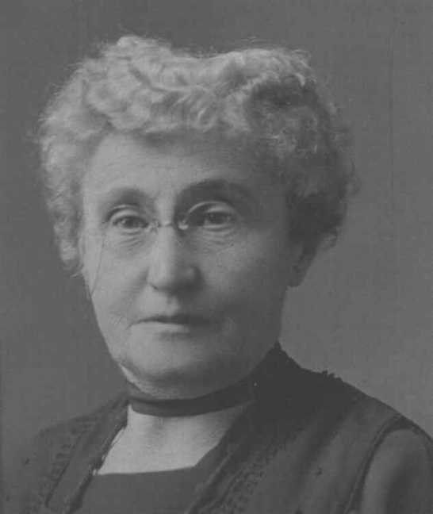  Figure 28: Jessie Fraser

Family of Alice Fraser and Alvin Daniels
 |  |  |  |  |  |  |  |  |  |  |  |  |  |  |  | James |  |  |  | Jane |  |  |  | William |  |  |  | Christina
 |  |  |  |  |  |  |  |  |  |  |  |  |  |  |  | Fraser |  |  |  | Fraser |  |  |  | Robertson |  |  |  | MacKenzie
 |  |  |  |  |  |  |  |  |  |  |  |  |  |  |  | 1777–1853 |  |  |  | 1779–1879 |  |  |  | 1769–1848 |  |  |  | 1780–1832
 |  |  |  |  |  |  |  |  |  |  |  |  |  |  |  |  | John |  |  |  |  |  |  |  | Annie
 |  |  |  |  |  |  |  |  |  |  |  |  |  |  |  |  | Fraser |  |  |  |  |  |  |  | Robertson
 |  |  |  |  |  |  |  |  |  |  |  |  |  |  |  |  | 1808–1894 |  |  |  |  |  |  |  | 1818–1909
 |  |  |  |  | Alvin |  |  |  |  |  |  |  |  |  |  |  |  |  |  |  | Alice
 |  |  |  |  | Daniels |  |  |  |  |  |  |  |  |  |  |  |  |  |  |  | Fraser
 |  |  |  |  |  |  |  |  |  |  |  |  |  |  |  |  |  |  |  |  | ca.1857–
 |  |  |  |  |  |  |  |  | Married
 |  |  |  |  |  |  |  | Flossie |  |  |  | Lizzie |  |  |  | Arthur |  |  |  | Russel
 |  |  |  |  |  |  |  | Daniels |  |  |  | Daniels |  |  |  | Daniels |  |  |  | Daniels

25. Alice Fraser was born about 1857. She was the daughter of John Fraser (11) and Annie Robertson.
  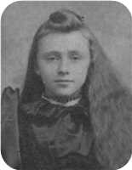
  Alice Fraser
She married Alvin Daniels. They had four children.
Children of Alice Fraser and Alvin Daniels:
f I. Flossie Daniels.
f II. Lizzie Daniels.
m III. Arthur Daniels.
m IV. Russel Daniels.

4th Generation

Family of Sarah Ives and Henry Kitchin
James |  |  |  | Elizabeth |  |  |  |  |  |  |  |  |  |  |  | John Turner |  |  |  | Sarah Frances |  |  |  | James
Kitchin |  |  |  | Rickerby |  |  |  |  |  |  |  |  |  |  |  | Ives |  |  |  | Ives |  |  |  | Ives
–1853 |  |  |  | 1801–1867 |  |  |  |  |  |  |  |  |  |  |  | 1804–1876 |  |  |  |  |  |  |  | ca.1790–
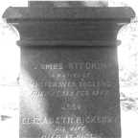
 | James |  |  |  |  |  |  |  | Elizabeth |  |  |  |  |  |  |  | James |  |  |  |  |  |  |  | Fanny Black
 | Kitchin |  |  |  |  |  |  |  | McConnell |  |  |  |  |  |  |  | Ives |  |  |  |  |  |  |  | Ives
 | 1818–1874 |  |  |  |  |  |  |  |  |  |  |  |  |  |  |  | ca.1824–1873 |  |  |  |  |  |  |  | 1828–1874
 | 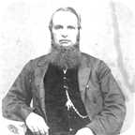
 |  |  |  |  | Henry |  |  |  |  |  |  |  |  |  |  |  |  |  |  |  | Sarah Frances
 |  |  |  |  | Kitchin |  |  |  |  |  |  |  |  |  |  |  |  |  |  |  | Ives
 |  |  |  |  |  |  |  |  |  |  |  |  |  |  |  |  |  |  |  |  | 1856–
 |  |  |  |  |  |  |  |  | Marriage: 1876

26. Sarah Frances Ives was born on Sunday, January 13, 1856. She was the daughter of James Ives (15) and Fanny Black Ives.
Eastern Chronicle Feb.7,1876
February 8: Married - Henry Kitchin, merchant, River John, to Sarah
F., eldest daughter of the late James Ives, Esq., Pictou, at the
residence of John Ives, Pictou, by Rev. James Bayne D. D.
Sarah Frances married Henry Kitchin on Tuesday, February 08, 1876, in Home of John Ives, Pictou, N.S. He was the son of James Kitchin and Elizabeth McConnell.
Eastern Chronicle Feb.7,1876
February 8: Married - Henry Kitchin, merchant, River John, to Sarah
F., eldest daughter of the late James Ives, Esq., Pictou, at the
residence of John Ives, Pictou, by Rev. James Bayne D. D.

Family of Henry Ives and Isabel Troop
John Turner |  |  |  | Sarah Frances |  |  |  | James
Ives |  |  |  | Ives |  |  |  | Ives
1804–1876 |  |  |  |  |  |  |  | ca.1790–
 | James |  |  |  |  |  |  |  | Fanny Black |  |  |  |  |  |  |  | Jared C
 | Ives |  |  |  |  |  |  |  | Ives |  |  |  |  |  |  |  | Troop
 | ca.1824–1873 |  |  |  |  |  |  |  | 1828–1874
 |  |  |  |  | Henry G |  |  |  |  |  |  |  |  |  |  |  |  |  |  |  | Isabel Grassie
 |  |  |  |  | Ives |  |  |  |  |  |  |  |  |  |  |  |  |  |  |  | Troop
 |  |  |  |  | 1858–
 |  |  |  |  |  |  |  |  | Marriage: 1890

27. Henry G Ives was born in 1858. He was the son of James Ives (15) and Fanny Black Ives.
Henry G married Isabel Grassie Troop on Monday, December 22, 1890, in Bridgetown, NS. She was the daughter of Jared C Troop.

Family of Edith Ives and Edward MacDonald
 |  |  |  |  |  |  |  |  |  |  |  |  |  |  |  | John Turner |  |  |  | Sarah Frances |  |  |  | James
 |  |  |  |  |  |  |  |  |  |  |  |  |  |  |  | Ives |  |  |  | Ives |  |  |  | Ives
 |  |  |  |  |  |  |  |  |  |  |  |  |  |  |  | 1804–1876 |  |  |  |  |  |  |  | ca.1790–
 |  |  |  |  |  |  |  |  |  |  |  |  |  |  |  |  | James |  |  |  |  |  |  |  | Fanny Black
 |  |  |  |  |  |  |  |  |  |  |  |  |  |  |  |  | Ives |  |  |  |  |  |  |  | Ives
 |  |  |  |  |  |  |  |  |  |  |  |  |  |  |  |  | ca.1824–1873 |  |  |  |  |  |  |  | 1828–1874
 |  |  |  |  | Edward M |  |  |  |  |  |  |  |  |  |  |  |  |  |  |  | Edith Lillian
 |  |  |  |  | MacDonald |  |  |  |  |  |  |  |  |  |  |  |  |  |  |  | Ives
 |  |  |  |  |  |  |  |  |  |  |  |  |  |  |  |  |  |  |  |  | 1867–
 |  |  |  |  |  |  |  |  | Marriage: 1889

28. Edith Lillian Ives was born in 1867. She was the daughter of James Ives (15) and Fanny Black Ives.
Edith Lillian married Edward M MacDonald on Wednesday, July 10, 1889, in Home of Mrs. John Turner Ives, Pictou, NS.[]

Family of Alexander Ives and Jessie Ross
John Turner |  |  |  | Sarah Frances
Ives |  |  |  | Ives
1804–1876
 | Robert |  |  |  |  |  |  |  | Grace
 | Ives |  |  |  |  |  |  |  | McLeod
 | 1842– |  |  |  |  |  |  |  | 1858–
 |  |  |  |  | Alexander William |  |  |  |  |  |  |  |  |  |  |  |  |  |  |  | Jessie May
 |  |  |  |  | Ives |  |  |  |  |  |  |  |  |  |  |  |  |  |  |  | Ross
 |  |  |  |  | 1879–
 |  |  |  |  |  |  |  |  | Marriage: 1921

29. Alexander William Ives was born in 1879. He was the son of Robert Ives (16) and Grace McLeod.
Alexander William married Jessie May Ross in 1921.

Family of Frederick Ives and ? ?
William |  |  |  | Christiana Ann |  |  |  | James
Ives |  |  |  | Fraser |  |  |  | McLeod
1808–1880 |  |  |  | 1813–1900
 | George Daniel |  |  |  |  |  |  |  | Amelia
 | Ives |  |  |  |  |  |  |  | McLeod
 | 1840–
 |  |  |  |  | Frederick George |  |  |  |  |  |  |  |  |  |  |  |  |  |  |  | ?
 |  |  |  |  | Ives |  |  |  |  |  |  |  |  |  |  |  |  |  |  |  | ?
 |  |  |  |  | ca.1876–1915
 |  |  |  |  |  |  |  |  |  |  |  |  |  |  |  |  |  |  |  |  | 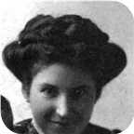
 |  |  |  |  |  |  |  |  | Married
 |  |  |  |  |  |  |  |  |  |  |  | George |  |  |  | Kenneth
 |  |  |  |  |  |  |  |  |  |  |  | Ives |  |  |  | Ives
 |  |  |  |  |  |  |  |  |  |  |  | 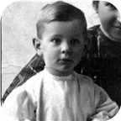 |  |  |  | 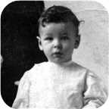

30. Frederick George Ives was born about 1876. He was the son of George Daniel Ives (17) and Amelia McLeod.  Frederick George died on February 27, 1915, at the age of 39.
  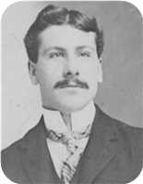
  Frederick George Ives
He married ? ?. They had two sons.
  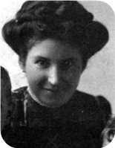
  ? ?
Sons of Frederick George Ives and ? ?:
m I. George Ives. George was employed in 1081.
  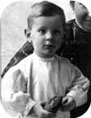
  George
m II. Kenneth Ives.
  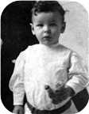
  Kenneth

Family of William Ives and Virginia Moore
William |  |  |  | Christiana Ann |  |  |  | Robert S |  |  |  | Janet
Ives |  |  |  | Fraser |  |  |  | Copeland |  |  |  | Smith
1808–1880 |  |  |  | 1813–1900 |  |  |  | 1800–1885 |  |  |  | 1805–1874
 | Charles William |  |  |  |  |  |  |  | Margaret Maggie
 | Ives |  |  |  |  |  |  |  | Copeland
 | 1841–1921 |  |  |  |  |  |  |  | 1848–1933
 |  |  |  |  | William Alexander |  |  |  |  |  |  |  |  |  |  |  |  |  |  |  | Virginia
 |  |  |  |  | Ives |  |  |  |  |  |  |  |  |  |  |  |  |  |  |  | Moore
 |  |  |  |  | 1880–
 |  |  |  |  |  |  |  |  | Marriage: 1905
 |  |  |  |  |  |  |  | Charles Moore |  |  |  | William Henry |  |  |  | Margaret |  |  |  | Virginia
 |  |  |  |  |  |  |  | Ives |  |  |  | Ives |  |  |  | Ives |  |  |  | Ives
 |  |  |  |  |  |  |  | 1906–2001 |  |  |  | –1911

31. William Alexander Ives was born on Saturday, December 25, 1880. He was the son of Charles William Ives (18) and Margaret Maggie Copeland.
William Alexander married Virginia Moore on Thursday, May 25, 1905, in Aiken,MD. They had four children.
Children of William Alexander Ives and Virginia Moore:
+ 41 m I. Charles Moore Ives was born in Philadelephia,PA, in 1906. He died in Santa Clarita,CA, on October 01, 2001, at the age of 95.
+ 42 m II. William Henry Ives was born in Pictou, N.S. He died on September 22, 1911.
f III. Margaret Ives.
+ 43 f IV. Virginia Ives.

Family of Christina Ives and James Bethume
 |  |  |  |  |  |  |  |  |  |  |  |  |  |  |  | William |  |  |  | Christiana Ann |  |  |  | Robert S |  |  |  | Janet
 |  |  |  |  |  |  |  |  |  |  |  |  |  |  |  | Ives |  |  |  | Fraser |  |  |  | Copeland |  |  |  | Smith
 |  |  |  |  |  |  |  |  |  |  |  |  |  |  |  | 1808–1880 |  |  |  | 1813–1900 |  |  |  | 1800–1885 |  |  |  | 1805–1874
 |  |  |  |  |  |  |  |  |  |  |  |  |  |  |  |  | Charles William |  |  |  |  |  |  |  | Margaret Maggie
 |  |  |  |  |  |  |  |  |  |  |  |  |  |  |  |  | Ives |  |  |  |  |  |  |  | Copeland
 |  |  |  |  |  |  |  |  |  |  |  |  |  |  |  |  | 1841–1921 |  |  |  |  |  |  |  | 1848–1933
 |  |  |  |  | James William |  |  |  |  |  |  |  |  |  |  |  |  |  |  |  | Christina Nan
 |  |  |  |  | Bethume |  |  |  |  |  |  |  |  |  |  |  |  |  |  |  | Ives
 |  |  |  |  | 1879–1940 |  |  |  |  |  |  |  |  |  |  |  |  |  |  |  | 1884–
 |  |  |  |  |  |  |  |  | Married

32. Christina Nan Ives was born on Monday, September 08, 1884. She was the daughter of Charles William Ives (18) and Margaret Maggie Copeland.
She married James William Bethume. James William was born in Prince Edward Island in 1879.
He reached 61 years of age and died in Pictou, N.S., on March 15, 1940.

Family of Daniel Harris and Jean Gesner
William H |  |  |  | Anne |  |  |  | William |  |  |  | Christiana Ann
Harris |  |  |  | Arnseon |  |  |  | Ives |  |  |  | Fraser
1805–1883 |  |  |  | 1815–1889 |  |  |  | 1808–1880 |  |  |  | 1813–1900
 | Simpson J |  |  |  |  |  |  |  | Emma
 | Harris |  |  |  |  |  |  |  | Ives
 | 1852–1934 |  |  |  |  |  |  |  | 1850–1933
 |  |  |  |  | Daniel Fraser |  |  |  |  |  |  |  |  |  |  |  |  |  |  |  | Jean H
 |  |  |  |  | Harris |  |  |  |  |  |  |  |  |  |  |  |  |  |  |  | Gesner
 |  |  |  |  | 1887–1970 |  |  |  |  |  |  |  |  |  |  |  |  |  |  |  | 1911–1994
 |  |  |  |  |  |  |  |  | Married

33. Daniel Fraser Harris was born on Saturday, May 21, 1887. He was the son of Simpson J Harris and Emma Ives (19).  Daniel Fraser died on April 24, 1970, at the age of 82. He was buried in Haliburton, Pictou,N.S.
  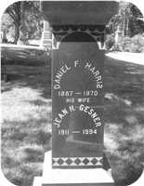
  Daniel Fraser Harris
He married Jean H Gesner. Jean H was born in 1911.
She reached 83 years of age and died in 1994. Jean H was buried in Haliburton.

Family of Margaret Harris and William Fraser
 |  |  |  |  |  |  |  |  |  |  |  |  |  |  |  |  |  |  |  |  |  |  |  | William H |  |  |  |  |  | Anne |  |  |  |  |  | William |  |  |  |  |  | Christiana Ann
 |  |  |  |  |  |  |  |  |  |  |  |  |  |  |  |  |  |  |  |  |  |  |  | Harris |  |  |  |  |  | Arnseon |  |  |  |  |  | Ives |  |  |  |  |  | Fraser
 |  |  |  |  |  |  |  |  |  |  |  |  |  |  |  |  |  |  |  |  |  |  |  | 1805–1883 |  |  |  |  |  | 1815–1889 |  |  |  |  |  | 1808–1880 |  |  |  |  |  | 1813–1900
 |  |  |  |  |  |  |  |  |  |  |  |  |  |  |  |  |  |  |  |  |  |  |  |  |  | Simpson J |  |  |  |  |  |  |  |  |  |  |  | Emma
 |  |  |  |  |  |  |  |  |  |  |  |  |  |  |  |  |  |  |  |  |  |  |  |  |  | Harris |  |  |  |  |  |  |  |  |  |  |  | Ives
 |  |  |  |  |  |  |  |  |  |  |  |  |  |  |  |  |  |  |  |  |  |  |  |  |  | 1852–1934 |  |  |  |  |  |  |  |  |  |  |  | 1850–1933
 |  |  |  |  |  |  |  | William |  |  |  |  |  |  |  |  |  |  |  |  |  |  |  |  |  |  |  |  |  |  |  | Margaret McLeod
 |  |  |  |  |  |  |  | Fraser |  |  |  |  |  |  |  |  |  |  |  |  |  |  |  |  |  |  |  |  |  |  |  | Harris
 |  |  |  |  |  |  |  | ca.1883– |  |  |  |  |  |  |  |  |  |  |  |  |  |  |  |  |  |  |  |  |  |  |  | 1888–
 |  |  |  |  |  |  |  |  |  |  |  |  |  | Married
 |  |  |  |  |  |  |  |  |  |  |  |  |  |  |  |  |  |  |  |  | Joseph
 |  |  |  |  |  |  |  |  |  |  |  |  |  |  |  |  |  |  |  |  | Fraser
 |  |  |  |  |  |  |  |  |  |  |  |  |  |  |  |  |  |  |  |  | –1941

34. Margaret McLeod Harris was born on Thursday, May 03, 1888. She was the daughter of Simpson J Harris and Emma Ives (19).
She married William Fraser. They had one son.
William was born about 1883.
Son of Margaret McLeod Harris and William Fraser:
m I. Joseph Fraser. Joseph died on December 16, 1941.

Family of Christina Harris and Harry McKiel
 |  |  |  |  |  |  |  |  |  |  |  |  |  |  |  | William H |  |  |  | Anne |  |  |  | William |  |  |  | Christiana Ann
 |  |  |  |  |  |  |  |  |  |  |  |  |  |  |  | Harris |  |  |  | Arnseon |  |  |  | Ives |  |  |  | Fraser
 |  |  |  |  |  |  |  |  |  |  |  |  |  |  |  | 1805–1883 |  |  |  | 1815–1889 |  |  |  | 1808–1880 |  |  |  | 1813–1900
 |  |  |  |  |  |  |  |  |  |  |  |  |  |  |  |  | Simpson J |  |  |  |  |  |  |  | Emma
 |  |  |  |  |  |  |  |  |  |  |  |  |  |  |  |  | Harris |  |  |  |  |  |  |  | Ives
 |  |  |  |  |  |  |  |  |  |  |  |  |  |  |  |  | 1852–1934 |  |  |  |  |  |  |  | 1850–1933
 |  |  |  |  | Harry W |  |  |  |  |  |  |  |  |  |  |  |  |  |  |  | Christina Ives
 |  |  |  |  | McKiel |  |  |  |  |  |  |  |  |  |  |  |  |  |  |  | Harris
 |  |  |  |  |  |  |  |  |  |  |  |  |  |  |  |  |  |  |  |  | 1890–
 |  |  |  |  |  |  |  |  | Married

35. Christina Ives Harris was born on Saturday, September 27, 1890. She was the daughter of Simpson J Harris and Emma Ives (19).
  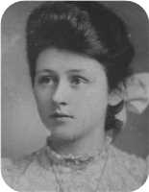
  Christina Ives Harris
She married Harry W McKiel.

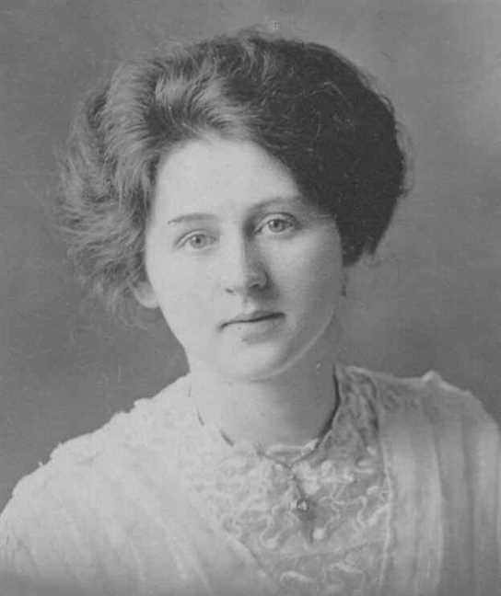
Figure 29: Christina Ives Harris

Family of Louisa Ives and Leonard Robertson
James |  |  |  | Isabella |  |  |  | Alexander |  |  |  | Jessie |  |  |  | William |  |  |  | Christiana Ann |  |  |  | John |  |  |  | Annie
Robertson |  |  |  | Dunbar |  |  |  | Campbell |  |  |  | McKillop |  |  |  | Ives |  |  |  | Fraser |  |  |  | Fraser |  |  |  | Robertson
1823–1894 |  |  |  | 1823–1897 |  |  |  | 1817–1908 |  |  |  | 1827–1900 |  |  |  | 1808–1880 |  |  |  | 1813–1900 |  |  |  | 1808–1894 |  |  |  | 1818–1909
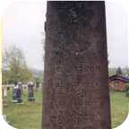
 | James Alexander |  |  |  |  |  |  |  | Annie Fraser |  |  |  |  |  |  |  | Arthur |  |  |  |  |  |  |  | Ocenia
 | Robertson |  |  |  |  |  |  |  | Campbell |  |  |  |  |  |  |  | Ives |  |  |  |  |  |  |  | Fraser
 | 1859–1947 |  |  |  |  |  |  |  | 1867–1960 |  |  |  |  |  |  |  | 1854–1913 |  |  |  |  |  |  |  | 1853–1935
 | 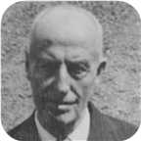 |  |  |  |  |  |  |  | 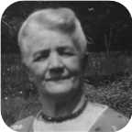
 |  |  |  |  | Leonard Bowman |  |  |  |  |  |  |  |  |  |  |  |  |  |  |  | Louisa Reid
 |  |  |  |  | Robertson |  |  |  |  |  |  |  |  |  |  |  |  |  |  |  | Ives
 |  |  |  |  | 1890–1972 |  |  |  |  |  |  |  |  |  |  |  |  |  |  |  | 1889–1982
 |  |  |  |  | 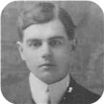
 |  |  |  |  |  |  |  |  | Marriage: 1914
 |  |  |  |  |  |  |  | Annie Oceania |  |  |  | James Ives |  |  |  | Leonard Bowman |  |  |  | Norah Louise
 |  |  |  |  |  |  |  | Robertson |  |  |  | Robertson |  |  |  | Robertson |  |  |  | Robertson
 |  |  |  |  |  |  |  | 1915–1920 |  |  |  | 1917–1989 |  |  |  | 1918– |  |  |  | 1921–
 |  |  |  |  |  |  |  | 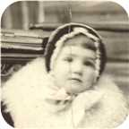 |  |  |  | 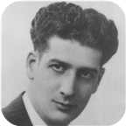 |  |  |  | 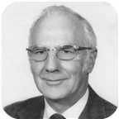 |  |  |  | 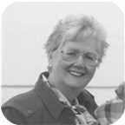

36. Louisa Reid Ives was born on Monday, September 23, 1889. She was the daughter of Arthur Ives (20) and Ocenia Fraser (21).  Louisa Reid died in Pictou, Nova Scotia, Canada, on March 09, 1982, at the age of 92. She was buried in Haliburton, Pictou,N.S.
  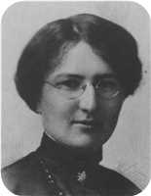
  Louisa Reid Ives
Louisa Read Ives and spouse Leonard Bowman Robertson are 3'rd cousins from common ancestors Colin MacKenzie (b.1721) and his spouse Isabella MacKenzie.
They are also 4th cousins from common ancestors Margaret MacKay (b.1732) and Roderick MacKay (b. 1746).
At the age of 25, Louisa Reid married Leonard Bowman Robertson on Wednesday, September 23, 1914, when he was 23 years old. They had four children.  Leonard Bowman was born in Churchville, Nova Scotia, on Monday, December 01, 1890. He was the son of James Alexander Robertson and Annie Fraser Campbell.
  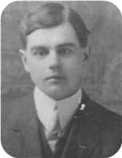
  Leonard Bowman Robertson
He was employed in Telegraph operator,Security guard. Leonard Bowman reached 81 years of age and died in Pictou, Nova Scotia, Canada, on January 18, 1972. He was buried in Haliburton, Pictou,N.S.
Perhaps Leonard Bowman Robertson was named after the Rev. Archibald Bowman who married his parents?
Louisa Read Ives and spouse Leonard Bowman Robertson are 3'rd cousins from common ancestors Colin MacKenzie (b.1721) and his spouse Isabella MacKenzie.
They are also 4th cousins from common ancestors Margaret MacKay (b.1732) and Roderick MacKay (b. 1746).
Children of Louisa Reid Ives and Leonard Bowman Robertson:
f I. Annie Oceania Robertson was born on August 20, 1915. She died on March 29, 1920, at the age of 4.
  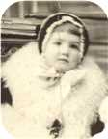
  Annie
+ 44 m II. James Ives Robertson was born in Stellarton, Nova Scotia, on January 28, 1917. He died in Pictou, Nova Scotia, Canada, on October 14, 1989, at the age of 72.
  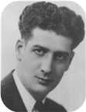
  James
+ 45 m III. Leonard Bowman Robertson was born in Stellerton,N.S., on October 19, 1918.
  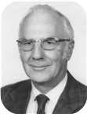
  Leonard
+ 46 f IV. Norah Louise Robertson was born in Niagara Falls,Ont., on February 17, 1921.
  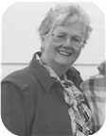
  Norah

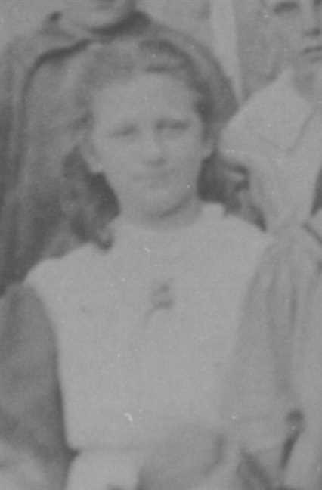  Figure 30: Louisa Reid Ives |  | 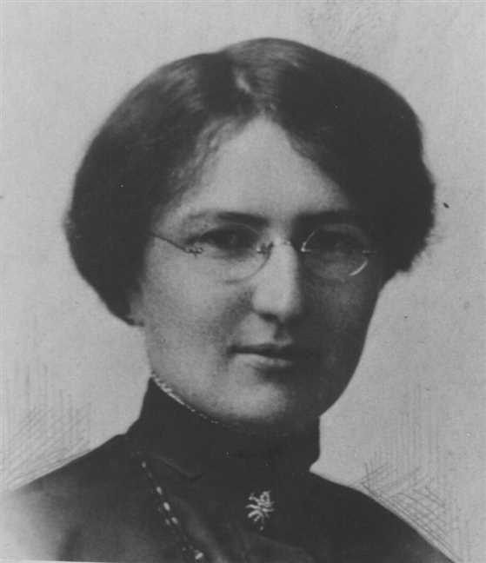  Figure 31: Louisa Reid Ives

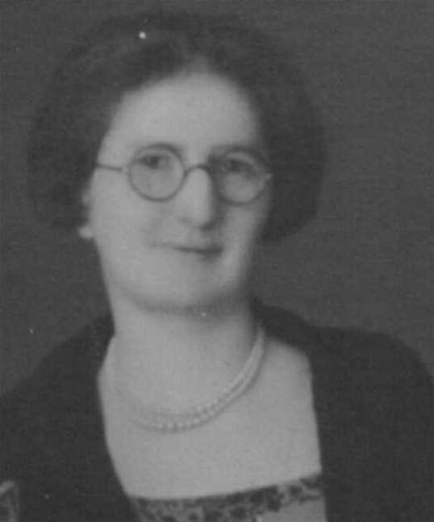  Figure 32: Louisa Reid Ives |  | 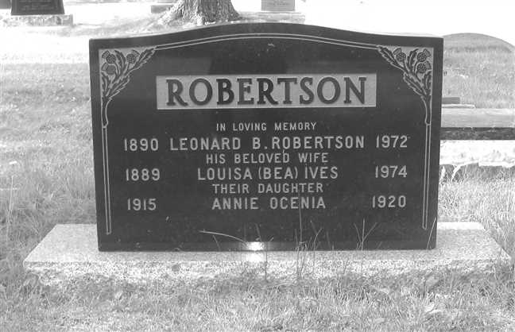  Figure 33: Grave Stone

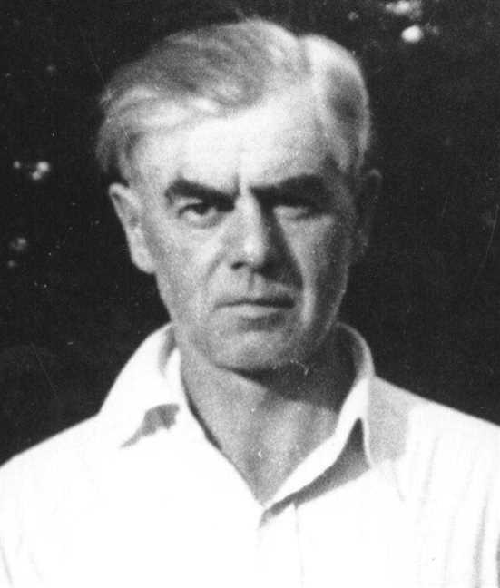  Figure 34: LBRobertsonSr2 |  | 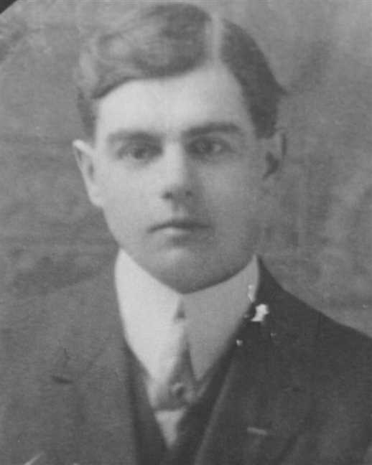  Figure 35: Leonard Bowman Robertson

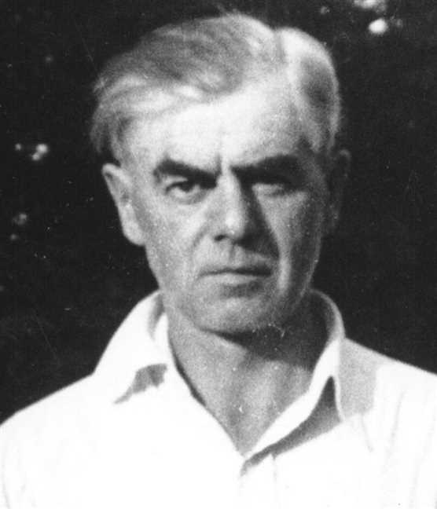
Figure 36: Leonard Bowman Robertson

Family of Daniel Ives and Laura Manship
William |  |  |  | Christiana Ann |  |  |  | John |  |  |  | Annie
Ives |  |  |  | Fraser |  |  |  | Fraser |  |  |  | Robertson
1808–1880 |  |  |  | 1813–1900 |  |  |  | 1808–1894 |  |  |  | 1818–1909
 | Arthur |  |  |  |  |  |  |  | Ocenia |  |  |  |  |  |  |  | Bliss |  |  |  |  |  |  |  | Abigail
 | Ives |  |  |  |  |  |  |  | Fraser |  |  |  |  |  |  |  | Manship |  |  |  |  |  |  |  | Baxter
 | 1854–1913 |  |  |  |  |  |  |  | 1853–1935
 |  |  |  |  | Daniel Fraser |  |  |  |  |  |  |  |  |  |  |  |  |  |  |  | Laura Maud
 |  |  |  |  | Ives |  |  |  |  |  |  |  |  |  |  |  |  |  |  |  | Manship
 |  |  |  |  | 1887–1964 |  |  |  |  |  |  |  |  |  |  |  |  |  |  |  | 1883–1979
 |  |  |  |  |  |  |  |  | Marriage: 1911
 |  |  |  |  |  |  |  | Russel Bliss |  |  |  | Frances C |  |  |  | Arthur |  |  |  | Hilda
 |  |  |  |  |  |  |  | Ives |  |  |  | Ives |  |  |  | Ives |  |  |  | Ives
 |  |  |  |  |  |  |  | –1912 |  |  |  |  |  |  |  | 1919–1933
 |  |  |  |  |  |  |  |  |  |  |  | 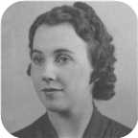

37. Daniel Fraser Ives was born on Monday, February 07, 1887. He was the son of Arthur Ives (20) and Ocenia Fraser (21).  Daniel Fraser died on March 13, 1964, at the age of 77.
  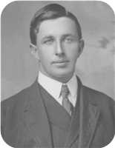
  Daniel Fraser Ives
At the age of 24, Daniel Fraser married Laura Maud Manship on Wednesday, October 25, 1911, when she was 28 years old. They had four children.
Laura Maud was born in Sackville,New Brunswick, on Monday, January 29, 1883. She was the daughter of Bliss Manship and Abigail Baxter.
Laura Maud reached 96 years of age and died on August 10, 1979.
Children of Daniel Fraser Ives and Laura Maud Manship:
+ 47 m I. Russel Bliss Ives. Russel Bliss died on September 19, 1912.
+ 48 f II. Frances C Ives.
  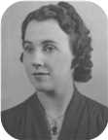
  Frances
m III. Arthur Ives was born in 1919. He died on October 22, 1933, at the age of 14. Arthur was buried in Haliburton Cemetery, Pictou,N.S.
+ 49 f IV. Hilda Ives. They were her parents by adoption.

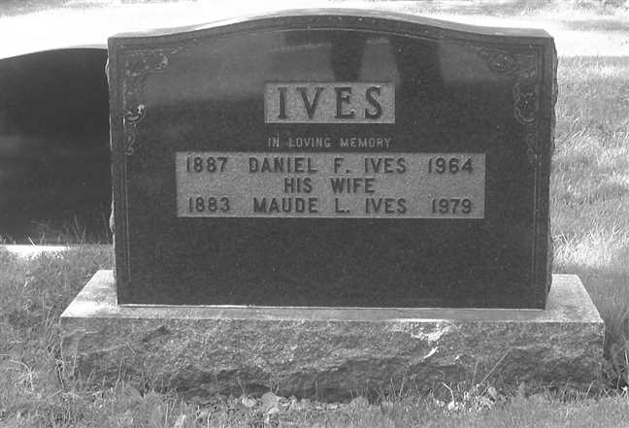
Figure 37: Grave Stone

Family of Lewis Ives and Jenny Eastwood
William |  |  |  | Christiana Ann |  |  |  | John |  |  |  | Annie
Ives |  |  |  | Fraser |  |  |  | Fraser |  |  |  | Robertson
1808–1880 |  |  |  | 1813–1900 |  |  |  | 1808–1894 |  |  |  | 1818–1909
 | Arthur |  |  |  |  |  |  |  | Ocenia |  |  |  |  |  |  |  | James |  |  |  |  |  |  |  | Mary
 | Ives |  |  |  |  |  |  |  | Fraser |  |  |  |  |  |  |  | Eastwood |  |  |  |  |  |  |  | MacIntosh
 | 1854–1913 |  |  |  |  |  |  |  | 1853–1935
 |  |  |  |  | Lewis Zindord |  |  |  |  |  |  |  |  |  |  |  |  |  |  |  | Jenny Mitchell
 |  |  |  |  | Ives |  |  |  |  |  |  |  |  |  |  |  |  |  |  |  | Eastwood
 |  |  |  |  | 1888–1941 |  |  |  |  |  |  |  |  |  |  |  |  |  |  |  | 1880–1942
 |  |  |  |  |  |  |  |  |  |  |  |  |  |  |  |  |  |  |  |  | 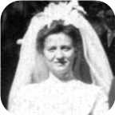
 |  |  |  |  |  |  |  |  | Marriage: 1911
 |  |  |  |  |  |  |  |  |  |  |  | James Eastwood |  |  |  | Lewis Gordon
 |  |  |  |  |  |  |  |  |  |  |  | Ives |  |  |  | Ives
 |  |  |  |  |  |  |  |  |  |  |  | 1916– |  |  |  | –1918
 |  |  |  |  |  |  |  |  |  |  |  | 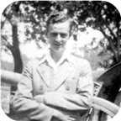

38. Lewis Zindord Ives was born on Monday, July 02, 1888. He was the son of Arthur Ives (20) and Ocenia Fraser (21).  Lewis Zindord died on December 15, 1941, at the age of 53.
  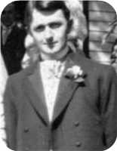
  Lewis Zindord Ives
Lewis Zindord married Jenny Mitchell Eastwood in 1911. They had two sons.  Jenny Mitchell was born in 1880. She was the daughter of James Eastwood and Mary MacIntosh.  Jenny Mitchell reached 62 years of age and died on December 13, 1942.
  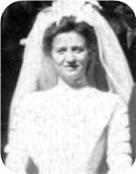
  Jenny Mitchell Eastwood
Sons of Lewis Zindord Ives and Jenny Mitchell Eastwood:
+ 50 m I. James Eastwood Ives was born on November 22, 1916.
  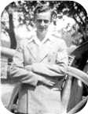
  James
m II. Lewis Gordon Ives. Lewis Gordon died on August 13, 1918.

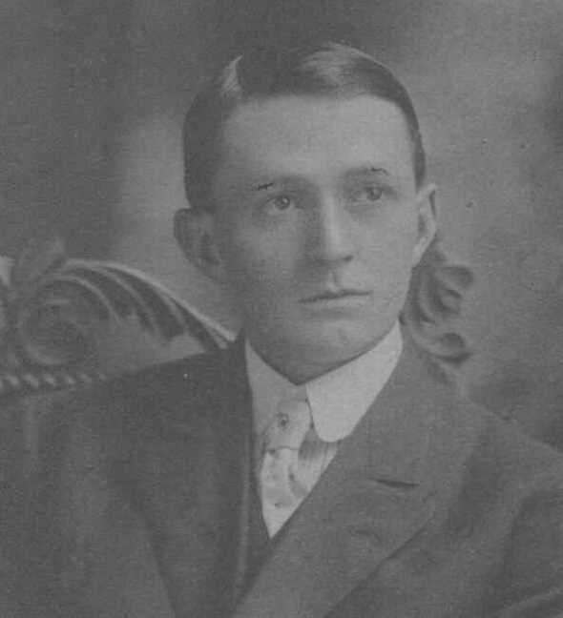  Figure 38: Lewis Zindord Ives |  | 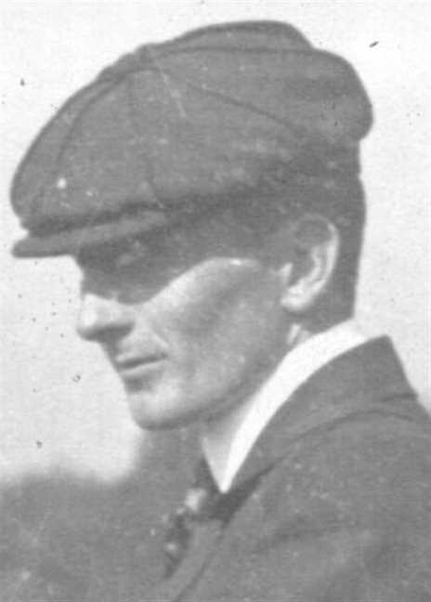  Figure 39: Lewis Zindord Ives

Family of John Ives and Jessie MacMillan
William |  |  |  | Christiana Ann |  |  |  | John |  |  |  | Annie
Ives |  |  |  | Fraser |  |  |  | Fraser |  |  |  | Robertson
1808–1880 |  |  |  | 1813–1900 |  |  |  | 1808–1894 |  |  |  | 1818–1909
 | Arthur |  |  |  |  |  |  |  | Ocenia |  |  |  |  |  |  |  | Hugh |  |  |  |  |  |  |  | Mary
 | Ives |  |  |  |  |  |  |  | Fraser |  |  |  |  |  |  |  | MacMillan |  |  |  |  |  |  |  | ?
 | 1854–1913 |  |  |  |  |  |  |  | 1853–1935
 |  |  |  |  | John Fraser |  |  |  |  |  |  |  |  |  |  |  |  |  |  |  | Jessie Margaret
 |  |  |  |  | Ives |  |  |  |  |  |  |  |  |  |  |  |  |  |  |  | MacMillan
 |  |  |  |  | 1895–1970 |  |  |  |  |  |  |  |  |  |  |  |  |  |  |  | 1898–1994
 |  |  |  |  |  |  |  |  |  |  |  |  |  |  |  |  |  |  |  |  | 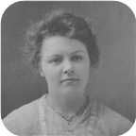
 |  |  |  |  |  |  |  |  | Marriage: 1919
 |  |  |  |  |  |  |  |  |  |  |  | David Hugh |  |  |  | Norah MacGillivary
 |  |  |  |  |  |  |  |  |  |  |  | Ives |  |  |  | Ives
 |  |  |  |  |  |  |  |  |  |  |  | 1924– |  |  |  | 1921–
 |  |  |  |  |  |  |  |  |  |  |  | 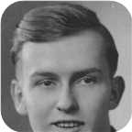 |  |  |  | 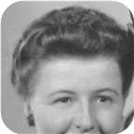

39. John Fraser Ives was born on Saturday, October 12, 1895, in Pictou,Nova Scotia. He was the son of Arthur Ives (20) and Ocenia Fraser (21).  John Fraser died in Plymouth Park, Nova Scotia, on July 25, 1970, at the age of 74.
  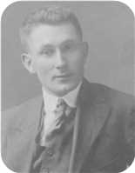
  John Fraser Ives
John Fraser married Jessie Margaret MacMillan in 1919. They had two children.  Jessie Margaret was born in Bridgeville on Wednesday, January 05, 1898. She was the daughter of Hugh MacMillan and Mary ?.  Jessie Margaret reached 96 years of age and died in Plymouth Park on August 14, 1994.
  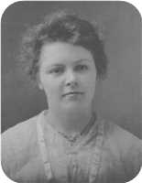
  Jessie Margaret MacMillan
Children of John Fraser Ives and Jessie Margaret MacMillan:
+ 51 m I. David Hugh Ives was born in New Glasgow,Nova Scotia, on February 25, 1924.
  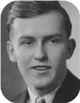
  David
+ 52 f II. Norah MacGillivary Ives was born on March 07, 1921.
  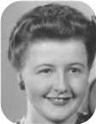
  Norah

Family of Mary Rood and Henry Gray
John |  |  |  |  |  | Mary Ann |  |  |  |  |  | William |  |  |  |  |  | Isabella |  |  |  |  |  | Stephen Bamford |  |  |  |  |  | Mary Anne |  |  |  |  |  | John |  |  |  |  |  | Annie
Gray |  |  |  |  |  | ? |  |  |  |  |  | Whyte |  |  |  |  |  | Brackenridge |  |  |  |  |  | Rood |  |  |  |  |  | Carroll |  |  |  |  |  | Fraser |  |  |  |  |  | Robertson
 |  |  |  |  |  |  |  |  |  |  |  |  |  |  |  |  |  |  |  |  |  |  |  | 1813–1890 |  |  |  |  |  | 1818–1877 |  |  |  |  |  | 1808–1894 |  |  |  |  |  | 1818–1909
 |  | Alexander Black |  |  |  |  |  |  |  |  |  |  |  | Agnes M. |  |  |  |  |  |  |  |  |  |  |  | Charles Lever |  |  |  |  |  |  |  |  |  |  |  | Jessie
 |  | Gray |  |  |  |  |  |  |  |  |  |  |  | Whyte |  |  |  |  |  |  |  |  |  |  |  | Rood |  |  |  |  |  |  |  |  |  |  |  | Fraser
 |  | 1847–1916 |  |  |  |  |  |  |  |  |  |  |  | 1847–1936 |  |  |  |  |  |  |  |  |  |  |  | 1850–1922 |  |  |  |  |  |  |  |  |  |  |  | 1855–1947
 |  |  |  |  |  |  |  | Henry Irving Beecher |  |  |  |  |  |  |  |  |  |  |  |  |  |  |  |  |  |  |  |  |  |  |  | Mary Alice
 |  |  |  |  |  |  |  | Gray |  |  |  |  |  |  |  |  |  |  |  |  |  |  |  |  |  |  |  |  |  |  |  | Rood
 |  |  |  |  |  |  |  | 1887–1976 |  |  |  |  |  |  |  |  |  |  |  |  |  |  |  |  |  |  |  |  |  |  |  | 1880–1973
 |  |  |  |  |  |  |  |  |  |  |  |  |  | Marriage: 1912
 |  |  |  |  |  |  |  |  |  |  |  |  |  |  | Charles Lever Rood |  |  |  |  |  | Harry Alexander |  |  |  |  |  | John Allan
 |  |  |  |  |  |  |  |  |  |  |  |  |  |  | Gray |  |  |  |  |  | Gray |  |  |  |  |  | Gray
 |  |  |  |  |  |  |  |  |  |  |  |  |  |  | 1913–1995 |  |  |  |  |  | 1916– |  |  |  |  |  | 1919–1994

40. Mary Alice Rood was born on Sunday, April 11, 1880, in Pictou,N.S. She was the daughter of Charles Lever Rood and Jessie Fraser (24). She was also known as Alla.  Mary Alice died in New Glasgow, N.S., on August 21, 1973, at the age of 93.
  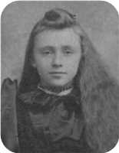
  Mary Alice Rood
Alice and Henry were married by Rev. F. Robertson. The witnesses were Alexander B. Gray and Jessie Rood.
Home was at the corner of Washington and Forbes Sts., New Glasgow,N.S.
At the age of 32, Mary Alice married Henry Irving Beecher Gray on Wednesday, December 18, 1912, when he was 25 years old. They had three sons.
Henry Irving Beecher was born in New Glasgow on Tuesday, August 09, 1887. He was the son of Alexander Black Gray and Agnes M. Whyte.
Henry Irving Beecher reached 88 years of age and died in New Glasgow on January 04, 1976.
Alice and Henry were married by Rev. F. Robertson. The witnesses were Alexander B. Gray and Jessie Rood.
Home was at the corner of Washington and Forbes Sts., New Glasgow,N.S.
Sons of Mary Alice Rood and Henry Irving Beecher Gray:
+ 53 m I. Charles Lever Rood Gray was born in New Glasgow on May 16, 1913. He died on January 12, 1995, at the age of 81.
+ 54 m II. Harry Alexander Gray was born in New Glasgow on March 10, 1916.
+ 55 m III. John Allan Gray was born in New Glasgow on January 20, 1919. He died in New Glasgow,Nova Scotia, on September 18, 1994, at the age of 75.

5th Generation

Charles Ives
41. Charles Moore Ives was born in 1906 in Philadelephia,PA. He was the son of William Alexander Ives (31) and Virginia Moore.
Charles Moore died in Santa Clarita,CA, on October 01, 2001, at the age of 95.
IVES, Charles Moore
IVES, Charles Moore - 95, died October 1, 2001, in Santa Clarita, California. Born in Philadelphia, he was a son of the late William A. and Virginia (Moore) Ives. When a small child, he moved with his parents to Pictou, Charles graduated from Pictou Academy and was employed with the Royal Bank and later transferred to Halifax. In 1925, his family moved to Halifax, where his family started Ives Engraving & Printing Company. Charles in his early 20's he decided to go back to the United States. He worked for Prudential Insurance Home Office in Newark, N.J. and later moved to California when they opened a home office on the west coast. He retired as manager of one of their divisions. Surviving are his wife, Maisie; son, Charles W. Ives (Jeannie); daughter, Virginia Bauer-Tapia; stepdaughters, Judy and Christina; five grandchildren; sister, Virginia Ives Mills, Windsor. He was predeceased by his wife, Eleanor; brother, William H. Ives (Halifax); sister, Margaret Ives Dawson (Kentville). There was a service held in Friendly Valley Church, Santa Clarita with a reception following. Cremation has taken place. Interment will follow. Charles will be missed, he had many friends and a good life.
--------------------------------------------------------------------------------
Marriages with Eleanor Arleen Colburg and (unknown given name) Maisie (Page 79) are known.

Family of Charles Ives and Eleanor Colburg
Charles William |  |  |  | Margaret Maggie
Ives |  |  |  | Copeland
1841–1921 |  |  |  | 1848–1933
 | William Alexander |  |  |  |  |  |  |  | Virginia
 | Ives |  |  |  |  |  |  |  | Moore
 | 1880–
 |  |  |  |  | Charles Moore |  |  |  |  |  |  |  |  |  |  |  |  |  |  |  | Eleanor Arleen
 |  |  |  |  | Ives |  |  |  |  |  |  |  |  |  |  |  |  |  |  |  | Colburg
 |  |  |  |  | 1906–2001
 |  |  |  |  |  |  |  |  | Marriage: 1934
 |  |  |  |  |  |  |  |  |  |  |  | Charles W |  |  |  | Virginia
 |  |  |  |  |  |  |  |  |  |  |  | Ives |  |  |  | Ives

Here are the details about Charles Moore Ives first marriage, with Eleanor Arleen Colburg. You can read more about Charles Moore on page 77.
Charles Moore Ives married Eleanor Arleen Colburg on Saturday, July 07, 1934. They had two children.
Children of Charles Moore Ives and Eleanor Arleen Colburg:
m I. Charles W Ives.
f II. Virginia Ives.

Family of Charles Ives and Maisie
Charles William |  |  |  | Margaret Maggie
Ives |  |  |  | Copeland
1841–1921 |  |  |  | 1848–1933
 | William Alexander |  |  |  |  |  |  |  | Virginia
 | Ives |  |  |  |  |  |  |  | Moore
 | 1880–
 |  |  |  |  | Charles Moore |  |  |  |  |  |  |  |  |  |  |  |  |  |  |  | (unknown given name)
 |  |  |  |  | Ives |  |  |  |  |  |  |  |  |  |  |  |  |  |  |  | Maisie
 |  |  |  |  | 1906–2001
 |  |  |  |  |  |  |  |  | Married
 |  |  |  |  |  |  |  |  |  |  |  | (unknown given name) |  |  |  | (unknown given name)
 |  |  |  |  |  |  |  |  |  |  |  | Judy |  |  |  | Christina

Here are the details about Charles Moore Ives second marriage, with (unknown given name) Maisie. You can read more about Charles Moore on page 77.
Charles Moore Ives married (unknown given name) Maisie. They had two daughters.
Daughters of Charles Moore Ives and (unknown given name) Maisie:
f I. (unknown given name) Judy.
f II. (unknown given name) Christina.

Family of William Ives and Winnifred Murray
Charles William |  |  |  | Margaret Maggie
Ives |  |  |  | Copeland
1841–1921 |  |  |  | 1848–1933
 | William Alexander |  |  |  |  |  |  |  | Virginia
 | Ives |  |  |  |  |  |  |  | Moore
 | 1880–
 |  |  |  |  | William Henry |  |  |  |  |  |  |  |  |  |  |  |  |  |  |  | Winnifred
 |  |  |  |  | Ives |  |  |  |  |  |  |  |  |  |  |  |  |  |  |  | Murray
 |  |  |  |  | –1911
 |  |  |  |  |  |  |  |  | Marriage: 1952

42. William Henry Ives was born in Pictou, N.S. He was the son of William Alexander Ives (31) and Virginia Moore.
William Henry died on September 22, 1911.
William Henry married Winnifred Murray on Saturday, October 04, 1952, in Halifax,N.S.

Family of Virginia Ives and ? Mills
 |  |  |  |  |  |  |  |  |  |  |  |  |  |  |  | Charles William |  |  |  | Margaret Maggie
 |  |  |  |  |  |  |  |  |  |  |  |  |  |  |  | Ives |  |  |  | Copeland
 |  |  |  |  |  |  |  |  |  |  |  |  |  |  |  | 1841–1921 |  |  |  | 1848–1933
 |  |  |  |  |  |  |  |  |  |  |  |  |  |  |  |  | William Alexander |  |  |  |  |  |  |  | Virginia
 |  |  |  |  |  |  |  |  |  |  |  |  |  |  |  |  | Ives |  |  |  |  |  |  |  | Moore
 |  |  |  |  |  |  |  |  |  |  |  |  |  |  |  |  | 1880–
 |  |  |  |  | ? |  |  |  |  |  |  |  |  |  |  |  |  |  |  |  | Virginia
 |  |  |  |  | Mills |  |  |  |  |  |  |  |  |  |  |  |  |  |  |  | Ives
 |  |  |  |  |  |  |  |  | Married

43. Virginia Ives. She was the daughter of William Alexander Ives (31) and Virginia Moore.
Never remarried. No children.
She married ? Mills.
? Mills was killed during WWII. Ship was torpedoed while heading for Europe.

Family of James Robertson and Charlotte MacDonell
James Alexander |  |  |  | Annie Fraser |  |  |  | Arthur |  |  |  | Ocenia |  |  |  | Angus Hugh |  |  |  | Flora |  |  |  | William Little |  |  |  | Charlotte
Robertson |  |  |  | Campbell |  |  |  | Ives |  |  |  | Fraser |  |  |  | MacDonell |  |  |  | MacDonell |  |  |  | MacDonald |  |  |  | MacDougall
1859–1947 |  |  |  | 1867–1960 |  |  |  | 1854–1913 |  |  |  | 1853–1935 |  |  |  | 1831–1917 |  |  |  | 1841–1919 |  |  |  | 1844–1917 |  |  |  | 1849–1934
 |  |  |  |  |  |  |  |  |  |  |  |  |  |  |  |  |  |  |  |  |  |  |  |  |  |  |  | 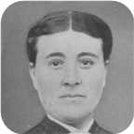
 | Leonard Bowman |  |  |  |  |  |  |  | Louisa Reid |  |  |  |  |  |  |  | Allan |  |  |  |  |  |  |  | Mary Christina
 | Robertson |  |  |  |  |  |  |  | Ives |  |  |  |  |  |  |  | MacDonell |  |  |  |  |  |  |  | MacDonald
 | 1890–1972 |  |  |  |  |  |  |  | 1889–1982 |  |  |  |  |  |  |  | 1880–1926 |  |  |  |  |  |  |  | 1895–1978
 |  |  |  |  |  |  |  |  |  |  |  |  |  |  |  |  | 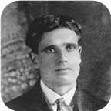 |  |  |  |  |  |  |  | 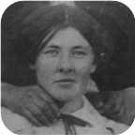
 |  |  |  |  | James Ives |  |  |  |  |  |  |  |  |  |  |  |  |  |  |  | Charlotte Helen
 |  |  |  |  | Robertson |  |  |  |  |  |  |  |  |  |  |  |  |  |  |  | MacDonell
 |  |  |  |  | 1917–1989 |  |  |  |  |  |  |  |  |  |  |  |  |  |  |  | 1922–2005
 |  |  |  |  |  |  |  |  |  |  |  |  |  |  |  |  |  |  |  |  | 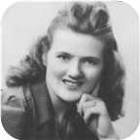
 |  |  |  |  |  |  |  |  | Marriage: 1942
 |  |  |  |  |  |  |  | Allan James |  |  |  | Lois Christina |  |  |  | Lewis William |  |  |  | Vivian Louise
 |  |  |  |  |  |  |  | Robertson |  |  |  | Robertson |  |  |  | Robertson |  |  |  | Robertson
 |  |  |  |  |  |  |  | 1943– |  |  |  | 1948–1979 |  |  |  | 1951– |  |  |  | 1957–
 |  |  |  |  |  |  |  |  |  |  |  | 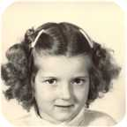 |  |  |  | 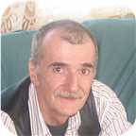 |  |  |  | 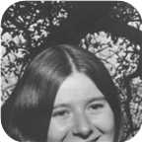

44. James Ives Robertson was born on Sunday, January 28, 1917, in Stellarton, Nova Scotia. He was the son of Leonard Bowman Robertson and Louisa Reid Ives (36).  James Ives was educated in Cumunity College. He was employed in Sheet Metal worker.
  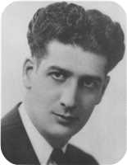
  James Ives Robertson
James Ives died in Pictou, Nova Scotia, Canada, on October 14, 1989, at the age of 72.
James was a sheet metal worker by trade. Most of his working career was spent at the Pictou shipyard (Ferguson Industries Ltd.).
At the age of 25, James Ives married Charlotte Helen MacDonell on Wednesday, April 29, 1942, in Cadillac,Quebec, when she was 19 years old. They had four children.  Charlotte Helen was born in Judique, Nova Scotia, on Monday, December 25, 1922.
  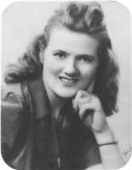
  Charlotte Helen MacDonell
She was the daughter of Allan MacDonell and Mary Christina MacDonald. Charlotte Helen reached 82 years of age and died on April 29, 2005.
Children of James Ives Robertson and Charlotte Helen MacDonell:
+ 56 m I. Allan James Robertson was born in Pictou, Nova Scotia, Canada, on August 26, 1943.
  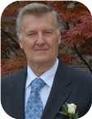
  Allan
+ 57 f II. Lois Christina Robertson was born in St Catharines, Ontario, on April 30, 1948. She died in Pictou, Nova Scotia, Canada, on January 23, 1979, at the age of 30.
  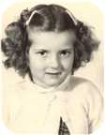
  Lois
m III. Lewis William Robertson was born on December 25, 1951. He is employed in Factory Worker.
  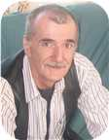
  Lewis
+ 58 f IV. Vivian Louise Robertson was born in Pictou, Nova Scotia, Canada, on January 30, 1957.
  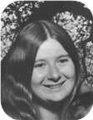
  Vivian

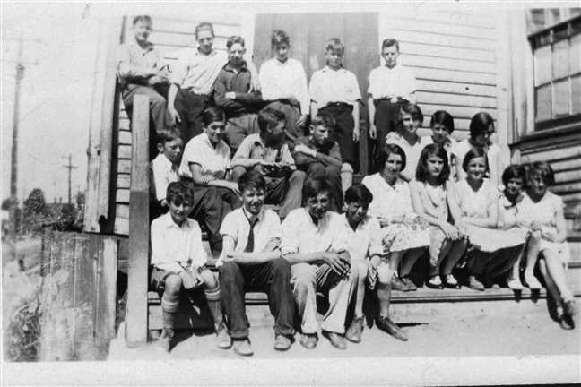  Figure 40: Dad's Grade 8 Class June 1930 |  | 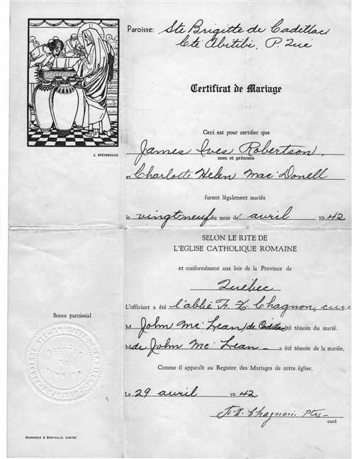  Figure 41: Helen and James Robertson Marrige

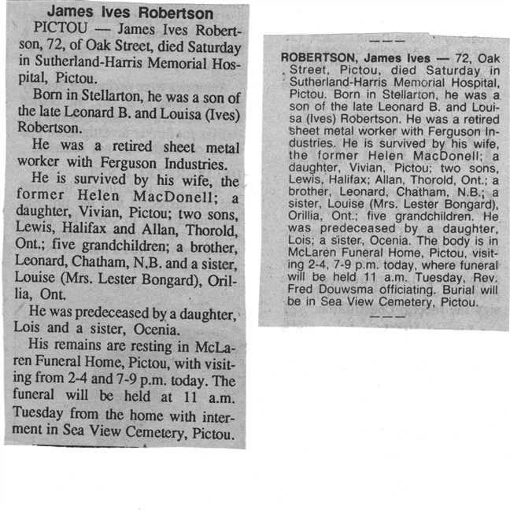  Figure 42: James Robertson's Obits |  | 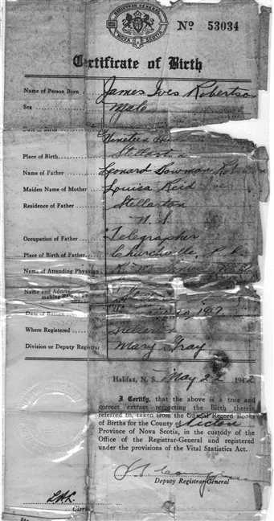  Figure 43: James Robertson' Baptism

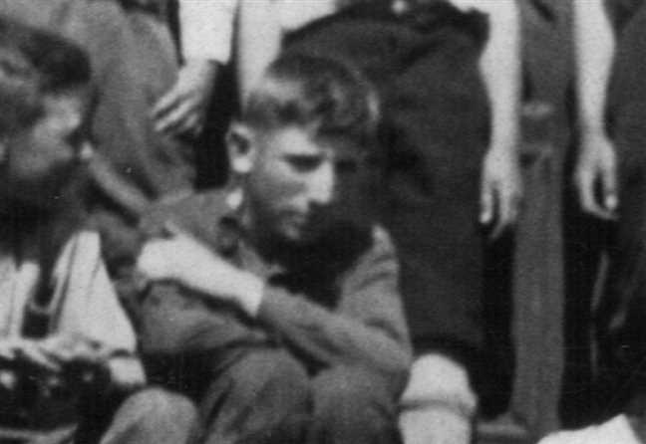  Figure 44: James Robertson's Grade 8 class photo HD croped |  | 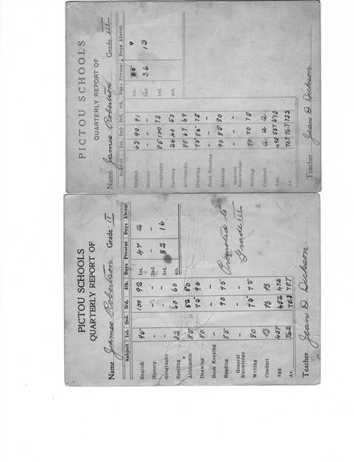  Figure 45: Dad's Grade 2 and 3 Report Cards

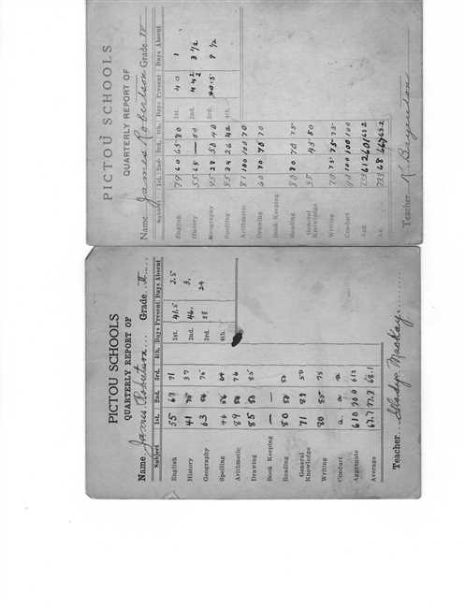  Figure 46: Dad's Grade 4 and 5 Report Cards |  | 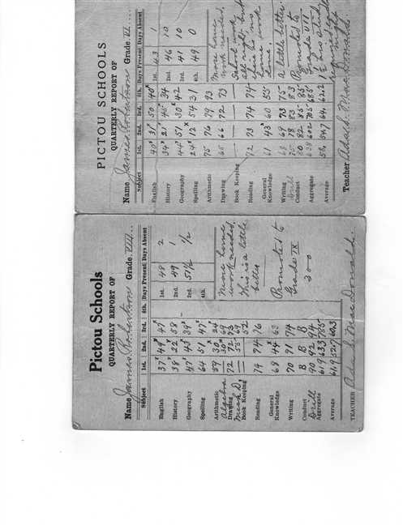  Figure 47: Dad's Grade 6 and 8 Report Cards

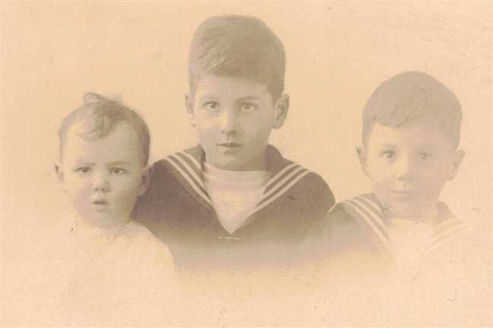  Figure 48: Nora James Leonard Robertson |  | 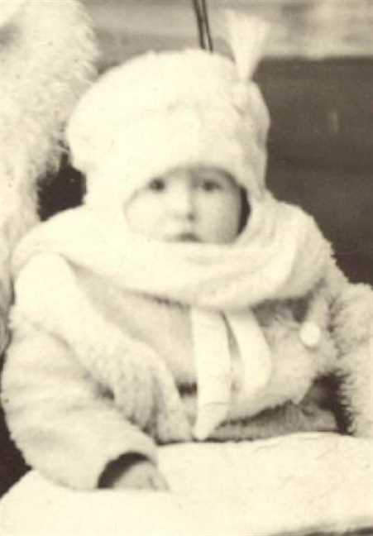  Figure 49: James Ives Robertson

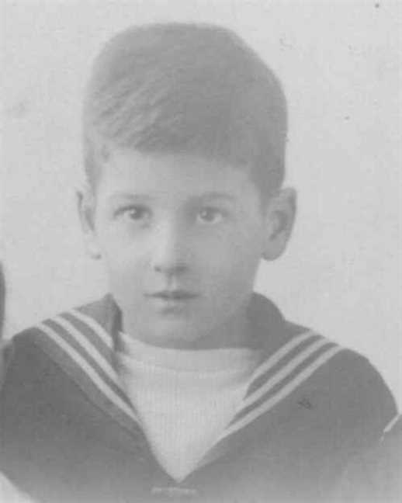  Figure 50: James I Robertson |  | 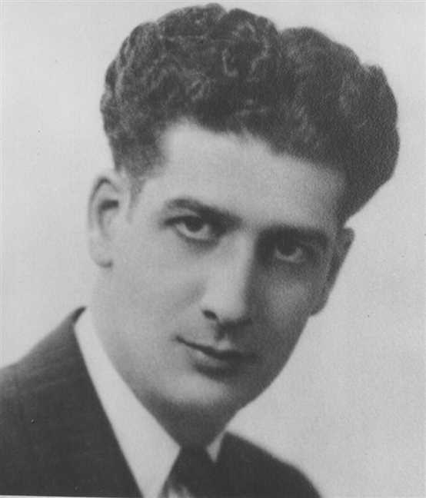  Figure 51: James Ives Robertson

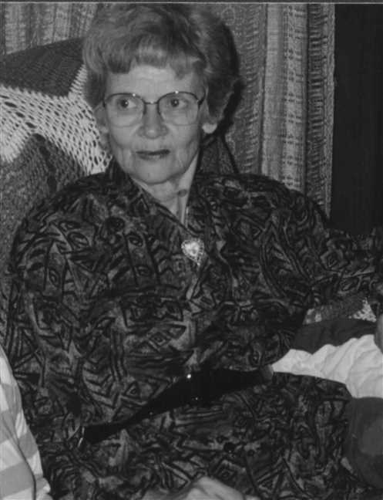  Figure 52: Charlotte H MacDonell |  | 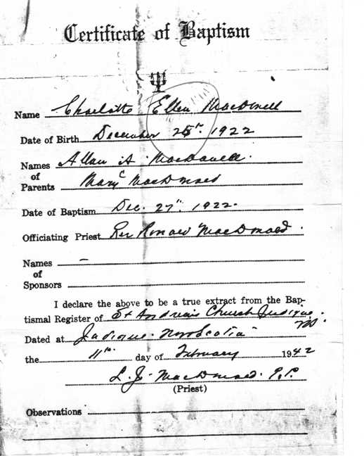  Figure 53: Charlotte Helen McDonell's Baptism Certificate

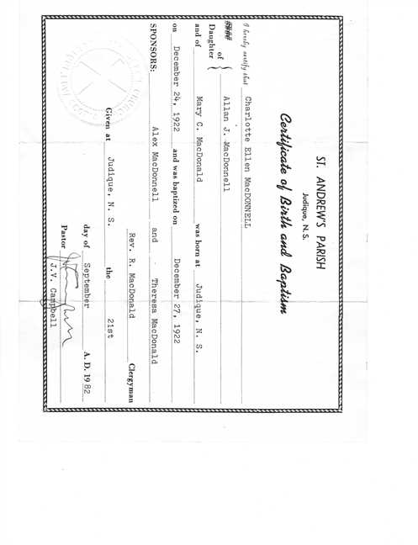  Figure 54: Charlotte Helen's Baptism 2 |  | 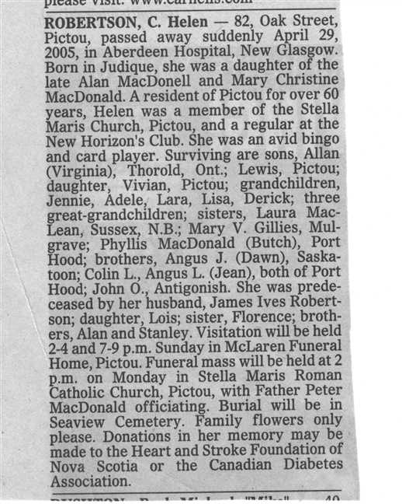  Figure 55: Charlotte Helen's Obit

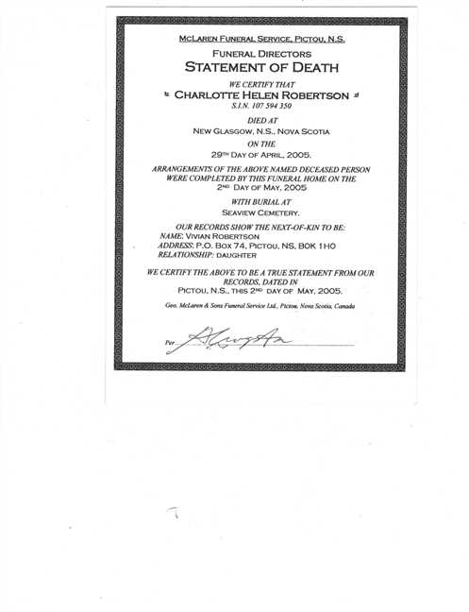  Figure 56: Statement of Death |  | 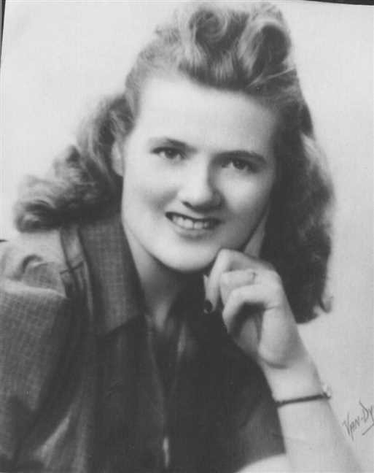  Figure 57: Charlotte H MacDonell

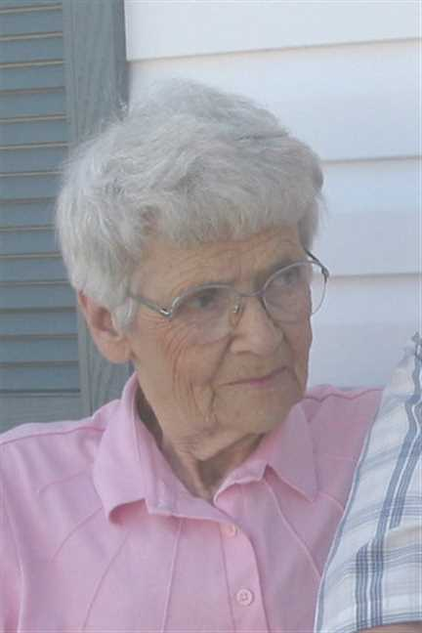
Figure 58: Charlotte H MacDonell

Family of Leonard Robertson and Edna Bell
James Alexander |  |  |  | Annie Fraser |  |  |  | Arthur |  |  |  | Ocenia |  |  |  | Hugh |  |  |  | Mary K |  |  |  | John James |  |  |  | Josephine
Robertson |  |  |  | Campbell |  |  |  | Ives |  |  |  | Fraser |  |  |  | Bell |  |  |  | Moore |  |  |  | Smith |  |  |  | French
1859–1947 |  |  |  | 1867–1960 |  |  |  | 1854–1913 |  |  |  | 1853–1935 |  |  |  |  |  |  |  | 1868–1894
 | Leonard Bowman |  |  |  |  |  |  |  | Louisa Reid |  |  |  |  |  |  |  | Roy Wesley |  |  |  |  |  |  |  | Ethel Irene
 | Robertson |  |  |  |  |  |  |  | Ives |  |  |  |  |  |  |  | Bell |  |  |  |  |  |  |  | Smith
 | 1890–1972 |  |  |  |  |  |  |  | 1889–1982 |  |  |  |  |  |  |  | 1888–1963 |  |  |  |  |  |  |  | 1896–1929
 |  |  |  |  |  |  |  |  |  |  |  |  |  |  |  |  | 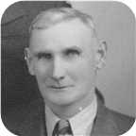
 |  |  |  |  | Leonard Bowman |  |  |  |  |  |  |  |  |  |  |  |  |  |  |  | Edna Effie
 |  |  |  |  | Robertson |  |  |  |  |  |  |  |  |  |  |  |  |  |  |  | Bell
 |  |  |  |  | 1918– |  |  |  |  |  |  |  |  |  |  |  |  |  |  |  | 1920–
 |  |  |  |  |  |  |  |  |  |  |  |  |  |  |  |  |  |  |  |  | 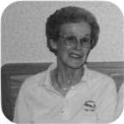
 |  |  |  |  |  |  |  |  | Marriage: 1945
 |  |  |  |  |  |  |  | Leonard Bowman |  |  |  | Roy Wesley |  |  |  | Ian Douglas |  |  |  | Janet Louise
 |  |  |  |  |  |  |  | Robertson |  |  |  | Robertson |  |  |  | Robertson |  |  |  | Robertson
 |  |  |  |  |  |  |  | 1947– |  |  |  | 1949–1949 |  |  |  | 1950– |  |  |  | 1951–
 |  |  |  |  |  |  |  | 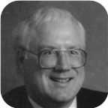 |  |  |  |  |  |  |  | 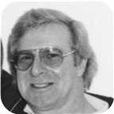 |  |  |  | 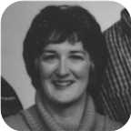

45. Captain Leonard Bowman Robertson was born on Saturday, October 19, 1918, in Stellerton,N.S. He is the son of Leonard Bowman Robertson and Louisa Reid Ives (36).  Leonard Bowman was educated in 1 year Mt Allison Academy (Commercial). He was employed in May 1936 in Branch Manager for Lownsbury's.
  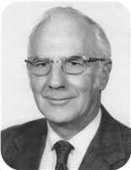
  Leonard Bowman Robertson
At the age of 26, Leonard Bowman married Edna Effie Bell on Saturday, September 08, 1945, in Saint John, N.B., when she was 24 years old. They had four children.  Edna Effie was born in Empress, Alberta, on Saturday, November 13, 1920.
  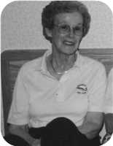
  Edna Effie Bell
She is the daughter of Roy Wesley Bell and Ethel Irene Smith. She is employed in Registered Nurse.
Children of Leonard Bowman Robertson and Edna Effie Bell:
+ 59 m I. Leonard Bowman Robertson was born in Moncton,N.B., on January 22, 1947.
  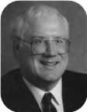
  Leonard
m II. Roy Wesley Robertson was born on January 14, 1949. He died on March 02, 1949.
m III. Ian Douglas Robertson was born in Chatham on August 23, 1950. He is employed in Taxi Driver.
  
  Ian
+ 60 f IV. Janet Louise Robertson was born on November 30, 1951.
  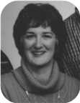
  Janet

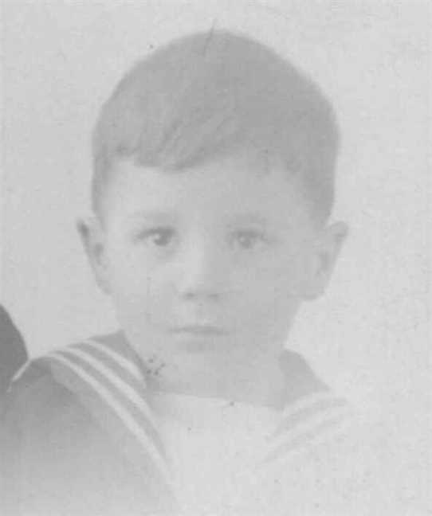  Figure 59: Leonard B Robertson |  | 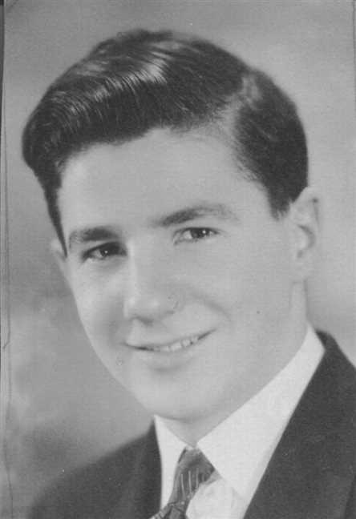  Figure 60: Leonard B Robertson

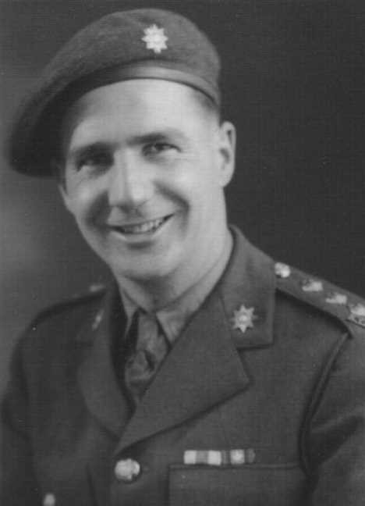  Figure 61: Leonard B Robertson |  | 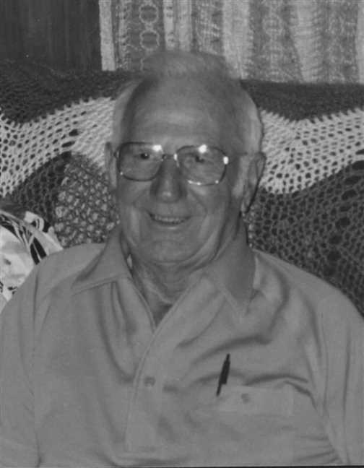  Figure 62: Leonard B Robertson

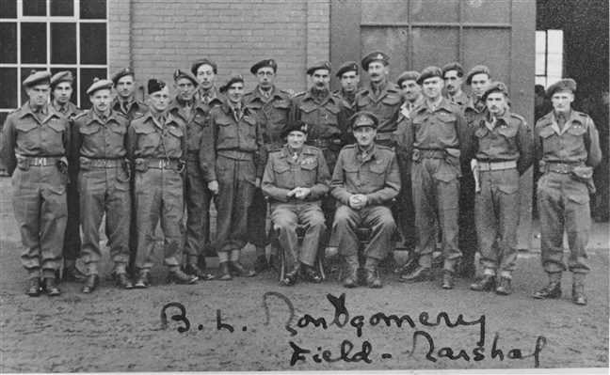  Figure 63: Army5 |  | Figure 64: Nora James Leonard Robertson(1)

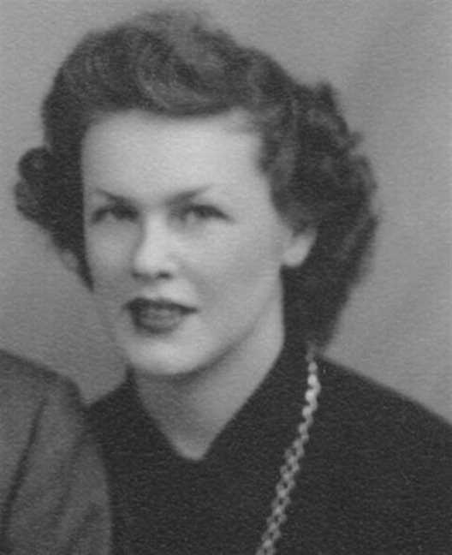  Figure 65: Edna Bell |  | 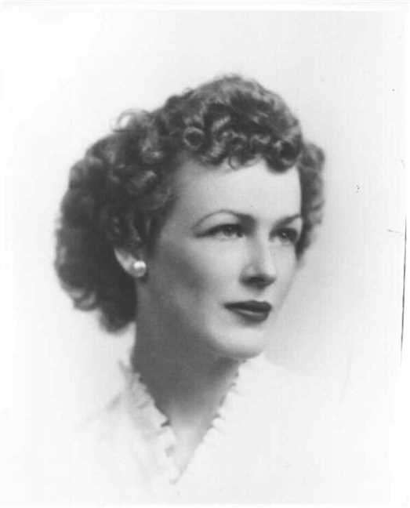  Figure 66: Edna Bell

Family of Norah Robertson and Lester Bongard
 |  |  |  |  |  |  |  |  |  |  |  |  |  |  |  | James Alexander |  |  |  | Annie Fraser |  |  |  | Arthur |  |  |  | Ocenia
 |  |  |  |  |  |  |  |  |  |  |  |  |  |  |  | Robertson |  |  |  | Campbell |  |  |  | Ives |  |  |  | Fraser
 |  |  |  |  |  |  |  |  |  |  |  |  |  |  |  | 1859–1947 |  |  |  | 1867–1960 |  |  |  | 1854–1913 |  |  |  | 1853–1935
 | ? |  |  |  |  |  |  |  | ? |  |  |  |  |  |  |  | Leonard Bowman |  |  |  |  |  |  |  | Louisa Reid
 | Bongard |  |  |  |  |  |  |  | ? |  |  |  |  |  |  |  | Robertson |  |  |  |  |  |  |  | Ives
 |  |  |  |  |  |  |  |  |  |  |  |  |  |  |  |  | 1890–1972 |  |  |  |  |  |  |  | 1889–1982
 |  |  |  |  | Lester William |  |  |  |  |  |  |  |  |  |  |  |  |  |  |  | Norah Louise
 |  |  |  |  | Bongard |  |  |  |  |  |  |  |  |  |  |  |  |  |  |  | Robertson
 |  |  |  |  | 1921–2000 |  |  |  |  |  |  |  |  |  |  |  |  |  |  |  | 1921–
 |  |  |  |  |  |  |  |  | Married
 |  |  |  |  |  |  |  | Robert William |  |  |  | John Reid |  |  |  | Norah Lynn |  |  |  | David
 |  |  |  |  |  |  |  | Bongard |  |  |  | Bongard |  |  |  | Bongard |  |  |  | Bongard
 |  |  |  |  |  |  |  | 1946– |  |  |  | 1949– |  |  |  | 1953– |  |  |  | 1958–
 |  |  |  |  |  |  |  |  |  |  |  |  |  |  |  | 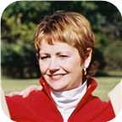

46. Norah Louise Robertson was born on Thursday, February 17, 1921, in Niagara Falls,Ont. She is the daughter of Leonard Bowman Robertson and Louisa Reid Ives (36).
  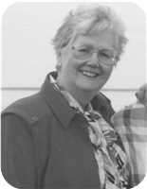
  Norah Louise Robertson
She married Lester William Bongard. They had four children.
Lester William was born in Norwood, Ontario, on Thursday, September 29, 1921. He was the son of ? Bongard and ? ?.
He was educated in From Orilia. Lester William was employed in Mechanical Engineer.
Lester William reached 78 years of age and died in Orillia,Ont., on January 14, 2000.
Children of Norah Louise Robertson and Lester William Bongard:
+ 61 m I. Robert William Bongard was born in Niagara Falls on August 04, 1946.
+ 62 m II. John Reid Bongard was born in Niagara Falls on September 18, 1949.
+ 63 f III. Norah Lynn Bongard was born in Niagara Falls on September 17, 1953.
  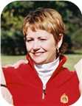
  Norah
m IV. David Bongard was born in Niagara Falls on December 25, 1958.

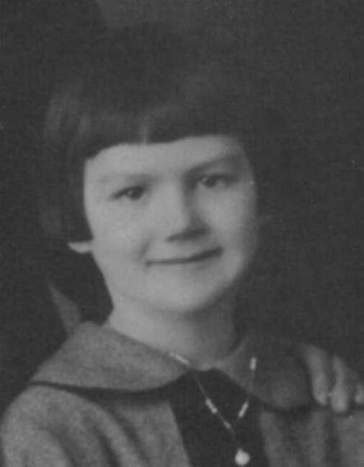  Figure 67: Norah Louise Robertson |  | 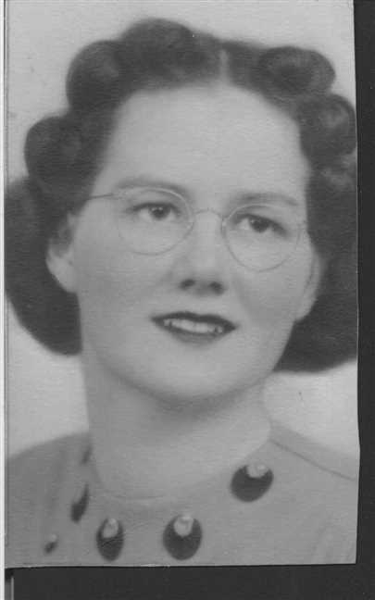  Figure 68: Norah Louise Robertson

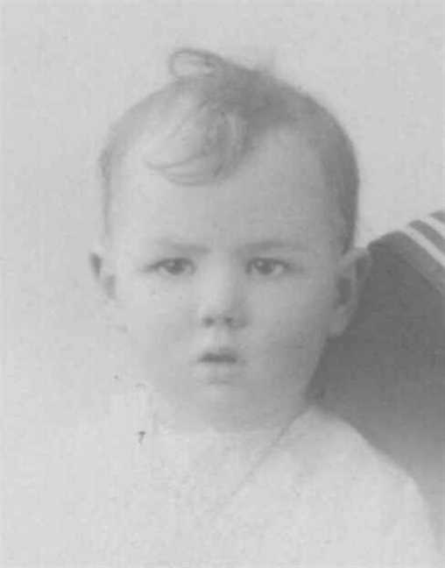
Figure 69: Norah Louise Robertson

Family of Russel Ives and Beryl Walker
Arthur |  |  |  | Ocenia |  |  |  | Bliss |  |  |  | Abigail
Ives |  |  |  | Fraser |  |  |  | Manship |  |  |  | Baxter
1854–1913 |  |  |  | 1853–1935
 | Daniel Fraser |  |  |  |  |  |  |  | Laura Maud
 | Ives |  |  |  |  |  |  |  | Manship
 | 1887–1964 |  |  |  |  |  |  |  | 1883–1979
 |  |  |  |  | Russel Bliss |  |  |  |  |  |  |  |  |  |  |  |  |  |  |  | Beryl
 |  |  |  |  | Ives |  |  |  |  |  |  |  |  |  |  |  |  |  |  |  | Walker
 |  |  |  |  | –1912
 |  |  |  |  |  |  |  |  | Married

47. Russel Bliss Ives. He was the son of Daniel Fraser Ives (37) and Laura Maud Manship.
Russel Bliss died on September 19, 1912.
He married Beryl Walker.

Family of Frances Ives and William MacCaullum
 |  |  |  |  |  |  |  |  |  |  |  |  |  |  |  | Arthur |  |  |  | Ocenia |  |  |  | Bliss |  |  |  | Abigail
 |  |  |  |  |  |  |  |  |  |  |  |  |  |  |  | Ives |  |  |  | Fraser |  |  |  | Manship |  |  |  | Baxter
 |  |  |  |  |  |  |  |  |  |  |  |  |  |  |  | 1854–1913 |  |  |  | 1853–1935
 |  |  |  |  |  |  |  |  |  |  |  |  |  |  |  |  | Daniel Fraser |  |  |  |  |  |  |  | Laura Maud
 |  |  |  |  |  |  |  |  |  |  |  |  |  |  |  |  | Ives |  |  |  |  |  |  |  | Manship
 |  |  |  |  |  |  |  |  |  |  |  |  |  |  |  |  | 1887–1964 |  |  |  |  |  |  |  | 1883–1979
 |  |  |  |  | William |  |  |  |  |  |  |  |  |  |  |  |  |  |  |  | Frances C
 |  |  |  |  | MacCaullum |  |  |  |  |  |  |  |  |  |  |  |  |  |  |  | Ives
 |  |  |  |  |  |  |  |  | Married

48. Frances C Ives. She was the daughter of Daniel Fraser Ives (37) and Laura Maud Manship.
  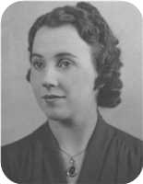
  Frances C Ives
She married William MacCaullum.

Family of Hilda Ives and George Wright
 |  |  |  |  | George |  |  |  |  |  |  |  |  |  |  |  |  |  |  |  | Hilda
 |  |  |  |  | Wright |  |  |  |  |  |  |  |  |  |  |  |  |  |  |  | Ives
 |  |  |  |  |  |  |  |  | Married

49. Hilda Ives.
She married George Wright.

Family of James Ives and Gladys Gaston
Arthur |  |  |  | Ocenia |  |  |  | James |  |  |  | Mary
Ives |  |  |  | Fraser |  |  |  | Eastwood |  |  |  | MacIntosh
1854–1913 |  |  |  | 1853–1935
 | Lewis Zindord |  |  |  |  |  |  |  | Jenny Mitchell |  |  |  |  |  |  |  | Clarence |  |  |  |  |  |  |  | Ernestine
 | Ives |  |  |  |  |  |  |  | Eastwood |  |  |  |  |  |  |  | Gaston |  |  |  |  |  |  |  | Hatch
 | 1888–1941 |  |  |  |  |  |  |  | 1880–1942
 |  |  |  |  | James Eastwood |  |  |  |  |  |  |  |  |  |  |  |  |  |  |  | Gladys Jean
 |  |  |  |  | Ives |  |  |  |  |  |  |  |  |  |  |  |  |  |  |  | Gaston
 |  |  |  |  | 1916– |  |  |  |  |  |  |  |  |  |  |  |  |  |  |  | 1916–1998
 |  |  |  |  |  |  |  |  | Married
 |  |  |  |  |  |  |  |  |  |  |  | John Gillan |  |  |  | Marjory
 |  |  |  |  |  |  |  |  |  |  |  | Ives |  |  |  | Ives

50. James Eastwood Ives was born on Wednesday, November 22, 1916. He is the son of Lewis Zindord Ives (38) and Jenny Mitchell Eastwood.
  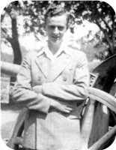
  James Eastwood Ives
He married Gladys Jean Gaston. They had two children.
Gladys Jean was born in Stellarton,N.S., on Tuesday, January 04, 1916. She was the daughter of Clarence Gaston and Ernestine Hatch.
Gladys Jean reached 82 years of age and died in Aberdeen Hospital, New Glasgow, on June 22, 1998.
Thursday, June 25, 1998 The Halifax Herald Limited
IVES, Gladys JeanIVES, Gladys Jean - Hopewell, died June 22, 1998, in Aberdeen Hospital, New Glasgow. Born January 4, 1916, in Stellarton, the second daughter of the late Clarence and Ernestine (Hatch) Gaston. Surviving are son, John (Jack) Gillan and Iris, Halifax; daughter, Rev. Marjory Cornelius and Arleigh, Hopewell; sister, Mrs. Carl (Helen) Tupper, Halifax; brother-in-law, Gordon Ives, Kingston; three grandchildren; three great-grandchildren; three stepchildren; a number of step-grandchildren and a step-great-grandchild. She was predeceased by her husband, J. Eastwood Ives; sister, Mrs. Vera Wadden, Stellarton; two infant grandchildren. Gladys was very active in the community, having been a member and officer of Goodwill Chapter 235 OES of Clifford, Ont., and a recent member of Armcrest Chapter 45 OES, Halifax. She was also a member and officer of the Cedars of Lebanon Shrine 21, East York, Ont. She was a member of Fairview United Church, Halifax, and the Carrie Rogers UCW Unit. She was an avid crocheter and knitter. She will be fondly remembered for her baby sets, blankets, teddy bears, afghans, lap and shoulder robes and mittens. In her earlier years, along with her sister and Anna MacKay, she operated Nova Craft Hat Shop, New Glasgow. She was later employed with Canadian Surety, Ontario, from where she retired. Following cremation, a funeral service will be held in Fairview United Church, Halifax, Friday, June 26, at 2:30 p.m., Rev. Kevin Little presiding. A reception will follow in the church hall. Memorial service will be held in St. Columba United Church, Hopewell, Saturday, June 27, at 11 a.m., Rev. Norman Marple presiding. A reception will follow in the church hall. Private family burial will be held in Lorne Street Cemetery, New Glasgow, following the reception. Family flowers only. Donations in Gladys' name may be made to Grand Chapter Estarl Fund of the Order of the Eastern Star of Nova Scotia and Prince Edward Island; the Pictou County Help Line, PO Box 386, New Glasgow, B2H 5E5 or a charity of one's choice. Arrangements entrusted to H.W. Angus Funeral Home, New Glasgow.
Children of James Eastwood Ives and Gladys Jean Gaston:
+ 64 m I. John Gillan Ives.
+ 65 f II. Marjory Ives.

Family of David Ives and Florence Smith
Arthur |  |  |  |  |  | Ocenia |  |  |  |  |  | Hugh |  |  |  |  |  | Mary
Ives |  |  |  |  |  | Fraser |  |  |  |  |  | MacMillan |  |  |  |  |  | ?
1854–1913 |  |  |  |  |  | 1853–1935
 |  | John Fraser |  |  |  |  |  |  |  |  |  |  |  | Jessie Margaret
 |  | Ives |  |  |  |  |  |  |  |  |  |  |  | MacMillan
 |  | 1895–1970 |  |  |  |  |  |  |  |  |  |  |  | 1898–1994
 |  |  |  |  |  |  |  | David Hugh |  |  |  |  |  |  |  |  |  |  |  |  |  |  |  |  |  |  |  |  |  |  |  | Florence
 |  |  |  |  |  |  |  | Ives |  |  |  |  |  |  |  |  |  |  |  |  |  |  |  |  |  |  |  |  |  |  |  | Smith
 |  |  |  |  |  |  |  | 1924–
 |  |  |  |  |  |  |  |  |  |  |  |  |  | Married
 |  |  |  |  |  |  |  |  | John David |  |  |  |  |  | Sarah Jean |  |  |  |  |  | Pearl |  |  |  |  |  | Joanne |  |  |  |  |  | Brian
 |  |  |  |  |  |  |  |  | Ives |  |  |  |  |  | Ives |  |  |  |  |  | Ives |  |  |  |  |  | Ives |  |  |  |  |  | Ives
 |  |  |  |  |  |  |  |  | 1969– |  |  |  |  |  | 1969–

51. David Hugh Ives was born on Monday, February 25, 1924, in New Glasgow,Nova Scotia. He is the son of John Fraser Ives (39) and Jessie Margaret MacMillan.
  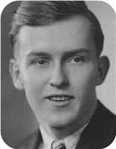
  David Hugh Ives
IVES, David Hugh "Fin"
IVES, David Hugh "Fin" - 59 Bridge Ave., Stellarton, passed away Wednesday, October 17, 2001, in Aberdeen Hospital, New Glasgow. Born in New Glasgow, he was the son of the late John Fraser and Jessie Margaret (MacMillan) Ives. He was a resident of Plymouth and Stellarton for all of his life. He began his working career with the CNR in 1945 and retired with over 40 years of service. He was a member of the United Trainmen's Union, a long-time member of the Abercrombie Golf and Country Club and had served as a director of the Nova Scotia Golf Association. He was also active in the Pictou County Military Rifle Association. David was an active volunteer and supporter of Stellarton Minor Hockey Association and Kin Family of New Glasgow. He is survived by his wife, the former Florence "Flo" Smith; daughters, Jean Ives-Fraser, New Glasgow; Pearl (Bill) MacMillan, Stellarton; Joanne, Stellarton; sons, John David (Tammy), New Minas; Brian, Sinclairs Island; grandchildren, T-Anna, Cory, Mark, Matthew; sister, Nora Ramscar, Plymouth; nephews, Vincent, Larry; niece, Margaret. Besides his parents, he was predeceased by nephew, David; brother-in-law, Vic. His remains will rest in H.C. MacQuarrie Funeral Home, Stellarton, with visitation 2-4, 7-9 p.m. Saturday. Funeral service will be held 2:30 p.m. Sunday in First Presbyterian Church, Stellarton, Jessie Johnson officiating. Burial will take place in Riverton Cemetery. Family flowers only please. Donations in his memory may be made to the Stellarton Minor Hockey Association, Women Alike Breast Cancer Society, P.O. Box 254, New Glasgow, NS B2H 5E3 or a charity of one's choice.
He married Florence Smith. They have five children.
Children of David Hugh Ives and Florence Smith:
+ 66 m I. John David Ives was born in March 1969.
+ 67 f II. Sarah Jean Ives was born in March 1969.
+ 68 f III. Pearl Ives.
f IV. Joanne Ives.
m V. Brian Ives.

Family of Norah Ives and Clwyd Ramscar
 |  |  |  |  |  |  |  |  |  |  |  |  |  |  |  | Arthur |  |  |  | Ocenia |  |  |  | Hugh |  |  |  | Mary
 |  |  |  |  |  |  |  |  |  |  |  |  |  |  |  | Ives |  |  |  | Fraser |  |  |  | MacMillan |  |  |  | ?
 |  |  |  |  |  |  |  |  |  |  |  |  |  |  |  | 1854–1913 |  |  |  | 1853–1935
 |  |  |  |  |  |  |  |  |  |  |  |  |  |  |  |  | John Fraser |  |  |  |  |  |  |  | Jessie Margaret
 |  |  |  |  |  |  |  |  |  |  |  |  |  |  |  |  | Ives |  |  |  |  |  |  |  | MacMillan
 |  |  |  |  |  |  |  |  |  |  |  |  |  |  |  |  | 1895–1970 |  |  |  |  |  |  |  | 1898–1994
 |  |  |  |  | Clwyd Vincent |  |  |  |  |  |  |  |  |  |  |  |  |  |  |  | Norah MacGillivary
 |  |  |  |  | Ramscar |  |  |  |  |  |  |  |  |  |  |  |  |  |  |  | Ives
 |  |  |  |  | 1922–1988 |  |  |  |  |  |  |  |  |  |  |  |  |  |  |  | 1921–
 |  |  |  |  | 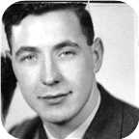
 |  |  |  |  |  |  |  |  | Marriage: 1943
 |  |  |  |  |  |  |  | David Frederick |  |  |  | John Vincent |  |  |  | Jessie Margaret |  |  |  | Lawrence James
 |  |  |  |  |  |  |  | Ramscar |  |  |  | Ramscar |  |  |  | Ramscar |  |  |  | Ramscar
 |  |  |  |  |  |  |  | 1944–1970 |  |  |  | 1947– |  |  |  | 1948– |  |  |  | 1951–

52. Norah MacGillivary Ives was born on Monday, March 07, 1921. She is the daughter of John Fraser Ives (39) and Jessie Margaret MacMillan.
  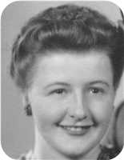
  Norah MacGillivary Ives
At the age of 22, Norah MacGillivary married Clwyd Vincent Ramscar on Tuesday, November 23, 1943, when he was 21 years old. They had four children.  Clwyd Vincent was born in St. Asaph, North Wales, on Saturday, September 23, 1922. He reached 65 years of age and died on January 18, 1988.
  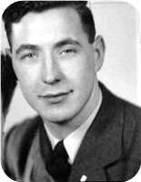
  Clwyd Vincent Ramscar
The Pictou Advocate, Wednesday, January 20, 1988 - Clwyd Vincent Ramscar, 65, Plymouth Park, Pictou County, died Monday, Jan. 18, at home. He was born in St. Asaph, Wales. He is survived by his wife, Norah; two sons, Vincent and Larry; a daughter, Margaret; three grandchildren; two brothers and two sisters, all in England. He was predeceased by his parents and a son, David. The body will be cremated.
Children of Norah MacGillivary Ives and Clwyd Vincent Ramscar:
m I. David Frederick Ramscar was born in June 1944. He died in 1970 at the age of 25.
+ 69 m II. John Vincent Ramscar was born in New Glasgow,Nova Scotia, on May 14, 1947.
+ 70 f III. Jessie Margaret Ramscar was born in July 1948.
m IV. Lawrence James Ramscar was born in March 1951.

Family of Charles Gray and Catherine Clark
Alexander Black |  |  |  |  |  | Agnes M. |  |  |  |  |  | Charles Lever |  |  |  |  |  | Jessie
Gray |  |  |  |  |  | Whyte |  |  |  |  |  | Rood |  |  |  |  |  | Fraser
1847–1916 |  |  |  |  |  | 1847–1936 |  |  |  |  |  | 1850–1922 |  |  |  |  |  | 1855–1947
 |  | Henry Irving Beecher |  |  |  |  |  |  |  |  |  |  |  | Mary Alice
 |  | Gray |  |  |  |  |  |  |  |  |  |  |  | Rood
 |  | 1887–1976 |  |  |  |  |  |  |  |  |  |  |  | 1880–1973
 |  |  |  |  |  |  |  | Charles Lever Rood |  |  |  |  |  |  |  |  |  |  |  |  |  |  |  |  |  |  |  |  |  |  |  | Catherine Jane
 |  |  |  |  |  |  |  | Gray |  |  |  |  |  |  |  |  |  |  |  |  |  |  |  |  |  |  |  |  |  |  |  | Clark
 |  |  |  |  |  |  |  | 1913–1995
 |  |  |  |  |  |  |  |  |  |  |  |  |  | Marriage: 1943
 |  |  |  |  |  |  |  |  |  |  |  |  |  |  |  |  |  |  |  |  | ?
 |  |  |  |  |  |  |  |  |  |  |  |  |  |  |  |  |  |  |  |  | Gray

53. Charles Lever Rood Gray was born on Friday, May 16, 1913, in New Glasgow, N.S. He was the son of Henry Irving Beecher Gray and Mary Alice Rood (40).
Charles Lever Rood died on January 12, 1995, at the age of 81.
Charles Lever Rood married Catherine Jane Clark on Tuesday, April 13, 1943, in New Glasgow, Nova Scotia. They had one daughter.
She was also known as Kay.
Daughter of Charles Lever Rood Gray and Catherine Jane Clark:
+ 71 f I. ? Gray.

Family of Harry Gray and Dorothy Phillips
Alexander Black |  |  |  |  |  | Agnes M. |  |  |  |  |  | Charles Lever |  |  |  |  |  | Jessie
Gray |  |  |  |  |  | Whyte |  |  |  |  |  | Rood |  |  |  |  |  | Fraser
1847–1916 |  |  |  |  |  | 1847–1936 |  |  |  |  |  | 1850–1922 |  |  |  |  |  | 1855–1947
 |  | Henry Irving Beecher |  |  |  |  |  |  |  |  |  |  |  | Mary Alice |  |  |  |  |  |  |  |  |  |  |  | William |  |  |  |  |  |  |  |  |  |  |  | Rose
 |  | Gray |  |  |  |  |  |  |  |  |  |  |  | Rood |  |  |  |  |  |  |  |  |  |  |  | Phillips |  |  |  |  |  |  |  |  |  |  |  | Smallcome
 |  | 1887–1976 |  |  |  |  |  |  |  |  |  |  |  | 1880–1973
 |  |  |  |  |  |  |  | Harry Alexander |  |  |  |  |  |  |  |  |  |  |  |  |  |  |  |  |  |  |  |  |  |  |  | Dorothy Hazel
 |  |  |  |  |  |  |  | Gray |  |  |  |  |  |  |  |  |  |  |  |  |  |  |  |  |  |  |  |  |  |  |  | Phillips
 |  |  |  |  |  |  |  | 1916– |  |  |  |  |  |  |  |  |  |  |  |  |  |  |  |  |  |  |  |  |  |  |  | 1919–
 |  |  |  |  |  |  |  |  |  |  |  |  |  | Married
 |  |  |  |  |  |  |  |  |  |  |  |  |  |  | Allan Roderick |  |  |  |  |  | Robert Irving |  |  |  |  |  | Norma Jean
 |  |  |  |  |  |  |  |  |  |  |  |  |  |  | Gray |  |  |  |  |  | Gray |  |  |  |  |  | Gray
 |  |  |  |  |  |  |  |  |  |  |  |  |  |  | 1944– |  |  |  |  |  | 1947–1983 |  |  |  |  |  | 1949–

54. Harry Alexander Gray was born on Friday, March 10, 1916, in New Glasgow, N.S. He is the son of Henry Irving Beecher Gray and Mary Alice Rood (40).
He married Dorothy Hazel Phillips. They had three children.
Dorothy Hazel was born in Stellarton,N.S., on Sunday, April 06, 1919. She is the daughter of William Phillips and Rose Smallcome.
Children of Harry Alexander Gray and Dorothy Hazel Phillips:
+ 72 m I. Allan Roderick Gray was born in Amherst on August 31, 1944.
+ 73 m II. Robert Irving Gray was born in Brockville,Ont., on December 27, 1947. He died in Nelson,B.C., on January 05, 1983, at the age of 35.
+ 74 f III. Norma Jean Gray was born in Brockville on May 02, 1949.

John Gray
55. Lt.Col John Allan Gray was born on Monday, January 20, 1919, in New Glasgow, N.S. He was the son of Henry Irving Beecher Gray and Mary Alice Rood (40).
John Allan died in New Glasgow,Nova Scotia, on September 18, 1994, at the age of 75.
John Allan Gray was a Lt. Col.
Relationships with Clare Ross Dennison and Dorothy Hartling (Page 101) are known.

John Gray and Clare Dennison
Alexander Black |  |  |  | Agnes M. |  |  |  | Charles Lever |  |  |  | Jessie
Gray |  |  |  | Whyte |  |  |  | Rood |  |  |  | Fraser
1847–1916 |  |  |  | 1847–1936 |  |  |  | 1850–1922 |  |  |  | 1855–1947
 | Henry Irving Beecher |  |  |  |  |  |  |  | Mary Alice
 | Gray |  |  |  |  |  |  |  | Rood
 | 1887–1976 |  |  |  |  |  |  |  | 1880–1973
 |  |  |  |  | John Allan |  |  |  |  |  |  |  |  |  |  |  |  |  |  |  | Clare Ross
 |  |  |  |  | Gray |  |  |  |  |  |  |  |  |  |  |  |  |  |  |  | Dennison
 |  |  |  |  | 1919–1994 |  |  |  |  |  |  |  |  |  |  |  |  |  |  |  | –1960
 |  |  |  |  |  |  |  |  | Partner
 |  |  |  |  |  |  |  |  |  |  |  | Leslie |  |  |  | Eleanor Mary Rood
 |  |  |  |  |  |  |  |  |  |  |  | Gray |  |  |  | Gray
 |  |  |  |  |  |  |  |  |  |  |  |  |  |  |  | 1950–

Here are the details about John Allan Gray's first relationship, with Clare Ross Dennison. You can read more about John Allan on page 99.
Lt.Col John Allan Gray was partnered with Clare Ross Dennison. They had two daughters.
Clare Ross died in New Glasgow in 1960.
Daughters of John Allan Gray and Clare Ross Dennison:
+ 75 f I. Leslie Gray was born in Winnigeg,Manitoba.
+ 76 f II. Eleanor Mary Rood Gray was born in 1950.

Family of John Gray and Dorothy Hartling
Alexander Black |  |  |  | Agnes M. |  |  |  | Charles Lever |  |  |  | Jessie
Gray |  |  |  | Whyte |  |  |  | Rood |  |  |  | Fraser
1847–1916 |  |  |  | 1847–1936 |  |  |  | 1850–1922 |  |  |  | 1855–1947
 | Henry Irving Beecher |  |  |  |  |  |  |  | Mary Alice
 | Gray |  |  |  |  |  |  |  | Rood
 | 1887–1976 |  |  |  |  |  |  |  | 1880–1973
 |  |  |  |  | John Allan |  |  |  |  |  |  |  |  |  |  |  |  |  |  |  | Dorothy
 |  |  |  |  | Gray |  |  |  |  |  |  |  |  |  |  |  |  |  |  |  | Hartling
 |  |  |  |  | 1919–1994
 |  |  |  |  |  |  |  |  | Marriage: 1970

Here are the details about John Allan Gray's second relationship, with Dorothy Hartling. You can read more about John Allan on page 99.
Lt.Col John Allan Gray married Dorothy Hartling in 1970 in New Glasgow, Nova Scotia.

6th Generation

Family of Allan Robertson and Virginia Worobel
Leonard Bowman |  |  |  |  |  | Louisa Reid |  |  |  |  |  | Allan |  |  |  |  |  | Mary Christina |  |  |  |  |  | Stephen |  |  |  |  |  | Catherine |  |  |  |  |  | Demetro |  |  |  |  |  | Dora
Robertson |  |  |  |  |  | Ives |  |  |  |  |  | MacDonell |  |  |  |  |  | MacDonald |  |  |  |  |  | Worobel |  |  |  |  |  | Kohut |  |  |  |  |  | Kolynchuk |  |  |  |  |  | Kwasnica
1890–1972 |  |  |  |  |  | 1889–1982 |  |  |  |  |  | 1880–1926 |  |  |  |  |  | 1895–1978 |  |  |  |  |  |  |  |  |  |  |  |  |  |  |  |  |  | 1897–1945 |  |  |  |  |  | 1899–1972
 |  |  |  |  |  |  |  |  |  |  |  |  |  |  |  |  |  |  |  |  |  |  |  | 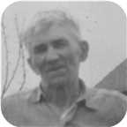 |  |  |  |  |  |  |  |  |  |  |  | 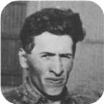 |  |  |  |  |  | 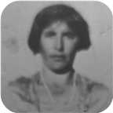
 |  | James Ives |  |  |  |  |  |  |  |  |  |  |  | Charlotte Helen |  |  |  |  |  |  |  |  |  |  |  | John |  |  |  |  |  |  |  |  |  |  |  | Jean
 |  | Robertson |  |  |  |  |  |  |  |  |  |  |  | MacDonell |  |  |  |  |  |  |  |  |  |  |  | Worobel |  |  |  |  |  |  |  |  |  |  |  | Kolynchuk
 |  | 1917–1989 |  |  |  |  |  |  |  |  |  |  |  | 1922–2005 |  |  |  |  |  |  |  |  |  |  |  | 1922–1979 |  |  |  |  |  |  |  |  |  |  |  | 1925–2012
 |  |  |  |  |  |  |  |  |  |  |  |  |  |  |  |  |  |  |  |  |  |  |  |  |  | 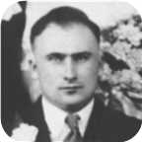 |  |  |  |  |  |  |  |  |  |  |  | 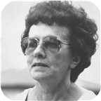
 |  |  |  |  |  |  |  | Allan James |  |  |  |  |  |  |  |  |  |  |  |  |  |  |  |  |  |  |  |  |  |  |  | Virginia
 |  |  |  |  |  |  |  | Robertson |  |  |  |  |  |  |  |  |  |  |  |  |  |  |  |  |  |  |  |  |  |  |  | Worobel
 |  |  |  |  |  |  |  | 1943– |  |  |  |  |  |  |  |  |  |  |  |  |  |  |  |  |  |  |  |  |  |  |  | 1945–
 |  |  |  |  |  |  |  |  |  |  |  |  |  |  |  |  |  |  |  |  |  |  |  |  |  |  |  |  |  |  |  | 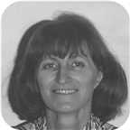
 |  |  |  |  |  |  |  |  |  |  |  |  |  | Marriage: 1969
 |  |  |  |  |  |  |  |  |  |  |  |  |  |  | Jenny Lind |  |  |  |  |  | Adele Marie |  |  |  |  |  | Lara Lynn
 |  |  |  |  |  |  |  |  |  |  |  |  |  |  | Robertson |  |  |  |  |  | Robertson |  |  |  |  |  | Robertson
 |  |  |  |  |  |  |  |  |  |  |  |  |  |  | 1970– |  |  |  |  |  | 1971– |  |  |  |  |  | 1973–
 |  |  |  |  |  |  |  |  |  |  |  |  |  |  | 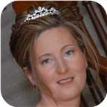 |  |  |  |  |  |  |  |  |  |  |  | 

56. Allan James Robertson was born on Thursday, August 26, 1943, in Pictou, Nova Scotia, Canada. He is the son of James Ives Robertson (44) and Charlotte Helen MacDonell.  Allan James was educated in BSc,MSc St Francis Xavier Univ. 1965,1967. He is employed in Chemist.
  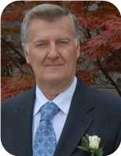
  Allan James Robertson
Allan James Robertson was born on Thursday, August 26, 1943, in Pictou, Nova Scotia, Canada. He is the son of James Ives Robertson and Charlotte Helen MacDonell. Allan's Father was born in Stellerton, NS but lived mainly in Pictou, NS. Allan's Mother was born in Judique on Cape Breton Island, NS She mainly grew up there but also later on lived in nearby Port Hood, NS. His paternal ancestors originated from a Scottish immigrant (John Robertson) who received a substantial land grant in the Churchville area of Pictou county, NS. Allan's maternal grandmother out lived three husbands (Allan MacDonell was the second and Father to Allan's Mother) The third husband was James MacDonald and he was the sheriff of Richmond county- Port Hood is the county seat. James's brother Angus L MacDonald was the premier of NS at one time. He has the Halifax harbour bridge named after him.
Allan's parents met in a place called Catalac, Quebec. They moved to Pictou, NS and then moved briefly to St, Catharines, ON where Allan's sister Lois was born in 1948. They lived in an apartment on Church St near Geneva St. Later that year, the family moved back to Pictou and lived for a brief period in a rented home on Beaches Road - near Laudon’s Beach. They then moved to Elm St in Pictou, NS. Later, they moved to 21 Chestnut St - Allan is most familiar with this address as he lived there from grade school until grade 10. Then his parents "swapped" homes with his paternal grand parents who lived 95 Faulkland St - SE corned of Faulkland and Patterson St. The house is still there but the number has changed due a change in the house numbering system. Bea's (nick name for his paternal grandmother) cousin - Margaret Harris (nee Fraser) lived in a home on Patterson St - across from Bea’s home. (SW corner of Faulkland and Patterson streets)
The home was actually jointly owned by Bea and her older (unmarried) sister Annie Ives. When Annie died, she willed her half to Allan's Father, When Bea died, Allan's Father got the home but his brother Len and sister Louise received all the fine antique furniture. Allan still has in his possession two mantle decorations that belonged to Bea's Mother - Ocenia Fraser. These pieces may even predate her as there is no record as to where they came from.
Allan's Father worked in the ship yard as a sheet metal worker. He later started his own business from some funding from his brother Len. However it was not entirely successful. They eventually sold the house and moved to a trailer home at 7 Oak St. Allan’s Father died in 1989.
Allan's kindergarten year was at the former Patterson school on Wellsford St near Poplar St. Grades 1 and 2 were at Stella Maris Convent. Allan remembers one of his class mates (his last name was Bell) drown after falling of the wharf. The whole class went to the funeral after visiting the remains in the family home. (Grades 3-6 were at the former Dawson school (now gone). Grades 7 and 8 were back at the Patterson school and finally grades 9 to 12 were at Pictou Academy. Allan's grades were "average" up until Grade 11 then in Grade 12, he and one of his friends (Wayne Madore) decided that they would be first in their class. Wayne did graduate 1st but Allan was 2nd. They edged out a girl (Maureen Mullins) who had continually placed first in her class through out her Junior and Senior high school years.
His closest friends while growing up were Wayne Madore and Melton Scanlan - they married two sisters and became teachers. They lived in Green Hill - near Pictou. John Murray who attended Dalhousie University and became a medical doctor. He practised in Sussex NB. Larry McCormack who also addended St Francis University and became a geologist.
In his younger years, Allan was very close to his paternal grandmother (Louisa "Bea" Robertson - nee Ives). He spent a lot of time with her and had a lot of fun playing cards with her. He was her "favourite grand child" - perhaps because he was the first. His grandmother also lived in St Catharines with him and his parents. Allan would often walk (mostly run) with her to Montebello Park and also visit with a family friends (Browns?) who lived at 56 lake St.
Bea willed him an old family photo album that belonged to her grandfather - William Ives. That photo album along with a booklet on the history of the Robertson family which was updated by his uncle Len Robertson, got Allan very much interested in the family genealogy. The result is this family tree of over 27,000 related persons.
Because of the influence of his high school science teacher (Mr. Peter Whyte), he decided to be a chemist. Mr. Whyte allowed Allan and his friend Wayne to stay after school and "experiment" in the lab - unsupervised!!. In hind sight, not a wise thing to do - but they survived with "all of their fingers" still attached.
Both Allan and Wayne enter the bachelors program at St Francis Xavier University in 1961 and took up chemistry as their major. Allan graduated from St Francis Xavier University (BS Hon. in 1965 and received his MSc 1967). Unfortunately, his friend Wayne got hooked on golf in his third year and then dropped out of university. He later took up teaching and did very well.
Allan lived on campus for his under graduate years and then boarded off campus while working on his master’s degree. Part of that time he lived with the Ray MacDonald family - Ray was a news announcer at the local radio station (CJFX). The MacDonald’s had five children - 4 boys named Mathew, Mark, Luke and John and one daughter - Mary.
His closest friends while at university were Tony McPhee-from Sydney, NS and one of the brightest students who was also a chemistry major. Tony taught Allan how to play chess. Out of hundreds of games, Allan only won once. Bruce Barron - a "pre-med". student from Portland, ME, Marry Osiany - she came from Hungary with her family in 1956 after the Hungarian uprising. Gary McQuade - also his roommate in his junior year. Gary was from Ottawa and was one of the star hockey players with St FX.
During his Freshman year, one of his chemistry lab instructors was a graduate student named "Bud Gallivan" - a nephew to "Danny Gallivan" who was a famous hockey announcer for the Montreal Canadians. Bud went on to Notre Dame University where he obtained his PhD. He then went to work for American Cyanamid at the corporate research lab in Stamford, CT. Bud rose through the ranks and eventually became VP of the division in which Allan worked. Allan’s boss at that time was a direct report to Bud and on his boss' passing, Allan reported to Bud for a brief period. Unfortunately, later in the same year, Bud died from a sudden heart attack. It was shortly after that that Allan was transferred from research to marketing. This was a traumatic change for a month or so, but then he thoroughly enjoyed the new position.
While at university, during the summer holidays, Allan worked as a lab technician for the then Cyanamid of Canada in Niagara Falls, ON. He worked at the "Welland Plant". For the first 4 summers, Allan resided with his Aunt and Uncle (Louise and Les Bongard). Louise is Allan's Father's younger sister. He hung out with his cousin Robert (Robbie). In later years, Robbie mover to Lunenburg, NS with his second wife.
He bought his first car in the summer of 1965 - a 1956 Ford Fairlane - for $160. Later, he drove it to Nova Scotia that fall and during the following spring, he sold it for $200 to a local in the Antigonish area.
During the summer of 1965, he resided at 138 Page St. in Catharines, ON. This is when he met his future wife - Virginia Worobel- who lived next door at 136 Page St. Virginia was in a nursing program at St. Joseph’s in Toronto. They "dated" - mostly by mail for about 2 years.
After Allan got his MSc degree in January of 1967, he moved back to 138 Page St. and got a permanent job with Cyanamid. Virginia finished her nursing program in 1968.
For the better part of a year during 1968 and Allan was transferred to Cyanamid’s Bound Brook NJ site. He boarded at a private home in Summerset, NJ for about 6 months (Mrs. Tureck’s home). While there he met a couple of friends who also worked for Cyanamid - Paul Gastrock and George Menghi. Both cane to Allan and Virginia’s wedding on April 19 of 1969.
After about 6 months, Allan rented an apartment in Raritan, NJ, During this year, he would commute to St Catharines every other weekend.
Then in December of 1968 he moved back to 136 Page St - just in time for a 3 -4 month labour strike at Cyanamid. During that period he was part of the management team that ran the Welland Plant as well as a limestone quarry in Beechville, ON. While at Beechville, he had a half hour training course on how to drive one of those huge trucks used to haul crude limestone from the quarry to the crusher. After 3 weeks of that he was reassigned to the Welland Plant as an operator in the production area - he much preferred this job.
The strike finally ended about a week prior to the wedding on April 19, 1969.. The wedding took place at the St Catharines cathedral with the reception at the Ukrainian Black Sea hall. It was a typical Ukrainian style wedding with approximately 150 guests. Allan's parents as well as his younger siblings, and aunts and uncles from Chatham, New Brunswick and Montreal attended. Virginia also had several relatives from Saskatoon and Winnipeg and Fort Frances, ON also attended.
Virginia's sister and brother-in-law were maid of honour and best man Allan's cousin Robert Bongard and Allan’s sister Lois as well as Virginia's cousin and a best friend - Ann Cotnam were also in the wedding party.
After the reception, they stayed over night at Prudholms hotel in Vineland before heading off to Jamaica for a week long honeymoon. They landed in Montego Bay and rented a car. They stayed there for two nights ant then toured the Island. Finally flew home from Kingston.
Virginia and Allan lived with her Mom at 136 Page St for about a year - during which Jenny was born on Jan 30, 1970. During the summer of the following year, they moved into a newly built home at 80 Meredith Dr. in St Catharines. Virginia's Mom moved with them. On July 6 of 1971 Adele was born and on August 11 of 1973 Lara was born.
The house on Meredith D.r was starting to get a bit crowded. They then bought their current home at 36 Forster Ave in Thorold for the amazing low price of $64,000 which likely would sell got $400,000 today (2018)
Allan spent his working career as a research chemist with Cyanamid of Canada Inc. - which later became Cytec Canada Inc. 1995 Since his retirement in 2013, Cytec was bought by Belgian company called Solvay. For about 40 years, he worked in the lab and then for the last 11 years, he took on a marketing role. Over his career, he obtained 12 patents and either authored or co-authored about 50 scientific papers. He also received a Circle of Excellence Award from the company for scientific achievement. As part of the award, there was a weekend all expenses paid visit to NYC - including a Broadway play and gala dinner with the other award winners and company executives. Stayed at a fancy hotel on Park avenue.
The job - especially in the later years, involved a considerable amount of travel - either to scientific conferences or visiting customers - almost all were outside of Canada - mainly in the US, Europe, South Africa and Australia. At several of the conferences, - those related to phosphorus chemistry- he presented talks. They took place is such places as Duke University in Durahm,SC, Tallin, Estonia, Saltzberg, Austria, Jeruslahem, San Francisco and Sundhi, Japan .On some occasions such as the conferences, Virginia came along.
In December of 1995, Cyanamid became Cytec. Allan eventually retired in April of 2013 after 51 years of serving with Cyanamid/Cytec. This was the second longest service term within the company. The company put on a great retirement party with about 70 employees attending. The guests also included the company CEO and well as the corporate HR VP.
At the age of 25, Allan James married Virginia Worobel on Saturday, April 19, 1969, in St Catharines, Niagara, Ontario, Canada, when she was 23 years old. They have three daughters.  Virginia was born in St Catharines, Ontario, on Monday, October 15, 1945.
  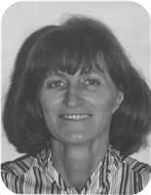
  Virginia Worobel
She is the daughter of John Worobel and Jean Kolynchuk.
Virginia received her RN degree from St Josephs (Toronto) in 1968. She worked for a time at Hotel Dieu (St Catharines) and later at The St Catharines General.
Daughters of Allan James Robertson and Virginia Worobel:
+ 77 f I. Jenny Lind Robertson was born in St. Catharines, Ontario, on January 30, 1970.
  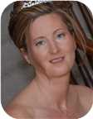
  Jenny
+ 78 f II. Adele Marie Robertson was born in St. Catharines on July 06, 1971.
  
  Adele
+ 79 f III. Lara Lynn Robertson was born in St. Catharines on August 11, 1973.
  
  Lara

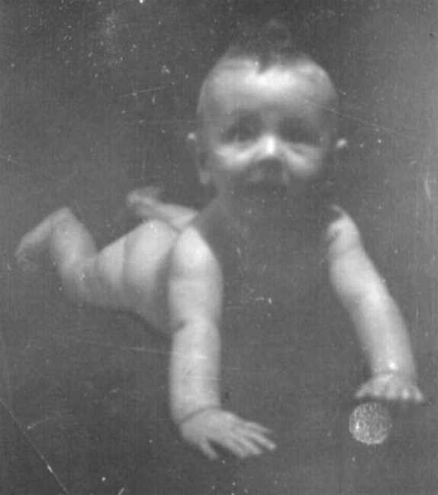  Figure 70: Allan James Robertson |  | 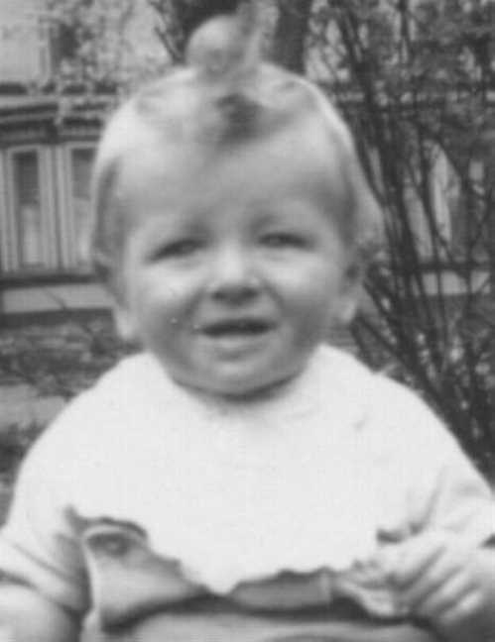  Figure 71: Allan James Robertson

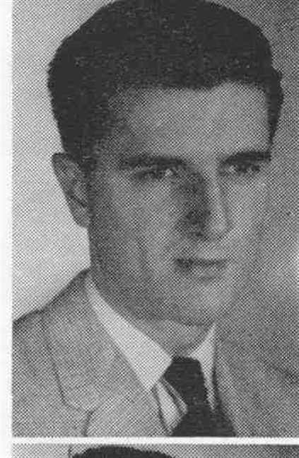  Figure 72: Allan James Robertson |  | 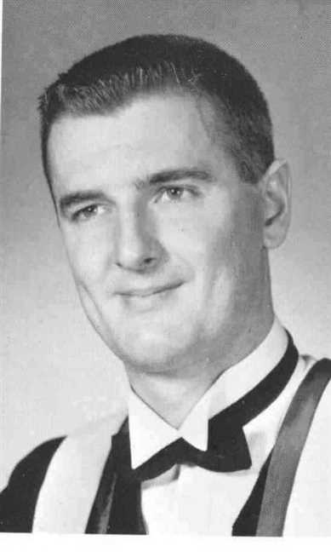  Figure 73: Allan James Robertson

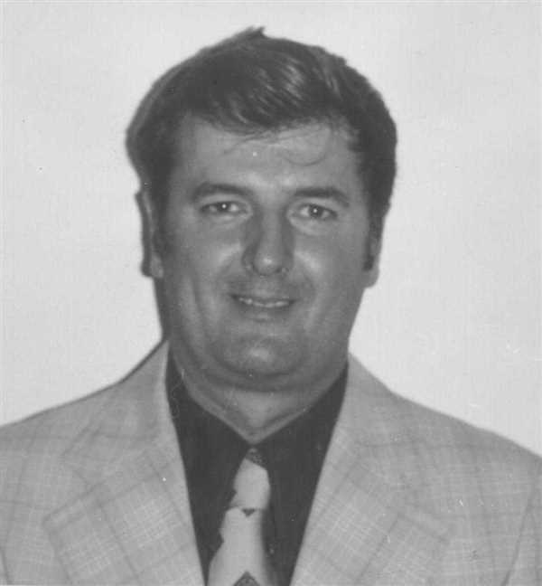  Figure 74: Allan James Robertson |  | 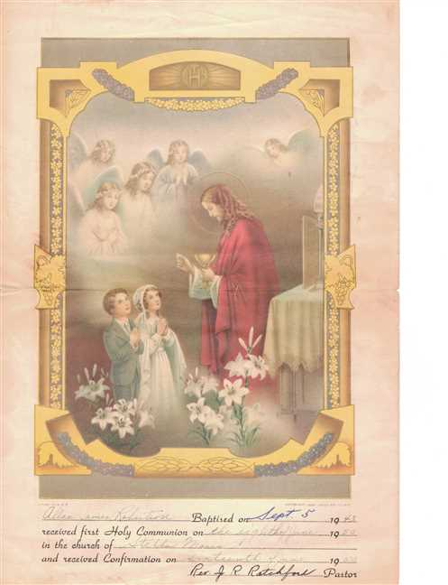  Figure 75: Allan Robertson's Baptism

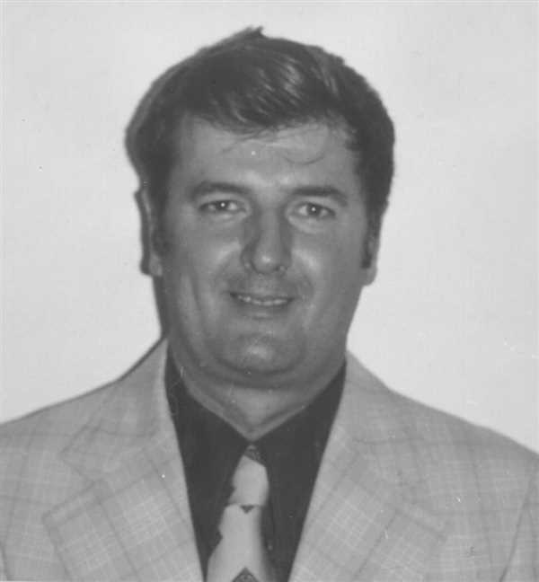  Figure 76: Allan James Robertson |  | 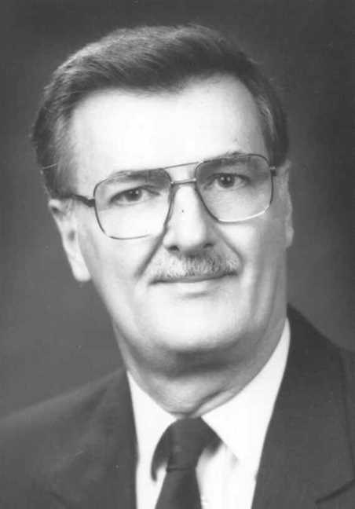  Figure 77: Allan James Robertson

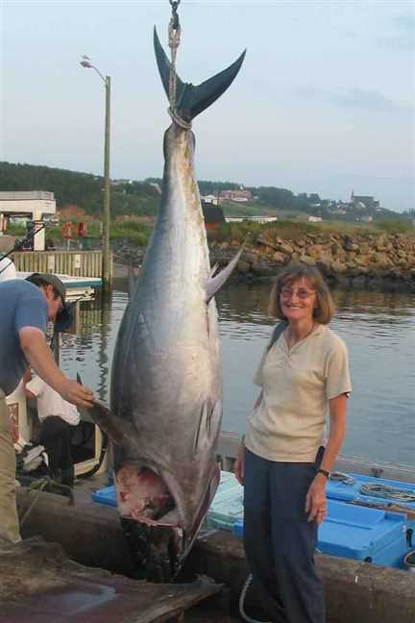  Figure 78: Vige and tuna |  | 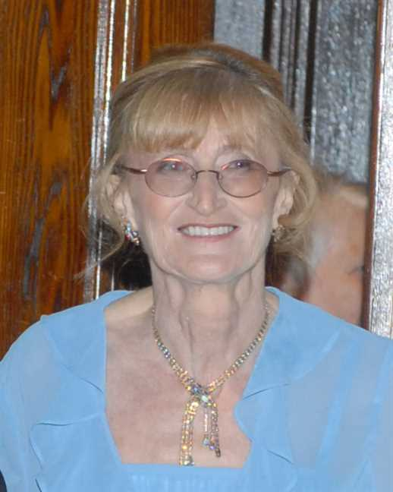  Figure 79: Virginia

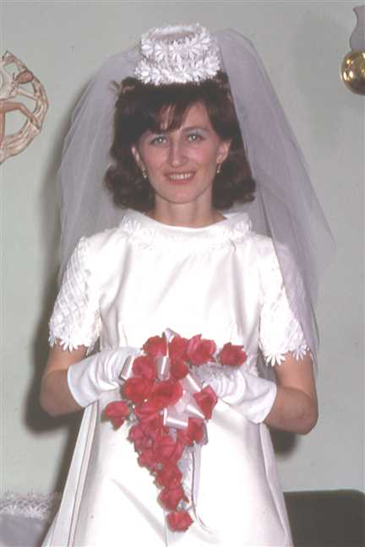  Figure 80: 196903-04Vige2b |  | 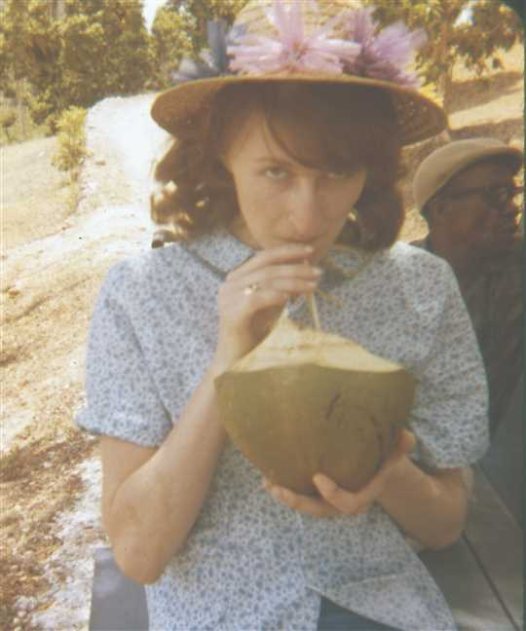  Figure 81: 196963-04YVige5

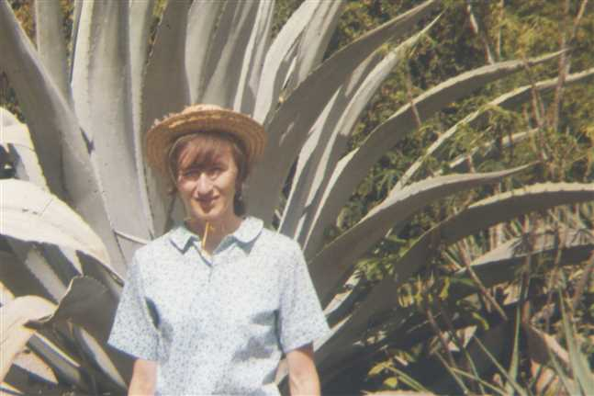  Figure 82: 196967-04YVige9 |  | 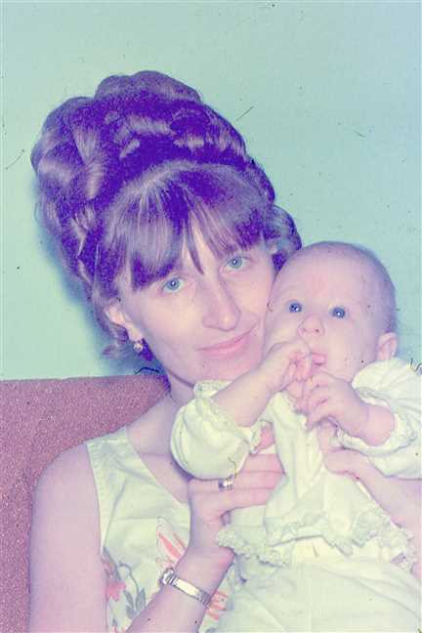  Figure 83: 197046-05Vige

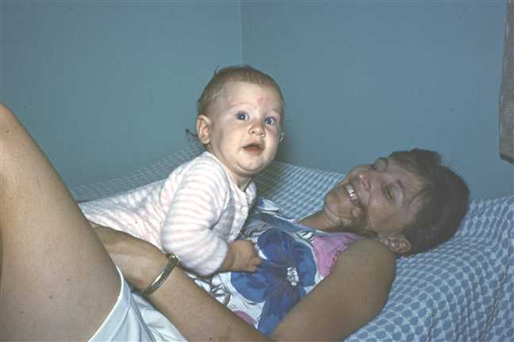  Figure 84: 197092-07VigeJenny2 |  | 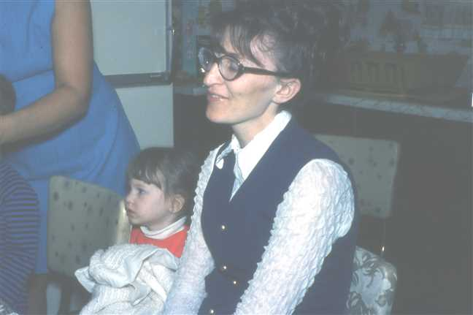  Figure 85: 1972-05JennyVige

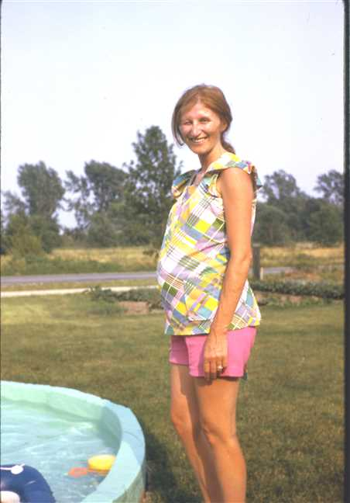  Figure 86: 1973-07Virginia |  | 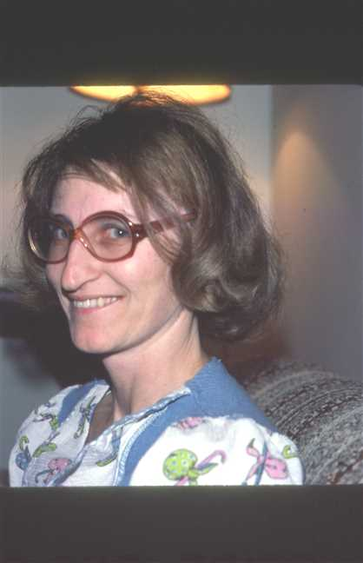  Figure 87: 1978-01Vige

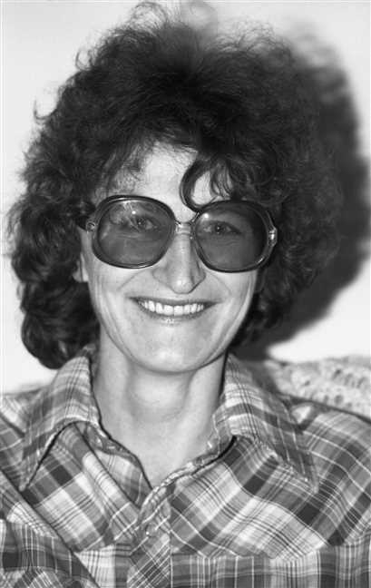  Figure 88: img001676 |  | 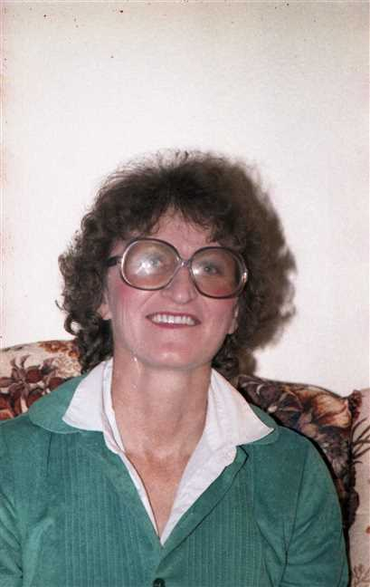  Figure 89: img001267

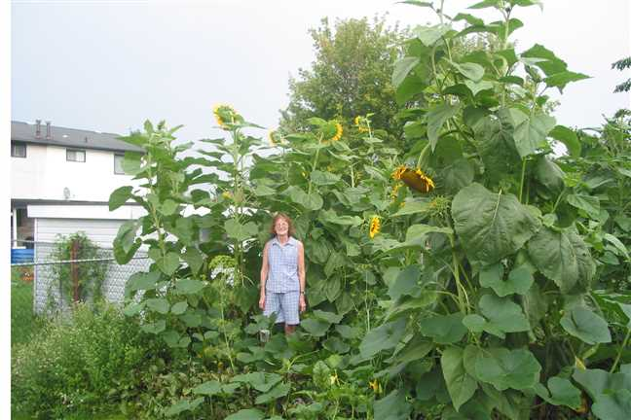
Figure 90: Garden1

Lois Robertson
57. Lois Christina Robertson was born on Friday, April 30, 1948, in St Catharines, Ontario. She was the daughter of James Ives Robertson (44) and Charlotte Helen MacDonell.  Lois Christina was educated in High School. She was employed in Secretary.
  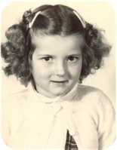
  Lois Christina Robertson
Lois Christina died in Pictou, Nova Scotia, Canada, on January 23, 1979, at the age of 30. Her cause of death was Complications from diabeties.
Lois was a diabetic from a very young age. (About 2 yr.) She had two children - one child from her first husband. The first was born in Montreal (about 1963) and the second born in St Catharines,Ont. (Nov. 3/1969) The first child was still-born. The second child was adopted at birth by a Dusette family in St Catharines, ON. She was named Michelle and later married Brian Procter.
She was married and divorced twice and was a friend of ? Cyr ( Pictou N.S.) who is the father of Michelle.
Lois died young due to diabetes complications.
Marriages with Joseph Dalton, Harold Little (Page 115) and ? Cyr (Page 116) are known.

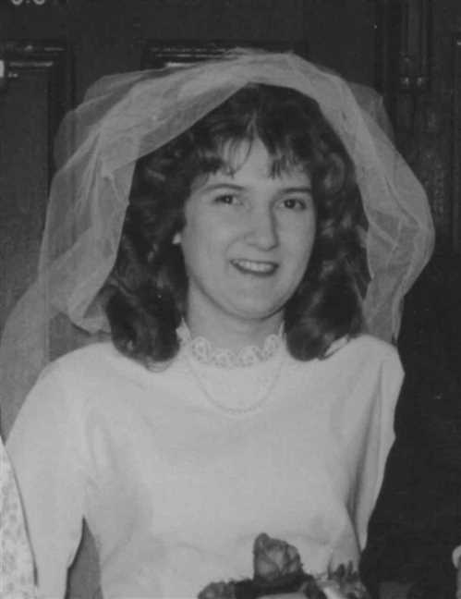  Figure 91: Lois Christina Robertson |  | 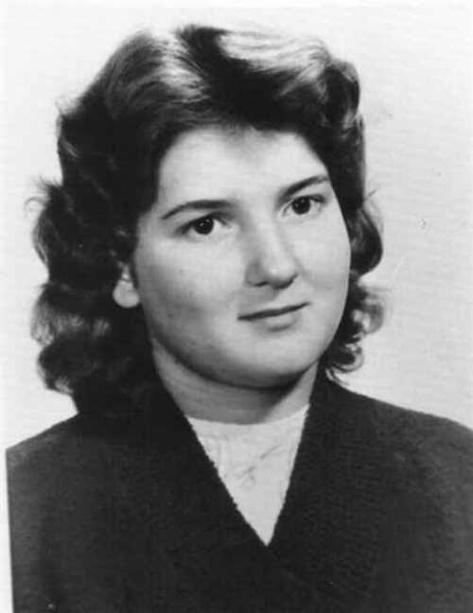  Figure 92: Lois Christina Robertson

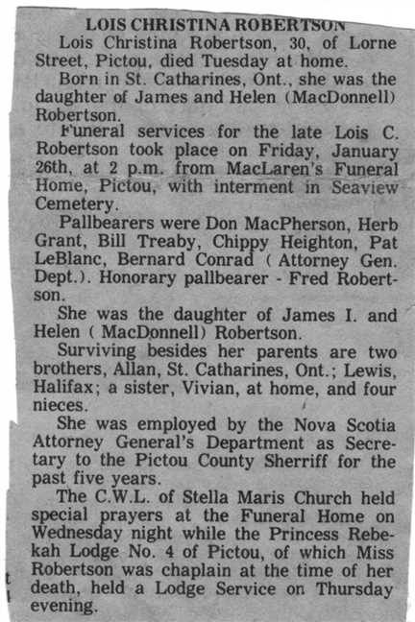
Figure 93: Lois Robertson Obit

Family of Lois Robertson and Joseph Dalton
 |  |  |  |  |  |  |  |  |  |  |  |  |  |  |  | Leonard Bowman |  |  |  | Louisa Reid |  |  |  | Allan |  |  |  | Mary Christina
 |  |  |  |  |  |  |  |  |  |  |  |  |  |  |  | Robertson |  |  |  | Ives |  |  |  | MacDonell |  |  |  | MacDonald
 |  |  |  |  |  |  |  |  |  |  |  |  |  |  |  | 1890–1972 |  |  |  | 1889–1982 |  |  |  | 1880–1926 |  |  |  | 1895–1978
 |  |  |  |  |  |  |  |  |  |  |  |  |  |  |  |  | James Ives |  |  |  |  |  |  |  | Charlotte Helen
 |  |  |  |  |  |  |  |  |  |  |  |  |  |  |  |  | Robertson |  |  |  |  |  |  |  | MacDonell
 |  |  |  |  |  |  |  |  |  |  |  |  |  |  |  |  | 1917–1989 |  |  |  |  |  |  |  | 1922–2005
 |  |  |  |  | Joseph |  |  |  |  |  |  |  |  |  |  |  |  |  |  |  | Lois Christina
 |  |  |  |  | Dalton |  |  |  |  |  |  |  |  |  |  |  |  |  |  |  | Robertson
 |  |  |  |  |  |  |  |  |  |  |  |  |  |  |  |  |  |  |  |  | 1948–1979
 |  |  |  |  |  |  |  |  | Divorce: 1963

Here are the details about Lois Christina Robertson's first marriage, with Joseph Dalton. You can read more about Lois Christina on page 112.
Lois Christina Robertson married Joseph Dalton. They were divorced in 1963.

Family of Lois Robertson and Harold Little
 |  |  |  |  |  |  |  |  |  |  |  |  |  |  |  | Leonard Bowman |  |  |  | Louisa Reid |  |  |  | Allan |  |  |  | Mary Christina
 |  |  |  |  |  |  |  |  |  |  |  |  |  |  |  | Robertson |  |  |  | Ives |  |  |  | MacDonell |  |  |  | MacDonald
 |  |  |  |  |  |  |  |  |  |  |  |  |  |  |  | 1890–1972 |  |  |  | 1889–1982 |  |  |  | 1880–1926 |  |  |  | 1895–1978
 |  |  |  |  |  |  |  |  |  |  |  |  |  |  |  |  | James Ives |  |  |  |  |  |  |  | Charlotte Helen
 |  |  |  |  |  |  |  |  |  |  |  |  |  |  |  |  | Robertson |  |  |  |  |  |  |  | MacDonell
 |  |  |  |  |  |  |  |  |  |  |  |  |  |  |  |  | 1917–1989 |  |  |  |  |  |  |  | 1922–2005
 |  |  |  |  | Harold |  |  |  |  |  |  |  |  |  |  |  |  |  |  |  | Lois Christina
 |  |  |  |  | Little |  |  |  |  |  |  |  |  |  |  |  |  |  |  |  | Robertson
 |  |  |  |  |  |  |  |  |  |  |  |  |  |  |  |  |  |  |  |  | 1948–1979
 |  |  |  |  |  |  |  |  | Divorce: 1977

Here are the details about Lois Christina Robertson's second marriage, with Harold Little. You can read more about Lois Christina on page 112.
Lois Christina Robertson married Harold Little. They were divorced in 1977.

Family of Lois Robertson and ? Cyr
 |  |  |  |  |  |  |  |  |  |  |  |  |  |  |  |  |  |  |  |  |  |  |  | Leonard Bowman |  |  |  |  |  | Louisa Reid |  |  |  |  |  | Allan |  |  |  |  |  | Mary Christina
 |  |  |  |  |  |  |  |  |  |  |  |  |  |  |  |  |  |  |  |  |  |  |  | Robertson |  |  |  |  |  | Ives |  |  |  |  |  | MacDonell |  |  |  |  |  | MacDonald
 |  |  |  |  |  |  |  |  |  |  |  |  |  |  |  |  |  |  |  |  |  |  |  | 1890–1972 |  |  |  |  |  | 1889–1982 |  |  |  |  |  | 1880–1926 |  |  |  |  |  | 1895–1978
 |  |  |  |  |  |  |  |  |  |  |  |  |  |  |  |  |  |  |  |  |  |  |  |  |  | James Ives |  |  |  |  |  |  |  |  |  |  |  | Charlotte Helen
 |  |  |  |  |  |  |  |  |  |  |  |  |  |  |  |  |  |  |  |  |  |  |  |  |  | Robertson |  |  |  |  |  |  |  |  |  |  |  | MacDonell
 |  |  |  |  |  |  |  |  |  |  |  |  |  |  |  |  |  |  |  |  |  |  |  |  |  | 1917–1989 |  |  |  |  |  |  |  |  |  |  |  | 1922–2005
 |  |  |  |  |  |  |  | ? |  |  |  |  |  |  |  |  |  |  |  |  |  |  |  |  |  |  |  |  |  |  |  | Lois Christina
 |  |  |  |  |  |  |  | Cyr |  |  |  |  |  |  |  |  |  |  |  |  |  |  |  |  |  |  |  |  |  |  |  | Robertson
 |  |  |  |  |  |  |  |  |  |  |  |  |  |  |  |  |  |  |  |  |  |  |  |  |  |  |  |  |  |  |  | 1948–1979
 |  |  |  |  |  |  |  |  |  |  |  |  |  | Married
 |  |  |  |  |  |  |  |  |  |  |  |  |  |  |  |  |  |  |  |  | Michelle
 |  |  |  |  |  |  |  |  |  |  |  |  |  |  |  |  |  |  |  |  | Dusette
 |  |  |  |  |  |  |  |  |  |  |  |  |  |  |  |  |  |  |  |  | 1969–

Here are the details about Lois Christina Robertson's third marriage, with ? Cyr. You can read more about Lois Christina on page 112.
Lois Christina Robertson married ? Cyr. They had one child.
Child of Lois Christina Robertson and ? Cyr:
+ 80 I. Michelle Dusette was born in St Catharines, Ontario, Canada, on November 03, 1969.

Vivian Robertson
58. Vivian Louise Robertson was born on Wednesday, January 30, 1957, in Pictou, Nova Scotia, Canada. She is the daughter of James Ives Robertson (44) and Charlotte Helen MacDonell.
  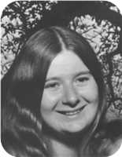
  Vivian Louise Robertson
Marriages with Roy Edward Gray and ? ? (Page 118) are known.

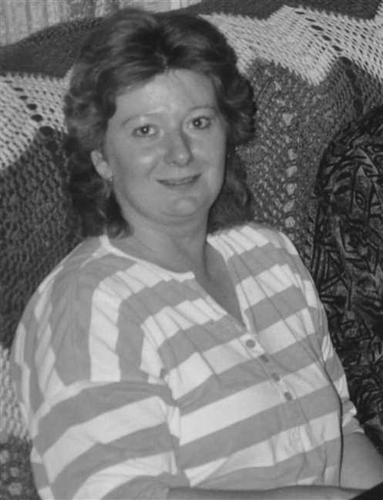
Figure 94: Vivian Robertson

Vivian Robertson and Roy Gray
 |  |  |  |  |  |  |  |  |  |  |  |  |  |  |  |  |  |  |  |  |  |  |  | Leonard Bowman |  |  |  |  |  | Louisa Reid |  |  |  |  |  | Allan |  |  |  |  |  | Mary Christina
 |  |  |  |  |  |  |  |  |  |  |  |  |  |  |  |  |  |  |  |  |  |  |  | Robertson |  |  |  |  |  | Ives |  |  |  |  |  | MacDonell |  |  |  |  |  | MacDonald
 |  |  |  |  |  |  |  |  |  |  |  |  |  |  |  |  |  |  |  |  |  |  |  | 1890–1972 |  |  |  |  |  | 1889–1982 |  |  |  |  |  | 1880–1926 |  |  |  |  |  | 1895–1978
 |  | Frederick Elmer Dicki |  |  |  |  |  |  |  |  |  |  |  | Jessie Winifred |  |  |  |  |  |  |  |  |  |  |  | James Ives |  |  |  |  |  |  |  |  |  |  |  | Charlotte Helen
 |  | Gray |  |  |  |  |  |  |  |  |  |  |  | Davis |  |  |  |  |  |  |  |  |  |  |  | Robertson |  |  |  |  |  |  |  |  |  |  |  | MacDonell
 |  |  |  |  |  |  |  |  |  |  |  |  |  | 1919– |  |  |  |  |  |  |  |  |  |  |  | 1917–1989 |  |  |  |  |  |  |  |  |  |  |  | 1922–2005
 |  |  |  |  |  |  |  | Roy Edward |  |  |  |  |  |  |  |  |  |  |  |  |  |  |  |  |  |  |  |  |  |  |  | Vivian Louise
 |  |  |  |  |  |  |  | Gray |  |  |  |  |  |  |  |  |  |  |  |  |  |  |  |  |  |  |  |  |  |  |  | Robertson
 |  |  |  |  |  |  |  | 1951– |  |  |  |  |  |  |  |  |  |  |  |  |  |  |  |  |  |  |  |  |  |  |  | 1957–
 |  |  |  |  |  |  |  |  |  |  |  |  |  | Partner
 |  |  |  |  |  |  |  |  |  |  |  |  |  |  |  |  |  |  |  |  | Lisa
 |  |  |  |  |  |  |  |  |  |  |  |  |  |  |  |  |  |  |  |  | Robertson
 |  |  |  |  |  |  |  |  |  |  |  |  |  |  |  |  |  |  |  |  | 1974–
 |  |  |  |  |  |  |  |  |  |  |  |  |  |  |  |  |  |  |  |  | 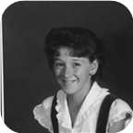

Here are the details about Vivian Louise Robertson's first relationship, with Roy Edward Gray. You can read more about Vivian Louise on page 116.
Vivian Louise Robertson is partnered with Roy Edward Gray. They have one daughter.
Roy Edward was born in Pictou, N.S., on Thursday, August 09, 1951. He is the son of Frederick Elmer Dicki Gray and Jessie Winifred Davis.
Daughter of Vivian Louise Robertson and Roy Edward Gray:
+ 81 f I. Lisa Robertson was born in Pictou, Nova Scotia, Canada, on August 08, 1974.
  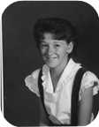
  Lisa

Family of Vivian Robertson and ? ?
 |  |  |  |  |  |  |  |  |  |  |  |  |  |  |  |  |  |  |  |  |  |  |  | Leonard Bowman |  |  |  |  |  | Louisa Reid |  |  |  |  |  | Allan |  |  |  |  |  | Mary Christina
 |  |  |  |  |  |  |  |  |  |  |  |  |  |  |  |  |  |  |  |  |  |  |  | Robertson |  |  |  |  |  | Ives |  |  |  |  |  | MacDonell |  |  |  |  |  | MacDonald
 |  |  |  |  |  |  |  |  |  |  |  |  |  |  |  |  |  |  |  |  |  |  |  | 1890–1972 |  |  |  |  |  | 1889–1982 |  |  |  |  |  | 1880–1926 |  |  |  |  |  | 1895–1978
 |  |  |  |  |  |  |  |  |  |  |  |  |  |  |  |  |  |  |  |  |  |  |  |  |  | James Ives |  |  |  |  |  |  |  |  |  |  |  | Charlotte Helen
 |  |  |  |  |  |  |  |  |  |  |  |  |  |  |  |  |  |  |  |  |  |  |  |  |  | Robertson |  |  |  |  |  |  |  |  |  |  |  | MacDonell
 |  |  |  |  |  |  |  |  |  |  |  |  |  |  |  |  |  |  |  |  |  |  |  |  |  | 1917–1989 |  |  |  |  |  |  |  |  |  |  |  | 1922–2005
 |  |  |  |  |  |  |  | ? |  |  |  |  |  |  |  |  |  |  |  |  |  |  |  |  |  |  |  |  |  |  |  | Vivian Louise
 |  |  |  |  |  |  |  | ? |  |  |  |  |  |  |  |  |  |  |  |  |  |  |  |  |  |  |  |  |  |  |  | Robertson
 |  |  |  |  |  |  |  |  |  |  |  |  |  |  |  |  |  |  |  |  |  |  |  |  |  |  |  |  |  |  |  | 1957–
 |  |  |  |  |  |  |  |  |  |  |  |  |  | Married
 |  |  |  |  |  |  |  |  |  |  |  |  |  |  |  |  |  |  |  |  | Derek
 |  |  |  |  |  |  |  |  |  |  |  |  |  |  |  |  |  |  |  |  | Robertson
 |  |  |  |  |  |  |  |  |  |  |  |  |  |  |  |  |  |  |  |  | 1990–

Here are the details about Vivian Louise Robertson's first marriage, with ? ?. You can read more about Vivian Louise on page 116.
Vivian Louise Robertson married ? ?. They have one son.
Son of Vivian Louise Robertson and ? ?:
m I. Derek Robertson was born in Pictou,NS, in August 1990.

Family of Leonard Robertson and Laysha Lenyk
Leonard Bowman |  |  |  | Louisa Reid |  |  |  | Roy Wesley |  |  |  | Ethel Irene
Robertson |  |  |  | Ives |  |  |  | Bell |  |  |  | Smith
1890–1972 |  |  |  | 1889–1982 |  |  |  | 1888–1963 |  |  |  | 1896–1929
 | Leonard Bowman |  |  |  |  |  |  |  | Edna Effie
 | Robertson |  |  |  |  |  |  |  | Bell
 | 1918– |  |  |  |  |  |  |  | 1920–
 |  |  |  |  | Leonard Bowman |  |  |  |  |  |  |  |  |  |  |  |  |  |  |  | Laysha
 |  |  |  |  | Robertson |  |  |  |  |  |  |  |  |  |  |  |  |  |  |  | Lenyk
 |  |  |  |  | 1947– |  |  |  |  |  |  |  |  |  |  |  |  |  |  |  | 1947–
 |  |  |  |  |  |  |  |  |  |  |  |  |  |  |  |  |  |  |  |  | 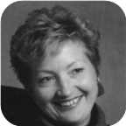
 |  |  |  |  |  |  |  |  | Married
 |  |  |  |  |  |  |  |  |  |  |  | Richard Bruce |  |  |  | Michael Leonard
 |  |  |  |  |  |  |  |  |  |  |  | Robertson |  |  |  | Robertson
 |  |  |  |  |  |  |  |  |  |  |  | 1976– |  |  |  | 1978–

59. Leonard Bowman Robertson was born on Wednesday, January 22, 1947, in Moncton,N.B. He is the son of Leonard Bowman Robertson (45) and Edna Effie Bell.  Leonard Bowman was educated in B.Eng. from UNB. He is employed in Civil Engineer.
  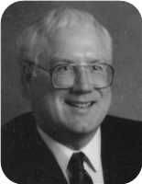
  Leonard Bowman Robertson
He married Laysha Lenyk. They have two sons.  Laysha was born on Tuesday, November 25, 1947.
  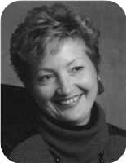
  Laysha Lenyk
Sons of Leonard Bowman Robertson and Laysha Lenyk:
m I. Richard Bruce Robertson was born on November 25, 1976.
m II. Michael Leonard Robertson was born on April 03, 1978.

Family of Janet Robertson and John Champion
 |  |  |  |  |  |  |  |  |  |  |  |  |  |  |  | Leonard Bowman |  |  |  | Louisa Reid |  |  |  | Roy Wesley |  |  |  | Ethel Irene
 |  |  |  |  |  |  |  |  |  |  |  |  |  |  |  | Robertson |  |  |  | Ives |  |  |  | Bell |  |  |  | Smith
 |  |  |  |  |  |  |  |  |  |  |  |  |  |  |  | 1890–1972 |  |  |  | 1889–1982 |  |  |  | 1888–1963 |  |  |  | 1896–1929
 | Harry |  |  |  |  |  |  |  | Marguerite |  |  |  |  |  |  |  | Leonard Bowman |  |  |  |  |  |  |  | Edna Effie
 | Champion |  |  |  |  |  |  |  | Fortin |  |  |  |  |  |  |  | Robertson |  |  |  |  |  |  |  | Bell
 | 1919–1985 |  |  |  |  |  |  |  | 1917– |  |  |  |  |  |  |  | 1918– |  |  |  |  |  |  |  | 1920–
 |  |  |  |  | John Douglas |  |  |  |  |  |  |  |  |  |  |  |  |  |  |  | Janet Louise
 |  |  |  |  | Champion |  |  |  |  |  |  |  |  |  |  |  |  |  |  |  | Robertson
 |  |  |  |  | 1951– |  |  |  |  |  |  |  |  |  |  |  |  |  |  |  | 1951–
 |  |  |  |  | 
 |  |  |  |  |  |  |  |  | Married
 |  |  |  |  |  |  |  |  |  |  |  | Timothy Edward |  |  |  | Barbara Ann
 |  |  |  |  |  |  |  |  |  |  |  | Champion |  |  |  | Champion
 |  |  |  |  |  |  |  |  |  |  |  | 1976– |  |  |  | 1978–
 |  |  |  |  |  |  |  |  |  |  |  | 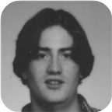 |  |  |  | 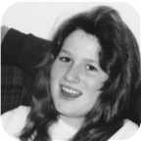

60. Janet Louise Robertson was born on Friday, November 30, 1951. She is the daughter of Leonard Bowman Robertson (45) and Edna Effie Bell.  Janet Louise was educated in BA from UNB.
  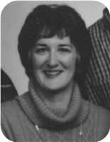
  Janet Louise Robertson
She married John Douglas Champion. They have two children.  John Douglas was born in North Bay,Ontario, on Tuesday, March 20, 1951. He is the son of Harry Champion and Marguerite Fortin.  He is employed in Worked for CP railway.
  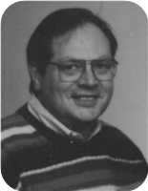
  John Douglas Champion
Children of Janet Louise Robertson and John Douglas Champion:
m I. Timothy Edward Champion was born on April 18, 1976.
  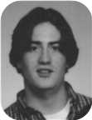
  Timothy
f II. Barbara Ann Champion was born on June 14, 1978.
  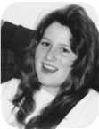
  Barbara

Robert Bongard
61. Robert William Bongard was born on Sunday, August 04, 1946, in Niagara Falls,Ont. He is the son of Lester William Bongard and Norah Louise Robertson (46).
Marriages with Catherine Brooks and Yvone ? (Page 122) are known.

Family of Robert Bongard and Catherine Brooks
? |  |  |  | ? |  |  |  | Leonard Bowman |  |  |  | Louisa Reid
Bongard |  |  |  | ? |  |  |  | Robertson |  |  |  | Ives
 |  |  |  |  |  |  |  | 1890–1972 |  |  |  | 1889–1982
 | Lester William |  |  |  |  |  |  |  | Norah Louise
 | Bongard |  |  |  |  |  |  |  | Robertson
 | 1921–2000 |  |  |  |  |  |  |  | 1921–
 |  |  |  |  | Robert William |  |  |  |  |  |  |  |  |  |  |  |  |  |  |  | Catherine
 |  |  |  |  | Bongard |  |  |  |  |  |  |  |  |  |  |  |  |  |  |  | Brooks
 |  |  |  |  | 1946–
 |  |  |  |  |  |  |  |  | Married

Here are the details about Robert William Bongard's first marriage, with Catherine Brooks. You can read more about Robert William on page 121.
Robert William Bongard married Catherine Brooks.

Family of Robert Bongard and Yvone ?
? |  |  |  | ? |  |  |  | Leonard Bowman |  |  |  | Louisa Reid
Bongard |  |  |  | ? |  |  |  | Robertson |  |  |  | Ives
 |  |  |  |  |  |  |  | 1890–1972 |  |  |  | 1889–1982
 | Lester William |  |  |  |  |  |  |  | Norah Louise
 | Bongard |  |  |  |  |  |  |  | Robertson
 | 1921–2000 |  |  |  |  |  |  |  | 1921–
 |  |  |  |  | Robert William |  |  |  |  |  |  |  |  |  |  |  |  |  |  |  | Yvone
 |  |  |  |  | Bongard |  |  |  |  |  |  |  |  |  |  |  |  |  |  |  | ?
 |  |  |  |  | 1946–
 |  |  |  |  |  |  |  |  | Married

Here are the details about Robert William Bongard's second marriage, with Yvone ?. You can read more about Robert William on page 121.
Robert William Bongard married Yvone ?.

Family of John Bongard and ? ?
? |  |  |  | ? |  |  |  | Leonard Bowman |  |  |  | Louisa Reid
Bongard |  |  |  | ? |  |  |  | Robertson |  |  |  | Ives
 |  |  |  |  |  |  |  | 1890–1972 |  |  |  | 1889–1982
 | Lester William |  |  |  |  |  |  |  | Norah Louise
 | Bongard |  |  |  |  |  |  |  | Robertson
 | 1921–2000 |  |  |  |  |  |  |  | 1921–
 |  |  |  |  | John Reid |  |  |  |  |  |  |  |  |  |  |  |  |  |  |  | ?
 |  |  |  |  | Bongard |  |  |  |  |  |  |  |  |  |  |  |  |  |  |  | ?
 |  |  |  |  | 1949–
 |  |  |  |  |  |  |  |  | Married
 |  |  |  |  |  |  |  |  |  |  |  | ? |  |  |  | ?
 |  |  |  |  |  |  |  |  |  |  |  | Bongard |  |  |  | Bongard

62. John Reid Bongard was born on Sunday, September 18, 1949, in Niagara Falls,Ont. He is the son of Lester William Bongard and Norah Louise Robertson (46).
He married ? ?. They have two daughters.
Daughters of John Reid Bongard and ? ?:
f I. ? Bongard.
f II. ? Bongard.

Family of Norah Bongard and Jerrery Biggs
 |  |  |  |  |  |  |  |  |  |  |  |  |  |  |  |  |  |  |  |  |  |  |  | ? |  |  |  |  |  | ? |  |  |  |  |  | Leonard Bowman |  |  |  |  |  | Louisa Reid
 |  |  |  |  |  |  |  |  |  |  |  |  |  |  |  |  |  |  |  |  |  |  |  | Bongard |  |  |  |  |  | ? |  |  |  |  |  | Robertson |  |  |  |  |  | Ives
 |  |  |  |  |  |  |  |  |  |  |  |  |  |  |  |  |  |  |  |  |  |  |  |  |  |  |  |  |  |  |  |  |  |  |  | 1890–1972 |  |  |  |  |  | 1889–1982
 |  |  |  |  |  |  |  |  |  |  |  |  |  |  |  |  |  |  |  |  |  |  |  |  |  | Lester William |  |  |  |  |  |  |  |  |  |  |  | Norah Louise
 |  |  |  |  |  |  |  |  |  |  |  |  |  |  |  |  |  |  |  |  |  |  |  |  |  | Bongard |  |  |  |  |  |  |  |  |  |  |  | Robertson
 |  |  |  |  |  |  |  |  |  |  |  |  |  |  |  |  |  |  |  |  |  |  |  |  |  | 1921–2000 |  |  |  |  |  |  |  |  |  |  |  | 1921–
 |  |  |  |  |  |  |  | Jerrery F |  |  |  |  |  |  |  |  |  |  |  |  |  |  |  |  |  |  |  |  |  |  |  | Norah Lynn
 |  |  |  |  |  |  |  | Biggs |  |  |  |  |  |  |  |  |  |  |  |  |  |  |  |  |  |  |  |  |  |  |  | Bongard
 |  |  |  |  |  |  |  | –ca.1988 |  |  |  |  |  |  |  |  |  |  |  |  |  |  |  |  |  |  |  |  |  |  |  | 1953–
 |  |  |  |  |  |  |  |  |  |  |  |  |  | Marriage: 1973
 |  |  |  |  |  |  |  |  |  |  |  |  |  |  |  |  |  |  |  |  | Lauren Alexis
 |  |  |  |  |  |  |  |  |  |  |  |  |  |  |  |  |  |  |  |  | Biggs
 |  |  |  |  |  |  |  |  |  |  |  |  |  |  |  |  |  |  |  |  | 1982–

63. Norah Lynn Bongard was born on Thursday, September 17, 1953, in Niagara Falls,Ont. She is the daughter of Lester William Bongard and Norah Louise Robertson (46).  Norah Lynn was educated in From Niagara Falls.
  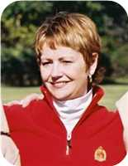
  Norah Lynn Bongard
Norah Lynn married Jerrery F Biggs on Saturday, June 02, 1973, in Montreal,Quebec. They had one daughter.
Jerrery F died in Toronto,ON, about 1988.
Daughter of Norah Lynn Bongard and Jerrery F Biggs:
f I. Lauren Alexis Biggs was born on June 19, 1982.

Family of John Ives and Iris ?
Lewis Zindord |  |  |  | Jenny Mitchell |  |  |  | Clarence |  |  |  | Ernestine
Ives |  |  |  | Eastwood |  |  |  | Gaston |  |  |  | Hatch
1888–1941 |  |  |  | 1880–1942
 | James Eastwood |  |  |  |  |  |  |  | Gladys Jean
 | Ives |  |  |  |  |  |  |  | Gaston
 | 1916– |  |  |  |  |  |  |  | 1916–1998
 |  |  |  |  | John Gillan |  |  |  |  |  |  |  |  |  |  |  |  |  |  |  | Iris
 |  |  |  |  | Ives |  |  |  |  |  |  |  |  |  |  |  |  |  |  |  | ?
 |  |  |  |  |  |  |  |  | Married

64. John Gillan Ives. He is the son of James Eastwood Ives (50) and Gladys Jean Gaston.
He married Iris ?.

Family of Marjory Ives and Arleigh Cornelius
 |  |  |  |  |  |  |  |  |  |  |  |  |  |  |  | Lewis Zindord |  |  |  | Jenny Mitchell |  |  |  | Clarence |  |  |  | Ernestine
 |  |  |  |  |  |  |  |  |  |  |  |  |  |  |  | Ives |  |  |  | Eastwood |  |  |  | Gaston |  |  |  | Hatch
 |  |  |  |  |  |  |  |  |  |  |  |  |  |  |  | 1888–1941 |  |  |  | 1880–1942
 |  |  |  |  |  |  |  |  |  |  |  |  |  |  |  |  | James Eastwood |  |  |  |  |  |  |  | Gladys Jean
 |  |  |  |  |  |  |  |  |  |  |  |  |  |  |  |  | Ives |  |  |  |  |  |  |  | Gaston
 |  |  |  |  |  |  |  |  |  |  |  |  |  |  |  |  | 1916– |  |  |  |  |  |  |  | 1916–1998
 |  |  |  |  | Arleigh |  |  |  |  |  |  |  |  |  |  |  |  |  |  |  | Marjory
 |  |  |  |  | Cornelius |  |  |  |  |  |  |  |  |  |  |  |  |  |  |  | Ives
 |  |  |  |  |  |  |  |  | Married

65. Rev. Marjory Ives. She is the daughter of James Eastwood Ives (50) and Gladys Jean Gaston.
She married Arleigh Cornelius.

Family of John Ives and Tammy ?
John Fraser |  |  |  | Jessie Margaret
Ives |  |  |  | MacMillan
1895–1970 |  |  |  | 1898–1994
 | David Hugh |  |  |  |  |  |  |  | Florence
 | Ives |  |  |  |  |  |  |  | Smith
 | 1924–
 |  |  |  |  | John David |  |  |  |  |  |  |  |  |  |  |  |  |  |  |  | Tammy
 |  |  |  |  | Ives |  |  |  |  |  |  |  |  |  |  |  |  |  |  |  | ?
 |  |  |  |  | 1969–
 |  |  |  |  |  |  |  |  | Married

66. John David Ives was born in March 1969. He is the son of David Hugh Ives (51) and Florence Smith.
He married Tammy ?.

Family of Sarah Ives and ? Fraser
 |  |  |  |  |  |  |  |  |  |  |  |  |  |  |  | John Fraser |  |  |  | Jessie Margaret
 |  |  |  |  |  |  |  |  |  |  |  |  |  |  |  | Ives |  |  |  | MacMillan
 |  |  |  |  |  |  |  |  |  |  |  |  |  |  |  | 1895–1970 |  |  |  | 1898–1994
 |  |  |  |  |  |  |  |  |  |  |  |  |  |  |  |  | David Hugh |  |  |  |  |  |  |  | Florence
 |  |  |  |  |  |  |  |  |  |  |  |  |  |  |  |  | Ives |  |  |  |  |  |  |  | Smith
 |  |  |  |  |  |  |  |  |  |  |  |  |  |  |  |  | 1924–
 |  |  |  |  | ? |  |  |  |  |  |  |  |  |  |  |  |  |  |  |  | Sarah Jean
 |  |  |  |  | Fraser |  |  |  |  |  |  |  |  |  |  |  |  |  |  |  | Ives
 |  |  |  |  |  |  |  |  |  |  |  |  |  |  |  |  |  |  |  |  | 1969–
 |  |  |  |  |  |  |  |  | Married

67. Sarah Jean Ives was born in March 1969. She is the daughter of David Hugh Ives (51) and Florence Smith.
She married ? Fraser.

Family of Pearl Ives and William MacMillan
 |  |  |  |  |  |  |  |  |  |  |  |  |  |  |  | John Fraser |  |  |  | Jessie Margaret
 |  |  |  |  |  |  |  |  |  |  |  |  |  |  |  | Ives |  |  |  | MacMillan
 |  |  |  |  |  |  |  |  |  |  |  |  |  |  |  | 1895–1970 |  |  |  | 1898–1994
 |  |  |  |  |  |  |  |  |  |  |  |  |  |  |  |  | David Hugh |  |  |  |  |  |  |  | Florence
 |  |  |  |  |  |  |  |  |  |  |  |  |  |  |  |  | Ives |  |  |  |  |  |  |  | Smith
 |  |  |  |  |  |  |  |  |  |  |  |  |  |  |  |  | 1924–
 |  |  |  |  | William |  |  |  |  |  |  |  |  |  |  |  |  |  |  |  | Pearl
 |  |  |  |  | MacMillan |  |  |  |  |  |  |  |  |  |  |  |  |  |  |  | Ives
 |  |  |  |  |  |  |  |  | Married

68. Pearl Ives. She is the daughter of David Hugh Ives (51) and Florence Smith.
She married William MacMillan.

Family of John Ramscar and Anne MacKenzie
 |  |  |  |  |  |  |  | John Fraser |  |  |  | Jessie Margaret |  |  |  | John Duncan |  |  |  | Bess
 |  |  |  |  |  |  |  | Ives |  |  |  | MacMillan |  |  |  | MacKenzie |  |  |  | Anderson
 |  |  |  |  |  |  |  | 1895–1970 |  |  |  | 1898–1994 |  |  |  | 1870–1932
 | Clwyd Vincent |  |  |  |  |  |  |  | Norah MacGillivary |  |  |  |  |  |  |  | Donald |  |  |  |  |  |  |  | Georgina
 | Ramscar |  |  |  |  |  |  |  | Ives |  |  |  |  |  |  |  | MacKenzie |  |  |  |  |  |  |  | Ross
 | 1922–1988 |  |  |  |  |  |  |  | 1921–
 |  |  |  |  | John Vincent |  |  |  |  |  |  |  |  |  |  |  |  |  |  |  | Anne Dawson
 |  |  |  |  | Ramscar |  |  |  |  |  |  |  |  |  |  |  |  |  |  |  | MacKenzie
 |  |  |  |  | 1947– |  |  |  |  |  |  |  |  |  |  |  |  |  |  |  | 1949–
 |  |  |  |  |  |  |  |  | Marriage: 1970
 |  |  |  |  |  |  |  |  |  |  |  | Anna Victiria |  |  |  | Mark Vincent
 |  |  |  |  |  |  |  |  |  |  |  | Ramscar |  |  |  | Ramscar
 |  |  |  |  |  |  |  |  |  |  |  | 1973– |  |  |  | 1978–

69. John Vincent Ramscar was born on Wednesday, May 14, 1947, in New Glasgow,Nova Scotia. He is the son of Clwyd Vincent Ramscar and Norah MacGillivary Ives (52).
John Vincent married Anne Dawson MacKenzie in June 1970 in Sydney. They have two children.
Anne Dawson was born in July 1949. She is the daughter of Donald MacKenzie and Georgina Ross.
Children of John Vincent Ramscar and Anne Dawson MacKenzie:
f I. Anna Victiria Ramscar was born in Prince Edward Island in April 1973.
m II. Mark Vincent Ramscar was born in New Glasgow,Nova Scotia, in June 1978.

Family of Jessie Ramscar and John Allan
 |  |  |  |  |  |  |  |  |  |  |  |  |  |  |  |  |  |  |  |  |  |  |  | John Fraser |  |  |  | Jessie Margaret
 |  |  |  |  |  |  |  |  |  |  |  |  |  |  |  |  |  |  |  |  |  |  |  | Ives |  |  |  | MacMillan
 |  |  |  |  |  |  |  |  |  |  |  |  |  |  |  |  |  |  |  |  |  |  |  | 1895–1970 |  |  |  | 1898–1994
 |  |  |  |  |  |  |  |  |  |  |  |  |  |  |  |  | Clwyd Vincent |  |  |  |  |  |  |  | Norah MacGillivary
 |  |  |  |  |  |  |  |  |  |  |  |  |  |  |  |  | Ramscar |  |  |  |  |  |  |  | Ives
 |  |  |  |  |  |  |  |  |  |  |  |  |  |  |  |  | 1922–1988 |  |  |  |  |  |  |  | 1921–
 |  |  |  |  | John David |  |  |  |  |  |  |  |  |  |  |  |  |  |  |  | Jessie Margaret
 |  |  |  |  | Allan |  |  |  |  |  |  |  |  |  |  |  |  |  |  |  | Ramscar
 |  |  |  |  | 1951– |  |  |  |  |  |  |  |  |  |  |  |  |  |  |  | 1948–
 |  |  |  |  |  |  |  |  | Marriage: 1975

70. Jessie Margaret Ramscar was born in July 1948. She is the daughter of Clwyd Vincent Ramscar and Norah MacGillivary Ives (52).
Jessie Margaret married John David Allan in October 1975. John David was born in May 1951.

Family of ? Gray and David Chappell
 |  |  |  |  |  |  |  |  |  |  |  |  |  |  |  | Henry Irving Beecher |  |  |  | Mary Alice
 |  |  |  |  |  |  |  |  |  |  |  |  |  |  |  | Gray |  |  |  | Rood
 |  |  |  |  |  |  |  |  |  |  |  |  |  |  |  | 1887–1976 |  |  |  | 1880–1973
 |  |  |  |  |  |  |  |  |  |  |  |  |  |  |  |  | Charles Lever Rood |  |  |  |  |  |  |  | Catherine Jane
 |  |  |  |  |  |  |  |  |  |  |  |  |  |  |  |  | Gray |  |  |  |  |  |  |  | Clark
 |  |  |  |  |  |  |  |  |  |  |  |  |  |  |  |  | 1913–1995
 |  |  |  |  | David |  |  |  |  |  |  |  |  |  |  |  |  |  |  |  | ?
 |  |  |  |  | Chappell |  |  |  |  |  |  |  |  |  |  |  |  |  |  |  | Gray
 |  |  |  |  |  |  |  |  | Marriage: 1971

71. ? Gray. She was the daughter of Charles Lever Rood Gray (53) and Catherine Jane Clark.
? married David Chappell in 1971 in Toronto,Ontario.

Family of Allan Gray and Donna Hunter
Henry Irving Beecher |  |  |  | Mary Alice |  |  |  | William |  |  |  | Rose
Gray |  |  |  | Rood |  |  |  | Phillips |  |  |  | Smallcome
1887–1976 |  |  |  | 1880–1973
 | Harry Alexander |  |  |  |  |  |  |  | Dorothy Hazel |  |  |  |  |  |  |  | John Gordon
 | Gray |  |  |  |  |  |  |  | Phillips |  |  |  |  |  |  |  | Hunter
 | 1916– |  |  |  |  |  |  |  | 1919–
 |  |  |  |  | Allan Roderick |  |  |  |  |  |  |  |  |  |  |  |  |  |  |  | Donna Marie
 |  |  |  |  | Gray |  |  |  |  |  |  |  |  |  |  |  |  |  |  |  | Hunter
 |  |  |  |  | 1944– |  |  |  |  |  |  |  |  |  |  |  |  |  |  |  | 1945–
 |  |  |  |  |  |  |  |  | Marriage: 1983

72. Allan Roderick Gray was born on Thursday, August 31, 1944, in Amherst,N.S. He is the son of Harry Alexander Gray (54) and Dorothy Hazel Phillips.
At the age of 39, Allan Roderick married Donna Marie Hunter on Saturday, December 31, 1983, in White Rock,B.C., when she was 38 years old. Donna Marie was born in Winnipeg,Manitoba, on Sunday, July 01, 1945. She is the daughter of John Gordon Hunter.
Donna was granted a divorce fromDonald Lawrence Christensen in Toronto on Jan 22,1975

Family of Robert Gray and Penny MacIntyre
Henry Irving Beecher |  |  |  | Mary Alice |  |  |  | William |  |  |  | Rose
Gray |  |  |  | Rood |  |  |  | Phillips |  |  |  | Smallcome
1887–1976 |  |  |  | 1880–1973
 | Harry Alexander |  |  |  |  |  |  |  | Dorothy Hazel |  |  |  |  |  |  |  | R.E.
 | Gray |  |  |  |  |  |  |  | Phillips |  |  |  |  |  |  |  | MacIntyre
 | 1916– |  |  |  |  |  |  |  | 1919–
 |  |  |  |  | Robert Irving |  |  |  |  |  |  |  |  |  |  |  |  |  |  |  | Penny
 |  |  |  |  | Gray |  |  |  |  |  |  |  |  |  |  |  |  |  |  |  | MacIntyre
 |  |  |  |  | 1947–1983
 |  |  |  |  |  |  |  |  | Married
 |  |  |  |  |  |  |  |  |  |  |  | Ellen Casey |  |  |  | Katie Lexia
 |  |  |  |  |  |  |  |  |  |  |  | Gray |  |  |  | Gray
 |  |  |  |  |  |  |  |  |  |  |  | 1980– |  |  |  | 1982–

73. Robert Irving Gray was born on Saturday, December 27, 1947, in Brockville,Ont. He was the son of Harry Alexander Gray (54) and Dorothy Hazel Phillips.
Robert Irving died in Nelson,B.C., on January 05, 1983, at the age of 35.
He married Penny MacIntyre. They had two daughters. She was the daughter of R.E. MacIntyre.
Daughters of Robert Irving Gray and Penny MacIntyre:
f I. Ellen Casey Gray was born in Nelson on October 09, 1980.
f II. Katie Lexia Gray was born in Nelson on November 02, 1982.

Family of Norma Gray and Mark Dewolfe
 |  |  |  |  |  |  |  |  |  |  |  |  |  |  |  |  |  |  |  |  |  |  |  | Henry Irving Beecher |  |  |  |  |  | Mary Alice |  |  |  |  |  | William |  |  |  |  |  | Rose
 |  |  |  |  |  |  |  |  |  |  |  |  |  |  |  |  |  |  |  |  |  |  |  | Gray |  |  |  |  |  | Rood |  |  |  |  |  | Phillips |  |  |  |  |  | Smallcome
 |  |  |  |  |  |  |  |  |  |  |  |  |  |  |  |  |  |  |  |  |  |  |  | 1887–1976 |  |  |  |  |  | 1880–1973
 |  | Lome |  |  |  |  |  |  |  |  |  |  |  |  |  |  |  |  |  |  |  |  |  |  |  | Harry Alexander |  |  |  |  |  |  |  |  |  |  |  | Dorothy Hazel
 |  | Dewolfe |  |  |  |  |  |  |  |  |  |  |  |  |  |  |  |  |  |  |  |  |  |  |  | Gray |  |  |  |  |  |  |  |  |  |  |  | Phillips
 |  |  |  |  |  |  |  |  |  |  |  |  |  |  |  |  |  |  |  |  |  |  |  |  |  | 1916– |  |  |  |  |  |  |  |  |  |  |  | 1919–
 |  |  |  |  |  |  |  | Mark Steams |  |  |  |  |  |  |  |  |  |  |  |  |  |  |  |  |  |  |  |  |  |  |  | Norma Jean
 |  |  |  |  |  |  |  | Dewolfe |  |  |  |  |  |  |  |  |  |  |  |  |  |  |  |  |  |  |  |  |  |  |  | Gray
 |  |  |  |  |  |  |  | 1948– |  |  |  |  |  |  |  |  |  |  |  |  |  |  |  |  |  |  |  |  |  |  |  | 1949–
 |  |  |  |  |  |  |  |  |  |  |  |  |  | Marriage: 1971
 |  |  |  |  |  |  |  |  |  |  |  |  |  |  | Holly Virginia |  |  |  |  |  | Rodan Alexander |  |  |  |  |  | Adam Phillips
 |  |  |  |  |  |  |  |  |  |  |  |  |  |  | Dewolfe |  |  |  |  |  | Dewolfe |  |  |  |  |  | Dewolfe
 |  |  |  |  |  |  |  |  |  |  |  |  |  |  | 1972– |  |  |  |  |  | 1974– |  |  |  |  |  | 1980–

74. Norma Jean Gray was born on Monday, May 02, 1949, in Brockville,Ont. She is the daughter of Harry Alexander Gray (54) and Dorothy Hazel Phillips.
At the age of 21, Norma Jean married Mark Steams Dewolfe on Saturday, January 16, 1971, in Winsor when he was 22 years old. They have three children.
Mark Steams was born in Winsor on Saturday, October 23, 1948. He is the son of Lome Dewolfe.
Children of Norma Jean Gray and Mark Steams Dewolfe:
f I. Holly Virginia Dewolfe was born in Campbell River,B.C., on December 29, 1972.
m II. Rodan Alexander Dewolfe was born in Campbell River on July 27, 1974.
m III. Adam Phillips Dewolfe was born in Campbell River on January 20, 1980.

Family of Leslie Gray and Brice Murphy
 |  |  |  |  |  |  |  |  |  |  |  |  |  |  |  |  |  |  |  |  |  |  |  | Henry Irving Beecher |  |  |  |  |  | Mary Alice
 |  |  |  |  |  |  |  |  |  |  |  |  |  |  |  |  |  |  |  |  |  |  |  | Gray |  |  |  |  |  | Rood
 |  |  |  |  |  |  |  |  |  |  |  |  |  |  |  |  |  |  |  |  |  |  |  | 1887–1976 |  |  |  |  |  | 1880–1973
 |  |  |  |  |  |  |  |  |  |  |  |  |  |  |  |  |  |  |  |  |  |  |  |  |  | John Allan |  |  |  |  |  |  |  |  |  |  |  | Clare Ross
 |  |  |  |  |  |  |  |  |  |  |  |  |  |  |  |  |  |  |  |  |  |  |  |  |  | Gray |  |  |  |  |  |  |  |  |  |  |  | Dennison
 |  |  |  |  |  |  |  |  |  |  |  |  |  |  |  |  |  |  |  |  |  |  |  |  |  | 1919–1994 |  |  |  |  |  |  |  |  |  |  |  | –1960
 |  |  |  |  |  |  |  | Brice |  |  |  |  |  |  |  |  |  |  |  |  |  |  |  |  |  |  |  |  |  |  |  | Leslie
 |  |  |  |  |  |  |  | Murphy |  |  |  |  |  |  |  |  |  |  |  |  |  |  |  |  |  |  |  |  |  |  |  | Gray
 |  |  |  |  |  |  |  |  |  |  |  |  |  | Married
 |  |  |  |  |  |  |  |  |  |  |  |  |  |  | ? |  |  |  |  |  | ? |  |  |  |  |  | Jullian Harmah
 |  |  |  |  |  |  |  |  |  |  |  |  |  |  | Murphy |  |  |  |  |  | Murphy |  |  |  |  |  | Murphy
 |  |  |  |  |  |  |  |  |  |  |  |  |  |  |  |  |  |  |  |  | 1993– |  |  |  |  |  | 1994–

75. Leslie Gray was born in Winnigeg,Manitoba. She was the daughter of John Allan Gray (55) and Clare Ross Dennison.
She married Brice Murphy. They had three daughters.
Daughters of Leslie Gray and Brice Murphy:
f I. ? Murphy.
f II. ? Murphy was born on September 16, 1993.
f III. Jullian Harmah Murphy was born on November 23, 1994.

Family of Eleanor Gray and Phillip Goodman
 |  |  |  |  |  |  |  |  |  |  |  |  |  |  |  | Henry Irving Beecher |  |  |  | Mary Alice
 |  |  |  |  |  |  |  |  |  |  |  |  |  |  |  | Gray |  |  |  | Rood
 |  |  |  |  |  |  |  |  |  |  |  |  |  |  |  | 1887–1976 |  |  |  | 1880–1973
 | Nordau R |  |  |  |  |  |  |  |  |  |  |  |  |  |  |  | John Allan |  |  |  |  |  |  |  | Clare Ross
 | Goodman |  |  |  |  |  |  |  |  |  |  |  |  |  |  |  | Gray |  |  |  |  |  |  |  | Dennison
 |  |  |  |  |  |  |  |  |  |  |  |  |  |  |  |  | 1919–1994 |  |  |  |  |  |  |  | –1960
 |  |  |  |  | Phillip Anders |  |  |  |  |  |  |  |  |  |  |  |  |  |  |  | Eleanor Mary Rood
 |  |  |  |  | Goodman |  |  |  |  |  |  |  |  |  |  |  |  |  |  |  | Gray
 |  |  |  |  |  |  |  |  |  |  |  |  |  |  |  |  |  |  |  |  | 1950–
 |  |  |  |  |  |  |  |  | Marriage: 1980

76. Eleanor Mary Rood Gray was born in 1950. She is the daughter of John Allan Gray (55) and Clare Ross Dennison.
Eleanor Mary Rood married Phillip Anders Goodman on Saturday, August 16, 1980, in Little Harbour,N.S. He is the son of Nordau R Goodman.

7th Generation

Family of Jenny Robertson and Steve Taylor
Willam J |  |  |  | Hazel |  |  |  |  |  |  |  |  |  |  |  | James Ives |  |  |  | Charlotte Helen |  |  |  | John |  |  |  | Jean
Taylor |  |  |  | MaBee |  |  |  |  |  |  |  |  |  |  |  | Robertson |  |  |  | MacDonell |  |  |  | Worobel |  |  |  | Kolynchuk
1921–2012 |  |  |  |  |  |  |  |  |  |  |  |  |  |  |  | 1917–1989 |  |  |  | 1922–2005 |  |  |  | 1922–1979 |  |  |  | 1925–2012
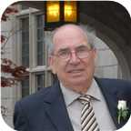
 | William George |  |  |  |  |  |  |  | Betty Ann |  |  |  |  |  |  |  | Allan James |  |  |  |  |  |  |  | Virginia
 | Taylor |  |  |  |  |  |  |  | ? |  |  |  |  |  |  |  | Robertson |  |  |  |  |  |  |  | Worobel
 | –2007 |  |  |  |  |  |  |  |  |  |  |  |  |  |  |  | 1943– |  |  |  |  |  |  |  | 1945–
 |  |  |  |  |  |  |  |  | 
 |  |  |  |  | Steve |  |  |  |  |  |  |  |  |  |  |  |  |  |  |  | Jenny Lind
 |  |  |  |  | Taylor |  |  |  |  |  |  |  |  |  |  |  |  |  |  |  | Robertson
 |  |  |  |  |  |  |  |  |  |  |  |  |  |  |  |  |  |  |  |  | 1970–
 |  |  |  |  | 
 |  |  |  |  |  |  |  |  | Divorce: 2017
 |  |  |  |  |  |  |  |  |  |  |  | Peyton Jackson |  |  |  | James Elliott
 |  |  |  |  |  |  |  |  |  |  |  | Taylor |  |  |  | Taylor
 |  |  |  |  |  |  |  |  |  |  |  | 2009– |  |  |  | 2011–
 |  |  |  |  |  |  |  |  |  |  |  |  |  |  |  | 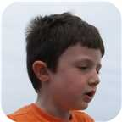

77. Jenny Lind Robertson was born on Friday, January 30, 1970, in St. Catharines, Ontario. She is the daughter of Allan James Robertson (56) and Virginia Worobel.
  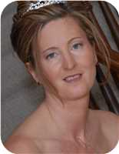
  Jenny Lind Robertson
She married Steve Taylor. They were divorced in Welland, Ontario, Canada, in 2017. They have two sons. He is the son of William George Taylor and Betty Ann ?.
  
  Steve Taylor
Sons of Jenny Lind Robertson and Steve Taylor:
m I. Peyton Jackson Taylor was born in St Catharines on May 21, 2009.
  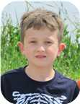
  Peyton
m II. James Elliott Taylor was born in St Catharines on March 16, 2011.
  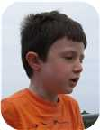
  James

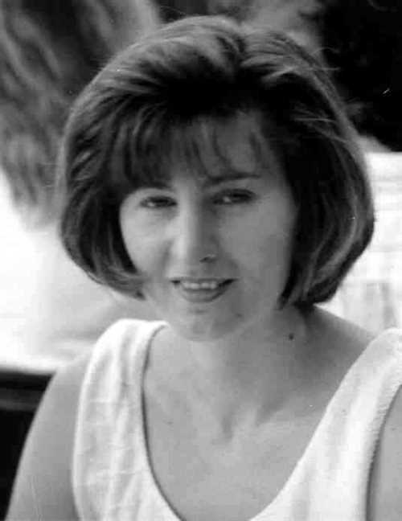  Figure 95: Jenny Lind Robertson |  | 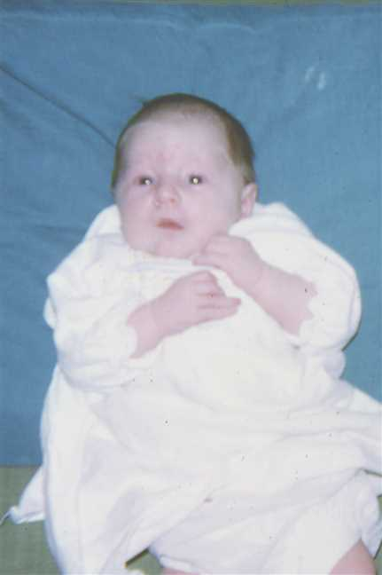  Figure 96: 197008-02Jenny5

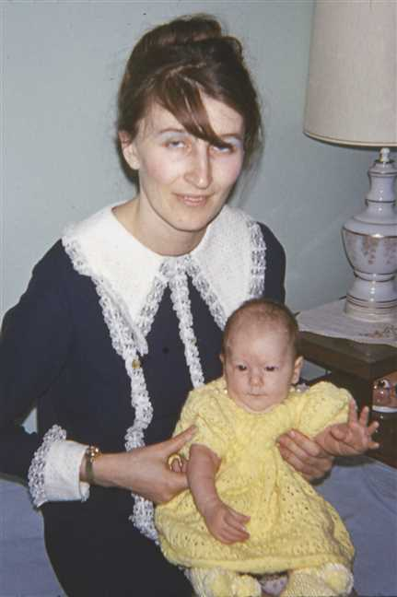  Figure 97: 197031-03VigeJenny |  | 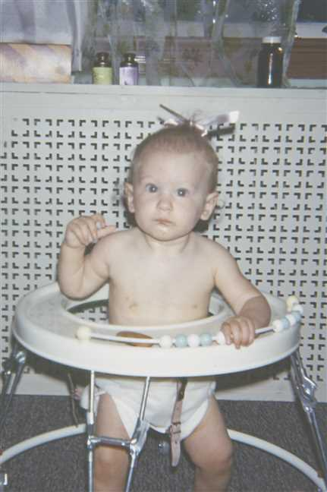  Figure 98: 197097-08Jenny2

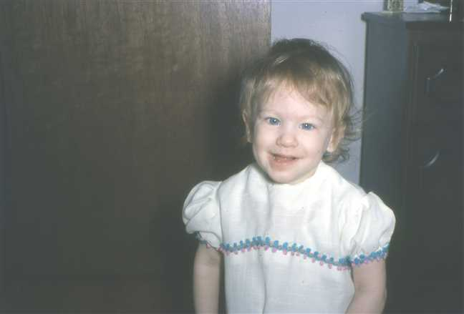  Figure 99: 1971-04Jenny |  | 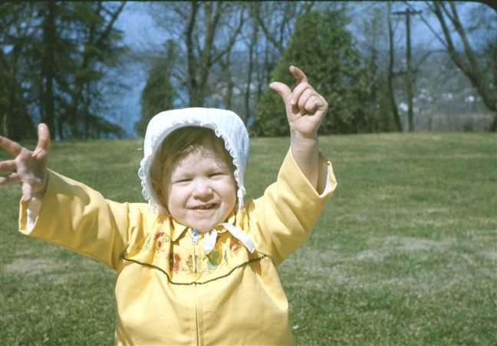  Figure 100: 1971-05Jenny6

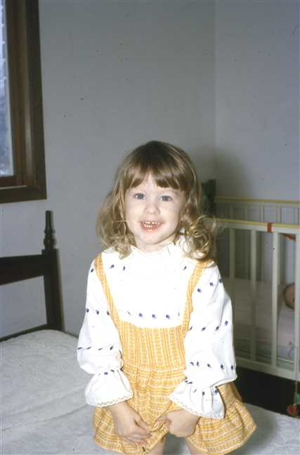  Figure 101: 1972-02Jenny |  | 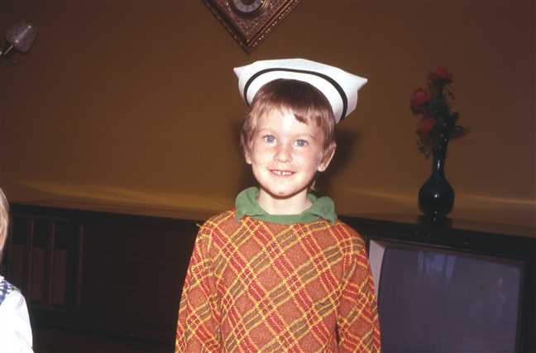  Figure 102: 1973-10JenyNurseHat

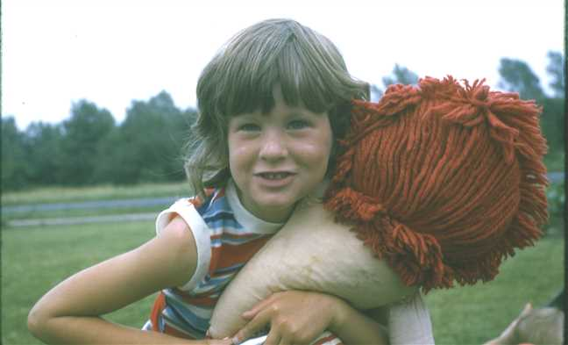  Figure 103: 1974-07Jenny3 |  | 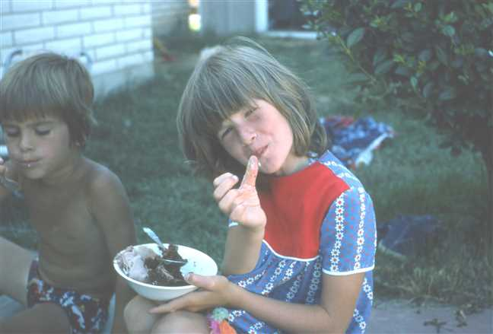  Figure 104: 1975-07Adele'sBirthday8

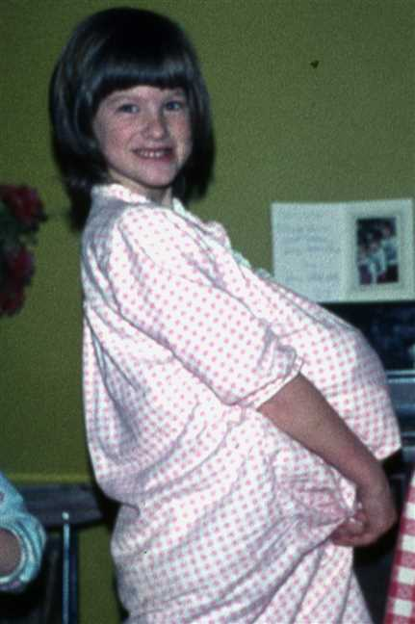  Figure 105: 1976-Jenny |  | 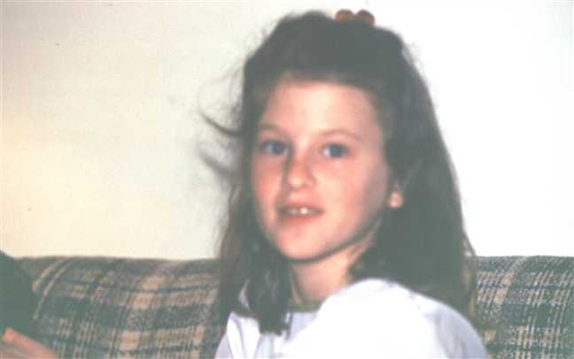  Figure 106: 1978-03Jenny

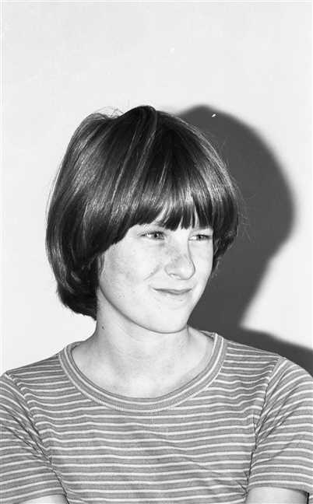  Figure 107: img001380 |  | 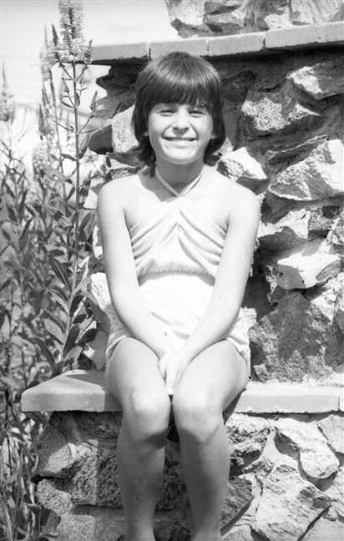  Figure 108: img001660

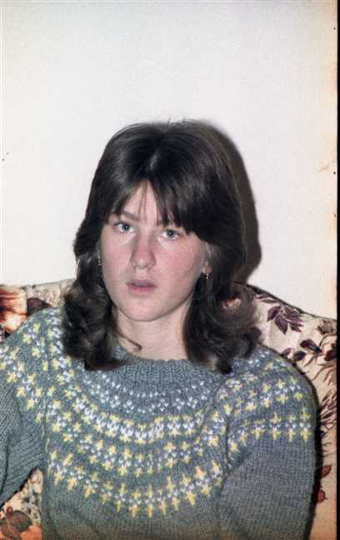  Figure 109: img001281 |  | 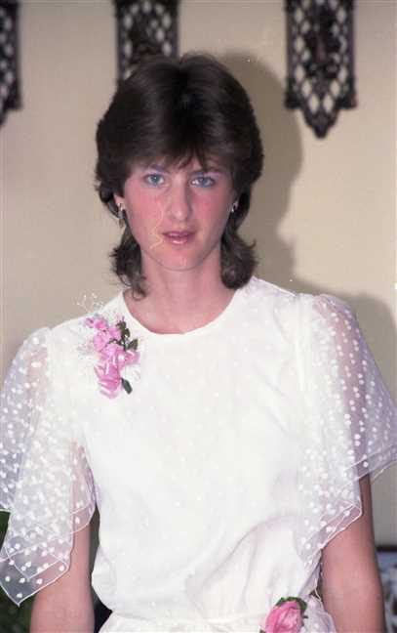  Figure 110: img001215

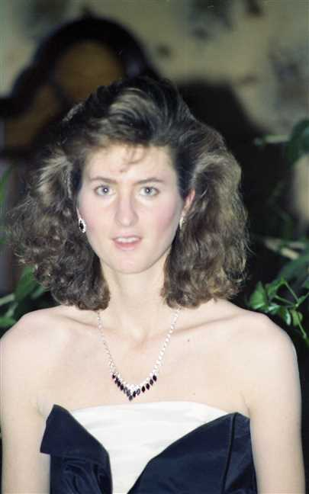  Figure 111: img001115 |  | 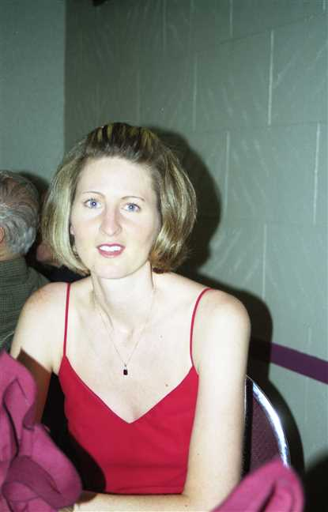  Figure 112: img001167

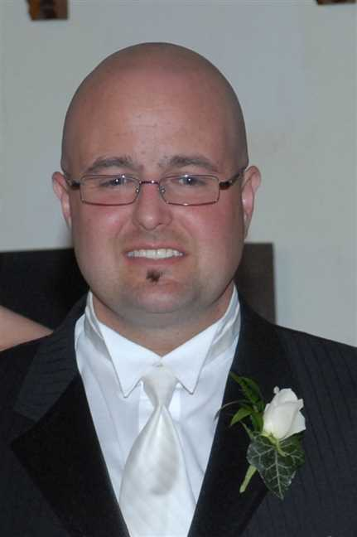
Figure 113: Steve

Adele Robertson
78. Adele Marie Robertson was born on Tuesday, July 06, 1971, in St. Catharines, Ontario. She is the daughter of Allan James Robertson (56) and Virginia Worobel.
  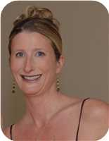
  Adele Marie Robertson
Adele never married either Jeff Graige or Geard Seward.
Marriages with Jeffery Craige and Geard Seward (Page 142) are known.

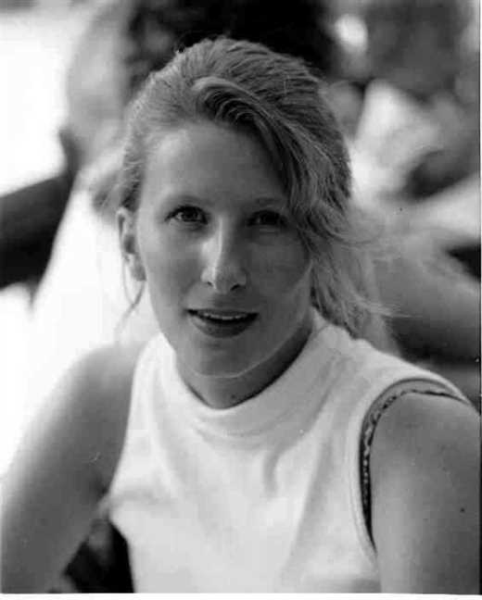  Figure 114: Adele Marie Robertson |  | 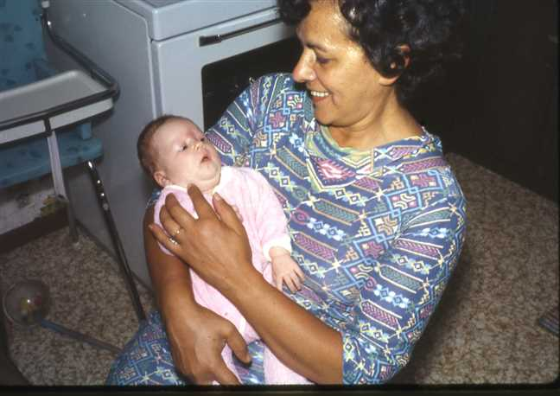  Figure 115: 1971-07AdeleBaba

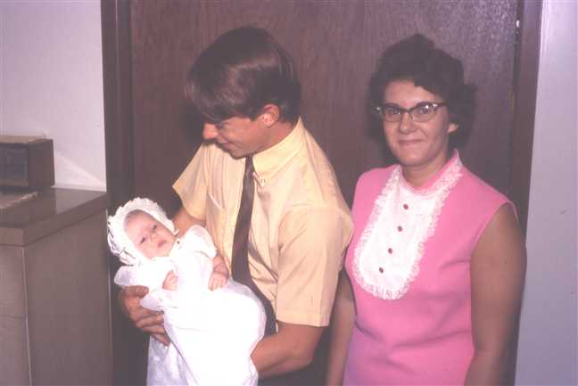  Figure 116: 1971-08AdeleAnnieDavid |  | 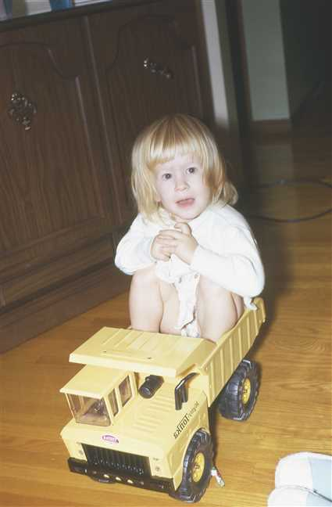  Figure 117: 1972-12Adele2

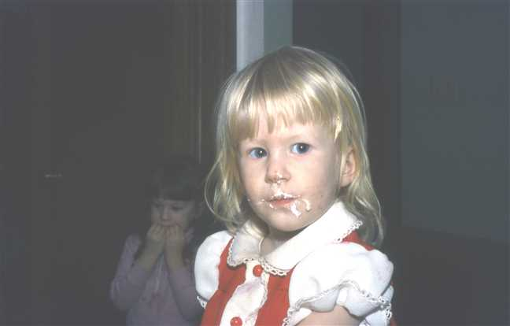  Figure 118: 1973-01Adele7 |  | 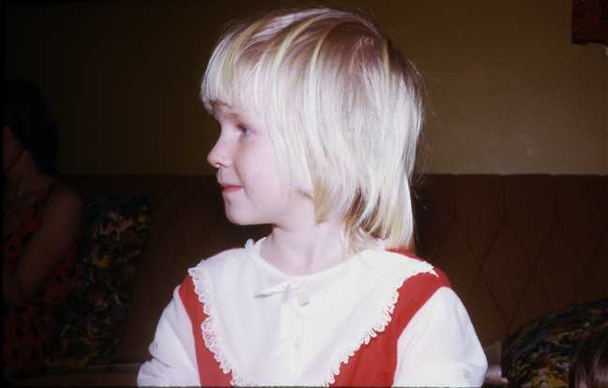  Figure 119: 1974-02Adele3

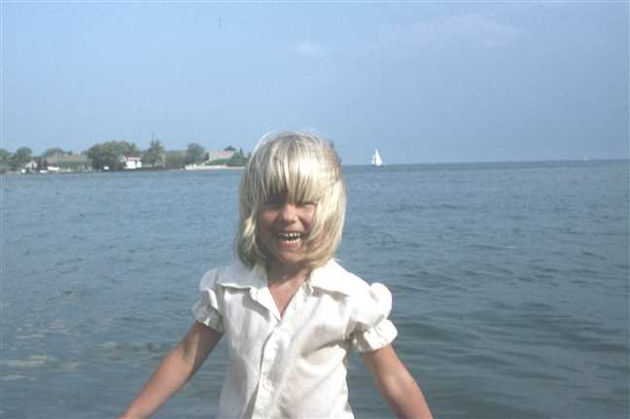  Figure 120: 1975-07Adele2 |  | 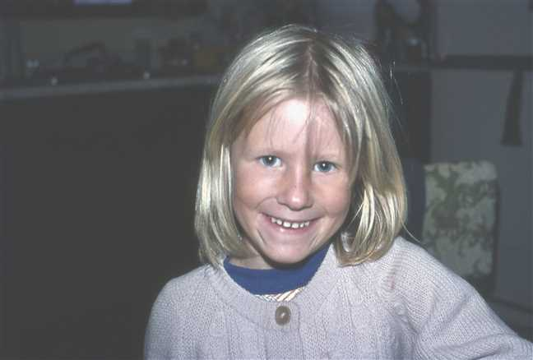  Figure 121: 1976-08Adele

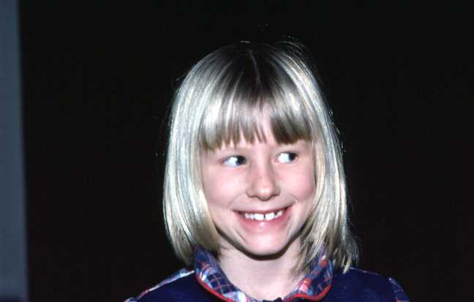  Figure 122: 1978-01Adele |  | 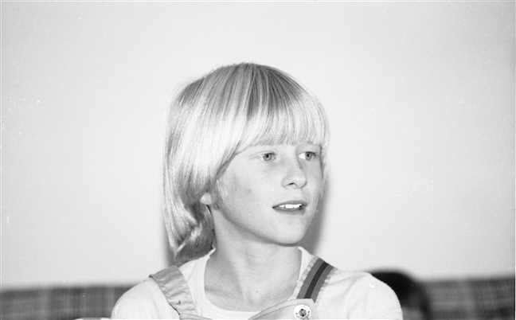  Figure 123: img001365

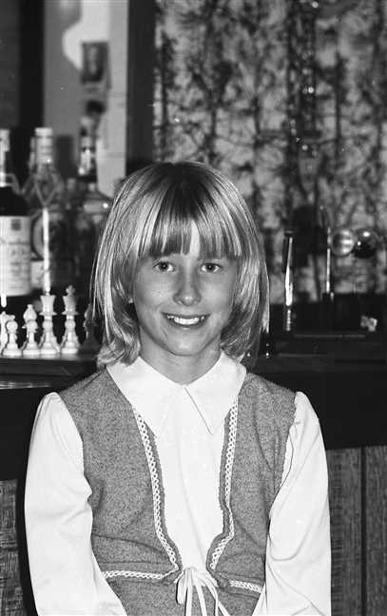  Figure 124: img001488 |  | 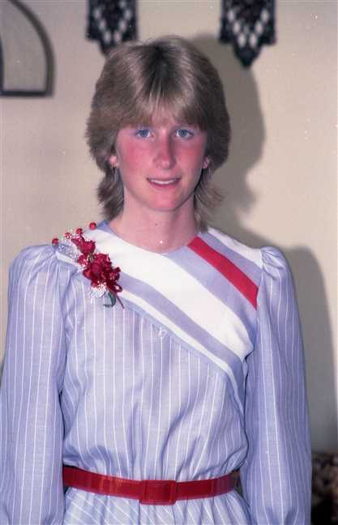  Figure 125: img001214

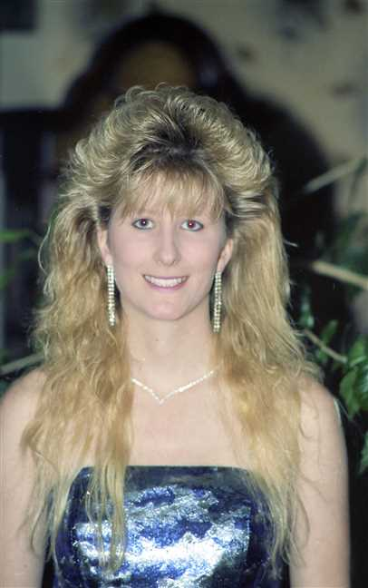
Figure 126: img001114

Family of Adele Robertson and Jeffery Craige
 |  |  |  |  |  |  |  |  |  |  |  |  |  |  |  |  |  |  |  |  |  |  |  | James Ives |  |  |  |  |  | Charlotte Helen |  |  |  |  |  | John |  |  |  |  |  | Jean
 |  |  |  |  |  |  |  |  |  |  |  |  |  |  |  |  |  |  |  |  |  |  |  | Robertson |  |  |  |  |  | MacDonell |  |  |  |  |  | Worobel |  |  |  |  |  | Kolynchuk
 |  |  |  |  |  |  |  |  |  |  |  |  |  |  |  |  |  |  |  |  |  |  |  | 1917–1989 |  |  |  |  |  | 1922–2005 |  |  |  |  |  | 1922–1979 |  |  |  |  |  | 1925–2012
 |  | ? |  |  |  |  |  |  |  |  |  |  |  | Jean |  |  |  |  |  |  |  |  |  |  |  | Allan James |  |  |  |  |  |  |  |  |  |  |  | Virginia
 |  | Craige |  |  |  |  |  |  |  |  |  |  |  | ? |  |  |  |  |  |  |  |  |  |  |  | Robertson |  |  |  |  |  |  |  |  |  |  |  | Worobel
 |  |  |  |  |  |  |  |  |  |  |  |  |  |  |  |  |  |  |  |  |  |  |  |  |  | 1943– |  |  |  |  |  |  |  |  |  |  |  | 1945–
 |  |  |  |  |  |  |  | Jeffery |  |  |  |  |  |  |  |  |  |  |  |  |  |  |  |  |  |  |  |  |  |  |  | Adele Marie
 |  |  |  |  |  |  |  | Craige |  |  |  |  |  |  |  |  |  |  |  |  |  |  |  |  |  |  |  |  |  |  |  | Robertson
 |  |  |  |  |  |  |  |  |  |  |  |  |  |  |  |  |  |  |  |  |  |  |  |  |  |  |  |  |  |  |  | 1971–
 |  |  |  |  |  |  |  |  |  |  |  |  |  | Married
 |  |  |  |  |  |  |  |  |  |  |  |  |  |  |  |  |  |  |  |  | Jude Allan
 |  |  |  |  |  |  |  |  |  |  |  |  |  |  |  |  |  |  |  |  | Robertson
 |  |  |  |  |  |  |  |  |  |  |  |  |  |  |  |  |  |  |  |  | 2004–
 |  |  |  |  |  |  |  |  |  |  |  |  |  |  |  |  |  |  |  |  | 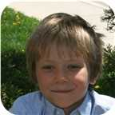

Here are the details about Adele Marie Robertson's first marriage, with Jeffery Craige. You can read more about Adele Marie on page 138.
Adele Marie Robertson married Jeffery Craige. They have one son. He is the son of ? Craige and Jean ?.
Jeff was adopten by Jean Craige and her first housband. Jeff's real parents are unknown but his biological Father is believed to be Austrian and his biological Mother is believed tobe Jamacian. Jeff has another older son - Kyle by another but unknown woman. He also has two more daughters by two other but unknown women.
Son of Adele Marie Robertson and Jeffery Craige:
m I. Jude Allan Robertson was born in St. Catharines, ON, on November 10, 2004.
  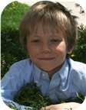
  Jude

Family of Adele Robertson and Geard Seward
 |  |  |  |  |  |  |  |  |  |  |  |  |  |  |  |  |  |  |  |  |  |  |  | James Ives |  |  |  |  |  | Charlotte Helen |  |  |  |  |  | John |  |  |  |  |  | Jean
 |  |  |  |  |  |  |  |  |  |  |  |  |  |  |  |  |  |  |  |  |  |  |  | Robertson |  |  |  |  |  | MacDonell |  |  |  |  |  | Worobel |  |  |  |  |  | Kolynchuk
 |  |  |  |  |  |  |  |  |  |  |  |  |  |  |  |  |  |  |  |  |  |  |  | 1917–1989 |  |  |  |  |  | 1922–2005 |  |  |  |  |  | 1922–1979 |  |  |  |  |  | 1925–2012
 |  | ? |  |  |  |  |  |  |  |  |  |  |  | Lynda |  |  |  |  |  |  |  |  |  |  |  | Allan James |  |  |  |  |  |  |  |  |  |  |  | Virginia
 |  | Seward |  |  |  |  |  |  |  |  |  |  |  | ? |  |  |  |  |  |  |  |  |  |  |  | Robertson |  |  |  |  |  |  |  |  |  |  |  | Worobel
 |  |  |  |  |  |  |  |  |  |  |  |  |  |  |  |  |  |  |  |  |  |  |  |  |  | 1943– |  |  |  |  |  |  |  |  |  |  |  | 1945–
 |  |  |  |  |  |  |  | Geard |  |  |  |  |  |  |  |  |  |  |  |  |  |  |  |  |  |  |  |  |  |  |  | Adele Marie
 |  |  |  |  |  |  |  | Seward |  |  |  |  |  |  |  |  |  |  |  |  |  |  |  |  |  |  |  |  |  |  |  | Robertson
 |  |  |  |  |  |  |  |  |  |  |  |  |  |  |  |  |  |  |  |  |  |  |  |  |  |  |  |  |  |  |  | 1971–
 |  |  |  |  |  |  |  |  |  |  |  |  |  | Married
 |  |  |  |  |  |  |  |  |  |  |  |  |  |  |  |  |  |  |  |  | Genevieve Alice
 |  |  |  |  |  |  |  |  |  |  |  |  |  |  |  |  |  |  |  |  | Seward
 |  |  |  |  |  |  |  |  |  |  |  |  |  |  |  |  |  |  |  |  | 2014–

Here are the details about Adele Marie Robertson's second marriage, with Geard Seward. You can read more about Adele Marie on page 138.
Adele Marie Robertson married Geard Seward. They have one daughter. He is the son of ? Seward and Lynda ?.
Daughter of Adele Marie Robertson and Geard Seward:
f I. Genevieve Alice Seward was born in St Catharines, Ontario, Canada, on May 19, 2014.

Family of Lara Robertson and Jeremy Bowen
Wilfred Fletcher |  |  |  |  |  | Helen |  |  |  |  |  | Pedro |  |  |  |  |  | Carmen |  |  |  |  |  | James Ives |  |  |  |  |  | Charlotte Helen |  |  |  |  |  | John |  |  |  |  |  | Jean
Bowen |  |  |  |  |  | Brodeur |  |  |  |  |  | Traverso |  |  |  |  |  | Soler |  |  |  |  |  | Robertson |  |  |  |  |  | MacDonell |  |  |  |  |  | Worobel |  |  |  |  |  | Kolynchuk
1927–2018 |  |  |  |  |  |  |  |  |  |  |  | 1927–2019 |  |  |  |  |  | –1991 |  |  |  |  |  | 1917–1989 |  |  |  |  |  | 1922–2005 |  |  |  |  |  | 1922–1979 |  |  |  |  |  | 1925–2012
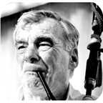 |  |  |  |  |  |  |  |  |  |  |  | 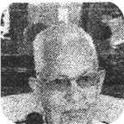
 |  | Ronald |  |  |  |  |  |  |  |  |  |  |  | Miriam |  |  |  |  |  |  |  |  |  |  |  | Allan James |  |  |  |  |  |  |  |  |  |  |  | Virginia
 |  | Bowen |  |  |  |  |  |  |  |  |  |  |  | Traverso |  |  |  |  |  |  |  |  |  |  |  | Robertson |  |  |  |  |  |  |  |  |  |  |  | Worobel
 |  |  |  |  |  |  |  |  |  |  |  |  |  |  |  |  |  |  |  |  |  |  |  |  |  | 1943– |  |  |  |  |  |  |  |  |  |  |  | 1945–
 |  |  |  |  |  |  |  |  |  |  |  |  |  | 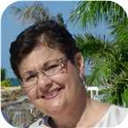
 |  |  |  |  |  |  |  | Jeremy |  |  |  |  |  |  |  |  |  |  |  |  |  |  |  |  |  |  |  |  |  |  |  | Lara Lynn
 |  |  |  |  |  |  |  | Bowen |  |  |  |  |  |  |  |  |  |  |  |  |  |  |  |  |  |  |  |  |  |  |  | Robertson
 |  |  |  |  |  |  |  | 1975– |  |  |  |  |  |  |  |  |  |  |  |  |  |  |  |  |  |  |  |  |  |  |  | 1973–
 |  |  |  |  |  |  |  | 
 |  |  |  |  |  |  |  |  |  |  |  |  |  | Married
 |  |  |  |  |  |  |  |  |  |  |  |  |  |  |  |  |  |  |  |  | Avalyn
 |  |  |  |  |  |  |  |  |  |  |  |  |  |  |  |  |  |  |  |  | Bowen
 |  |  |  |  |  |  |  |  |  |  |  |  |  |  |  |  |  |  |  |  | 2012–
 |  |  |  |  |  |  |  |  |  |  |  |  |  |  |  |  |  |  |  |  | 

79. Lara Lynn Robertson was born on Saturday, August 11, 1973, in St. Catharines, Ontario. She is the daughter of Allan James Robertson (56) and Virginia Worobel.
  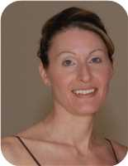
  Lara Lynn Robertson
She married Jeremy Bowen. They have one daughter.  Jeremy was born on Friday, December 26, 1975. He is the son of Ronald Bowen and Miriam Traverso.
  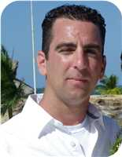
  Jeremy Bowen
Daughter of Lara Lynn Robertson and Jeremy Bowen:
f I. Avalyn Bowen was born in St Catharines, Ontario, Canada, on October 11, 2012.
  
  Avalyn

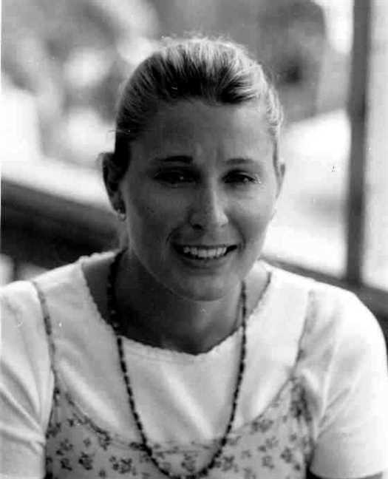  Figure 127: Lara Lynn Robertson |  | Figure 128: 1973-07Virginia(1)

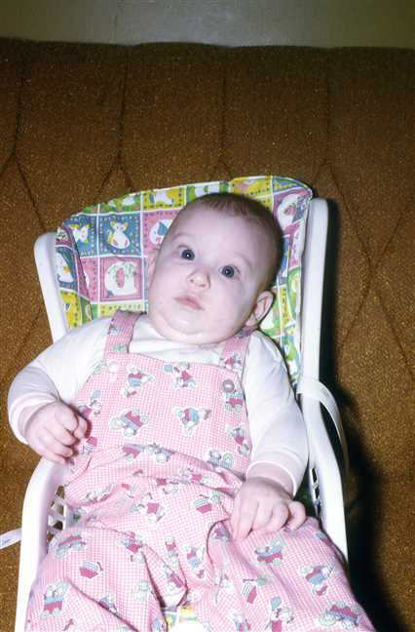  Figure 129: 1974-01Lara2 |  | 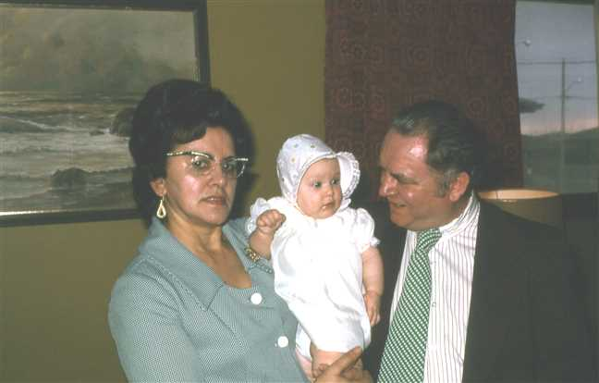  Figure 130: 1974-03BabaLaraWally

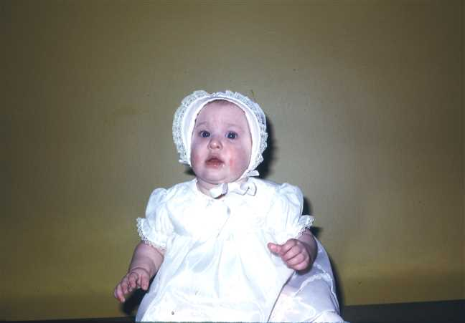  Figure 131: 1974-03Lara |  | 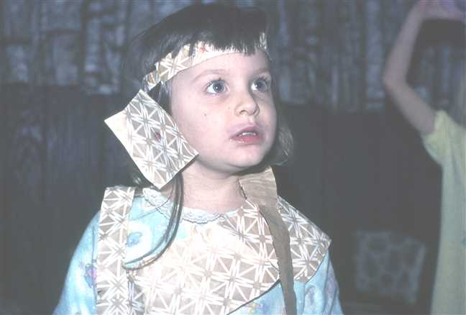  Figure 132: 1976-11Lara

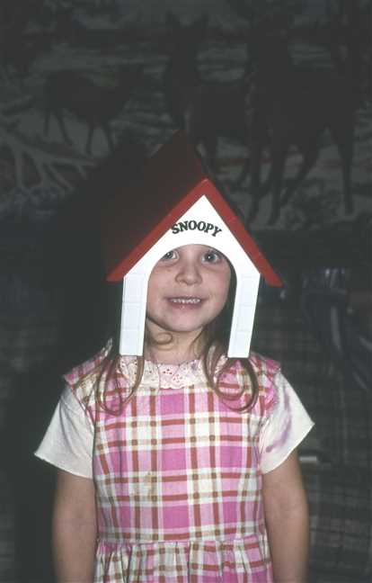  Figure 133: 1977-01Lara3 |  | 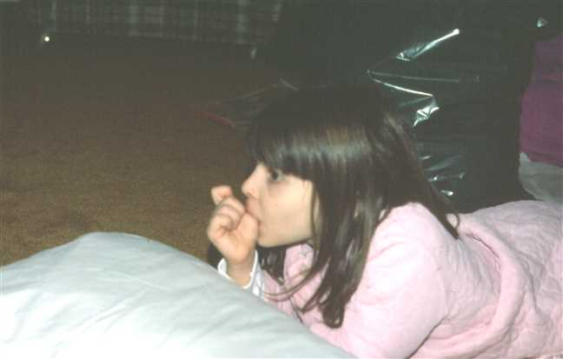  Figure 134: 1978-01Lara4

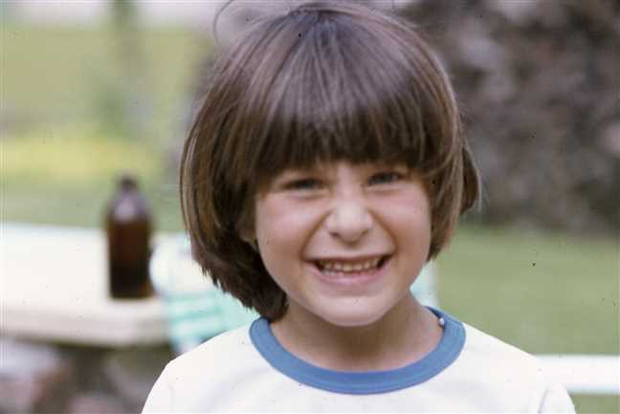  Figure 135: 1978-06Lara2 |  | 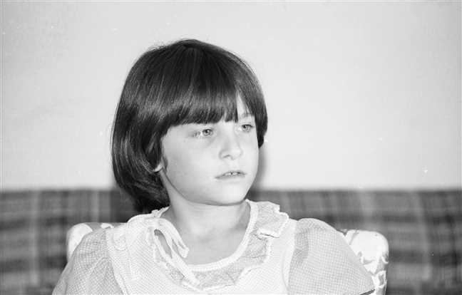  Figure 136: img001426

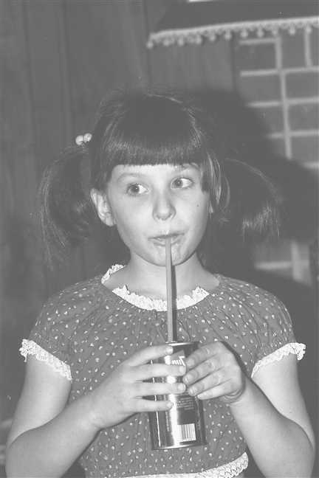  Figure 137: 1981-01 Lara |  | 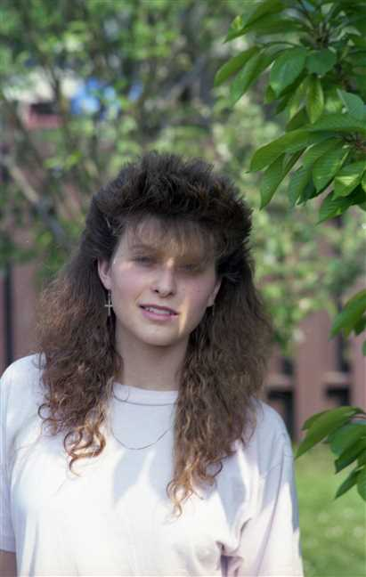  Figure 138: img001040

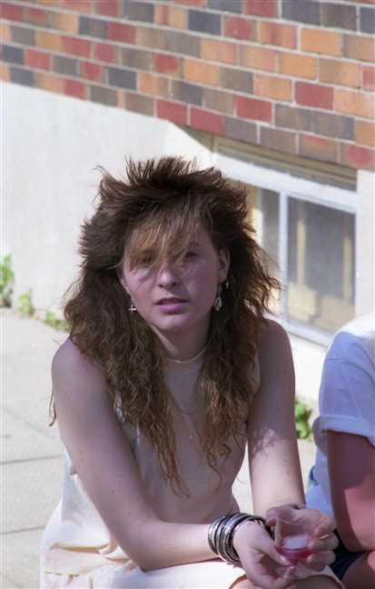
Figure 139: img001056

Family of Michelle Dusette and Brian Procter
 |  |  |  |  |  |  |  | James Ives |  |  |  | Charlotte Helen
 |  |  |  |  |  |  |  | Robertson |  |  |  | MacDonell
 |  |  |  |  |  |  |  | 1917–1989 |  |  |  | 1922–2005
 | ? |  |  |  |  |  |  |  | Lois Christina
 | Cyr |  |  |  |  |  |  |  | Robertson
 |  |  |  |  |  |  |  |  | 1948–1979
 |  |  |  |  | Michelle |  |  |  |  |  |  |  |  |  |  |  |  |  |  |  | Brian
 |  |  |  |  | Dusette |  |  |  |  |  |  |  |  |  |  |  |  |  |  |  | Procter
 |  |  |  |  | 1969–
 |  |  |  |  |  |  |  |  | Marriage: 1995
 |  |  |  |  |  |  |  |  |  |  |  | Jessica |  |  |  | Rebecca
 |  |  |  |  |  |  |  |  |  |  |  | Procter |  |  |  | Procter
 |  |  |  |  |  |  |  |  |  |  |  | 1997– |  |  |  | 2001–

80. Michelle Dusette was born on Monday, November 03, 1969, in St Catharines, Ontario, Canada. He or she is a child of ? Cyr and Lois Christina Robertson (57).
Michelle married Brian Procter in 1995. They have two children.
Children of Michelle Dusette and Brian Procter:
I. Jessica Procter was born in St Catharines on January 16, 1997.
II. Rebecca Procter was born in St Catharines on April 03, 2001.

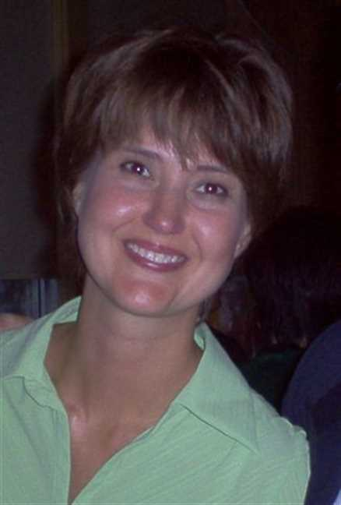  Figure 140: michelle pic |  | 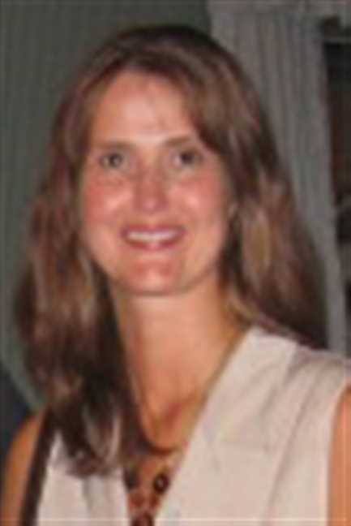  Figure 141: Michelle2

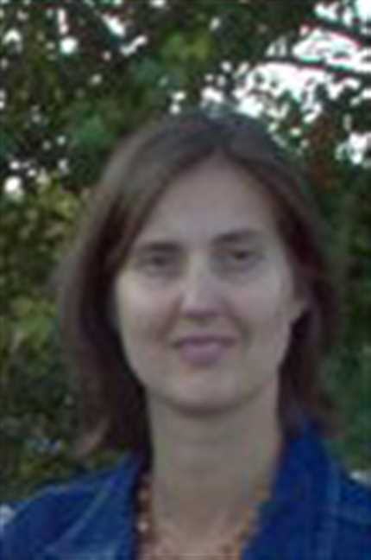  Figure 142: Michelle3 |  | 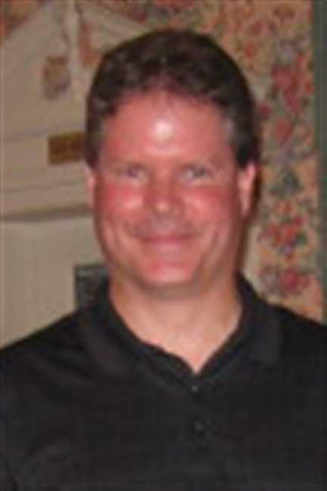  Figure 143: Brian

Lisa Robertson and John Brown
 |  |  |  |  |  |  |  | Kipling |  |  |  | Mary Ellen |  |  |  | Frederick Elmer Dicki |  |  |  | Jessie Winifred |  |  |  | James Ives |  |  |  | Charlotte Helen
 |  |  |  |  |  |  |  | MacKenzie |  |  |  | Foley |  |  |  | Gray |  |  |  | Davis |  |  |  | Robertson |  |  |  | MacDonell
 |  |  |  |  |  |  |  | ca.1910–1968 |  |  |  | –1987 |  |  |  |  |  |  |  | 1919– |  |  |  | 1917–1989 |  |  |  | 1922–2005
 | Joseph Owen |  |  |  |  |  |  |  | Catherine Alexandra |  |  |  |  |  |  |  | Roy Edward |  |  |  |  |  |  |  | Vivian Louise
 | Brown |  |  |  |  |  |  |  | MacKenzie |  |  |  |  |  |  |  | Gray |  |  |  |  |  |  |  | Robertson
 | 1932– |  |  |  |  |  |  |  | 1935–1992 |  |  |  |  |  |  |  | 1951– |  |  |  |  |  |  |  | 1957–
 |  |  |  |  | John Christopher |  |  |  |  |  |  |  |  |  |  |  |  |  |  |  | Lisa
 |  |  |  |  | Brown |  |  |  |  |  |  |  |  |  |  |  |  |  |  |  | Robertson
 |  |  |  |  | 1971– |  |  |  |  |  |  |  |  |  |  |  |  |  |  |  | 1974–
 |  |  |  |  |  |  |  |  | Partner
 |  |  |  |  |  |  |  |  |  |  |  | William Blair Robertson |  |  |  | Devon Alexander
 |  |  |  |  |  |  |  |  |  |  |  | Brown |  |  |  | Brown
 |  |  |  |  |  |  |  |  |  |  |  | 1996– |  |  |  | 2003–
 |  |  |  |  |  |  |  |  |  |  |  | 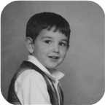

81. Lisa Robertson was born on Thursday, August 08, 1974, in Pictou, Nova Scotia, Canada. She is the daughter of Roy Edward Gray and Vivian Louise Robertson (58).
  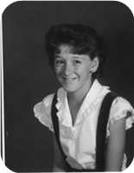
  Lisa Robertson
She is partnered with John Christopher Brown. They have two sons.
John Christopher was born in Pictou, N.S., on Saturday, March 13, 1971. He is the son of Joseph Owen Brown and Catherine Alexandra MacKenzie.
Sons of Lisa Robertson and John Christopher Brown:
m I. William Blair Robertson Brown was born in New Glasgow, Nova Scotia, on January 12, 1996.
  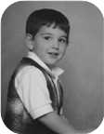
  William
m II. Devon Alexander Brown was born in Saskatoon, Sask., on March 28, 2003.

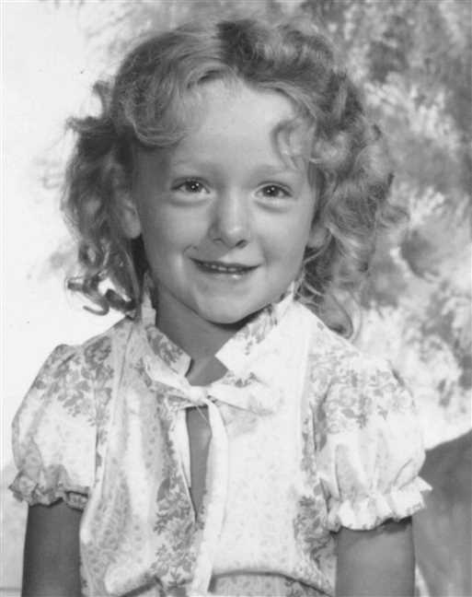  Figure 144: Lisa Robertson |  | 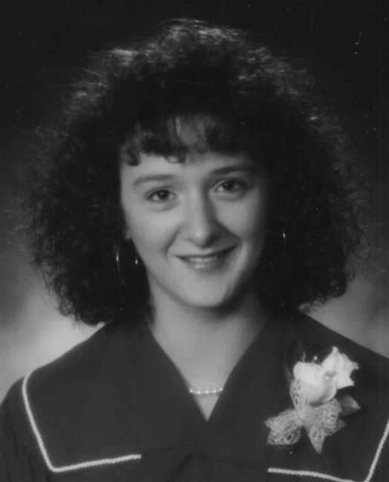  Figure 145: Lisa Robertson

Index of Places

1 year Mt Allison Academy (Commercial)
Robertson, Leonard Bowman (1918–) 87
1081
Ives, George 60
12 Mile House, Pictou Co., N.S.
Fraser, Ocenia (1853–1935) 46
Ives, Arthur (1854–1913) 43
Aberdeen Hospital, New Glasgow, N.S.
Gaston, Gladys Jean (1916–1998) 93
Aiken, MD
Ives, William Alexander (1880–) 61
Amherst, N.S
Ives, Alfred J (1862–1883) 33
Amherst, N.S.
Gray, Allan Roderick (1944–) 99, 128
B.Eng. from UNB
Robertson, Leonard Bowman (1947–) 119
BA from UNB
Robertson, Janet Louise (1951–) 120
Branch Manager for Lownsbury's
Robertson, Leonard Bowman (1918–) 87
Bridgetown, NS
Ives, Henry G (1858–) 58
Bridgeville, Nova Scotia
MacMillan, Jessie Margaret (1898–1994) 74
Brockville, Ont.
Gray, Norma Jean (1949–) 99, 130
Gray, Robert Irving (1947–1983) 99, 129
Brooklyn, NY
Ives, Lewis N (ca.1858–1895) 33
Brule Point, Colchester Co. NS
Ives, Robert (1842–) 17, 34
Brule Point, Colchester Co., N.S
Ives, James (ca.1824–1873) 17, 32
BSc, MSc St Francis Xavier Univ. 1965, 1967
Robertson, Allan James (1943–) 103
Cadillac, Quebec
Robertson, James Ives (1917–1989) 81
Campbell River, B.C.
Dewolfe, Adam Phillips (1980–) 130
Dewolfe, Holly Virginia (1972–) 130
Dewolfe, Rodan Alexander (1974–) 130
Chatham, N.B.
Robertson, Ian Douglas (1950–) 87
Chemist
Robertson, Allan James (1943–) 103
Churchville, Nova Scotia
Robertson, Leonard Bowman (1890–1972) 67
Civil Engineer
Robertson, Leonard Bowman (1947–) 119
Cumunity College
Robertson, James Ives (1917–1989) 80
Durham Cemetery
Fraser, James William (1848–1882) 46
Durham Cemetery, N.S.
Fraser, Jane (1779–1879) 11
Fraser, John (1808–1894) 26
Robertson, Annie (1818–1909) 27
Durham, Nova Scotia
Fraser, Mary Jane (1850–1940) 27
Empress, Alberta
Bell, Edna Effie (1920–) 87
Factory Worker
Robertson, Lewis William (1951–) 81
Fisher's Grant, N.S.
Fraser, Georgina (1839–1933) 15, 31
From Niagara Falls
Bongard, Norah Lynn (1953–) 123
From Orilia
Bongard, Lester William (1921–2000) 90
Greenwood Cemetery, Pictou Landing , NS
Ives, Jane (1806–1856) 14
Greenwood Cemetery, Pictou Landing, N.S.
Fraser, Catharine (1778–1865) 11
Haliburton Cemetery, Pictou, N.S.
Fraser, Ocenia (1853–1935) 45
Ives, Alfred J (1862–1883) 33
Ives, Arthur (1854–1913) 43
Ives, Arthur (1919–1933) 71
Ives, Charles Copeland (1883–1888) 39
Ives, Fanny Black (1828–1874) 32
Ives, James (ca.1824–1873) 32
Ives, Jannet (1882–1882) 39
Ives, John Clift (ca.1853–1858) 33
Ives, John Turner (1804–1876) 16
Ives, Lewis N (ca.1858–1895) 33
Ives, Robert Copeland (1878–1883) 39
Ives, Welsford B (ca.1861–1929) 33
Ives, William (ca.1855–1857) 33
Haliburton Cemetry , Pictou N.S.
Rood, Harry Morrison (1878–1880) 54
Haliburton, Pictou, N.S.
Copeland, Margaret Maggie (1848–1933) 38
Fraser, Jessie (1855–1947) 49
Gesner, Jean H (1911–1994) 63
Harris, Daniel Fraser (1887–1970) 63
Harris, Joseph Ives (1883–1902) 41
Harris, Mary Glennie (1891–1891) 41
Harris, Simpson J (1852–1934) 40
Harris, William Henry (1882–1965) 41
Ives, Charles William (1841–1921) 36
Ives, Emma (1850–1933) 40
Ives, Louisa Reid (1889–1982) 66
Robertson, Leonard Bowman (1890–1972) 67
Rood, Charles Lever (1850–1922) 51
Halifax, N.S.
Ives, William Henry (–1911) 79
Halifax, NS
Ives, Fanny Black (1828–1874) 32
High School
Robertson, Lois Christina (1948–1979) 112
Home of John Ives, Pictou, N.S.
Ives, Sarah Frances (1856–) 57
Home of Mrs. John Turner Ives, Pictou, NS
Ives, Edith Lillian (1867–) 59
Judique, Nova Scotia
MacDonell, Charlotte Helen (1922–2005) 81
Lauel Hill Cemetery, Pictou, NS
Fraser, Charles (1748–1811) 9
Laurel Hill Cemetery, Pictou, N.S.
Fraser, Christiana Ann (1813–1900) 21
Ives, Anna (1800–1878) 13
Ives, Catherine Fraser (1843–1847) 23
Ives, Daniel Fraser (1852–1884) 24
Ives, Infant Daughter (1851–1851) 24
Ives, John Robert (1845–1845) 23
Ives, William (1808–1880) 18
Ives, William Howard (1846–1848) 23
Little Harbour, N.S.
Gray, Eleanor Mary Rood (1950–) 132
Mechanical Engineer
Bongard, Lester William (1921–2000) 90
Merchant
Ives, John Turner (1804–1876) 16
Merigomish, N.S. - Smith Copeland's home
Ives, Charles William (1841–1921) 38
Moncton, N.B.
Robertson, Leonard Bowman (1947–) 87, 119
Montreal, Quebec
Bongard, Norah Lynn (1953–) 123
Nelson, B.C.
Gray, Ellen Casey (1980–) 129
Gray, Katie Lexia (1982–) 129
Gray, Robert Irving (1947–1983) 99, 129
New Glasgow, N.S.
Dennison, Clare Ross (–1960) 100
Graham, Joseph Cunard (1836–1917) 31
Gray, Charles Lever Rood (1913–1995) 76, 98
Gray, Harry Alexander (1916–) 76, 99
Gray, Henry Irving Beecher (1887–1976) 76
Gray, John Allan (1919–1994) 76, 99
Ives, Annie (1880–1956) 44
Rood, Mary Alice (1880–1973) 54, 75
New Glasgow, Nova Scotia
Brown, William Blair Robertson (1996–) 148
Fraser, Jessie (1855–1947) 27, 49
Fraser, John (1808–1894) 26
Gray, Charles Lever Rood (1913–1995) 98
Gray, John Allan (1919–1994) 76, 99, 101
Ives, David Hugh (1924–) 75, 95
Ramscar, John Vincent (1947–) 97, 126
Ramscar, Mark Vincent (1978–) 127
Robertson, Annie (1818–1909) 27
Rood, Charles Lever (1850–1922) 51
New Glasgow, Nova Scotia (home of Alex. Fraser)
Fraser, John (1808–1894) 27
Niagara Falls, Ont.
Bongard, David (1958–) 90
Bongard, John Reid (1949–) 90, 122
Bongard, Norah Lynn (1953–) 90, 123
Bongard, Robert William (1946–) 90, 121
Robertson, Norah Louise (1921–) 67, 90
North Bay, Ontario
Champion, John Douglas (1951–) 120
Norwood, Ontario
Bongard, Lester William (1921–2000) 90
Orillia, Ont.
Bongard, Lester William (1921–2000) 90
Philadelephia, PA
Ives, Charles Moore (1906–2001) 61, 77
Pictou, N.S.
Bethume, James William (1879–1940) 62
Brown, John Christopher (1971–) 148
Gray, Roy Edward (1951–) 118
Ives, John Turner (1804–1876) 16
Ives, William Henry (–1911) 61, 79
McPhail, Anna (1844–1872) 37
Rood, Mary Alice (1880–1973) 54, 75
Pictou, N.S. by Rev. William C Brown
Ives, Charles William (1841–1921) 37
Pictou, Nova Scotia
Ives, John Fraser (1895–1970) 44, 74
Pictou, Nova Scotia, Canada
(45.6782° N, 62.7071° W)
Ives, Louisa Reid (1889–1982) 44, 66
Patterson, Matthew (1785–1858) 13
Robertson, Allan James (1943–) 81, 103
Robertson, James Ives (1917–1989) 67, 80
Robertson, Leonard Bowman (1890–1972) 67
Robertson, Lisa (1974–) 118, 148
Robertson, Lois Christina (1948–1979) 81, 112
Robertson, Vivian Louise (1957–) 81, 116
Pictou, NS
Robertson, Derek (1990–) 118
Plymouth Park, Nova Scotia
Ives, John Fraser (1895–1970) 44, 74
MacMillan, Jessie Margaret (1898–1994) 74
Prince Edward Island
Bethume, James William (1879–1940) 62
Ramscar, Anna Victiria (1973–) 127
Pugwash, N.S.
Graham, Charles Archibald (1863–1882) 32
Registered Nurse
Bell, Edna Effie (1920–) 87
River John, Nova Scotia
Rood, Charles Lever (1850–1922) 51
Sackville, New Brunswick
Manship, Laura Maud (1883–1979) 70
Saint John, N.B.
Robertson, Leonard Bowman (1918–) 87
Santa Clarita, CA
Ives, Charles Moore (1906–2001) 61, 77
Saskatoon, Sask.
Brown, Devon Alexander (2003–) 148
Secretary
Robertson, Lois Christina (1948–1979) 112
Sheet Metal worker
Robertson, James Ives (1917–1989) 80
Sheriff
Harris, Simpson J (1852–1934) 40
St Catharines, Niagara, Ontario, Canada
(43.1592° N, 79.2465° W)
Robertson, Allan James (1943–) 107
St Catharines, Ontario
Robertson, Lois Christina (1948–1979) 81, 112
Worobel, Virginia (1945–) 107
St Catharines, Ontario, Canada
(43.1667° N, 79.2334° W)
Bowen, Avalyn (2012–) 143
Dusette, Michelle (1969–) 116, 146
Procter, Jessica (1997–) 146
Procter, Rebecca (2001–) 147
Seward, Genevieve Alice (2014–) 142
Taylor, James Elliott (2011–) 134
Taylor, Peyton Jackson (2009–) 134
St. Asaph, North Wales
Ramscar, Clwyd Vincent (1922–1988) 97
St. Catharines, ON
Robertson, Jude Allan (2004–) 141
St. Catharines, Ontario
Robertson, Adele Marie (1971–) 108, 138
Robertson, Jenny Lind (1970–) 107, 133
Robertson, Lara Lynn (1973–) 108, 143
Stellarton, N.S.
Gaston, Gladys Jean (1916–1998) 93
Phillips, Dorothy Hazel (1919–) 99
Stellarton, Nova Scotia
Robertson, James Ives (1917–1989) 67, 80
Stellerton, N.S.
Robertson, Leonard Bowman (1918–) 67, 87
Sydney, Nova Scotia
Ramscar, John Vincent (1947–) 127
Taxi Driver
Robertson, Ian Douglas (1950–) 87
Telegraph operator, Security guard
Robertson, Leonard Bowman (1890–1972) 67
Toronto, ON
Biggs, Jerrery F (–ca.1988) 123
Toronto, Ontario
Gray, ? 128
Twelve Mile House, West River, Pictou Co., N.S.
Fraser, Jessie (1855–1947) 27, 49
Welland, Ontario, Canada
(42.9935° N, 79.2393° W)
Taylor, Steve 133
West River, Nova Scotia
Fraser, James (1777–1853) 11
West River, Pictou Co., Nova Scotia
Fraser, Jane (1779–1879) 9, 10, 11
Fraser, John (1808–1894) 26
White Rock, B.C.
Gray, Allan Roderick (1944–) 128
Winnigeg, Manitoba
Gray, Leslie 100, 131
Winnipeg, Manitoba
Hunter, Donna Marie (1945–) 128
Winsor, Ont.
Dewolfe, Mark Steams (1948–) 130
Gray, Norma Jean (1949–) 130
Worked for CP railway
Champion, John Douglas (1951–) 120

Index of Individuals

?
? 13, 14, 16, 17, 60, 89, 90, 118, 121, 122, 123
Ann 10, 11, 26, 29
Betty Ann 133
Iris 124
Jean 141
Lynda 142
Mary 74, 95, 96
Mary Ann 75
Tammy 125
Yvone 122
Allan
John David (1951–) 127
Anderson
Bess 126
Ann?
(unknown given name) 9, 11, 12, 13, 14, 16, 17
Arnseon
Anne (1815–1889) 39, 40, 63, 64, 65
Baxter
Abigail 70, 91, 92
Bell
Edna Effie (1920–) 86, 87, 119, 120
Hugh 86
Roy Wesley (1888–1963) 86, 87, 119, 120
Bethume
James William (1879–1940) 62
Biggs
Jerrery F (–ca.1988) 123
Lauren Alexis (1982–) 123
Bongard
? 89, 90, 121, 122, 123
David (1958–) 89, 90
John Reid (1949–) 89, 90, 122
Lester William (1921–2000) 89, 90, 121, 122, 123
Norah Lynn (1953–) 89, 90, 123
Robert William (1946–) 89, 90, 121, 122
Bowen
Avalyn (2012–) 143
Jeremy (1975–) 143
Ronald 143
Wilfred Fletcher (1927–2018) 143
Brackenridge
Isabella 75
Brodeur
Helen 143
Brooks
Catherine 121
Brown
Devon Alexander (2003–) 148
John Christopher (1971–) 148
Joseph Owen (1932–) 148
William Blair Robertson (1996–) 148
Campbell
Alexander (1817–1908) 66
Annie Fraser (1867–1960) 66, 67, 80, 86, 89
Carroll
Jerimiah 48
Mary Anne (1818–1877) 48, 51, 75
Champion
Barbara Ann (1978–) 120, 121
Harry (1919–1985) 120
John Douglas (1951–) 120
Timothy Edward (1976–) 120, 121
Chappell
David 128
Christina
(unknown given name) 78, 79
Clark
Catherine Jane 98, 128
Kay (Catherine J. Clark) 98
Colburg
Eleanor Arleen 78
Copeland
Margaret Maggie (1848–1933) 38, 61, 62, 78, 79
Robert S (1800–1885) 38, 61, 62
Samuel (–ca.1807) 38
Cornelius
Arleigh 124
Craige
? 141
Jeffery 141
Cyr
? 116, 146
Dalton
Joseph 114
Daniels
Alvin 55
Arthur 55
Flossie 55
Lizzie 55
Russel 55
Davis
Jessie Winifred (1919–) 117, 118, 148
Dennison
Clare Ross (–1960) 100, 131
Dewolfe
Adam Phillips (1980–) 130
Holly Virginia (1972–) 130
Lome 130
Mark Steams (1948–) 130
Rodan Alexander (1974–) 130
Dunbar
Isabella (1823–1897) 66
Dusette
Michelle (1969–) 116, 146
Eastwood
James 72, 93
Jenny Mitchell (1880–1942) 72, 93, 124
Foley
Mary Ellen (–1987) 148
Fortin
Marguerite (1917–) 120
Fraser
? 29, 125
Alice (ca.1857–) 26, 27, 55
Anna (ca.1852–) 26, 27, 47
Archibald (1801–1892) 14, 15, 31
Catharine (1778–1865) 9, 10, 11, 13, 14, 16, 17, 18, 31, 32, 33, 34, 37, 38, 39, 43
Charles (1748–1811) 9, 10, 11, 12, 13, 14, 16, 17, 26, 29
Christiana Ann (1813–1900) 17, 21, 34, 36, 37, 38, 39, 40, 43, 60, 61, 62, 63, 64, 65, 66, 70, 72, 74
Christina (1790–1832) 9, 10, 11, 12
Daniel (1769–1850) 17, 21, 34, 37, 38, 39, 43
Donald (1780–1851) 9
Donald (1789–) 9
Georgina (1839–1933) 14, 15, 31
Grace 9, 10, 12
Hugh (1744–1803) 26, 29
James (1777–1853) 11, 26, 29, 43, 46, 47, 48, 55
James Turner (1842–) 14, 15
James William (1848–1882) 26, 27, 46
Jane (1779–1879) 9, 10, 11, 26, 29, 43, 46, 47, 48, 55
Jessie (1855–1947) 26, 27, 48, 49, 75, 98, 99, 100, 101
John (1787–) 9
John (1808–1894) 26, 43, 45, 46, 47, 48, 49, 55, 66, 70, 72, 74, 75
John J 29
John T Ives (1861–1863) 26, 28
Joseph (–1941) 64
Mary 9, 10, 12
Mary Jane (1850–1940) 26, 27
Nancy (1776–1854) 9
Ocenia (1853–1935) 26, 27, 43, 45, 66, 70, 72, 74, 80, 86, 89, 91, 92, 93, 95, 96
William (ca.1883–) 64
William J (1816–1914) 29
William Russel 46
French
Josephine 86
Gaston
Clarence 93, 124
Gladys Jean (1916–1998) 93, 124
Gesner
Jean H (1911–1994) 63
Goodman
Nordau R 131, 132
Phillip Anders 131, 132
Graham
Charles Archibald (1863–1882) 31, 32
John T (1866–1867) 31
Joseph Cunard (1836–1917) 31
Thomas (1776–1839) 31
Thomas (1807–1864) 31
Grant
Christiana (1752–1818) 17
Elizabeth (1771–) 31
Gray
? 98, 128
Alexander Black (1847–1916) 75, 76, 98, 99, 100, 101
Allan Roderick (1944–) 99, 128
Charles Lever Rood (1913–1995) 75, 76, 98, 128
Eleanor Mary Rood (1950–) 100, 131
Ellen Casey (1980–) 129
Frederick Elmer Dicki 117, 118, 148
Harry Alexander (1916–) 75, 76, 99, 128, 129, 130
Henry Irving Beecher (1887–1976) 75, 76, 98, 99, 100, 101, 128, 129, 130, 131
John 75
John Allan (1919–1994) 75, 76, 99, 100, 101, 131
Katie Lexia (1982–) 129
Leslie 100, 131
Norma Jean (1949–) 99, 130
Robert Irving (1947–1983) 99, 129
Roy Edward (1951–) 117, 118, 148
Harris
Ann (ca.1766–1823) 13
Christina Ives (1890–) 39, 41, 65
Daniel Fraser (1887–1970) 39, 41, 63
George Stewart (1885–1968) 39, 41
John W 39
Joseph Ives (1883–1902) 39, 41
Margaret McLeod (1888–) 39, 41, 64
Mary Glennie (1891–1891) 39, 41
Matthew (1735–1829) 13
Simpson J (1852–1934) 39, 40, 63, 64, 65
William H (1805–1883) 39, 40, 63, 64, 65
William Henry (1882–1965) 39, 41
Hartling
Dorothy 101
Hatch
Ernestine 93, 124
Hunter
Donna Marie (1945–) 128
John Gordon 128
Ives
Alexander William (1879–) 33, 34, 59
Alfred J (1862–1883) 32, 33
Anna (1800–1878) 13
Annie (1880–1956) 43, 44
Arthur (1854–1913) 17, 24, 43, 46, 66, 70, 72, 74, 80, 86, 89, 91, 92, 93, 95, 96
Arthur (1919–1933) 70, 71
Brian 95, 96
Catherine Fraser (1843–1847) 17, 23
Charles Copeland (1883–1888) 38, 39
Charles Moore (1906–2001) 61, 77, 78, 79
Charles W 78
Charles William (1841–1921) 17, 23, 36, 37, 38, 61, 62, 78, 79
Christina Nan (1884–) 38, 39, 62
Daniel Fraser (1852–1884) 17, 24
Daniel Fraser (1887–1964) 43, 44, 70, 91, 92
David Hugh (1924–) 74, 75, 95, 125, 126
Edith Lillian (1867–) 32, 33, 58
Emma (1850–1933) 17, 24, 39, 40, 63, 64, 65
Fanny Black (1828–1874) 32, 57, 58
Frances C 70, 71, 92
Frederick George (ca.1876–1915) 34, 35, 60
George 60
George (ca.1770–1862) 11, 13, 14, 16, 17, 18, 31, 32, 33, 34, 37, 38, 39, 43
George Daniel (1840–) 17, 23, 34, 60
Henry G (1858–) 32, 33, 58
Hilda 70, 71, 92
Infant Daughter (1851–1851) 17, 24
James (1881–) 33, 34
James (ca.1790–) 32, 57, 58
James (ca.1824–1873) 16, 17, 32, 57, 58
James Eastwood (1916–) 72, 93, 124
Jane (1806–1856) 14, 31
Jane Oxley (1875–1875) 34, 35
Jannet (1882–1882) 38, 39
Joanne 95, 96
John (ca.1740–ca.1782) 13, 14, 16, 17
John Clift (ca.1853–1858) 32, 33
John David (1969–) 95, 96, 125
John Fraser (1895–1970) 43, 44, 74, 95, 96, 97, 125, 126, 127
John Gillan 93, 94, 124
John Robert (1845–1845) 17, 23
John Turner (1804–1876) 16, 32, 33, 34, 57, 58, 59
Kenneth 60, 61
Lewis Gordon (–1918) 72, 73
Lewis N (ca.1858–1895) 32, 33
Lewis Zindord (1888–1941) 43, 44, 72, 93, 124
Louisa Reid (1889–1982) 43, 44, 66, 80, 86, 87, 89, 90, 103, 114, 115, 116, 117, 118, 119, 120, 121, 122, 123
Margaret 61
Marjory 93, 94, 124
Norah MacGillivary (1921–) 74, 75, 96, 97, 126, 127
Pearl 95, 96, 126
Robert (1842–) 16, 17, 33, 34, 59
Robert Copeland (1878–1883) 38, 39
Russel Bliss (–1912) 70, 91
Sarah Frances 16, 17, 32, 33, 34, 57, 58, 59
Sarah Frances (1856–) 32, 33, 57
Sarah Jean (1969–) 95, 96, 125
Virginia 61, 78, 79, 80
Welsford B (ca.1861–1929) 32, 33
William (1808–1880) 17, 18, 34, 36, 37, 38, 39, 40, 43, 60, 61, 62, 63, 64, 65, 66, 70, 72, 74
William (1874–1875) 34, 35
William (ca.1849–) 17, 23
William (ca.1855–1857) 32, 33
William Alexander (1880–) 38, 39, 61, 77, 78, 79, 80
William Henry (–1911) 61, 79
William Howard (1846–1848) 17, 23
Judy
(unknown given name) 78, 79
Keene
Catherine 48
Kernaghan
George 47
Kitchin
Henry 57
James (1818–1874) 57
James (–1853) 57
Kohut
Catherine 103
Kolynchuk
Demetro (1897–1945) 103
Jean (1925–2012) 103, 107, 133, 141, 142, 143
Kwasnica
Dora (1899–1972) 103
Lenyk
Laysha (1947–) 119
Little
Harold 115
MaBee
Hazel 133
MacCaullum
William 92
MacDonald
Edward M 58, 59
Mary Christina (1895–1978) 80, 81, 103, 114, 115, 116, 117, 118
William Little (1844–1917) 80
MacDonell
Allan (1880–1926) 80, 81, 103, 114, 115, 116, 117, 118
Angus Hugh (1831–1917) 80
Charlotte Helen (1922–2005) 80, 81, 103, 112, 114, 115, 116, 117, 118, 133, 141, 142, 143, 146, 148
Flora (1841–1919) 80
MacDougall
Charlotte (1849–1934) 80
MacIntosh
Mary 72, 93
MacIntyre
Penny 129
R.E. 129
Mackay
John 12
MacKay
Catherine (1775–1864) 17, 21, 34, 37, 38, 39, 43
Margaret (ca.1732–1825) 26
Roderick (1746–1829) 17
Mackenzie
Colin (1721–1825) 26
MacKenzie
Anne Dawson (1949–) 126, 127
Catherine Alexandra (1935–1992) 148
Christina (1780–1832) 26, 27, 43, 46, 47, 48, 55
Donald 126, 127
Isabella 26
John Duncan (1870–1932) 126
Kipling (ca.1910–1968) 148
Magdalen (1749–1826) 26, 29
MacMillan
Hugh 74, 95, 96
Jessie Margaret (1898–1994) 74, 95, 96, 97, 125, 126, 127
William 126
Maisie
(unknown given name) 78, 79
Manship
Bliss 70, 91, 92
Laura Maud (1883–1979) 70, 91, 92
Matheson
Jessie (–1902) 29
William 29
McConnell
Elizabeth 57
McDougall
James 11, 12
William (–1845) 12
McKiel
Harry W 65
McKillop
Jessie (1827–1900) 66
McLellan
Mary (1807–1892) 31
McLeod
Amelia 34, 35, 60
Grace (1858–) 33, 34, 59
James 34, 35, 60
McPhail
Alexander 37
Anna (1844–1872) 37
Mills
? 79, 80
Moore
Mary K (1868–1894) 86
Virginia 61, 77, 78, 79, 80
Murphy
? 131
? (1993–) 131
Brice 131
Jullian Harmah (1994–) 131
Murray
Winnifred 79
O'Brian
Catharine 38
Patterson
John (1708–) 13
John (1748–1808) 13
Matthew (1785–1858) 13
Phillips
Dorothy Hazel (1919–) 99, 128, 129, 130
William 99, 128, 129, 130
Procter
Brian 146
Jessica (1997–) 146
Rebecca (2001–) 146, 147
Ramscar
Anna Victiria (1973–) 126, 127
Clwyd Vincent (1922–1988) 96, 97, 126, 127
David Frederick (1944–1970) 96, 97
Jessie Margaret (1948–) 96, 97, 127
John Vincent (1947–) 96, 97, 126
Lawrence James (1951–) 96, 97
Mark Vincent (1978–) 126, 127
Rickerby
Elizabeth (1801–1867) 57
Robertson
Adele Marie (1971–) 103, 108, 138, 141, 142
Allan James (1943–) 80, 81, 103, 133, 138, 141, 142, 143
Annie (1818–1909) 26, 27, 43, 45, 46, 47, 48, 49, 55, 66, 70, 72, 74, 75
Annie Oceania (1915–1920) 66, 67
Derek (1990–) 118
Ian Douglas (1950–) 86, 87
James (1823–1894) 66
James Alexander (1859–1947) 66, 67, 80, 86, 89
James Ives (1917–1989) 66, 67, 80, 103, 112, 114, 115, 116, 117, 118, 133, 141, 142, 143, 146, 148
Janet Louise (1951–) 86, 87, 120
Jenny Lind (1970–) 103, 107, 133
John (ca.1729–1818) 26
Jude Allan (2004–) 141
Lara Lynn (1973–) 103, 108, 143
Leonard Bowman (1890–1972) 66, 67, 80, 86, 87, 89, 90, 103, 114, 115, 116, 117, 118, 119, 120, 121, 122, 123
Leonard Bowman (1918–) 66, 67, 86, 87, 119, 120
Leonard Bowman (1947–) 86, 87, 119
Lewis William (1951–) 80, 81
Lisa (1974–) 117, 118, 148
Lois Christina (1948–1979) 80, 81, 112, 114, 115, 116, 146
Michael Leonard (1978–) 119
Norah Louise (1921–) 66, 67, 89, 90, 121, 122, 123
Richard Bruce (1976–) 119
Roy Wesley (1949–1949) 86, 87
Vivian Louise (1957–) 80, 81, 116, 117, 118, 148
William (1769–1848) 26, 27, 43, 46, 47, 48, 55
Rood
Alla (Mary A. Rood) (1880–1973) 54, 75
Charles Lever (1850–1922) 48, 51, 75, 98, 99, 100, 101
Harry Morrison (1878–1880) 48, 54
Mary Alice (1880–1973) 48, 54, 75, 98, 99, 100, 101, 128, 129, 130, 131
Stephen Bamford (1813–1890) 48, 51, 75
Ross
Georgina 126, 127
Jessie May 59
Russel
M 46
Seward
? 142
Geard 142
Genevieve Alice (2014–) 142
Smallcome
Rose 99, 128, 129, 130
Smith
Ethel Irene (1896–1929) 86, 87, 119, 120
Florence 95, 96, 125, 126
Janet (1805–1874) 38, 61, 62
John James 86
Snodgrass
Margaret (1710–) 13
Soler
Carmen (–1991) 143
Symptom
William 11
Taylor
James Elliott (2011–) 133, 134
Peyton Jackson (2009–) 133, 134
Steve 133
Willam J (1921–2012) 133
William George (–2007) 133
Trail
Hannah 48
Traverso
Miriam 143
Pedro (1927–2019) 143
Troop
Isabel Grassie 58
Jared C 58
Walker
Beryl 91
Whyte
Agnes M. (1847–1936) 75, 76, 98, 99, 100, 101
William 75
Worobel
John (1922–1979) 103, 107, 133, 141, 142, 143
Stephen 103
Virginia (1945–) 103, 107, 133, 138, 141, 142, 143
Wright
George 92

m. at the home of Mrs. John Turner Ives, Pictou, NS by Rev. A. Falconer, assisted by Rev. George Carson, to Edward M MacDonald, Pictou, barrister-at-law/ Edith Lillian Ives, youngent dau. of late James Ives.

