Descendants of John Ives (1740-1782)
Compiled by Allan Robertson
36 Forster Ave.
Thorold, ON
L2V4J5
forsteralal@cogeco.ca
2021-07-20

Contents
Introduction 5
Family of the Starting Person 7
John Ives and ? ? 7
Families of his Descendants 9
1st Generation 9
George Ives and Catharine Fraser 9
2nd Generation 11
Anna Ives and Matthew Patterson 11
Jane Ives and Archibald Fraser 12
John Ives and Sarah Ives 14
William Ives and Christiana Fraser 15
3rd Generation 25
Georgina Fraser and Joseph Graham 25
James Ives and Fanny Ives 26
Robert Ives and Grace McLeod 27
George Ives and Amelia McLeod 28
Charles Ives 30
Charles Ives and Anna McPhail 31
Charles Ives and Margaret Copeland 32
Emma Ives and Simpson Harris 33
Arthur Ives and Ocenia Fraser 36
4th Generation 41
Sarah Ives and Henry Kitchin 41
Henry Ives and Isabel Troop 42
Edith Ives and Edward MacDonald 42
Alexander Ives and Jessie Ross 43
Frederick Ives and ? ? 44
William Ives and Virginia Moore 45
Christina Ives and James Bethume 46
Daniel Harris and Jean Gesner 47
Margaret Harris and William Fraser 48
Christina Harris and Harry McKiel 49
Louisa Ives and Leonard Robertson 50
Daniel Ives and Laura Manship 54
Lewis Ives and Jenny Eastwood 56
John Ives and Jessie MacMillan 58
5th Generation 61
Charles Ives 61
Charles Ives and Eleanor Colburg 62
Charles Ives and Maisie 62
William Ives and Winnifred Murray 63
Virginia Ives and ? Mills 63
James Robertson and Charlotte MacDonell 64
Leonard Robertson and Edna Bell 70
Norah Robertson and Lester Bongard 73
Russel Ives and Beryl Walker 75
Frances Ives and William MacCaullum 76
Hilda Ives and George Wright 76
James Ives and Gladys Gaston 77
David Ives and Florence Smith 79
Norah Ives and Clwyd Ramscar 80
6th Generation 83
Allan Robertson and Virginia Worobel 83
Lois Robertson 92
Lois Robertson and Joseph Dalton 94
Lois Robertson and Harold Little 95
Lois Robertson and ? Cyr 96
Vivian Robertson 96
Vivian Robertson and Roy Gray 97
Vivian Robertson and ? ? 98
Leonard Robertson and Laysha Lenyk 99
Janet Robertson and John Champion 100
Robert Bongard 101
Robert Bongard and Catherine Brooks 101
Robert Bongard and Yvone ? 102
John Bongard and ? ? 102
Norah Bongard and Jerrery Biggs 103
John Ives and Iris ? 104
Marjory Ives and Arleigh Cornelius 104
John Ives and Tammy ? 105
Sarah Ives and ? Fraser 105
Pearl Ives and William MacMillan 106
John Ramscar and Anne MacKenzie 106
Jessie Ramscar and John Allan 107
7th Generation 109
Jenny Robertson and Steve Taylor 109
Adele Robertson 114
Adele Robertson and Jeffery Craige 117
Adele Robertson and Geard Seward 118
Lara Robertson and Jeremy Bowen 119
Michelle Dusette and Brian Procter 122
Lisa Robertson and John Brown 124
Index of Places 127
Index of Individuals 131

Introduction
The following pages list data for all known family members as of <2021-07-20>.
Each immediate family is presented in their own section that contains a graphical family tree as well as a description with information about each referenced person and their children. The child section provides information about the children of the preceding couple. When a child has offspring of their own this is presented in a separate family section for that child. In this case a '+' is used to denote that an individual will appear later in the book as a parent with his/her own children and there is a link to the appropriate family reference number. For children with partners but no offspring the partner data is given with the reference family. Roman numerals, followed by a period, are used to indicate the birth order.
In the chapter titled "Family of the Starting Person" the ancestors of John Ives and ? ? are presented in a kind of enhanced Pedigree Chart which displays the graphic representation of their direct-line ancestors and the children of the couple. This chapter contains information about the couple whose offspring are listed in the later chapters.
The chapter titled "Families of his Descendants" provides details (as known as of the publication date) for the offspring of John Ives and ? ?. There is a chapter for each generation. Relatives are listed in the order of the nearness of their relationship.
Sources for the information provided are given in the footnotes.
This document reports the details of 192 individuals, of whom 106 are male and 82 are female. The sex of 4 individuals is unknown. Of the 68 individuals with recorded birth and death dates, the average lifespan was 51.6 years. Of these, 42 males averaged 49.4 years, and 26 females averaged 55.2 years. The longest living male was Charles Moore Ives (1906–2001), who died aged 95. The longest living female was Jessie Margaret MacMillan (1898–1994), who died aged 96.

Family of the Starting Person

Family of John Ives and ? ?
 |  |  |  |  |  |  |  | John |  |  |  |  |  |  |  |  |  |  |  |  |  |  |  |  |  |  |  |  |  |  |  | ?
 |  |  |  |  |  |  |  | Ives |  |  |  |  |  |  |  |  |  |  |  |  |  |  |  |  |  |  |  |  |  |  |  | ?
 |  |  |  |  |  |  |  | ca.1740–ca.1782
 |  |  |  |  |  |  |  |  |  |  |  |  |  | Married
 |  |  |  |  |  |  |  |  |  |  |  |  |  |  |  |  |  |  |  |  | George
 |  |  |  |  |  |  |  |  |  |  |  |  |  |  |  |  |  |  |  |  | Ives
 |  |  |  |  |  |  |  |  |  |  |  |  |  |  |  |  |  |  |  |  | ca.1770–1862
 |  |  |  |  |  |  |  |  |  |  |  |  |  |  |  |  |  |  |  |  | 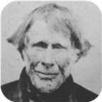

1. John Ives was born about 1740 in Nottingham,England. He died in Halifax,N.S., about 1782 at the age of 42.
John was a drummer in the 82'nd Regiment and received a grant of 100 acres at Fishers Grant. He was a native of Nottingham,England but later moved to Northern Ireland and married there. He died in Halifax, leaving his grant to his 12 year old son George.
He married ? ?. They had one son.
Son of John Ives and ? ?:
+ 2 m I. George Ives was born about 1770. He died on April 16, 1862, at the age of 92.
  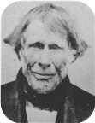
  George

Families of his Descendants

1st Generation

Family of George Ives and Catharine Fraser
 | John |  |  |  |  |  |  |  | ? |  |  |  |  |  |  |  | Charles |  |  |  |  |  |  |  | (unknown given name)
 | Ives |  |  |  |  |  |  |  | ? |  |  |  |  |  |  |  | Fraser |  |  |  |  |  |  |  | Ann?
 | ca.1740–ca.1782 |  |  |  |  |  |  |  |  |  |  |  |  |  |  |  | 1748–1811
 |  |  |  |  | George |  |  |  |  |  |  |  |  |  |  |  |  |  |  |  | Catharine
 |  |  |  |  | Ives |  |  |  |  |  |  |  |  |  |  |  |  |  |  |  | Fraser
 |  |  |  |  | ca.1770–1862 |  |  |  |  |  |  |  |  |  |  |  |  |  |  |  | 1778–1865
 |  |  |  |  |  |  |  |  |  |  |  |  |  |  |  |  |  |  |  |  | 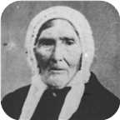
 |  |  |  |  |  |  |  |  | Marriage: 1795
Anna |  |  |  | Isabella |  |  |  | Jane |  |  |  | John K |  |  |  | John Turner |  |  |  | William |  |  |  | Charles |  |  |  | Infant Dau
Ives |  |  |  | Ives |  |  |  | Ives |  |  |  | Ives |  |  |  | Ives |  |  |  | Ives |  |  |  | Ives |  |  |  | Ives
1800–1878 |  |  |  |  |  |  |  | 1806–1856 |  |  |  |  |  |  |  | 1804–1876 |  |  |  | 1808–1880 |  |  |  | 1802–1870 |  |  |  | 1798–1799
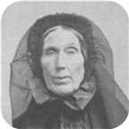 |  |  |  |  |  |  |  |  |  |  |  | 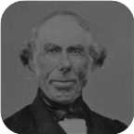 |  |  |  | 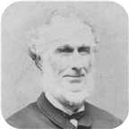 |  |  |  | 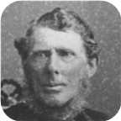

2. George Ives was born about 1770. He was the son of John Ives (1) and ? ?.  George died on April 16, 1862, at the age of 92. He was buried in Greenwood Cemetery, Pictou Landing,N.S.
  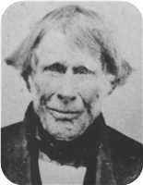
  George Ives
George married Catharine Fraser on Monday, October 26, 1795. They had eight children.  Catharine was born in 1778. She was the daughter of Charles Fraser and (unknown given name) Ann?.  Catharine reached 87 years of age and died in 1865. She was buried in Greenwood Cemetery.
  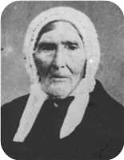
  Catharine Fraser
Children of George Ives and Catharine Fraser:
+ 3 f I. Anna Ives was born on December 11, 1800. She died on August 18, 1878, at the age of 77.
  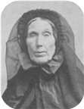
  Anna
f II. Isabella Ives.
+ 4 f III. Jane Ives was born on January 07, 1806. She died on May 24, 1856, at the age of 50.
m IV. John K Ives.
  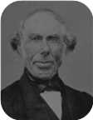
  John
+ 5 m V. John Turner Ives was born in July 1804. He died in Pictou on April 04, 1876, at the age of 71.
  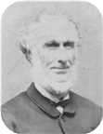
  John
+ 6 m VI. William Ives was born on April 27, 1808. He died on July 13, 1880, at the age of 72.
  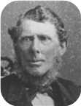
  William
m VII. Charles Ives was born on September 01, 1802. He died on March 06, 1870, at the age of 67. Charles was buried in Greenwood Cemetery.
f VIII. Infant Dau Ives was born in 1798. She died in 1799 at the age of 1.

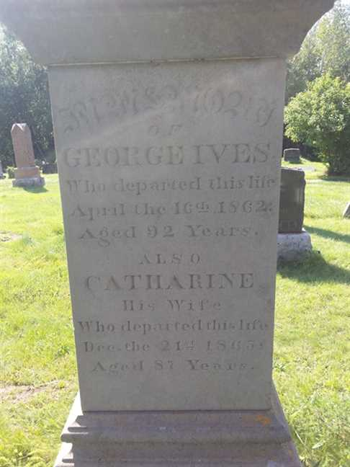  Figure 1: George Ives Grave |  | Figure 2: George Ives Grave(1)

2nd Generation

Family of Anna Ives and Matthew Patterson
John |  |  |  | Margaret |  |  |  | Matthew |  |  |  |  |  |  |  | John |  |  |  | ? |  |  |  | Charles |  |  |  | (unknown given name)
Patterson |  |  |  | Snodgrass |  |  |  | Harris |  |  |  |  |  |  |  | Ives |  |  |  | ? |  |  |  | Fraser |  |  |  | Ann?
1708– |  |  |  | 1710– |  |  |  | 1735–1829 |  |  |  |  |  |  |  | ca.1740–ca.1782 |  |  |  |  |  |  |  | 1748–1811
 | John |  |  |  |  |  |  |  | Ann |  |  |  |  |  |  |  | George |  |  |  |  |  |  |  | Catharine
 | Patterson |  |  |  |  |  |  |  | Harris |  |  |  |  |  |  |  | Ives |  |  |  |  |  |  |  | Fraser
 | 1748–1808 |  |  |  |  |  |  |  | ca.1766–1823 |  |  |  |  |  |  |  | ca.1770–1862 |  |  |  |  |  |  |  | 1778–1865
 |  |  |  |  | Matthew |  |  |  |  |  |  |  |  |  |  |  |  |  |  |  | Anna
 |  |  |  |  | Patterson |  |  |  |  |  |  |  |  |  |  |  |  |  |  |  | Ives
 |  |  |  |  | 1785–1858 |  |  |  |  |  |  |  |  |  |  |  |  |  |  |  | 1800–1878
 |  |  |  |  |  |  |  |  | Marriage: 1843

3. Anna Ives was born on Thursday, December 11, 1800. She was the daughter of George Ives (2) and Catharine Fraser.  Anna died on August 18, 1878, at the age of 77. She was buried in Laurel Hill Cemetery, Pictou, N.S.
  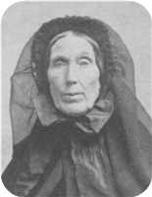
  Anna Ives
Anna married Matthew Patterson on Saturday, April 22, 1843. Matthew was born in 1785. He was the son of John Patterson and Ann Harris.
Matthew reached 73 years of age and died in Pictou, Nova Scotia, Canada, on April 13, 1858.

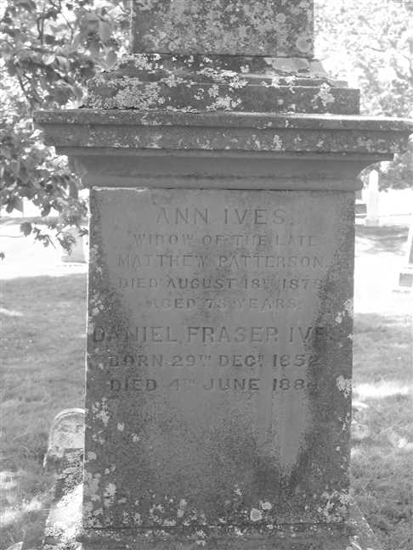  Figure 3: Grave Stone |  | 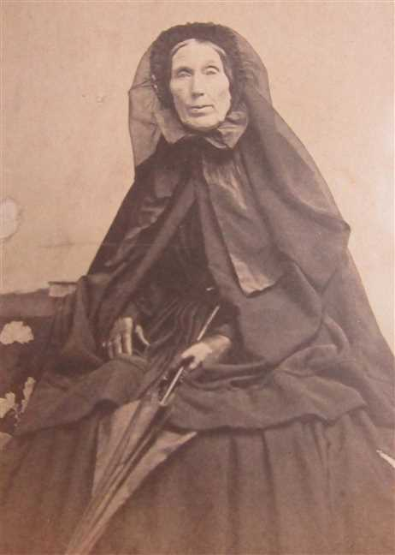  Figure 4: Ann Ives

Family of Jane Ives and Archibald Fraser
 |  |  |  |  |  |  |  |  |  |  |  |  |  |  |  | John |  |  |  | ? |  |  |  | Charles |  |  |  | (unknown given name)
 |  |  |  |  |  |  |  |  |  |  |  |  |  |  |  | Ives |  |  |  | ? |  |  |  | Fraser |  |  |  | Ann?
 |  |  |  |  |  |  |  |  |  |  |  |  |  |  |  | ca.1740–ca.1782 |  |  |  |  |  |  |  | 1748–1811
 |  |  |  |  |  |  |  |  |  |  |  |  |  |  |  |  | George |  |  |  |  |  |  |  | Catharine
 |  |  |  |  |  |  |  |  |  |  |  |  |  |  |  |  | Ives |  |  |  |  |  |  |  | Fraser
 |  |  |  |  |  |  |  |  |  |  |  |  |  |  |  |  | ca.1770–1862 |  |  |  |  |  |  |  | 1778–1865
 |  |  |  |  | Archibald |  |  |  |  |  |  |  |  |  |  |  |  |  |  |  | Jane
 |  |  |  |  | Fraser |  |  |  |  |  |  |  |  |  |  |  |  |  |  |  | Ives
 |  |  |  |  | 1801–1892 |  |  |  |  |  |  |  |  |  |  |  |  |  |  |  | 1806–1856
 |  |  |  |  |  |  |  |  | Marriage: 1833
 |  |  |  |  |  |  |  |  |  |  |  | Georgina |  |  |  | James Turner
 |  |  |  |  |  |  |  |  |  |  |  | Fraser |  |  |  | Fraser
 |  |  |  |  |  |  |  |  |  |  |  | 1839–1933 |  |  |  | 1842–
 |  |  |  |  |  |  |  |  |  |  |  | 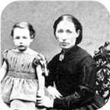

4. Jane Ives was born on Tuesday, January 07, 1806. She was the daughter of George Ives (2) and Catharine Fraser.
Jane died on May 24, 1856, at the age of 50. She was buried in Greenwood Cemetery, Pictou Landing , NS.
It is not absolutely certain that this Jane Ives is a daughter of George Ives. However, she would be about the correct age and George inherited his Father's property at Fisher's Grant. This wedding was recorded in the Colonial Patriot - Tues. Aug. 13,1833. The paster was Rev. Lewis.
Jane Ives is listed as a student in the 1822-3 school year in the Fisher's Grant School taught be Hugh Dunbar (b.1792). William and Isabella Ives are also listed as students. Hugh Dunbar was later a minister in Sumerside P.E.I.
Jane married Archibald Fraser on Tuesday, August 06, 1833. They had two children.
Archibald was born in 1801. He reached 91 years of age and died in 1892.
Archibald Fraser was from the West River.
Children of Jane Ives and Archibald Fraser:
+ 7 f I. Georgina Fraser was born in Fisher's Grant, N.S., on June 18, 1839. She died in 1933 at the age of 93.
  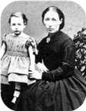
  Georgina
m II. James Turner Fraser was born on December 04, 1842.

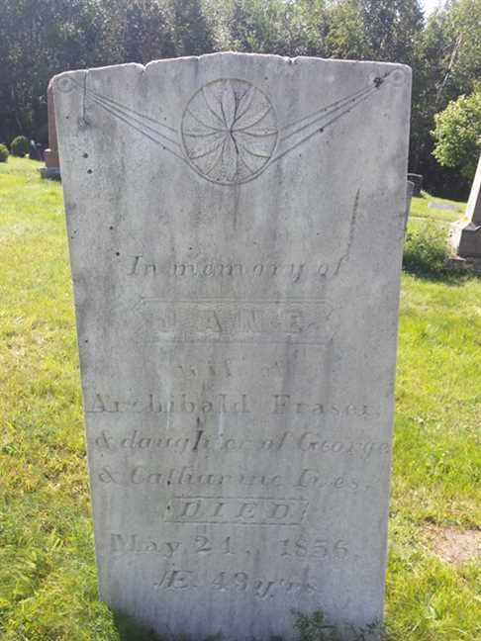
Figure 5: Jane Ives

Family of John Ives and Sarah Ives
John |  |  |  | ? |  |  |  | Charles |  |  |  | (unknown given name)
Ives |  |  |  | ? |  |  |  | Fraser |  |  |  | Ann?
ca.1740–ca.1782 |  |  |  |  |  |  |  | 1748–1811
 | George |  |  |  |  |  |  |  | Catharine
 | Ives |  |  |  |  |  |  |  | Fraser
 | ca.1770–1862 |  |  |  |  |  |  |  | 1778–1865
 |  |  |  |  | John Turner |  |  |  |  |  |  |  |  |  |  |  |  |  |  |  | Sarah Frances
 |  |  |  |  | Ives |  |  |  |  |  |  |  |  |  |  |  |  |  |  |  | Ives
 |  |  |  |  | 1804–1876
 |  |  |  |  |  |  |  |  | Marriage: 1840
 |  |  |  |  |  |  |  |  |  |  |  | James |  |  |  | Robert
 |  |  |  |  |  |  |  |  |  |  |  | Ives |  |  |  | Ives
 |  |  |  |  |  |  |  |  |  |  |  | ca.1824–1873 |  |  |  | 1842–
 |  |  |  |  |  |  |  |  |  |  |  | 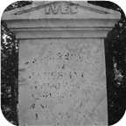

5. John Turner Ives was born in July 1804. He was the son of George Ives (2) and Catharine Fraser.  John Turner was employed in Merchant. He died in Pictou,N.S., on April 04, 1876, at the age of 71. John Turner was buried in Haliburton Cemetery, Pictou.
  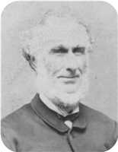
  John Turner Ives
MACDONALD, ALEXANDER C. (1849 - 1929)
BORN: Scotch Hill, Pictou County 27 January 1849
Commenced working as a Clerk with John T. Ives (General Merchants). After Ive’s death, he continued the business with Henry G. Ives, as John T. Ives & Company. Later he obtained, with his partner and F. D. Corbett of Halifax (firm of Corbett & Richardson, Commission Merchants), a controlling interest in the Logan Tannery Co., Lyons Brook, serving successfully as Manager, until the Tannery was destroyed by fire in 1911. Of late years, he spent much of his time in Florida.
Served on Town Council as was Mayor from 1901 - 1905 inclusive.
Married to Laura M. Farquarson - Died March 28/31.
Member of First Presbyterian Church.
Eastern Chronicle Apr.6,1876
April 4: Died - John T. Ives, Merchant & Shipbuilder, Pictou, age 72.
John Turner married Sarah Frances Ives on Thursday, February 13, 1840. They had two sons.
Sons of John Turner Ives and Sarah Frances Ives:
+ 8 m I. James Ives was born in Brule Point, Colchester Co.,N.S, about 1824. He died on January 12, 1873, at the age of 49.
  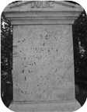
  James
+ 9 m II. Robert Ives was born in Brule Point, Colchester Co. NS, in 1842.

Family of William Ives and Christiana Fraser
John |  |  |  |  |  | ? |  |  |  |  |  | Charles |  |  |  |  |  | (unknown given name) |  |  |  |  |  |  |  |  |  |  |  |  |  |  |  |  |  | Roderick |  |  |  |  |  | Christiana
Ives |  |  |  |  |  | ? |  |  |  |  |  | Fraser |  |  |  |  |  | Ann? |  |  |  |  |  |  |  |  |  |  |  |  |  |  |  |  |  | MacKay |  |  |  |  |  | Grant
ca.1740–ca.1782 |  |  |  |  |  |  |  |  |  |  |  | 1748–1811 |  |  |  |  |  |  |  |  |  |  |  |  |  |  |  |  |  |  |  |  |  |  |  | 1746–1829 |  |  |  |  |  | 1752–1818
 |  | George |  |  |  |  |  |  |  |  |  |  |  | Catharine |  |  |  |  |  |  |  |  |  |  |  | Daniel |  |  |  |  |  |  |  |  |  |  |  | Catherine
 |  | Ives |  |  |  |  |  |  |  |  |  |  |  | Fraser |  |  |  |  |  |  |  |  |  |  |  | Fraser |  |  |  |  |  |  |  |  |  |  |  | MacKay
 |  | ca.1770–1862 |  |  |  |  |  |  |  |  |  |  |  | 1778–1865 |  |  |  |  |  |  |  |  |  |  |  | 1769–1850 |  |  |  |  |  |  |  |  |  |  |  | 1775–1864
 |  |  |  |  |  |  |  | William |  |  |  |  |  |  |  |  |  |  |  |  |  |  |  |  |  |  |  |  |  |  |  | Christiana Ann
 |  |  |  |  |  |  |  | Ives |  |  |  |  |  |  |  |  |  |  |  |  |  |  |  |  |  |  |  |  |  |  |  | Fraser
 |  |  |  |  |  |  |  | 1808–1880 |  |  |  |  |  |  |  |  |  |  |  |  |  |  |  |  |  |  |  |  |  |  |  | 1813–1900
 |  |  |  |  |  |  |  |  |  |  |  |  |  |  |  |  |  |  |  |  |  |  |  |  |  |  |  |  |  |  |  | 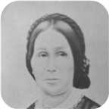
 |  |  |  |  |  |  |  |  |  |  |  |  |  | Marriage: 1840
 |  |  |  |  |  | George Daniel |  |  |  |  |  | Catherine Fraser |  |  |  |  |  | William Howard |  |  |  |  |  | Emma |  |  |  |  |  | Daniel Fraser
 |  |  |  |  |  | Ives |  |  |  |  |  | Ives |  |  |  |  |  | Ives |  |  |  |  |  | Ives |  |  |  |  |  | Ives
 |  |  |  |  |  | 1840– |  |  |  |  |  | 1843–1847 |  |  |  |  |  | 1846–1848 |  |  |  |  |  | 1850–1933 |  |  |  |  |  | 1852–1884
 |  |  |  |  |  | 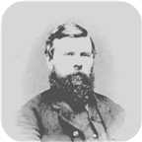 |  |  |  |  |  | 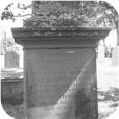 |  |  |  |  |  | 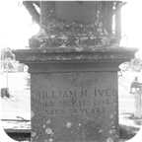 |  |  |  |  |  | 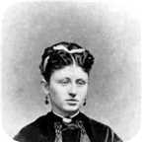
 |  |  |  |  |  |  |  |  | Charles William |  |  |  |  |  | John Robert |  |  |  |  |  | William |  |  |  |  |  | Infant Daughter |  |  |  |  |  | Arthur
 |  |  |  |  |  |  |  |  | Ives |  |  |  |  |  | Ives |  |  |  |  |  | Ives |  |  |  |  |  | Ives |  |  |  |  |  | Ives
 |  |  |  |  |  |  |  |  | 1841–1921 |  |  |  |  |  | 1845–1845 |  |  |  |  |  | ca.1849– |  |  |  |  |  | 1851–1851 |  |  |  |  |  | 1854–1913
 |  |  |  |  |  |  |  |  | 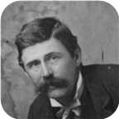 |  |  |  |  |  |  |  |  |  |  |  |  |  |  |  |  |  |  |  |  |  |  |  | 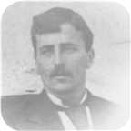

6. William Ives was born on Wednesday, April 27, 1808. He was the son of George Ives (2) and Catharine Fraser.  William died on July 13, 1880, at the age of 72. He was buried in Laurel Hill Cemetery, Pictou, N.S.
  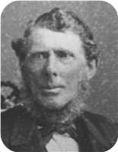
  William Ives
William Ives was a merchant in Pictou. He was the original owner of a photograph album which contained many of the old "Ives", "Fraser", "Rood", "Copeland" and "Robertson" photos contained in this Family Tree data base. It was passed to his granddaughter Louisa Reid Ives and finally to her grandson Allan James Robertson. A family bible owned by William is now at the McCulloch Center in Pictou, NS
William is listed as a 58 year old merchant in the 1871 Pictou County census.
The folowing is a record of a sale of land by William Ives to the British Government to be used as an Indian reservation. The property is located across the harbour from Pictou town.
Transcript of Treaty IT-282/IA-142, (1874)
Source of transcripts for the SchoolNet site:
Indian Treaties and Surrenders: From 1680 to 1890 Vol. I-II. (Ottawa: Brown Chamberlin [Queen's Printer], 1891)
No. 142.
This INDENTURE made this seventh day of December, in the year of Our
Lord one thousand eight hundred and seventy-four, between William Ives,
of the town and County of Pictou, in the Province of Nova Scotia merchant,
and Christianna Ives, his wife, of the one part, and Her Majesty Queen
Victoria, represented herein by the Minister of the Interior of the
Dominion of Canada, of the other part.
WHEREAS, Her said majesty Queen Victoria, represented as aforesaid,
has agreed with the said William Ives to purchase the lot of land
hereinafter described for the use and benefit of the Micmac Indians in the
County of Pictou aforesaid, for the price or sum hereinafter mentioned.
NOW THEREFORE, this Indenture witnesseth that the said William Ives
and Christianna Ives his wife, in consideration of the sum of one thousand
one hundred and fifty-seven dollars of lawful money of Canada to the said
William Ives, in hand well and truly paid by Her said Majesty, represented
herein as aforesaid, at or before the ensealing and delivery of these
presents, the receipt whereof is hereby acknowledged, have and each of
them hath granted, bargained, sold, aliened, enfeoffed, released, remised,
conveyed and confirmed, and by these presents do and each of them doth
grant, biargain, sell, alien, enfeoff, release, remise, convey and confirm
unto Her Majesty Queen Victoria, represented as aforesaid, Her heirs and
successors.
All that certain lot and piece of land situate, lying and being at Fisher's
Grant, in the said County of Pictou, and described as follows, that is to
say :-
Beginning on the north shore of Boat Harbour, at the south-east corner
of lands owned by James G. Sproull, and running thence north thirty-seven
degrees forty-five minutes west by the magnet of June, 1873, along the
east line of said Sproull's land seventy-four chains, thence north fifty-
two degrees fifteen minutes east by the magnet aforesaid, along the south
line of lands owned by the said William Ives, eleven chains and thirty-five
links to the west line of Edwin Sproull's land, thence south thirty-
seven degrees and forty-five minutes east by the magnet aforesaid, along
the last mentioned line and west line of lands owned by James G. Sproull
aforesaid and William Powell the elder sixty-one chains and eighty-five
links to the waters of Boat Harbour aforesaid, thence south-
eastwardly,southwardly and westwardly, and by the various courses of
the shore of said Boat Harbour to the place of beginning, containing
eighty-nine acres, more or less.
Together with all and singular the houses, outhouses, barns, buildings,
ways, waters, watercourses, easements, privileges and appurtenances to
the same, belonging or in any wise appertaining, and the reversion and
reversions, remainder and remainders, rents, issues and profits thereof,
and also all the estate, right, title, interest, claim, property and demand,
both at law and in equity of them, the said William Ives and Christianna
Ives, his wife, of, in, to or out of the same or any part thereof to have and
to hold the said land and premises with the appurtenances and every part
thereof unto Her said Majesty Queen Victoria, represented as aforesaid,
Her heirs and successor, to Her and their sole use, benefit, and behoof
forever.
And the said William Ives doth hereby for himself, his heirs, executors
and administrators, grant, covenant, promise, and agree to and with Her
said Majesty Queen Victoria, represented as aforesaid, Her heirs and
successors, in manner following, that is to say :
That it shall and maybe lawful for Her said Majesty, represented as
aforesaid, Her heirs and successors, from time to time and at all times
hereafter, peaceably and quietly to enter into the said land and premises,
and to have, hold, occupy, posses and enjoy the same without the lawful
let; suit, hindrance, eviction, denial or disturbance of, from or by the said
William Ives or Christianiia Ives, his wife, or any person or persons
whomsoever lawfully claiming or to claim the same.
And also, that the said William Ives and Christianna Ives, his wife, or
one of them, have a good, sure, perfect and indefeasible estate of
inheritance in fee simple in the said land and premises, and have good
right, full power and lawful authority to sell and convey the same in
manner and form as they are hereby sold and conveyed or mentioned, or
intended so to be.
And lastly, that the said William Ives and his heirs, the said land and
premises, and every part thereof, unto Her said Majesty Queen Victoria,
represented as aforesaid, Her heirs and successors, against the lawful
claims of all persons whomsoever, shall and will by these presents
warrant and forever defend :
IN WITNESS WHEREOF, the parties to these presents have hereto their
hands and seals set and affixed on the day and year first above written.
Signed, sealed and delivered
in presence of WILLIAM IVES. [L.S.]
DANIEL F. IVES, CHRISTIANNA IVES [L.S.]
G.H. ELLIOT.
PROVINCE OF NOVA SCOTIA,
HALIFAX, S.S.
Be it remembered that on this seventh day of December, one thousand
eight hundred and seventy-four, before me the subscriber personally
came and appeared Christianna Ives, wife of William Ives, mentioned in
the foregoing Indenture, who having been by me examined separate and
apart from her said husband, did declare and acknowledge that she
executed the said Indenture as and for her act and deed without fear,
threat or compulsion, of, from or by her said husband, and for a full
release of all her claims to the land therein described.
G. H. ELLIOT,
Barrister and Notary Public.
Recorded 3rd March, l875.
Lib. S. Folio. 217.
R. W. SCOTT,
Secretary of State and Registrar General of Canada.
--------------------------------------------------------------------------------
--------------------------------------------------------------------------------
William Ives is listed as a student in the 1822-3 school year in the Fisher's Grant School taught be Hugh Dunbar (b.1792). Hugh Dunbar was later a minister in Sumerside P.E.I.
At the age of 31, William married Christiana Ann Fraser on Thursday, February 13, 1840, when she was 26 years old. They had ten children.  Christiana Ann was born on Monday, April 12, 1813. She was the daughter of Daniel Fraser and Catherine MacKay.
  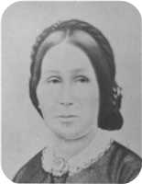
  Christiana Ann Fraser
Christiana Ann reached 86 years of age and died on March 19, 1900. She was buried in Laurel Hill Cemetery.
Description Will of Christiana Ives of Pictou, NS
(Handwritten)
Will of Christiana Ives, deceased
Certified Copy for Reg of Deeds
I Christiana Ives of Pictou in the County of Pictou Widow of William Ives late of Pictou aforesaid Merchant deceased do hereby make publish and declare this to be my last will and testament hereby revoking all wills at by me any time heretofore made.
I appoint my son George D Ives and Frederick W Fraser Druggist of said Pictou to be the executors and trustees of this my Will
I give devise and bequeath to Maggie Ives wife of my son Charles W Ives the bill of Sale or chattel Mortgage filed in the Registry of Deeds for Pictou County on or about the 16th day of February AD 1884 and made by the said Charles W Ives as Grantor to me as grantee, the money due me thereon, the household furniture and other property therein described or conveyed and I also give to said Maggie Ives all other my household furniture now in her possession or that of her late husband Charles W Ives
I also give devise and bequeath to said Maggie Ives all my case of Silver ware (except the tea Service herein after mentioned) now in her possession
I give and bequeath to my daughter Emma Harris my writing desk and Silver tea Service
I give and bcqueath to Ocenia Ives wife of my son Arthur Ives all my household furniture now in the farm house on the south side of the West River Road wherein they reside
I give and bequeath to Christiana daughter of the said Arthur my share in the Merchant's Bank Halifax Capital Stock now held by me
I give devise and bequeath all my real and personal estate not hereinbefore of unto my said executors and trustees in trust that they may my said executors and trustees shall see call in and convert into money the same or such part thereof as shall not consist of money and shall with and out of the previous produced by such sale calling in and Conversion and with and out of my ready money pay my funeral and Testamentary expenses and
debts and shall stand possessed of the residue or remainder upon the trusts following viz to pay the following legacies
I To pay my son William H Ives the Sum of one thousand five hundred dollars
2 To pay my son George D Ives the Sum of Six hundred dollars
3 To pay my Grandson Fred Ives son of George D Ives the sum of one hundred dollars
4 To pay Willie and Christiana Ives the children of my son Charles W Ives the Sum of fifty dollars each
5 To pay to Daniel Fraser, Lewis and Louisa children of my son Arthur Ives the Sum of fifty dollars each
6 To pay to Daniel F Harris and Christiana Harris children of my daughter Emma Harris the Sum of fifty dollars each
If any residue and monies be their remaining I will and direct that they shall be equally divided between the respective wives of my son George D Charles W and Arthur Ives and my daughter Emma Harris to each an equal share
It is also my will and hereby expressly declare and direct that the foregoing devises and bequests are respectively intended to be and shall be construed to be in full satisfaction and discharge of any debts or debt which at the time of my death may be owing by me to such respective deviser or legatees or the husband or wife of such respective deviser or legatee whether such legacy or devise shall be less or more in value or amount than the debts owning or claimed
I do will and direct that should any of the legatees under this my will or the husband or wife of such legatees after my death commence any legal proceedings against my executors or estate for the recovery of any alleged just debtedness that hereupon all legacies and bequests hereinbefore made to such legatee or the husband or wife of the person commencing such proceedings shall lapse determine and become forfeit null and void
In Witness Whereof I have hereunto set my hand to this my will the tenth day of July
Signed Christiana Ives L.S.
Signed by the within named Christiana Ives as her last Will and Testament in the presence of us who in her presence and in the presence of each other have hereunto subscribed our names as witnesses.
Signed Bessie A Ross
Signed Jno W Ross
County of Pictou S.S.
In the Court of Probate of Wills
I John D. McLeod Registrar of said Court do hereby certify that the foregoing paper writing is a correct copy of the last Will and Testament of Christiana Ives late of West River Road in the County of Pictou Widow deceased which said will was duly admitted to Probate in said Court at Pictou on the llth day of June 1900.
Given under my hand at Pictou aforesaid this 10th.day of June 1900.
John D. MacLeod Registrar
Stamp
PROVINCE OF NOVA SCOTIA, REGISTRAR OF DEEDS
Office, County of Pictou, AUG 14 1900 I certify that the within instrument was duly registered at 11 AM of the above day in Book 3, page 255 - 257 on the certificate of John D. MacLeod Reg
John Yorstor. Registrar
Children of William Ives and Christiana Ann Fraser:
+ 10 m I. George Daniel Ives was born on November 11, 1840.
  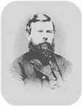
  George
+ 11 m II. Charles William Ives was born on February 09, 1841. He died in 1921 at the age of 79.
  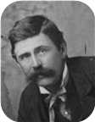
  Charles
f III. Catherine Fraser Ives was born on August 01, 1843. She died on April 08, 1847, at the age of 3. Catherine Fraser was buried in Laurel Hill Cemetery.
  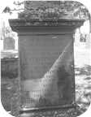
  Catherine
m IV. John Robert Ives was born on February 24, 1845. He died on December 12, 1845. John Robert was buried in Laurel Hill Cemetery.
m V. William Howard Ives was born on November 01, 1846. He died on January 22, 1848, at the age of 1. William Howard was buried in Laurel Hill Cemetery.
  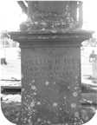
  William
m VI. William Ives was born about 1849.
+ 12 f VII. Emma Ives was born on April 09, 1850. She died on July 26, 1933, at the age of 83.
  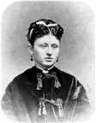
  Emma
f VIII. Infant Daughter Ives was born on August 08, 1851. She died on August 18, 1851. Infant Daughter was buried in Laurel Hill Cemetery.
m IX. Daniel Fraser Ives was born on December 29, 1852. He died on June 04, 1884, at the age of 31. Daniel Fraser was buried in Laurel Hill Cemetery.
+ 13 m X. Arthur Ives was born on March 03, 1854. He died on June 30, 1913, at the age of 59.
  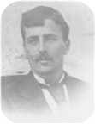
  Arthur

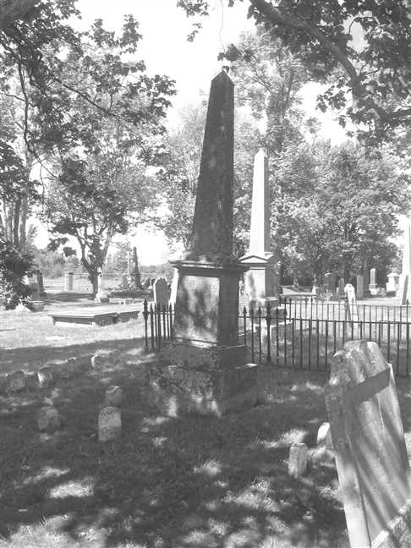  Figure 6: Grave Stone |  | 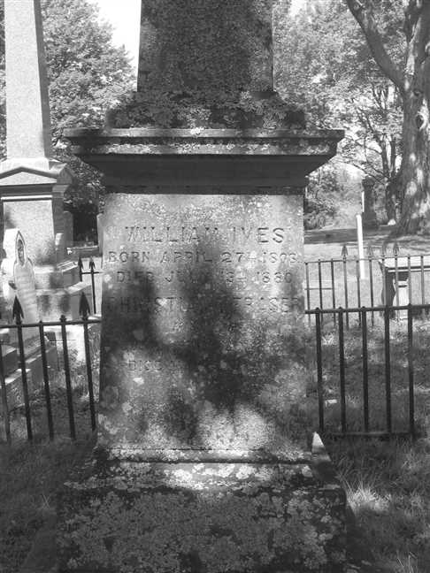  Figure 7: Grave Stone

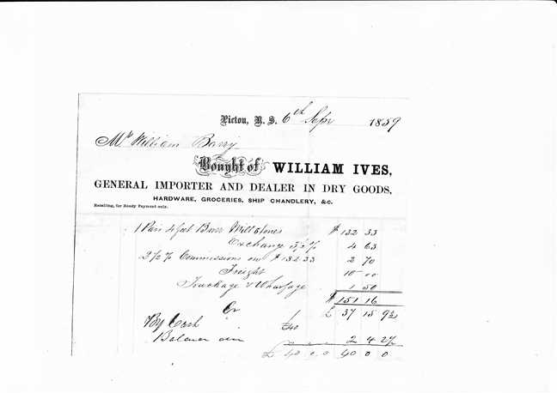  Figure 8: William Ives.Invoice.1859.Russel Maclean.Apr.2019 |  | 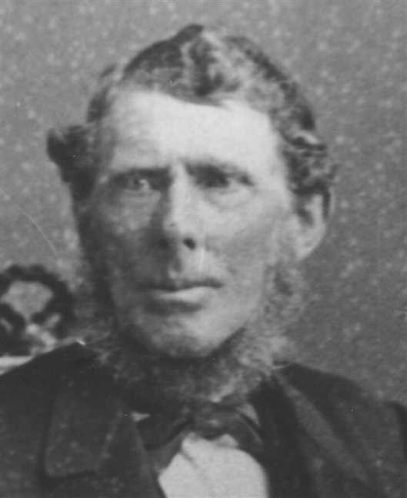  Figure 9: William Ives

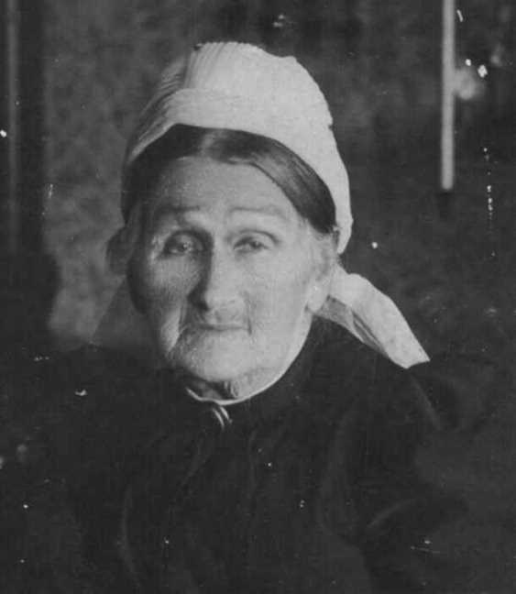
Figure 10: Christina Ann Fraser

3rd Generation

Family of Georgina Fraser and Joseph Graham
Thomas |  |  |  | Elizabeth |  |  |  |  |  |  |  |  |  |  |  |  |  |  |  |  |  |  |  | George |  |  |  | Catharine
Graham |  |  |  | Grant |  |  |  |  |  |  |  |  |  |  |  |  |  |  |  |  |  |  |  | Ives |  |  |  | Fraser
1776–1839 |  |  |  | 1771– |  |  |  |  |  |  |  |  |  |  |  |  |  |  |  |  |  |  |  | ca.1770–1862 |  |  |  | 1778–1865
 | Thomas |  |  |  |  |  |  |  | Mary |  |  |  |  |  |  |  | Archibald |  |  |  |  |  |  |  | Jane
 | Graham |  |  |  |  |  |  |  | McLellan |  |  |  |  |  |  |  | Fraser |  |  |  |  |  |  |  | Ives
 | 1807–1864 |  |  |  |  |  |  |  | 1807–1892 |  |  |  |  |  |  |  | 1801–1892 |  |  |  |  |  |  |  | 1806–1856
 |  |  |  |  | Joseph Cunard |  |  |  |  |  |  |  |  |  |  |  |  |  |  |  | Georgina
 |  |  |  |  | Graham |  |  |  |  |  |  |  |  |  |  |  |  |  |  |  | Fraser
 |  |  |  |  | 1836–1917 |  |  |  |  |  |  |  |  |  |  |  |  |  |  |  | 1839–1933
 |  |  |  |  | 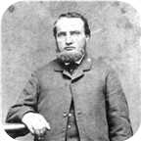
 |  |  |  |  |  |  |  |  | Married
 |  |  |  |  |  |  |  |  |  |  |  | John T |  |  |  | Charles Archibald
 |  |  |  |  |  |  |  |  |  |  |  | Graham |  |  |  | Graham
 |  |  |  |  |  |  |  |  |  |  |  | 1866–1867 |  |  |  | 1863–1882

7. Georgina Fraser was born on Tuesday, June 18, 1839, in Fisher's Grant, N.S. She was the daughter of Archibald Fraser and Jane Ives (4).  Georgina died in 1933 at the age of 93.
  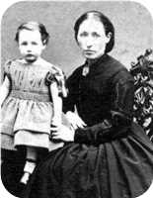
  Georgina Fraser
She married Capt. Joseph Cunard Graham. They had two sons.  Joseph Cunard was born in New Glasgow,N.S., in 1836. He was the son of Thomas Graham and Mary McLellan.  Joseph Cunard reached 81 years of age and died in New Glasgow in 1917.
  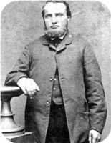
  Joseph Cunard Graham
Capt. Joe Graham had his masters ticket and skippered his first ship across the Pacific Ocean before he was twenty-one. In later life, he built or shared in the building of the sailing ships "Tana", "Cabot", "Lochael" and the "Minnie Gordon".
Sons of Georgina Fraser and Joseph Cunard Graham:
m I. John T Graham was born in 1866. He died on September 12, 1867, at the age of 1.
m II. Charles Archibald Graham was born in 1863. He died in Pugwash on November 11, 1882, at the age of 19.
  Charles

Family of James Ives and Fanny Ives
George |  |  |  | Catharine
Ives |  |  |  | Fraser
ca.1770–1862 |  |  |  | 1778–1865
 | John Turner |  |  |  |  |  |  |  | Sarah Frances |  |  |  |  |  |  |  | James
 | Ives |  |  |  |  |  |  |  | Ives |  |  |  |  |  |  |  | Ives
 | 1804–1876 |  |  |  |  |  |  |  |  |  |  |  |  |  |  |  | ca.1790–
 |  |  |  |  | James |  |  |  |  |  |  |  |  |  |  |  |  |  |  |  | Fanny Black
 |  |  |  |  | Ives |  |  |  |  |  |  |  |  |  |  |  |  |  |  |  | Ives
 |  |  |  |  | ca.1824–1873 |  |  |  |  |  |  |  |  |  |  |  |  |  |  |  | 1828–1874
 |  |  |  |  |  |  |  |  | Marriage: 1853
John Clift |  |  |  | William |  |  |  | Sarah Frances |  |  |  | Lewis N |  |  |  | Henry G |  |  |  | Welsford B |  |  |  | Alfred J |  |  |  | Edith Lillian
Ives |  |  |  | Ives |  |  |  | Ives |  |  |  | Ives |  |  |  | Ives |  |  |  | Ives |  |  |  | Ives |  |  |  | Ives
ca.1853–1858 |  |  |  | ca.1855–1857 |  |  |  | 1856– |  |  |  | ca.1858–1895 |  |  |  | 1858– |  |  |  | ca.1861–1929 |  |  |  | 1862–1883 |  |  |  | 1867–
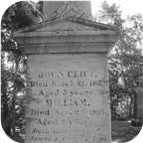 |  |  |  |  |  |  |  |  |  |  |  | 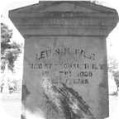 |  |  |  |  |  |  |  |  |  |  |  | 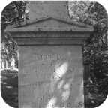

8. James Ives was born about 1824 in Brule Point, Colchester Co.,N.S. He was the son of John Turner Ives (5) and Sarah Frances Ives.  James died on January 12, 1873, at the age of 49. He was buried in Haliburton Cemetery, Pictou,N.S.
  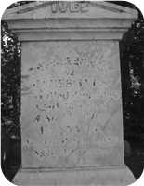
  James Ives
James married Fanny Black Ives in 1853. They had eight children.
Fanny Black was born in Halifax,NS, in 1828. She was the daughter of James Ives.
Fanny Black reached 46 years of age and died on September 05, 1874. She was buried in Haliburton Cemetery, Pictou,N.S.
Children of James Ives and Fanny Black Ives:
m I. John Clift Ives was born about 1853. He died on March 31, 1858, at the age of 5. John Clift was buried in Haliburton Cemetery.
  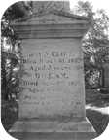
  John
m II. William Ives was born about 1855. He died on September 26, 1857, at the age of 2. William was buried in Haliburton Cemetery.
+ 14 f III. Sarah Frances Ives was born on January 13, 1856.
m IV. Lewis N Ives was born about 1858. He died in Brooklyn,NY, on September 14, 1895, at the age of 37. Lewis N was buried in Haliburton Cemetery, Pictou,N.S.
  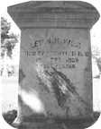
  Lewis
+ 15 m V. Henry G Ives was born in 1858.
m VI. Welsford B Ives was born about 1861. He died on March 06, 1929, at the age of 68. Welsford B was buried in Haliburton Cemetery.
m VII. Alfred J Ives was born in 1862. He died in Amherst,N.S, on July 02, 1883, at the age of 21. Alfred J was buried in Haliburton Cemetery, Pictou,N.S.
  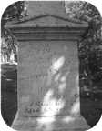
  Alfred
+ 16 f VIII. Edith Lillian Ives was born in 1867.

Family of Robert Ives and Grace McLeod
George |  |  |  | Catharine
Ives |  |  |  | Fraser
ca.1770–1862 |  |  |  | 1778–1865
 | John Turner |  |  |  |  |  |  |  | Sarah Frances
 | Ives |  |  |  |  |  |  |  | Ives
 | 1804–1876
 |  |  |  |  | Robert |  |  |  |  |  |  |  |  |  |  |  |  |  |  |  | Grace
 |  |  |  |  | Ives |  |  |  |  |  |  |  |  |  |  |  |  |  |  |  | McLeod
 |  |  |  |  | 1842– |  |  |  |  |  |  |  |  |  |  |  |  |  |  |  | 1858–
 |  |  |  |  |  |  |  |  | Married
 |  |  |  |  |  |  |  |  |  |  |  | Alexander William |  |  |  | James
 |  |  |  |  |  |  |  |  |  |  |  | Ives |  |  |  | Ives
 |  |  |  |  |  |  |  |  |  |  |  | 1879– |  |  |  | 1881–

9. Robert Ives was born in 1842 in Brule Point, Colchester Co. NS. He was the son of John Turner Ives (5) and Sarah Frances Ives.
He married Grace McLeod. They had two sons.
Grace was born in 1858.
Sons of Robert Ives and Grace McLeod:
+ 17 m I. Alexander William Ives was born in 1879.
m II. James Ives was born in 1881.

Family of George Ives and Amelia McLeod
George |  |  |  |  |  | Catharine |  |  |  |  |  | Daniel |  |  |  |  |  | Catherine
Ives |  |  |  |  |  | Fraser |  |  |  |  |  | Fraser |  |  |  |  |  | MacKay
ca.1770–1862 |  |  |  |  |  | 1778–1865 |  |  |  |  |  | 1769–1850 |  |  |  |  |  | 1775–1864
 |  | William |  |  |  |  |  |  |  |  |  |  |  | Christiana Ann |  |  |  |  |  |  |  |  |  |  |  | James
 |  | Ives |  |  |  |  |  |  |  |  |  |  |  | Fraser |  |  |  |  |  |  |  |  |  |  |  | McLeod
 |  | 1808–1880 |  |  |  |  |  |  |  |  |  |  |  | 1813–1900
 |  |  |  |  |  |  |  | George Daniel |  |  |  |  |  |  |  |  |  |  |  |  |  |  |  |  |  |  |  |  |  |  |  | Amelia
 |  |  |  |  |  |  |  | Ives |  |  |  |  |  |  |  |  |  |  |  |  |  |  |  |  |  |  |  |  |  |  |  | McLeod
 |  |  |  |  |  |  |  | 1840–
 |  |  |  |  |  |  |  |  |  |  |  |  |  |  |  |  |  |  |  |  |  |  |  |  |  |  |  |  |  |  |  | 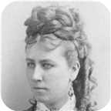
 |  |  |  |  |  |  |  |  |  |  |  |  |  | Married
 |  |  |  |  |  |  |  |  |  |  |  |  |  |  | Frederick George |  |  |  |  |  | William |  |  |  |  |  | Jane Oxley
 |  |  |  |  |  |  |  |  |  |  |  |  |  |  | Ives |  |  |  |  |  | Ives |  |  |  |  |  | Ives
 |  |  |  |  |  |  |  |  |  |  |  |  |  |  | ca.1876–1915 |  |  |  |  |  | 1874–1875 |  |  |  |  |  | 1875–1875
 |  |  |  |  |  |  |  |  |  |  |  |  |  |  | 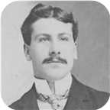

10. George Daniel Ives was born on Wednesday, November 11, 1840. He was the son of William Ives (6) and Christiana Ann Fraser.
  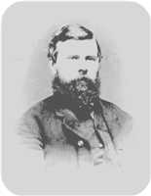
  George Daniel Ives
George Ives is listed as a 30 year old merchant in the 1871 Pictou County census.
He married Amelia McLeod. They had three children. She was the daughter of James McLeod.
  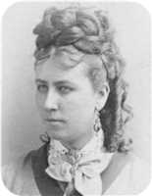
  Amelia McLeod
Children of George Daniel Ives and Amelia McLeod:
+ 18 m I. Frederick George Ives was born about 1876. He died on February 27, 1915, at the age of 39.
  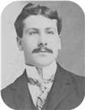
  Frederick
m II. William Ives was born in February 1874. He died on October 09, 1875, at the age of 1.
f III. Jane Oxley Ives was born on April 02, 1875. She died on September 25, 1875.

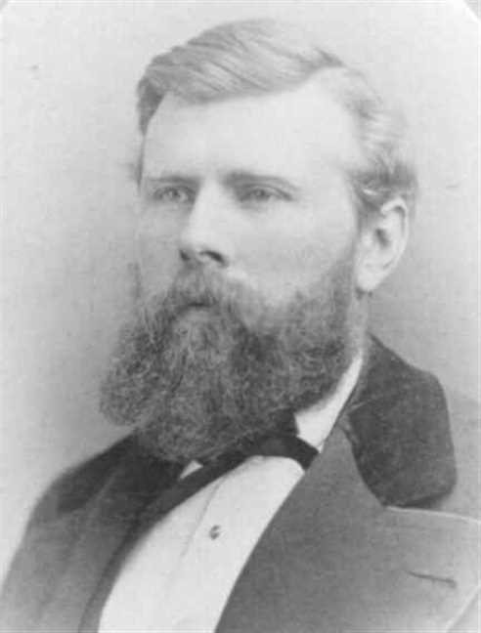  Figure 11: George Daniel Ives |  | 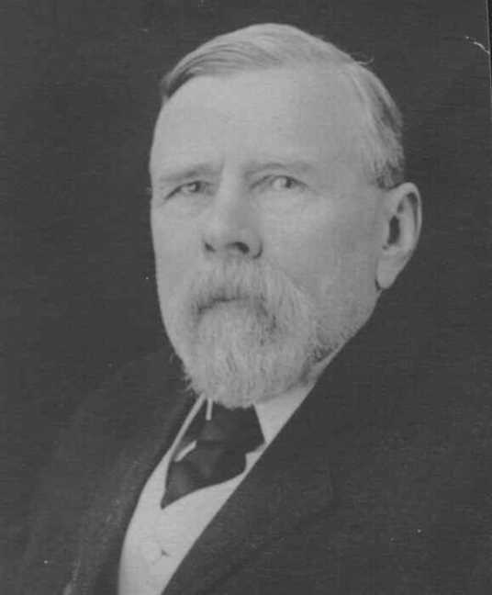  Figure 12: George Daniel Ives

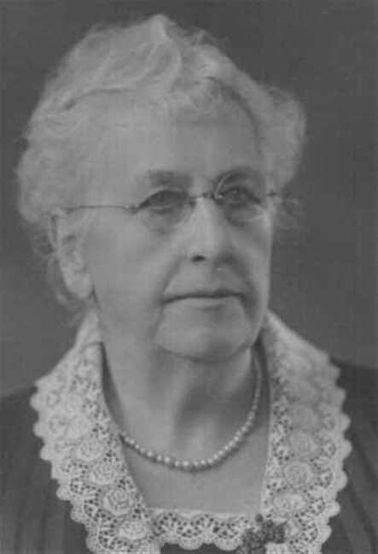
Figure 13: Amelia McLeod

Charles Ives
11. Charles William Ives was born on Tuesday, February 09, 1841. He was the son of William Ives (6) and Christiana Ann Fraser.  Charles William died in 1921 at the age of 79. He was buried in Haliburton, Pictou,N.S.
  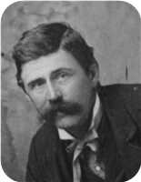
  Charles William Ives
Charles Ives is listed as a 29 year old merchant in the 1871 Pictou County census.
Eastern Chronicle June 14,1877
June 7: Married - Charles Ives, Esq., to Maggie, youngest daughter
of R. S. Copeland, Esq., M.P.P., of Merigomish, at the residence of the
bride's brother, by Rev. H. McDonald Scott, B.D.
Marriages with Anna McPhail and Margaret Maggie Copeland (Page 32) are known.

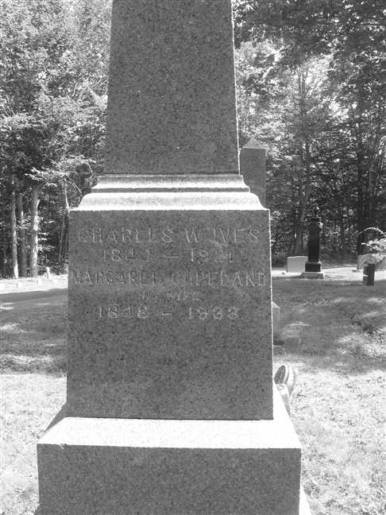
Figure 14: Grave Stone

Family of Charles Ives and Anna McPhail
George |  |  |  | Catharine |  |  |  | Daniel |  |  |  | Catherine
Ives |  |  |  | Fraser |  |  |  | Fraser |  |  |  | MacKay
ca.1770–1862 |  |  |  | 1778–1865 |  |  |  | 1769–1850 |  |  |  | 1775–1864
 | William |  |  |  |  |  |  |  | Christiana Ann |  |  |  |  |  |  |  | Alexander
 | Ives |  |  |  |  |  |  |  | Fraser |  |  |  |  |  |  |  | McPhail
 | 1808–1880 |  |  |  |  |  |  |  | 1813–1900
 |  |  |  |  | Charles William |  |  |  |  |  |  |  |  |  |  |  |  |  |  |  | Anna
 |  |  |  |  | Ives |  |  |  |  |  |  |  |  |  |  |  |  |  |  |  | McPhail
 |  |  |  |  | 1841–1921 |  |  |  |  |  |  |  |  |  |  |  |  |  |  |  | 1844–1872
 |  |  |  |  |  |  |  |  | Marriage: 1872

Here are the details about Charles William Ives first marriage, with Anna McPhail. You can read more about Charles William on page 30.
Charles William Ives married Anna McPhail on Wednesday, January 17, 1872, in Pictou,N.S. by Rev. William C Brown. Anna was born in 1844. She was the daughter of Alexander McPhail.
Anna reached 28 years of age and died in Pictou,N.S., in 1872.
Anna was with child when she slipped and fell. She lost the baby and later died herself.
January 17: Married - Charles W. Ives, to Anna Gibb, daughter of Alex
McPhail, Esq., at Pictou by Rev. William C. Brown

Family of Charles Ives and Margaret Copeland
George |  |  |  |  |  | Catharine |  |  |  |  |  | Daniel |  |  |  |  |  | Catherine |  |  |  |  |  | Samuel |  |  |  |  |  | Catharine
Ives |  |  |  |  |  | Fraser |  |  |  |  |  | Fraser |  |  |  |  |  | MacKay |  |  |  |  |  | Copeland |  |  |  |  |  | O'Brian
ca.1770–1862 |  |  |  |  |  | 1778–1865 |  |  |  |  |  | 1769–1850 |  |  |  |  |  | 1775–1864 |  |  |  |  |  | –ca.1807
 |  | William |  |  |  |  |  |  |  |  |  |  |  | Christiana Ann |  |  |  |  |  |  |  |  |  |  |  | Robert S |  |  |  |  |  |  |  |  |  |  |  | Janet
 |  | Ives |  |  |  |  |  |  |  |  |  |  |  | Fraser |  |  |  |  |  |  |  |  |  |  |  | Copeland |  |  |  |  |  |  |  |  |  |  |  | Smith
 |  | 1808–1880 |  |  |  |  |  |  |  |  |  |  |  | 1813–1900 |  |  |  |  |  |  |  |  |  |  |  | 1800–1885 |  |  |  |  |  |  |  |  |  |  |  | 1805–1874
 |  |  |  |  |  |  |  | Charles William |  |  |  |  |  |  |  |  |  |  |  |  |  |  |  |  |  |  |  |  |  |  |  | Margaret Maggie
 |  |  |  |  |  |  |  | Ives |  |  |  |  |  |  |  |  |  |  |  |  |  |  |  |  |  |  |  |  |  |  |  | Copeland
 |  |  |  |  |  |  |  | 1841–1921 |  |  |  |  |  |  |  |  |  |  |  |  |  |  |  |  |  |  |  |  |  |  |  | 1848–1933
 |  |  |  |  |  |  |  |  |  |  |  |  |  |  |  |  |  |  |  |  |  |  |  |  |  |  |  |  |  |  |  | 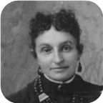
 |  |  |  |  |  |  |  |  |  |  |  |  |  | Marriage: 1877
 |  |  |  |  |  |  |  |  | Robert Copeland |  |  |  |  |  | William Alexander |  |  |  |  |  | Jannet |  |  |  |  |  | Charles Copeland |  |  |  |  |  | Christina Nan
 |  |  |  |  |  |  |  |  | Ives |  |  |  |  |  | Ives |  |  |  |  |  | Ives |  |  |  |  |  | Ives |  |  |  |  |  | Ives
 |  |  |  |  |  |  |  |  | 1878–1883 |  |  |  |  |  | 1880– |  |  |  |  |  | 1882–1882 |  |  |  |  |  | 1883–1888 |  |  |  |  |  | 1884–
 |  |  |  |  |  |  |  |  | 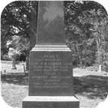 |  |  |  |  |  |  |  |  |  |  |  |  |  |  |  |  |  | 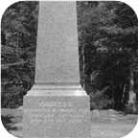

Here are the details about Charles William Ives second marriage, with Margaret Maggie Copeland. You can read more about Charles William on page 30.
Charles William Ives married Margaret Maggie Copeland on Thursday, June 07, 1877, in Merigomish,N.S. - Smith Copeland's home. They had five children.  Margaret Maggie was born in 1848. She was the daughter of Robert S Copeland and Janet Smith.  Margaret Maggie reached 85 years of age and died in 1933. She was buried in Haliburton, Pictou,N.S.
  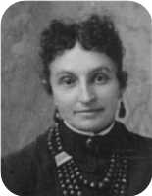
  Margaret Maggie Copeland
Eastern Chronicle June 14,1877
June 7: Married - Charles Ives, Esq., to Maggie, youngest daughter
of R. S. Copeland, Esq., M.P.P., of Merigomish, at the residence of the
bride's father, by Rev. H. McDonald Scott, B.D.
Children of Charles William Ives and Margaret Maggie Copeland:
m I. Robert Copeland Ives was born on July 09, 1878. He died on March 21, 1883, at the age of 4. Robert Copeland was buried in Haliburton Cemetery, Pictou,N.S.
  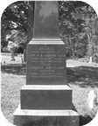
  Robert
+ 19 m II. William Alexander Ives was born on December 25, 1880.
f III. Jannet Ives was born on January 15, 1882. She died on July 18, 1882. Jannet was buried in Haliburton Cemetery, Pictou,N.S.
m IV. Charles Copeland Ives was born on January 26, 1883. He died on May 20, 1888, at the age of 5. Charles Copeland was buried in Haliburton Cemetery, Pictou,N.S.
  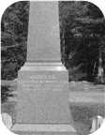
  Charles
+ 20 f V. Christina Nan Ives was born on September 08, 1884.

Family of Emma Ives and Simpson Harris
John W |  |  |  |  |  |  |  |  |  |  |  |  |  |  |  |  |  |  |  |  |  |  |  | George |  |  |  |  |  | Catharine |  |  |  |  |  | Daniel |  |  |  |  |  | Catherine
Harris |  |  |  |  |  |  |  |  |  |  |  |  |  |  |  |  |  |  |  |  |  |  |  | Ives |  |  |  |  |  | Fraser |  |  |  |  |  | Fraser |  |  |  |  |  | MacKay
 |  |  |  |  |  |  |  |  |  |  |  |  |  |  |  |  |  |  |  |  |  |  |  | ca.1770–1862 |  |  |  |  |  | 1778–1865 |  |  |  |  |  | 1769–1850 |  |  |  |  |  | 1775–1864
 |  | William H |  |  |  |  |  |  |  |  |  |  |  | Anne |  |  |  |  |  |  |  |  |  |  |  | William |  |  |  |  |  |  |  |  |  |  |  | Christiana Ann
 |  | Harris |  |  |  |  |  |  |  |  |  |  |  | Arnseon |  |  |  |  |  |  |  |  |  |  |  | Ives |  |  |  |  |  |  |  |  |  |  |  | Fraser
 |  | 1805–1883 |  |  |  |  |  |  |  |  |  |  |  | 1815–1889 |  |  |  |  |  |  |  |  |  |  |  | 1808–1880 |  |  |  |  |  |  |  |  |  |  |  | 1813–1900
 |  | 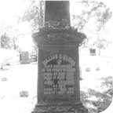
 |  |  |  |  |  |  |  | Simpson J |  |  |  |  |  |  |  |  |  |  |  |  |  |  |  |  |  |  |  |  |  |  |  | Emma
 |  |  |  |  |  |  |  | Harris |  |  |  |  |  |  |  |  |  |  |  |  |  |  |  |  |  |  |  |  |  |  |  | Ives
 |  |  |  |  |  |  |  | 1852–1934 |  |  |  |  |  |  |  |  |  |  |  |  |  |  |  |  |  |  |  |  |  |  |  | 1850–1933
 |  |  |  |  |  |  |  |  |  |  |  |  |  | Married
 |  |  | William Henry |  |  |  |  |  | Joseph Ives |  |  |  |  |  | George Stewart |  |  |  |  |  | Daniel Fraser |  |  |  |  |  | Margaret McLeod |  |  |  |  |  | Christina Ives |  |  |  |  |  | Mary Glennie
 |  |  | Harris |  |  |  |  |  | Harris |  |  |  |  |  | Harris |  |  |  |  |  | Harris |  |  |  |  |  | Harris |  |  |  |  |  | Harris |  |  |  |  |  | Harris
 |  |  | 1882–1965 |  |  |  |  |  | 1883–1902 |  |  |  |  |  | 1885–1968 |  |  |  |  |  | 1887–1970 |  |  |  |  |  | 1888– |  |  |  |  |  | 1890– |  |  |  |  |  | 1891–1891
 |  |  | 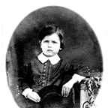 |  |  |  |  |  | 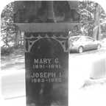 |  |  |  |  |  |  |  |  |  |  |  | 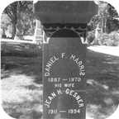 |  |  |  |  |  |  |  |  |  |  |  | 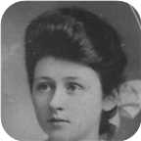

12. Emma Ives was born on Tuesday, April 09, 1850. She was the daughter of William Ives (6) and Christiana Ann Fraser.  Emma died on July 26, 1933, at the age of 83. She was buried in Haliburton, Pictou,N.S.
  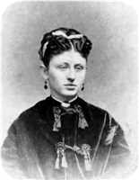
  Emma Ives
She married Simpson J Harris. They had seven children.
Simpson J was born in 1852. He was the son of William H Harris and Anne Arnseon.
He was employed in Sheriff. Simpson J reached 82 years of age and died in 1934. He was buried in Haliburton, Pictou,N.S.
Simpson was the Sheriff of Pictou - last in the line of six Sheriff Harrises covering 140-150 years and four generations.
Notes from Debra Arnison-Sutton
J. Sim Harris was the attorney for many legal documents for Joseph Simpson ARNISON of Pictou, Nova Scotia (from archives of Dalhousie University, Halifax, NS; copies held by Debra Arnison Sutton) 1860s, 1870s
------
High Sheriff of Pictou, NS, 1894-ish
Pictou town website has a historical photo of his house
Genealogical history of the Duncan-Stuart family in America; Stuart, Joseph A; Caxton Press, 1894; http://www.heritagequestonline.com/prod/genealogy/ (subscription site I was able to access briefly on a trial basis)
online images of book pages 94-95
Page 94:
"We have alread mentioned the children of Dr. HARRIS, and will now speak more especially of the son John W. and his descendants, many of whom are residents of the United States.
In 1811 John Washington HARRIS succeeded his cousin Thomas HARRIS, sr., as Deputy Sheriff [of Pictou], which office he held some years, then was made High Sheriff and continued in office till 1857. At that time his eyesight had become so impaired, presumably from exposure to winter snow and dazzling sunlight, that he resigned in favor of his son William H. [HARRIS], who had been his Deputy. William held the office till his death in 1883, at which time his son George S. [HARRIS] was formally appointed High Sheriff. As his father's deputy he had discharged the active duties of the office, his father's failing eyesight making it impossible for him to them. --- George S. HARRIS was Sheriff but a short time, for in 1885 he, too, passed away, and his only brother, J. Sim HARRIS, was appointed to succeed him. A Pictou paper published some years since said "The Shrievalty in this County has become hereditary and fixed in the family of HARRIS, and the appointment of any other than one of that name would be passing strange." The present incumbent is the fifth in office, and fifth of that name to occupy an office which has existed in that county one-hundred-and-two years.--- since the year 1791."
Children of Emma Ives and Simpson J Harris:
m I. William Henry Harris was born on March 07, 1882. He died on December 02, 1965, at the age of 83. William Henry was buried in Haliburton.
  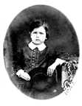
  William
m II. Joseph Ives Harris was born on May 13, 1883. He died in September 1902 at the age of 19. Joseph Ives was buried in Haliburton.
  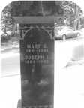
  Joseph
m III. George Stewart Harris was born on June 30, 1885. He died on March 21, 1968, at the age of 82.
+ 21 m IV. Daniel Fraser Harris was born on May 21, 1887. He died on April 24, 1970, at the age of 82.
  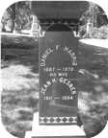
  Daniel
+ 22 f V. Margaret McLeod Harris was born on May 03, 1888.
+ 23 f VI. Christina Ives Harris was born on September 27, 1890.
  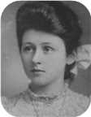
  Christina
f VII. Mary Glennie Harris was born on April 04, 1891. She died on July 10, 1891. Mary Glennie was buried in Haliburton.

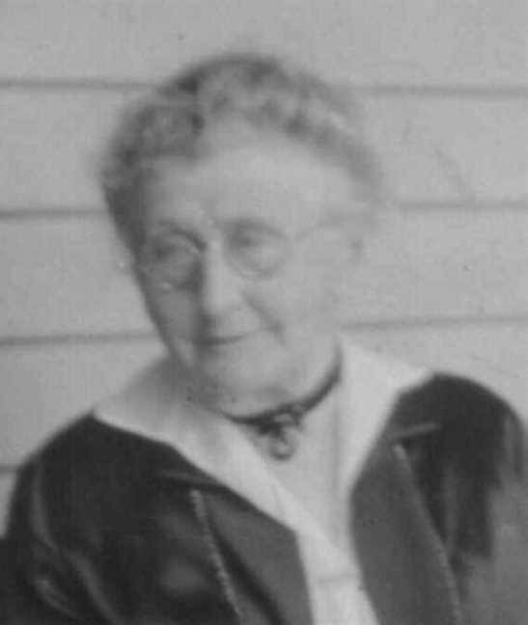  Figure 15: Emma Ives |  | 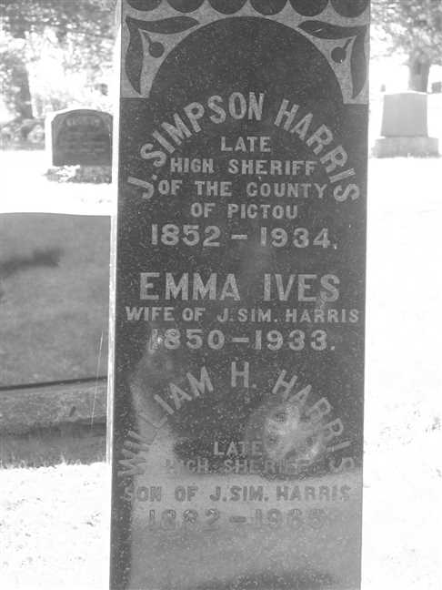  Figure 16: Grave Stone

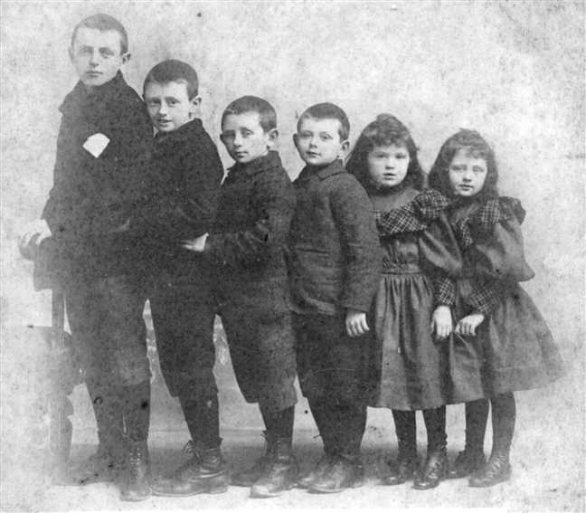
Figure 17: Harris children

Family of Arthur Ives and Ocenia Fraser
George |  |  |  |  |  | Catharine |  |  |  |  |  | Daniel |  |  |  |  |  | Catherine |  |  |  |  |  | James |  |  |  |  |  | Jane |  |  |  |  |  | William |  |  |  |  |  | Christina
Ives |  |  |  |  |  | Fraser |  |  |  |  |  | Fraser |  |  |  |  |  | MacKay |  |  |  |  |  | Fraser |  |  |  |  |  | Fraser |  |  |  |  |  | Robertson |  |  |  |  |  | MacKenzie
ca.1770–1862 |  |  |  |  |  | 1778–1865 |  |  |  |  |  | 1769–1850 |  |  |  |  |  | 1775–1864 |  |  |  |  |  | 1777–1853 |  |  |  |  |  | 1779–1879 |  |  |  |  |  | 1769–1848 |  |  |  |  |  | 1780–1832
 |  |  |  |  |  |  |  |  |  |  |  |  |  |  |  |  |  |  |  |  |  |  |  |  |  |  |  |  |  |  |  |  |  |  |  | 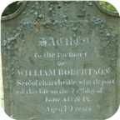 |  |  |  |  |  | 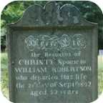
 |  | William |  |  |  |  |  |  |  |  |  |  |  | Christiana Ann |  |  |  |  |  |  |  |  |  |  |  | John |  |  |  |  |  |  |  |  |  |  |  | Annie
 |  | Ives |  |  |  |  |  |  |  |  |  |  |  | Fraser |  |  |  |  |  |  |  |  |  |  |  | Fraser |  |  |  |  |  |  |  |  |  |  |  | Robertson
 |  | 1808–1880 |  |  |  |  |  |  |  |  |  |  |  | 1813–1900 |  |  |  |  |  |  |  |  |  |  |  | 1808–1894 |  |  |  |  |  |  |  |  |  |  |  | 1818–1909
 |  |  |  |  |  |  |  |  |  |  |  |  |  |  |  |  |  |  |  |  |  |  |  |  |  | 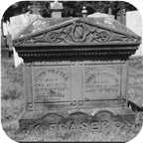 |  |  |  |  |  |  |  |  |  |  |  | 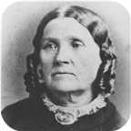
 |  |  |  |  |  |  |  | Arthur |  |  |  |  |  |  |  |  |  |  |  |  |  |  |  |  |  |  |  |  |  |  |  | Ocenia
 |  |  |  |  |  |  |  | Ives |  |  |  |  |  |  |  |  |  |  |  |  |  |  |  |  |  |  |  |  |  |  |  | Fraser
 |  |  |  |  |  |  |  | 1854–1913 |  |  |  |  |  |  |  |  |  |  |  |  |  |  |  |  |  |  |  |  |  |  |  | 1853–1935
 |  |  |  |  |  |  |  |  |  |  |  |  |  |  |  |  |  |  |  |  |  |  |  |  |  |  |  |  |  |  |  | 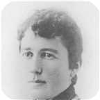
 |  |  |  |  |  |  |  |  |  |  |  |  |  | Marriage: 1876
 |  |  |  |  |  |  |  |  | Louisa Reid |  |  |  |  |  | Annie |  |  |  |  |  | Daniel Fraser |  |  |  |  |  | Lewis Zindord |  |  |  |  |  | John Fraser
 |  |  |  |  |  |  |  |  | Ives |  |  |  |  |  | Ives |  |  |  |  |  | Ives |  |  |  |  |  | Ives |  |  |  |  |  | Ives
 |  |  |  |  |  |  |  |  | 1889–1982 |  |  |  |  |  | 1880–1956 |  |  |  |  |  | 1887–1964 |  |  |  |  |  | 1888–1941 |  |  |  |  |  | 1895–1970
 |  |  |  |  |  |  |  |  | 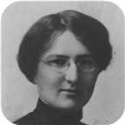 |  |  |  |  |  | 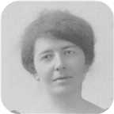 |  |  |  |  |  | 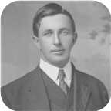 |  |  |  |  |  | 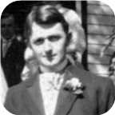 |  |  |  |  |  | 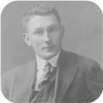

13. Arthur Ives was born on Friday, March 03, 1854. He was the son of William Ives (6) and Christiana Ann Fraser.  Arthur died on June 30, 1913, at the age of 59. He was buried in Haliburton Cemetery, Pictou,N.S.
  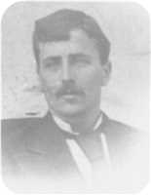
  Arthur Ives
Arthur Ives is listed as a 17 year old store clerk in the 1871 Pictou County census.
Eastern Chronicle July 6,1876
July 3: Married - Arthur Ives, merchant, Pictou, to Ocenia, daughter
of John Fraser, 12 Mile House, at the residence of the bride's father,
by Rev. G. Roddick.
Arthur married Ocenia Fraser on Monday, July 03, 1876, in 12 Mile House, Pictou Co., N.S. They had five children.  Ocenia was born in 1853. She was the daughter of John Fraser and Annie Robertson.
  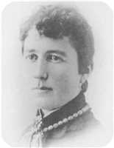
  Ocenia Fraser
Ocenia reached 82 years of age and died on March 19, 1935. She was buried in Haliburton Cemetery, Pictou,N.S.
Eastern Chronicle July 6,1876
July 3: Married - Arthur Ives, merchant, Pictou, to Ocenia, daughter
of John Fraser, 12 Mile House, at the residence of the bride's father,
by Rev. G. Roddick.
Children of Arthur Ives and Ocenia Fraser:
+ 24 f I. Louisa Reid Ives was born on September 23, 1889. She died in Pictou, Nova Scotia, Canada, on March 09, 1982, at the age of 92.
  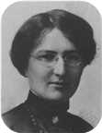
  Louisa
f II. Annie Ives was born on January 27, 1880. She died in New Glasgow,N.S., on November 09, 1956, at the age of 76.
  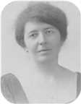
  Annie
+ 25 m III. Daniel Fraser Ives was born on February 07, 1887. He died on March 13, 1964, at the age of 77.
  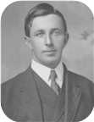
  Daniel
+ 26 m IV. Lewis Zindord Ives was born on July 02, 1888. He died on December 15, 1941, at the age of 53.
  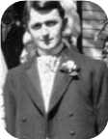
  Lewis
+ 27 m V. John Fraser Ives was born in Pictou,Nova Scotia, on October 12, 1895. He died in Plymouth Park, Nova Scotia, on July 25, 1970, at the age of 74.
  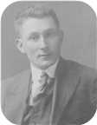
  John

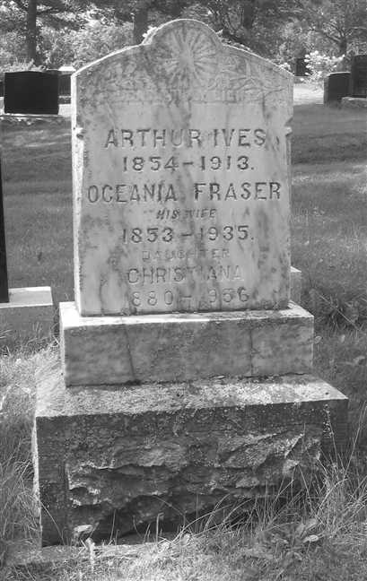  Figure 18: Grave Stone |  | 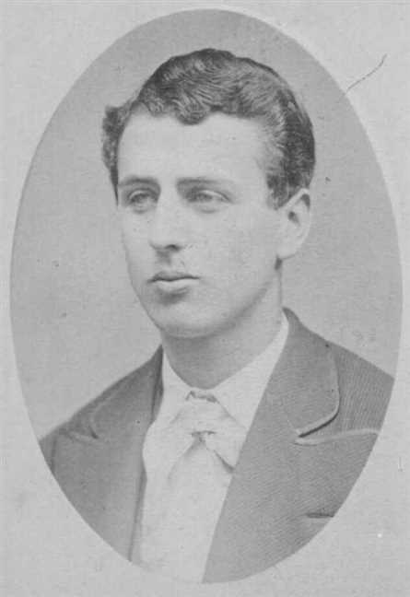  Figure 19: Arthur Ives

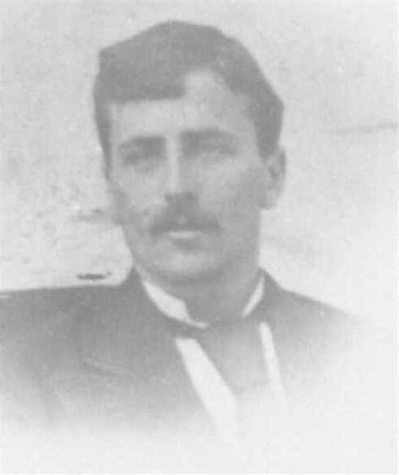  Figure 20: Arthur Ives |  | 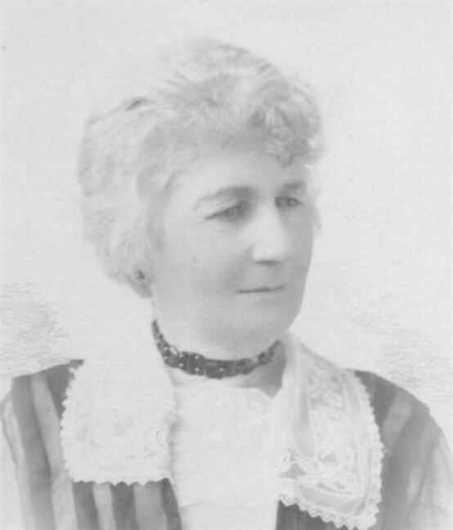  Figure 21: Oceniae Fraser

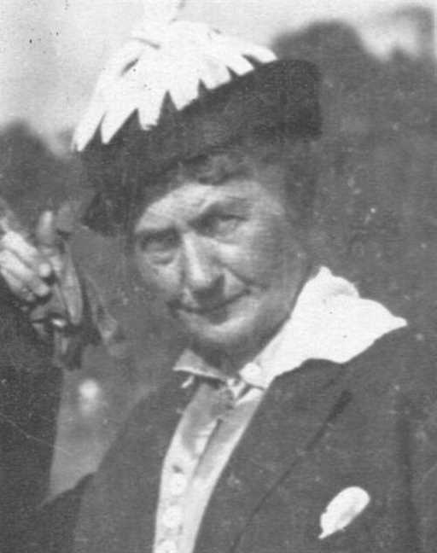  Figure 22: Oceniae Fraser |  | 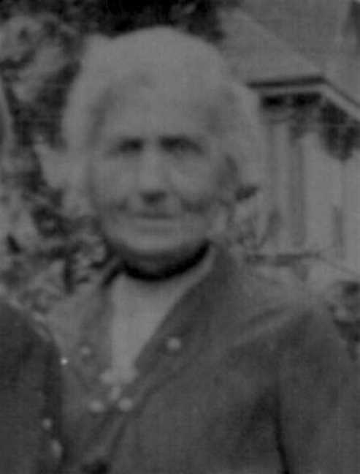  Figure 23: Oceniae Fraser

4th Generation

Family of Sarah Ives and Henry Kitchin
James |  |  |  | Elizabeth |  |  |  |  |  |  |  |  |  |  |  | John Turner |  |  |  | Sarah Frances |  |  |  | James
Kitchin |  |  |  | Rickerby |  |  |  |  |  |  |  |  |  |  |  | Ives |  |  |  | Ives |  |  |  | Ives
–1853 |  |  |  | 1801–1867 |  |  |  |  |  |  |  |  |  |  |  | 1804–1876 |  |  |  |  |  |  |  | ca.1790–
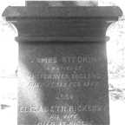
 | James |  |  |  |  |  |  |  | Elizabeth |  |  |  |  |  |  |  | James |  |  |  |  |  |  |  | Fanny Black
 | Kitchin |  |  |  |  |  |  |  | McConnell |  |  |  |  |  |  |  | Ives |  |  |  |  |  |  |  | Ives
 | 1818–1874 |  |  |  |  |  |  |  |  |  |  |  |  |  |  |  | ca.1824–1873 |  |  |  |  |  |  |  | 1828–1874
 | 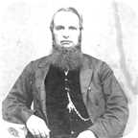
 |  |  |  |  | Henry |  |  |  |  |  |  |  |  |  |  |  |  |  |  |  | Sarah Frances
 |  |  |  |  | Kitchin |  |  |  |  |  |  |  |  |  |  |  |  |  |  |  | Ives
 |  |  |  |  |  |  |  |  |  |  |  |  |  |  |  |  |  |  |  |  | 1856–
 |  |  |  |  |  |  |  |  | Marriage: 1876

14. Sarah Frances Ives was born on Sunday, January 13, 1856. She was the daughter of James Ives (8) and Fanny Black Ives.
Eastern Chronicle Feb.7,1876
February 8: Married - Henry Kitchin, merchant, River John, to Sarah
F., eldest daughter of the late James Ives, Esq., Pictou, at the
residence of John Ives, Pictou, by Rev. James Bayne D. D.
Sarah Frances married Henry Kitchin on Tuesday, February 08, 1876, in Home of John Ives, Pictou, N.S. He was the son of James Kitchin and Elizabeth McConnell.
Eastern Chronicle Feb.7,1876
February 8: Married - Henry Kitchin, merchant, River John, to Sarah
F., eldest daughter of the late James Ives, Esq., Pictou, at the
residence of John Ives, Pictou, by Rev. James Bayne D. D.

Family of Henry Ives and Isabel Troop
John Turner |  |  |  | Sarah Frances |  |  |  | James
Ives |  |  |  | Ives |  |  |  | Ives
1804–1876 |  |  |  |  |  |  |  | ca.1790–
 | James |  |  |  |  |  |  |  | Fanny Black |  |  |  |  |  |  |  | Jared C
 | Ives |  |  |  |  |  |  |  | Ives |  |  |  |  |  |  |  | Troop
 | ca.1824–1873 |  |  |  |  |  |  |  | 1828–1874
 |  |  |  |  | Henry G |  |  |  |  |  |  |  |  |  |  |  |  |  |  |  | Isabel Grassie
 |  |  |  |  | Ives |  |  |  |  |  |  |  |  |  |  |  |  |  |  |  | Troop
 |  |  |  |  | 1858–
 |  |  |  |  |  |  |  |  | Marriage: 1890

15. Henry G Ives was born in 1858. He was the son of James Ives (8) and Fanny Black Ives.
Henry G married Isabel Grassie Troop on Monday, December 22, 1890, in Bridgetown, NS. She was the daughter of Jared C Troop.

Family of Edith Ives and Edward MacDonald
 |  |  |  |  |  |  |  |  |  |  |  |  |  |  |  | John Turner |  |  |  | Sarah Frances |  |  |  | James
 |  |  |  |  |  |  |  |  |  |  |  |  |  |  |  | Ives |  |  |  | Ives |  |  |  | Ives
 |  |  |  |  |  |  |  |  |  |  |  |  |  |  |  | 1804–1876 |  |  |  |  |  |  |  | ca.1790–
 |  |  |  |  |  |  |  |  |  |  |  |  |  |  |  |  | James |  |  |  |  |  |  |  | Fanny Black
 |  |  |  |  |  |  |  |  |  |  |  |  |  |  |  |  | Ives |  |  |  |  |  |  |  | Ives
 |  |  |  |  |  |  |  |  |  |  |  |  |  |  |  |  | ca.1824–1873 |  |  |  |  |  |  |  | 1828–1874
 |  |  |  |  | Edward M |  |  |  |  |  |  |  |  |  |  |  |  |  |  |  | Edith Lillian
 |  |  |  |  | MacDonald |  |  |  |  |  |  |  |  |  |  |  |  |  |  |  | Ives
 |  |  |  |  |  |  |  |  |  |  |  |  |  |  |  |  |  |  |  |  | 1867–
 |  |  |  |  |  |  |  |  | Marriage: 1889

16. Edith Lillian Ives was born in 1867. She was the daughter of James Ives (8) and Fanny Black Ives.
Edith Lillian married Edward M MacDonald on Wednesday, July 10, 1889, in Home of Mrs. John Turner Ives, Pictou, NS.[]

Family of Alexander Ives and Jessie Ross
John Turner |  |  |  | Sarah Frances
Ives |  |  |  | Ives
1804–1876
 | Robert |  |  |  |  |  |  |  | Grace
 | Ives |  |  |  |  |  |  |  | McLeod
 | 1842– |  |  |  |  |  |  |  | 1858–
 |  |  |  |  | Alexander William |  |  |  |  |  |  |  |  |  |  |  |  |  |  |  | Jessie May
 |  |  |  |  | Ives |  |  |  |  |  |  |  |  |  |  |  |  |  |  |  | Ross
 |  |  |  |  | 1879–
 |  |  |  |  |  |  |  |  | Marriage: 1921

17. Alexander William Ives was born in 1879. He was the son of Robert Ives (9) and Grace McLeod.
Alexander William married Jessie May Ross in 1921.

Family of Frederick Ives and ? ?
William |  |  |  | Christiana Ann |  |  |  | James
Ives |  |  |  | Fraser |  |  |  | McLeod
1808–1880 |  |  |  | 1813–1900
 | George Daniel |  |  |  |  |  |  |  | Amelia
 | Ives |  |  |  |  |  |  |  | McLeod
 | 1840–
 |  |  |  |  | Frederick George |  |  |  |  |  |  |  |  |  |  |  |  |  |  |  | ?
 |  |  |  |  | Ives |  |  |  |  |  |  |  |  |  |  |  |  |  |  |  | ?
 |  |  |  |  | ca.1876–1915
 |  |  |  |  |  |  |  |  |  |  |  |  |  |  |  |  |  |  |  |  | 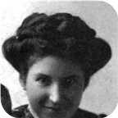
 |  |  |  |  |  |  |  |  | Married
 |  |  |  |  |  |  |  |  |  |  |  | George |  |  |  | Kenneth
 |  |  |  |  |  |  |  |  |  |  |  | Ives |  |  |  | Ives
 |  |  |  |  |  |  |  |  |  |  |  | 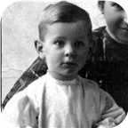 |  |  |  | 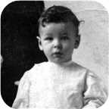

18. Frederick George Ives was born about 1876. He was the son of George Daniel Ives (10) and Amelia McLeod.  Frederick George died on February 27, 1915, at the age of 39.
  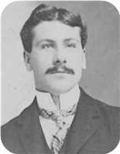
  Frederick George Ives
He married ? ?. They had two sons.
  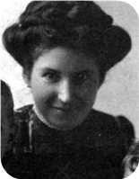
  ? ?
Sons of Frederick George Ives and ? ?:
m I. George Ives. George was employed in 1081.
  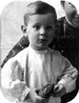
  George
m II. Kenneth Ives.
  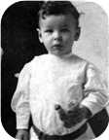
  Kenneth

Family of William Ives and Virginia Moore
William |  |  |  | Christiana Ann |  |  |  | Robert S |  |  |  | Janet
Ives |  |  |  | Fraser |  |  |  | Copeland |  |  |  | Smith
1808–1880 |  |  |  | 1813–1900 |  |  |  | 1800–1885 |  |  |  | 1805–1874
 | Charles William |  |  |  |  |  |  |  | Margaret Maggie
 | Ives |  |  |  |  |  |  |  | Copeland
 | 1841–1921 |  |  |  |  |  |  |  | 1848–1933
 |  |  |  |  | William Alexander |  |  |  |  |  |  |  |  |  |  |  |  |  |  |  | Virginia
 |  |  |  |  | Ives |  |  |  |  |  |  |  |  |  |  |  |  |  |  |  | Moore
 |  |  |  |  | 1880–
 |  |  |  |  |  |  |  |  | Marriage: 1905
 |  |  |  |  |  |  |  | Charles Moore |  |  |  | William Henry |  |  |  | Margaret |  |  |  | Virginia
 |  |  |  |  |  |  |  | Ives |  |  |  | Ives |  |  |  | Ives |  |  |  | Ives
 |  |  |  |  |  |  |  | 1906–2001 |  |  |  | –1911

19. William Alexander Ives was born on Saturday, December 25, 1880. He was the son of Charles William Ives (11) and Margaret Maggie Copeland.
William Alexander married Virginia Moore on Thursday, May 25, 1905, in Aiken,MD. They had four children.
Children of William Alexander Ives and Virginia Moore:
+ 28 m I. Charles Moore Ives was born in Philadelephia,PA, in 1906. He died in Santa Clarita,CA, on October 01, 2001, at the age of 95.
+ 29 m II. William Henry Ives was born in Pictou, N.S. He died on September 22, 1911.
f III. Margaret Ives.
+ 30 f IV. Virginia Ives.

Family of Christina Ives and James Bethume
 |  |  |  |  |  |  |  |  |  |  |  |  |  |  |  | William |  |  |  | Christiana Ann |  |  |  | Robert S |  |  |  | Janet
 |  |  |  |  |  |  |  |  |  |  |  |  |  |  |  | Ives |  |  |  | Fraser |  |  |  | Copeland |  |  |  | Smith
 |  |  |  |  |  |  |  |  |  |  |  |  |  |  |  | 1808–1880 |  |  |  | 1813–1900 |  |  |  | 1800–1885 |  |  |  | 1805–1874
 |  |  |  |  |  |  |  |  |  |  |  |  |  |  |  |  | Charles William |  |  |  |  |  |  |  | Margaret Maggie
 |  |  |  |  |  |  |  |  |  |  |  |  |  |  |  |  | Ives |  |  |  |  |  |  |  | Copeland
 |  |  |  |  |  |  |  |  |  |  |  |  |  |  |  |  | 1841–1921 |  |  |  |  |  |  |  | 1848–1933
 |  |  |  |  | James William |  |  |  |  |  |  |  |  |  |  |  |  |  |  |  | Christina Nan
 |  |  |  |  | Bethume |  |  |  |  |  |  |  |  |  |  |  |  |  |  |  | Ives
 |  |  |  |  | 1879–1940 |  |  |  |  |  |  |  |  |  |  |  |  |  |  |  | 1884–
 |  |  |  |  |  |  |  |  | Married

20. Christina Nan Ives was born on Monday, September 08, 1884. She was the daughter of Charles William Ives (11) and Margaret Maggie Copeland.
She married James William Bethume. James William was born in Prince Edward Island in 1879.
He reached 61 years of age and died in Pictou, N.S., on March 15, 1940.

Family of Daniel Harris and Jean Gesner
William H |  |  |  | Anne |  |  |  | William |  |  |  | Christiana Ann
Harris |  |  |  | Arnseon |  |  |  | Ives |  |  |  | Fraser
1805–1883 |  |  |  | 1815–1889 |  |  |  | 1808–1880 |  |  |  | 1813–1900
 | Simpson J |  |  |  |  |  |  |  | Emma
 | Harris |  |  |  |  |  |  |  | Ives
 | 1852–1934 |  |  |  |  |  |  |  | 1850–1933
 |  |  |  |  | Daniel Fraser |  |  |  |  |  |  |  |  |  |  |  |  |  |  |  | Jean H
 |  |  |  |  | Harris |  |  |  |  |  |  |  |  |  |  |  |  |  |  |  | Gesner
 |  |  |  |  | 1887–1970 |  |  |  |  |  |  |  |  |  |  |  |  |  |  |  | 1911–1994
 |  |  |  |  |  |  |  |  | Married

21. Daniel Fraser Harris was born on Saturday, May 21, 1887. He was the son of Simpson J Harris and Emma Ives (12).  Daniel Fraser died on April 24, 1970, at the age of 82. He was buried in Haliburton, Pictou,N.S.
  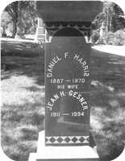
  Daniel Fraser Harris
He married Jean H Gesner. Jean H was born in 1911.
She reached 83 years of age and died in 1994. Jean H was buried in Haliburton.

Family of Margaret Harris and William Fraser
 |  |  |  |  |  |  |  |  |  |  |  |  |  |  |  |  |  |  |  |  |  |  |  | William H |  |  |  |  |  | Anne |  |  |  |  |  | William |  |  |  |  |  | Christiana Ann
 |  |  |  |  |  |  |  |  |  |  |  |  |  |  |  |  |  |  |  |  |  |  |  | Harris |  |  |  |  |  | Arnseon |  |  |  |  |  | Ives |  |  |  |  |  | Fraser
 |  |  |  |  |  |  |  |  |  |  |  |  |  |  |  |  |  |  |  |  |  |  |  | 1805–1883 |  |  |  |  |  | 1815–1889 |  |  |  |  |  | 1808–1880 |  |  |  |  |  | 1813–1900
 |  |  |  |  |  |  |  |  |  |  |  |  |  |  |  |  |  |  |  |  |  |  |  |  |  | Simpson J |  |  |  |  |  |  |  |  |  |  |  | Emma
 |  |  |  |  |  |  |  |  |  |  |  |  |  |  |  |  |  |  |  |  |  |  |  |  |  | Harris |  |  |  |  |  |  |  |  |  |  |  | Ives
 |  |  |  |  |  |  |  |  |  |  |  |  |  |  |  |  |  |  |  |  |  |  |  |  |  | 1852–1934 |  |  |  |  |  |  |  |  |  |  |  | 1850–1933
 |  |  |  |  |  |  |  | William |  |  |  |  |  |  |  |  |  |  |  |  |  |  |  |  |  |  |  |  |  |  |  | Margaret McLeod
 |  |  |  |  |  |  |  | Fraser |  |  |  |  |  |  |  |  |  |  |  |  |  |  |  |  |  |  |  |  |  |  |  | Harris
 |  |  |  |  |  |  |  | ca.1883– |  |  |  |  |  |  |  |  |  |  |  |  |  |  |  |  |  |  |  |  |  |  |  | 1888–
 |  |  |  |  |  |  |  |  |  |  |  |  |  | Married
 |  |  |  |  |  |  |  |  |  |  |  |  |  |  |  |  |  |  |  |  | Joseph
 |  |  |  |  |  |  |  |  |  |  |  |  |  |  |  |  |  |  |  |  | Fraser
 |  |  |  |  |  |  |  |  |  |  |  |  |  |  |  |  |  |  |  |  | –1941

22. Margaret McLeod Harris was born on Thursday, May 03, 1888. She was the daughter of Simpson J Harris and Emma Ives (12).
She married William Fraser. They had one son.
William was born about 1883.
Son of Margaret McLeod Harris and William Fraser:
m I. Joseph Fraser. Joseph died on December 16, 1941.

Family of Christina Harris and Harry McKiel
 |  |  |  |  |  |  |  |  |  |  |  |  |  |  |  | William H |  |  |  | Anne |  |  |  | William |  |  |  | Christiana Ann
 |  |  |  |  |  |  |  |  |  |  |  |  |  |  |  | Harris |  |  |  | Arnseon |  |  |  | Ives |  |  |  | Fraser
 |  |  |  |  |  |  |  |  |  |  |  |  |  |  |  | 1805–1883 |  |  |  | 1815–1889 |  |  |  | 1808–1880 |  |  |  | 1813–1900
 |  |  |  |  |  |  |  |  |  |  |  |  |  |  |  |  | Simpson J |  |  |  |  |  |  |  | Emma
 |  |  |  |  |  |  |  |  |  |  |  |  |  |  |  |  | Harris |  |  |  |  |  |  |  | Ives
 |  |  |  |  |  |  |  |  |  |  |  |  |  |  |  |  | 1852–1934 |  |  |  |  |  |  |  | 1850–1933
 |  |  |  |  | Harry W |  |  |  |  |  |  |  |  |  |  |  |  |  |  |  | Christina Ives
 |  |  |  |  | McKiel |  |  |  |  |  |  |  |  |  |  |  |  |  |  |  | Harris
 |  |  |  |  |  |  |  |  |  |  |  |  |  |  |  |  |  |  |  |  | 1890–
 |  |  |  |  |  |  |  |  | Married

23. Christina Ives Harris was born on Saturday, September 27, 1890. She was the daughter of Simpson J Harris and Emma Ives (12).
  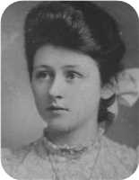
  Christina Ives Harris
She married Harry W McKiel.

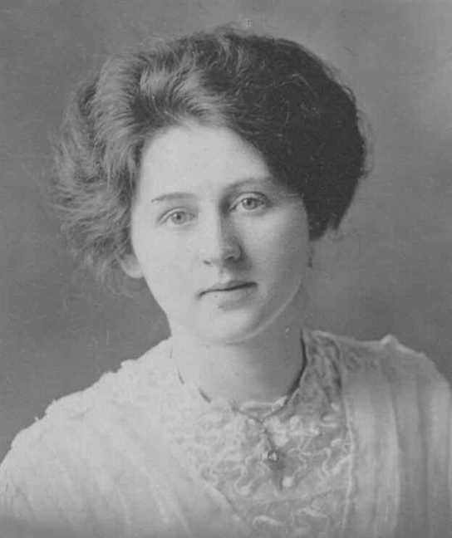
Figure 24: Christina Ives Harris

Family of Louisa Ives and Leonard Robertson
James |  |  |  | Isabella |  |  |  | Alexander |  |  |  | Jessie |  |  |  | William |  |  |  | Christiana Ann |  |  |  | John |  |  |  | Annie
Robertson |  |  |  | Dunbar |  |  |  | Campbell |  |  |  | McKillop |  |  |  | Ives |  |  |  | Fraser |  |  |  | Fraser |  |  |  | Robertson
1823–1894 |  |  |  | 1823–1897 |  |  |  | 1817–1908 |  |  |  | 1827–1900 |  |  |  | 1808–1880 |  |  |  | 1813–1900 |  |  |  | 1808–1894 |  |  |  | 1818–1909
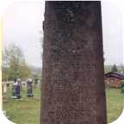
 | James Alexander |  |  |  |  |  |  |  | Annie Fraser |  |  |  |  |  |  |  | Arthur |  |  |  |  |  |  |  | Ocenia
 | Robertson |  |  |  |  |  |  |  | Campbell |  |  |  |  |  |  |  | Ives |  |  |  |  |  |  |  | Fraser
 | 1859–1947 |  |  |  |  |  |  |  | 1867–1960 |  |  |  |  |  |  |  | 1854–1913 |  |  |  |  |  |  |  | 1853–1935
 | 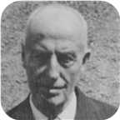 |  |  |  |  |  |  |  | 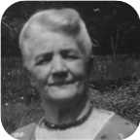
 |  |  |  |  | Leonard Bowman |  |  |  |  |  |  |  |  |  |  |  |  |  |  |  | Louisa Reid
 |  |  |  |  | Robertson |  |  |  |  |  |  |  |  |  |  |  |  |  |  |  | Ives
 |  |  |  |  | 1890–1972 |  |  |  |  |  |  |  |  |  |  |  |  |  |  |  | 1889–1982
 |  |  |  |  | 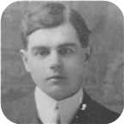
 |  |  |  |  |  |  |  |  | Marriage: 1914
 |  |  |  |  |  |  |  | Annie Oceania |  |  |  | James Ives |  |  |  | Leonard Bowman |  |  |  | Norah Louise
 |  |  |  |  |  |  |  | Robertson |  |  |  | Robertson |  |  |  | Robertson |  |  |  | Robertson
 |  |  |  |  |  |  |  | 1915–1920 |  |  |  | 1917–1989 |  |  |  | 1918– |  |  |  | 1921–
 |  |  |  |  |  |  |  | 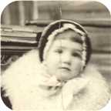 |  |  |  | 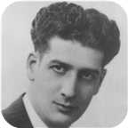 |  |  |  | 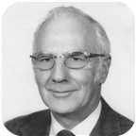 |  |  |  | 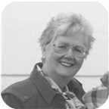

24. Louisa Reid Ives was born on Monday, September 23, 1889. She was the daughter of Arthur Ives (13) and Ocenia Fraser.  Louisa Reid died in Pictou, Nova Scotia, Canada, on March 09, 1982, at the age of 92. She was buried in Haliburton, Pictou,N.S.
  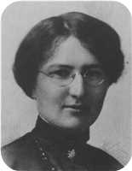
  Louisa Reid Ives
Louisa Read Ives and spouse Leonard Bowman Robertson are 3'rd cousins from common ancestors Colin MacKenzie (b.1721) and his spouse Isabella MacKenzie.
They are also 4th cousins from common ancestors Margaret MacKay (b.1732) and Roderick MacKay (b. 1746).
At the age of 25, Louisa Reid married Leonard Bowman Robertson on Wednesday, September 23, 1914, when he was 23 years old. They had four children.  Leonard Bowman was born in Churchville, Nova Scotia, on Monday, December 01, 1890. He was the son of James Alexander Robertson and Annie Fraser Campbell.
  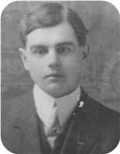
  Leonard Bowman Robertson
He was employed in Telegraph operator,Security guard. Leonard Bowman reached 81 years of age and died in Pictou, Nova Scotia, Canada, on January 18, 1972. He was buried in Haliburton, Pictou,N.S.
Perhaps Leonard Bowman Robertson was named after the Rev. Archibald Bowman who married his parents?
Louisa Read Ives and spouse Leonard Bowman Robertson are 3'rd cousins from common ancestors Colin MacKenzie (b.1721) and his spouse Isabella MacKenzie.
They are also 4th cousins from common ancestors Margaret MacKay (b.1732) and Roderick MacKay (b. 1746).
Children of Louisa Reid Ives and Leonard Bowman Robertson:
f I. Annie Oceania Robertson was born on August 20, 1915. She died on March 29, 1920, at the age of 4.
  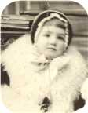
  Annie
+ 31 m II. James Ives Robertson was born in Stellarton, Nova Scotia, on January 28, 1917. He died in Pictou, Nova Scotia, Canada, on October 14, 1989, at the age of 72.
  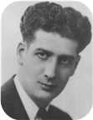
  James
+ 32 m III. Leonard Bowman Robertson was born in Stellerton,N.S., on October 19, 1918.
  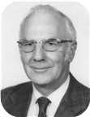
  Leonard
+ 33 f IV. Norah Louise Robertson was born in Niagara Falls,Ont., on February 17, 1921.
  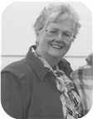
  Norah

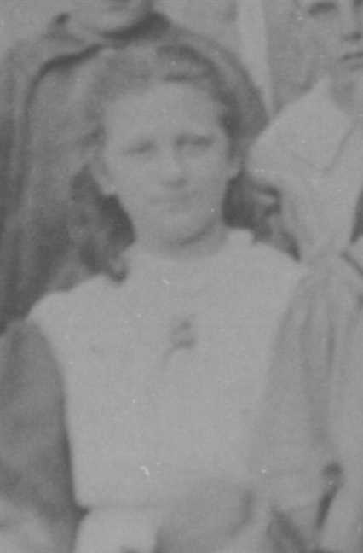  Figure 25: Louisa Reid Ives |  | 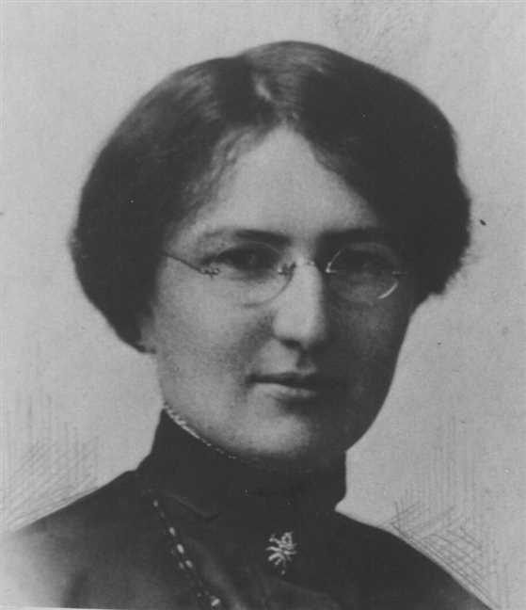  Figure 26: Louisa Reid Ives

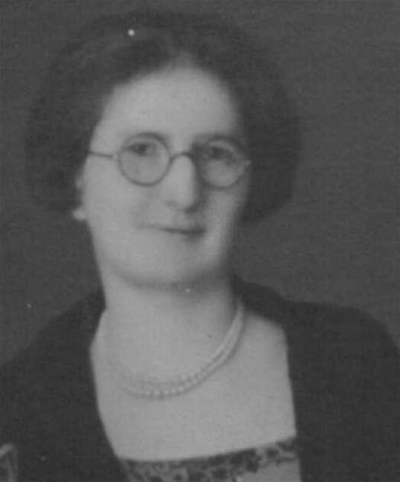  Figure 27: Louisa Reid Ives |  | 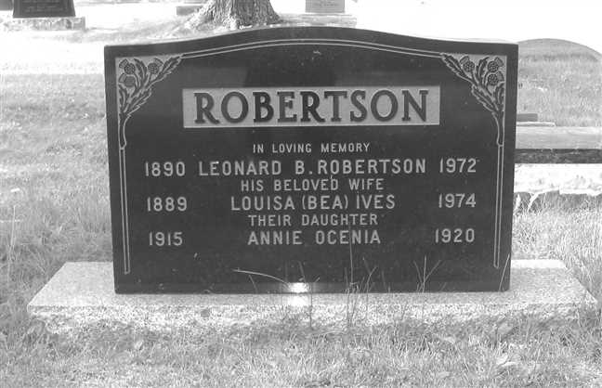  Figure 28: Grave Stone

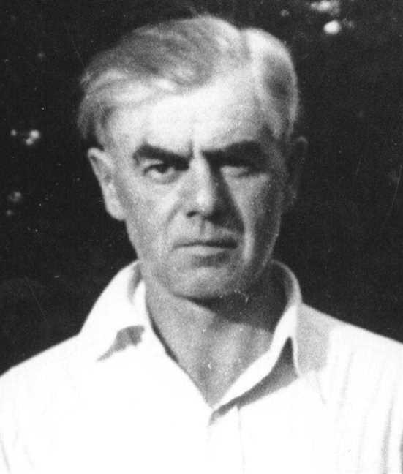  Figure 29: LBRobertsonSr2 |  | 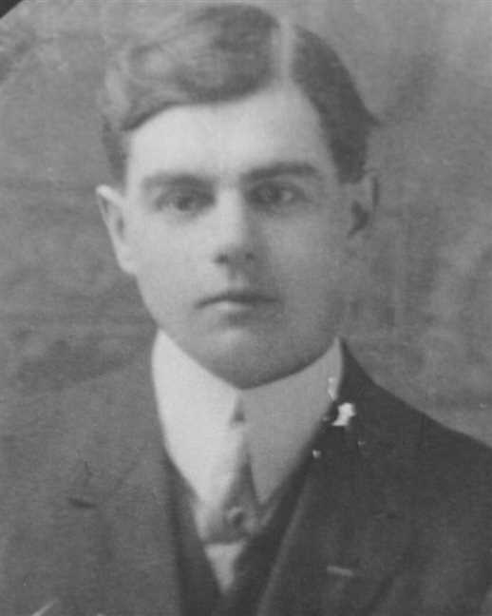  Figure 30: Leonard Bowman Robertson

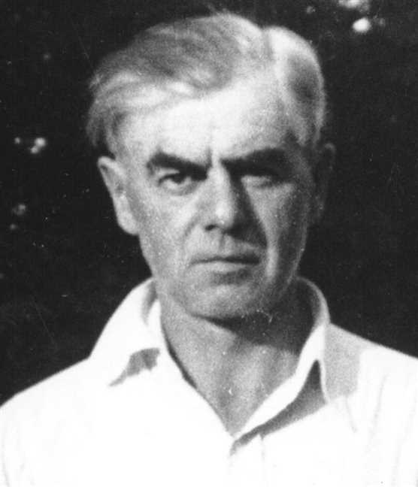
Figure 31: Leonard Bowman Robertson

Family of Daniel Ives and Laura Manship
William |  |  |  | Christiana Ann |  |  |  | John |  |  |  | Annie
Ives |  |  |  | Fraser |  |  |  | Fraser |  |  |  | Robertson
1808–1880 |  |  |  | 1813–1900 |  |  |  | 1808–1894 |  |  |  | 1818–1909
 | Arthur |  |  |  |  |  |  |  | Ocenia |  |  |  |  |  |  |  | Bliss |  |  |  |  |  |  |  | Abigail
 | Ives |  |  |  |  |  |  |  | Fraser |  |  |  |  |  |  |  | Manship |  |  |  |  |  |  |  | Baxter
 | 1854–1913 |  |  |  |  |  |  |  | 1853–1935
 |  |  |  |  | Daniel Fraser |  |  |  |  |  |  |  |  |  |  |  |  |  |  |  | Laura Maud
 |  |  |  |  | Ives |  |  |  |  |  |  |  |  |  |  |  |  |  |  |  | Manship
 |  |  |  |  | 1887–1964 |  |  |  |  |  |  |  |  |  |  |  |  |  |  |  | 1883–1979
 |  |  |  |  |  |  |  |  | Marriage: 1911
 |  |  |  |  |  |  |  | Russel Bliss |  |  |  | Frances C |  |  |  | Arthur |  |  |  | Hilda
 |  |  |  |  |  |  |  | Ives |  |  |  | Ives |  |  |  | Ives |  |  |  | Ives
 |  |  |  |  |  |  |  | –1912 |  |  |  |  |  |  |  | 1919–1933
 |  |  |  |  |  |  |  |  |  |  |  | 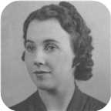

25. Daniel Fraser Ives was born on Monday, February 07, 1887. He was the son of Arthur Ives (13) and Ocenia Fraser.  Daniel Fraser died on March 13, 1964, at the age of 77.
  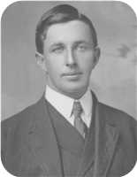
  Daniel Fraser Ives
At the age of 24, Daniel Fraser married Laura Maud Manship on Wednesday, October 25, 1911, when she was 28 years old. They had four children.
Laura Maud was born in Sackville,New Brunswick, on Monday, January 29, 1883. She was the daughter of Bliss Manship and Abigail Baxter.
Laura Maud reached 96 years of age and died on August 10, 1979.
Children of Daniel Fraser Ives and Laura Maud Manship:
+ 34 m I. Russel Bliss Ives. Russel Bliss died on September 19, 1912.
+ 35 f II. Frances C Ives.
  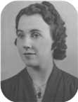
  Frances
m III. Arthur Ives was born in 1919. He died on October 22, 1933, at the age of 14. Arthur was buried in Haliburton Cemetery, Pictou,N.S.
+ 36 f IV. Hilda Ives. They were her parents by adoption.

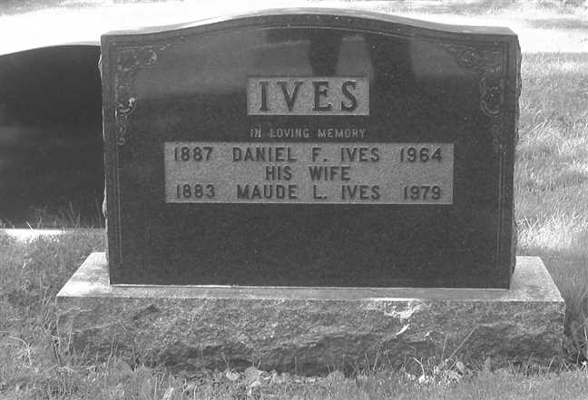
Figure 32: Grave Stone

Family of Lewis Ives and Jenny Eastwood
William |  |  |  | Christiana Ann |  |  |  | John |  |  |  | Annie
Ives |  |  |  | Fraser |  |  |  | Fraser |  |  |  | Robertson
1808–1880 |  |  |  | 1813–1900 |  |  |  | 1808–1894 |  |  |  | 1818–1909
 | Arthur |  |  |  |  |  |  |  | Ocenia |  |  |  |  |  |  |  | James |  |  |  |  |  |  |  | Mary
 | Ives |  |  |  |  |  |  |  | Fraser |  |  |  |  |  |  |  | Eastwood |  |  |  |  |  |  |  | MacIntosh
 | 1854–1913 |  |  |  |  |  |  |  | 1853–1935
 |  |  |  |  | Lewis Zindord |  |  |  |  |  |  |  |  |  |  |  |  |  |  |  | Jenny Mitchell
 |  |  |  |  | Ives |  |  |  |  |  |  |  |  |  |  |  |  |  |  |  | Eastwood
 |  |  |  |  | 1888–1941 |  |  |  |  |  |  |  |  |  |  |  |  |  |  |  | 1880–1942
 |  |  |  |  |  |  |  |  |  |  |  |  |  |  |  |  |  |  |  |  | 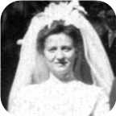
 |  |  |  |  |  |  |  |  | Marriage: 1911
 |  |  |  |  |  |  |  |  |  |  |  | James Eastwood |  |  |  | Lewis Gordon
 |  |  |  |  |  |  |  |  |  |  |  | Ives |  |  |  | Ives
 |  |  |  |  |  |  |  |  |  |  |  | 1916– |  |  |  | –1918
 |  |  |  |  |  |  |  |  |  |  |  | 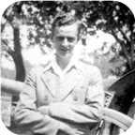

26. Lewis Zindord Ives was born on Monday, July 02, 1888. He was the son of Arthur Ives (13) and Ocenia Fraser.  Lewis Zindord died on December 15, 1941, at the age of 53.
  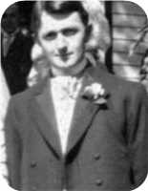
  Lewis Zindord Ives
Lewis Zindord married Jenny Mitchell Eastwood in 1911. They had two sons.  Jenny Mitchell was born in 1880. She was the daughter of James Eastwood and Mary MacIntosh.  Jenny Mitchell reached 62 years of age and died on December 13, 1942.
  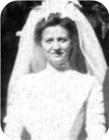
  Jenny Mitchell Eastwood
Sons of Lewis Zindord Ives and Jenny Mitchell Eastwood:
+ 37 m I. James Eastwood Ives was born on November 22, 1916.
  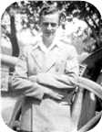
  James
m II. Lewis Gordon Ives. Lewis Gordon died on August 13, 1918.

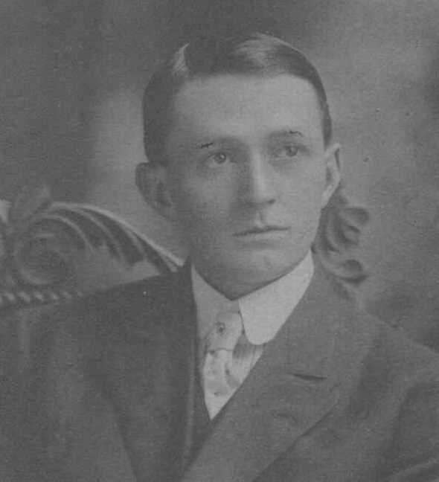  Figure 33: Lewis Zindord Ives |  | 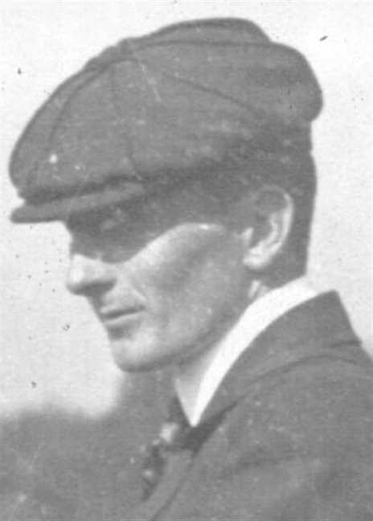  Figure 34: Lewis Zindord Ives

Family of John Ives and Jessie MacMillan
William |  |  |  | Christiana Ann |  |  |  | John |  |  |  | Annie
Ives |  |  |  | Fraser |  |  |  | Fraser |  |  |  | Robertson
1808–1880 |  |  |  | 1813–1900 |  |  |  | 1808–1894 |  |  |  | 1818–1909
 | Arthur |  |  |  |  |  |  |  | Ocenia |  |  |  |  |  |  |  | Hugh |  |  |  |  |  |  |  | Mary
 | Ives |  |  |  |  |  |  |  | Fraser |  |  |  |  |  |  |  | MacMillan |  |  |  |  |  |  |  | ?
 | 1854–1913 |  |  |  |  |  |  |  | 1853–1935
 |  |  |  |  | John Fraser |  |  |  |  |  |  |  |  |  |  |  |  |  |  |  | Jessie Margaret
 |  |  |  |  | Ives |  |  |  |  |  |  |  |  |  |  |  |  |  |  |  | MacMillan
 |  |  |  |  | 1895–1970 |  |  |  |  |  |  |  |  |  |  |  |  |  |  |  | 1898–1994
 |  |  |  |  |  |  |  |  |  |  |  |  |  |  |  |  |  |  |  |  | 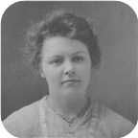
 |  |  |  |  |  |  |  |  | Marriage: 1919
 |  |  |  |  |  |  |  |  |  |  |  | David Hugh |  |  |  | Norah MacGillivary
 |  |  |  |  |  |  |  |  |  |  |  | Ives |  |  |  | Ives
 |  |  |  |  |  |  |  |  |  |  |  | 1924– |  |  |  | 1921–
 |  |  |  |  |  |  |  |  |  |  |  | 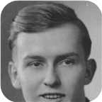 |  |  |  | 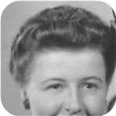

27. John Fraser Ives was born on Saturday, October 12, 1895, in Pictou,Nova Scotia. He was the son of Arthur Ives (13) and Ocenia Fraser.  John Fraser died in Plymouth Park, Nova Scotia, on July 25, 1970, at the age of 74.
  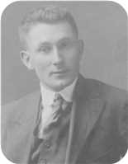
  John Fraser Ives
John Fraser married Jessie Margaret MacMillan in 1919. They had two children.  Jessie Margaret was born in Bridgeville on Wednesday, January 05, 1898. She was the daughter of Hugh MacMillan and Mary ?.  Jessie Margaret reached 96 years of age and died in Plymouth Park on August 14, 1994.
  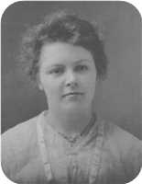
  Jessie Margaret MacMillan
Children of John Fraser Ives and Jessie Margaret MacMillan:
+ 38 m I. David Hugh Ives was born in New Glasgow,Nova Scotia, on February 25, 1924.
  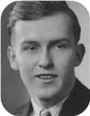
  David
+ 39 f II. Norah MacGillivary Ives was born on March 07, 1921.
  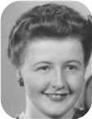
  Norah

5th Generation

Charles Ives
28. Charles Moore Ives was born in 1906 in Philadelephia,PA. He was the son of William Alexander Ives (19) and Virginia Moore.
Charles Moore died in Santa Clarita,CA, on October 01, 2001, at the age of 95.
IVES, Charles Moore
IVES, Charles Moore - 95, died October 1, 2001, in Santa Clarita, California. Born in Philadelphia, he was a son of the late William A. and Virginia (Moore) Ives. When a small child, he moved with his parents to Pictou, Charles graduated from Pictou Academy and was employed with the Royal Bank and later transferred to Halifax. In 1925, his family moved to Halifax, where his family started Ives Engraving & Printing Company. Charles in his early 20's he decided to go back to the United States. He worked for Prudential Insurance Home Office in Newark, N.J. and later moved to California when they opened a home office on the west coast. He retired as manager of one of their divisions. Surviving are his wife, Maisie; son, Charles W. Ives (Jeannie); daughter, Virginia Bauer-Tapia; stepdaughters, Judy and Christina; five grandchildren; sister, Virginia Ives Mills, Windsor. He was predeceased by his wife, Eleanor; brother, William H. Ives (Halifax); sister, Margaret Ives Dawson (Kentville). There was a service held in Friendly Valley Church, Santa Clarita with a reception following. Cremation has taken place. Interment will follow. Charles will be missed, he had many friends and a good life.
--------------------------------------------------------------------------------
Marriages with Eleanor Arleen Colburg and (unknown given name) Maisie (Page 63) are known.

Family of Charles Ives and Eleanor Colburg
Charles William |  |  |  | Margaret Maggie
Ives |  |  |  | Copeland
1841–1921 |  |  |  | 1848–1933
 | William Alexander |  |  |  |  |  |  |  | Virginia
 | Ives |  |  |  |  |  |  |  | Moore
 | 1880–
 |  |  |  |  | Charles Moore |  |  |  |  |  |  |  |  |  |  |  |  |  |  |  | Eleanor Arleen
 |  |  |  |  | Ives |  |  |  |  |  |  |  |  |  |  |  |  |  |  |  | Colburg
 |  |  |  |  | 1906–2001
 |  |  |  |  |  |  |  |  | Marriage: 1934
 |  |  |  |  |  |  |  |  |  |  |  | Charles W |  |  |  | Virginia
 |  |  |  |  |  |  |  |  |  |  |  | Ives |  |  |  | Ives

Here are the details about Charles Moore Ives first marriage, with Eleanor Arleen Colburg. You can read more about Charles Moore on page 61.
Charles Moore Ives married Eleanor Arleen Colburg on Saturday, July 07, 1934. They had two children.
Children of Charles Moore Ives and Eleanor Arleen Colburg:
m I. Charles W Ives.
f II. Virginia Ives.

Family of Charles Ives and Maisie
Charles William |  |  |  | Margaret Maggie
Ives |  |  |  | Copeland
1841–1921 |  |  |  | 1848–1933
 | William Alexander |  |  |  |  |  |  |  | Virginia
 | Ives |  |  |  |  |  |  |  | Moore
 | 1880–
 |  |  |  |  | Charles Moore |  |  |  |  |  |  |  |  |  |  |  |  |  |  |  | (unknown given name)
 |  |  |  |  | Ives |  |  |  |  |  |  |  |  |  |  |  |  |  |  |  | Maisie
 |  |  |  |  | 1906–2001
 |  |  |  |  |  |  |  |  | Married
 |  |  |  |  |  |  |  |  |  |  |  | (unknown given name) |  |  |  | (unknown given name)
 |  |  |  |  |  |  |  |  |  |  |  | Judy |  |  |  | Christina

Here are the details about Charles Moore Ives second marriage, with (unknown given name) Maisie. You can read more about Charles Moore on page 61.
Charles Moore Ives married (unknown given name) Maisie. They had two daughters.
Daughters of Charles Moore Ives and (unknown given name) Maisie:
f I. (unknown given name) Judy.
f II. (unknown given name) Christina.

Family of William Ives and Winnifred Murray
Charles William |  |  |  | Margaret Maggie
Ives |  |  |  | Copeland
1841–1921 |  |  |  | 1848–1933
 | William Alexander |  |  |  |  |  |  |  | Virginia
 | Ives |  |  |  |  |  |  |  | Moore
 | 1880–
 |  |  |  |  | William Henry |  |  |  |  |  |  |  |  |  |  |  |  |  |  |  | Winnifred
 |  |  |  |  | Ives |  |  |  |  |  |  |  |  |  |  |  |  |  |  |  | Murray
 |  |  |  |  | –1911
 |  |  |  |  |  |  |  |  | Marriage: 1952

29. William Henry Ives was born in Pictou, N.S. He was the son of William Alexander Ives (19) and Virginia Moore.
William Henry died on September 22, 1911.
William Henry married Winnifred Murray on Saturday, October 04, 1952, in Halifax,N.S.

Family of Virginia Ives and ? Mills
 |  |  |  |  |  |  |  |  |  |  |  |  |  |  |  | Charles William |  |  |  | Margaret Maggie
 |  |  |  |  |  |  |  |  |  |  |  |  |  |  |  | Ives |  |  |  | Copeland
 |  |  |  |  |  |  |  |  |  |  |  |  |  |  |  | 1841–1921 |  |  |  | 1848–1933
 |  |  |  |  |  |  |  |  |  |  |  |  |  |  |  |  | William Alexander |  |  |  |  |  |  |  | Virginia
 |  |  |  |  |  |  |  |  |  |  |  |  |  |  |  |  | Ives |  |  |  |  |  |  |  | Moore
 |  |  |  |  |  |  |  |  |  |  |  |  |  |  |  |  | 1880–
 |  |  |  |  | ? |  |  |  |  |  |  |  |  |  |  |  |  |  |  |  | Virginia
 |  |  |  |  | Mills |  |  |  |  |  |  |  |  |  |  |  |  |  |  |  | Ives
 |  |  |  |  |  |  |  |  | Married

30. Virginia Ives. She was the daughter of William Alexander Ives (19) and Virginia Moore.
Never remarried. No children.
She married ? Mills.
? Mills was killed during WWII. Ship was torpedoed while heading for Europe.

Family of James Robertson and Charlotte MacDonell
James Alexander |  |  |  | Annie Fraser |  |  |  | Arthur |  |  |  | Ocenia |  |  |  | Angus Hugh |  |  |  | Flora |  |  |  | William Little |  |  |  | Charlotte
Robertson |  |  |  | Campbell |  |  |  | Ives |  |  |  | Fraser |  |  |  | MacDonell |  |  |  | MacDonell |  |  |  | MacDonald |  |  |  | MacDougall
1859–1947 |  |  |  | 1867–1960 |  |  |  | 1854–1913 |  |  |  | 1853–1935 |  |  |  | 1831–1917 |  |  |  | 1841–1919 |  |  |  | 1844–1917 |  |  |  | 1849–1934
 |  |  |  |  |  |  |  |  |  |  |  |  |  |  |  |  |  |  |  |  |  |  |  |  |  |  |  | 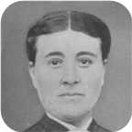
 | Leonard Bowman |  |  |  |  |  |  |  | Louisa Reid |  |  |  |  |  |  |  | Allan |  |  |  |  |  |  |  | Mary Christina
 | Robertson |  |  |  |  |  |  |  | Ives |  |  |  |  |  |  |  | MacDonell |  |  |  |  |  |  |  | MacDonald
 | 1890–1972 |  |  |  |  |  |  |  | 1889–1982 |  |  |  |  |  |  |  | 1880–1926 |  |  |  |  |  |  |  | 1895–1978
 |  |  |  |  |  |  |  |  |  |  |  |  |  |  |  |  | 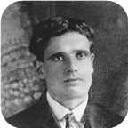 |  |  |  |  |  |  |  | 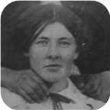
 |  |  |  |  | James Ives |  |  |  |  |  |  |  |  |  |  |  |  |  |  |  | Charlotte Helen
 |  |  |  |  | Robertson |  |  |  |  |  |  |  |  |  |  |  |  |  |  |  | MacDonell
 |  |  |  |  | 1917–1989 |  |  |  |  |  |  |  |  |  |  |  |  |  |  |  | 1922–2005
 |  |  |  |  |  |  |  |  |  |  |  |  |  |  |  |  |  |  |  |  | 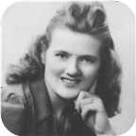
 |  |  |  |  |  |  |  |  | Marriage: 1942
 |  |  |  |  |  |  |  | Allan James |  |  |  | Lois Christina |  |  |  | Lewis William |  |  |  | Vivian Louise
 |  |  |  |  |  |  |  | Robertson |  |  |  | Robertson |  |  |  | Robertson |  |  |  | Robertson
 |  |  |  |  |  |  |  | 1943– |  |  |  | 1948–1979 |  |  |  | 1951– |  |  |  | 1957–
 |  |  |  |  |  |  |  |  |  |  |  | 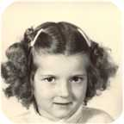 |  |  |  | 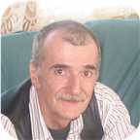 |  |  |  | 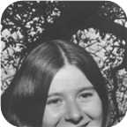

31. James Ives Robertson was born on Sunday, January 28, 1917, in Stellarton, Nova Scotia. He was the son of Leonard Bowman Robertson and Louisa Reid Ives (24).  James Ives was educated in Cumunity College. He was employed in Sheet Metal worker.
  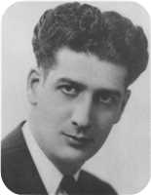
  James Ives Robertson
James Ives died in Pictou, Nova Scotia, Canada, on October 14, 1989, at the age of 72.
James was a sheet metal worker by trade. Most of his working career was spent at the Pictou shipyard (Ferguson Industries Ltd.).
At the age of 25, James Ives married Charlotte Helen MacDonell on Wednesday, April 29, 1942, in Cadillac,Quebec, when she was 19 years old. They had four children.  Charlotte Helen was born in Judique, Nova Scotia, on Monday, December 25, 1922.
  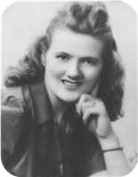
  Charlotte Helen MacDonell
She was the daughter of Allan MacDonell and Mary Christina MacDonald. Charlotte Helen reached 82 years of age and died on April 29, 2005.
Children of James Ives Robertson and Charlotte Helen MacDonell:
+ 40 m I. Allan James Robertson was born in Pictou, Nova Scotia, Canada, on August 26, 1943.
  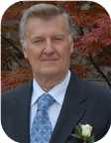
  Allan
+ 41 f II. Lois Christina Robertson was born in St Catharines, Ontario, on April 30, 1948. She died in Pictou, Nova Scotia, Canada, on January 23, 1979, at the age of 30.
  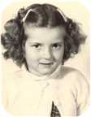
  Lois
m III. Lewis William Robertson was born on December 25, 1951. He is employed in Factory Worker.
  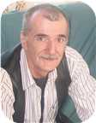
  Lewis
+ 42 f IV. Vivian Louise Robertson was born in Pictou, Nova Scotia, Canada, on January 30, 1957.
  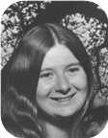
  Vivian

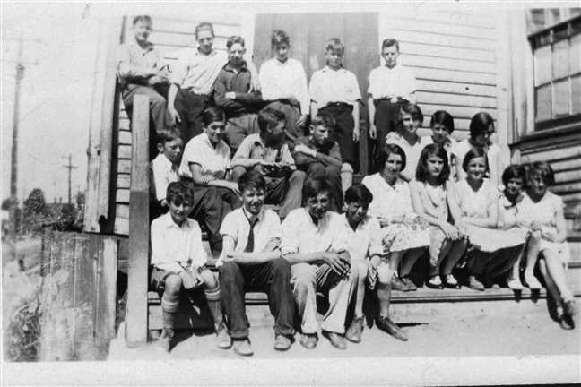  Figure 35: Dad's Grade 8 Class June 1930 |  | 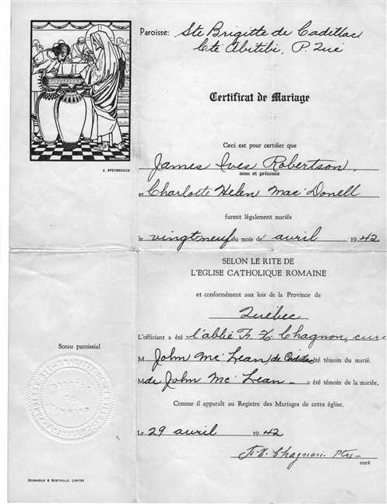  Figure 36: Helen and James Robertson Marrige

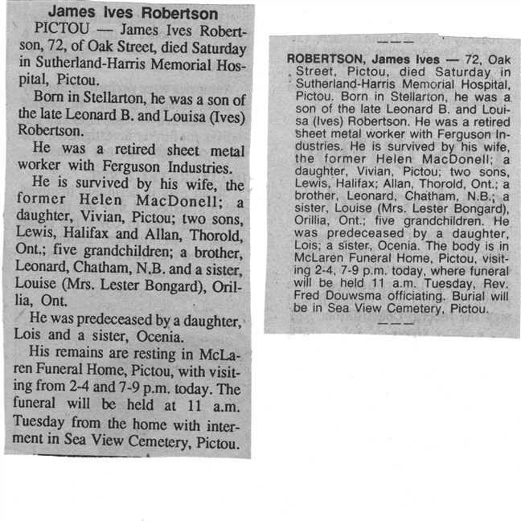  Figure 37: James Robertson's Obits |  | 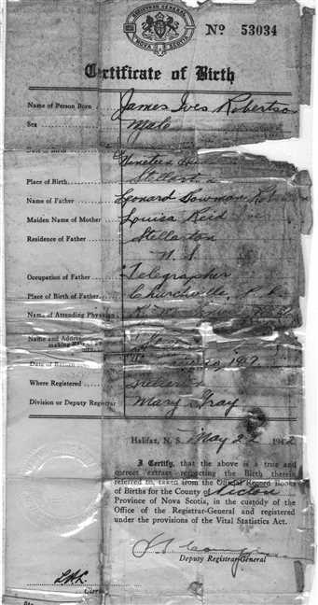  Figure 38: James Robertson' Baptism

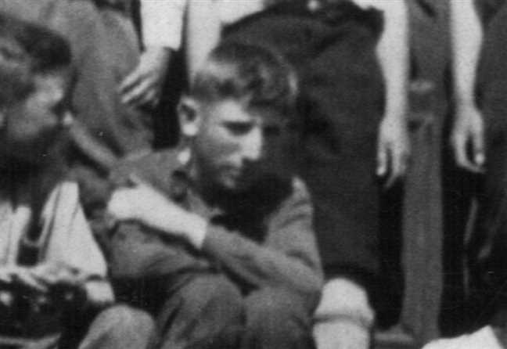  Figure 39: James Robertson's Grade 8 class photo HD croped |  | 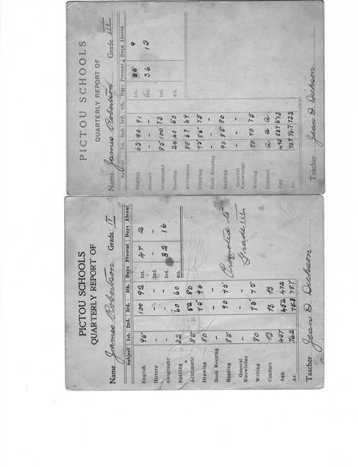  Figure 40: Dad's Grade 2 and 3 Report Cards

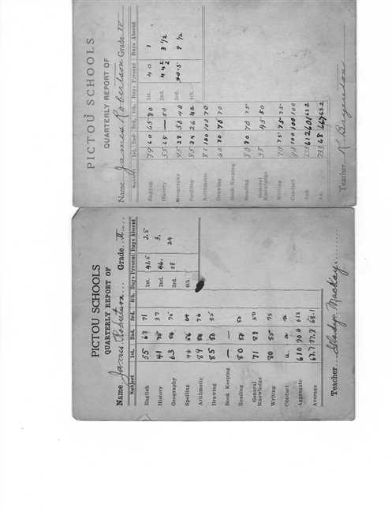  Figure 41: Dad's Grade 4 and 5 Report Cards |  | 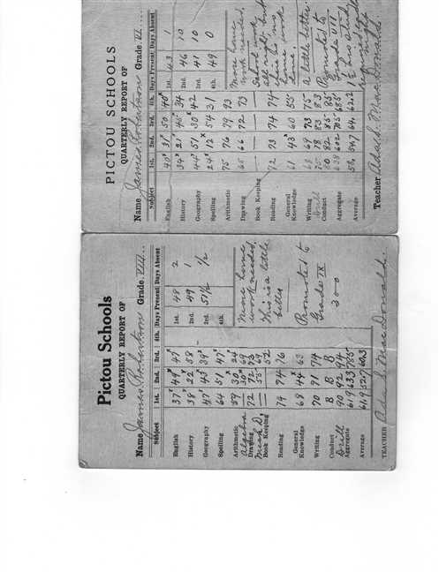  Figure 42: Dad's Grade 6 and 8 Report Cards

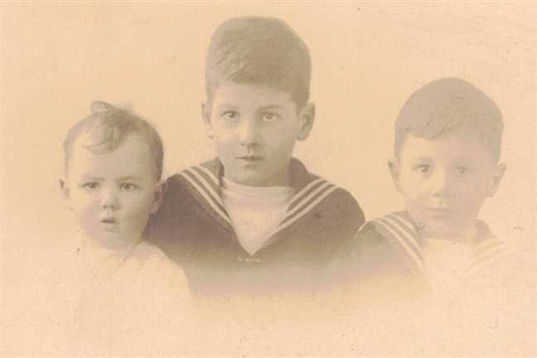  Figure 43: Nora James Leonard Robertson |  | 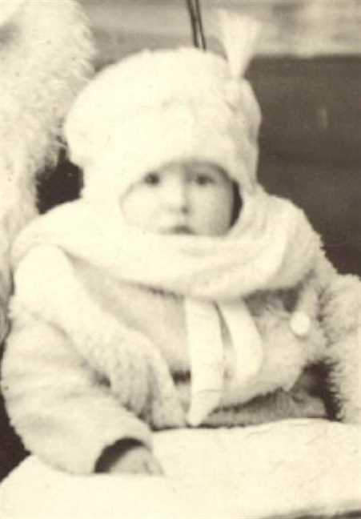  Figure 44: James Ives Robertson

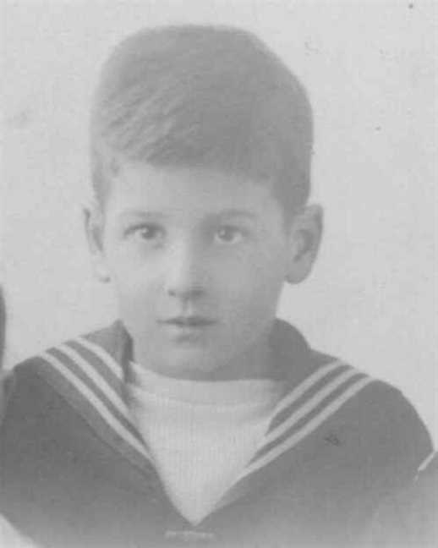  Figure 45: James I Robertson |  | 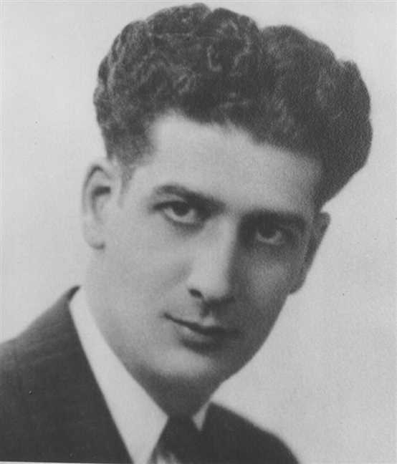  Figure 46: James Ives Robertson

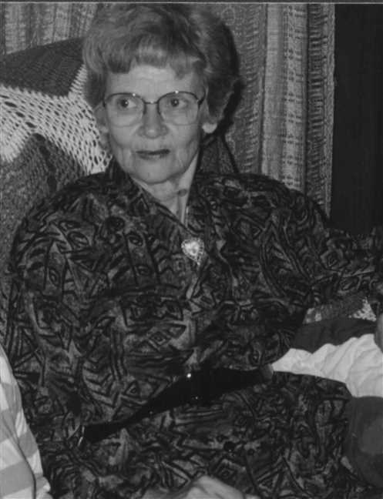  Figure 47: Charlotte H MacDonell |  | 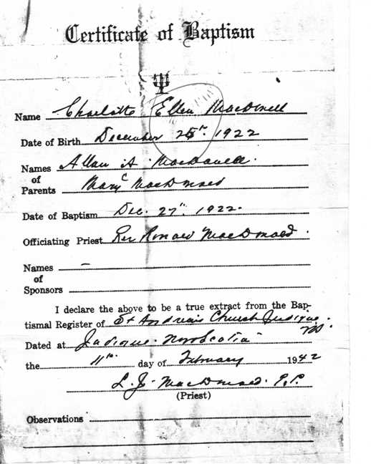  Figure 48: Charlotte Helen McDonell's Baptism Certificate

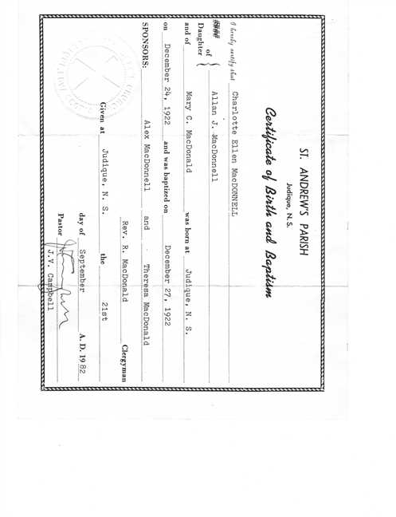  Figure 49: Charlotte Helen's Baptism 2 |  | 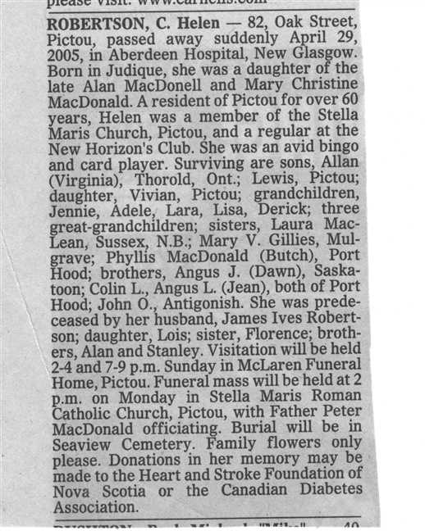  Figure 50: Charlotte Helen's Obit

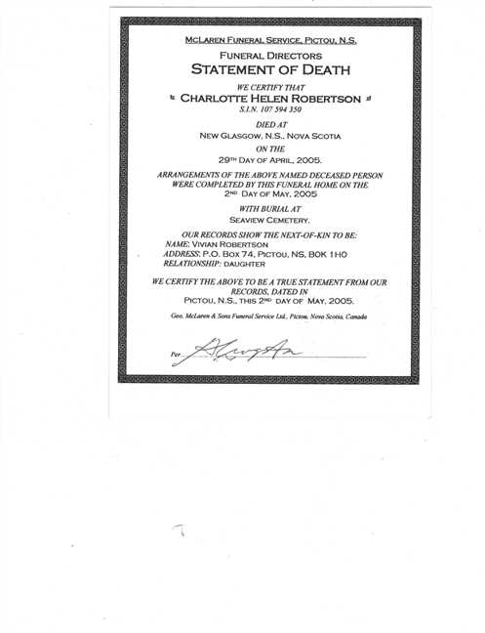  Figure 51: Statement of Death |  | 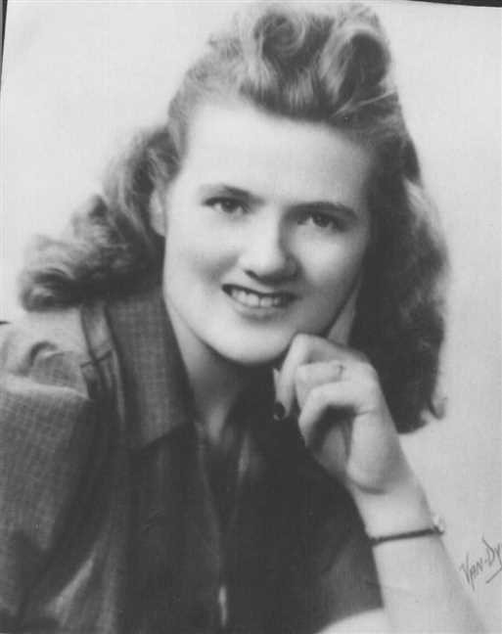  Figure 52: Charlotte H MacDonell

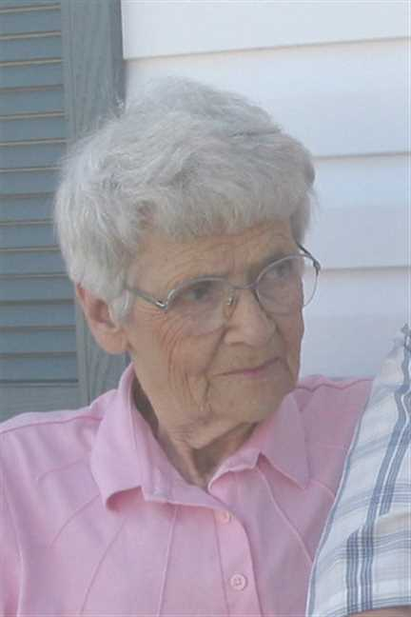
Figure 53: Charlotte H MacDonell

Family of Leonard Robertson and Edna Bell
James Alexander |  |  |  | Annie Fraser |  |  |  | Arthur |  |  |  | Ocenia |  |  |  | Hugh |  |  |  | Mary K |  |  |  | John James |  |  |  | Josephine
Robertson |  |  |  | Campbell |  |  |  | Ives |  |  |  | Fraser |  |  |  | Bell |  |  |  | Moore |  |  |  | Smith |  |  |  | French
1859–1947 |  |  |  | 1867–1960 |  |  |  | 1854–1913 |  |  |  | 1853–1935 |  |  |  |  |  |  |  | 1868–1894
 | Leonard Bowman |  |  |  |  |  |  |  | Louisa Reid |  |  |  |  |  |  |  | Roy Wesley |  |  |  |  |  |  |  | Ethel Irene
 | Robertson |  |  |  |  |  |  |  | Ives |  |  |  |  |  |  |  | Bell |  |  |  |  |  |  |  | Smith
 | 1890–1972 |  |  |  |  |  |  |  | 1889–1982 |  |  |  |  |  |  |  | 1888–1963 |  |  |  |  |  |  |  | 1896–1929
 |  |  |  |  |  |  |  |  |  |  |  |  |  |  |  |  | 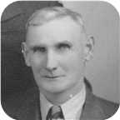
 |  |  |  |  | Leonard Bowman |  |  |  |  |  |  |  |  |  |  |  |  |  |  |  | Edna Effie
 |  |  |  |  | Robertson |  |  |  |  |  |  |  |  |  |  |  |  |  |  |  | Bell
 |  |  |  |  | 1918– |  |  |  |  |  |  |  |  |  |  |  |  |  |  |  | 1920–
 |  |  |  |  |  |  |  |  |  |  |  |  |  |  |  |  |  |  |  |  | 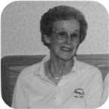
 |  |  |  |  |  |  |  |  | Marriage: 1945
 |  |  |  |  |  |  |  | Leonard Bowman |  |  |  | Roy Wesley |  |  |  | Ian Douglas |  |  |  | Janet Louise
 |  |  |  |  |  |  |  | Robertson |  |  |  | Robertson |  |  |  | Robertson |  |  |  | Robertson
 |  |  |  |  |  |  |  | 1947– |  |  |  | 1949–1949 |  |  |  | 1950– |  |  |  | 1951–
 |  |  |  |  |  |  |  | 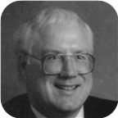 |  |  |  |  |  |  |  | 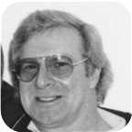 |  |  |  | 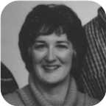

32. Captain Leonard Bowman Robertson was born on Saturday, October 19, 1918, in Stellerton,N.S. He is the son of Leonard Bowman Robertson and Louisa Reid Ives (24).  Leonard Bowman was educated in 1 year Mt Allison Academy (Commercial). He was employed in May 1936 in Branch Manager for Lownsbury's.
  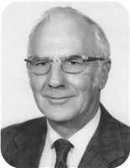
  Leonard Bowman Robertson
At the age of 26, Leonard Bowman married Edna Effie Bell on Saturday, September 08, 1945, in Saint John, N.B., when she was 24 years old. They had four children.  Edna Effie was born in Empress, Alberta, on Saturday, November 13, 1920.
  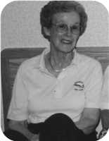
  Edna Effie Bell
She is the daughter of Roy Wesley Bell and Ethel Irene Smith. She is employed in Registered Nurse.
Children of Leonard Bowman Robertson and Edna Effie Bell:
+ 43 m I. Leonard Bowman Robertson was born in Moncton,N.B., on January 22, 1947.
  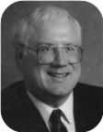
  Leonard
m II. Roy Wesley Robertson was born on January 14, 1949. He died on March 02, 1949.
m III. Ian Douglas Robertson was born in Chatham on August 23, 1950. He is employed in Taxi Driver.
  
  Ian
+ 44 f IV. Janet Louise Robertson was born on November 30, 1951.
  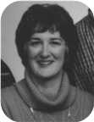
  Janet

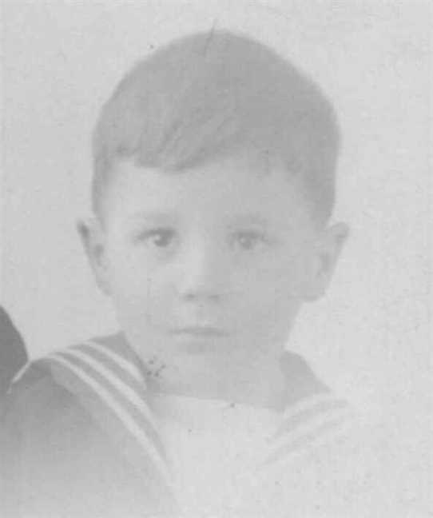  Figure 54: Leonard B Robertson |  | 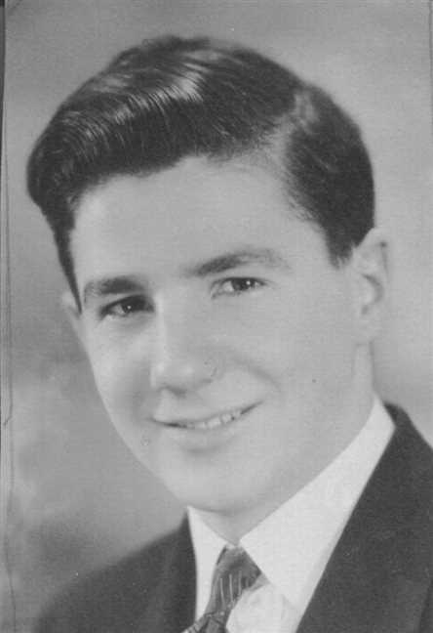  Figure 55: Leonard B Robertson

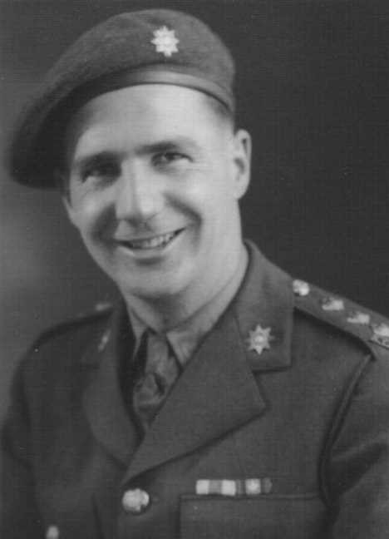  Figure 56: Leonard B Robertson |  | 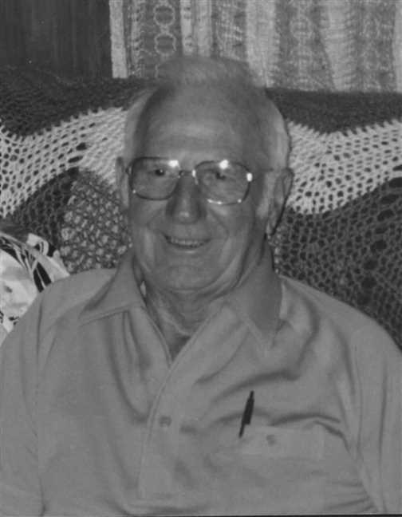  Figure 57: Leonard B Robertson

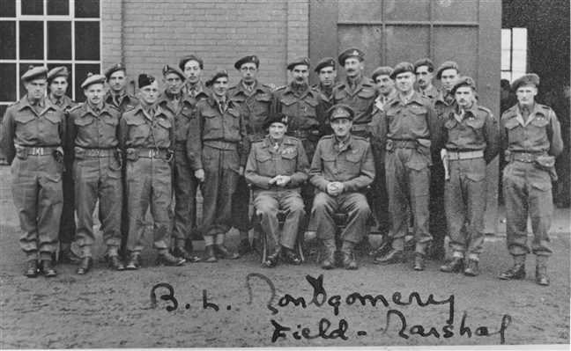  Figure 58: Army5 |  | Figure 59: Nora James Leonard Robertson(1)

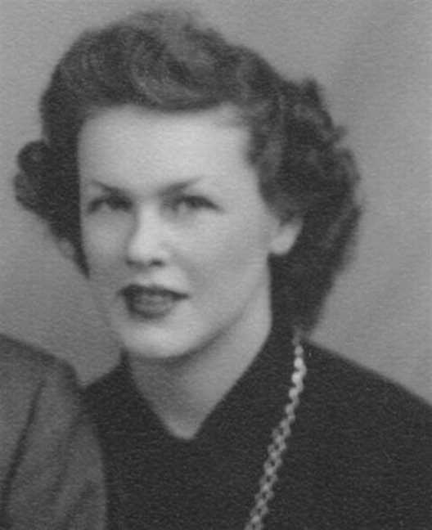  Figure 60: Edna Bell |  | 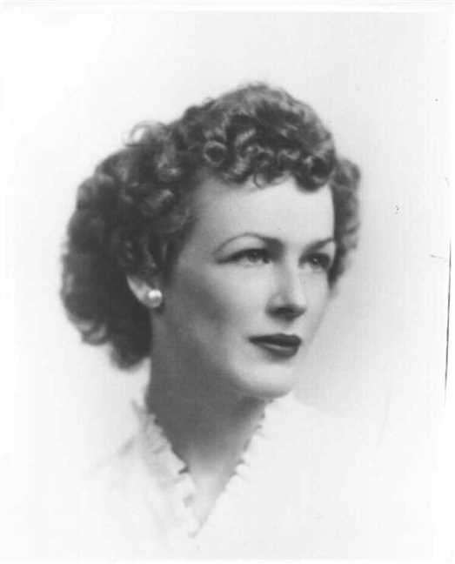  Figure 61: Edna Bell

Family of Norah Robertson and Lester Bongard
 |  |  |  |  |  |  |  |  |  |  |  |  |  |  |  | James Alexander |  |  |  | Annie Fraser |  |  |  | Arthur |  |  |  | Ocenia
 |  |  |  |  |  |  |  |  |  |  |  |  |  |  |  | Robertson |  |  |  | Campbell |  |  |  | Ives |  |  |  | Fraser
 |  |  |  |  |  |  |  |  |  |  |  |  |  |  |  | 1859–1947 |  |  |  | 1867–1960 |  |  |  | 1854–1913 |  |  |  | 1853–1935
 | ? |  |  |  |  |  |  |  | ? |  |  |  |  |  |  |  | Leonard Bowman |  |  |  |  |  |  |  | Louisa Reid
 | Bongard |  |  |  |  |  |  |  | ? |  |  |  |  |  |  |  | Robertson |  |  |  |  |  |  |  | Ives
 |  |  |  |  |  |  |  |  |  |  |  |  |  |  |  |  | 1890–1972 |  |  |  |  |  |  |  | 1889–1982
 |  |  |  |  | Lester William |  |  |  |  |  |  |  |  |  |  |  |  |  |  |  | Norah Louise
 |  |  |  |  | Bongard |  |  |  |  |  |  |  |  |  |  |  |  |  |  |  | Robertson
 |  |  |  |  | 1921–2000 |  |  |  |  |  |  |  |  |  |  |  |  |  |  |  | 1921–
 |  |  |  |  |  |  |  |  | Married
 |  |  |  |  |  |  |  | Robert William |  |  |  | John Reid |  |  |  | Norah Lynn |  |  |  | David
 |  |  |  |  |  |  |  | Bongard |  |  |  | Bongard |  |  |  | Bongard |  |  |  | Bongard
 |  |  |  |  |  |  |  | 1946– |  |  |  | 1949– |  |  |  | 1953– |  |  |  | 1958–
 |  |  |  |  |  |  |  |  |  |  |  |  |  |  |  | 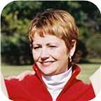

33. Norah Louise Robertson was born on Thursday, February 17, 1921, in Niagara Falls,Ont. She is the daughter of Leonard Bowman Robertson and Louisa Reid Ives (24).
  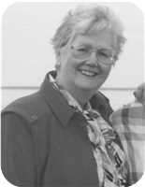
  Norah Louise Robertson
She married Lester William Bongard. They had four children.
Lester William was born in Norwood, Ontario, on Thursday, September 29, 1921. He was the son of ? Bongard and ? ?.
He was educated in From Orilia. Lester William was employed in Mechanical Engineer.
Lester William reached 78 years of age and died in Orillia,Ont., on January 14, 2000.
Children of Norah Louise Robertson and Lester William Bongard:
+ 45 m I. Robert William Bongard was born in Niagara Falls on August 04, 1946.
+ 46 m II. John Reid Bongard was born in Niagara Falls on September 18, 1949.
+ 47 f III. Norah Lynn Bongard was born in Niagara Falls on September 17, 1953.
  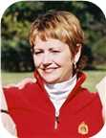
  Norah
m IV. David Bongard was born in Niagara Falls on December 25, 1958.

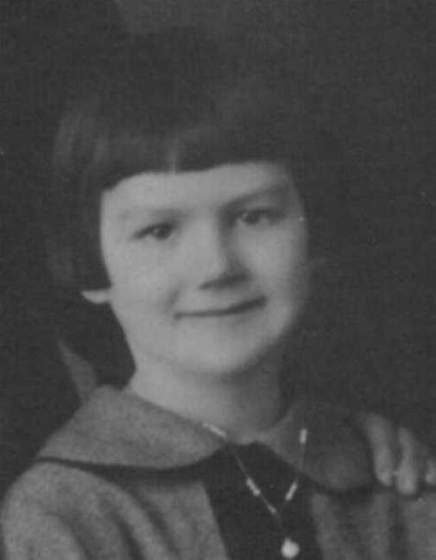  Figure 62: Norah Louise Robertson |  | 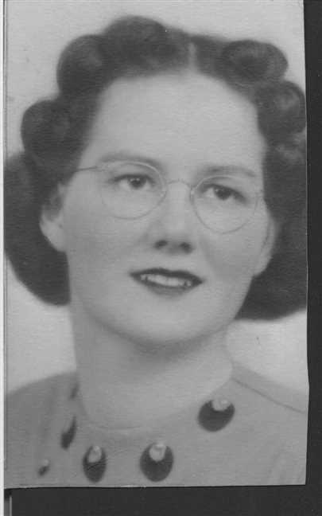  Figure 63: Norah Louise Robertson

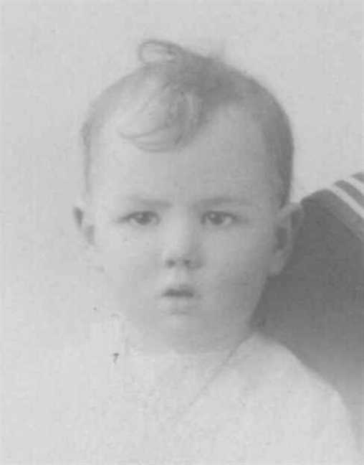
Figure 64: Norah Louise Robertson

Family of Russel Ives and Beryl Walker
Arthur |  |  |  | Ocenia |  |  |  | Bliss |  |  |  | Abigail
Ives |  |  |  | Fraser |  |  |  | Manship |  |  |  | Baxter
1854–1913 |  |  |  | 1853–1935
 | Daniel Fraser |  |  |  |  |  |  |  | Laura Maud
 | Ives |  |  |  |  |  |  |  | Manship
 | 1887–1964 |  |  |  |  |  |  |  | 1883–1979
 |  |  |  |  | Russel Bliss |  |  |  |  |  |  |  |  |  |  |  |  |  |  |  | Beryl
 |  |  |  |  | Ives |  |  |  |  |  |  |  |  |  |  |  |  |  |  |  | Walker
 |  |  |  |  | –1912
 |  |  |  |  |  |  |  |  | Married

34. Russel Bliss Ives. He was the son of Daniel Fraser Ives (25) and Laura Maud Manship.
Russel Bliss died on September 19, 1912.
He married Beryl Walker.

Family of Frances Ives and William MacCaullum
 |  |  |  |  |  |  |  |  |  |  |  |  |  |  |  | Arthur |  |  |  | Ocenia |  |  |  | Bliss |  |  |  | Abigail
 |  |  |  |  |  |  |  |  |  |  |  |  |  |  |  | Ives |  |  |  | Fraser |  |  |  | Manship |  |  |  | Baxter
 |  |  |  |  |  |  |  |  |  |  |  |  |  |  |  | 1854–1913 |  |  |  | 1853–1935
 |  |  |  |  |  |  |  |  |  |  |  |  |  |  |  |  | Daniel Fraser |  |  |  |  |  |  |  | Laura Maud
 |  |  |  |  |  |  |  |  |  |  |  |  |  |  |  |  | Ives |  |  |  |  |  |  |  | Manship
 |  |  |  |  |  |  |  |  |  |  |  |  |  |  |  |  | 1887–1964 |  |  |  |  |  |  |  | 1883–1979
 |  |  |  |  | William |  |  |  |  |  |  |  |  |  |  |  |  |  |  |  | Frances C
 |  |  |  |  | MacCaullum |  |  |  |  |  |  |  |  |  |  |  |  |  |  |  | Ives
 |  |  |  |  |  |  |  |  | Married

35. Frances C Ives. She was the daughter of Daniel Fraser Ives (25) and Laura Maud Manship.
  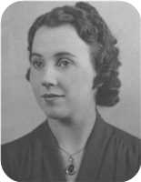
  Frances C Ives
She married William MacCaullum.

Family of Hilda Ives and George Wright
 |  |  |  |  | George |  |  |  |  |  |  |  |  |  |  |  |  |  |  |  | Hilda
 |  |  |  |  | Wright |  |  |  |  |  |  |  |  |  |  |  |  |  |  |  | Ives
 |  |  |  |  |  |  |  |  | Married

36. Hilda Ives.
She married George Wright.

Family of James Ives and Gladys Gaston
Arthur |  |  |  | Ocenia |  |  |  | James |  |  |  | Mary
Ives |  |  |  | Fraser |  |  |  | Eastwood |  |  |  | MacIntosh
1854–1913 |  |  |  | 1853–1935
 | Lewis Zindord |  |  |  |  |  |  |  | Jenny Mitchell |  |  |  |  |  |  |  | Clarence |  |  |  |  |  |  |  | Ernestine
 | Ives |  |  |  |  |  |  |  | Eastwood |  |  |  |  |  |  |  | Gaston |  |  |  |  |  |  |  | Hatch
 | 1888–1941 |  |  |  |  |  |  |  | 1880–1942
 |  |  |  |  | James Eastwood |  |  |  |  |  |  |  |  |  |  |  |  |  |  |  | Gladys Jean
 |  |  |  |  | Ives |  |  |  |  |  |  |  |  |  |  |  |  |  |  |  | Gaston
 |  |  |  |  | 1916– |  |  |  |  |  |  |  |  |  |  |  |  |  |  |  | 1916–1998
 |  |  |  |  |  |  |  |  | Married
 |  |  |  |  |  |  |  |  |  |  |  | John Gillan |  |  |  | Marjory
 |  |  |  |  |  |  |  |  |  |  |  | Ives |  |  |  | Ives

37. James Eastwood Ives was born on Wednesday, November 22, 1916. He is the son of Lewis Zindord Ives (26) and Jenny Mitchell Eastwood.
  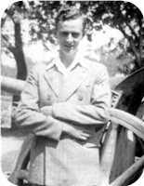
  James Eastwood Ives
He married Gladys Jean Gaston. They had two children.
Gladys Jean was born in Stellarton,N.S., on Tuesday, January 04, 1916. She was the daughter of Clarence Gaston and Ernestine Hatch.
Gladys Jean reached 82 years of age and died in Aberdeen Hospital, New Glasgow, on June 22, 1998.
Thursday, June 25, 1998 The Halifax Herald Limited
IVES, Gladys JeanIVES, Gladys Jean - Hopewell, died June 22, 1998, in Aberdeen Hospital, New Glasgow. Born January 4, 1916, in Stellarton, the second daughter of the late Clarence and Ernestine (Hatch) Gaston. Surviving are son, John (Jack) Gillan and Iris, Halifax; daughter, Rev. Marjory Cornelius and Arleigh, Hopewell; sister, Mrs. Carl (Helen) Tupper, Halifax; brother-in-law, Gordon Ives, Kingston; three grandchildren; three great-grandchildren; three stepchildren; a number of step-grandchildren and a step-great-grandchild. She was predeceased by her husband, J. Eastwood Ives; sister, Mrs. Vera Wadden, Stellarton; two infant grandchildren. Gladys was very active in the community, having been a member and officer of Goodwill Chapter 235 OES of Clifford, Ont., and a recent member of Armcrest Chapter 45 OES, Halifax. She was also a member and officer of the Cedars of Lebanon Shrine 21, East York, Ont. She was a member of Fairview United Church, Halifax, and the Carrie Rogers UCW Unit. She was an avid crocheter and knitter. She will be fondly remembered for her baby sets, blankets, teddy bears, afghans, lap and shoulder robes and mittens. In her earlier years, along with her sister and Anna MacKay, she operated Nova Craft Hat Shop, New Glasgow. She was later employed with Canadian Surety, Ontario, from where she retired. Following cremation, a funeral service will be held in Fairview United Church, Halifax, Friday, June 26, at 2:30 p.m., Rev. Kevin Little presiding. A reception will follow in the church hall. Memorial service will be held in St. Columba United Church, Hopewell, Saturday, June 27, at 11 a.m., Rev. Norman Marple presiding. A reception will follow in the church hall. Private family burial will be held in Lorne Street Cemetery, New Glasgow, following the reception. Family flowers only. Donations in Gladys' name may be made to Grand Chapter Estarl Fund of the Order of the Eastern Star of Nova Scotia and Prince Edward Island; the Pictou County Help Line, PO Box 386, New Glasgow, B2H 5E5 or a charity of one's choice. Arrangements entrusted to H.W. Angus Funeral Home, New Glasgow.
Children of James Eastwood Ives and Gladys Jean Gaston:
+ 48 m I. John Gillan Ives.
+ 49 f II. Marjory Ives.

Family of David Ives and Florence Smith
Arthur |  |  |  |  |  | Ocenia |  |  |  |  |  | Hugh |  |  |  |  |  | Mary
Ives |  |  |  |  |  | Fraser |  |  |  |  |  | MacMillan |  |  |  |  |  | ?
1854–1913 |  |  |  |  |  | 1853–1935
 |  | John Fraser |  |  |  |  |  |  |  |  |  |  |  | Jessie Margaret
 |  | Ives |  |  |  |  |  |  |  |  |  |  |  | MacMillan
 |  | 1895–1970 |  |  |  |  |  |  |  |  |  |  |  | 1898–1994
 |  |  |  |  |  |  |  | David Hugh |  |  |  |  |  |  |  |  |  |  |  |  |  |  |  |  |  |  |  |  |  |  |  | Florence
 |  |  |  |  |  |  |  | Ives |  |  |  |  |  |  |  |  |  |  |  |  |  |  |  |  |  |  |  |  |  |  |  | Smith
 |  |  |  |  |  |  |  | 1924–
 |  |  |  |  |  |  |  |  |  |  |  |  |  | Married
 |  |  |  |  |  |  |  |  | John David |  |  |  |  |  | Sarah Jean |  |  |  |  |  | Pearl |  |  |  |  |  | Joanne |  |  |  |  |  | Brian
 |  |  |  |  |  |  |  |  | Ives |  |  |  |  |  | Ives |  |  |  |  |  | Ives |  |  |  |  |  | Ives |  |  |  |  |  | Ives
 |  |  |  |  |  |  |  |  | 1969– |  |  |  |  |  | 1969–

38. David Hugh Ives was born on Monday, February 25, 1924, in New Glasgow,Nova Scotia. He is the son of John Fraser Ives (27) and Jessie Margaret MacMillan.
  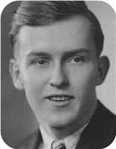
  David Hugh Ives
IVES, David Hugh "Fin"
IVES, David Hugh "Fin" - 59 Bridge Ave., Stellarton, passed away Wednesday, October 17, 2001, in Aberdeen Hospital, New Glasgow. Born in New Glasgow, he was the son of the late John Fraser and Jessie Margaret (MacMillan) Ives. He was a resident of Plymouth and Stellarton for all of his life. He began his working career with the CNR in 1945 and retired with over 40 years of service. He was a member of the United Trainmen's Union, a long-time member of the Abercrombie Golf and Country Club and had served as a director of the Nova Scotia Golf Association. He was also active in the Pictou County Military Rifle Association. David was an active volunteer and supporter of Stellarton Minor Hockey Association and Kin Family of New Glasgow. He is survived by his wife, the former Florence "Flo" Smith; daughters, Jean Ives-Fraser, New Glasgow; Pearl (Bill) MacMillan, Stellarton; Joanne, Stellarton; sons, John David (Tammy), New Minas; Brian, Sinclairs Island; grandchildren, T-Anna, Cory, Mark, Matthew; sister, Nora Ramscar, Plymouth; nephews, Vincent, Larry; niece, Margaret. Besides his parents, he was predeceased by nephew, David; brother-in-law, Vic. His remains will rest in H.C. MacQuarrie Funeral Home, Stellarton, with visitation 2-4, 7-9 p.m. Saturday. Funeral service will be held 2:30 p.m. Sunday in First Presbyterian Church, Stellarton, Jessie Johnson officiating. Burial will take place in Riverton Cemetery. Family flowers only please. Donations in his memory may be made to the Stellarton Minor Hockey Association, Women Alike Breast Cancer Society, P.O. Box 254, New Glasgow, NS B2H 5E3 or a charity of one's choice.
He married Florence Smith. They have five children.
Children of David Hugh Ives and Florence Smith:
+ 50 m I. John David Ives was born in March 1969.
+ 51 f II. Sarah Jean Ives was born in March 1969.
+ 52 f III. Pearl Ives.
f IV. Joanne Ives.
m V. Brian Ives.

Family of Norah Ives and Clwyd Ramscar
 |  |  |  |  |  |  |  |  |  |  |  |  |  |  |  | Arthur |  |  |  | Ocenia |  |  |  | Hugh |  |  |  | Mary
 |  |  |  |  |  |  |  |  |  |  |  |  |  |  |  | Ives |  |  |  | Fraser |  |  |  | MacMillan |  |  |  | ?
 |  |  |  |  |  |  |  |  |  |  |  |  |  |  |  | 1854–1913 |  |  |  | 1853–1935
 |  |  |  |  |  |  |  |  |  |  |  |  |  |  |  |  | John Fraser |  |  |  |  |  |  |  | Jessie Margaret
 |  |  |  |  |  |  |  |  |  |  |  |  |  |  |  |  | Ives |  |  |  |  |  |  |  | MacMillan
 |  |  |  |  |  |  |  |  |  |  |  |  |  |  |  |  | 1895–1970 |  |  |  |  |  |  |  | 1898–1994
 |  |  |  |  | Clwyd Vincent |  |  |  |  |  |  |  |  |  |  |  |  |  |  |  | Norah MacGillivary
 |  |  |  |  | Ramscar |  |  |  |  |  |  |  |  |  |  |  |  |  |  |  | Ives
 |  |  |  |  | 1922–1988 |  |  |  |  |  |  |  |  |  |  |  |  |  |  |  | 1921–
 |  |  |  |  | 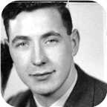
 |  |  |  |  |  |  |  |  | Marriage: 1943
 |  |  |  |  |  |  |  | David Frederick |  |  |  | John Vincent |  |  |  | Jessie Margaret |  |  |  | Lawrence James
 |  |  |  |  |  |  |  | Ramscar |  |  |  | Ramscar |  |  |  | Ramscar |  |  |  | Ramscar
 |  |  |  |  |  |  |  | 1944–1970 |  |  |  | 1947– |  |  |  | 1948– |  |  |  | 1951–

39. Norah MacGillivary Ives was born on Monday, March 07, 1921. She is the daughter of John Fraser Ives (27) and Jessie Margaret MacMillan.
  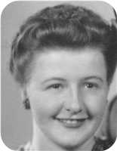
  Norah MacGillivary Ives
At the age of 22, Norah MacGillivary married Clwyd Vincent Ramscar on Tuesday, November 23, 1943, when he was 21 years old. They had four children.  Clwyd Vincent was born in St. Asaph, North Wales, on Saturday, September 23, 1922. He reached 65 years of age and died on January 18, 1988.
  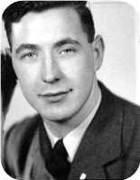
  Clwyd Vincent Ramscar
The Pictou Advocate, Wednesday, January 20, 1988 - Clwyd Vincent Ramscar, 65, Plymouth Park, Pictou County, died Monday, Jan. 18, at home. He was born in St. Asaph, Wales. He is survived by his wife, Norah; two sons, Vincent and Larry; a daughter, Margaret; three grandchildren; two brothers and two sisters, all in England. He was predeceased by his parents and a son, David. The body will be cremated.
Children of Norah MacGillivary Ives and Clwyd Vincent Ramscar:
m I. David Frederick Ramscar was born in June 1944. He died in 1970 at the age of 25.
+ 53 m II. John Vincent Ramscar was born in New Glasgow,Nova Scotia, on May 14, 1947.
+ 54 f III. Jessie Margaret Ramscar was born in July 1948.
m IV. Lawrence James Ramscar was born in March 1951.

6th Generation

Family of Allan Robertson and Virginia Worobel
Leonard Bowman |  |  |  |  |  | Louisa Reid |  |  |  |  |  | Allan |  |  |  |  |  | Mary Christina |  |  |  |  |  | Stephen |  |  |  |  |  | Catherine |  |  |  |  |  | Demetro |  |  |  |  |  | Dora
Robertson |  |  |  |  |  | Ives |  |  |  |  |  | MacDonell |  |  |  |  |  | MacDonald |  |  |  |  |  | Worobel |  |  |  |  |  | Kohut |  |  |  |  |  | Kolynchuk |  |  |  |  |  | Kwasnica
1890–1972 |  |  |  |  |  | 1889–1982 |  |  |  |  |  | 1880–1926 |  |  |  |  |  | 1895–1978 |  |  |  |  |  |  |  |  |  |  |  |  |  |  |  |  |  | 1897–1945 |  |  |  |  |  | 1899–1972
 |  |  |  |  |  |  |  |  |  |  |  |  |  |  |  |  |  |  |  |  |  |  |  | 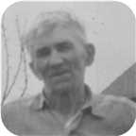 |  |  |  |  |  |  |  |  |  |  |  | 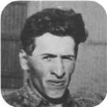 |  |  |  |  |  | 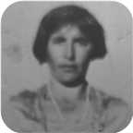
 |  | James Ives |  |  |  |  |  |  |  |  |  |  |  | Charlotte Helen |  |  |  |  |  |  |  |  |  |  |  | John |  |  |  |  |  |  |  |  |  |  |  | Jean
 |  | Robertson |  |  |  |  |  |  |  |  |  |  |  | MacDonell |  |  |  |  |  |  |  |  |  |  |  | Worobel |  |  |  |  |  |  |  |  |  |  |  | Kolynchuk
 |  | 1917–1989 |  |  |  |  |  |  |  |  |  |  |  | 1922–2005 |  |  |  |  |  |  |  |  |  |  |  | 1922–1979 |  |  |  |  |  |  |  |  |  |  |  | 1925–2012
 |  |  |  |  |  |  |  |  |  |  |  |  |  |  |  |  |  |  |  |  |  |  |  |  |  | 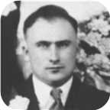 |  |  |  |  |  |  |  |  |  |  |  | 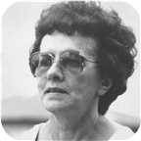
 |  |  |  |  |  |  |  | Allan James |  |  |  |  |  |  |  |  |  |  |  |  |  |  |  |  |  |  |  |  |  |  |  | Virginia
 |  |  |  |  |  |  |  | Robertson |  |  |  |  |  |  |  |  |  |  |  |  |  |  |  |  |  |  |  |  |  |  |  | Worobel
 |  |  |  |  |  |  |  | 1943– |  |  |  |  |  |  |  |  |  |  |  |  |  |  |  |  |  |  |  |  |  |  |  | 1945–
 |  |  |  |  |  |  |  |  |  |  |  |  |  |  |  |  |  |  |  |  |  |  |  |  |  |  |  |  |  |  |  | 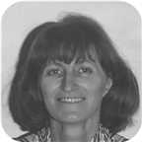
 |  |  |  |  |  |  |  |  |  |  |  |  |  | Marriage: 1969
 |  |  |  |  |  |  |  |  |  |  |  |  |  |  | Jenny Lind |  |  |  |  |  | Adele Marie |  |  |  |  |  | Lara Lynn
 |  |  |  |  |  |  |  |  |  |  |  |  |  |  | Robertson |  |  |  |  |  | Robertson |  |  |  |  |  | Robertson
 |  |  |  |  |  |  |  |  |  |  |  |  |  |  | 1970– |  |  |  |  |  | 1971– |  |  |  |  |  | 1973–
 |  |  |  |  |  |  |  |  |  |  |  |  |  |  | 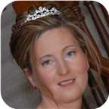 |  |  |  |  |  |  |  |  |  |  |  | 

40. Allan James Robertson was born on Thursday, August 26, 1943, in Pictou, Nova Scotia, Canada. He is the son of James Ives Robertson (31) and Charlotte Helen MacDonell.  Allan James was educated in BSc,MSc St Francis Xavier Univ. 1965,1967. He is employed in Chemist.
  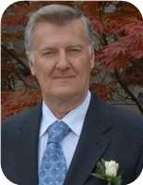
  Allan James Robertson
Allan James Robertson was born on Thursday, August 26, 1943, in Pictou, Nova Scotia, Canada. He is the son of James Ives Robertson and Charlotte Helen MacDonell. Allan's Father was born in Stellerton, NS but lived mainly in Pictou, NS. Allan's Mother was born in Judique on Cape Breton Island, NS She mainly grew up there but also later on lived in nearby Port Hood, NS. His paternal ancestors originated from a Scottish immigrant (John Robertson) who received a substantial land grant in the Churchville area of Pictou county, NS. Allan's maternal grandmother out lived three husbands (Allan MacDonell was the second and Father to Allan's Mother) The third husband was James MacDonald and he was the sheriff of Richmond county- Port Hood is the county seat. James's brother Angus L MacDonald was the premier of NS at one time. He has the Halifax harbour bridge named after him.
Allan's parents met in a place called Catalac, Quebec. They moved to Pictou, NS and then moved briefly to St, Catharines, ON where Allan's sister Lois was born in 1948. They lived in an apartment on Church St near Geneva St. Later that year, the family moved back to Pictou and lived for a brief period in a rented home on Beaches Road - near Laudon’s Beach. They then moved to Elm St in Pictou, NS. Later, they moved to 21 Chestnut St - Allan is most familiar with this address as he lived there from grade school until grade 10. Then his parents "swapped" homes with his paternal grand parents who lived 95 Faulkland St - SE corned of Faulkland and Patterson St. The house is still there but the number has changed due a change in the house numbering system. Bea's (nick name for his paternal grandmother) cousin - Margaret Harris (nee Fraser) lived in a home on Patterson St - across from Bea’s home. (SW corner of Faulkland and Patterson streets)
The home was actually jointly owned by Bea and her older (unmarried) sister Annie Ives. When Annie died, she willed her half to Allan's Father, When Bea died, Allan's Father got the home but his brother Len and sister Louise received all the fine antique furniture. Allan still has in his possession two mantle decorations that belonged to Bea's Mother - Ocenia Fraser. These pieces may even predate her as there is no record as to where they came from.
Allan's Father worked in the ship yard as a sheet metal worker. He later started his own business from some funding from his brother Len. However it was not entirely successful. They eventually sold the house and moved to a trailer home at 7 Oak St. Allan’s Father died in 1989.
Allan's kindergarten year was at the former Patterson school on Wellsford St near Poplar St. Grades 1 and 2 were at Stella Maris Convent. Allan remembers one of his class mates (his last name was Bell) drown after falling of the wharf. The whole class went to the funeral after visiting the remains in the family home. (Grades 3-6 were at the former Dawson school (now gone). Grades 7 and 8 were back at the Patterson school and finally grades 9 to 12 were at Pictou Academy. Allan's grades were "average" up until Grade 11 then in Grade 12, he and one of his friends (Wayne Madore) decided that they would be first in their class. Wayne did graduate 1st but Allan was 2nd. They edged out a girl (Maureen Mullins) who had continually placed first in her class through out her Junior and Senior high school years.
His closest friends while growing up were Wayne Madore and Melton Scanlan - they married two sisters and became teachers. They lived in Green Hill - near Pictou. John Murray who attended Dalhousie University and became a medical doctor. He practised in Sussex NB. Larry McCormack who also addended St Francis University and became a geologist.
In his younger years, Allan was very close to his paternal grandmother (Louisa "Bea" Robertson - nee Ives). He spent a lot of time with her and had a lot of fun playing cards with her. He was her "favourite grand child" - perhaps because he was the first. His grandmother also lived in St Catharines with him and his parents. Allan would often walk (mostly run) with her to Montebello Park and also visit with a family friends (Browns?) who lived at 56 lake St.
Bea willed him an old family photo album that belonged to her grandfather - William Ives. That photo album along with a booklet on the history of the Robertson family which was updated by his uncle Len Robertson, got Allan very much interested in the family genealogy. The result is this family tree of over 27,000 related persons.
Because of the influence of his high school science teacher (Mr. Peter Whyte), he decided to be a chemist. Mr. Whyte allowed Allan and his friend Wayne to stay after school and "experiment" in the lab - unsupervised!!. In hind sight, not a wise thing to do - but they survived with "all of their fingers" still attached.
Both Allan and Wayne enter the bachelors program at St Francis Xavier University in 1961 and took up chemistry as their major. Allan graduated from St Francis Xavier University (BS Hon. in 1965 and received his MSc 1967). Unfortunately, his friend Wayne got hooked on golf in his third year and then dropped out of university. He later took up teaching and did very well.
Allan lived on campus for his under graduate years and then boarded off campus while working on his master’s degree. Part of that time he lived with the Ray MacDonald family - Ray was a news announcer at the local radio station (CJFX). The MacDonald’s had five children - 4 boys named Mathew, Mark, Luke and John and one daughter - Mary.
His closest friends while at university were Tony McPhee-from Sydney, NS and one of the brightest students who was also a chemistry major. Tony taught Allan how to play chess. Out of hundreds of games, Allan only won once. Bruce Barron - a "pre-med". student from Portland, ME, Marry Osiany - she came from Hungary with her family in 1956 after the Hungarian uprising. Gary McQuade - also his roommate in his junior year. Gary was from Ottawa and was one of the star hockey players with St FX.
During his Freshman year, one of his chemistry lab instructors was a graduate student named "Bud Gallivan" - a nephew to "Danny Gallivan" who was a famous hockey announcer for the Montreal Canadians. Bud went on to Notre Dame University where he obtained his PhD. He then went to work for American Cyanamid at the corporate research lab in Stamford, CT. Bud rose through the ranks and eventually became VP of the division in which Allan worked. Allan’s boss at that time was a direct report to Bud and on his boss' passing, Allan reported to Bud for a brief period. Unfortunately, later in the same year, Bud died from a sudden heart attack. It was shortly after that that Allan was transferred from research to marketing. This was a traumatic change for a month or so, but then he thoroughly enjoyed the new position.
While at university, during the summer holidays, Allan worked as a lab technician for the then Cyanamid of Canada in Niagara Falls, ON. He worked at the "Welland Plant". For the first 4 summers, Allan resided with his Aunt and Uncle (Louise and Les Bongard). Louise is Allan's Father's younger sister. He hung out with his cousin Robert (Robbie). In later years, Robbie mover to Lunenburg, NS with his second wife.
He bought his first car in the summer of 1965 - a 1956 Ford Fairlane - for $160. Later, he drove it to Nova Scotia that fall and during the following spring, he sold it for $200 to a local in the Antigonish area.
During the summer of 1965, he resided at 138 Page St. in Catharines, ON. This is when he met his future wife - Virginia Worobel- who lived next door at 136 Page St. Virginia was in a nursing program at St. Joseph’s in Toronto. They "dated" - mostly by mail for about 2 years.
After Allan got his MSc degree in January of 1967, he moved back to 138 Page St. and got a permanent job with Cyanamid. Virginia finished her nursing program in 1968.
For the better part of a year during 1968 and Allan was transferred to Cyanamid’s Bound Brook NJ site. He boarded at a private home in Summerset, NJ for about 6 months (Mrs. Tureck’s home). While there he met a couple of friends who also worked for Cyanamid - Paul Gastrock and George Menghi. Both cane to Allan and Virginia’s wedding on April 19 of 1969.
After about 6 months, Allan rented an apartment in Raritan, NJ, During this year, he would commute to St Catharines every other weekend.
Then in December of 1968 he moved back to 136 Page St - just in time for a 3 -4 month labour strike at Cyanamid. During that period he was part of the management team that ran the Welland Plant as well as a limestone quarry in Beechville, ON. While at Beechville, he had a half hour training course on how to drive one of those huge trucks used to haul crude limestone from the quarry to the crusher. After 3 weeks of that he was reassigned to the Welland Plant as an operator in the production area - he much preferred this job.
The strike finally ended about a week prior to the wedding on April 19, 1969.. The wedding took place at the St Catharines cathedral with the reception at the Ukrainian Black Sea hall. It was a typical Ukrainian style wedding with approximately 150 guests. Allan's parents as well as his younger siblings, and aunts and uncles from Chatham, New Brunswick and Montreal attended. Virginia also had several relatives from Saskatoon and Winnipeg and Fort Frances, ON also attended.
Virginia's sister and brother-in-law were maid of honour and best man Allan's cousin Robert Bongard and Allan’s sister Lois as well as Virginia's cousin and a best friend - Ann Cotnam were also in the wedding party.
After the reception, they stayed over night at Prudholms hotel in Vineland before heading off to Jamaica for a week long honeymoon. They landed in Montego Bay and rented a car. They stayed there for two nights ant then toured the Island. Finally flew home from Kingston.
Virginia and Allan lived with her Mom at 136 Page St for about a year - during which Jenny was born on Jan 30, 1970. During the summer of the following year, they moved into a newly built home at 80 Meredith Dr. in St Catharines. Virginia's Mom moved with them. On July 6 of 1971 Adele was born and on August 11 of 1973 Lara was born.
The house on Meredith D.r was starting to get a bit crowded. They then bought their current home at 36 Forster Ave in Thorold for the amazing low price of $64,000 which likely would sell got $400,000 today (2018)
Allan spent his working career as a research chemist with Cyanamid of Canada Inc. - which later became Cytec Canada Inc. 1995 Since his retirement in 2013, Cytec was bought by Belgian company called Solvay. For about 40 years, he worked in the lab and then for the last 11 years, he took on a marketing role. Over his career, he obtained 12 patents and either authored or co-authored about 50 scientific papers. He also received a Circle of Excellence Award from the company for scientific achievement. As part of the award, there was a weekend all expenses paid visit to NYC - including a Broadway play and gala dinner with the other award winners and company executives. Stayed at a fancy hotel on Park avenue.
The job - especially in the later years, involved a considerable amount of travel - either to scientific conferences or visiting customers - almost all were outside of Canada - mainly in the US, Europe, South Africa and Australia. At several of the conferences, - those related to phosphorus chemistry- he presented talks. They took place is such places as Duke University in Durahm,SC, Tallin, Estonia, Saltzberg, Austria, Jeruslahem, San Francisco and Sundhi, Japan .On some occasions such as the conferences, Virginia came along.
In December of 1995, Cyanamid became Cytec. Allan eventually retired in April of 2013 after 51 years of serving with Cyanamid/Cytec. This was the second longest service term within the company. The company put on a great retirement party with about 70 employees attending. The guests also included the company CEO and well as the corporate HR VP.
At the age of 25, Allan James married Virginia Worobel on Saturday, April 19, 1969, in St Catharines, Niagara, Ontario, Canada, when she was 23 years old. They have three daughters.  Virginia was born in St Catharines, Ontario, on Monday, October 15, 1945.
  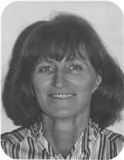
  Virginia Worobel
She is the daughter of John Worobel and Jean Kolynchuk.
Virginia received her RN degree from St Josephs (Toronto) in 1968. She worked for a time at Hotel Dieu (St Catharines) and later at The St Catharines General.
Daughters of Allan James Robertson and Virginia Worobel:
+ 55 f I. Jenny Lind Robertson was born in St. Catharines, Ontario, on January 30, 1970.
  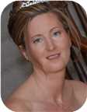
  Jenny
+ 56 f II. Adele Marie Robertson was born in St. Catharines on July 06, 1971.
  
  Adele
+ 57 f III. Lara Lynn Robertson was born in St. Catharines on August 11, 1973.
  
  Lara

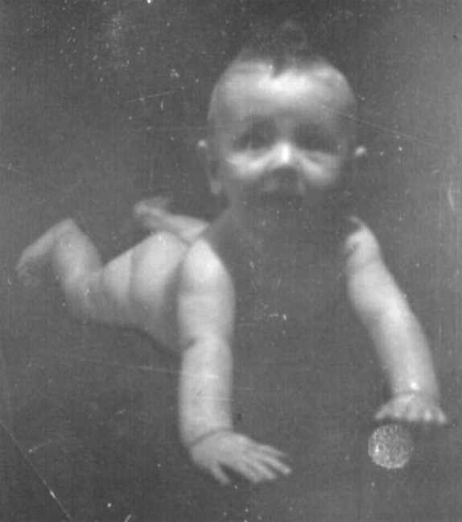  Figure 65: Allan James Robertson |  | 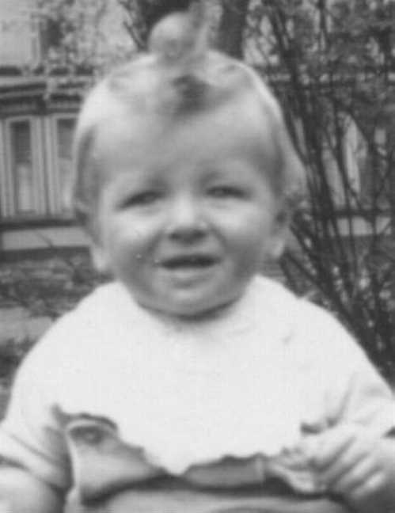  Figure 66: Allan James Robertson

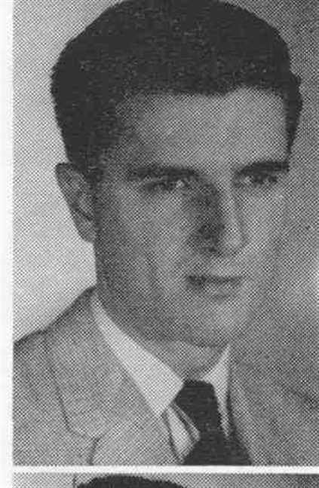  Figure 67: Allan James Robertson |  | 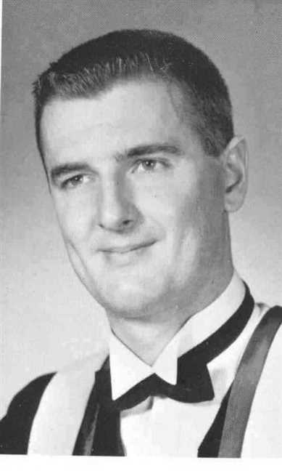  Figure 68: Allan James Robertson

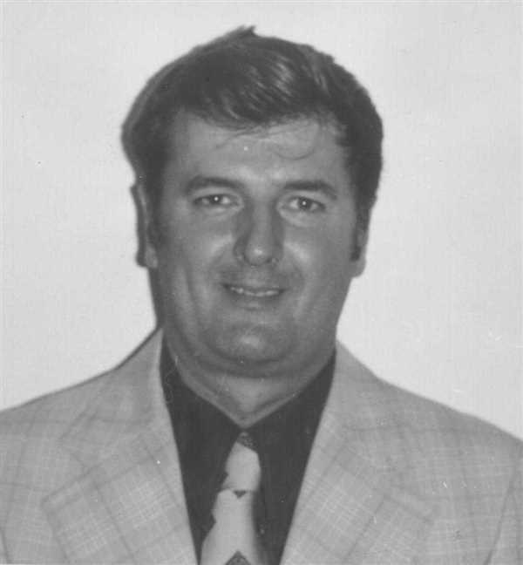  Figure 69: Allan James Robertson |  | 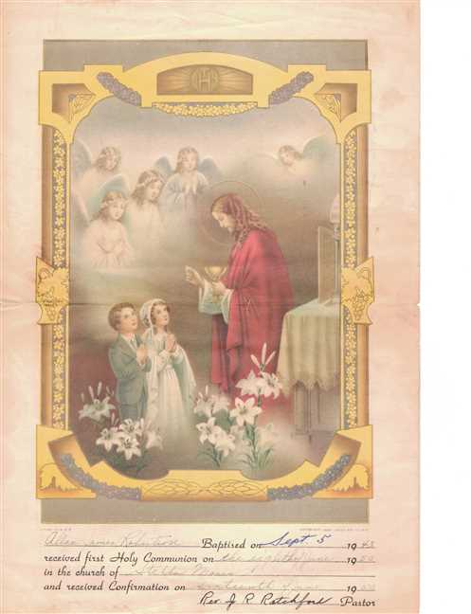  Figure 70: Allan Robertson's Baptism

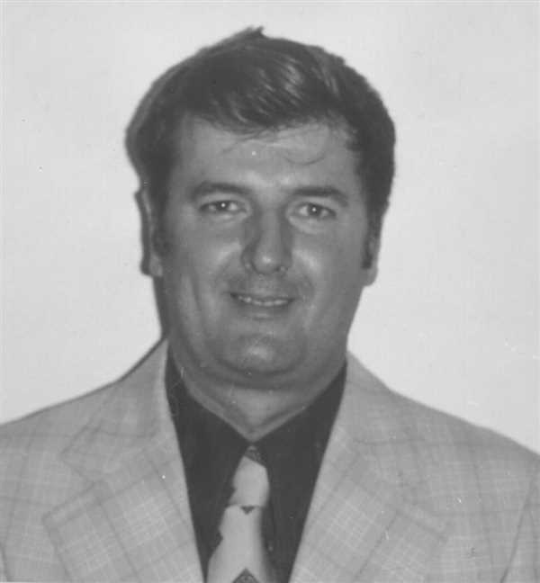  Figure 71: Allan James Robertson |  | 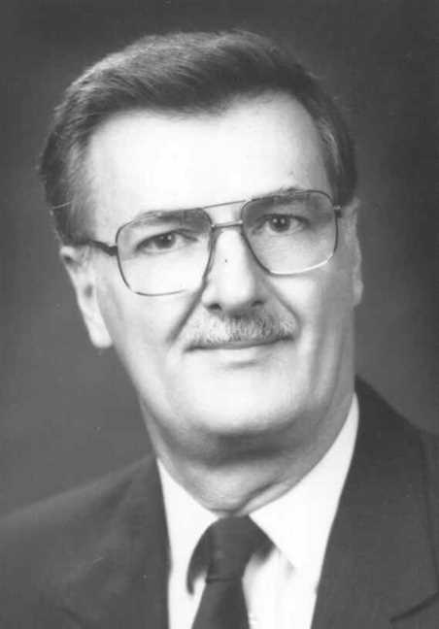  Figure 72: Allan James Robertson

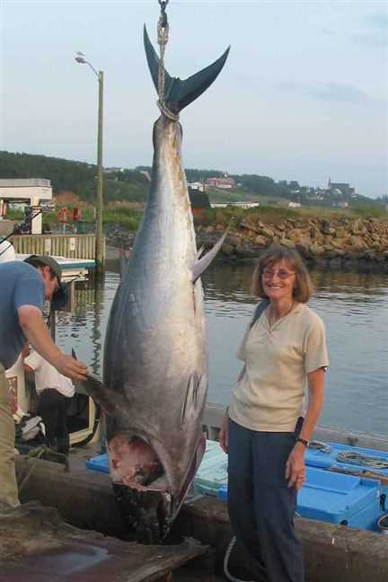  Figure 73: Vige and tuna |  | 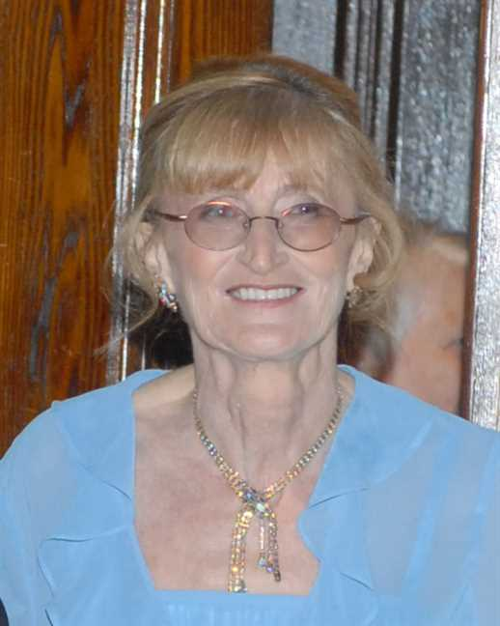  Figure 74: Virginia

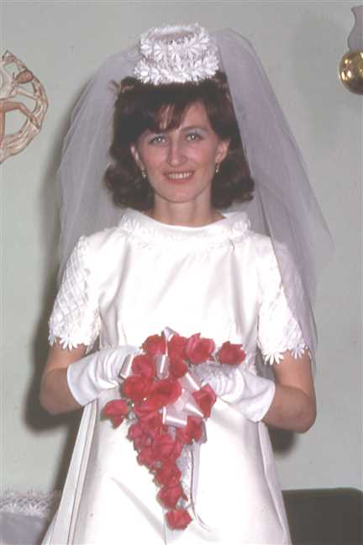  Figure 75: 196903-04Vige2b |  | 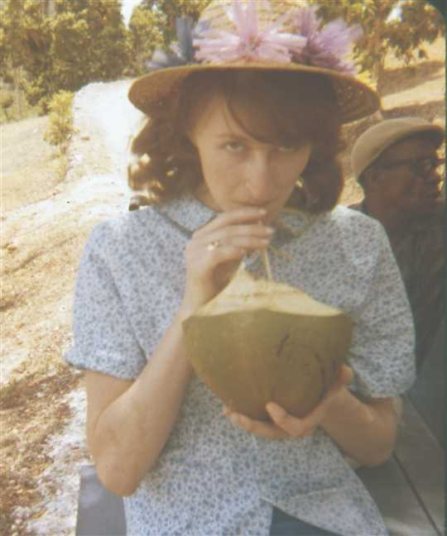  Figure 76: 196963-04YVige5

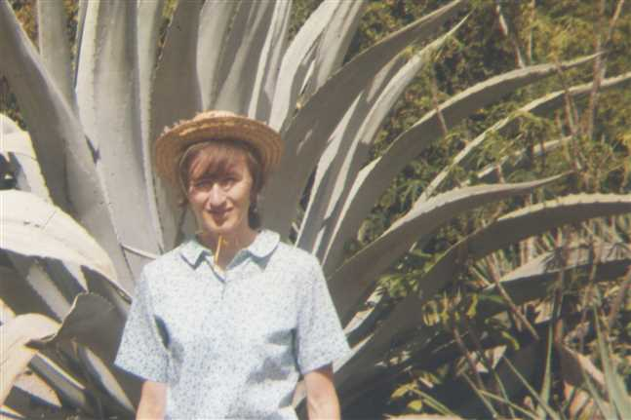  Figure 77: 196967-04YVige9 |  | 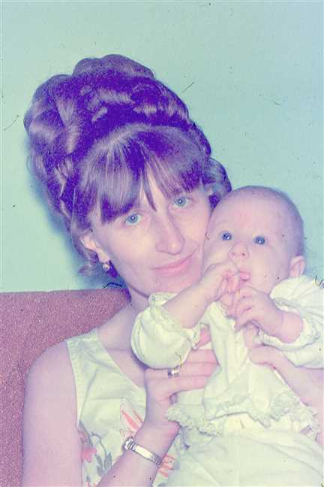  Figure 78: 197046-05Vige

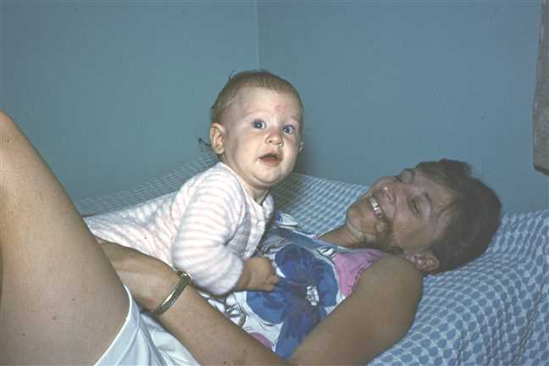  Figure 79: 197092-07VigeJenny2 |  | 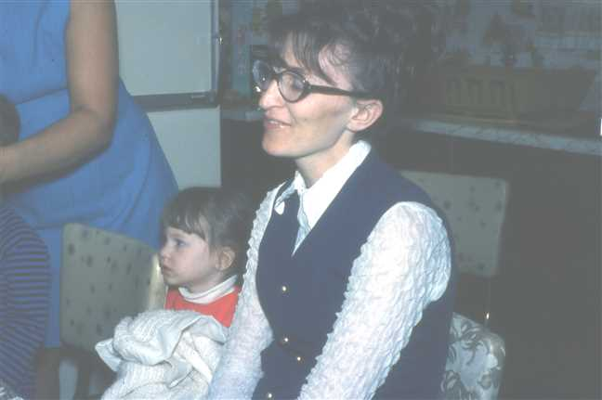  Figure 80: 1972-05JennyVige

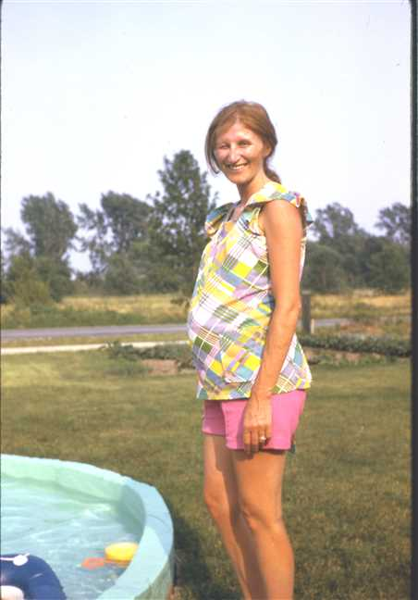  Figure 81: 1973-07Virginia |  | 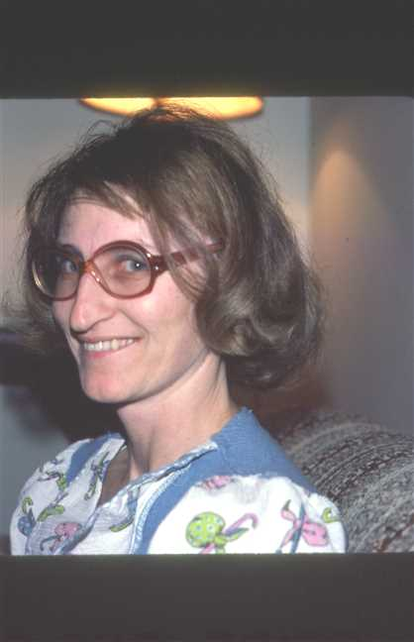  Figure 82: 1978-01Vige

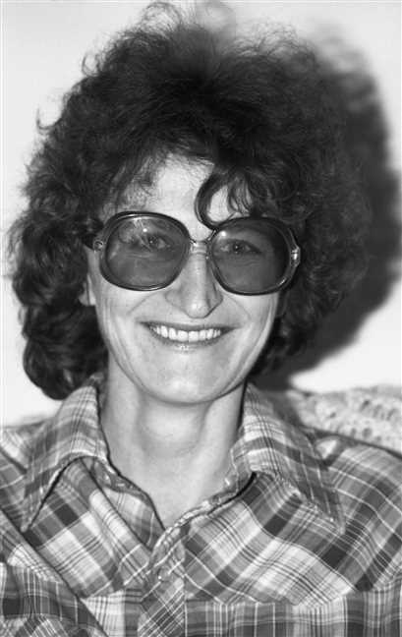  Figure 83: img001676 |  | 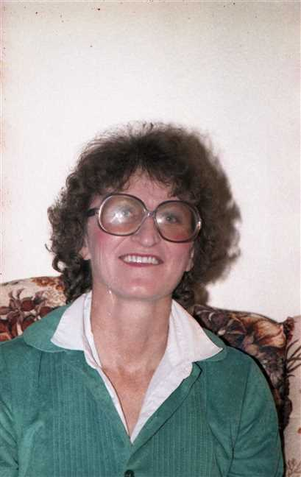  Figure 84: img001267

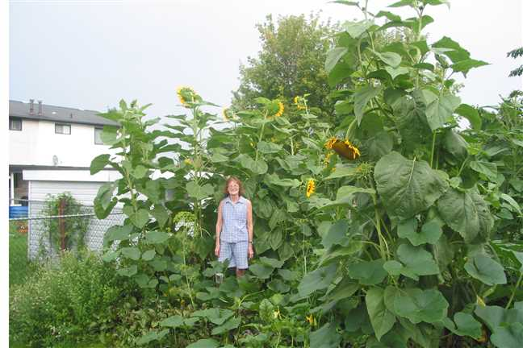
Figure 85: Garden1

Lois Robertson
41. Lois Christina Robertson was born on Friday, April 30, 1948, in St Catharines, Ontario. She was the daughter of James Ives Robertson (31) and Charlotte Helen MacDonell.  Lois Christina was educated in High School. She was employed in Secretary.
  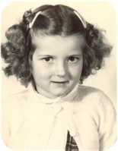
  Lois Christina Robertson
Lois Christina died in Pictou, Nova Scotia, Canada, on January 23, 1979, at the age of 30. Her cause of death was Complications from diabeties.
Lois was a diabetic from a very young age. (About 2 yr.) She had two children - one child from her first husband. The first was born in Montreal (about 1963) and the second born in St Catharines,Ont. (Nov. 3/1969) The first child was still-born. The second child was adopted at birth by a Dusette family in St Catharines, ON. She was named Michelle and later married Brian Procter.
She was married and divorced twice and was a friend of ? Cyr ( Pictou N.S.) who is the father of Michelle.
Lois died young due to diabetes complications.
Marriages with Joseph Dalton, Harold Little (Page 95) and ? Cyr (Page 96) are known.

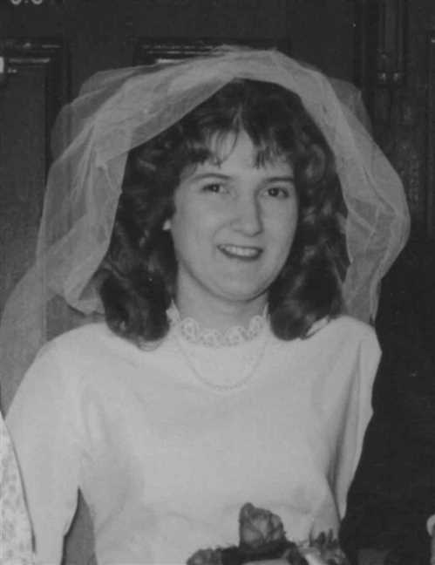  Figure 86: Lois Christina Robertson |  | 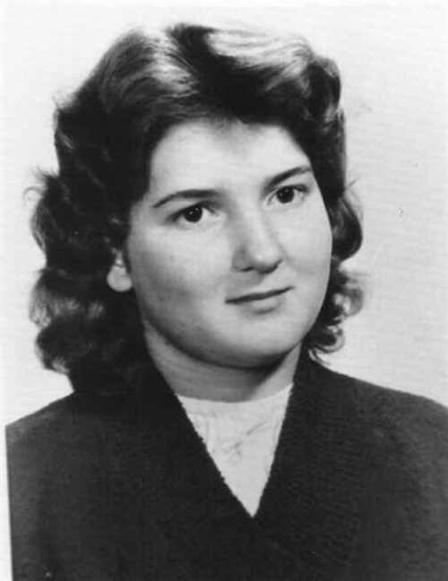  Figure 87: Lois Christina Robertson

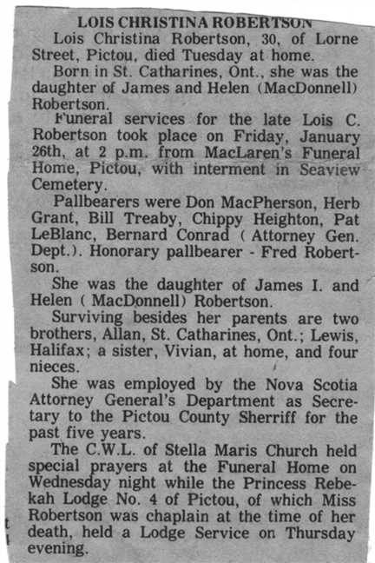
Figure 88: Lois Robertson Obit

Family of Lois Robertson and Joseph Dalton
 |  |  |  |  |  |  |  |  |  |  |  |  |  |  |  | Leonard Bowman |  |  |  | Louisa Reid |  |  |  | Allan |  |  |  | Mary Christina
 |  |  |  |  |  |  |  |  |  |  |  |  |  |  |  | Robertson |  |  |  | Ives |  |  |  | MacDonell |  |  |  | MacDonald
 |  |  |  |  |  |  |  |  |  |  |  |  |  |  |  | 1890–1972 |  |  |  | 1889–1982 |  |  |  | 1880–1926 |  |  |  | 1895–1978
 |  |  |  |  |  |  |  |  |  |  |  |  |  |  |  |  | James Ives |  |  |  |  |  |  |  | Charlotte Helen
 |  |  |  |  |  |  |  |  |  |  |  |  |  |  |  |  | Robertson |  |  |  |  |  |  |  | MacDonell
 |  |  |  |  |  |  |  |  |  |  |  |  |  |  |  |  | 1917–1989 |  |  |  |  |  |  |  | 1922–2005
 |  |  |  |  | Joseph |  |  |  |  |  |  |  |  |  |  |  |  |  |  |  | Lois Christina
 |  |  |  |  | Dalton |  |  |  |  |  |  |  |  |  |  |  |  |  |  |  | Robertson
 |  |  |  |  |  |  |  |  |  |  |  |  |  |  |  |  |  |  |  |  | 1948–1979
 |  |  |  |  |  |  |  |  | Divorce: 1963

Here are the details about Lois Christina Robertson's first marriage, with Joseph Dalton. You can read more about Lois Christina on page 92.
Lois Christina Robertson married Joseph Dalton. They were divorced in 1963.

Family of Lois Robertson and Harold Little
 |  |  |  |  |  |  |  |  |  |  |  |  |  |  |  | Leonard Bowman |  |  |  | Louisa Reid |  |  |  | Allan |  |  |  | Mary Christina
 |  |  |  |  |  |  |  |  |  |  |  |  |  |  |  | Robertson |  |  |  | Ives |  |  |  | MacDonell |  |  |  | MacDonald
 |  |  |  |  |  |  |  |  |  |  |  |  |  |  |  | 1890–1972 |  |  |  | 1889–1982 |  |  |  | 1880–1926 |  |  |  | 1895–1978
 |  |  |  |  |  |  |  |  |  |  |  |  |  |  |  |  | James Ives |  |  |  |  |  |  |  | Charlotte Helen
 |  |  |  |  |  |  |  |  |  |  |  |  |  |  |  |  | Robertson |  |  |  |  |  |  |  | MacDonell
 |  |  |  |  |  |  |  |  |  |  |  |  |  |  |  |  | 1917–1989 |  |  |  |  |  |  |  | 1922–2005
 |  |  |  |  | Harold |  |  |  |  |  |  |  |  |  |  |  |  |  |  |  | Lois Christina
 |  |  |  |  | Little |  |  |  |  |  |  |  |  |  |  |  |  |  |  |  | Robertson
 |  |  |  |  |  |  |  |  |  |  |  |  |  |  |  |  |  |  |  |  | 1948–1979
 |  |  |  |  |  |  |  |  | Divorce: 1977

Here are the details about Lois Christina Robertson's second marriage, with Harold Little. You can read more about Lois Christina on page 92.
Lois Christina Robertson married Harold Little. They were divorced in 1977.

Family of Lois Robertson and ? Cyr
 |  |  |  |  |  |  |  |  |  |  |  |  |  |  |  |  |  |  |  |  |  |  |  | Leonard Bowman |  |  |  |  |  | Louisa Reid |  |  |  |  |  | Allan |  |  |  |  |  | Mary Christina
 |  |  |  |  |  |  |  |  |  |  |  |  |  |  |  |  |  |  |  |  |  |  |  | Robertson |  |  |  |  |  | Ives |  |  |  |  |  | MacDonell |  |  |  |  |  | MacDonald
 |  |  |  |  |  |  |  |  |  |  |  |  |  |  |  |  |  |  |  |  |  |  |  | 1890–1972 |  |  |  |  |  | 1889–1982 |  |  |  |  |  | 1880–1926 |  |  |  |  |  | 1895–1978
 |  |  |  |  |  |  |  |  |  |  |  |  |  |  |  |  |  |  |  |  |  |  |  |  |  | James Ives |  |  |  |  |  |  |  |  |  |  |  | Charlotte Helen
 |  |  |  |  |  |  |  |  |  |  |  |  |  |  |  |  |  |  |  |  |  |  |  |  |  | Robertson |  |  |  |  |  |  |  |  |  |  |  | MacDonell
 |  |  |  |  |  |  |  |  |  |  |  |  |  |  |  |  |  |  |  |  |  |  |  |  |  | 1917–1989 |  |  |  |  |  |  |  |  |  |  |  | 1922–2005
 |  |  |  |  |  |  |  | ? |  |  |  |  |  |  |  |  |  |  |  |  |  |  |  |  |  |  |  |  |  |  |  | Lois Christina
 |  |  |  |  |  |  |  | Cyr |  |  |  |  |  |  |  |  |  |  |  |  |  |  |  |  |  |  |  |  |  |  |  | Robertson
 |  |  |  |  |  |  |  |  |  |  |  |  |  |  |  |  |  |  |  |  |  |  |  |  |  |  |  |  |  |  |  | 1948–1979
 |  |  |  |  |  |  |  |  |  |  |  |  |  | Married
 |  |  |  |  |  |  |  |  |  |  |  |  |  |  |  |  |  |  |  |  | Michelle
 |  |  |  |  |  |  |  |  |  |  |  |  |  |  |  |  |  |  |  |  | Dusette
 |  |  |  |  |  |  |  |  |  |  |  |  |  |  |  |  |  |  |  |  | 1969–

Here are the details about Lois Christina Robertson's third marriage, with ? Cyr. You can read more about Lois Christina on page 92.
Lois Christina Robertson married ? Cyr. They had one child.
Child of Lois Christina Robertson and ? Cyr:
+ 58 I. Michelle Dusette was born in St Catharines, Ontario, Canada, on November 03, 1969.

Vivian Robertson
42. Vivian Louise Robertson was born on Wednesday, January 30, 1957, in Pictou, Nova Scotia, Canada. She is the daughter of James Ives Robertson (31) and Charlotte Helen MacDonell.
  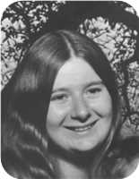
  Vivian Louise Robertson
Marriages with Roy Edward Gray and ? ? (Page 98) are known.

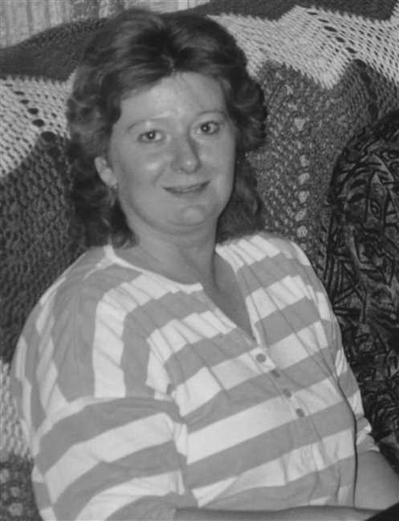
Figure 89: Vivian Robertson

Vivian Robertson and Roy Gray
 |  |  |  |  |  |  |  |  |  |  |  |  |  |  |  |  |  |  |  |  |  |  |  | Leonard Bowman |  |  |  |  |  | Louisa Reid |  |  |  |  |  | Allan |  |  |  |  |  | Mary Christina
 |  |  |  |  |  |  |  |  |  |  |  |  |  |  |  |  |  |  |  |  |  |  |  | Robertson |  |  |  |  |  | Ives |  |  |  |  |  | MacDonell |  |  |  |  |  | MacDonald
 |  |  |  |  |  |  |  |  |  |  |  |  |  |  |  |  |  |  |  |  |  |  |  | 1890–1972 |  |  |  |  |  | 1889–1982 |  |  |  |  |  | 1880–1926 |  |  |  |  |  | 1895–1978
 |  | Frederick Elmer Dicki |  |  |  |  |  |  |  |  |  |  |  | Jessie Winifred |  |  |  |  |  |  |  |  |  |  |  | James Ives |  |  |  |  |  |  |  |  |  |  |  | Charlotte Helen
 |  | Gray |  |  |  |  |  |  |  |  |  |  |  | Davis |  |  |  |  |  |  |  |  |  |  |  | Robertson |  |  |  |  |  |  |  |  |  |  |  | MacDonell
 |  |  |  |  |  |  |  |  |  |  |  |  |  | 1919– |  |  |  |  |  |  |  |  |  |  |  | 1917–1989 |  |  |  |  |  |  |  |  |  |  |  | 1922–2005
 |  |  |  |  |  |  |  | Roy Edward |  |  |  |  |  |  |  |  |  |  |  |  |  |  |  |  |  |  |  |  |  |  |  | Vivian Louise
 |  |  |  |  |  |  |  | Gray |  |  |  |  |  |  |  |  |  |  |  |  |  |  |  |  |  |  |  |  |  |  |  | Robertson
 |  |  |  |  |  |  |  | 1951– |  |  |  |  |  |  |  |  |  |  |  |  |  |  |  |  |  |  |  |  |  |  |  | 1957–
 |  |  |  |  |  |  |  |  |  |  |  |  |  | Partner
 |  |  |  |  |  |  |  |  |  |  |  |  |  |  |  |  |  |  |  |  | Lisa
 |  |  |  |  |  |  |  |  |  |  |  |  |  |  |  |  |  |  |  |  | Robertson
 |  |  |  |  |  |  |  |  |  |  |  |  |  |  |  |  |  |  |  |  | 1974–
 |  |  |  |  |  |  |  |  |  |  |  |  |  |  |  |  |  |  |  |  | 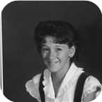

Here are the details about Vivian Louise Robertson's first relationship, with Roy Edward Gray. You can read more about Vivian Louise on page 96.
Vivian Louise Robertson is partnered with Roy Edward Gray. They have one daughter.
Roy Edward was born in Pictou, N.S., on Thursday, August 09, 1951. He is the son of Frederick Elmer Dicki Gray and Jessie Winifred Davis.
Daughter of Vivian Louise Robertson and Roy Edward Gray:
+ 59 f I. Lisa Robertson was born in Pictou, Nova Scotia, Canada, on August 08, 1974.
  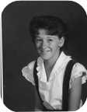
  Lisa

Family of Vivian Robertson and ? ?
 |  |  |  |  |  |  |  |  |  |  |  |  |  |  |  |  |  |  |  |  |  |  |  | Leonard Bowman |  |  |  |  |  | Louisa Reid |  |  |  |  |  | Allan |  |  |  |  |  | Mary Christina
 |  |  |  |  |  |  |  |  |  |  |  |  |  |  |  |  |  |  |  |  |  |  |  | Robertson |  |  |  |  |  | Ives |  |  |  |  |  | MacDonell |  |  |  |  |  | MacDonald
 |  |  |  |  |  |  |  |  |  |  |  |  |  |  |  |  |  |  |  |  |  |  |  | 1890–1972 |  |  |  |  |  | 1889–1982 |  |  |  |  |  | 1880–1926 |  |  |  |  |  | 1895–1978
 |  |  |  |  |  |  |  |  |  |  |  |  |  |  |  |  |  |  |  |  |  |  |  |  |  | James Ives |  |  |  |  |  |  |  |  |  |  |  | Charlotte Helen
 |  |  |  |  |  |  |  |  |  |  |  |  |  |  |  |  |  |  |  |  |  |  |  |  |  | Robertson |  |  |  |  |  |  |  |  |  |  |  | MacDonell
 |  |  |  |  |  |  |  |  |  |  |  |  |  |  |  |  |  |  |  |  |  |  |  |  |  | 1917–1989 |  |  |  |  |  |  |  |  |  |  |  | 1922–2005
 |  |  |  |  |  |  |  | ? |  |  |  |  |  |  |  |  |  |  |  |  |  |  |  |  |  |  |  |  |  |  |  | Vivian Louise
 |  |  |  |  |  |  |  | ? |  |  |  |  |  |  |  |  |  |  |  |  |  |  |  |  |  |  |  |  |  |  |  | Robertson
 |  |  |  |  |  |  |  |  |  |  |  |  |  |  |  |  |  |  |  |  |  |  |  |  |  |  |  |  |  |  |  | 1957–
 |  |  |  |  |  |  |  |  |  |  |  |  |  | Married
 |  |  |  |  |  |  |  |  |  |  |  |  |  |  |  |  |  |  |  |  | Derek
 |  |  |  |  |  |  |  |  |  |  |  |  |  |  |  |  |  |  |  |  | Robertson
 |  |  |  |  |  |  |  |  |  |  |  |  |  |  |  |  |  |  |  |  | 1990–

Here are the details about Vivian Louise Robertson's first marriage, with ? ?. You can read more about Vivian Louise on page 96.
Vivian Louise Robertson married ? ?. They have one son.
Son of Vivian Louise Robertson and ? ?:
m I. Derek Robertson was born in Pictou,NS, in August 1990.

Family of Leonard Robertson and Laysha Lenyk
Leonard Bowman |  |  |  | Louisa Reid |  |  |  | Roy Wesley |  |  |  | Ethel Irene
Robertson |  |  |  | Ives |  |  |  | Bell |  |  |  | Smith
1890–1972 |  |  |  | 1889–1982 |  |  |  | 1888–1963 |  |  |  | 1896–1929
 | Leonard Bowman |  |  |  |  |  |  |  | Edna Effie
 | Robertson |  |  |  |  |  |  |  | Bell
 | 1918– |  |  |  |  |  |  |  | 1920–
 |  |  |  |  | Leonard Bowman |  |  |  |  |  |  |  |  |  |  |  |  |  |  |  | Laysha
 |  |  |  |  | Robertson |  |  |  |  |  |  |  |  |  |  |  |  |  |  |  | Lenyk
 |  |  |  |  | 1947– |  |  |  |  |  |  |  |  |  |  |  |  |  |  |  | 1947–
 |  |  |  |  |  |  |  |  |  |  |  |  |  |  |  |  |  |  |  |  | 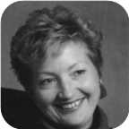
 |  |  |  |  |  |  |  |  | Married
 |  |  |  |  |  |  |  |  |  |  |  | Richard Bruce |  |  |  | Michael Leonard
 |  |  |  |  |  |  |  |  |  |  |  | Robertson |  |  |  | Robertson
 |  |  |  |  |  |  |  |  |  |  |  | 1976– |  |  |  | 1978–

43. Leonard Bowman Robertson was born on Wednesday, January 22, 1947, in Moncton,N.B. He is the son of Leonard Bowman Robertson (32) and Edna Effie Bell.  Leonard Bowman was educated in B.Eng. from UNB. He is employed in Civil Engineer.
  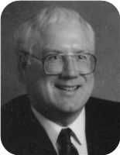
  Leonard Bowman Robertson
He married Laysha Lenyk. They have two sons.  Laysha was born on Tuesday, November 25, 1947.
  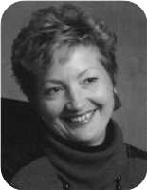
  Laysha Lenyk
Sons of Leonard Bowman Robertson and Laysha Lenyk:
m I. Richard Bruce Robertson was born on November 25, 1976.
m II. Michael Leonard Robertson was born on April 03, 1978.

Family of Janet Robertson and John Champion
 |  |  |  |  |  |  |  |  |  |  |  |  |  |  |  | Leonard Bowman |  |  |  | Louisa Reid |  |  |  | Roy Wesley |  |  |  | Ethel Irene
 |  |  |  |  |  |  |  |  |  |  |  |  |  |  |  | Robertson |  |  |  | Ives |  |  |  | Bell |  |  |  | Smith
 |  |  |  |  |  |  |  |  |  |  |  |  |  |  |  | 1890–1972 |  |  |  | 1889–1982 |  |  |  | 1888–1963 |  |  |  | 1896–1929
 | Harry |  |  |  |  |  |  |  | Marguerite |  |  |  |  |  |  |  | Leonard Bowman |  |  |  |  |  |  |  | Edna Effie
 | Champion |  |  |  |  |  |  |  | Fortin |  |  |  |  |  |  |  | Robertson |  |  |  |  |  |  |  | Bell
 | 1919–1985 |  |  |  |  |  |  |  | 1917– |  |  |  |  |  |  |  | 1918– |  |  |  |  |  |  |  | 1920–
 |  |  |  |  | John Douglas |  |  |  |  |  |  |  |  |  |  |  |  |  |  |  | Janet Louise
 |  |  |  |  | Champion |  |  |  |  |  |  |  |  |  |  |  |  |  |  |  | Robertson
 |  |  |  |  | 1951– |  |  |  |  |  |  |  |  |  |  |  |  |  |  |  | 1951–
 |  |  |  |  | 
 |  |  |  |  |  |  |  |  | Married
 |  |  |  |  |  |  |  |  |  |  |  | Timothy Edward |  |  |  | Barbara Ann
 |  |  |  |  |  |  |  |  |  |  |  | Champion |  |  |  | Champion
 |  |  |  |  |  |  |  |  |  |  |  | 1976– |  |  |  | 1978–
 |  |  |  |  |  |  |  |  |  |  |  | 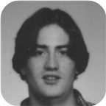 |  |  |  | 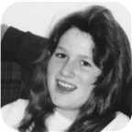

44. Janet Louise Robertson was born on Friday, November 30, 1951. She is the daughter of Leonard Bowman Robertson (32) and Edna Effie Bell.  Janet Louise was educated in BA from UNB.
  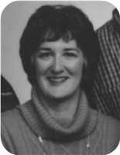
  Janet Louise Robertson
She married John Douglas Champion. They have two children.  John Douglas was born in North Bay,Ontario, on Tuesday, March 20, 1951. He is the son of Harry Champion and Marguerite Fortin.  He is employed in Worked for CP railway.
  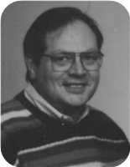
  John Douglas Champion
Children of Janet Louise Robertson and John Douglas Champion:
m I. Timothy Edward Champion was born on April 18, 1976.
  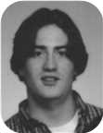
  Timothy
f II. Barbara Ann Champion was born on June 14, 1978.
  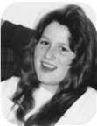
  Barbara

Robert Bongard
45. Robert William Bongard was born on Sunday, August 04, 1946, in Niagara Falls,Ont. He is the son of Lester William Bongard and Norah Louise Robertson (33).
Marriages with Catherine Brooks and Yvone ? (Page 102) are known.

Family of Robert Bongard and Catherine Brooks
? |  |  |  | ? |  |  |  | Leonard Bowman |  |  |  | Louisa Reid
Bongard |  |  |  | ? |  |  |  | Robertson |  |  |  | Ives
 |  |  |  |  |  |  |  | 1890–1972 |  |  |  | 1889–1982
 | Lester William |  |  |  |  |  |  |  | Norah Louise
 | Bongard |  |  |  |  |  |  |  | Robertson
 | 1921–2000 |  |  |  |  |  |  |  | 1921–
 |  |  |  |  | Robert William |  |  |  |  |  |  |  |  |  |  |  |  |  |  |  | Catherine
 |  |  |  |  | Bongard |  |  |  |  |  |  |  |  |  |  |  |  |  |  |  | Brooks
 |  |  |  |  | 1946–
 |  |  |  |  |  |  |  |  | Married

Here are the details about Robert William Bongard's first marriage, with Catherine Brooks. You can read more about Robert William on page 101.
Robert William Bongard married Catherine Brooks.

Family of Robert Bongard and Yvone ?
? |  |  |  | ? |  |  |  | Leonard Bowman |  |  |  | Louisa Reid
Bongard |  |  |  | ? |  |  |  | Robertson |  |  |  | Ives
 |  |  |  |  |  |  |  | 1890–1972 |  |  |  | 1889–1982
 | Lester William |  |  |  |  |  |  |  | Norah Louise
 | Bongard |  |  |  |  |  |  |  | Robertson
 | 1921–2000 |  |  |  |  |  |  |  | 1921–
 |  |  |  |  | Robert William |  |  |  |  |  |  |  |  |  |  |  |  |  |  |  | Yvone
 |  |  |  |  | Bongard |  |  |  |  |  |  |  |  |  |  |  |  |  |  |  | ?
 |  |  |  |  | 1946–
 |  |  |  |  |  |  |  |  | Married

Here are the details about Robert William Bongard's second marriage, with Yvone ?. You can read more about Robert William on page 101.
Robert William Bongard married Yvone ?.

Family of John Bongard and ? ?
? |  |  |  | ? |  |  |  | Leonard Bowman |  |  |  | Louisa Reid
Bongard |  |  |  | ? |  |  |  | Robertson |  |  |  | Ives
 |  |  |  |  |  |  |  | 1890–1972 |  |  |  | 1889–1982
 | Lester William |  |  |  |  |  |  |  | Norah Louise
 | Bongard |  |  |  |  |  |  |  | Robertson
 | 1921–2000 |  |  |  |  |  |  |  | 1921–
 |  |  |  |  | John Reid |  |  |  |  |  |  |  |  |  |  |  |  |  |  |  | ?
 |  |  |  |  | Bongard |  |  |  |  |  |  |  |  |  |  |  |  |  |  |  | ?
 |  |  |  |  | 1949–
 |  |  |  |  |  |  |  |  | Married
 |  |  |  |  |  |  |  |  |  |  |  | ? |  |  |  | ?
 |  |  |  |  |  |  |  |  |  |  |  | Bongard |  |  |  | Bongard

46. John Reid Bongard was born on Sunday, September 18, 1949, in Niagara Falls,Ont. He is the son of Lester William Bongard and Norah Louise Robertson (33).
He married ? ?. They have two daughters.
Daughters of John Reid Bongard and ? ?:
f I. ? Bongard.
f II. ? Bongard.

Family of Norah Bongard and Jerrery Biggs
 |  |  |  |  |  |  |  |  |  |  |  |  |  |  |  |  |  |  |  |  |  |  |  | ? |  |  |  |  |  | ? |  |  |  |  |  | Leonard Bowman |  |  |  |  |  | Louisa Reid
 |  |  |  |  |  |  |  |  |  |  |  |  |  |  |  |  |  |  |  |  |  |  |  | Bongard |  |  |  |  |  | ? |  |  |  |  |  | Robertson |  |  |  |  |  | Ives
 |  |  |  |  |  |  |  |  |  |  |  |  |  |  |  |  |  |  |  |  |  |  |  |  |  |  |  |  |  |  |  |  |  |  |  | 1890–1972 |  |  |  |  |  | 1889–1982
 |  |  |  |  |  |  |  |  |  |  |  |  |  |  |  |  |  |  |  |  |  |  |  |  |  | Lester William |  |  |  |  |  |  |  |  |  |  |  | Norah Louise
 |  |  |  |  |  |  |  |  |  |  |  |  |  |  |  |  |  |  |  |  |  |  |  |  |  | Bongard |  |  |  |  |  |  |  |  |  |  |  | Robertson
 |  |  |  |  |  |  |  |  |  |  |  |  |  |  |  |  |  |  |  |  |  |  |  |  |  | 1921–2000 |  |  |  |  |  |  |  |  |  |  |  | 1921–
 |  |  |  |  |  |  |  | Jerrery F |  |  |  |  |  |  |  |  |  |  |  |  |  |  |  |  |  |  |  |  |  |  |  | Norah Lynn
 |  |  |  |  |  |  |  | Biggs |  |  |  |  |  |  |  |  |  |  |  |  |  |  |  |  |  |  |  |  |  |  |  | Bongard
 |  |  |  |  |  |  |  | –ca.1988 |  |  |  |  |  |  |  |  |  |  |  |  |  |  |  |  |  |  |  |  |  |  |  | 1953–
 |  |  |  |  |  |  |  |  |  |  |  |  |  | Marriage: 1973
 |  |  |  |  |  |  |  |  |  |  |  |  |  |  |  |  |  |  |  |  | Lauren Alexis
 |  |  |  |  |  |  |  |  |  |  |  |  |  |  |  |  |  |  |  |  | Biggs
 |  |  |  |  |  |  |  |  |  |  |  |  |  |  |  |  |  |  |  |  | 1982–

47. Norah Lynn Bongard was born on Thursday, September 17, 1953, in Niagara Falls,Ont. She is the daughter of Lester William Bongard and Norah Louise Robertson (33).  Norah Lynn was educated in From Niagara Falls.
  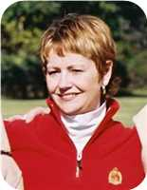
  Norah Lynn Bongard
Norah Lynn married Jerrery F Biggs on Saturday, June 02, 1973, in Montreal,Quebec. They had one daughter.
Jerrery F died in Toronto,ON, about 1988.
Daughter of Norah Lynn Bongard and Jerrery F Biggs:
f I. Lauren Alexis Biggs was born on June 19, 1982.

Family of John Ives and Iris ?
Lewis Zindord |  |  |  | Jenny Mitchell |  |  |  | Clarence |  |  |  | Ernestine
Ives |  |  |  | Eastwood |  |  |  | Gaston |  |  |  | Hatch
1888–1941 |  |  |  | 1880–1942
 | James Eastwood |  |  |  |  |  |  |  | Gladys Jean
 | Ives |  |  |  |  |  |  |  | Gaston
 | 1916– |  |  |  |  |  |  |  | 1916–1998
 |  |  |  |  | John Gillan |  |  |  |  |  |  |  |  |  |  |  |  |  |  |  | Iris
 |  |  |  |  | Ives |  |  |  |  |  |  |  |  |  |  |  |  |  |  |  | ?
 |  |  |  |  |  |  |  |  | Married

48. John Gillan Ives. He is the son of James Eastwood Ives (37) and Gladys Jean Gaston.
He married Iris ?.

Family of Marjory Ives and Arleigh Cornelius
 |  |  |  |  |  |  |  |  |  |  |  |  |  |  |  | Lewis Zindord |  |  |  | Jenny Mitchell |  |  |  | Clarence |  |  |  | Ernestine
 |  |  |  |  |  |  |  |  |  |  |  |  |  |  |  | Ives |  |  |  | Eastwood |  |  |  | Gaston |  |  |  | Hatch
 |  |  |  |  |  |  |  |  |  |  |  |  |  |  |  | 1888–1941 |  |  |  | 1880–1942
 |  |  |  |  |  |  |  |  |  |  |  |  |  |  |  |  | James Eastwood |  |  |  |  |  |  |  | Gladys Jean
 |  |  |  |  |  |  |  |  |  |  |  |  |  |  |  |  | Ives |  |  |  |  |  |  |  | Gaston
 |  |  |  |  |  |  |  |  |  |  |  |  |  |  |  |  | 1916– |  |  |  |  |  |  |  | 1916–1998
 |  |  |  |  | Arleigh |  |  |  |  |  |  |  |  |  |  |  |  |  |  |  | Marjory
 |  |  |  |  | Cornelius |  |  |  |  |  |  |  |  |  |  |  |  |  |  |  | Ives
 |  |  |  |  |  |  |  |  | Married

49. Rev. Marjory Ives. She is the daughter of James Eastwood Ives (37) and Gladys Jean Gaston.
She married Arleigh Cornelius.

Family of John Ives and Tammy ?
John Fraser |  |  |  | Jessie Margaret
Ives |  |  |  | MacMillan
1895–1970 |  |  |  | 1898–1994
 | David Hugh |  |  |  |  |  |  |  | Florence
 | Ives |  |  |  |  |  |  |  | Smith
 | 1924–
 |  |  |  |  | John David |  |  |  |  |  |  |  |  |  |  |  |  |  |  |  | Tammy
 |  |  |  |  | Ives |  |  |  |  |  |  |  |  |  |  |  |  |  |  |  | ?
 |  |  |  |  | 1969–
 |  |  |  |  |  |  |  |  | Married

50. John David Ives was born in March 1969. He is the son of David Hugh Ives (38) and Florence Smith.
He married Tammy ?.

Family of Sarah Ives and ? Fraser
 |  |  |  |  |  |  |  |  |  |  |  |  |  |  |  | John Fraser |  |  |  | Jessie Margaret
 |  |  |  |  |  |  |  |  |  |  |  |  |  |  |  | Ives |  |  |  | MacMillan
 |  |  |  |  |  |  |  |  |  |  |  |  |  |  |  | 1895–1970 |  |  |  | 1898–1994
 |  |  |  |  |  |  |  |  |  |  |  |  |  |  |  |  | David Hugh |  |  |  |  |  |  |  | Florence
 |  |  |  |  |  |  |  |  |  |  |  |  |  |  |  |  | Ives |  |  |  |  |  |  |  | Smith
 |  |  |  |  |  |  |  |  |  |  |  |  |  |  |  |  | 1924–
 |  |  |  |  | ? |  |  |  |  |  |  |  |  |  |  |  |  |  |  |  | Sarah Jean
 |  |  |  |  | Fraser |  |  |  |  |  |  |  |  |  |  |  |  |  |  |  | Ives
 |  |  |  |  |  |  |  |  |  |  |  |  |  |  |  |  |  |  |  |  | 1969–
 |  |  |  |  |  |  |  |  | Married

51. Sarah Jean Ives was born in March 1969. She is the daughter of David Hugh Ives (38) and Florence Smith.
She married ? Fraser.

Family of Pearl Ives and William MacMillan
 |  |  |  |  |  |  |  |  |  |  |  |  |  |  |  | John Fraser |  |  |  | Jessie Margaret
 |  |  |  |  |  |  |  |  |  |  |  |  |  |  |  | Ives |  |  |  | MacMillan
 |  |  |  |  |  |  |  |  |  |  |  |  |  |  |  | 1895–1970 |  |  |  | 1898–1994
 |  |  |  |  |  |  |  |  |  |  |  |  |  |  |  |  | David Hugh |  |  |  |  |  |  |  | Florence
 |  |  |  |  |  |  |  |  |  |  |  |  |  |  |  |  | Ives |  |  |  |  |  |  |  | Smith
 |  |  |  |  |  |  |  |  |  |  |  |  |  |  |  |  | 1924–
 |  |  |  |  | William |  |  |  |  |  |  |  |  |  |  |  |  |  |  |  | Pearl
 |  |  |  |  | MacMillan |  |  |  |  |  |  |  |  |  |  |  |  |  |  |  | Ives
 |  |  |  |  |  |  |  |  | Married

52. Pearl Ives. She is the daughter of David Hugh Ives (38) and Florence Smith.
She married William MacMillan.

Family of John Ramscar and Anne MacKenzie
 |  |  |  |  |  |  |  | John Fraser |  |  |  | Jessie Margaret |  |  |  | John Duncan |  |  |  | Bess
 |  |  |  |  |  |  |  | Ives |  |  |  | MacMillan |  |  |  | MacKenzie |  |  |  | Anderson
 |  |  |  |  |  |  |  | 1895–1970 |  |  |  | 1898–1994 |  |  |  | 1870–1932
 | Clwyd Vincent |  |  |  |  |  |  |  | Norah MacGillivary |  |  |  |  |  |  |  | Donald |  |  |  |  |  |  |  | Georgina
 | Ramscar |  |  |  |  |  |  |  | Ives |  |  |  |  |  |  |  | MacKenzie |  |  |  |  |  |  |  | Ross
 | 1922–1988 |  |  |  |  |  |  |  | 1921–
 |  |  |  |  | John Vincent |  |  |  |  |  |  |  |  |  |  |  |  |  |  |  | Anne Dawson
 |  |  |  |  | Ramscar |  |  |  |  |  |  |  |  |  |  |  |  |  |  |  | MacKenzie
 |  |  |  |  | 1947– |  |  |  |  |  |  |  |  |  |  |  |  |  |  |  | 1949–
 |  |  |  |  |  |  |  |  | Marriage: 1970
 |  |  |  |  |  |  |  |  |  |  |  | Anna Victiria |  |  |  | Mark Vincent
 |  |  |  |  |  |  |  |  |  |  |  | Ramscar |  |  |  | Ramscar
 |  |  |  |  |  |  |  |  |  |  |  | 1973– |  |  |  | 1978–

53. John Vincent Ramscar was born on Wednesday, May 14, 1947, in New Glasgow,Nova Scotia. He is the son of Clwyd Vincent Ramscar and Norah MacGillivary Ives (39).
John Vincent married Anne Dawson MacKenzie in June 1970 in Sydney. They have two children.
Anne Dawson was born in July 1949. She is the daughter of Donald MacKenzie and Georgina Ross.
Children of John Vincent Ramscar and Anne Dawson MacKenzie:
f I. Anna Victiria Ramscar was born in Prince Edward Island in April 1973.
m II. Mark Vincent Ramscar was born in New Glasgow,Nova Scotia, in June 1978.

Family of Jessie Ramscar and John Allan
 |  |  |  |  |  |  |  |  |  |  |  |  |  |  |  |  |  |  |  |  |  |  |  | John Fraser |  |  |  | Jessie Margaret
 |  |  |  |  |  |  |  |  |  |  |  |  |  |  |  |  |  |  |  |  |  |  |  | Ives |  |  |  | MacMillan
 |  |  |  |  |  |  |  |  |  |  |  |  |  |  |  |  |  |  |  |  |  |  |  | 1895–1970 |  |  |  | 1898–1994
 |  |  |  |  |  |  |  |  |  |  |  |  |  |  |  |  | Clwyd Vincent |  |  |  |  |  |  |  | Norah MacGillivary
 |  |  |  |  |  |  |  |  |  |  |  |  |  |  |  |  | Ramscar |  |  |  |  |  |  |  | Ives
 |  |  |  |  |  |  |  |  |  |  |  |  |  |  |  |  | 1922–1988 |  |  |  |  |  |  |  | 1921–
 |  |  |  |  | John David |  |  |  |  |  |  |  |  |  |  |  |  |  |  |  | Jessie Margaret
 |  |  |  |  | Allan |  |  |  |  |  |  |  |  |  |  |  |  |  |  |  | Ramscar
 |  |  |  |  | 1951– |  |  |  |  |  |  |  |  |  |  |  |  |  |  |  | 1948–
 |  |  |  |  |  |  |  |  | Marriage: 1975

54. Jessie Margaret Ramscar was born in July 1948. She is the daughter of Clwyd Vincent Ramscar and Norah MacGillivary Ives (39).
Jessie Margaret married John David Allan in October 1975. John David was born in May 1951.

7th Generation

Family of Jenny Robertson and Steve Taylor
Willam J |  |  |  | Hazel |  |  |  |  |  |  |  |  |  |  |  | James Ives |  |  |  | Charlotte Helen |  |  |  | John |  |  |  | Jean
Taylor |  |  |  | MaBee |  |  |  |  |  |  |  |  |  |  |  | Robertson |  |  |  | MacDonell |  |  |  | Worobel |  |  |  | Kolynchuk
1921–2012 |  |  |  |  |  |  |  |  |  |  |  |  |  |  |  | 1917–1989 |  |  |  | 1922–2005 |  |  |  | 1922–1979 |  |  |  | 1925–2012
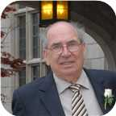
 | William George |  |  |  |  |  |  |  | Betty Ann |  |  |  |  |  |  |  | Allan James |  |  |  |  |  |  |  | Virginia
 | Taylor |  |  |  |  |  |  |  | ? |  |  |  |  |  |  |  | Robertson |  |  |  |  |  |  |  | Worobel
 | –2007 |  |  |  |  |  |  |  |  |  |  |  |  |  |  |  | 1943– |  |  |  |  |  |  |  | 1945–
 |  |  |  |  |  |  |  |  | 
 |  |  |  |  | Steve |  |  |  |  |  |  |  |  |  |  |  |  |  |  |  | Jenny Lind
 |  |  |  |  | Taylor |  |  |  |  |  |  |  |  |  |  |  |  |  |  |  | Robertson
 |  |  |  |  |  |  |  |  |  |  |  |  |  |  |  |  |  |  |  |  | 1970–
 |  |  |  |  | 
 |  |  |  |  |  |  |  |  | Divorce: 2017
 |  |  |  |  |  |  |  |  |  |  |  | Peyton Jackson |  |  |  | James Elliott
 |  |  |  |  |  |  |  |  |  |  |  | Taylor |  |  |  | Taylor
 |  |  |  |  |  |  |  |  |  |  |  | 2009– |  |  |  | 2011–
 |  |  |  |  |  |  |  |  |  |  |  |  |  |  |  | 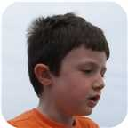

55. Jenny Lind Robertson was born on Friday, January 30, 1970, in St. Catharines, Ontario. She is the daughter of Allan James Robertson (40) and Virginia Worobel.
  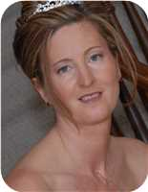
  Jenny Lind Robertson
She married Steve Taylor. They were divorced in Welland, Ontario, Canada, in 2017. They have two sons. He is the son of William George Taylor and Betty Ann ?.
  
  Steve Taylor
Sons of Jenny Lind Robertson and Steve Taylor:
m I. Peyton Jackson Taylor was born in St Catharines on May 21, 2009.
  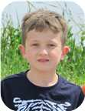
  Peyton
m II. James Elliott Taylor was born in St Catharines on March 16, 2011.
  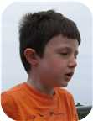
  James

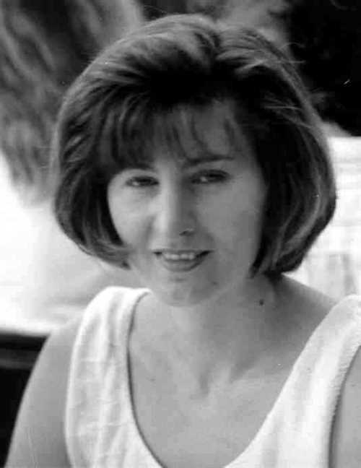  Figure 90: Jenny Lind Robertson |  | 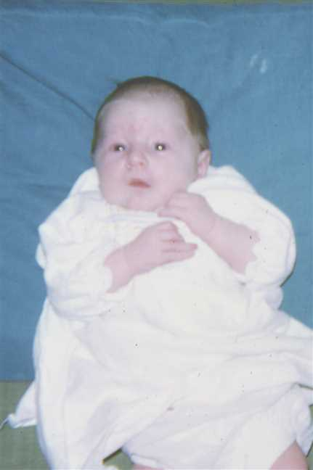  Figure 91: 197008-02Jenny5

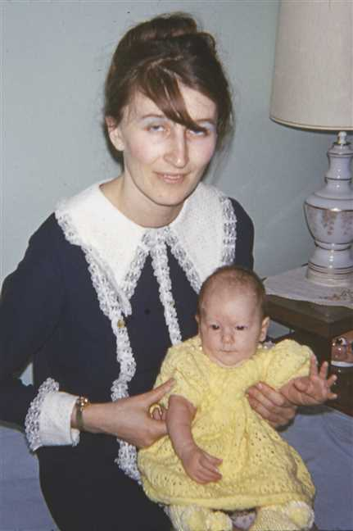  Figure 92: 197031-03VigeJenny |  | 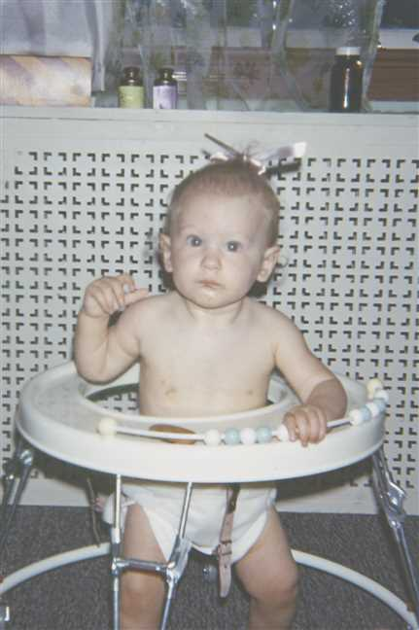  Figure 93: 197097-08Jenny2

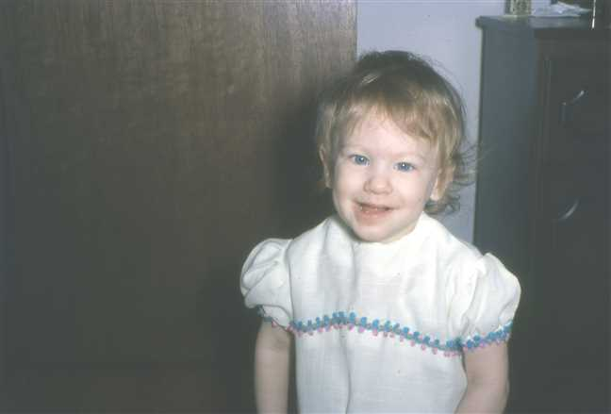  Figure 94: 1971-04Jenny |  | 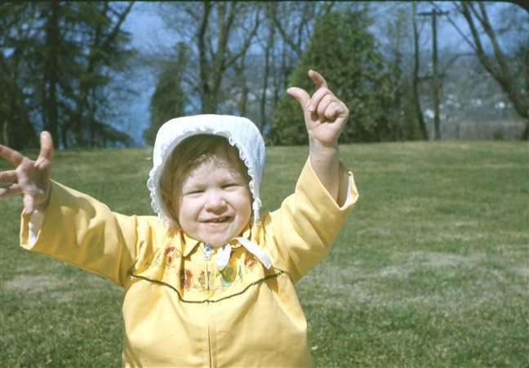  Figure 95: 1971-05Jenny6

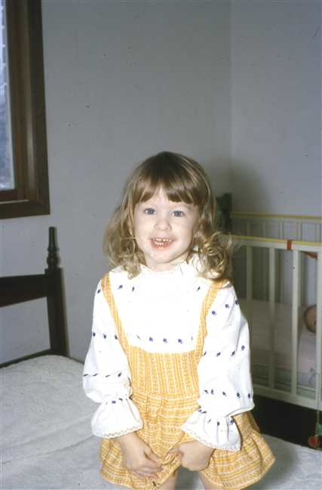  Figure 96: 1972-02Jenny |  | 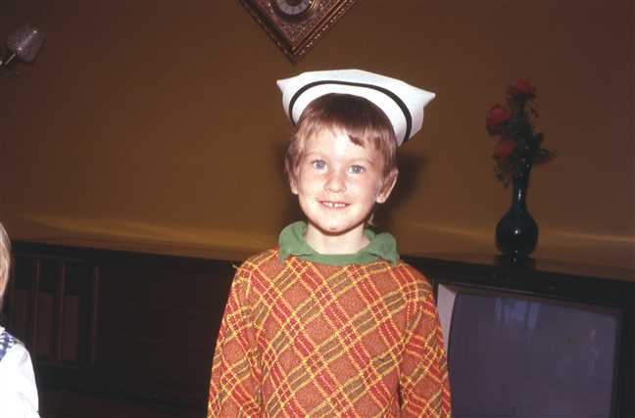  Figure 97: 1973-10JenyNurseHat

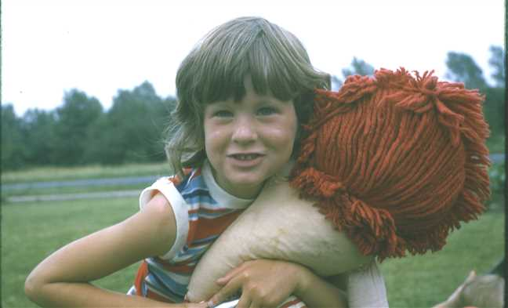  Figure 98: 1974-07Jenny3 |  | 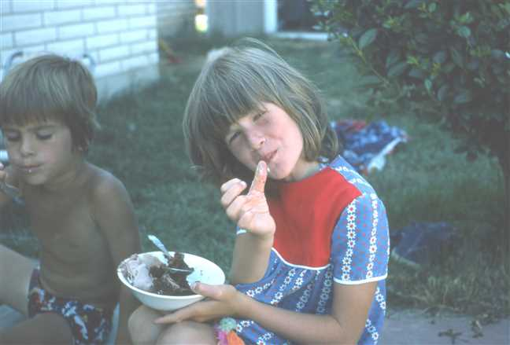  Figure 99: 1975-07Adele'sBirthday8

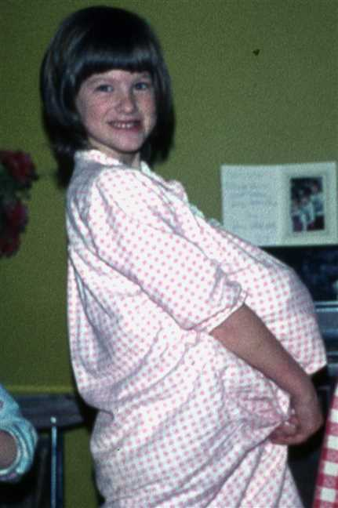  Figure 100: 1976-Jenny |  | 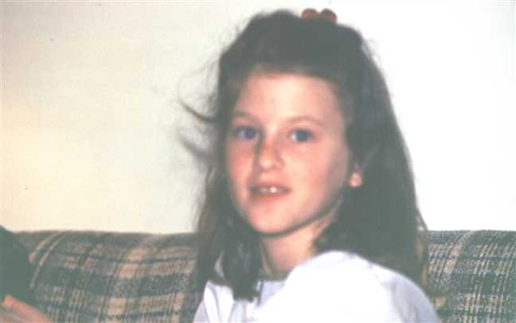  Figure 101: 1978-03Jenny

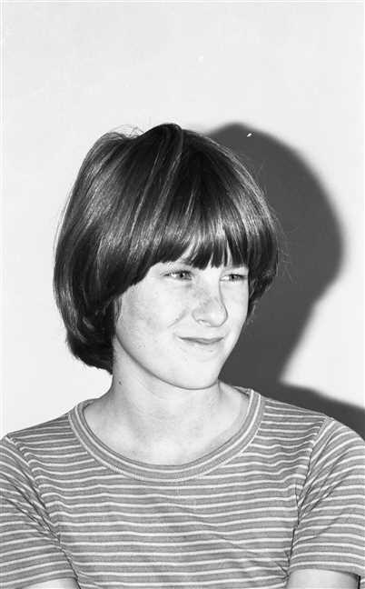  Figure 102: img001380 |  | 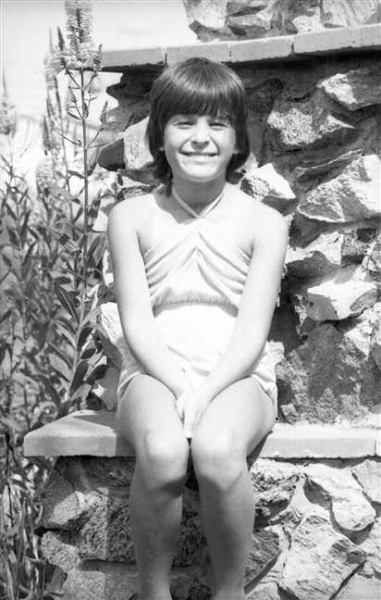  Figure 103: img001660

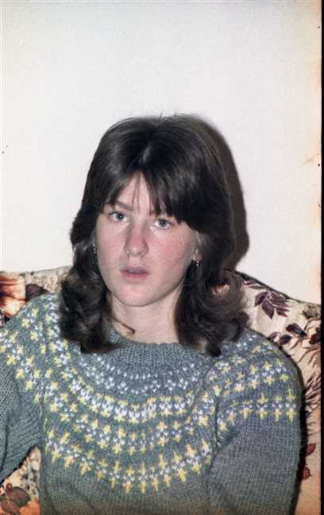  Figure 104: img001281 |  | 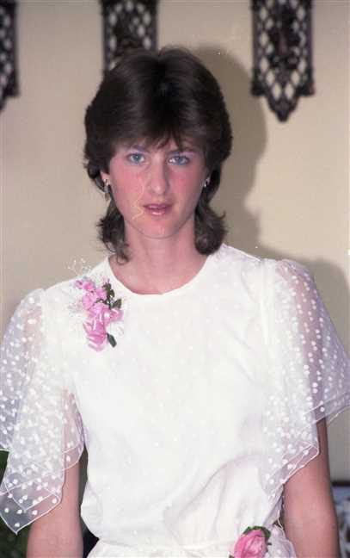  Figure 105: img001215

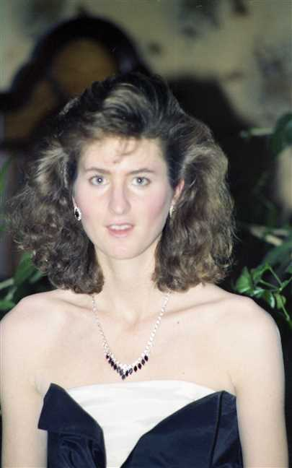  Figure 106: img001115 |  | 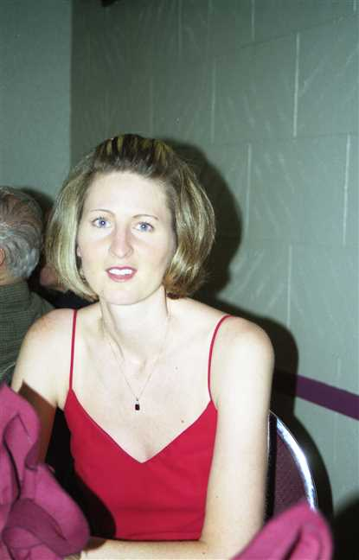  Figure 107: img001167

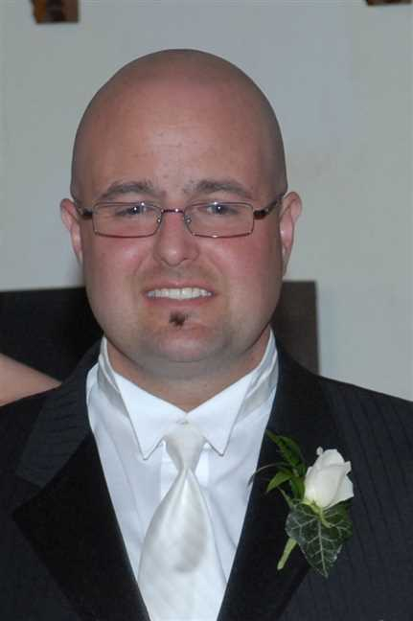
Figure 108: Steve

Adele Robertson
56. Adele Marie Robertson was born on Tuesday, July 06, 1971, in St. Catharines, Ontario. She is the daughter of Allan James Robertson (40) and Virginia Worobel.
  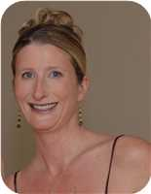
  Adele Marie Robertson
Adele never married either Jeff Graige or Geard Seward.
Marriages with Jeffery Craige and Geard Seward (Page 118) are known.

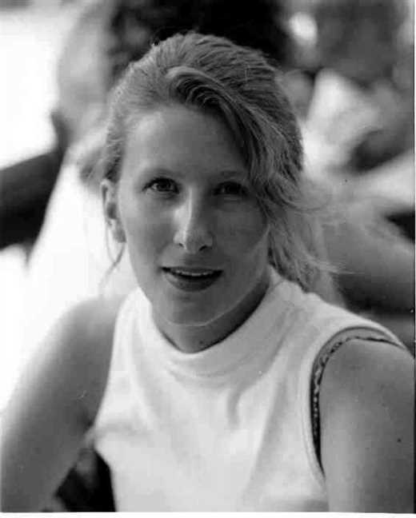  Figure 109: Adele Marie Robertson |  | 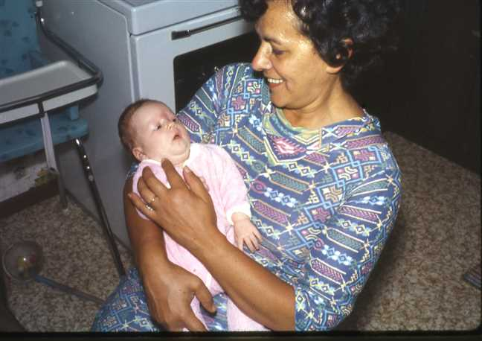  Figure 110: 1971-07AdeleBaba

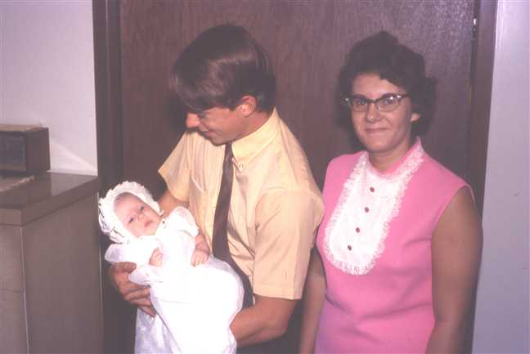  Figure 111: 1971-08AdeleAnnieDavid |  | 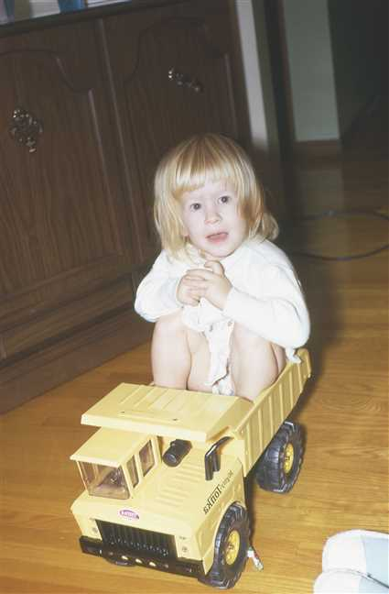  Figure 112: 1972-12Adele2

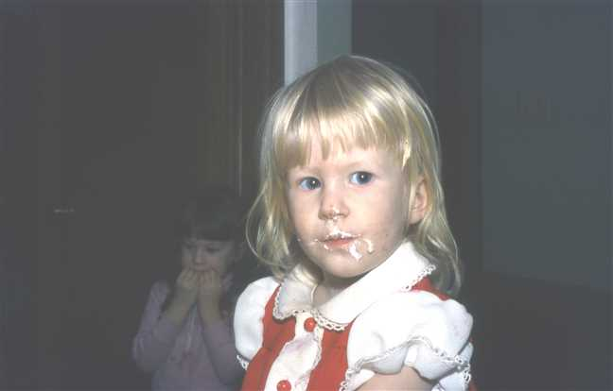  Figure 113: 1973-01Adele7 |  | 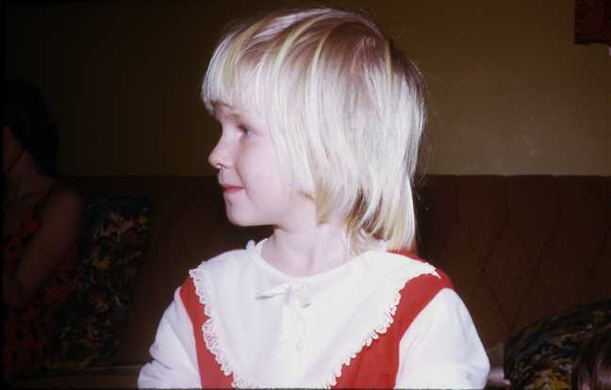  Figure 114: 1974-02Adele3

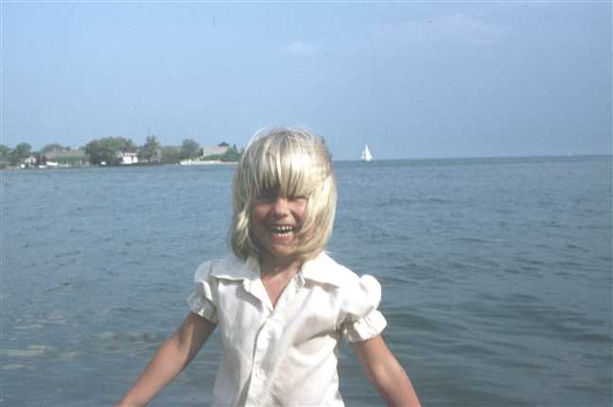  Figure 115: 1975-07Adele2 |  | 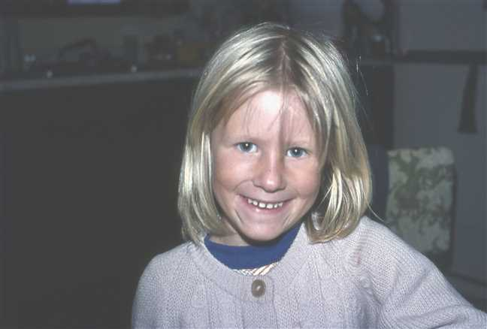  Figure 116: 1976-08Adele

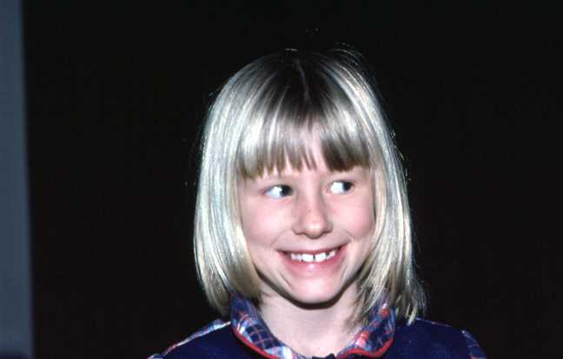  Figure 117: 1978-01Adele |  | 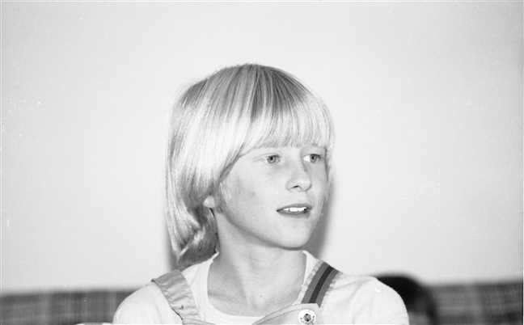  Figure 118: img001365

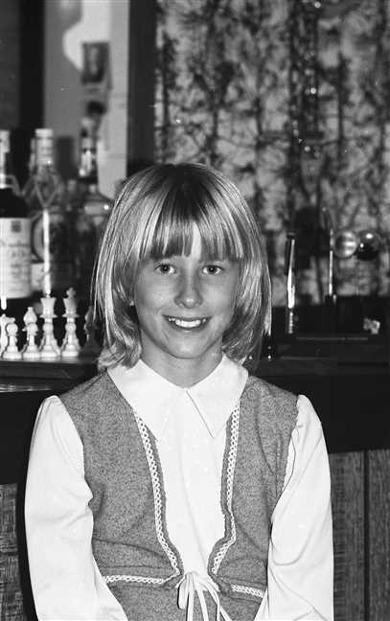  Figure 119: img001488 |  | 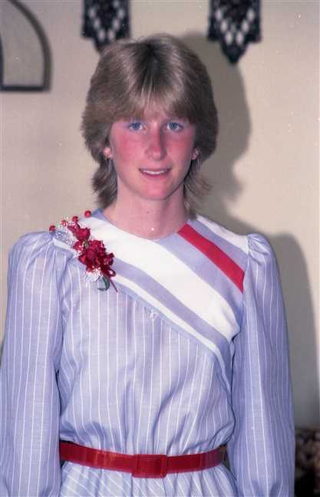  Figure 120: img001214

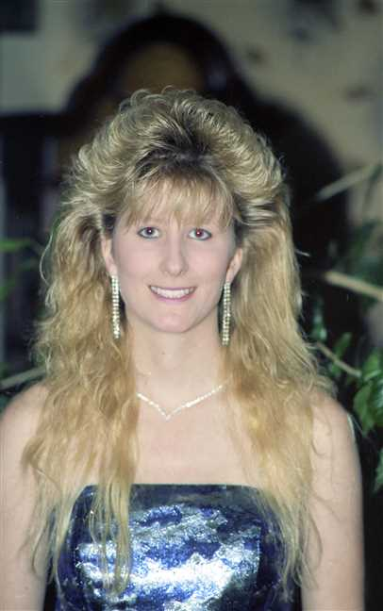
Figure 121: img001114

Family of Adele Robertson and Jeffery Craige
 |  |  |  |  |  |  |  |  |  |  |  |  |  |  |  |  |  |  |  |  |  |  |  | James Ives |  |  |  |  |  | Charlotte Helen |  |  |  |  |  | John |  |  |  |  |  | Jean
 |  |  |  |  |  |  |  |  |  |  |  |  |  |  |  |  |  |  |  |  |  |  |  | Robertson |  |  |  |  |  | MacDonell |  |  |  |  |  | Worobel |  |  |  |  |  | Kolynchuk
 |  |  |  |  |  |  |  |  |  |  |  |  |  |  |  |  |  |  |  |  |  |  |  | 1917–1989 |  |  |  |  |  | 1922–2005 |  |  |  |  |  | 1922–1979 |  |  |  |  |  | 1925–2012
 |  | ? |  |  |  |  |  |  |  |  |  |  |  | Jean |  |  |  |  |  |  |  |  |  |  |  | Allan James |  |  |  |  |  |  |  |  |  |  |  | Virginia
 |  | Craige |  |  |  |  |  |  |  |  |  |  |  | ? |  |  |  |  |  |  |  |  |  |  |  | Robertson |  |  |  |  |  |  |  |  |  |  |  | Worobel
 |  |  |  |  |  |  |  |  |  |  |  |  |  |  |  |  |  |  |  |  |  |  |  |  |  | 1943– |  |  |  |  |  |  |  |  |  |  |  | 1945–
 |  |  |  |  |  |  |  | Jeffery |  |  |  |  |  |  |  |  |  |  |  |  |  |  |  |  |  |  |  |  |  |  |  | Adele Marie
 |  |  |  |  |  |  |  | Craige |  |  |  |  |  |  |  |  |  |  |  |  |  |  |  |  |  |  |  |  |  |  |  | Robertson
 |  |  |  |  |  |  |  |  |  |  |  |  |  |  |  |  |  |  |  |  |  |  |  |  |  |  |  |  |  |  |  | 1971–
 |  |  |  |  |  |  |  |  |  |  |  |  |  | Married
 |  |  |  |  |  |  |  |  |  |  |  |  |  |  |  |  |  |  |  |  | Jude Allan
 |  |  |  |  |  |  |  |  |  |  |  |  |  |  |  |  |  |  |  |  | Robertson
 |  |  |  |  |  |  |  |  |  |  |  |  |  |  |  |  |  |  |  |  | 2004–
 |  |  |  |  |  |  |  |  |  |  |  |  |  |  |  |  |  |  |  |  | 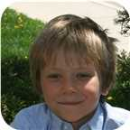

Here are the details about Adele Marie Robertson's first marriage, with Jeffery Craige. You can read more about Adele Marie on page 114.
Adele Marie Robertson married Jeffery Craige. They have one son. He is the son of ? Craige and Jean ?.
Jeff was adopten by Jean Craige and her first housband. Jeff's real parents are unknown but his biological Father is believed to be Austrian and his biological Mother is believed tobe Jamacian. Jeff has another older son - Kyle by another but unknown woman. He also has two more daughters by two other but unknown women.
Son of Adele Marie Robertson and Jeffery Craige:
m I. Jude Allan Robertson was born in St. Catharines, ON, on November 10, 2004.
  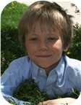
  Jude

Family of Adele Robertson and Geard Seward
 |  |  |  |  |  |  |  |  |  |  |  |  |  |  |  |  |  |  |  |  |  |  |  | James Ives |  |  |  |  |  | Charlotte Helen |  |  |  |  |  | John |  |  |  |  |  | Jean
 |  |  |  |  |  |  |  |  |  |  |  |  |  |  |  |  |  |  |  |  |  |  |  | Robertson |  |  |  |  |  | MacDonell |  |  |  |  |  | Worobel |  |  |  |  |  | Kolynchuk
 |  |  |  |  |  |  |  |  |  |  |  |  |  |  |  |  |  |  |  |  |  |  |  | 1917–1989 |  |  |  |  |  | 1922–2005 |  |  |  |  |  | 1922–1979 |  |  |  |  |  | 1925–2012
 |  | ? |  |  |  |  |  |  |  |  |  |  |  | Lynda |  |  |  |  |  |  |  |  |  |  |  | Allan James |  |  |  |  |  |  |  |  |  |  |  | Virginia
 |  | Seward |  |  |  |  |  |  |  |  |  |  |  | ? |  |  |  |  |  |  |  |  |  |  |  | Robertson |  |  |  |  |  |  |  |  |  |  |  | Worobel
 |  |  |  |  |  |  |  |  |  |  |  |  |  |  |  |  |  |  |  |  |  |  |  |  |  | 1943– |  |  |  |  |  |  |  |  |  |  |  | 1945–
 |  |  |  |  |  |  |  | Geard |  |  |  |  |  |  |  |  |  |  |  |  |  |  |  |  |  |  |  |  |  |  |  | Adele Marie
 |  |  |  |  |  |  |  | Seward |  |  |  |  |  |  |  |  |  |  |  |  |  |  |  |  |  |  |  |  |  |  |  | Robertson
 |  |  |  |  |  |  |  |  |  |  |  |  |  |  |  |  |  |  |  |  |  |  |  |  |  |  |  |  |  |  |  | 1971–
 |  |  |  |  |  |  |  |  |  |  |  |  |  | Married
 |  |  |  |  |  |  |  |  |  |  |  |  |  |  |  |  |  |  |  |  | Genevieve Alice
 |  |  |  |  |  |  |  |  |  |  |  |  |  |  |  |  |  |  |  |  | Seward
 |  |  |  |  |  |  |  |  |  |  |  |  |  |  |  |  |  |  |  |  | 2014–

Here are the details about Adele Marie Robertson's second marriage, with Geard Seward. You can read more about Adele Marie on page 114.
Adele Marie Robertson married Geard Seward. They have one daughter. He is the son of ? Seward and Lynda ?.
Daughter of Adele Marie Robertson and Geard Seward:
f I. Genevieve Alice Seward was born in St Catharines, Ontario, Canada, on May 19, 2014.

Family of Lara Robertson and Jeremy Bowen
Wilfred Fletcher |  |  |  |  |  | Helen |  |  |  |  |  | Pedro |  |  |  |  |  | Carmen |  |  |  |  |  | James Ives |  |  |  |  |  | Charlotte Helen |  |  |  |  |  | John |  |  |  |  |  | Jean
Bowen |  |  |  |  |  | Brodeur |  |  |  |  |  | Traverso |  |  |  |  |  | Soler |  |  |  |  |  | Robertson |  |  |  |  |  | MacDonell |  |  |  |  |  | Worobel |  |  |  |  |  | Kolynchuk
1927–2018 |  |  |  |  |  |  |  |  |  |  |  | 1927–2019 |  |  |  |  |  | –1991 |  |  |  |  |  | 1917–1989 |  |  |  |  |  | 1922–2005 |  |  |  |  |  | 1922–1979 |  |  |  |  |  | 1925–2012
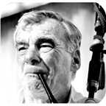 |  |  |  |  |  |  |  |  |  |  |  | 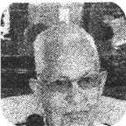
 |  | Ronald |  |  |  |  |  |  |  |  |  |  |  | Miriam |  |  |  |  |  |  |  |  |  |  |  | Allan James |  |  |  |  |  |  |  |  |  |  |  | Virginia
 |  | Bowen |  |  |  |  |  |  |  |  |  |  |  | Traverso |  |  |  |  |  |  |  |  |  |  |  | Robertson |  |  |  |  |  |  |  |  |  |  |  | Worobel
 |  |  |  |  |  |  |  |  |  |  |  |  |  |  |  |  |  |  |  |  |  |  |  |  |  | 1943– |  |  |  |  |  |  |  |  |  |  |  | 1945–
 |  |  |  |  |  |  |  |  |  |  |  |  |  | 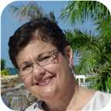
 |  |  |  |  |  |  |  | Jeremy |  |  |  |  |  |  |  |  |  |  |  |  |  |  |  |  |  |  |  |  |  |  |  | Lara Lynn
 |  |  |  |  |  |  |  | Bowen |  |  |  |  |  |  |  |  |  |  |  |  |  |  |  |  |  |  |  |  |  |  |  | Robertson
 |  |  |  |  |  |  |  | 1975– |  |  |  |  |  |  |  |  |  |  |  |  |  |  |  |  |  |  |  |  |  |  |  | 1973–
 |  |  |  |  |  |  |  | 
 |  |  |  |  |  |  |  |  |  |  |  |  |  | Married
 |  |  |  |  |  |  |  |  |  |  |  |  |  |  |  |  |  |  |  |  | Avalyn
 |  |  |  |  |  |  |  |  |  |  |  |  |  |  |  |  |  |  |  |  | Bowen
 |  |  |  |  |  |  |  |  |  |  |  |  |  |  |  |  |  |  |  |  | 2012–
 |  |  |  |  |  |  |  |  |  |  |  |  |  |  |  |  |  |  |  |  | 

57. Lara Lynn Robertson was born on Saturday, August 11, 1973, in St. Catharines, Ontario. She is the daughter of Allan James Robertson (40) and Virginia Worobel.
  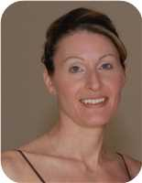
  Lara Lynn Robertson
She married Jeremy Bowen. They have one daughter.  Jeremy was born on Friday, December 26, 1975. He is the son of Ronald Bowen and Miriam Traverso.
  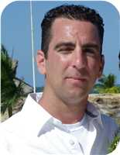
  Jeremy Bowen
Daughter of Lara Lynn Robertson and Jeremy Bowen:
f I. Avalyn Bowen was born in St Catharines, Ontario, Canada, on October 11, 2012.
  
  Avalyn

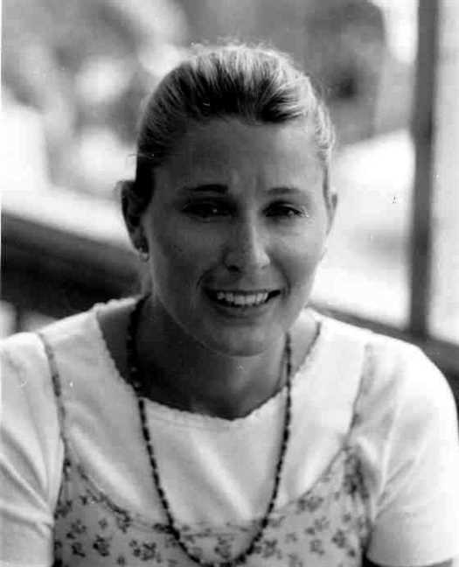  Figure 122: Lara Lynn Robertson |  | Figure 123: 1973-07Virginia(1)

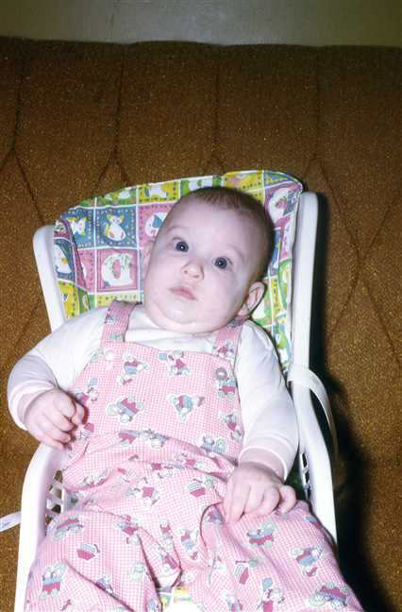  Figure 124: 1974-01Lara2 |  | 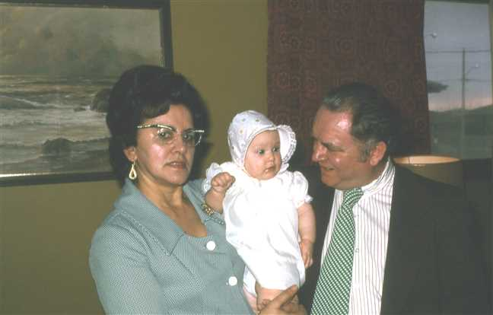  Figure 125: 1974-03BabaLaraWally

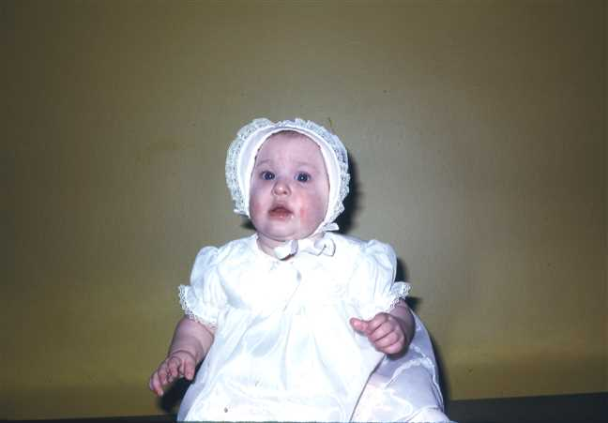  Figure 126: 1974-03Lara |  | 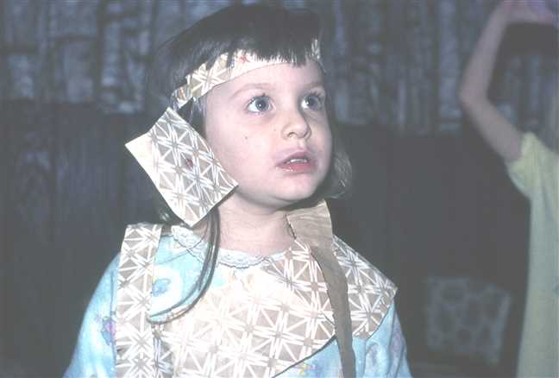  Figure 127: 1976-11Lara

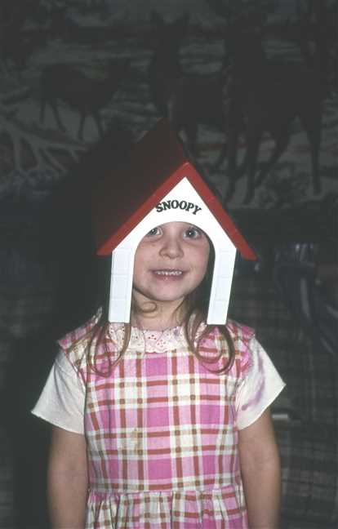  Figure 128: 1977-01Lara3 |  | 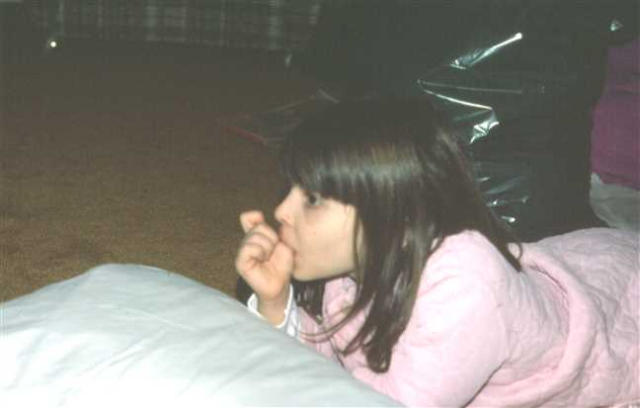  Figure 129: 1978-01Lara4

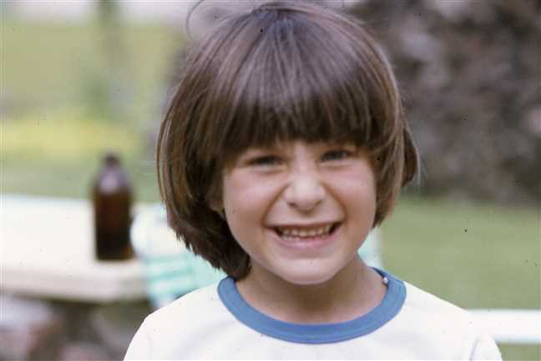  Figure 130: 1978-06Lara2 |  | 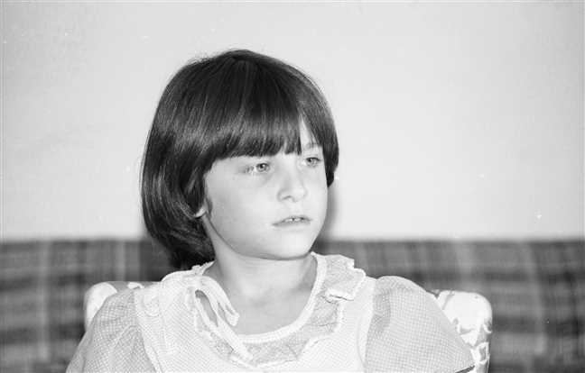  Figure 131: img001426

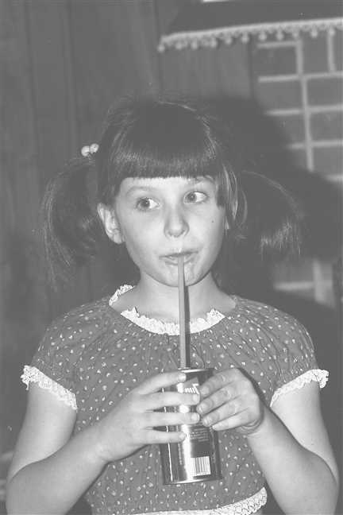  Figure 132: 1981-01 Lara |  | 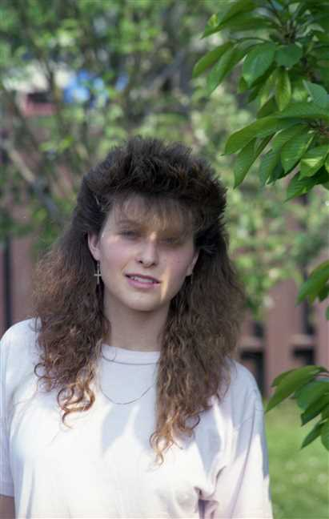  Figure 133: img001040

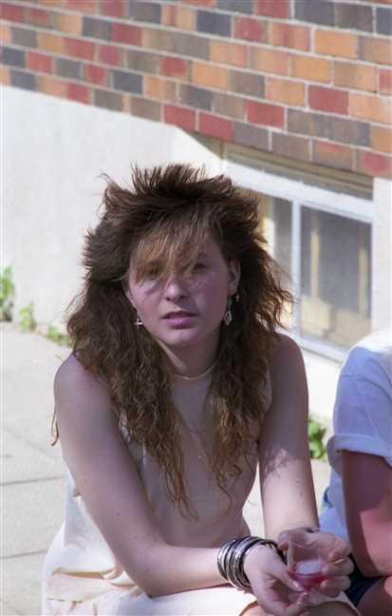
Figure 134: img001056

Family of Michelle Dusette and Brian Procter
 |  |  |  |  |  |  |  | James Ives |  |  |  | Charlotte Helen
 |  |  |  |  |  |  |  | Robertson |  |  |  | MacDonell
 |  |  |  |  |  |  |  | 1917–1989 |  |  |  | 1922–2005
 | ? |  |  |  |  |  |  |  | Lois Christina
 | Cyr |  |  |  |  |  |  |  | Robertson
 |  |  |  |  |  |  |  |  | 1948–1979
 |  |  |  |  | Michelle |  |  |  |  |  |  |  |  |  |  |  |  |  |  |  | Brian
 |  |  |  |  | Dusette |  |  |  |  |  |  |  |  |  |  |  |  |  |  |  | Procter
 |  |  |  |  | 1969–
 |  |  |  |  |  |  |  |  | Marriage: 1995
 |  |  |  |  |  |  |  |  |  |  |  | Jessica |  |  |  | Rebecca
 |  |  |  |  |  |  |  |  |  |  |  | Procter |  |  |  | Procter
 |  |  |  |  |  |  |  |  |  |  |  | 1997– |  |  |  | 2001–

58. Michelle Dusette was born on Monday, November 03, 1969, in St Catharines, Ontario, Canada. He or she is a child of ? Cyr and Lois Christina Robertson (41).
Michelle married Brian Procter in 1995. They have two children.
Children of Michelle Dusette and Brian Procter:
I. Jessica Procter was born in St Catharines on January 16, 1997.
II. Rebecca Procter was born in St Catharines on April 03, 2001.

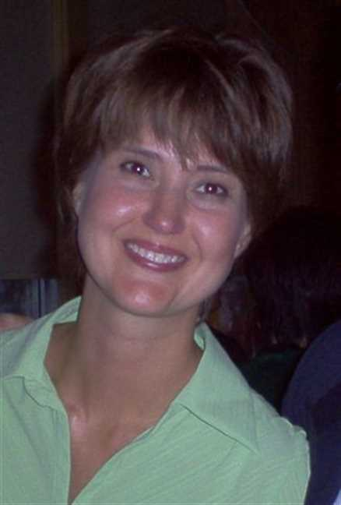  Figure 135: michelle pic |  | 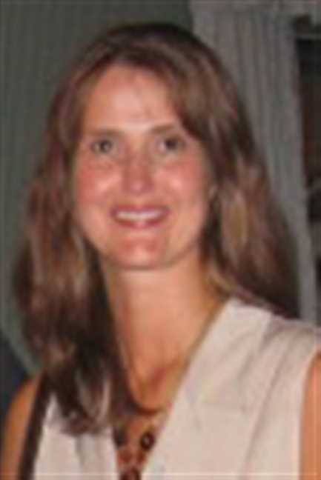  Figure 136: Michelle2

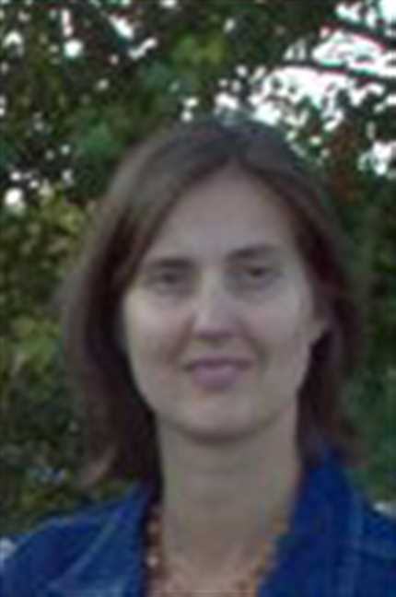  Figure 137: Michelle3 |  | 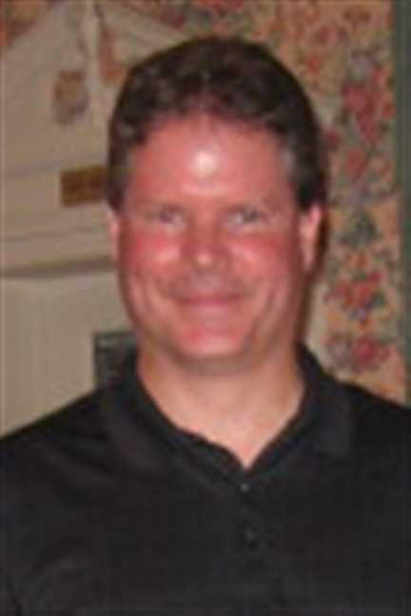  Figure 138: Brian

Lisa Robertson and John Brown
 |  |  |  |  |  |  |  | Kipling |  |  |  | Mary Ellen |  |  |  | Frederick Elmer Dicki |  |  |  | Jessie Winifred |  |  |  | James Ives |  |  |  | Charlotte Helen
 |  |  |  |  |  |  |  | MacKenzie |  |  |  | Foley |  |  |  | Gray |  |  |  | Davis |  |  |  | Robertson |  |  |  | MacDonell
 |  |  |  |  |  |  |  | ca.1910–1968 |  |  |  | –1987 |  |  |  |  |  |  |  | 1919– |  |  |  | 1917–1989 |  |  |  | 1922–2005
 | Joseph Owen |  |  |  |  |  |  |  | Catherine Alexandra |  |  |  |  |  |  |  | Roy Edward |  |  |  |  |  |  |  | Vivian Louise
 | Brown |  |  |  |  |  |  |  | MacKenzie |  |  |  |  |  |  |  | Gray |  |  |  |  |  |  |  | Robertson
 | 1932– |  |  |  |  |  |  |  | 1935–1992 |  |  |  |  |  |  |  | 1951– |  |  |  |  |  |  |  | 1957–
 |  |  |  |  | John Christopher |  |  |  |  |  |  |  |  |  |  |  |  |  |  |  | Lisa
 |  |  |  |  | Brown |  |  |  |  |  |  |  |  |  |  |  |  |  |  |  | Robertson
 |  |  |  |  | 1971– |  |  |  |  |  |  |  |  |  |  |  |  |  |  |  | 1974–
 |  |  |  |  |  |  |  |  | Partner
 |  |  |  |  |  |  |  |  |  |  |  | William Blair Robertson |  |  |  | Devon Alexander
 |  |  |  |  |  |  |  |  |  |  |  | Brown |  |  |  | Brown
 |  |  |  |  |  |  |  |  |  |  |  | 1996– |  |  |  | 2003–
 |  |  |  |  |  |  |  |  |  |  |  | 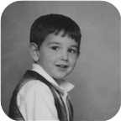

59. Lisa Robertson was born on Thursday, August 08, 1974, in Pictou, Nova Scotia, Canada. She is the daughter of Roy Edward Gray and Vivian Louise Robertson (42).
  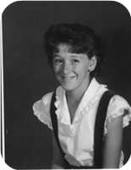
  Lisa Robertson
She is partnered with John Christopher Brown. They have two sons.
John Christopher was born in Pictou, N.S., on Saturday, March 13, 1971. He is the son of Joseph Owen Brown and Catherine Alexandra MacKenzie.
Sons of Lisa Robertson and John Christopher Brown:
m I. William Blair Robertson Brown was born in New Glasgow, Nova Scotia, on January 12, 1996.
  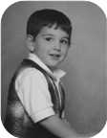
  William
m II. Devon Alexander Brown was born in Saskatoon, Sask., on March 28, 2003.

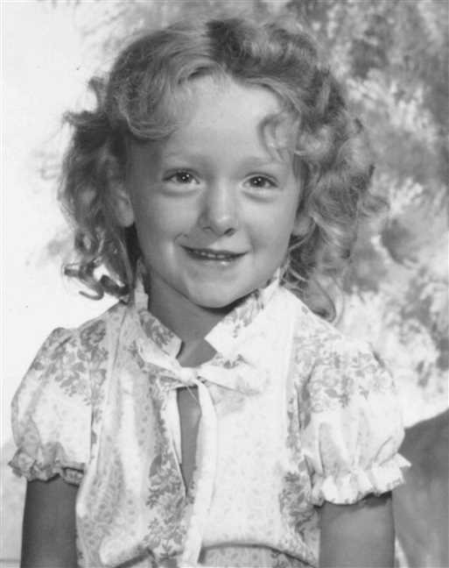  Figure 139: Lisa Robertson |  | 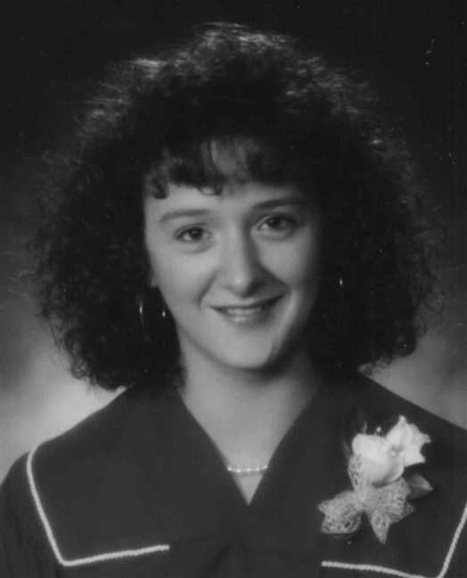  Figure 140: Lisa Robertson

Index of Places

1 year Mt Allison Academy (Commercial)
Robertson, Leonard Bowman (1918–) 71
1081
Ives, George 44
12 Mile House, Pictou Co., N.S.
Ives, Arthur (1854–1913) 37
Aberdeen Hospital, New Glasgow, N.S.
Gaston, Gladys Jean (1916–1998) 77
Aiken, MD
Ives, William Alexander (1880–) 45
Amherst, N.S
Ives, Alfred J (1862–1883) 27
B.Eng. from UNB
Robertson, Leonard Bowman (1947–) 99
BA from UNB
Robertson, Janet Louise (1951–) 100
Branch Manager for Lownsbury's
Robertson, Leonard Bowman (1918–) 71
Bridgetown, NS
Ives, Henry G (1858–) 42
Bridgeville, Nova Scotia
MacMillan, Jessie Margaret (1898–1994) 58
Brooklyn, NY
Ives, Lewis N (ca.1858–1895) 27
Brule Point, Colchester Co. NS
Ives, Robert (1842–) 15, 28
Brule Point, Colchester Co., N.S
Ives, James (ca.1824–1873) 15, 26
BSc, MSc St Francis Xavier Univ. 1965, 1967
Robertson, Allan James (1943–) 83
Cadillac, Quebec
Robertson, James Ives (1917–1989) 65
Chatham, N.B.
Robertson, Ian Douglas (1950–) 71
Chemist
Robertson, Allan James (1943–) 83
Churchville, Nova Scotia
Robertson, Leonard Bowman (1890–1972) 51
Civil Engineer
Robertson, Leonard Bowman (1947–) 99
Cumunity College
Robertson, James Ives (1917–1989) 64
Empress, Alberta
Bell, Edna Effie (1920–) 71
Factory Worker
Robertson, Lewis William (1951–) 65
Fisher's Grant, N.S.
Fraser, Georgina (1839–1933) 13, 25
From Niagara Falls
Bongard, Norah Lynn (1953–) 103
From Orilia
Bongard, Lester William (1921–2000) 74
Greenwood Cemetery, Pictou Landing , NS
Ives, Jane (1806–1856) 12
Greenwood Cemetery, Pictou Landing, N.S.
Fraser, Catharine (1778–1865) 9
Ives, Charles (1802–1870) 10
Ives, George (ca.1770–1862) 9
Haliburton Cemetery, Pictou, N.S.
Fraser, Ocenia (1853–1935) 37
Ives, Alfred J (1862–1883) 27
Ives, Arthur (1854–1913) 37
Ives, Arthur (1919–1933) 55
Ives, Charles Copeland (1883–1888) 33
Ives, Fanny Black (1828–1874) 26
Ives, James (ca.1824–1873) 26
Ives, Jannet (1882–1882) 33
Ives, John Clift (ca.1853–1858) 27
Ives, John Turner (1804–1876) 14
Ives, Lewis N (ca.1858–1895) 27
Ives, Robert Copeland (1878–1883) 33
Ives, Welsford B (ca.1861–1929) 27
Ives, William (ca.1855–1857) 27
Haliburton, Pictou, N.S.
Copeland, Margaret Maggie (1848–1933) 32
Gesner, Jean H (1911–1994) 47
Harris, Daniel Fraser (1887–1970) 47
Harris, Joseph Ives (1883–1902) 35
Harris, Mary Glennie (1891–1891) 35
Harris, Simpson J (1852–1934) 34
Harris, William Henry (1882–1965) 35
Ives, Charles William (1841–1921) 30
Ives, Emma (1850–1933) 34
Ives, Louisa Reid (1889–1982) 50
Robertson, Leonard Bowman (1890–1972) 51
Halifax, N.S.
Ives, John (ca.1740–ca.1782) 7
Ives, William Henry (–1911) 63
Halifax, NS
Ives, Fanny Black (1828–1874) 26
High School
Robertson, Lois Christina (1948–1979) 92
Home of John Ives, Pictou, N.S.
Ives, Sarah Frances (1856–) 41
Home of Mrs. John Turner Ives, Pictou, NS
Ives, Edith Lillian (1867–) 43
Judique, Nova Scotia
MacDonell, Charlotte Helen (1922–2005) 65
Laurel Hill Cemetery, Pictou, N.S.
Fraser, Christiana Ann (1813–1900) 19
Ives, Anna (1800–1878) 11
Ives, Catherine Fraser (1843–1847) 21
Ives, Daniel Fraser (1852–1884) 22
Ives, Infant Daughter (1851–1851) 22
Ives, John Robert (1845–1845) 21
Ives, William (1808–1880) 16
Ives, William Howard (1846–1848) 21
Mechanical Engineer
Bongard, Lester William (1921–2000) 74
Merchant
Ives, John Turner (1804–1876) 14
Merigomish, N.S. - Smith Copeland's home
Ives, Charles William (1841–1921) 32
Moncton, N.B.
Robertson, Leonard Bowman (1947–) 71, 99
Montreal, Quebec
Bongard, Norah Lynn (1953–) 103
New Glasgow, N.S.
Graham, Joseph Cunard (1836–1917) 25
Ives, Annie (1880–1956) 37
New Glasgow, Nova Scotia
Brown, William Blair Robertson (1996–) 124
Ives, David Hugh (1924–) 59, 79
Ramscar, John Vincent (1947–) 81, 106
Ramscar, Mark Vincent (1978–) 107
Niagara Falls, Ont.
Bongard, David (1958–) 74
Bongard, John Reid (1949–) 74, 102
Bongard, Norah Lynn (1953–) 74, 103
Bongard, Robert William (1946–) 74, 101
Robertson, Norah Louise (1921–) 51, 74
North Bay, Ontario
Champion, John Douglas (1951–) 100
Norwood, Ontario
Bongard, Lester William (1921–2000) 74
Nottingham, England
Ives, John (ca.1740–ca.1782) 7
Orillia, Ont.
Bongard, Lester William (1921–2000) 74
Philadelephia, PA
Ives, Charles Moore (1906–2001) 45, 61
Pictou, N.S.
Bethume, James William (1879–1940) 46
Brown, John Christopher (1971–) 124
Gray, Roy Edward (1951–) 98
Ives, John Turner (1804–1876) 10, 14
Ives, William Henry (–1911) 45, 63
McPhail, Anna (1844–1872) 31
Pictou, N.S. by Rev. William C Brown
Ives, Charles William (1841–1921) 31
Pictou, Nova Scotia
Ives, John Fraser (1895–1970) 37, 58
Pictou, Nova Scotia, Canada
(45.6782° N, 62.7071° W)
Ives, Louisa Reid (1889–1982) 37, 50
Patterson, Matthew (1785–1858) 11
Robertson, Allan James (1943–) 65, 83
Robertson, James Ives (1917–1989) 51, 64
Robertson, Leonard Bowman (1890–1972) 51
Robertson, Lisa (1974–) 98, 124
Robertson, Lois Christina (1948–1979) 65, 92
Robertson, Vivian Louise (1957–) 65, 96
Pictou, NS
Robertson, Derek (1990–) 98
Plymouth Park, Nova Scotia
Ives, John Fraser (1895–1970) 37, 58
MacMillan, Jessie Margaret (1898–1994) 58
Prince Edward Island
Bethume, James William (1879–1940) 46
Ramscar, Anna Victiria (1973–) 107
Pugwash, N.S.
Graham, Charles Archibald (1863–1882) 26
Registered Nurse
Bell, Edna Effie (1920–) 71
Sackville, New Brunswick
Manship, Laura Maud (1883–1979) 54
Saint John, N.B.
Robertson, Leonard Bowman (1918–) 71
Santa Clarita, CA
Ives, Charles Moore (1906–2001) 45, 61
Saskatoon, Sask.
Brown, Devon Alexander (2003–) 124
Secretary
Robertson, Lois Christina (1948–1979) 92
Sheet Metal worker
Robertson, James Ives (1917–1989) 64
Sheriff
Harris, Simpson J (1852–1934) 34
St Catharines, Niagara, Ontario, Canada
(43.1592° N, 79.2465° W)
Robertson, Allan James (1943–) 87
St Catharines, Ontario
Robertson, Lois Christina (1948–1979) 65, 92
Worobel, Virginia (1945–) 87
St Catharines, Ontario, Canada
(43.1667° N, 79.2334° W)
Bowen, Avalyn (2012–) 119
Dusette, Michelle (1969–) 96, 122
Procter, Jessica (1997–) 122
Procter, Rebecca (2001–) 123
Seward, Genevieve Alice (2014–) 118
Taylor, James Elliott (2011–) 110
Taylor, Peyton Jackson (2009–) 110
St. Asaph, North Wales
Ramscar, Clwyd Vincent (1922–1988) 81
St. Catharines, ON
Robertson, Jude Allan (2004–) 117
St. Catharines, Ontario
Robertson, Adele Marie (1971–) 88, 114
Robertson, Jenny Lind (1970–) 87, 109
Robertson, Lara Lynn (1973–) 88, 119
Stellarton, N.S.
Gaston, Gladys Jean (1916–1998) 77
Stellarton, Nova Scotia
Robertson, James Ives (1917–1989) 51, 64
Stellerton, N.S.
Robertson, Leonard Bowman (1918–) 51, 71
Sydney, Nova Scotia
Ramscar, John Vincent (1947–) 107
Taxi Driver
Robertson, Ian Douglas (1950–) 71
Telegraph operator, Security guard
Robertson, Leonard Bowman (1890–1972) 51
Toronto, ON
Biggs, Jerrery F (–ca.1988) 103
Welland, Ontario, Canada
(42.9935° N, 79.2393° W)
Taylor, Steve 109
Worked for CP railway
Champion, John Douglas (1951–) 100

Index of Individuals

?
? 7, 9, 11, 12, 14, 15, 44, 73, 74, 98, 101, 102, 103
Betty Ann 109
Iris 104
Jean 117
Lynda 118
Mary 58, 79, 80
Tammy 105
Yvone 102
Allan
John David (1951–) 107
Anderson
Bess 106
Ann?
(unknown given name) 9, 11, 12, 14, 15
Arnseon
Anne (1815–1889) 33, 34, 47, 48, 49
Baxter
Abigail 54, 75, 76
Bell
Edna Effie (1920–) 70, 71, 99, 100
Hugh 70
Roy Wesley (1888–1963) 70, 71, 99, 100
Bethume
James William (1879–1940) 46
Biggs
Jerrery F (–ca.1988) 103
Lauren Alexis (1982–) 103
Bongard
? 73, 74, 101, 102, 103
David (1958–) 73, 74
John Reid (1949–) 73, 74, 102
Lester William (1921–2000) 73, 74, 101, 102, 103
Norah Lynn (1953–) 73, 74, 103
Robert William (1946–) 73, 74, 101, 102
Bowen
Avalyn (2012–) 119
Jeremy (1975–) 119
Ronald 119
Wilfred Fletcher (1927–2018) 119
Brodeur
Helen 119
Brooks
Catherine 101
Brown
Devon Alexander (2003–) 124
John Christopher (1971–) 124
Joseph Owen (1932–) 124
William Blair Robertson (1996–) 124
Campbell
Alexander (1817–1908) 50
Annie Fraser (1867–1960) 50, 51, 64, 70, 73
Champion
Barbara Ann (1978–) 100, 101
Harry (1919–1985) 100
John Douglas (1951–) 100
Timothy Edward (1976–) 100, 101
Christina
(unknown given name) 62, 63
Colburg
Eleanor Arleen 62
Copeland
Margaret Maggie (1848–1933) 32, 45, 46, 62, 63
Robert S (1800–1885) 32, 45, 46
Samuel (–ca.1807) 32
Cornelius
Arleigh 104
Craige
? 117
Jeffery 117
Cyr
? 96, 122
Dalton
Joseph 94
Davis
Jessie Winifred (1919–) 97, 98, 124
Dunbar
Isabella (1823–1897) 50
Dusette
Michelle (1969–) 96, 122
Eastwood
James 56, 77
Jenny Mitchell (1880–1942) 56, 77, 104
Foley
Mary Ellen (–1987) 124
Fortin
Marguerite (1917–) 100
Fraser
? 105
Archibald (1801–1892) 12, 13, 25
Catharine (1778–1865) 9, 11, 12, 14, 15, 16, 25, 26, 27, 28, 31, 32, 33, 36
Charles (1748–1811) 9, 11, 12, 14, 15
Christiana Ann (1813–1900) 15, 19, 28, 30, 31, 32, 33, 34, 36, 37, 44, 45, 46, 47, 48, 49, 50, 54, 56, 58
Daniel (1769–1850) 15, 19, 28, 31, 32, 33, 36
Georgina (1839–1933) 12, 13, 25
James (1777–1853) 36
James Turner (1842–) 12, 13
Jane (1779–1879) 36
John (1808–1894) 36, 37, 50, 54, 56, 58
Joseph (–1941) 48
Ocenia (1853–1935) 36, 37, 50, 54, 56, 58, 64, 70, 73, 75, 76, 77, 79, 80
William (ca.1883–) 48
French
Josephine 70
Gaston
Clarence 77, 104
Gladys Jean (1916–1998) 77, 104
Gesner
Jean H (1911–1994) 47
Graham
Charles Archibald (1863–1882) 25, 26
John T (1866–1867) 25
Joseph Cunard (1836–1917) 25
Thomas (1776–1839) 25
Thomas (1807–1864) 25
Grant
Christiana (1752–1818) 15
Elizabeth (1771–) 25
Gray
Frederick Elmer Dicki 97, 98, 124
Roy Edward (1951–) 97, 98, 124
Harris
Ann (ca.1766–1823) 11
Christina Ives (1890–) 33, 35, 49
Daniel Fraser (1887–1970) 33, 35, 47
George Stewart (1885–1968) 33, 35
John W 33
Joseph Ives (1883–1902) 33, 35
Margaret McLeod (1888–) 33, 35, 48
Mary Glennie (1891–1891) 33, 35
Matthew (1735–1829) 11
Simpson J (1852–1934) 33, 34, 47, 48, 49
William H (1805–1883) 33, 34, 47, 48, 49
William Henry (1882–1965) 33, 35
Hatch
Ernestine 77, 104
Ives
Alexander William (1879–) 27, 28, 43
Alfred J (1862–1883) 26, 27
Anna (1800–1878) 9, 11
Annie (1880–1956) 36, 37
Arthur (1854–1913) 15, 22, 36, 37, 50, 54, 56, 58, 64, 70, 73, 75, 76, 77, 79, 80
Arthur (1919–1933) 54, 55
Brian 79, 80
Catherine Fraser (1843–1847) 15, 21
Charles (1802–1870) 9, 10
Charles Copeland (1883–1888) 32, 33
Charles Moore (1906–2001) 45, 61, 62, 63
Charles W 62
Charles William (1841–1921) 15, 21, 30, 31, 32, 45, 46, 62, 63
Christina Nan (1884–) 32, 33, 46
Daniel Fraser (1852–1884) 15, 22
Daniel Fraser (1887–1964) 36, 37, 54, 75, 76
David Hugh (1924–) 58, 59, 79, 105, 106
Edith Lillian (1867–) 26, 27, 42
Emma (1850–1933) 15, 22, 33, 34, 47, 48, 49
Fanny Black (1828–1874) 26, 41, 42
Frances C 54, 55, 76
Frederick George (ca.1876–1915) 28, 29, 44
George 44
George (ca.1770–1862) 7, 9, 11, 12, 14, 15, 16, 25, 26, 27, 28, 31, 32, 33, 36
George Daniel (1840–) 15, 21, 28, 44
Henry G (1858–) 26, 27, 42
Hilda 54, 55, 76
Infant Dau (1798–1799) 9, 10
Infant Daughter (1851–1851) 15, 22
Isabella 9
James (1881–) 27, 28
James (ca.1790–) 26, 41, 42
James (ca.1824–1873) 14, 15, 26, 41, 42
James Eastwood (1916–) 56, 77, 104
Jane (1806–1856) 9, 12, 25
Jane Oxley (1875–1875) 28, 29
Jannet (1882–1882) 32, 33
Joanne 79, 80
John (ca.1740–ca.1782) 7, 9, 11, 12, 14, 15
John Clift (ca.1853–1858) 26, 27
John David (1969–) 79, 80, 105
John Fraser (1895–1970) 36, 37, 58, 79, 80, 81, 105, 106, 107
John Gillan 77, 78, 104
John K 9
John Robert (1845–1845) 15, 21
John Turner (1804–1876) 9, 10, 14, 26, 27, 28, 41, 42, 43
Kenneth 44, 45
Lewis Gordon (–1918) 56, 57
Lewis N (ca.1858–1895) 26, 27
Lewis Zindord (1888–1941) 36, 37, 56, 77, 104
Louisa Reid (1889–1982) 36, 37, 50, 64, 70, 71, 73, 74, 83, 94, 95, 96, 97, 98, 99, 100, 101, 102, 103
Margaret 45
Marjory 77, 78, 104
Norah MacGillivary (1921–) 58, 59, 80, 81, 106, 107
Pearl 79, 80, 106
Robert (1842–) 14, 15, 27, 28, 43
Robert Copeland (1878–1883) 32, 33
Russel Bliss (–1912) 54, 75
Sarah Frances 14, 15, 26, 27, 28, 41, 42, 43
Sarah Frances (1856–) 26, 27, 41
Sarah Jean (1969–) 79, 80, 105
Virginia 45, 62, 63, 64
Welsford B (ca.1861–1929) 26, 27
William (1808–1880) 9, 10, 15, 16, 28, 30, 31, 32, 33, 34, 36, 37, 44, 45, 46, 47, 48, 49, 50, 54, 56, 58
William (1874–1875) 28, 29
William (ca.1849–) 15, 21
William (ca.1855–1857) 26, 27
William Alexander (1880–) 32, 33, 45, 61, 62, 63, 64
William Henry (–1911) 45, 63
William Howard (1846–1848) 15, 21
Judy
(unknown given name) 62, 63
Kitchin
Henry 41
James (1818–1874) 41
James (–1853) 41
Kohut
Catherine 83
Kolynchuk
Demetro (1897–1945) 83
Jean (1925–2012) 83, 87, 109, 117, 118, 119
Kwasnica
Dora (1899–1972) 83
Lenyk
Laysha (1947–) 99
Little
Harold 95
MaBee
Hazel 109
MacCaullum
William 76
MacDonald
Edward M 42, 43
Mary Christina (1895–1978) 64, 65, 83, 94, 95, 96, 97, 98
William Little (1844–1917) 64
MacDonell
Allan (1880–1926) 64, 65, 83, 94, 95, 96, 97, 98
Angus Hugh (1831–1917) 64
Charlotte Helen (1922–2005) 64, 65, 83, 92, 94, 95, 96, 97, 98, 109, 117, 118, 119, 122, 124
Flora (1841–1919) 64
MacDougall
Charlotte (1849–1934) 64
MacIntosh
Mary 56, 77
MacKay
Catherine (1775–1864) 15, 19, 28, 31, 32, 33, 36
Roderick (1746–1829) 15
MacKenzie
Anne Dawson (1949–) 106, 107
Catherine Alexandra (1935–1992) 124
Christina (1780–1832) 36
Donald 106, 107
John Duncan (1870–1932) 106
Kipling (ca.1910–1968) 124
MacMillan
Hugh 58, 79, 80
Jessie Margaret (1898–1994) 58, 79, 80, 81, 105, 106, 107
William 106
Maisie
(unknown given name) 62, 63
Manship
Bliss 54, 75, 76
Laura Maud (1883–1979) 54, 75, 76
McConnell
Elizabeth 41
McKiel
Harry W 49
McKillop
Jessie (1827–1900) 50
McLellan
Mary (1807–1892) 25
McLeod
Amelia 28, 29, 44
Grace (1858–) 27, 28, 43
James 28, 29, 44
McPhail
Alexander 31
Anna (1844–1872) 31
Mills
? 63, 64
Moore
Mary K (1868–1894) 70
Virginia 45, 61, 62, 63, 64
Murray
Winnifred 63
O'Brian
Catharine 32
Patterson
John (1708–) 11
John (1748–1808) 11
Matthew (1785–1858) 11
Procter
Brian 122
Jessica (1997–) 122
Rebecca (2001–) 122, 123
Ramscar
Anna Victiria (1973–) 106, 107
Clwyd Vincent (1922–1988) 80, 81, 106, 107
David Frederick (1944–1970) 80, 81
Jessie Margaret (1948–) 80, 81, 107
John Vincent (1947–) 80, 81, 106
Lawrence James (1951–) 80, 81
Mark Vincent (1978–) 106, 107
Rickerby
Elizabeth (1801–1867) 41
Robertson
Adele Marie (1971–) 83, 88, 114, 117, 118
Allan James (1943–) 64, 65, 83, 109, 114, 117, 118, 119
Annie (1818–1909) 36, 37, 50, 54, 56, 58
Annie Oceania (1915–1920) 50, 51
Derek (1990–) 98
Ian Douglas (1950–) 70, 71
James (1823–1894) 50
James Alexander (1859–1947) 50, 51, 64, 70, 73
James Ives (1917–1989) 50, 51, 64, 83, 92, 94, 95, 96, 97, 98, 109, 117, 118, 119, 122, 124
Janet Louise (1951–) 70, 71, 100
Jenny Lind (1970–) 83, 87, 109
Jude Allan (2004–) 117
Lara Lynn (1973–) 83, 88, 119
Leonard Bowman (1890–1972) 50, 51, 64, 70, 71, 73, 74, 83, 94, 95, 96, 97, 98, 99, 100, 101, 102, 103
Leonard Bowman (1918–) 50, 51, 70, 71, 99, 100
Leonard Bowman (1947–) 70, 71, 99
Lewis William (1951–) 64, 65
Lisa (1974–) 97, 98, 124
Lois Christina (1948–1979) 64, 65, 92, 94, 95, 96, 122
Michael Leonard (1978–) 99
Norah Louise (1921–) 50, 51, 73, 74, 101, 102, 103
Richard Bruce (1976–) 99
Roy Wesley (1949–1949) 70, 71
Vivian Louise (1957–) 64, 65, 96, 97, 98, 124
William (1769–1848) 36
Ross
Georgina 106, 107
Jessie May 43
Seward
? 118
Geard 118
Genevieve Alice (2014–) 118
Smith
Ethel Irene (1896–1929) 70, 71, 99, 100
Florence 79, 80, 105, 106
Janet (1805–1874) 32, 45, 46
John James 70
Snodgrass
Margaret (1710–) 11
Soler
Carmen (–1991) 119
Taylor
James Elliott (2011–) 109, 110
Peyton Jackson (2009–) 109, 110
Steve 109
Willam J (1921–2012) 109
William George (–2007) 109
Traverso
Miriam 119
Pedro (1927–2019) 119
Troop
Isabel Grassie 42
Jared C 42
Walker
Beryl 75
Worobel
John (1922–1979) 83, 87, 109, 117, 118, 119
Stephen 83
Virginia (1945–) 83, 87, 109, 114, 117, 118, 119
Wright
George 76

m. at the home of Mrs. John Turner Ives, Pictou, NS by Rev. A. Falconer, assisted by Rev. George Carson, to Edward M MacDonald, Pictou, barrister-at-law/ Edith Lillian Ives, youngent dau. of late James Ives.

