Pilot Officer
George Douglas MacDougall
February 4, 1943

Military Service:
Service Number:
J/16619
Age:
20
Force:
Air Force
Unit:
Royal Canadian Air Force
Division:
90 (R.A.F.) Sqdn
Plot 3. Row 1. Grave 1.
Location:
Montfoort is 17 kilometres south-west of Utrecht, and 46 kilometres east-north-east of Rotterdam. The MONTFOORT GENERAL CEMETERY is on the south-western side of the village, on the east side of the road from Montfoort to Oudewater. The graves are in the south-western part of the cemetery.
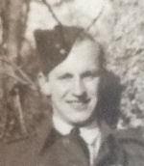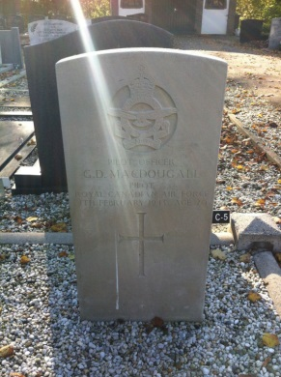
Montfoort is 17 kilometres south-west of Utrecht, and 46 kilometres east-north-east of Rotterdam. The MONTFOORT GENERAL CEMETERY is on the south-western side of the village, on the east side of the road from Montfoort to Oudewater. The graves are in the south-western part of the cemetery.

